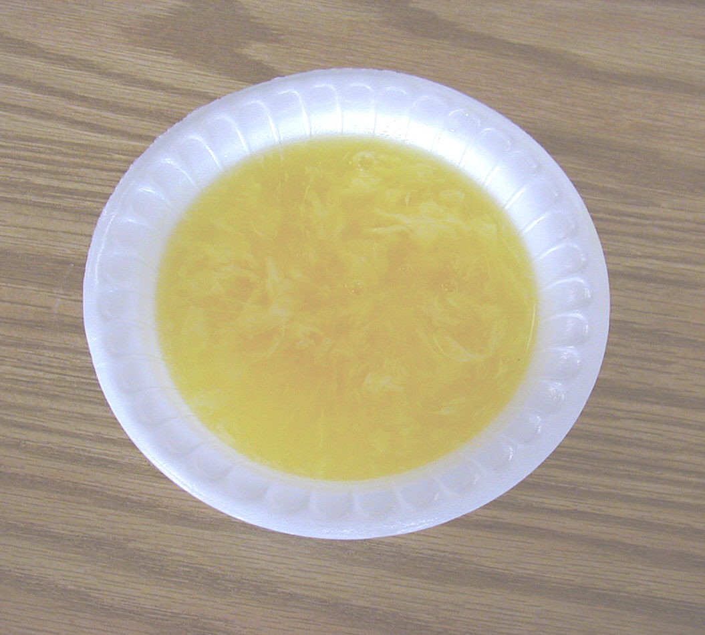
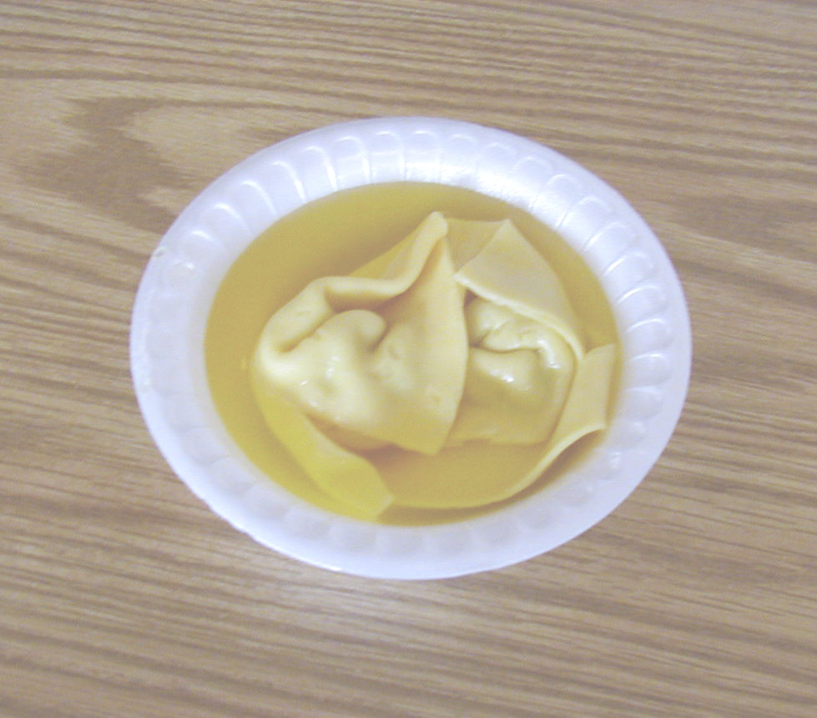

1. EGG DROP
2. WONTON

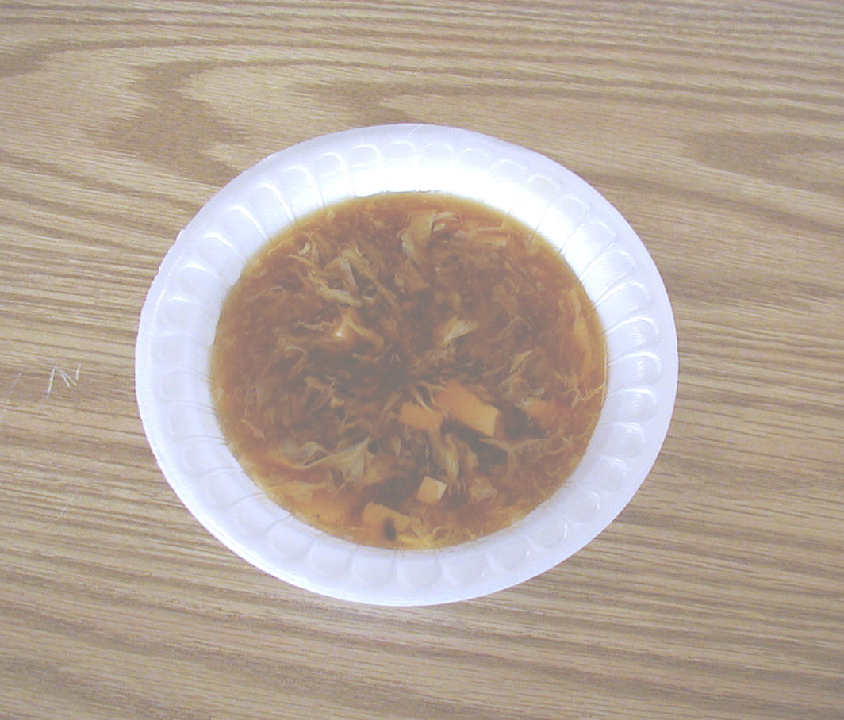
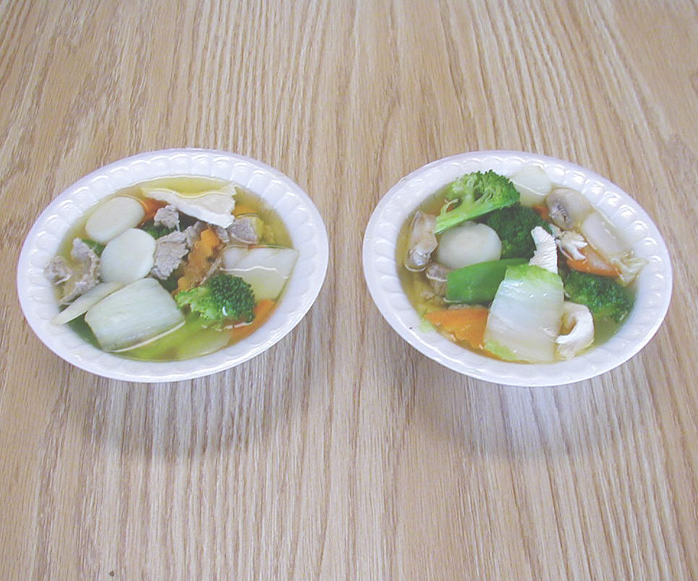

3. HOT & SOUR
4. HOUSE SPECIAL

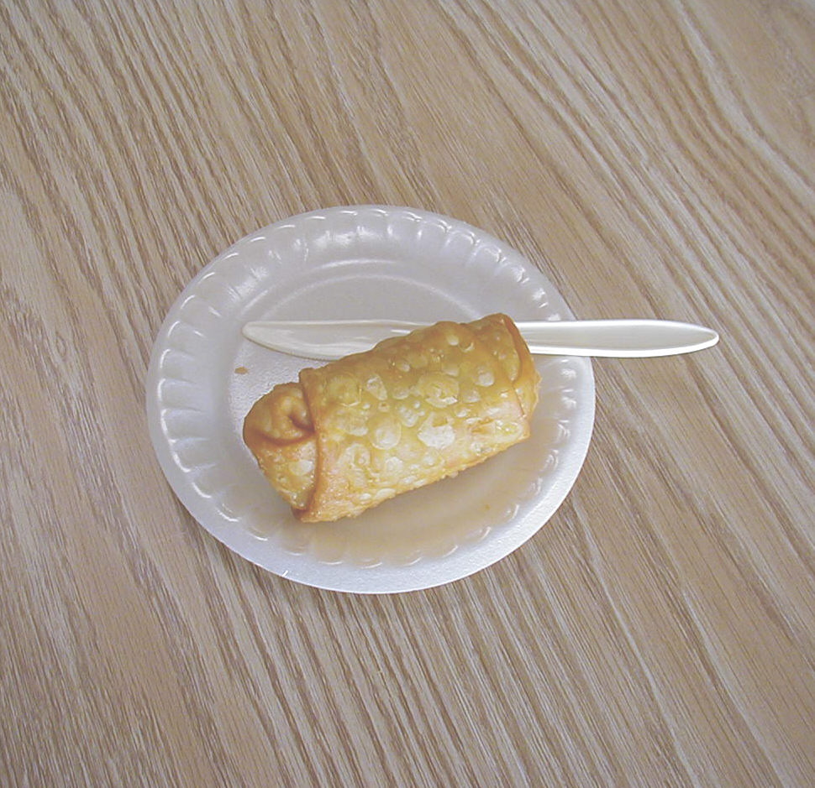
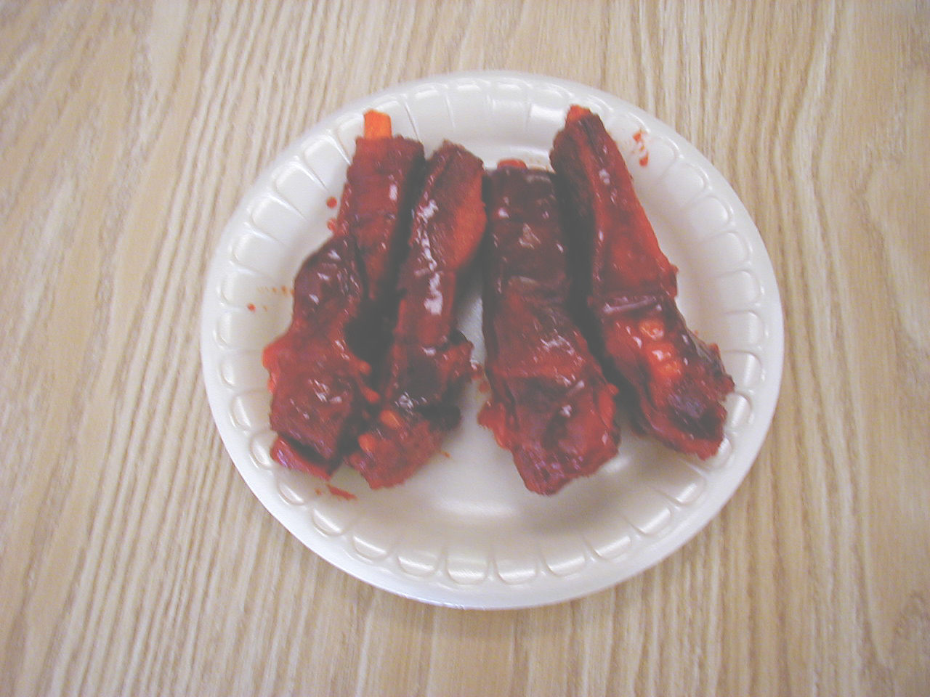
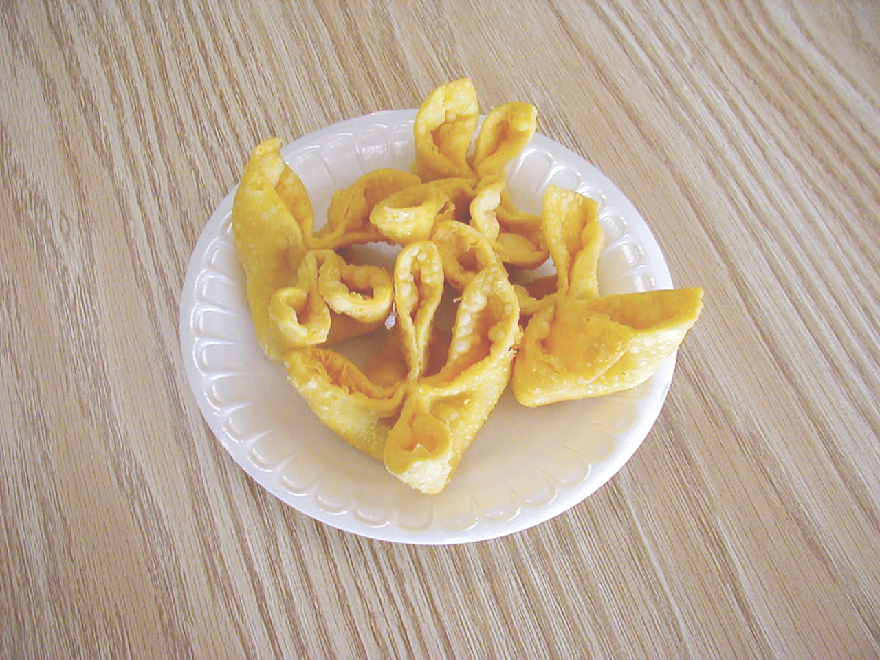
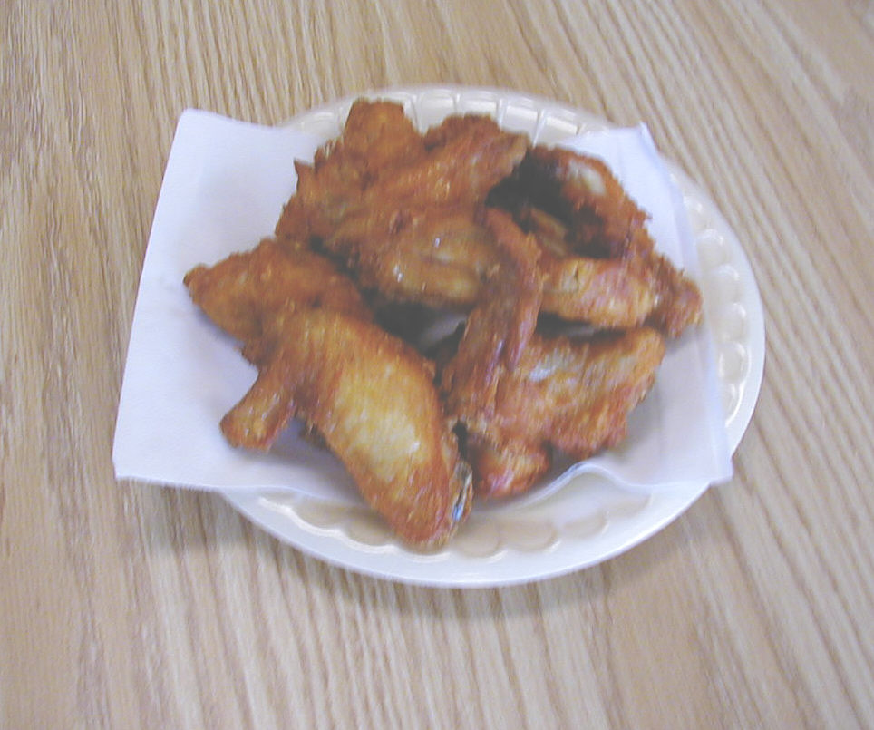
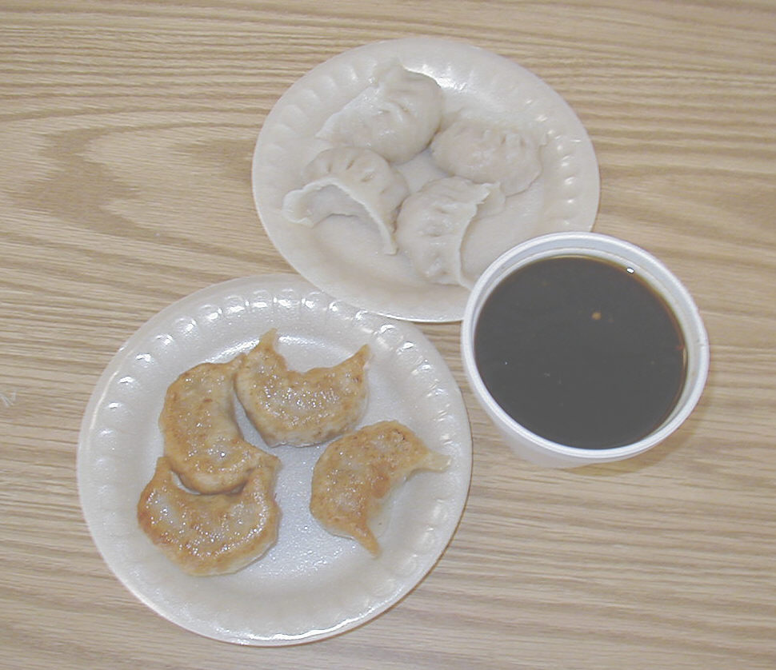
APPETIZERS
6. CRABMEAT FRIED WONTONS
7. FRIED CHICKEN WINGS (8)
8. DUMPLINGS (FRIED OR STEAMED)
9. BBQ SPARE RIBS
5. EGG ROLL

