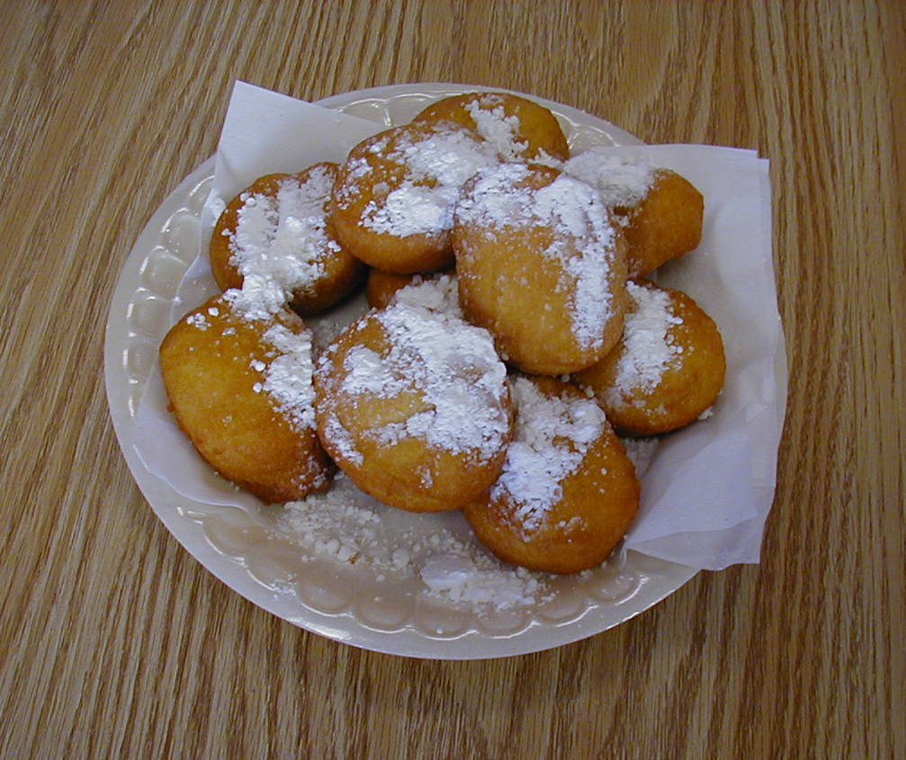
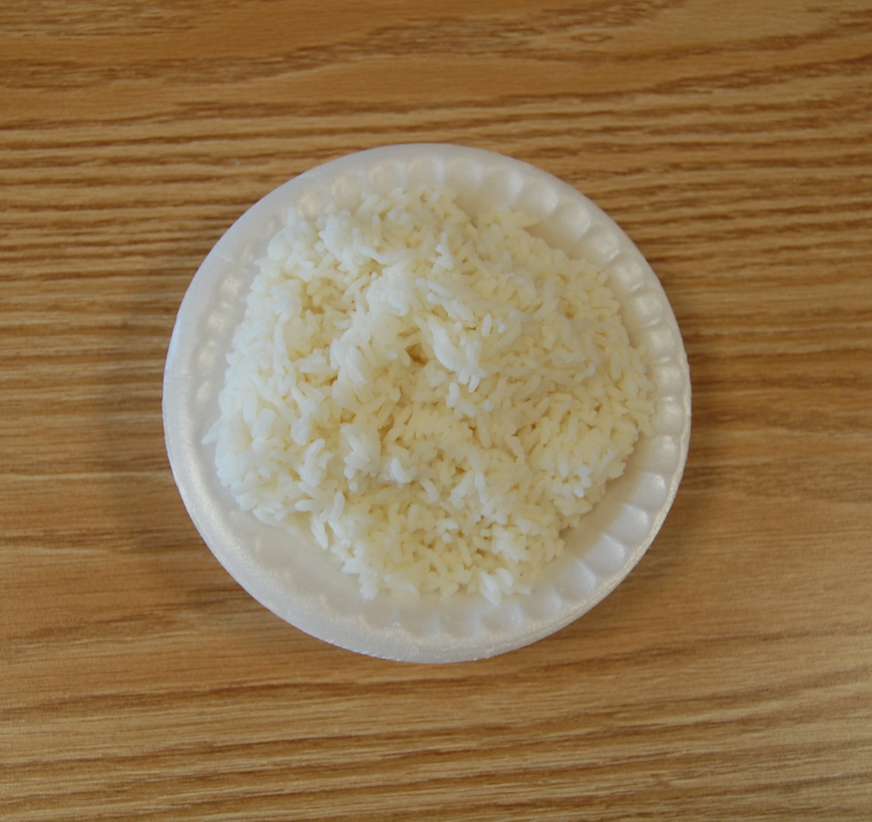
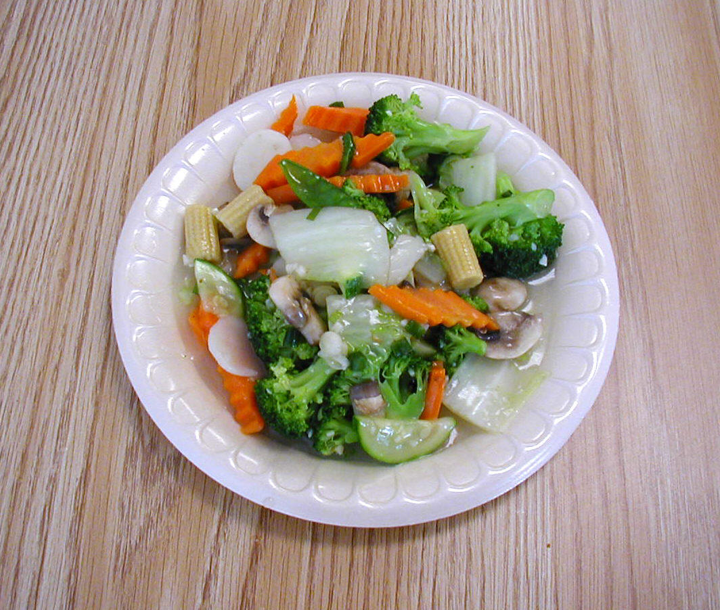
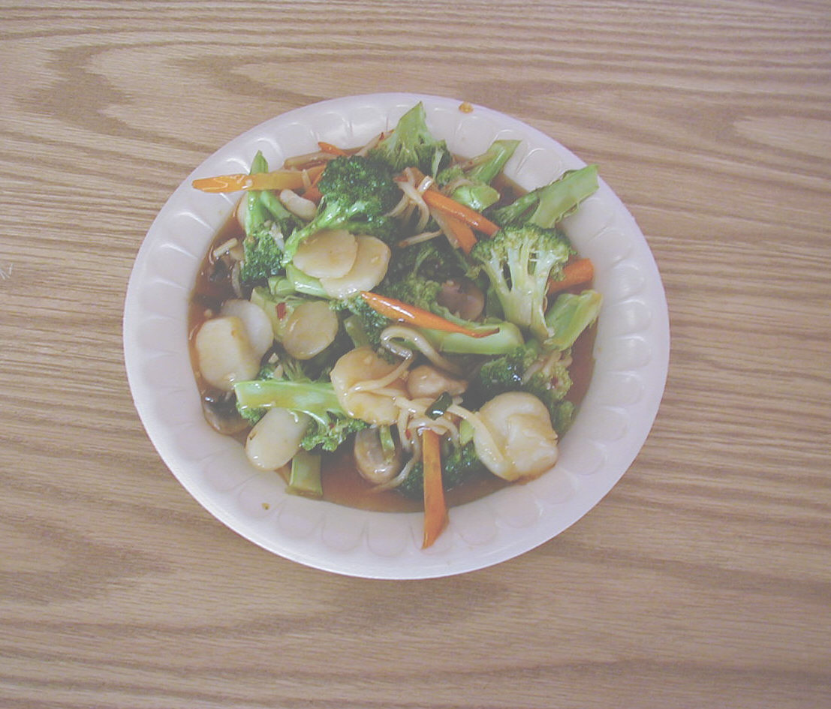
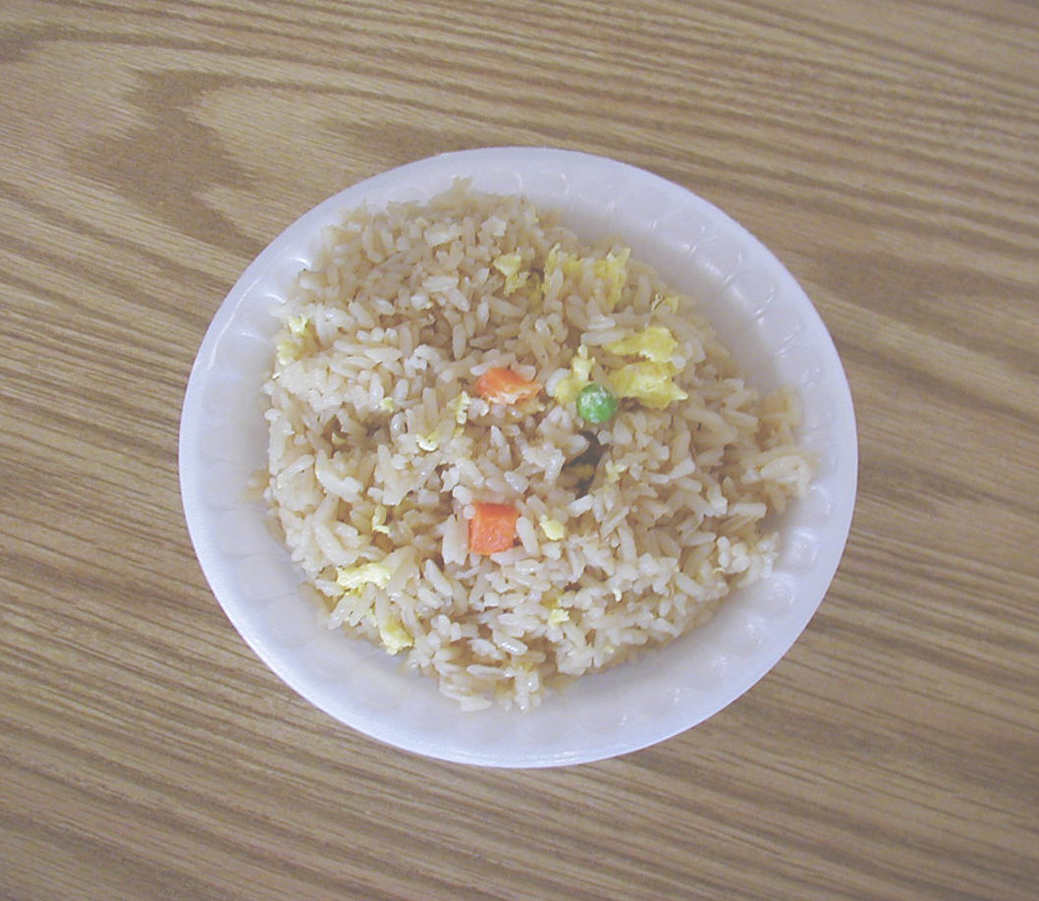
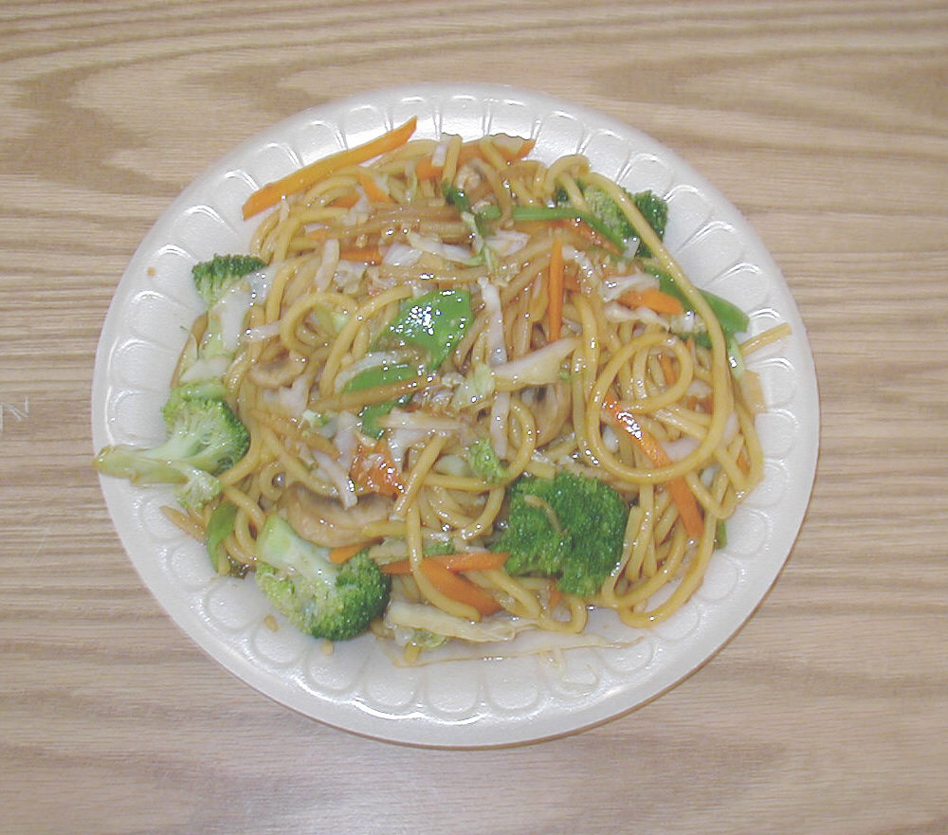
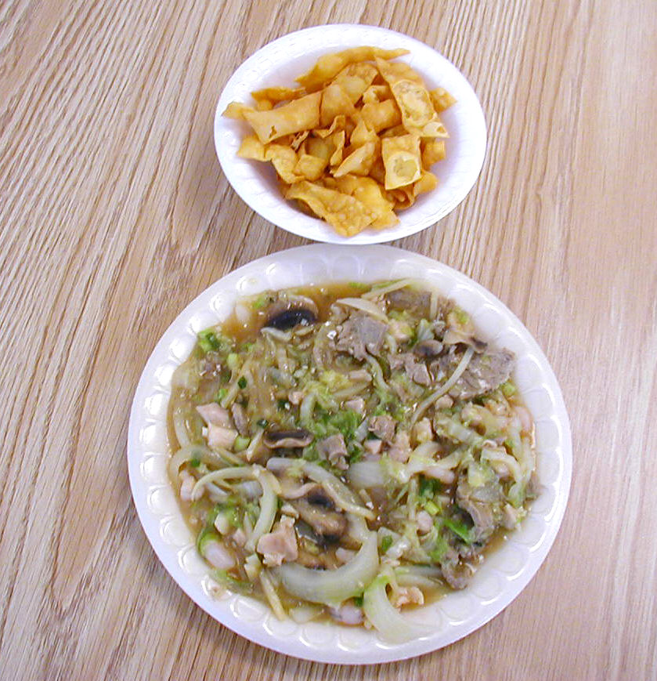
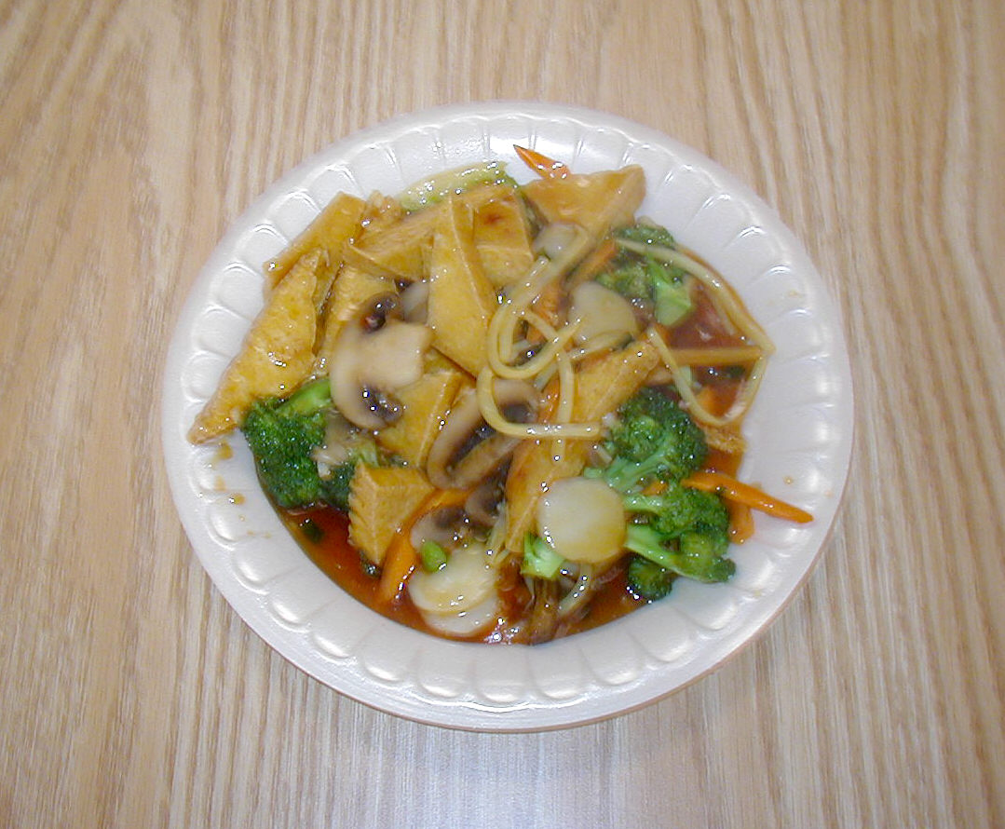
43. mixed Chinese vegetables
45. yu-shang bean curd
46. yU-shang broccoli
47. STANDARD fried rice
48. LO MEIN (pasta)
49. CHOW MEIN (vegetables)

RICE
CHINESE DONUTS

WHITE RICE

LO MEIN
CHOW MEIN

