**DAILY ONLINE ACTIVITIES SUMMARY**

|  |  |  |  |  |  |  |  |
| --- | --- | --- | --- | --- | --- | --- | --- |
| **Date:** | 01/06/2020 | | | | **Name:** | PONICA.J | |
| **Sem & Sec** | 4TH & B | | | | **USN:** | 4AL18CS055 | |
| **Online Test Summary** | | | | | | | |
| **Subject** | | MATHS | | | | | |
| **Max. Marks** | | 30 | | **Score** | | 27 | |
| **Certification Course Summary** | | | | | | | |
| **Course** | **Blockchain Basics** | | | | | | |
| **Certificate Provider** | | | **Coursera** | **Duration** | | | **4 weeks** |
| **Coding Challenges** | | | | | | | |
| PROBLEM STATEMENT: Given an array of positive integers. Write a C Program to find the leaders in the array. | | | | | | | |
| **Status: Completed** | | | | | | | |
| **Uploaded the report in Github** | | | | **YES** | | | |
| **If yes Repository name** | | | | **https://github.com/ponica-jaya/LOCKDOWN-CODING.git** | | | |
| **Uploaded the report in slack** | | | | **YES** | | | |

**TODAY WE HAD TEST FOR 30 MARKS AT 9.30 AM TO 10.10 AM WHICH HAD 2 ROUNDS OF MODULE 5 .**

**Certification Course Details: (Attach the snapshot and briefly write the report for the same)**

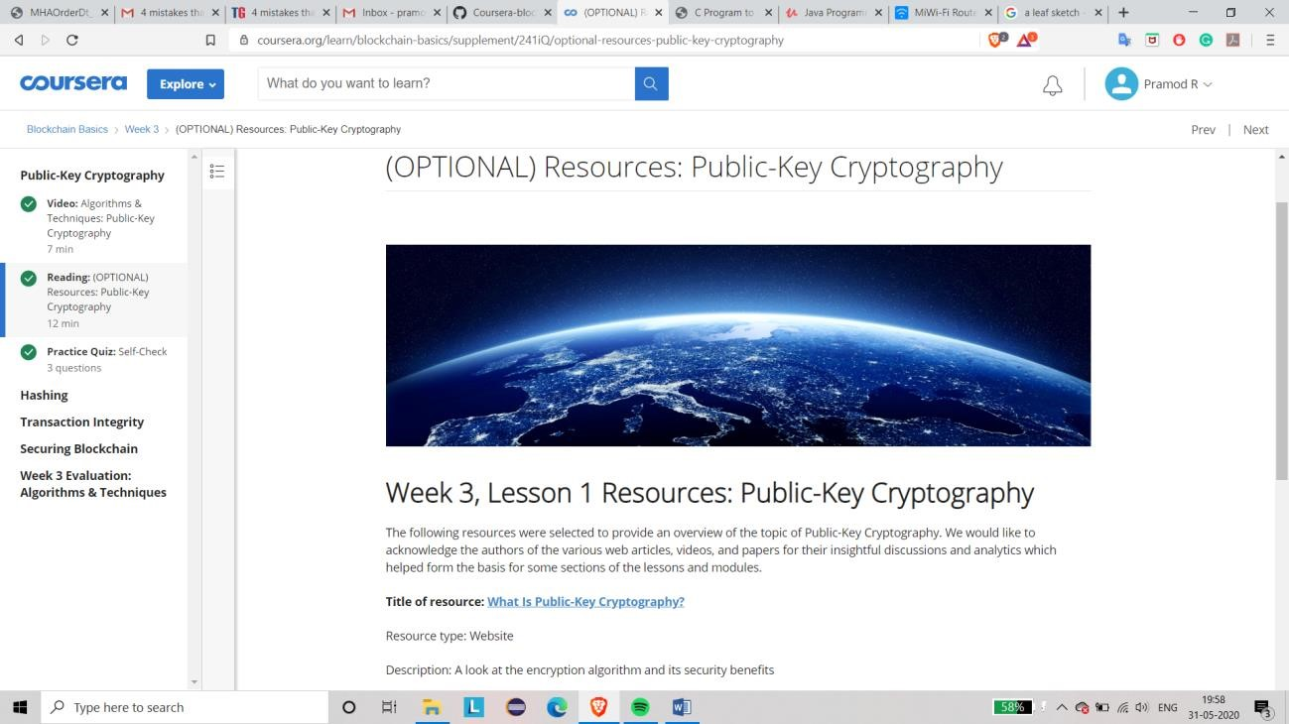

The course I have chosen during the lockdown period is Blockchain basics. Since I had previously knew few topics about bitcoin I am continuing this course. Since Blockchain is gaining a lot interest in the IT Sector I have preferred to choose this course.

**Coding Challenges Details: (Attach the snapshot and briefly write the report for the following)**

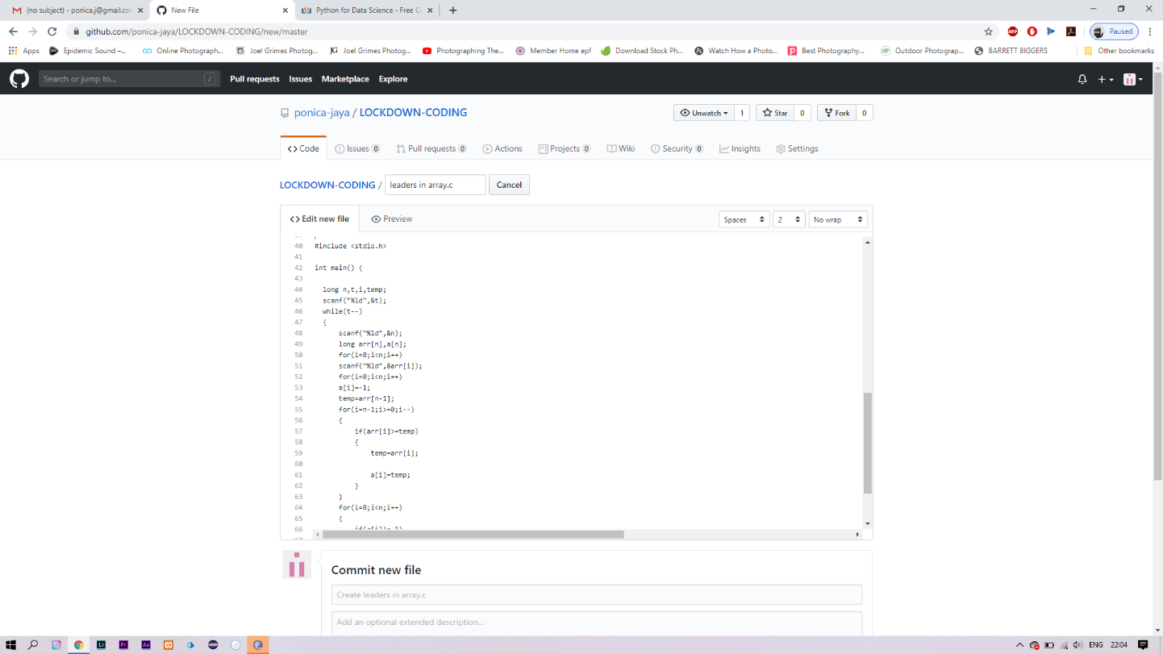

**Solution:** The above snapshot is the code which I have uploaded in my

Github repository