**DAILY ONLINE ACTIVITIES SUMMARY**

|  |  |  |  |  |  |  |  |
| --- | --- | --- | --- | --- | --- | --- | --- |
| **Date:** | **31/05/2020** | | | | **Name:** | PONICA | |
| **Sem & Sec** | **4th sem B section** | | | | **USN:** | **4AL18CS055** | |
| **Online Test Summary** | | | | | | | |
| **Subject** | | **-** | | | | | |
| **Max. Marks** | | **-** | | **Score** | | **-** | |
| **Certification Course Summary** | | | | | | | |
| **Course** | PYTHON IN DATASCIENCE | | | | | | |
| **Certificate Provider** | | | **COGNITIVE CLASS** | **Duration** | | | 5 HOURS |
| **Coding Challenges** | | | | | | | |
| **Problem Statement:**  **Input : Read a String (combination of character, numeric, special character) from keyboard. Ex: #HaaGs01fOr@haaks07 Output :**  **Upper case letters : 5**  **Lower case letters : 8**  **Numbers : 4**  **Special Characters : 2** | | | | | | | |
| **Status: Completed** | | | | | | | |
| **Uploaded the report in Github** | | | | **YES** | | | |
| **If yes Repository name** | | | | **https://github.com/ponica-jaya/LOCKDOWN-CODING.git** | | | |
| **Uploaded the report in slack** | | | | **YES** | | | |

**Certification Course Details: (Attach the snapshot and briefly write the report for the same)**

The course I have chosen during the lockdown period is python in datascience. Since datascience is just about as broad of a term as they come.It may be easiest to describe what it is by listing its more concrete components

**Coding Challenges Details: (Attach the snapshot and briefly write the report for the following)**

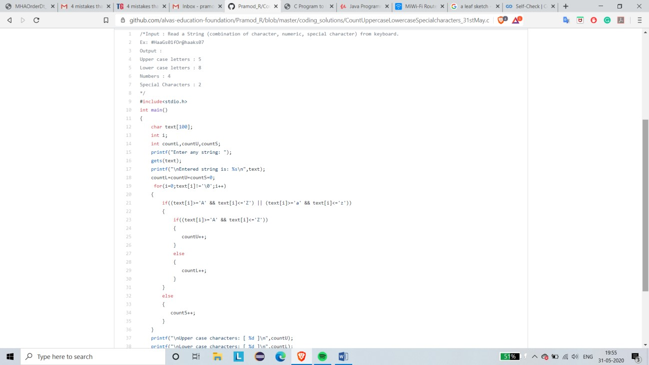

**The question I took to code is:**

Input : Read a String (combination of character, numeric, special character) from keyboard.

Ex: #HaaGs01fOr@haaks07

Output :

Upper case letters : 5

Lower case letters : 8

Numbers : 4

Special Characters : 2

**Solution:** The above snapshot is the code which I have uploaded in my

Github repository