Homework 2: Find three unusual points in NY property data

1. Zip code of city of New York should start with 1. However, there are three addresses start with 3, with the street name in New York Cit. One of them is owned by the city of New York.

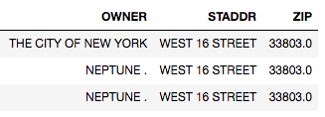

1. Generally from the descriptive information, we understand the mean total value of tax class 1B ranked the third from the bottom. However, by looking at the mean exemption, we can find tax class 1B ranked number six, just below tax class 2C.

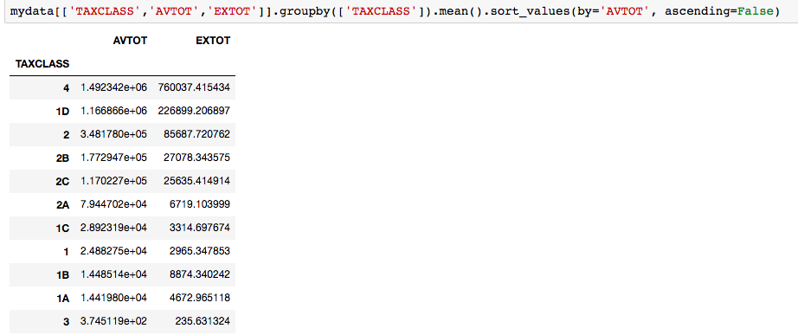

To further understand it, we can see that among the list of tax class 2(apartment) and tax class 4(others), there’s one property located at zip code 11359 (Fort Totten Park) that earned a lot of exemptions.

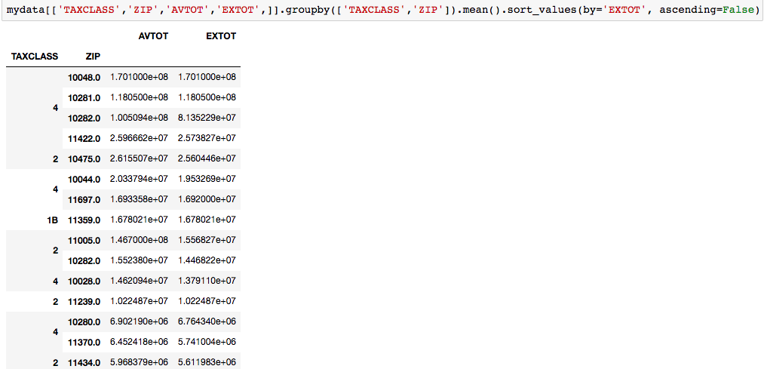

1. Most of the properties without owner records that receive some tax exemptions are apartments (tax class 2) gathered around Brooklyn bridge (zip code 11211, 11201).

