**Front-end Development with HTML CSS & Javascript**

**Project Documentation**

**1.Introduction**

**Project Title:** [FitFlex]

**Team Members:**

* P.Ponlinga divya – [Team Leader]
* S.Donald – [Team Member]
* D.Gurunathan – [Team Member]
* D.Madhunisha – [Team Member]
* P.Dillikumar – [Team Member]

To prepare a documentation for this program, we can break it down into several sections, including an overview, file structure, functionality, and usage instructions. Below is a structured documentation for the program:

**Fifflex** - Your Personal Fitness Companion

**Overview**

Fifflex is a web-based application designed to help users track their workouts, monitor their progress, and stay motivated on their fitness journey. The application consists of multiple HTML pages, each serving a specific purpose, such as logging workouts, viewing progress, and exploring different types of exercises.

The application is built using HTML,CSS, and JavaScript and it is designed to be simple, user-friendly, and responsive.

**File Structure**

The project consists of the following files:

1. divya.html - The main landing page of the application.

2. divya.css - The stylesheet for the main page (`divya.html`).

3. workout.html- A page that provides information about different types of workouts.

4. workout.css - The stylesheet for the workout page (`workout.html`).

5. progress.html - A page that displays user progress data.

6. script.js - The JavaScript file that handles the workout tracking functionality on the main page.

**Functionality**

1. Main Page (`divya.html`)

Header : Displays the application name and tagline.

Navigation Links : Provides links to other pages:

Workout : Redirects to `workout.html`.

Progress : Redirects to `progress.html`.

Login : Redirects to an external login page.

Workout Tracker : Allows users to input and track their workouts.

Users can enter a workout (e.g., "Push-ups, 20 reps") and click the "Add Workout" button to add it to the list.

The list of workouts is dynamically updated using JavaScript.

About Us : Provides a brief description of the application.

Contact : Displays contact information and a short paragraph.

2. Workout Page (`workout.html`)

Displays information about different types of workouts:

Yoga : Includes an image and description of yoga.

Push-ups : Includes an image and description of push-ups.

Squats : Includes an image and description of squats.

The page is styled using `workout.css` to ensure a clean and responsive layout.

3. Progress Page (`progress.html`)

Displays the progress of different users in a list format.

Each user's progress includes:

Weight

Height

Body Fat Percentage

The page is styled inline, with a green background for the header.

4. JavaScript (`script.js`)

Handles the functionality of adding workouts to the list on the main page.

Validates the input to ensure the user does not submit an empty workout.

Dynamically updates the workout list in the DOM.

**Usage Instructions**

1. Main Page (`divya.html`)

Open the `divya.html` file in a web browser.

Use the navigation links to explore the **Workout** and **Progress** pages.

To track your workouts:

Enter a workout in the input field (e.g., "Push-ups, 20 reps").

Click the "Add Workout" button to add it to the list.

The workout will appear in the list below the input field.

2. Workout Page (`workout.html`)

Click the "Workout" link on the main page to navigate to this page.

Explore the different types of workouts (Yoga, Push-ups, Squats) by reading the descriptions and viewing the images.

3. Progress Page (`progress.html`)

Click the "Progress" link on the main page to navigate to this page.

View the progress of different users, including their weight, height, and body fat percentage.

**Styling**

The application uses a consistent color scheme, with green (`#4CAF50`) as the primary color for headers and buttons.

The background color is light gray (`#f4f4f4`) to ensure a clean and modern look.

The layout is responsive, with elements adjusting to different screen sizes.

**Future Enhancements**

1. User Authentication : Add a login system to allow users to save their workout data.

2. Data Persistence : Store workout data in local storage or a database to persist across sessions.

3. Progress Tracking : Allow users to input and track their own progress over time.

4. Additional Workouts : Expand the workout page to include more exercises and detailed instructions.

5. Responsive Design : Further optimize the layout for mobile devices.

**Source code:**

<!DOCTYPE html>

<html lang="en">

<head>

    <meta charset="UTF-8">

    <meta name="viewport" content="width=device-width, initial-scale=1.0">

    <title>Fifflex - Your Personal Fitness Companion</title>

    <link rel="stylesheet" href="divya.css">

</head>

<body>

    <header>

        <h1>Fifflex</h1>

        <p>Your Personal Fitness Companion</p>

    </header>

    <ul class="link">

        <li>

            <a href="workout.html">1.workout</a>

        </li>

        <li>

            <a href="progress.html">2.Progress</a>

        </li>

        <li>

            <a href="https://fitflex.com">3.Login</a>

        </li>

    </ul>

    <main>

        <section class="welcome">

            <h2>Track Your Workouts & Stay Motivated!</h2>

            <p>Log your exercises, set goals, and improve your fitness journey.</p>

        </section>

        <section class="tracker">

            <h2>Workout Tracker</h2>

            <input type="text" id="workoutInput" placeholder="Enter workout (e.g., Push-ups, 20 reps)">

            <button onclick="addWorkout()">Add Workout</button>

            <ul id="workoutList"></ul>

        </section>

    </main>

    <script src="script.js"></script>

    <hr >

    <div class="about">

        <div class="one">

            <h2>About Us</h2>

        </div>

        <p>Lorem ipsum dolor sit amet consectetur adipisicing elit. Illo aperiam quas labore incidunt maiores. Assumenda odio eius, excepturi rerum natus, atque nam provident quos nulla quas quam omnis ut nobis beatae reiciendis quod velit quis, harum voluptatum eveniet in laborum quia aperiam? Sint perferendis quia sit, officia quasi deleniti modi ad atque illo sapiente quo est eligendi </p>

    </div>

    <div class="contact">

        <h2 style="padding: 5px;">contact</h2>

        <h4>8531861905</h4>

        <h4>ponlingadivya1905@gmail.com</h4>

        <p>

            Lorem ipsum dolor sit amet consectetur, adipisicing elit. Minus est repellat sapiente, maiores corrupti labore fuga alias fugiat accusamus reiciendis saepe quaerat sequi, similique aut facilis in at architecto voluptatem dolor quia iste, reprehenderit ratione ipsam! Necessitatibus cupiditate deserunt maiores, ipsa tempora nulla, inventore voluptatibus asperiores ex placeat repudiandae debitis!

        </p>

    </div>

</body>

</html>

body {

    font-family: Arial, sans-serif;

    text-align: center;

    background-color: #f4f4f4;

    margin: 0;

    padding: 0;

}

header {

    background-color: #4CAF50;

    color: white;

    padding: 20px;

    font-size: 24px;

}

main {

    padding: 20px;

}

.tracker {

    margin-top: 30px;

}

input {

    padding: 10px;

    width: 60%;

    margin-bottom: 10px;

}

button {

    background-color: #4CAF50;

    color: white;

    padding: 10px;

    border: none;

    cursor: pointer;

}

button:hover {

    background-color: #45a049;

}

ul {

    list-style-type: none;

    padding: 0;

}

ul li {

    background: white;

    padding: 10px;

    margin: 5px;

    border-radius: 5px;

}

.link{

    margin-left: 30px;

    text-align: left;

}

.contact{

    background-color: #45a049;

}

<!DOCTYPE html>

<html lang="en">

<head>

    <meta charset="UTF-8">

    <meta name="viewport" content="width=device-width, initial-scale=1.0">

    <title>Workout</title>

    <link rel="stylesheet" href="workout.css">

</head>

<body>

    <h1>Workout</h1>

<div class="content">

    <div class="yoga">

        <img src="ima yoga.jfif" alt="">

        <h2>Yoga</h2>

        <p>Yoga is an ancient system of practices that integrate physical, mental, and spiritual aspects. It includes techniques such as breathing, postures, relaxation, chanting, and meditation.</p>

    </div>

    <div class="push">

        <img src="img push.jpg" alt="">

        <h2>Push up</h2>

        <p>One of the most important benefits of push ups is that they can increase your functional strength with the help of full body activation. When you gradually lower your body,</p>

    </div>

    <div class="sq">

        <img src="ima sq.jpg" alt="">

        <h2>squat</h2>

        <p>A squat is a strength exercise that works the lower body. During the exercise, the trainee lowers their hips from a standing position and then stands back up.</p>

    </div>

</div>

</body>

</html>

body{

    background-color: #f4f4f4;

}

h1{

    height: 50px;

    background-color: #4CAF50;

    color:  #f4f4f4;

    padding: 20px;

    text-align: center;

}

.content{

    display: flex;

    justify-content: space-evenly;

    flex-wrap: wrap;

    flex-grow: 1;

}

.yoga{

    margin: 20px;

    display: inline-block;

    width: 220px;

}

.push{

    margin: 20px;

    display: inline-block;

    width: 220px;

}

.sq{

    margin: 20px;

    display: inline-block;

    width: 240px;

}

<!DOCTYPE html>

<html lang="en">

<head>

    <meta charset="UTF-8">

    <meta name="viewport" content="width=device-width, initial-scale=1.0">

    <title>Progress</title>

    <link rel="stylesheet" href="progress.css">

</head>

<body>

    <h1 style="

    background-color:#4CAF50;

    height:  60px;

    padding: 20px;

    color: #f4f4f4;">Progress</h1>

    <ul>

        <li><h2>Suresh</h2></li>

        <p>Weight: 70kg,Height: 175cm,Body Fat Percentage: 20%</p>

        <li><h2>Ramesh</h2></li>

        <p>Weight: 75kg,Height: 170cm,Body Fat Percentage: 25%</p>

        <li><h2>Rajesh</h2></li>

        <p>Weight: 60kg,Height: 165cm,Body Fat Percentage: 10%</p>

        <li><h2>Kamelesh</h2></li>

        <p>Weight: 80kg,Height: 185cm,Body Fat Percentage: 30%</p>

    </ul>

</body>

</html>

function addWorkout()

{

    let input = document.getElementById("workoutInput").value;

    if (input === "") {

        alert("Please enter a workout!");

        return;

    }

    let li = document.createElement("li");

    li.textContent = input;

    document.getElementById("workoutList").appendChild(li);

    document.getElementById("workoutInput").value = "";

}

**Output :**

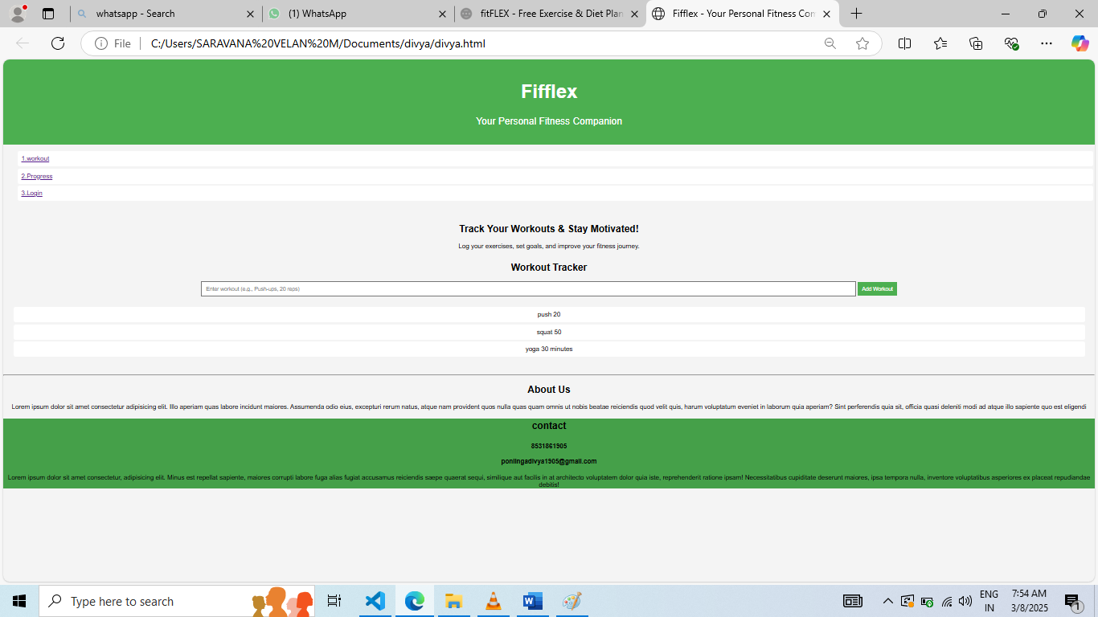

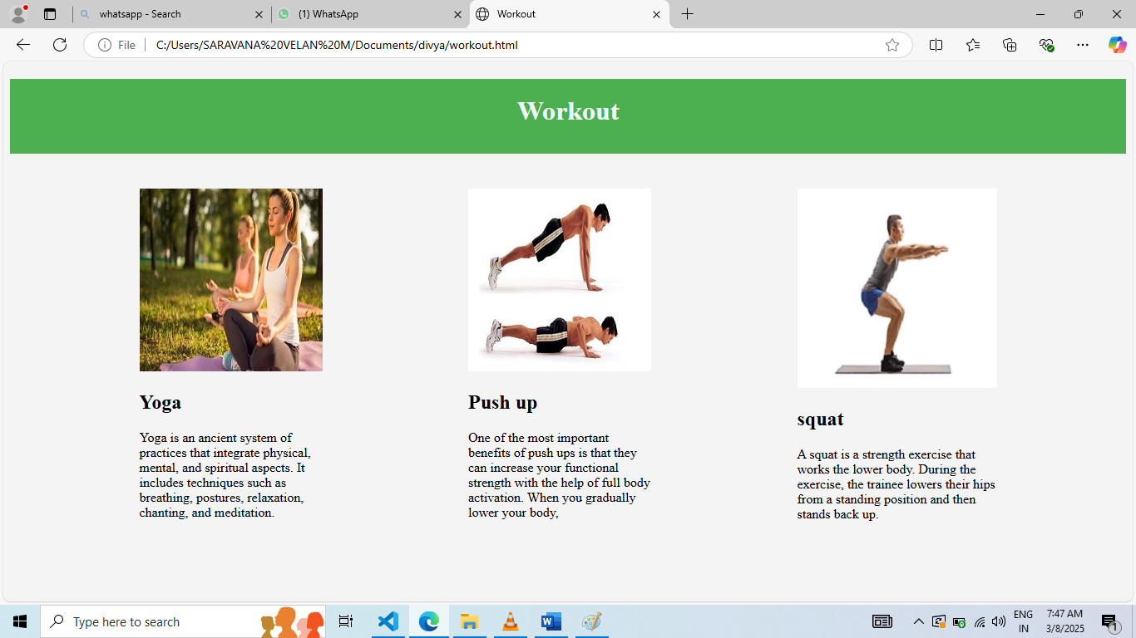

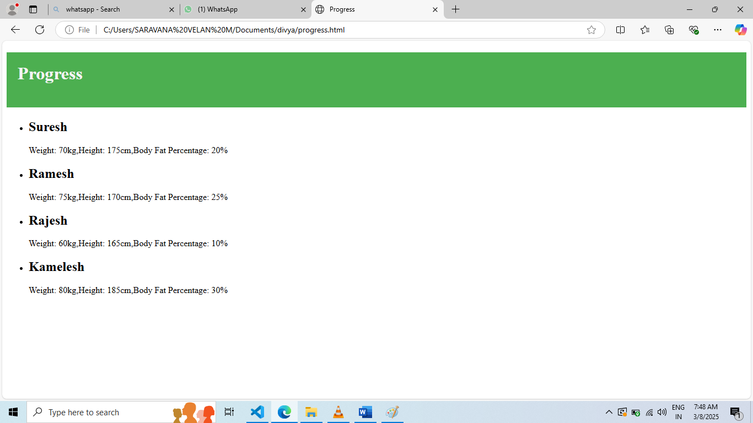

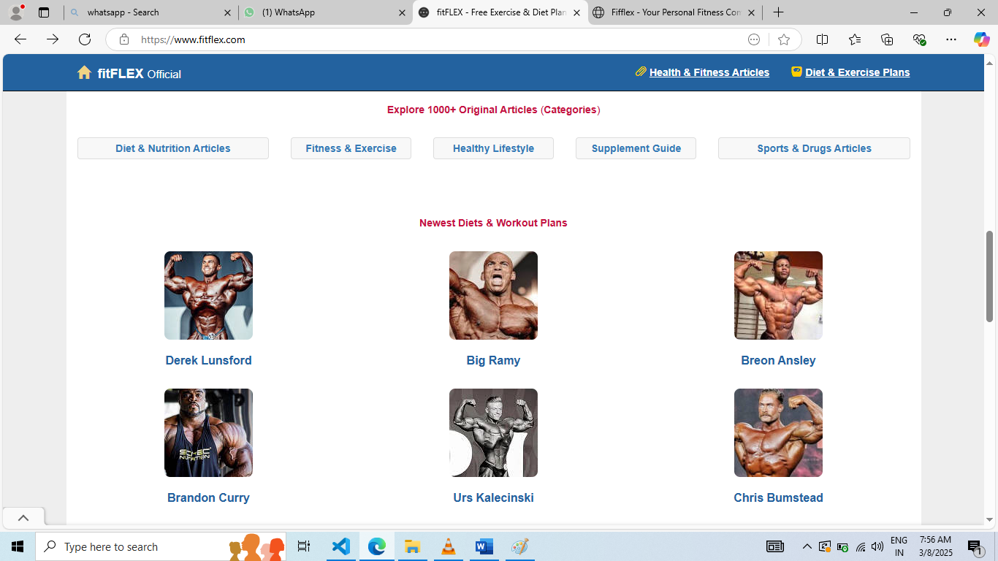

**Conclusion :**

Fifflex is a simple yet effective fitness tracking application that helps users stay motivated and organized in their fitness journey. With its intuitive interface and basic functionality, it serves as a great starting point for anyone looking to track their workouts and monitor their progress.