Nmap scan report
Active scanning task, TechBiz Academy cybersecurity internship
Prepared by Ponman David Labong
Date of scan: 2 November 2026
Objective
The task asked me to use Nmap for active scanning: find open ports, detect service versions, and explain what the aggressive scan (-A) shows. I ran the scans from Kali Linux (NetHunter) installed inside Termux on my Android phone, and I scanned one target only.
Target and permission
The lab target in the task was Metasploitable, which needs a virtual machine and can't run on a phone. I used scanme.nmap.org instead. The Nmap project runs this server for people to practise on and allows light scanning of it. Its IPv4 address is 45.33.32.156, and I used that address for every scan. I didn't scan any other machine or network.
Environment and its limits
Kali on Android runs inside a chroot, which means Nmap can't read the phone's routing table or open raw sockets. This caused two errors, "failed to determine route" and a scan that stopped with 0 hosts scanned. To get around it I added -sT, a normal TCP connect scan that doesn't need raw sockets, and -Pn, which skips the ping step. The same limit stopped OS detection and traceroute, which I explain further down.
Commands used
Command | What it does
nmap -sT -Pn -sV 45.33.32.156 | TCP connect scan, no ping, and service and version detection on the 1,000 most common ports.
nmap -sT -Pn -A 45.33.32.156 | Aggressive scan. It failed on my phone because OS detection needs raw sockets.
nmap -sT -Pn -sV -sC --traceroute 45.33.32.156 | Same as the first scan plus default scripts and traceroute. It failed again at the route step.
nmap -sT -Pn -sV -sC 45.33.32.156 | Service versions plus Nmap's default scripts. This one worked and gave the most detail.

Results
The host was up with a latency of 0.29 seconds. Nmap scanned the 1,000 most common TCP ports. Three were open and the other 997 were closed (connection refused). The version scan took 3.56 seconds, and the scan with default scripts took 30.09 seconds. Nmap also reported the operating system as Linux from the service information.

Port | State | Service | Version and extra detail
22/tcp | open | ssh | OpenSSH 6.6.1p1 Ubuntu 2ubuntu2.13, protocol 2.0. Host keys: DSA 1024, RSA 2048, ECDSA 256, ED25519 256
80/tcp | open | http | Apache httpd 2.4.7 (Ubuntu). Server header confirms Apache/2.4.7 (Ubuntu)
9929/tcp | open | nping-echo | Nping echo

Understanding the output
The PORT column gives the port number and protocol. STATE says whether something answered, and here all three listed ports are open. SERVICE is Nmap's name for what is running there, and VERSION is what it found when it probed the service, which is what -sV adds. The line "Not shown: 997 closed tcp ports" tells me Nmap saw the rest and found nothing listening.
The -A flag is a shortcut for four things: OS detection (-O), version detection (-sV), default scripts (-sC) and traceroute. Because -A failed on my phone, I ran the working parts myself. Version detection and default scripts gave me the service versions, the SSH host keys and the web server header. OS detection and traceroute were the parts I couldn't run. On a normal Linux machine or a laptop, -A would give all four in one command.
The default scripts added two useful results. The ssh-hostkey script listed the fingerprints of the server's four SSH host keys. The http-server-header script confirmed the web server is Apache 2.4.7 on Ubuntu.
Observations
The software on this server is old. OpenSSH 6.6.1 and Apache 2.4.7 are both from around 2014, and on a real network, outdated versions like these would be flagged because they have known vulnerabilities. The SSH server also offers a 1024-bit DSA host key, which is weak by today's standards. Port 9929 is a test service the Nmap project runs on purpose, so it isn't a real exposure. The server is set up this way for practice, so these are teaching points and not faults.
Screenshots
Figure 1 shows the service version scan. Figure 2 shows the failed -A attempt, which backs up my explanation of the phone's limits. Figure 3 shows the scan with default scripts, and above it the failed traceroute attempt.
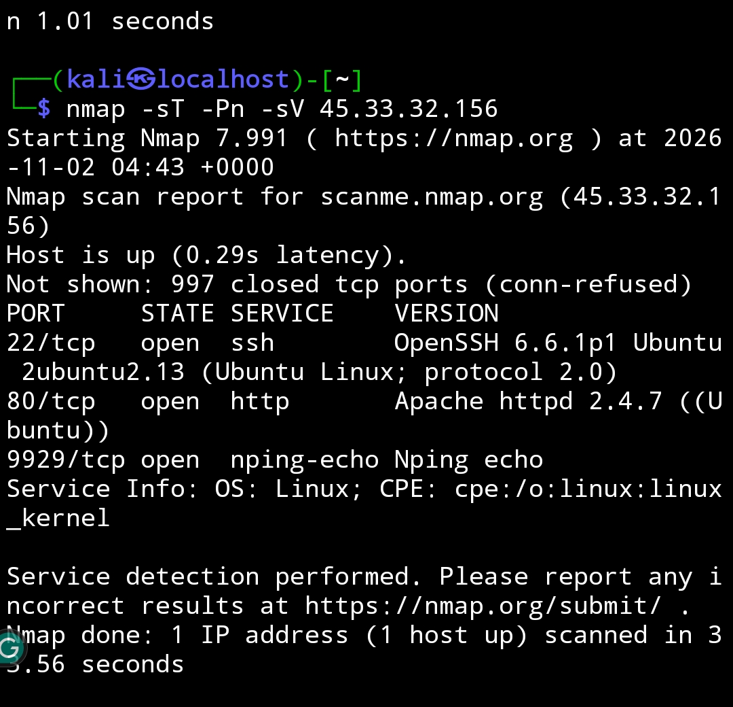
Figure 1: nmap -sT -Pn -sV 45.33.32.156
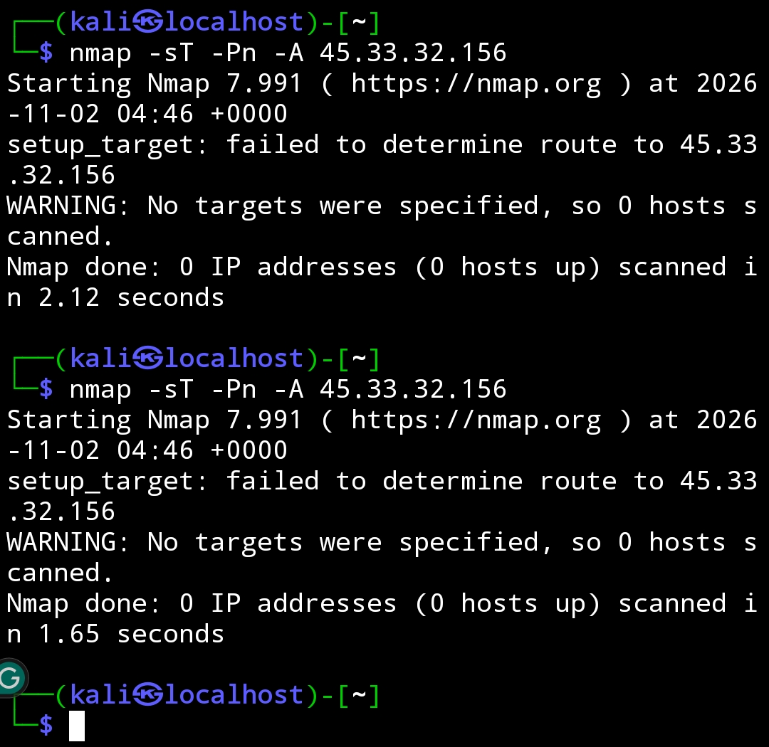
Figure 2: nmap -sT -Pn -A 45.33.32.156 (failed, no route or raw socket access)
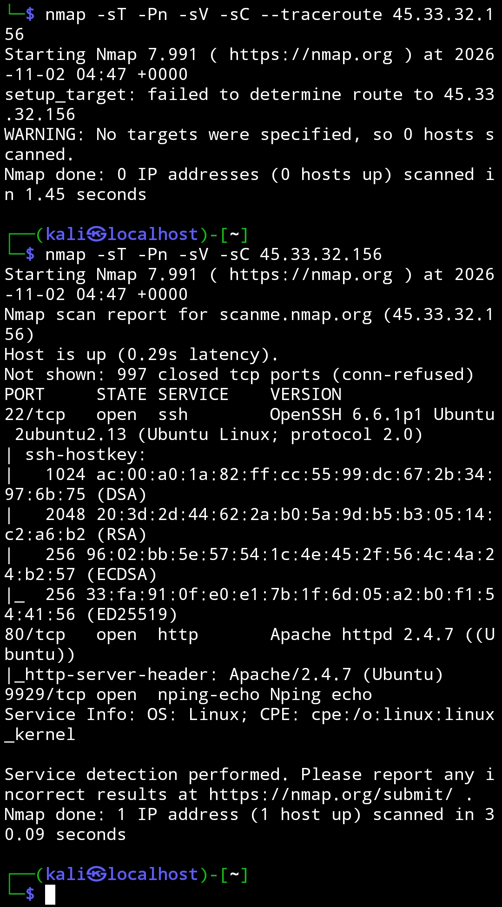
Figure 3: nmap -sT -Pn -sV -sC 45.33.32.156
What I learned
I learned how Nmap reads a target, how a TCP connect scan differs from the default scan, and what each flag inside -A is responsible for. I also learned that a tool can behave differently depending on where it runs, and that a failed command is worth explaining in a report. Next time I would run the same scans against a Metasploitable machine on a laptop or a TryHackMe room, so I can use the full -A scan and see the OS detection and traceroute results.

