Problem 3.3.1.2
For the 5 stocks we selected, "MMM", "GPC", "JNJ", "LOW", "PG", we did a pairwise selection and attempted to obtain the appropriate copula for each pair. The best approach we discovered in literature, was the use of the VineCopula library which is able to detect the most fitting copula choice for each pair. It was very interesting that for all 10 possible combinations, the t-copula was determined to be the best choice. Using this copula, we were able to obtain the stitch together a joint distribution by using the marginal distribution of each pair. The sscatter plot, the histogram of the joint and marginal distribution, the copula density and the shape parameters are listed below for each of the 10 pairs.
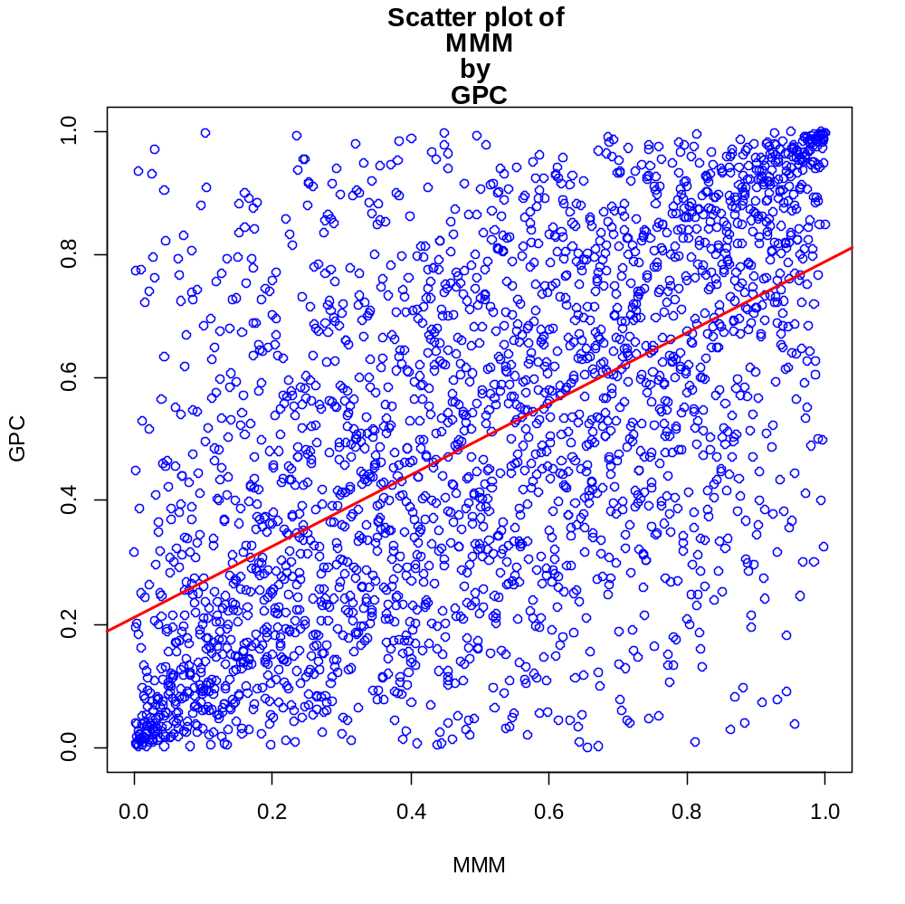
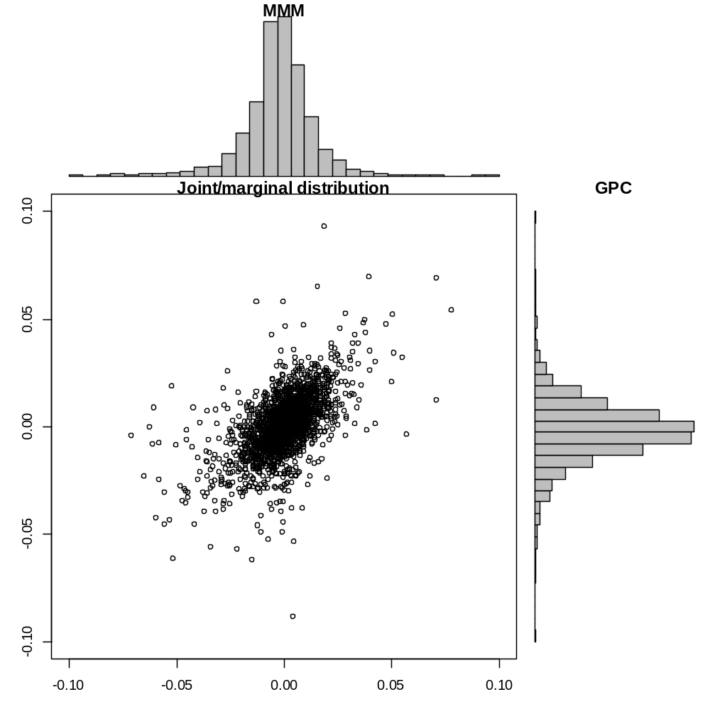
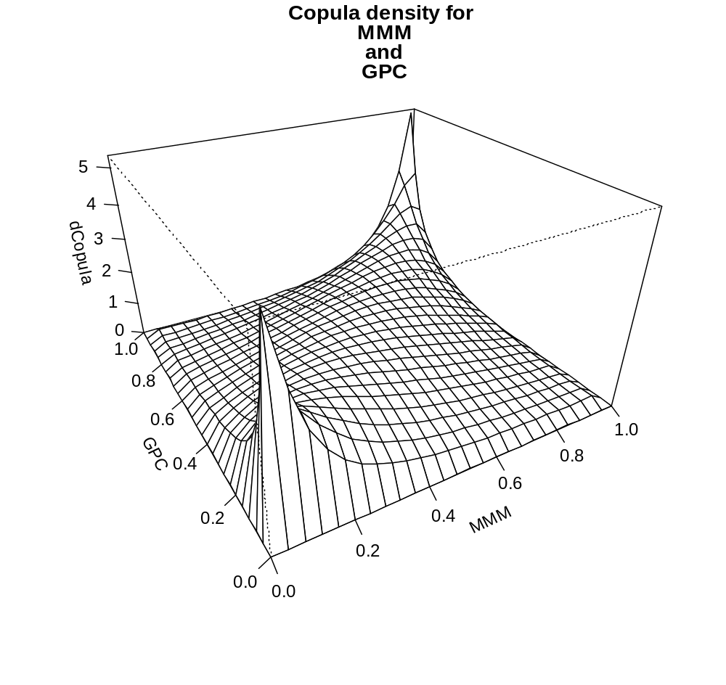
Parameter for Copula of MMM and GPC = Rho: 0.61 , DF: 4.104
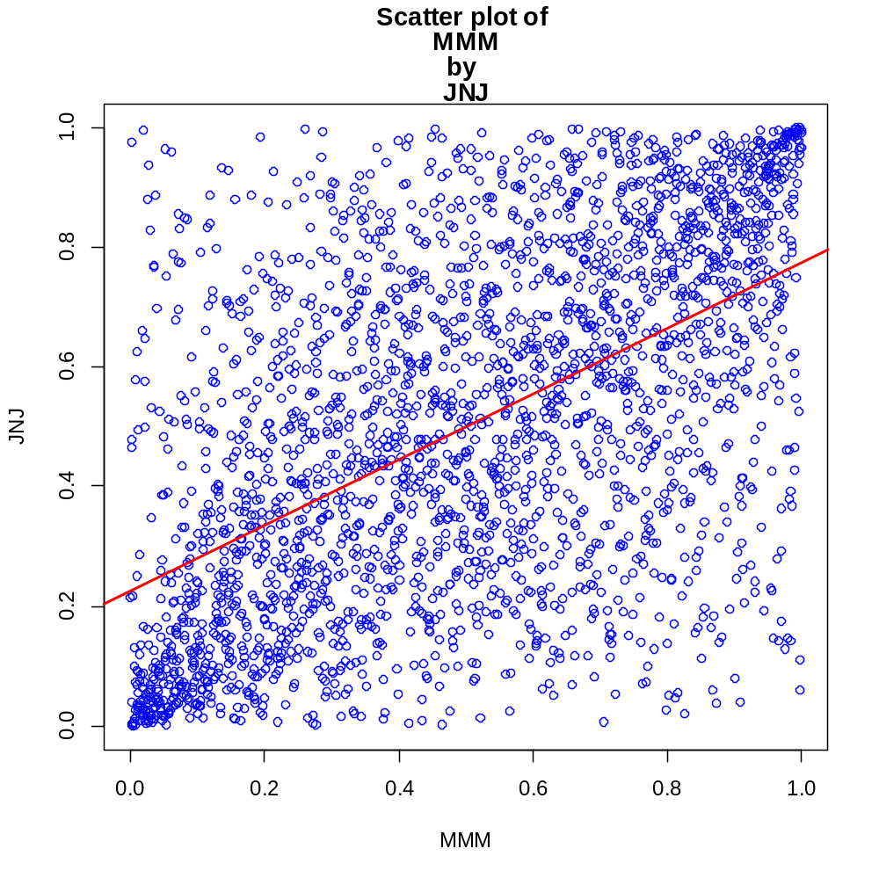
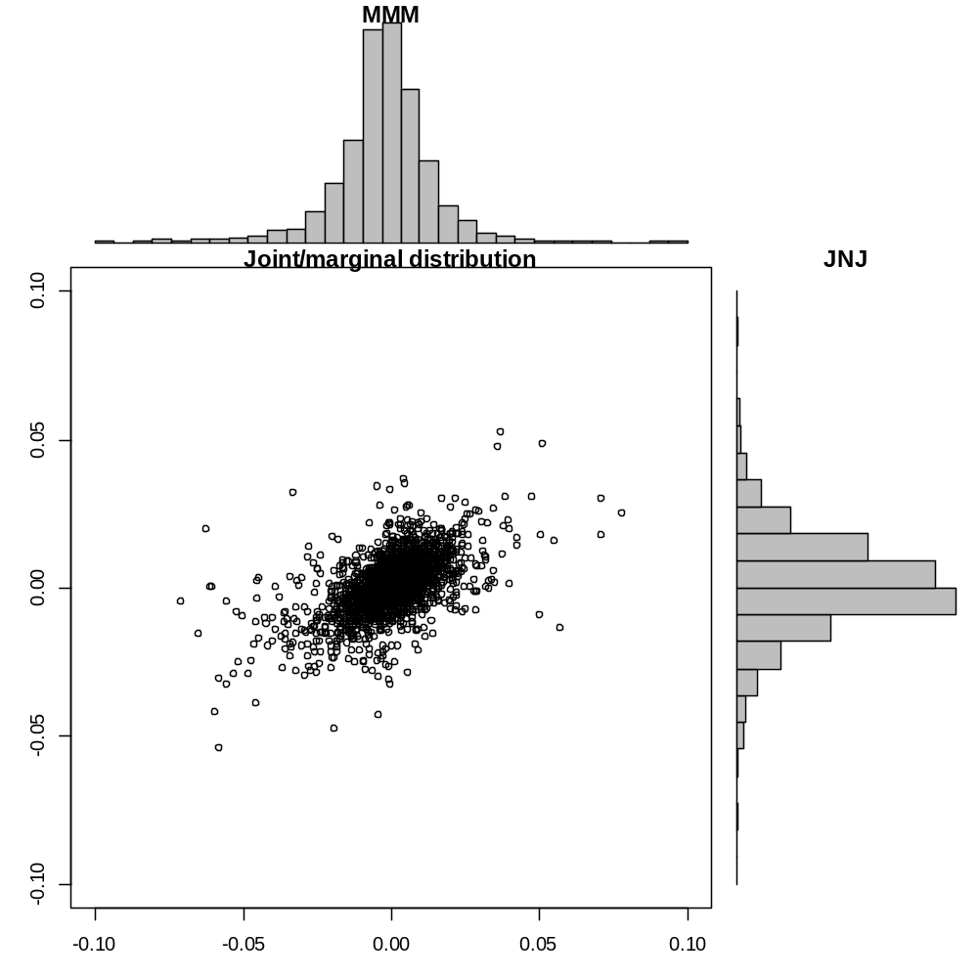
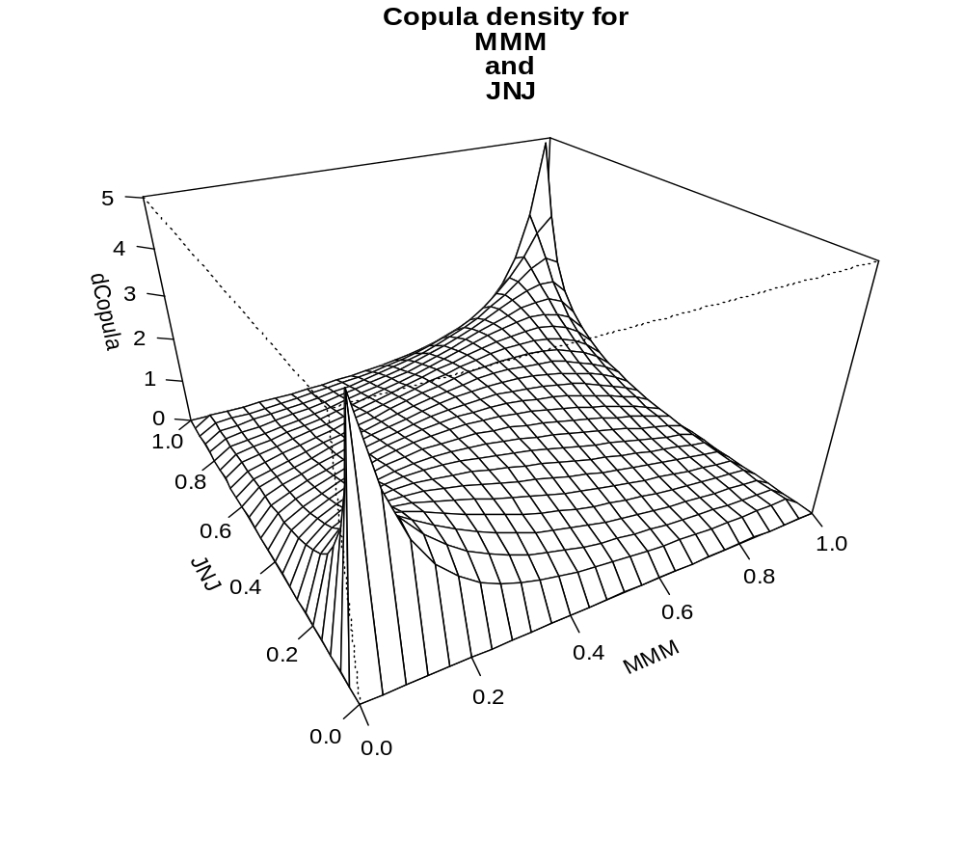
Parameter for Copula of MMM and JNJ = Rho: 0.581 , DF: 4.059

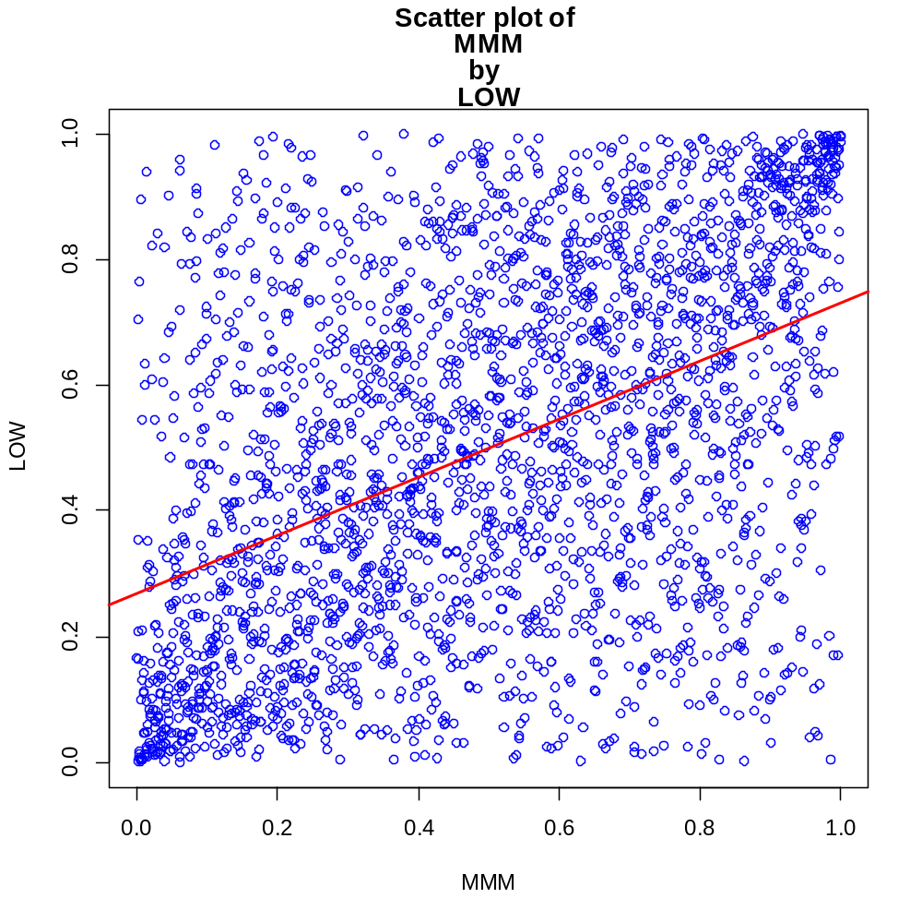
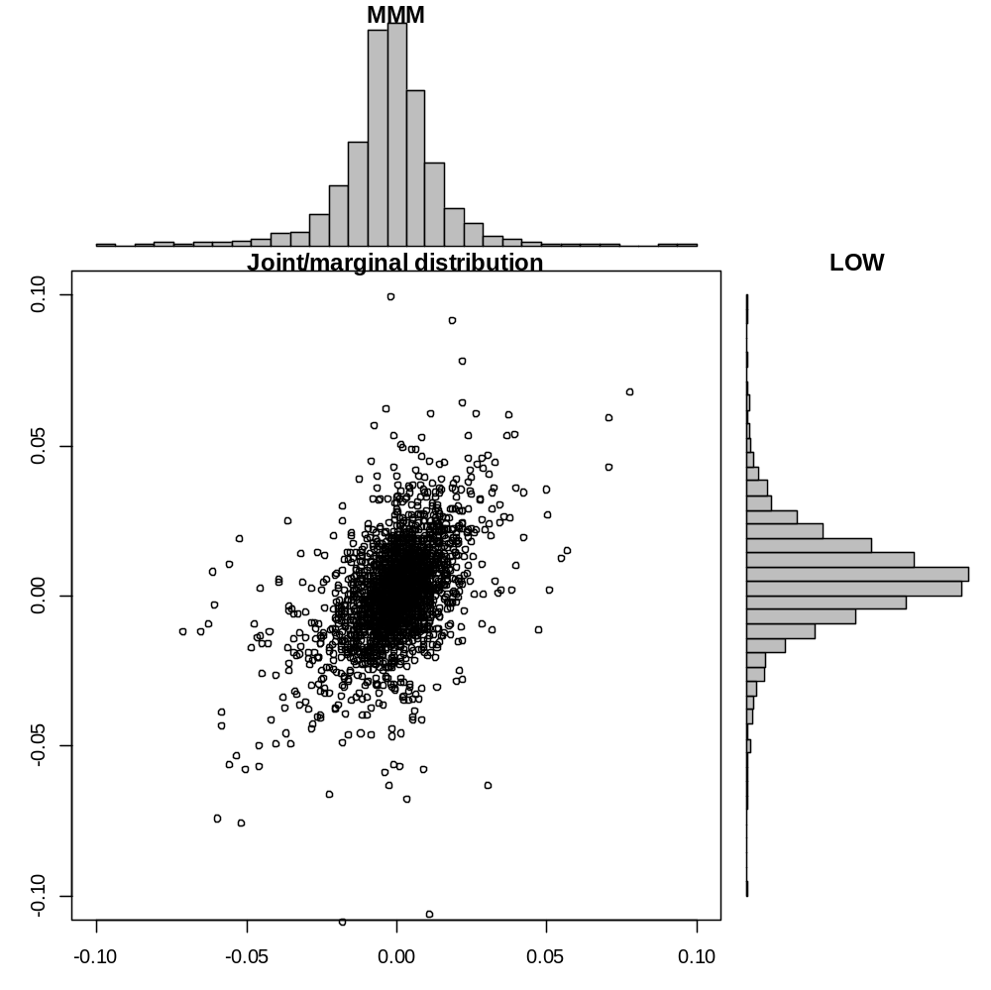
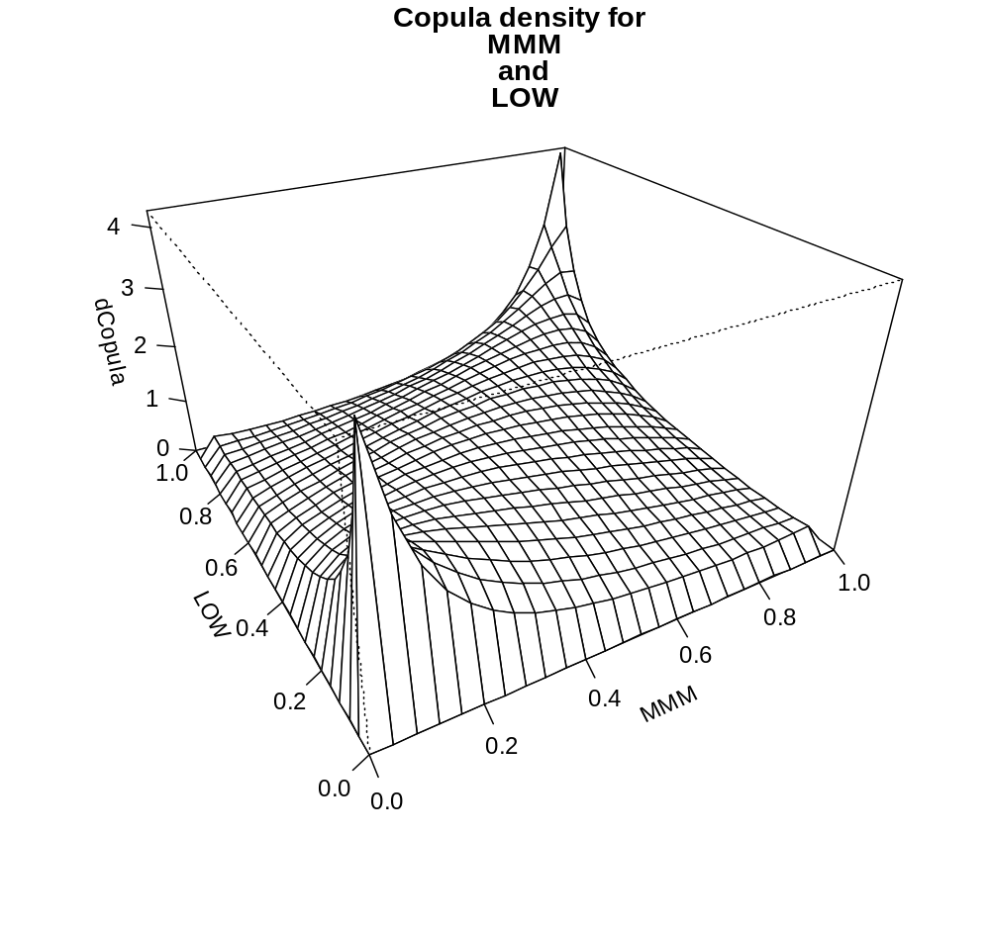
Parameter for Copula of MMM and LOW = Rho: 0.498 , DF: 4.116
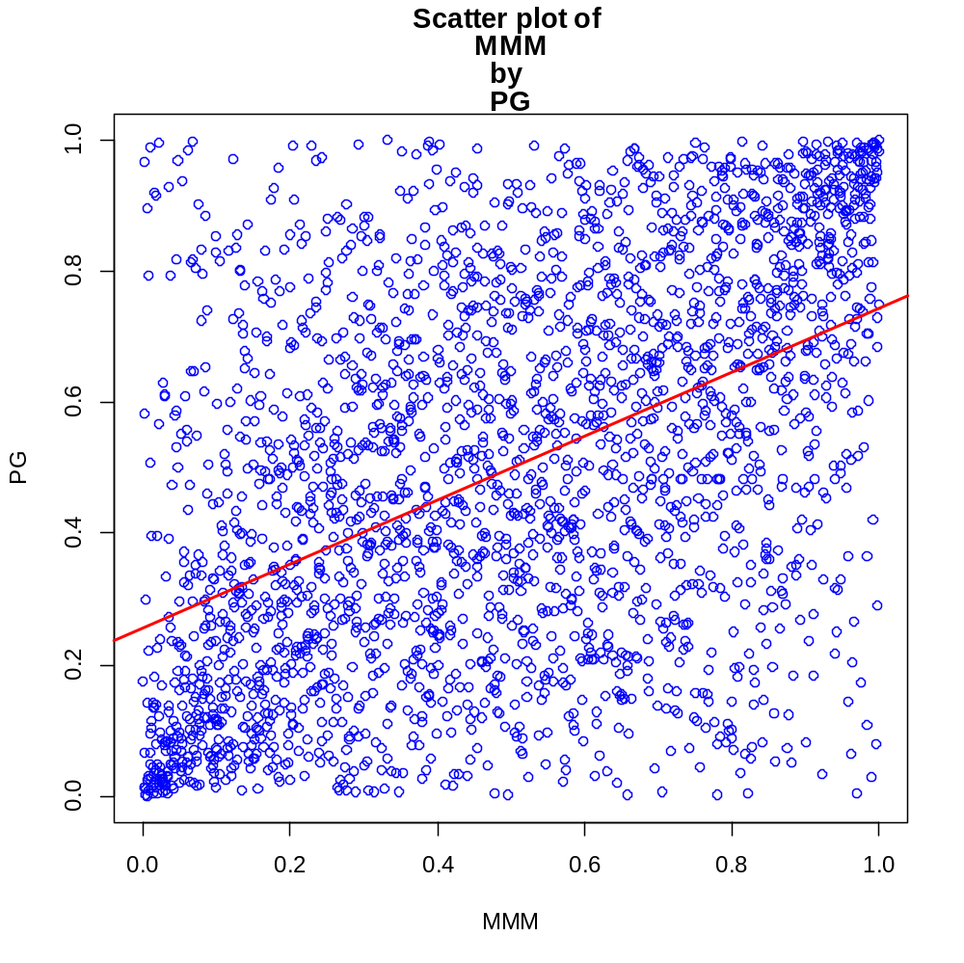
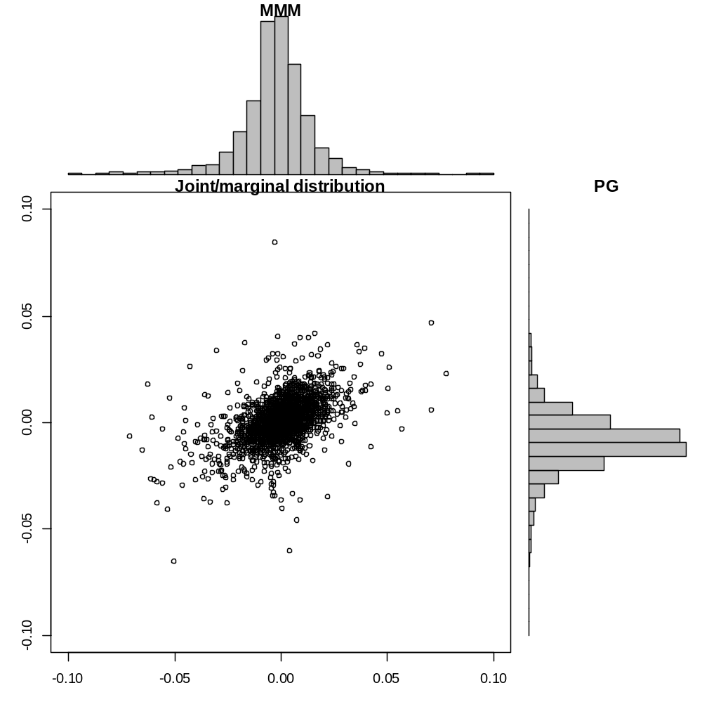
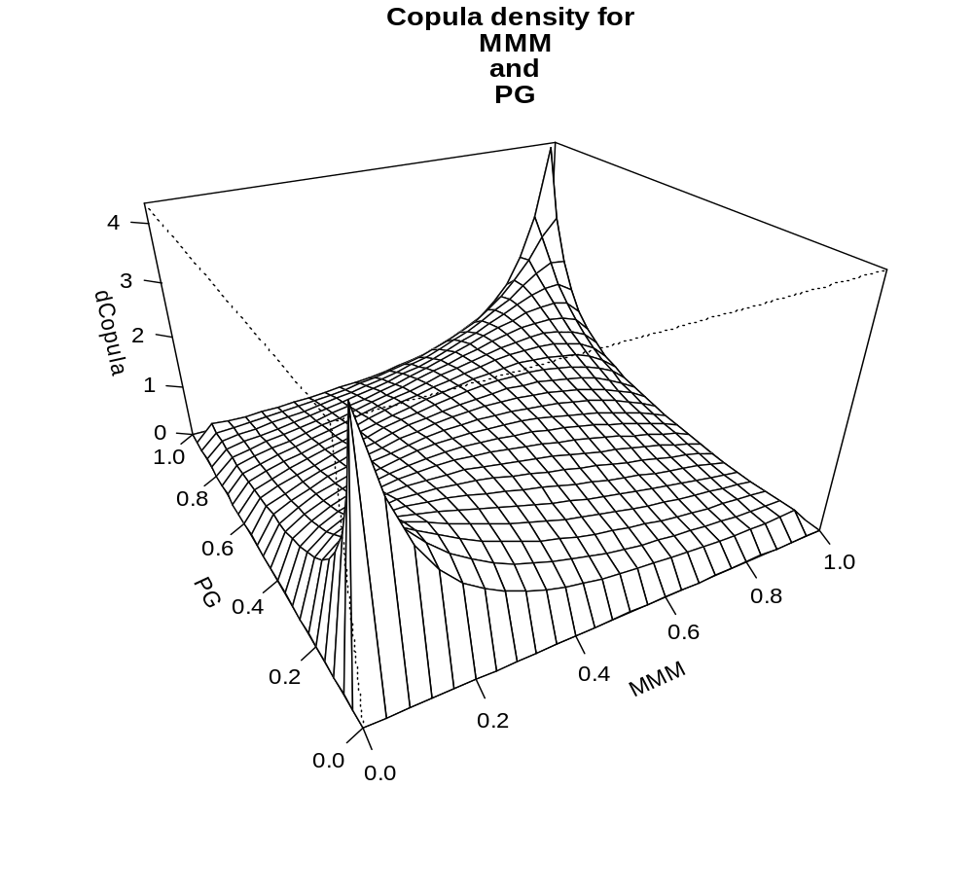
Parameter for Copula of MMM and PG = Rho: 0.518 , DF: 4.379
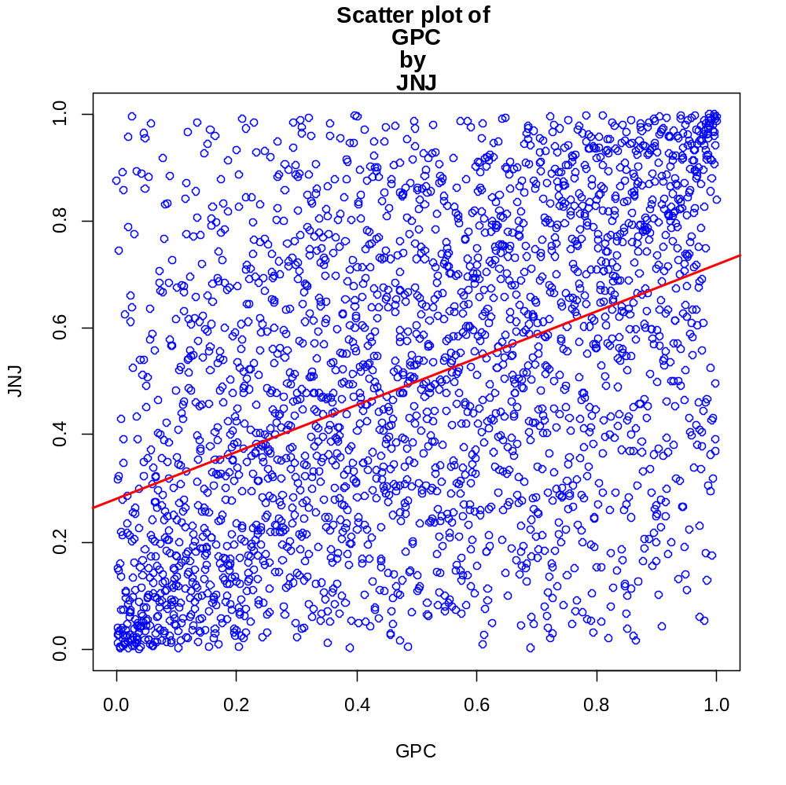
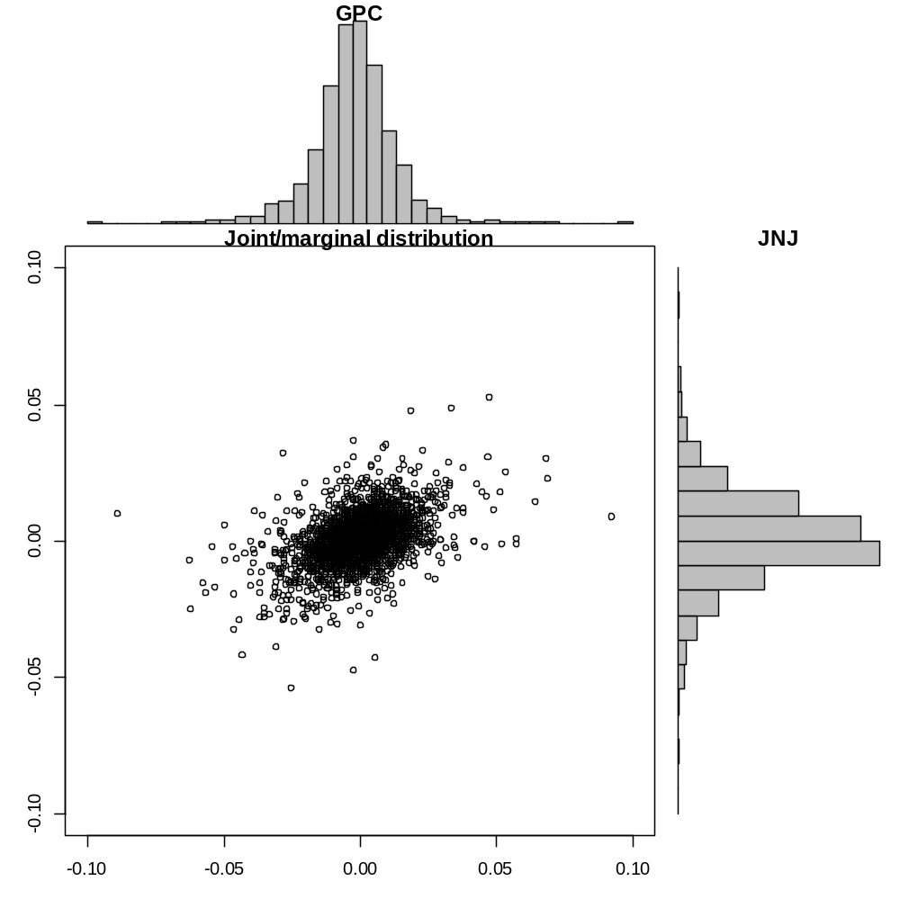
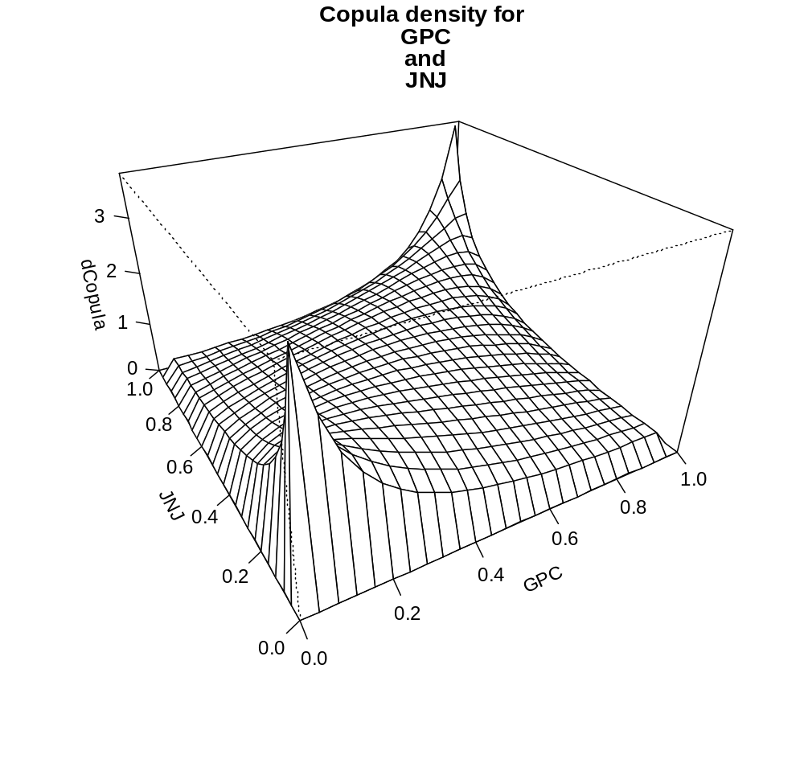
Parameter for Copula of GPC and JNJ = Rho: 0.469 , DF: 5.269
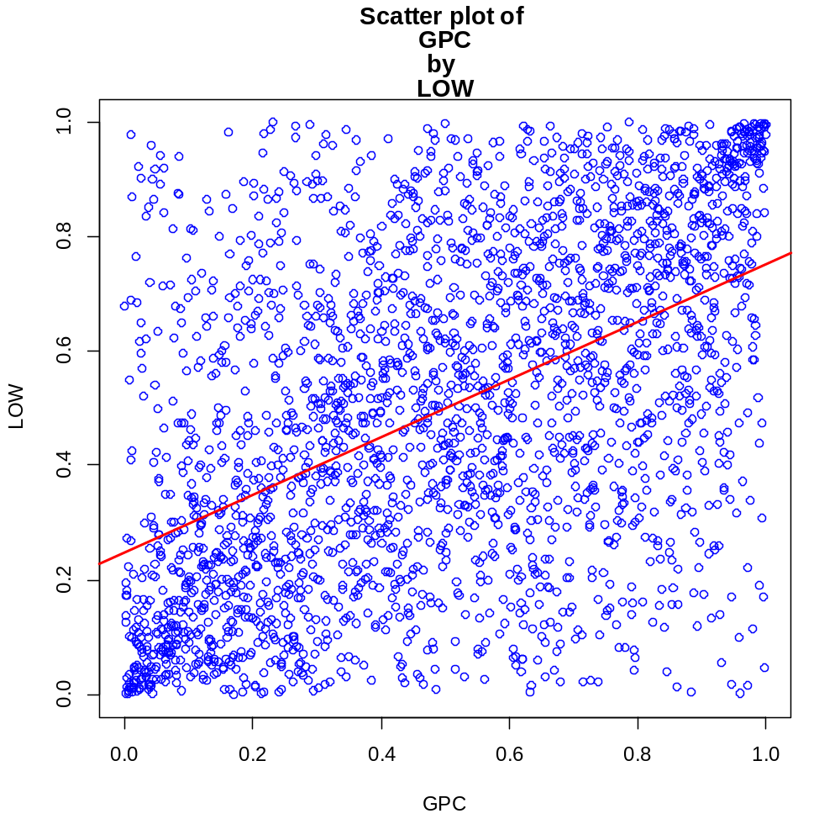
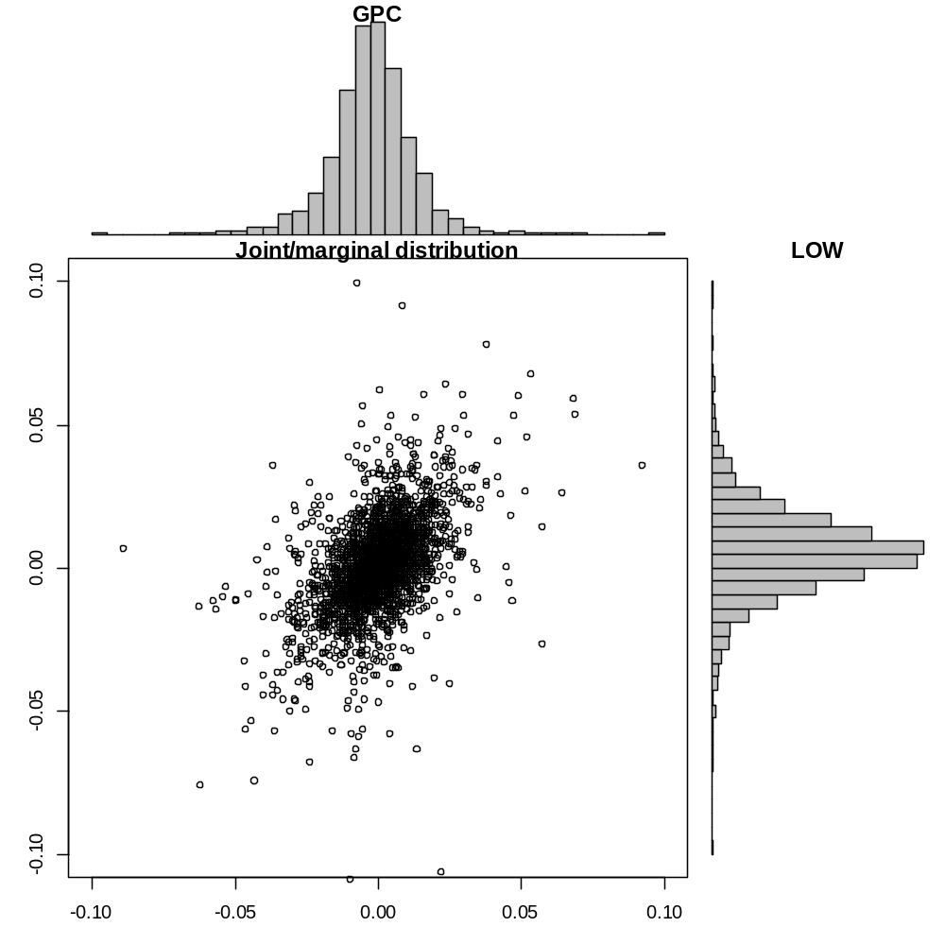
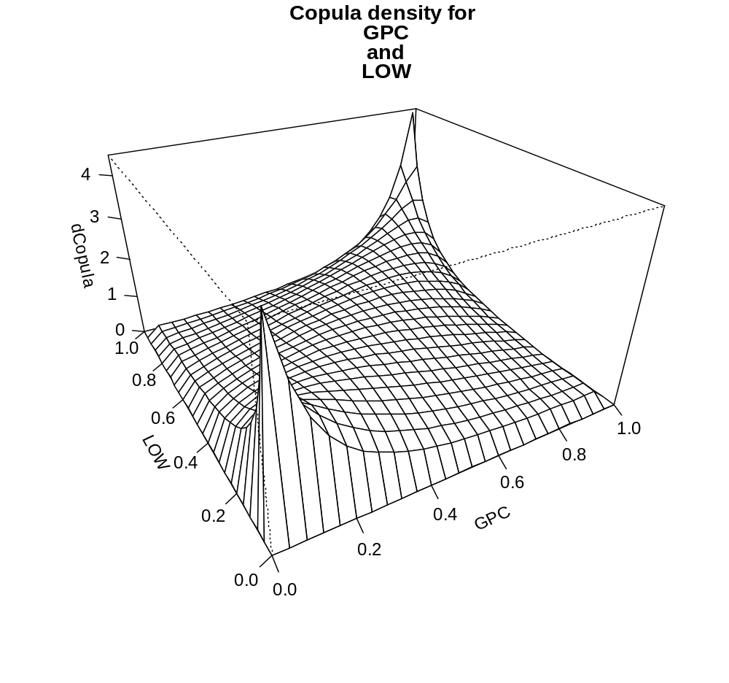
Parameter for Copula of GPC and LOW = Rho: 0.534 , DF: 4.463
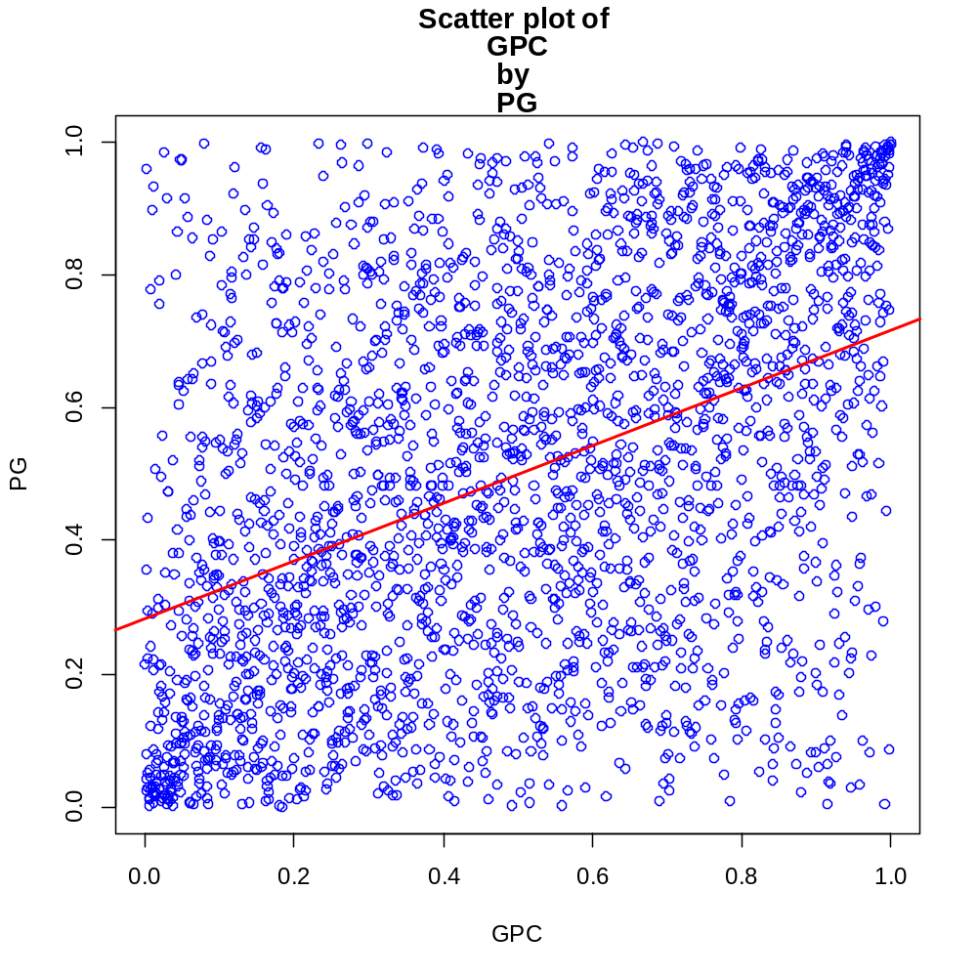
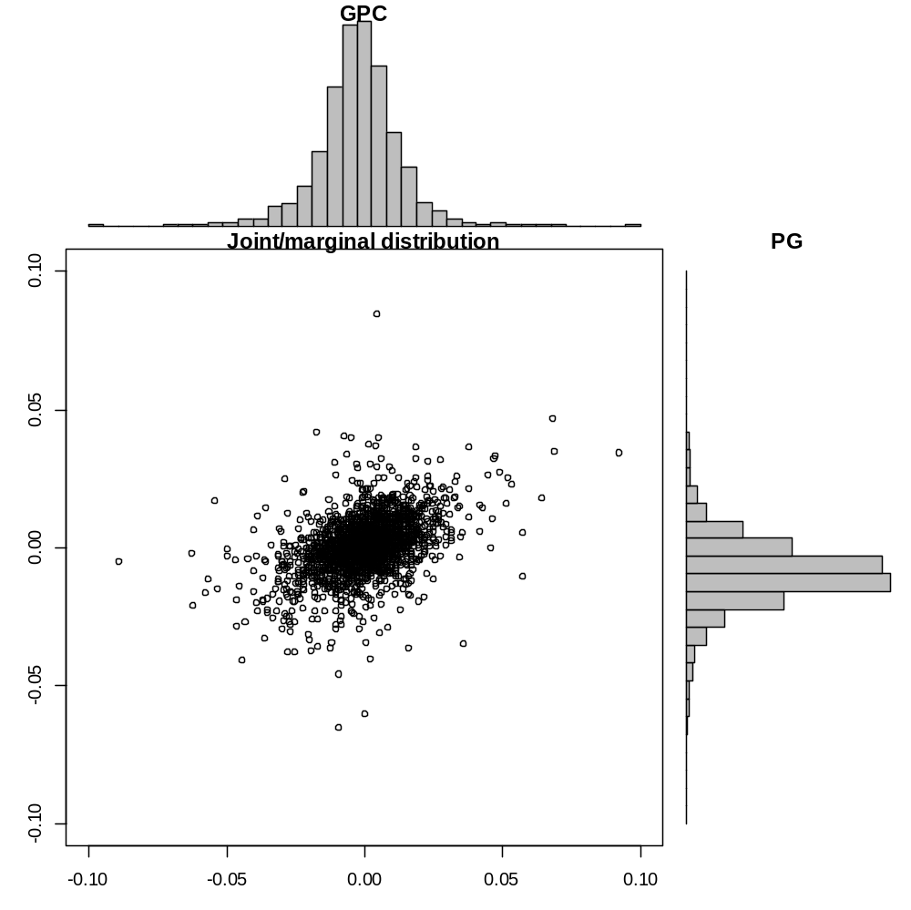
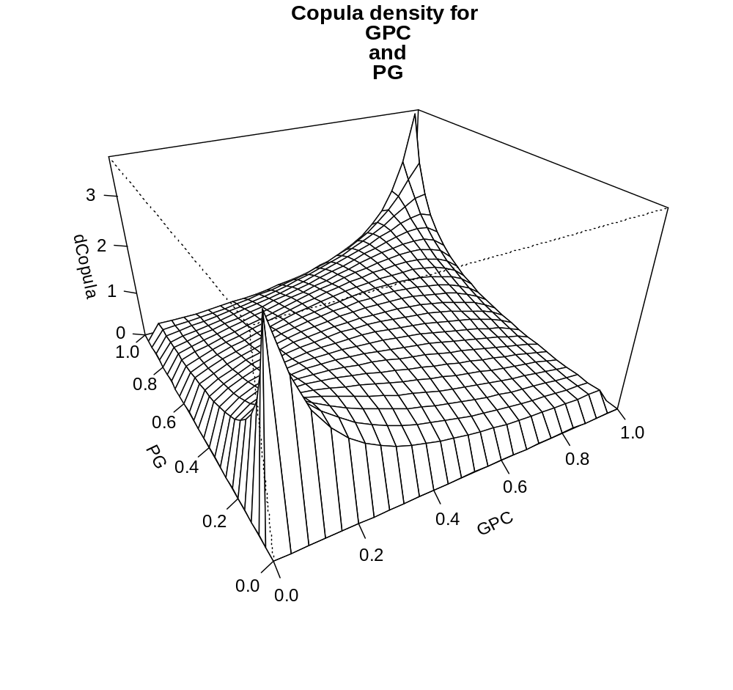
Parameter for Copula of GPC and PG = Rho: 0.462 , DF: 5.03
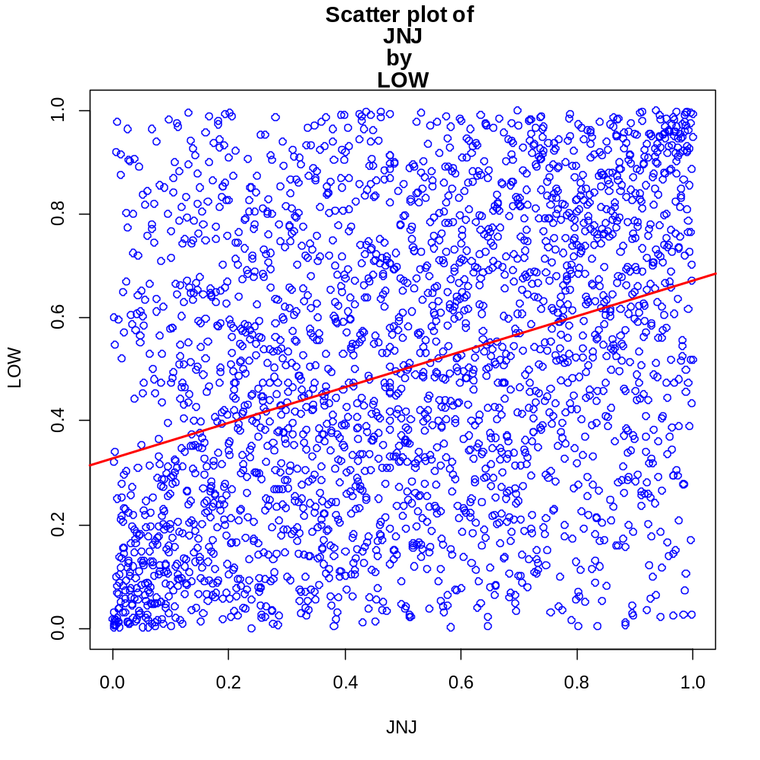
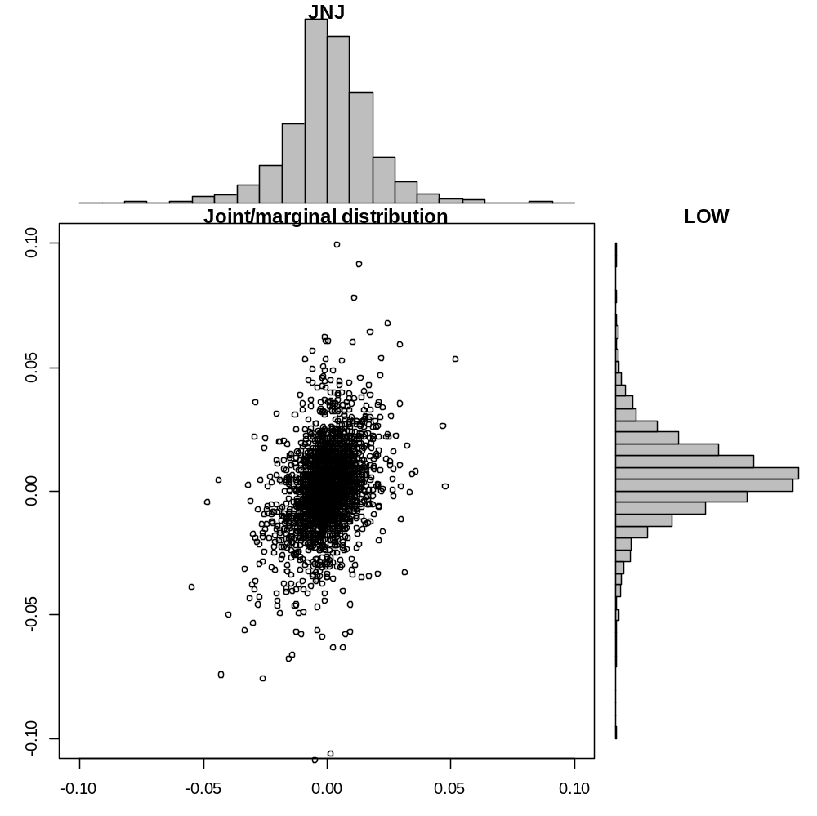
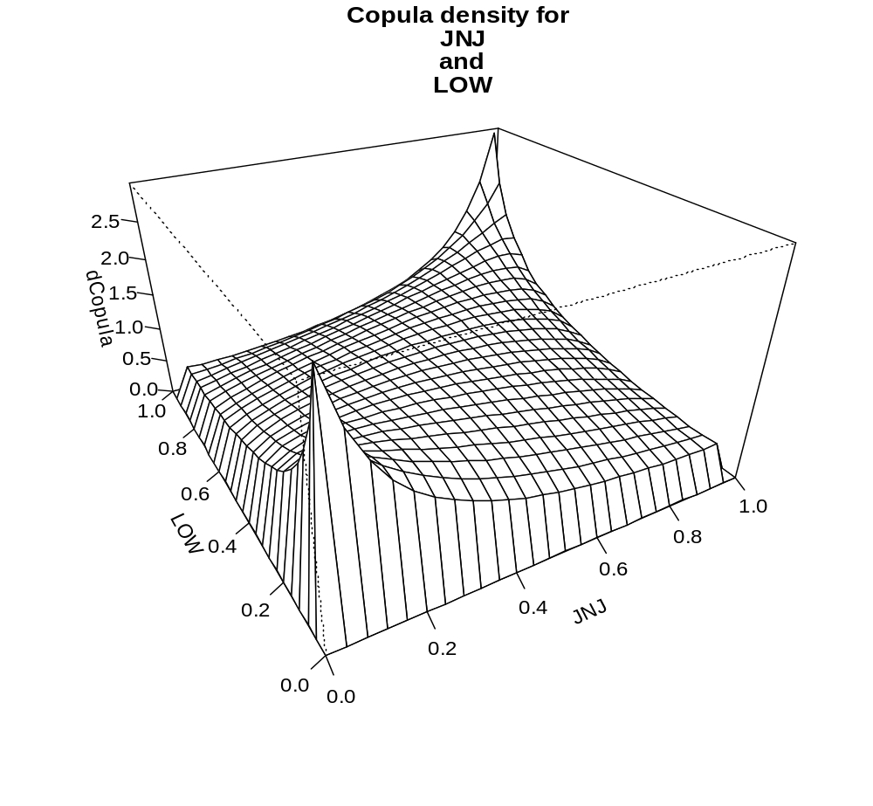
Parameter for Copula of JNJ and LOW = Rho: 0.368 , DF: 6.083
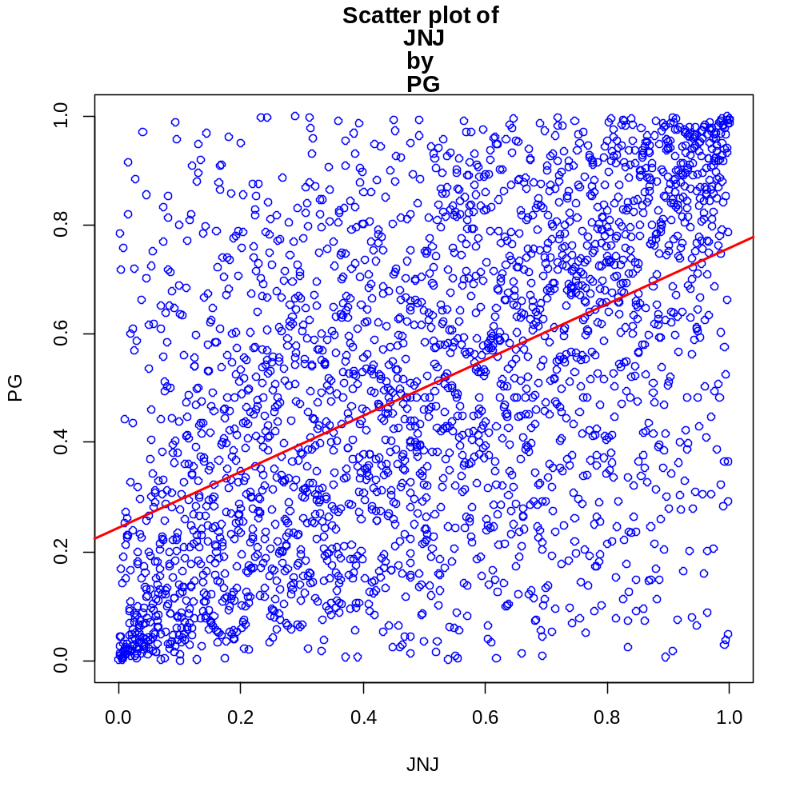
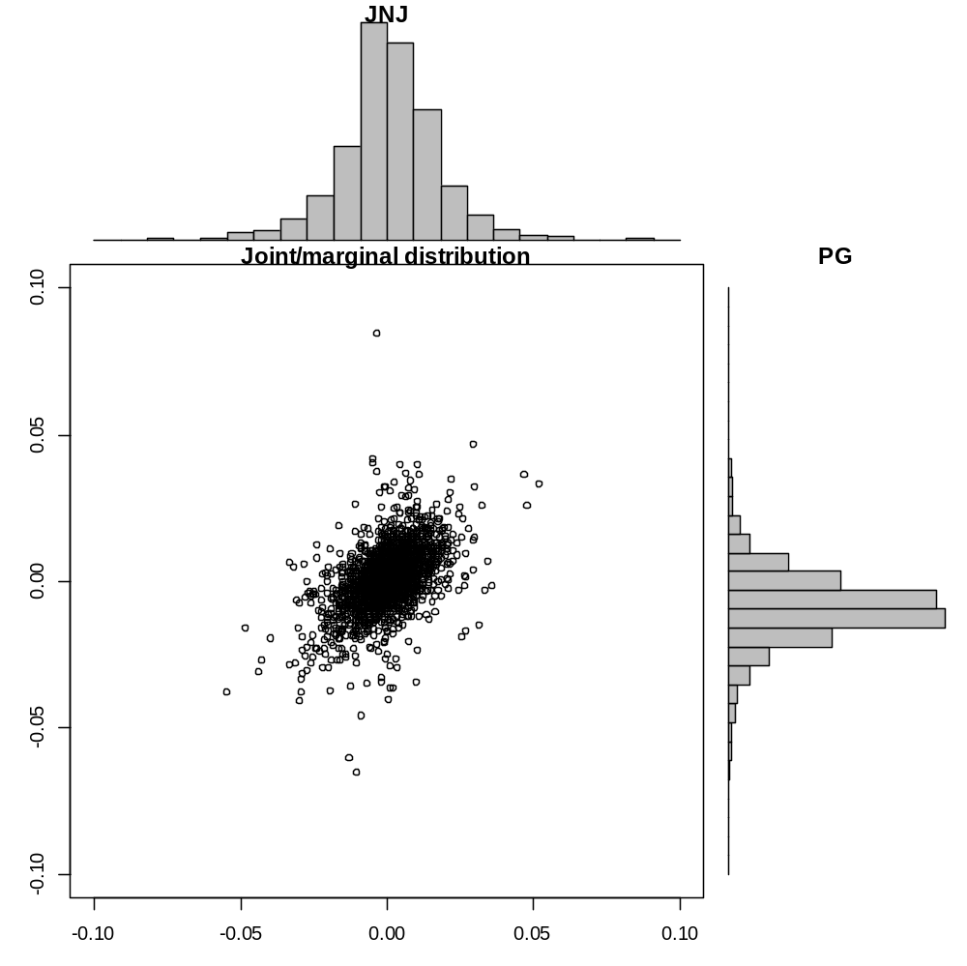

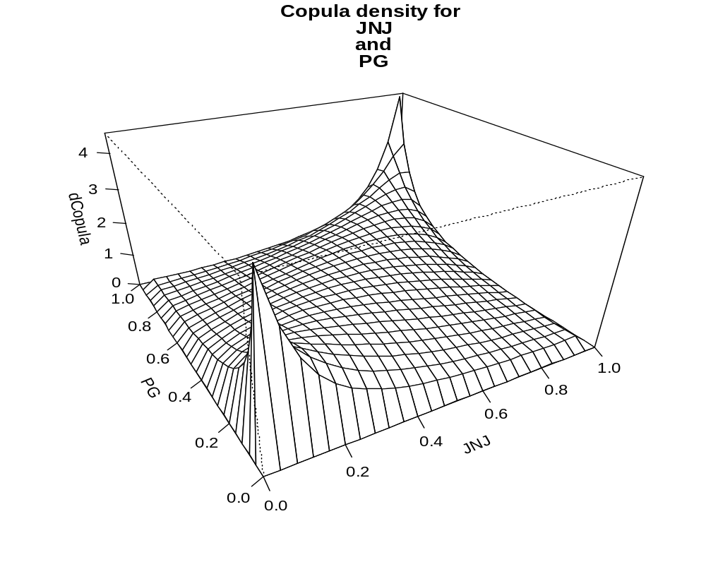
Parameter for Copula of JNJ and PG = Rho: 0.546 , DF: 4.539
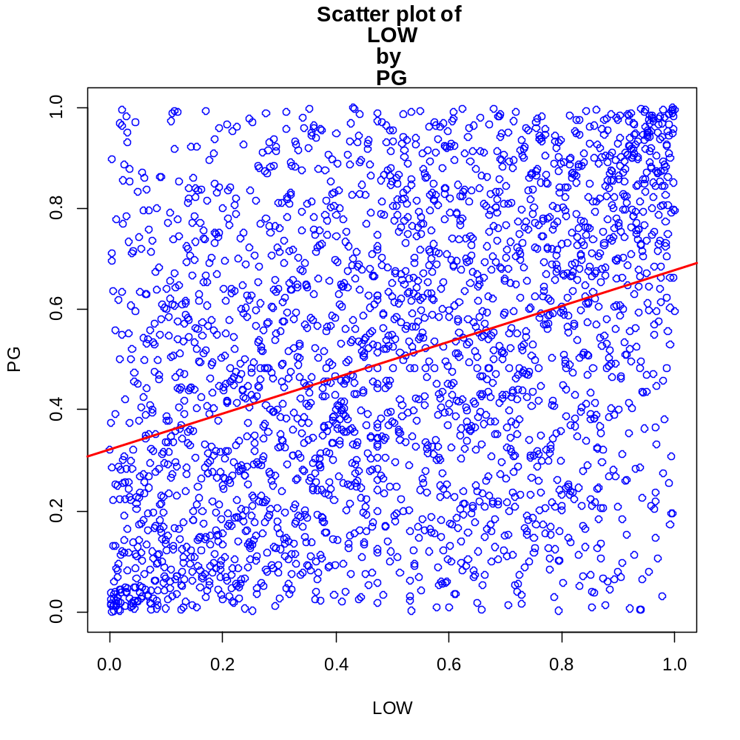
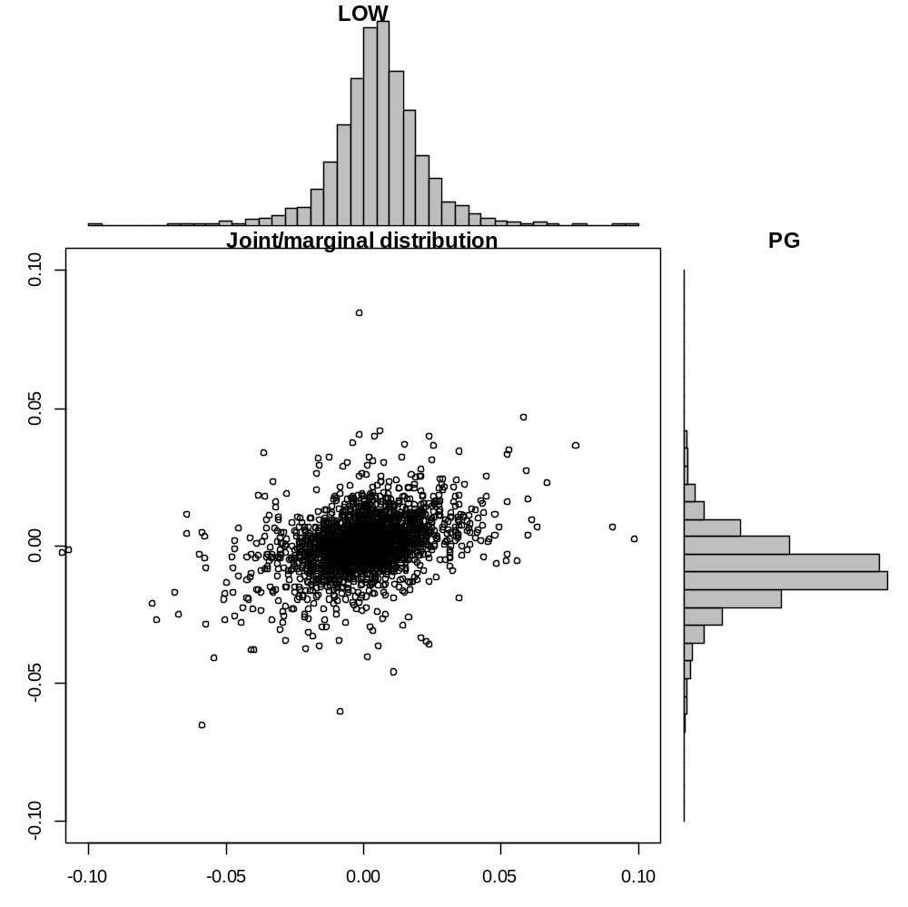
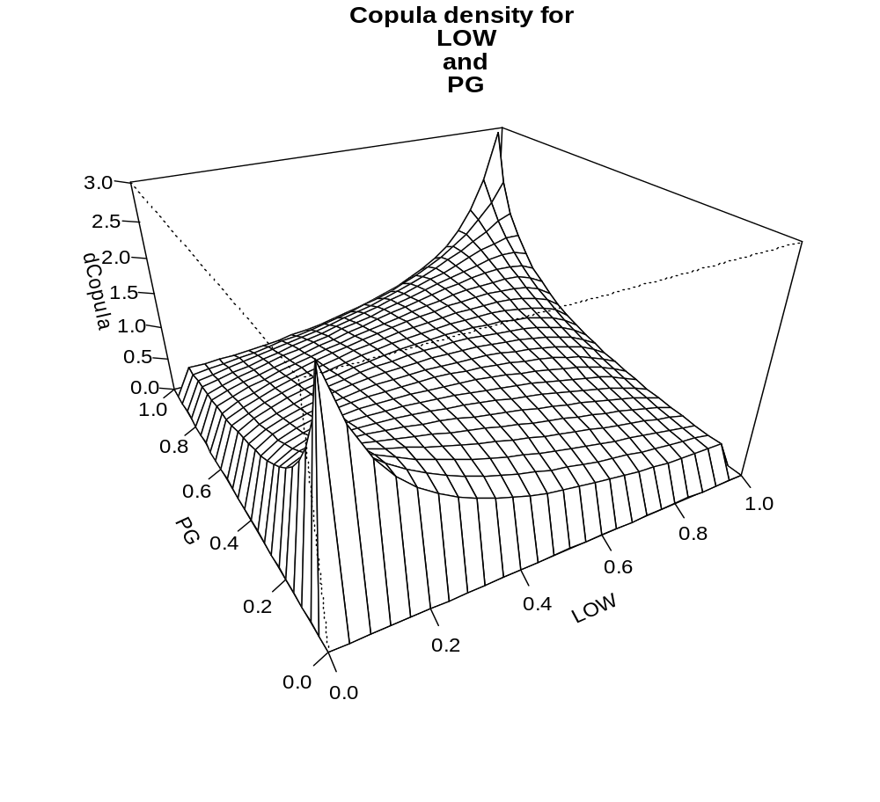
Parameter for Copula of LOW and PG = Rho: 0.378 , DF: 6.451

