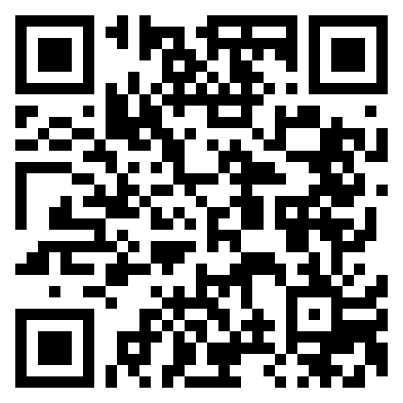
PONMUDI M R
Electronics & Communication Engineering Student | Embedded Systems & RF/SDR Engineer
Sathyamangalam, Tamil Nadu, India | 9790566940 | ponmudimr.ec25@bitsathy.ac.in | linkedin.com/in/mrponmudi | github.com/ponmudimr | ponmudimr.github.io/PORTFOLIO_WEBPAGE
SUMMARY
Second-year ECE student specializing in RF/SDR systems, LoRa mesh networking, and embedded hardware (ESP32/Arduino). Built and led award-winning disaster-communication and GPS-denied positioning systems recognized at national forums (NHIDE 1st Prize, IEEE YESIST12 National Finalist). Looking to bring hands-on embedded/RF product development to a [target role, e.g. Embedded Systems / RF Engineering] team.
TECHNICAL SKILLS
Languages: C, Embedded C, Python
Frameworks & Platforms: Arduino, ESP32 (WROOM-32/32D), Zephyr RTOS (STM32)
RF / SDR Tools: RTL-SDR V4, SDR++, SDRSharp, SatDump, JAERO, multimon-ng, GNU Radio, fldigi
Hardware & PCB: KiCad, PCB Design & Fabrication, LoRa (SX1278), Sensor Integration
Other Tools: Git/GitHub, Linux (Fedora), Google Apps Script
FREELANCE PROJECTS
TribalNet — Decentralized Disaster Communication & Survivor Tracking | Team Lead, Team 404 [Jan 2026] – Present
- Delivered a ~10 km line-of-sight disaster-communication network at ~₹1,500 per node by designing a solar-powered ESP32 + SX1278 (433 MHz) LoRa mesh system.
- Earned national recognition — 1st Prize (₹50,000) at NHIDE 2026 and National Finalist at IEEE YESIST12 2026 — for TribalNet's field-ready design.
- Improved survivor-tracking capability by extending the system with RSSI-based triangulation and an ML-driven hazard-prediction module; initiated IPR filing through BIT Sathy's IPR cell.
Cognitive Opportunistic LEO-PNT Receiver | iDEX/DRDO Submission, Team 404 [2025] – Present
- Enabled GPS-independent positioning by building an RTL-SDR V4 receiver that extracts Doppler shift from LEO satellites (Orbcomm, NOAA, Iridium).
- Automated signal identification by training a YOLOv8 classifier across 7 RF signal classes on a custom synthetic SDR dataset generator built from scratch.
- Strengthened positioning accuracy under GPS-denied conditions by implementing an EKF/IMU sensor-fusion pipeline.
Kanaku Book — Payment Ledger PWA | Freelance Project, SM TEX [month/year] – [month/year]
- Digitized day-to-day ledger tracking for a family textile business by designing and deploying a mobile-first PWA backed by Google Sheets/Apps Script.
- Maintained a clean, auditable contributor history using an orphan-branch git workflow; scoped Play Store distribution via PWABuilder.
Custom PCB Design & Fabrication | Independent Project [month/year] – [month/year]
- Took embedded projects from schematic to competition-ready hardware by designing and fabricating custom PCBs in KiCad.
- Enabled multi-platform sensor integration by interfacing ESP32, Arduino Mega, and Raspberry Pi across projects.
ACHIEVEMENTS & LEADERSHIP
- Placed 2nd at ChronoBIT'26 Hackathon by designing a 555-timer + CD4026 digital clock (HH:MM:SS) with rollover logic via segment decoding.
- Google Gemini Student Ambassador and IEEE Electron Devices Society member; active in BIT-IECC and AViNYA Club.
- [Add: any workshops/training you've conducted — e.g. 'Led a workshop on X for Y peers/juniors' — this is a strong leadership signal.]
EDUCATION
B.E. Electronics and Communication Engineering
Bannari Amman Institute of Technology (BIT Sathy), Sathyamangalam, Tamil Nadu | 2026 – 2029 (2nd Year)
LANGUAGES
Tamil (Native), English (Professional), German (Learning — targeting MS in Germany)

