Banana tree

# വാഴ

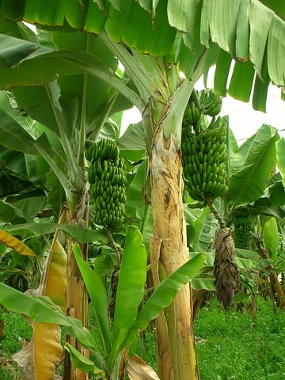

Common name: banana tree

Scientific Name: ***Musa***

Kingdom: Plantae

Family : Myrtaceae

Species : M.acuminata

Growth :20-40 feet

Origin: Malaysia

Medical use: diabetes,fever etc

A banana is an elongated, edible fruit – botanically a berry[1][2] – produced by several kinds of large herbaceous flowering plants in the genus Musa.[3] In some countries, bananas used for cooking may be called “plantains”, distinguishing them from dessert bananas.