# Bougaunvillea Spectabilis

കടലാസു ചെടി

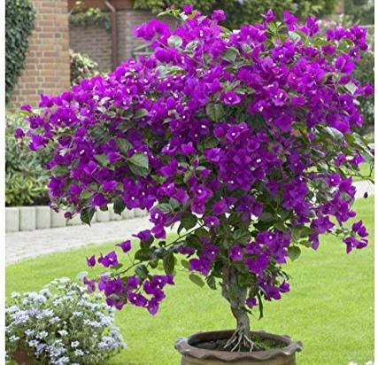

Common name: Papper Plant

Scientific Name: Bougainvillea Spectabilis

Kingdom: Plantae

Family : Nyctaginaceae

Species : Spectabilis

Growth :1-12 m

Origin:Brazil

A summer-flowering, grows as a woody vine or shrub ,reaching 15 to 40 feet(4.6 to 12m) with heart-shaped leaves and thorny,pubescent stem.