System Sequence Diagram : Review

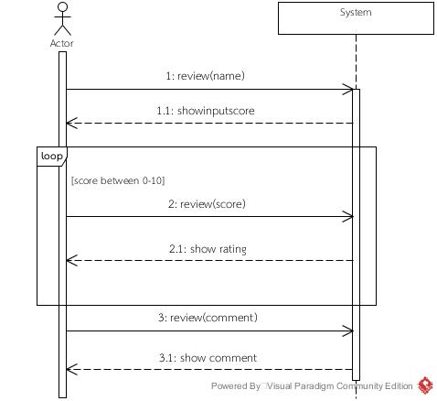

System Sequence Diagram : Check out

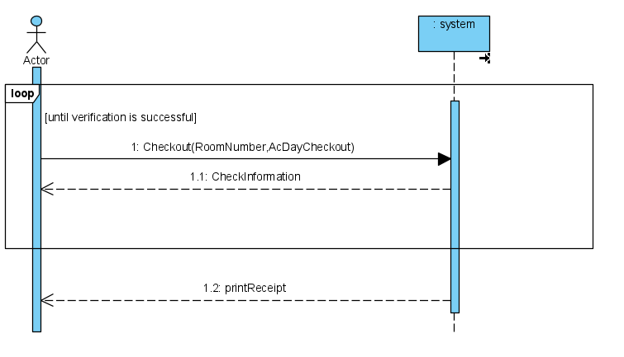

System Sequence Diagram : login

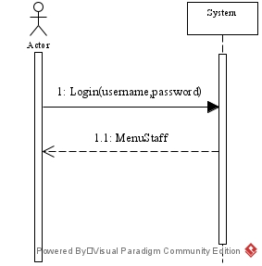

System Sequence Diagram : Check in(Booking)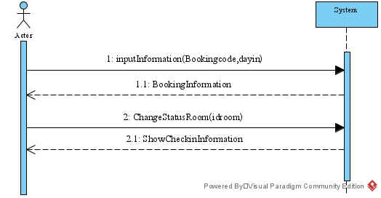

System Sequence Diagram : Check in(Walk in)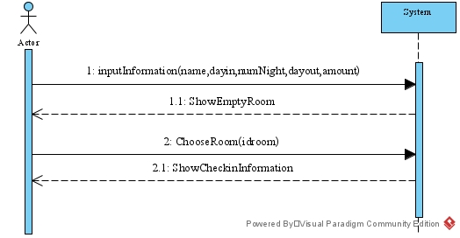

System Sequence Diagram : Check-out

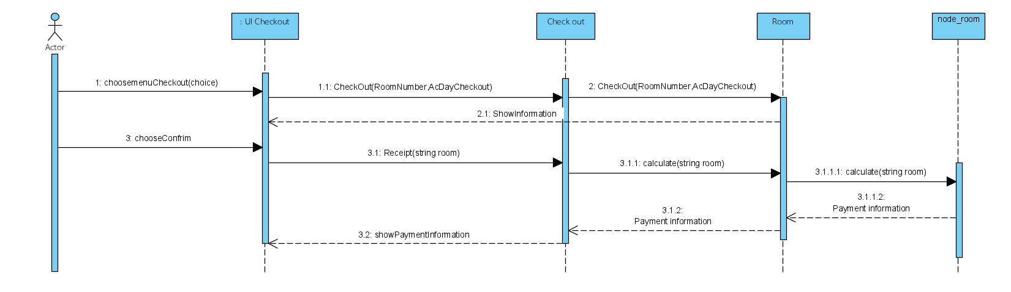

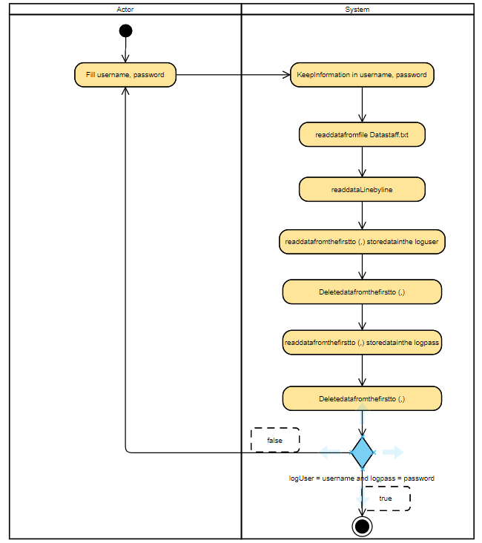Activity Diagram : login

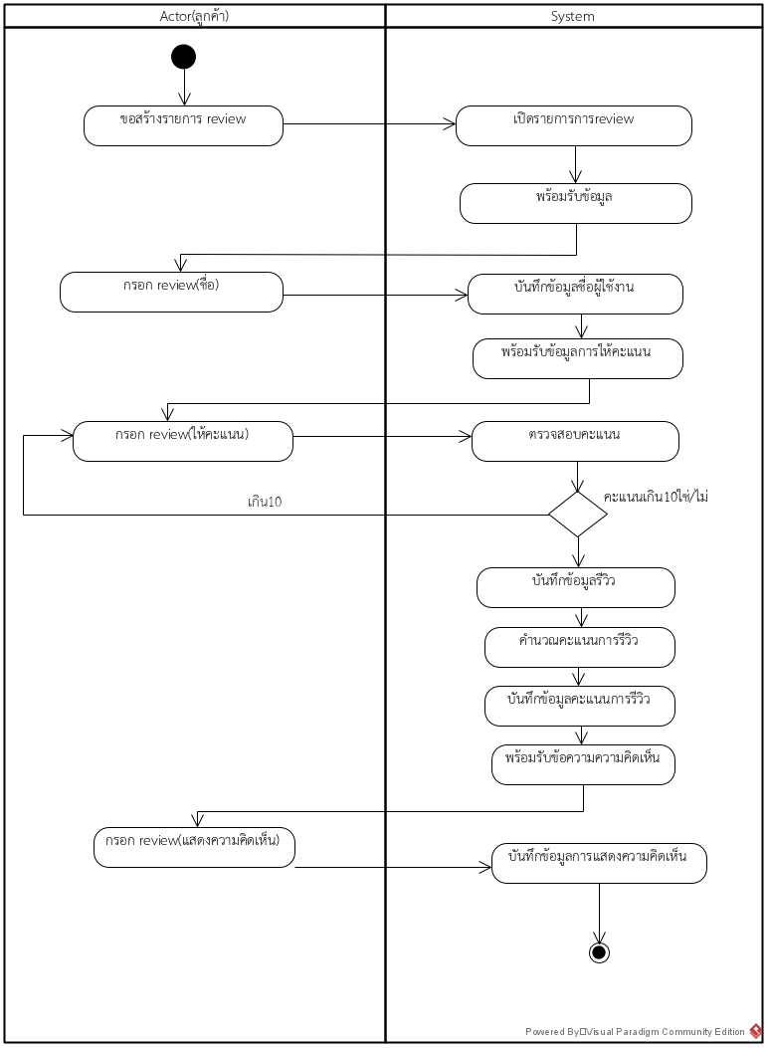Activity Diagram : Review

Activity Diagram : Checkout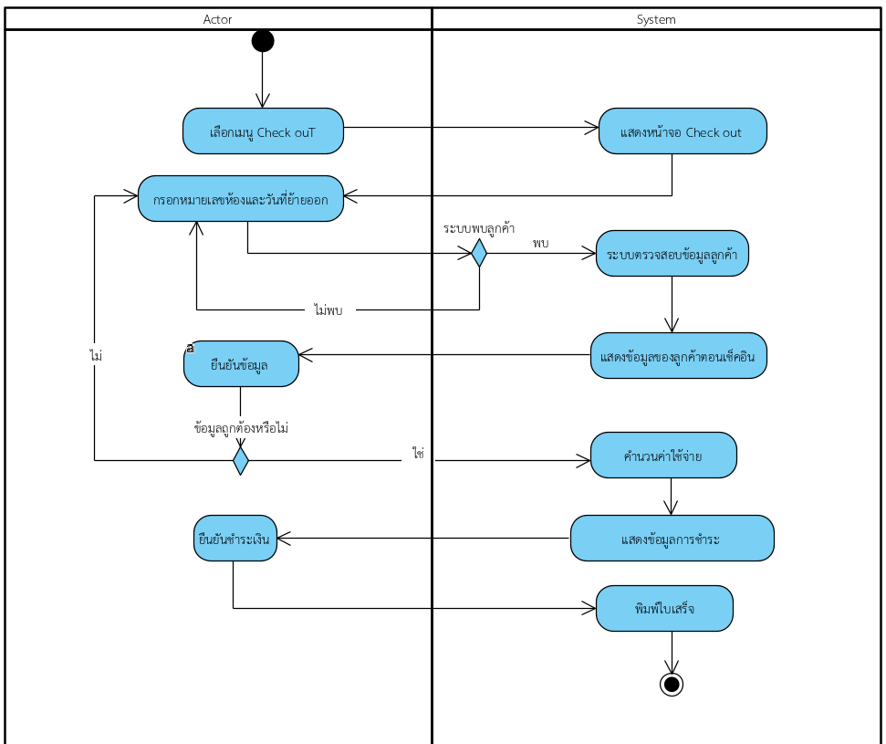

Use case Diagram: ระบบโรงแรม

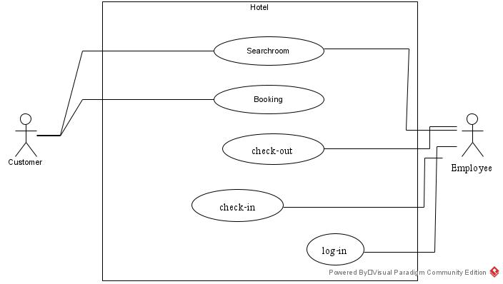

State machine Diagram: Room

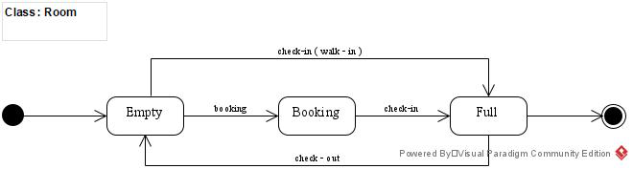

Sequence Diagram : Review 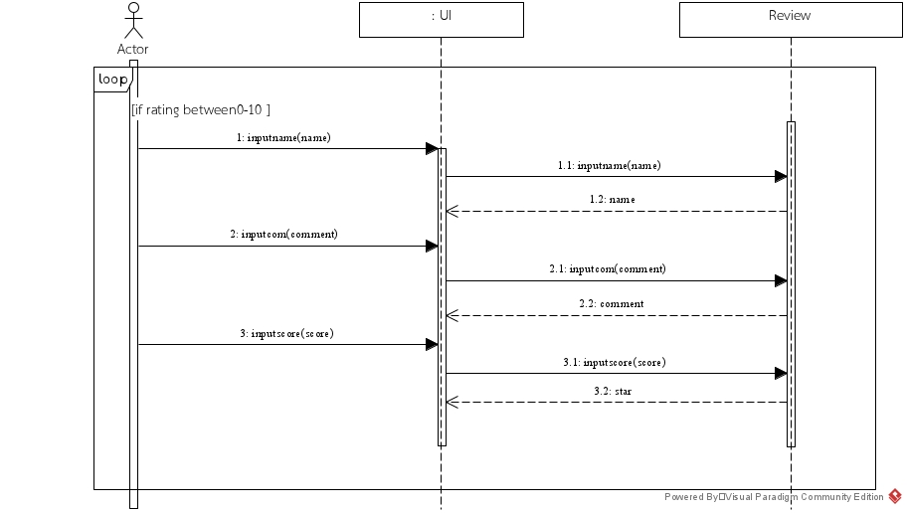

Activity Diagram : Booking

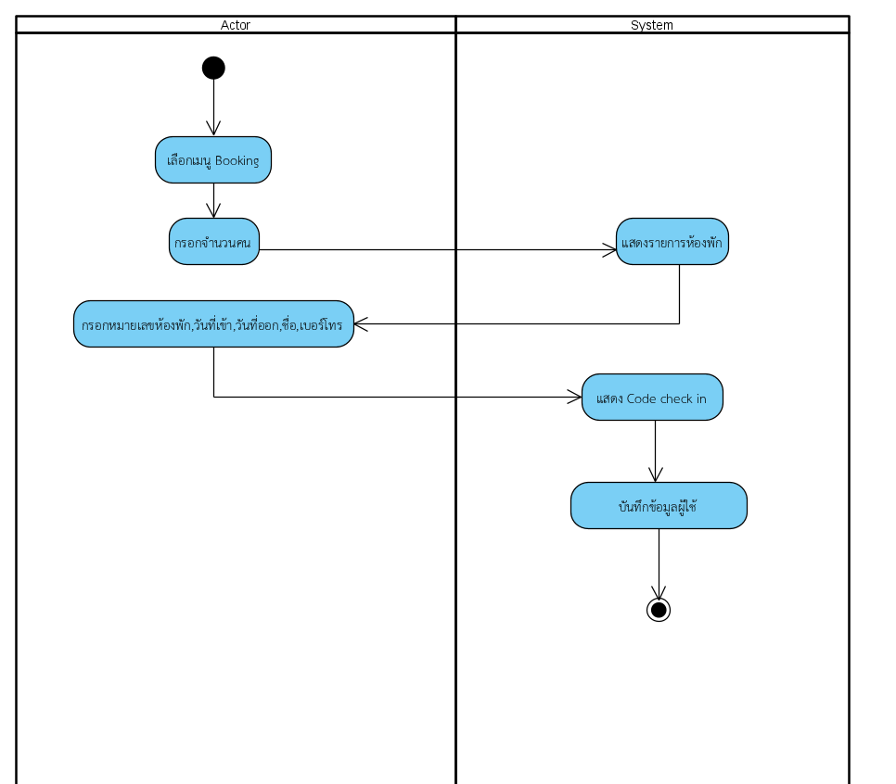

Activity Diagram : Search room

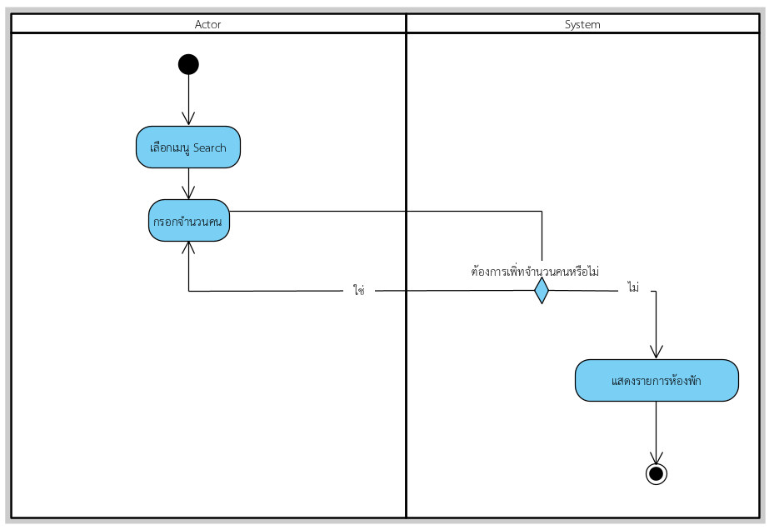

Sequence Diagram : login

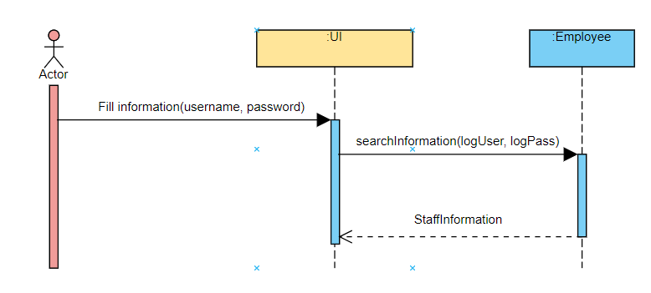

Activity Diagram : Check in (Booking)

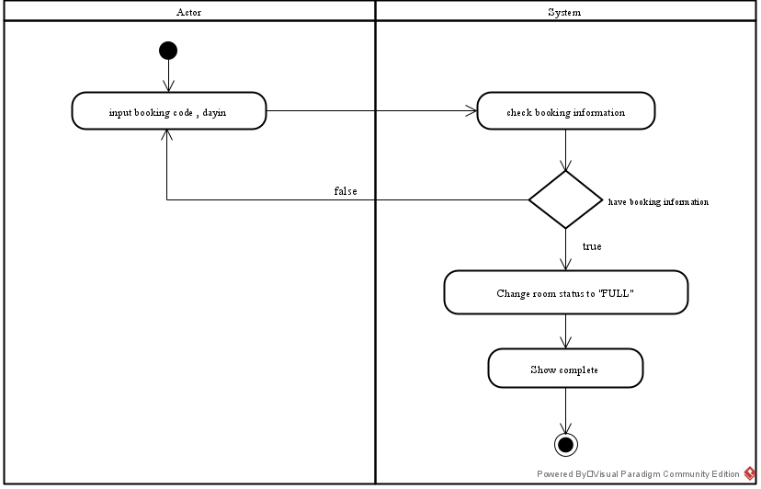

Activity Diagram : Check in (Walk in)

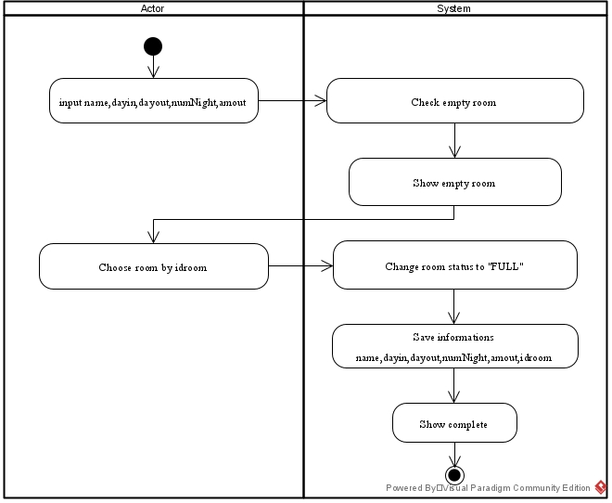

System Sequence : Search room

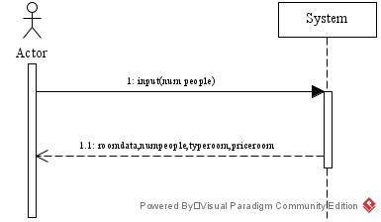

Sequence Diagram :Search room

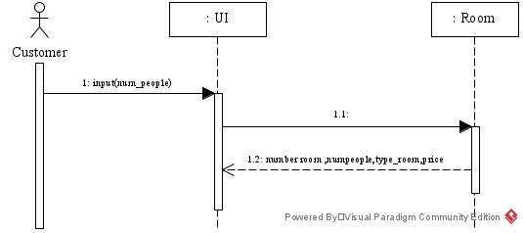

Class Daigram : Hotel

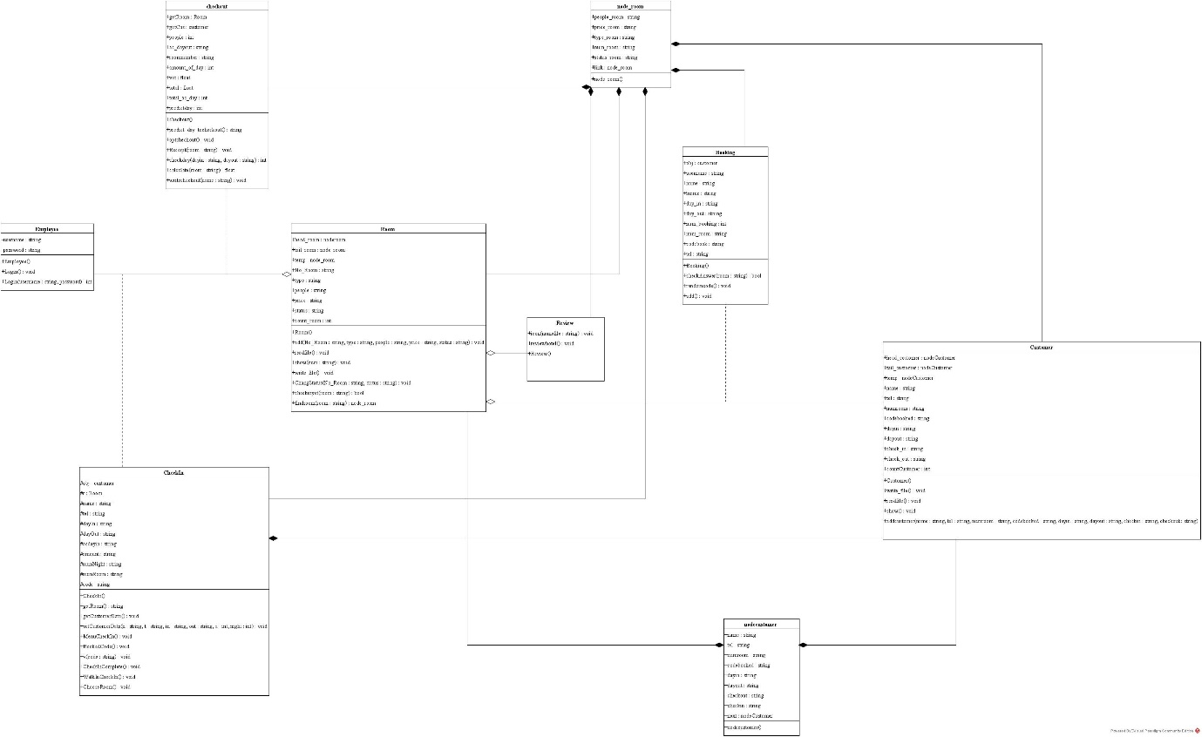

Domain Class Diagram : Hotel

