EXP NO 1: CREATE A SIMPLE CLOUD SOFTWARE APPLICATION AND PROVIDE
IT AS A SERVICE USING ANY CLOUD SERVICE PROVIDER TODEMONSTRATE SOFTWARE AS A SERVICE (SAAS).
DATE:23-07-26 Name:P.Sri Kousick
AIM: Reg No:192524431
To create a simple cloud software application and provide it as a service using any cloud service provider todemonstrate software as a service (saas).
PROCEDURE:
STEP1: GOTO ZOHO.COM
STEP 2: LOGIN TO THE ZOHO.COM STEP 3: SELECT ONE APPLICATION STEP 4: ENTER APPLICATION NAME STEP 5: CREATED NEW APPLICATION STEP 6: SELECT ONE FORM
STEP 7: THE SOFTWARE HASE BEEN CREATED.

IMPLEMENTATION:
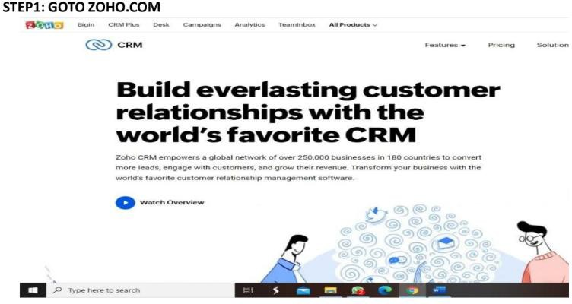

STEP 2· LOGINTOlHE ZOHO.COM

You're one step away from getting started with Zoho CRM,

Br��r- �L 'J'llll Jl(Tl!II! IDUla" Ml1
tr..m rncn�f ZntioCRM

STEP 3: SfLECT ONE APPLICATION

Create Application
- ...w ..,......
' "

- I
0

...

a a
._,.
�"'�' .,,.. .. ........ ..
Nin I 1 �I.IUl�i:dulia::r --
I _..�

""'"

El II a
•
ITA...Nli"ICMr l,...,..,......
eo...-.
Ertf'IIM
(Ir�.,_.---

---




STEP 4: ENTER APPLICATION NAME

Create Appllcatian
..
rTAn11T�tal'I'
a
E,c...._,._
■
a
CVlnl Pblin""
-a
II
E,q,c,-
(i,llet.Apohc•lNln NllllE


STEP 5: CREATED NEW APPLICATION




SiiEP6: SELECT ONE FORM

fur 11
011·1 huldir,g you1 ,1i11Jl1, 1,un by

, ,1 "� ,l


How would you like to creale youi form?
Ll
.....
lr:.m.11111

1 II Iii 11 1�

STEIP7: lHE SOFTWARE HASE BEEN CREATED.

J:l □ C Form�·WRD

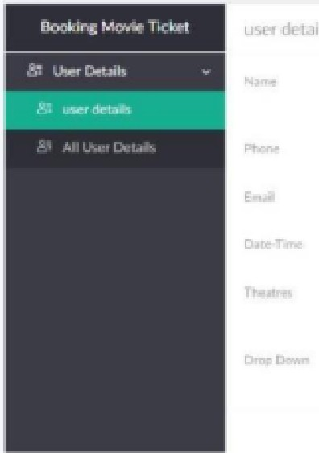
L_
_,
[
t
c. . ...'.:[==::::::...

� O:,t•
--
·fl,-,lfll•-

--· � '°40.:11en. ........
--
-8
-s
........
-
Fltldfl'operw,
ll
,.........
=
M.�1.....
...en [Q Al,_.,

..,.,_ ..-.�·- C!0-.0. t

.._c...
.....

,....,...., ... ..........
"' rm rw,tK:ime

,G_> c::;J
._...,
-
'"""""'

