PIC16F877A features(pic controller)

Operating Frequency ...............DC – 20 MHz

Resets (and Delays) .................POR, BOR (PWRT, OST)

Flash Program Memory ..........8K
(The PIC16F877A devices have 8K words x 14 bits of Flash program
memory,)

Data Memory (bytes) ............368
(The data memory is partitioned into multiple banks which contain the General Purpose Registers and the Special Function Registers. Bits RP1 (Status<6>) and RP0 (Status<5>) are the bank select bits.)

EEPROM Data Memory (bytes) .....256
(The data EEPROM and Flash program memory is readable and writable during normal operation (over the full VDD range). This memory is not directly mapped in the register file space. Instead, it is indirectly addressed through the Special Function Registers. There are six SFRs used to read and write this memory:)

Interrupts...............................15

I/O Ports Ports .....................Ports A, B, C, D, E

Timers ..................................3

Capture/Compare/PWM modules ....2

(PWM is a technique used to generate analog output signal using digital signals. It is commonly used to control average power delivered to a load, motor speed control, generating analog voltage levels and for generating analog waveforms)

Serial Communications ..................MSSP, USART

(Master SSP (MSSP) Module Overview The Master Synchronous Serial Port (MSSP) module is
a serial interface, useful for communicating with other peripheral or microcontroller devices. These peripheral devices may be serial EEPROMs, shift registers, display drivers, A/D converters, etc. The MSSP module can operate in one of two modes:
Serial Peripheral Interface (SPI)
• Inter-Integrated Circuit (I 2 C)
- Full Master mode
- Slave mode (with general address call

The I 2 C interface supports the following modes in
hardware
• Master mode
• Multi-Master mode
• Slave mode
)

Parallel Communications ............PSP
The Parallel Slave Port (PSP) is not implemented on the PIC16F873A or PIC16F876A. PORTD operates as an 8-bit wide Parallel Slave Port, or microprocessor port, when control bit PSPMODE (TRISE<4>) is set. In Slave mode, it is asynchronously readable and writable by the external world through RD control input pin, RE0/RD/AN5, and WR control input pin, RE1/WR/AN6.

10-bit Analog-to-Digital Module .........8 input channels

Analog Comparators ..............2

Instruction Set .....................35 instructions set

Packages......................

40-pin PDIP
44-pin PLCC
44-pin TQFP
44-pin QFN

lcd pin descriptions
A 16x2 LCD means it can display 16 characters per line and there are 2 such lines. In this LCD each character is displayed in 5x7 pixel matrix. This LCD has two registers, namely, Command and Data.
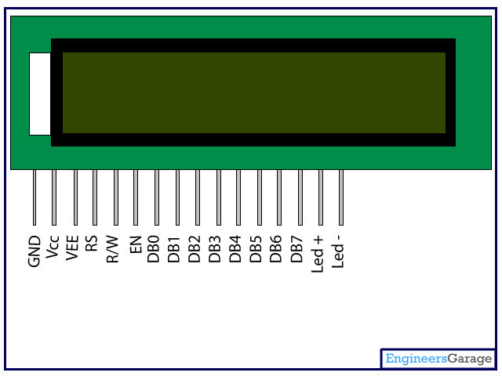

Pin No | Function | Name
1 | Ground (0V) | Ground
2 | Supply voltage; 5V (4.7V – 5.3V) | Vcc
3 | Contrast adjustment; through a variable resistor | VEE
4 | Selects command register when low; and data register when high | Register Select
5 | Low to write to the register; High to read from the register | Read/write
6 | Sends data to data pins when a high to low pulse is given | Enable
7 | 8-bit data pins | DB0
8 | 8-bit data pins | DB1
9 | 8-bit data pins | DB2
10 | 8-bit data pins | DB3
11 | 8-bit data pins | DB4
12 | 8-bit data pins | DB5
13 | 8-bit data pins | DB6
14 | 8-bit data pins | DB7
15 | Backlight VCC (5V) | Led+
16 | Backlight Ground (0V) | Led-

