##### A finite-difference scheme for the generalized diffuse interface model of the electrical breakdown process

A. S. Ponomarev1, E. V. Zipunova1  
1Keldysh Institute of Applied Mathematics, Moscow, Russia

The subject of the present work is numerical studies of a generalization of a diffuse interface model describing the development of the electrical breakdown channel. The Allen–Cahn type equation governing the phase field evolution is a nonlinear partial differential equation including 4-th order terms. The solutions of this equation may have singular behavior in some cases. In the paper, we propose a new finite-difference scheme allowing an exact accounting of the singularities of the solution and its accurate computation, even in the case when the boundary conditions are defined on objects of higher co-dimension.

Key words and phrases: diffuse interface model, phase field, stability, electrical breakdown.

## 1. Introduction

The electrical breakdown is a phenomenon of a sharp increase in the electric current in a dielectric medium under application of the electric field larger than a certain critical value. The process of the dielectric damage under the action of the electric field is complex and diverse: it can have various causes, mechanisms of its development and accompanying physical processes [1].

Among the variety of mathematical models designed to describe the development of an electrical breakdown channel, we will highlight the diffuse interface type model proposed in the work [2].

Diffuse interface type models are used to describe systems in which a medium can exist in several different states — phases — separated by inter-phase boundaries. The spatial distribution of the phases is described by a smooth function  — a phase field — which values are closed to a constant in each region of homogeneity. The inter-phase boundary is described as a thin separating layer, inside which phase filed varies smothly but fast. The thikness of the interface as well as evolution of the phase field is governed by the parameters of the model.

At present, diffuse interface models constitute a large class of approaches suitable to solving problems in various fields of science and technology. In particular, the model described in [2] itself is constructed as a formal generalization of previously known diffuse interface elastic fracture models. The study and further development of the mentioned model can be found in the works [3, 4].

In the context of the electric breakdown modelling, it is natural to consider two phases — undamaged one, which corresponds to the inital state of the medium before breakdown process occurs; and the damaged one, which corresponds to the state of the medium inside breakdown channel. The particular feature of the breakdown process is that the damaged phase usually occupies essentially one-dimensional spatial domain ("channel") in 3D space. In the work [3] it is shown that the original model proposed in [2] doesn't provide a correct mathematical setting in that case in model situations and certain modifications of the model are needed. This modifications lead to strongly non-linear and higher order partial differential equation which governs phase field evolution.

The subject of the present work is numerical studies of the generalization of a diffuse interface model describing the development of an electrical breakdown channel. The solutions of this equation may have singular behavior in some cases. We propose a new finite-difference scheme which allows for exact accounting of the singularities of the solution and for accurate computation for the problem under consideration even in the case when the boundary condition are defined on the boundaries of higher co-dimension. The presented scheme is based on finite-volume approximations and uses the specially chosen basis functions which accurately accounts for the solution behavior at the boundaries. Possible types of singularities are analyzed as well.

This work was supported by the Russian Science Foundation, project no. 22-11-00203.

## 2. Mathematical model

In this section we give short description of the phase field model for electric breakdown evolution suggested in [2]. More extensive presentation of the model and physical interpretation of its parameters is given in [3, 4].

Let  be a bounded domain. Distribution of damaged and undamaged phases is described by a smooth function $ϕ=ϕ(x,t)$, $ϕ:Ω×[0,+∞)_{t}→[0,1]$, called the phase field function. Values of $ϕ=1$ correspond to the undamaged phase and values of $ϕ=0$ to the damaged one.

Damaged and undamaged phases of the medium have different properties. The only one accounted in the simplest case is an electric permittivity $ε$ which depends on the phase field and is defined as:



$ε(x,t)=ε[ϕ]=\frac{ε_{0}(x)}{f(ϕ(x,t))+δ}.$

Here $ε_{0}(x)$ is electric permittivity of the undamaged medium, $f(ϕ)=4ϕ^{3}-3ϕ^{4}$ is the so called interpolation function and $0<δ≪1$ is regularization parameter which prevents form division by zero in . Such dependency of $ε$ on $ϕ$ assumes that the breakdown channel behaves like an ideal conductor with sufficiently large values of $ε\sim 1/δ$ in the damaged phase.

An electric field defined in the medium is described by an electric potential $Φ=Φ(x,t)$, $Φ:Ω×[0,+∞)_{t}→R, Φ(x,t)$.

The essence of the model is the following expression for the free energy of the medium:





$$Π=\int_{Ω}{‍}πdx,$$

$$π=-\frac{1}{2}ε[ϕ]\left(∇Φ,∇Φ\right)+Γ\frac{1-f(ϕ)}{l^{2}}+\frac{Γ}{4}\left(∇ϕ,∇ϕ\right),$$

where $Γ>0$, $l>0$ are parameters of the model. The first term in $π$ accounts for the energy of the electric field; other terms account for the energy spent for the formation of the damaged medium. The special structure of these terms allows (i) consider $Γ$ as an energy needed to create a breakdown channel of the unit length and (ii) assign this energy to the spatial domain which is a cylinder of the radius $l$ with center line being breakdown channel. More details are given in [2].

Evolution of fields $ϕ$ and $Φ$ is governed by the following equations:



$$\frac{δΠ}{δΦ}=0; \frac{1}{m}\frac{∂ϕ}{∂t}=-\frac{δΠ}{δϕ}.$$

Here $m>0$ is the so called mobility parameter. Speaking informally, these equations states that at each moment of time (i) an energy of the electric field is minimized whatever the distribution of the phase fields $ϕ$ is, and (ii) the phase field $ϕ$ evolves in such a way that minimizes the free energy of the system.

Computing variational derivatives explicitly, one arrives to the following system of partial differential equations (here $(⋅)'≡(⋅)_{ϕ'}$):





$div(ε[ϕ]∇Φ)=0;$

$\frac{1}{m}\frac{∂ϕ}{∂t}=\frac{1}{2}ε'(ϕ)\left(∇Φ,∇Φ\right)+\frac{Γ}{l^{2}}f'(ϕ)+\frac{1}{2}ΓΔϕ.$

This system consists of two equations: the first one has a form of the classical equation for the electric potential, and the second one is Allen–Cahn type equation which governs the phase field evolution.

As it was discussed earlier, non-linear terms in $π$ are responsible to the formation, during the damage evolution, of the "diffuse" breakdown channel, i.e. the "diffuse interface" itself. To study the structure of the diffuse interface it usually considered a simplified problem, solution of which is a stationary distribution of the phase field in the neighbourhood of the damaged zone.

Therefore, in what follows we assume that $Φ≡0$ and equation is satisfied identically. In this case, the stationary solution of satisfies



$\frac{2}{l^{2}}f'(ϕ)+Δϕ=0.$

Consider the spatial domain $\overline{Ω}=[0,+∞)_{x}×I_{y}×J_{z}$, where $I$ and $J$ are some intervals of $R$.

Let the boundary conditions for are defined as: ,  as , and also  on the "faces" of $\overline{Ω}$ which are perpendicular the $y$- and $z$-axes. The symbol $∂/∂n$ hereafter denotes derivative along external unit normal $n$ to $∂\overline{Ω}$. With such boundary conditions being defined it is easy to see that the solution of depends only on $x$, i.e., $ϕ(x)=ϕ(x)$.

In this case reduces to



$$\frac{∂^{2}ϕ}{∂x^{2}}=-\frac{2}{l^{2}}f'(ϕ).$$

which further can be simplified to the equation



$\frac{∂ϕ}{∂x}=\frac{2}{l}\sqrt{1-f(ϕ)},$

accompanied by the boundary condition $ϕ(0)=0$. It can be shown that solution of this problem exists and is unique.

Thus, we find distribution of the phase field $ϕ$ in the neighbourhood of the plane boundary located at $x=0$. At $x=0$ we have $ϕ=0$ which corresponds to the completely damaged phase. It can be shown [3], that for $x>l$ the solution of the problem $ϕ≈1$. In other words, the damaged medium is localized in the vicinity of $x=0$. Therefore, $ϕ$ can be used to localize changes of properties of the damaged medium is neighbourhood of the completely damaged plane. This is exactly the prototypical behavior of the phase field distribution which is governed by the nonlinear terms in $π$.

Such analysis is suitable in the case, if one assumes that the breakdown channel is a plane (i.e., it is not a "breakdown channel" but rather a "breakdown fracture"). In more realistic setting one expect $ϕ$ to be a solution of , which is localized around a 1d line, or a curve, embedded into the 3D domain $\overline{Ω}$.

In other words it natural to consider the following setting. Let, again, $Φ≡0$. Consider equation in the domain $\overline{Ω}=R_{x}×R_{y}×J_{z}$, with $J$ being some interval, together with the boundary conditions $ϕ|_{x,y=0}=0$, $ϕ→1$ at $r=\sqrt{x^{2}+y^{2}}→+∞$ and $∂ϕ/∂n=0$ at the faces of $\overline{Ω}$ which are perpendicular to $z$.

In this case we have a boundary value problem for the equation considered in the three-dimensional domain with boundary conditions defined on the co-dimension 2 "boundary" which is a straight line $x=y=0$. It can be shown that such problem statement is not correct because 2nd order partial differential equation doesn't allow for definition of the boundary conditions on co-dimension 2 boundaries. The reasons are explained in details in [3].

Modification of the problem which guaranties correctness in the case when the boundary conditions are defined at the boundary of co-dimension 2 is given in [3]. It is based on introduction in the expression for the free energy $π$ of specially chosen higher-order differential terms. The proposed expression for $π$ then reads:



$\begin{matrix}π=-\frac{1}{2}ε[ϕ]\left(∇Φ,∇Φ\right)+Γ\frac{1-f(ϕ)}{l^{2}} & +\frac{Γ}{4}\left(∇ϕ,∇ϕ\right)+ \\ & +α\frac{Γl^{2}}{8}(Δϕ)^{2}+β\frac{1}{p}Γl^{p-2}∥ ∇ϕ ∥_{2}^{p};\end{matrix}$

Here $α,β 0$ are parameters, $p≥4$ is an even natural number. Differential operator $div(∥ ∇ϕ ∥_{2}^{p-2}∇ϕ)$ is usually called $p$-laplacian, and $Δ^{2}ϕ=Δ(Δϕ)$ is bi-harmonic operator. For simplicity in what follows we set $p=4$.

Since in what further we will consider only phase field equation, we assume hereafter that $Φ≡0$ in , . Then the resulting equation for $ϕ$ reads:



$\frac{1}{m}\frac{∂ϕ}{∂t}=\frac{Γ}{l^{2}}f'(ϕ)+\frac{1}{2}ΓΔϕ--α\frac{Γl^{2}}{4}Δ^{2}ϕ+βΓl^{p-2}div(∥ ∇ϕ ∥_{2}^{p-2}∇ϕ).$

or, in a more compact form,



$\frac{1}{m}\frac{∂ϕ}{∂t}=\frac{Γ}{l^{2}}f'(ϕ)+Γdivρ,$

where



$ρ=\frac{1}{2}∇ϕ-α\frac{l^{2}}{4}∇(Δϕ)+βl^{2}∥ ∇ϕ ∥_{2}^{2}∇ϕ.$

## 3. Finite-difference scheme

### 3.1. General setting

Our goal is to study stationary solutions of numerically and we are mostly interesting in three particular cases: two ones described in the section 2 and the third one described below. These cases differs only in boundary conditions, which are defined on the boundaries of the different co-dimension:

1. , , ,  at . This is one-dimensional planar case. The boundary conditions are given at the co-dimsion 1 set — 2d plane .

2. , ,  at . This is one-dimansional axially symmetric case. The boundary conditions are given at co-dimension 2 set — the 1d axis .

3. , ,  at . This is one-dimensional spherically symmetric case. The boundary conditions are given at co-dimension 3 set — the 0d point $r=0$.

Note that the only difference between the cases is the dimension of the set where boundary conditions are defined.

The cases 1 and 2 were discussed in the section 2. The case 3 naturally extends cases 1 and 2.

According to the derivation of the equations, stationary solutions minimize the free energy $Π$. In turn, evolutionary equations of the models are constructed to minimize $Π$ during temporal evolution (see section 2 for details). Therefore, it is possible to construct stationary solution by solving evolutionary equation on the sufficiently long time interval: the resulting limiting solution will be the stationary solution of the equation under consideration.

In cases 2 and 3 it natural to use cylindrical and spherical coordinate systems, respectively and assume that phase field depends only on radial variable, i.e., $ϕ=ϕ(r,t)$. So, in all setting we have $ϕ(x,t)=ϕ(r,t)$.

Since we assume that solutions decay quite fast to the their values at infinity, in what further we shift boundary conditions form infinity to the finite point $r=R$ for sufficiently larger value of $R$. Then boundary conditions for all three cases can be written as $ϕ(0)=0$ $ϕ(R)=1$ with $R≫l$ being the external radius of $Ω$.

To construct finite-dimensional problem, we use the finite volume technique.

To proceed, decompose $Ω$ into $n+1$ cells (which are planar, or cylindrical, or spherical layers), which we define as $Ω_{0},…,Ω_{n}$. Let the boundaries of the cells be $0=r_{-1/2},r_{1/2},…,r_{n+1/2}=R$.

Define $V(r)$ to be a volume of planar, cylindrical or spherical subdomain of $Ω$ extended from $0$ to $r$. Let $S(r)$ be the area of its (external) boundary. Then the volume of the cell $Ω_{i}$ is equal to $dV_{i}=V(r_{i+1/2})-V(r_{i-1/2})$, and areas of its internal and external boundaries are given by $S_{i-1/2}=S(r_{i-1/2})$ and $S_{i+1/2}=S(r_{i+1/2})$ respectively. For the cases under consideration one has:

1. Planar case:. $V(r)=r⋅|I_{y}|⋅|J_{z}|$, $S(r)=|I_{y}|⋅|J_{z}|$. Since the coefficients which doesn't depend on $r$ can be cancelled during construction of the finite-difference scheme, see below, we set just , .

2. Axisymmetric case: $V(r)=πr^{2}⋅|J_{z}|$, $S(r)=2πr⋅|J_{z}|$. On the same basis as before we set , .

3. Sperically symmetric case: $V(r)=(4/3)πr^{3}$, $S(r)=4πr^{2}$, or, again, $V(r)=r^{3},$ $S(r)=3r^{2}$.

Note that for all three cases we can set $V(r)=r^{k+1}$, $S(r)=(k+1)r^{k}$, where $k=0$ for planar case, $k=1$ for axisymmetric case and $k=2$ for sperically symmetric case.

We now proceed to the construction of the finite-volume scheme. First, integrate over $[t_{j},t_{j+1}]×Ω_{i}$. For the left hand side one has:



$$\int_{Ω_{i}}{‍}\int_{t_{j}}^{t_{j+1}}{‍}\frac{1}{m}\frac{∂ϕ}{∂t}dtdx=\frac{1}{m}\int_{Ω_{i}}{‍}[ϕ(x,t_{j+1})-ϕ(x,t_{j})]dx=\frac{dV_{i}}{m}[{\tilde{ϕ}}_{i}(t_{j+1})-{\tilde{ϕ}}_{i}(t_{j})],$$

where ${\tilde{ϕ}}_{i}$ is integral average of $ϕ$ over $Ω_{i}$. For the right hand side one obtains



$$\int_{t_{j}}^{t_{j+1}}{‍}\int_{Ω_{i}}{‍}\left(\frac{Γ}{l^{2}}f'(ϕ)+Γdivρ\right)dxdt=Γ\int_{t_{j}}^{t_{j+1}}{‍}\left(\frac{1}{l^{2}}\int_{Ω_{i}}{‍}f'(ϕ)dx+\int_{∂Ω_{i}}{‍}(ρ,n)dS\right)dt.$$

Since $ϕ$ depends only on $r$, the flux $ρ$ is always collinear to $r$-axis and we have



$$\int_{∂Ω_{i}}{‍}(ρ,n)dS=F_{i+1/2}-F_{i-1/2}=ρ_{i+1/2}S_{i+1/2}-ρ_{i-1/2}S_{i-1/2},.$$

with



$$F_{i±1/2}(t)=\int_{r=r_{i±1/2}}{‍}(ρ,n)dS=\int_{r=r_{i±1/2}}{‍}ρ_{r}dS=ρ_{r}S(r_{i±1/2})=ρ_{i±1/2}(t)⋅S_{i±1/2},$$

Here $ρ_{r}$ defines the only nonvanishing radial component of $ρ$ and $ρ_{i±1/2}(t)=ρ_{r}(r_{i±1/2},t)$ is the flux over the respective boundary.

Hence, the balance equation for the cell $Ω_{i}$ reads:



$\frac{dV_{i}}{m}[{\tilde{ϕ}}_{i}(t_{j+1})-{\tilde{ϕ}}_{i}(t_{j})]=Γ\int_{t_{j}}^{t_{j+1}}{‍}\left[\frac{1}{l^{2}}\int_{Ω_{i}}{‍}f'(ϕ)dx+ρ_{i+1/2}S_{i+1/2}-ρ_{i-1/2}S_{i-1/2}\right]dt.$

The scheme in its final form will be presented later. Here we just mention that the first term under integral in the right hand side of can easily be approximated as $l^{-2}⋅dV_{i}⋅f'[{\tilde{ϕ}}_{i}(t_{j})]$ and time integral can be approximated in the simplest way as a product of the integrand evaluated at $t_{j}$ and $(t_{j+1}-t_{j})$.

The more difficult task to which we proceed now is to construct approximations $ρ_{i±1/2}$ of the flux $ρ$.

First, note that for an arbitrary function $ψ(x)=ψ(r)$, we have



$$(∇ψ)_{r}=\frac{∂ψ}{∂r}, (∇ψ)_{θ}=(∇ψ)_{z}=0,$$

where $∇ψ$ also depends only on $r$. Therefore, from we arrive to:



$ρ_{r}=\frac{1}{2}\frac{∂ϕ}{∂r}-α\frac{l^{2}}{4}\frac{∂}{∂r}(Δϕ)+βl^{2}{\left(\frac{∂ϕ}{∂r}\right)}^{3}.$

Conventionally finite-volume methods, in their simplest form, assume that finite-dimensional solution is a constant function inside every finite volume. Since in our case the solution can be finite but singular or fast growing function at $r=0$, where a boundary condition is defined at lower dimensional set, such assumption can be unreasonable. To account for probably singular solution behaviour we assume that solution can be described well using linear combination for two specially chosen basis functions. Their concrete form differs for the cases 1 to 3 mentioned above and is a subject of special analysis performed later. Below we assume that they are known and show a general construction of the scheme.

So, let us construct approximation of some function $ψ(r)$ in the neighbour finite volume cells $Ω_{i}$ and $Ω_{i+1}$ if average values ${\tilde{ψ}}_{i}$ and ${\tilde{ψ}}_{i+1}$ over $Ω_{i}$ and $Ω_{i+1}$ are known.

Let



$g(r)=a⋅g^{(a)}(r)+b⋅g^{(b)}(r)$

be a function constructed as a linear combination of two basis functions  and  (which are for local approximation of ) with  and  being the respective weights. Condition to determine  and  in such q way that integral averages of  over  and  would be equal to the given values of  , respectively, is given by



Let



Since ,  are known, values of  and  are assumed to be known as well. The system is equivalent to



which solution reads





where .

Equations and allows to compute coefficients  and  as soon as  and  are given and  are pre-computed.

The derivative  at the boundary  between cells  and  can be approximated using as



We assume here that derivatives  and  are known.

To define approximation of  at the inter-cell boundaries with  — i.e., for all inter-cell boundaries except first two and the last one, we set  and define , . In this case ; computation of  and  also doesn't introduce any problem. In this way we approximate  as a linear function in pairs of the neighbourhood cells.

Approximation of  at the boundary cells of  is more diffucult task which will be addressed in the following section.

Finally, we need to approximate  and its derivative in , see . Proceeding in the same way as above, we arrive to



With  being defined, approximation to  at the boundaries  (i.e., at all internal boundaries) can be constructed in the same way as it was done for , with , , .

### 3.2. Approximation of boundary conditions

We now to turn to the most essential part of the paper, — approximation of the boundary conditions for equation , at .

Boundary conditions for , , discussed in the previous section, are defined as: , , where  and . If the coefficient  in , these conditions are not enough due to higher order of differential operator involved (the equation is of the 2nd order for  and of the 4th order for ). One option to define the additional boundary conditions is to set



In the discreet setting, boundary conditions at  are easily defined as , . This turns out to be sufficient as at , solution  of , is smooth, slowly varying and almost equal to 1.

Much more complex situation arises at . The reason are twofold: first, spatial differential operator in has a geometric singularity at  in cylindrical and spherical coordinates; second — at least for axisymmetric and spherically symmetric case it is expected that  and  may grow fast or even have singularity at .

The approach suggested in what follows assumes that these singularities, if any, can be approximated with high accuracy using specially chosen basis functions .

So, to define boundary conditions at , we proceed as follows.

Let us chose such functions  and , that: (i) both satisfies boundary conditions at  and (ii) one of them has the same asymptotic behavior at  as its is expected for . Then, using  defined as above, it easy to obtain the desired approximation:





In the last expression we use the general formula for Laplacian of  for planar, axisymmetric and spherically symmetric case



We now need to define concrete basis functions to approximate  in first two cells of the mesh depending on the concrete setting and values of  and .

**Planar case.**

In this case we don't expect any singularities in  (and also in , if ) at . The motivation is as follows. One has . Hence, for the flux  to be nonvanishing it is enough to have nonvanishing and bounded flux . For , the only boundary condition at  is . So, it is possible to define , . For  one also has boundary condition , and one can set , .

**Axisymmetric case.**

One has , and, hence,  as soon as the flux  is bounded. However, if to assume that , then  as , i.e., the flux in bounded and nonvanishing. If  growth asymptotically slower than , then the flux will be equal to zero, otherwise it will be unbounded.

Let now . Then in the expression we have , and we define  such that . After integration we have  and  as . Hence, boundary condition  can not be satisfied. This indirectly confirms conclusions from [3], that for considered values of parameters the solution of doesn't exists.

Let , . Then includes the term  powered to 1 and 3. Hence, one can assume . The first degree of the derivative gives vanishing input to the flux; the input from the third derivative will be finite and nonvanishing. As a result, after integration, . Taking the boundary condition into account, define . The second basis function can be defined as .

Let ,  or . Then includes  term (it also includes  term, but the latter one is vanishing due to the boundary condition). So one need to find to fund such , that . Note, that Laplacian of , in axisymmetric case, is given by with . Integrating  three times, we arrive to . To satisfy boundary conditions one need , therefore  and it is enough to set . So the function  satisfies boundary condition . The second basis function can be chosen as .

**Spherically symmetric case.**

Similarly to the axisymmetric case we are about to find such basis function that the flux  would be finite and nonvanishing. Then  should have singularity of the form , since in this case  as .

Let . Define , such that . After integration, one has . Observe that  as , — i.e., the boundary condition  can not be satisfied.

Let , . Similarly to the previous case, one need , and, hence, . Taking boundary conditions into account, we finally define , .

Now let ,  or . Repeating the previous argumentation, , and, after integration,  where . As a result,  and boundary condition for derivative can not be satisfied.

So we arrive to the situation, when for  it looks impossible to satisfy the desired boundary conditions under no matter what assumptions for the spherically-symmetric case.

### 3.3. Finite-difference scheme

In this section we present the derived finite difference scheme in the closed form together with approximations for the boundary conditions. In previous section it was assumed that radial coordinates of cell boundaries can be an arbitrary monotonically increasing sequence, . In what further we assume, for simplicity, that the spatial mesh is uniform such that : . We also assume that temporal step size is constant, i.e.,  with  being fixed. Values of mesh functions defined at time step  will be denoted by superscript .

Initial condition is given by cell averages , . In the finite-difference equation below,  corresponds to the planar case,  to the axisymmetric case and  to the spherically symmetric one.

Based on the derivation of the previous section, the complete finite-difference scheme for solution of the equation , reads as follows.























In equations above, the symbol "" denotes application of the reconstruction procedure, which maps cell averages in the boundary cells to the coefficients of the expansion in basis functions  and , see equations and .

Concrete form of the basis functions  and  depends on the symmetry properties of the problems setting and values of the coefficients  and :

1. Planar case, :



2. Planar case, :



3. Axisymmetric case, , :





4. Axisymmetric case, :





5. Spherically symmetric case, , :





In the equations above,  denotes generic integration limits.

## 4. Numerical experiment

In this section we show examples of application the proposed finite-difference scheme (18) – (24) for the solution of the equation , .

Let the parameters of the model be defined as



The external radius . As it will be seen such value is enough to provide the correct asymptotic behavior of  at large values of .

Let  for  and  otherwise. Then spatial mesh step size  or , respectively. The time step .

Since we are interesting in limit solution for , the choice of the initial conditions is not important. In the presented simulations it was set ,  and , otherwise.

To obtain stationary solution we perform all simulations until



For all cases maximum simulation time doesn't exceed .

The results of the computations are presented on Figs. 1 and 2 (case 1), 3 (case 2), 4 (case 3), 5 (case 4), 6 (case 5).

For the values of  not shown on the figures, . Graphs of the solution were plotted as the computed values of  related to the cell centers, connected by straight line segments. In the vicinity of , we use more fine, sub-cell, visualization mesh to show asymptotic behavior of basis functions which were used during computations.

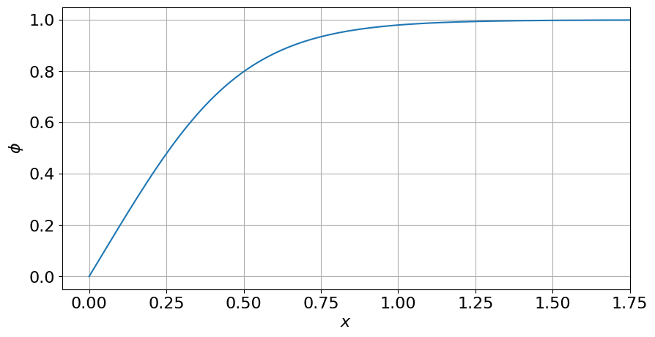

Figure 1. Solution  for planar case for , .

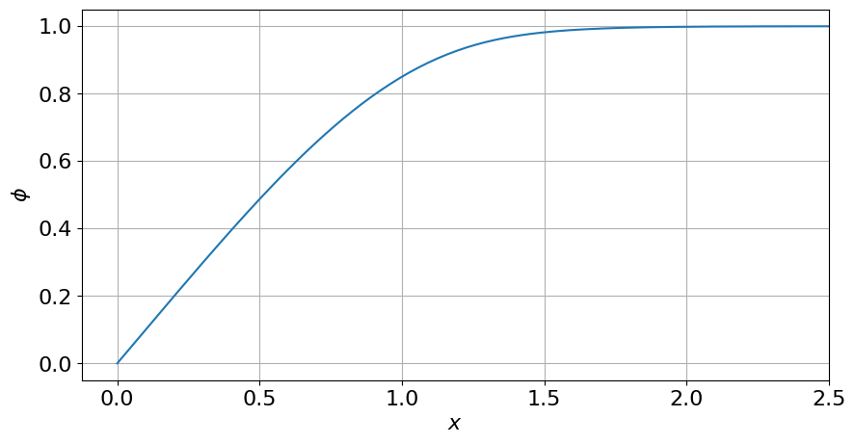

Figure 2. Solution  for planar case for , .

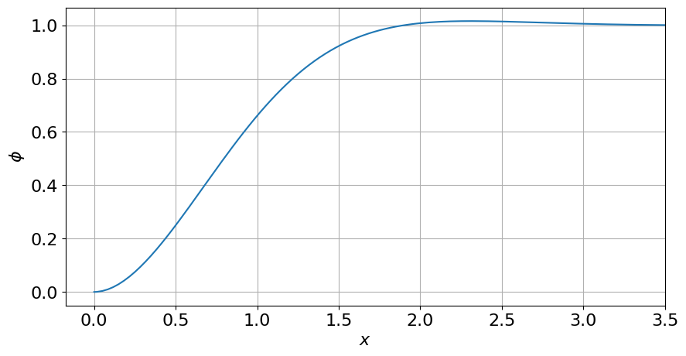

Figure 3. Solution  for planar case for , .

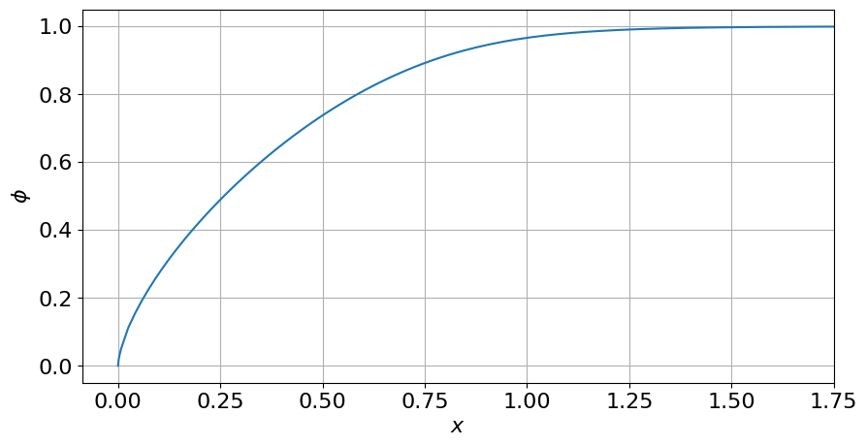

Figure 4. Solution  for axisymmetric case for , .

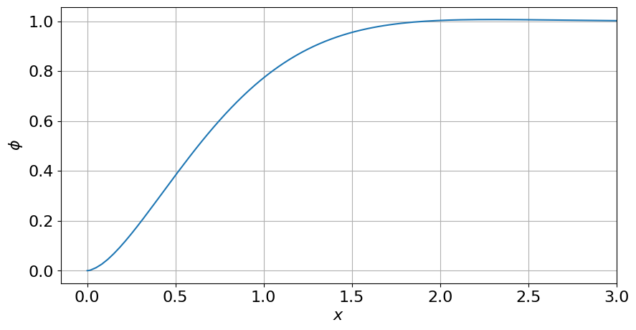

Figure 5. Solution  for axisymmetric case for , .

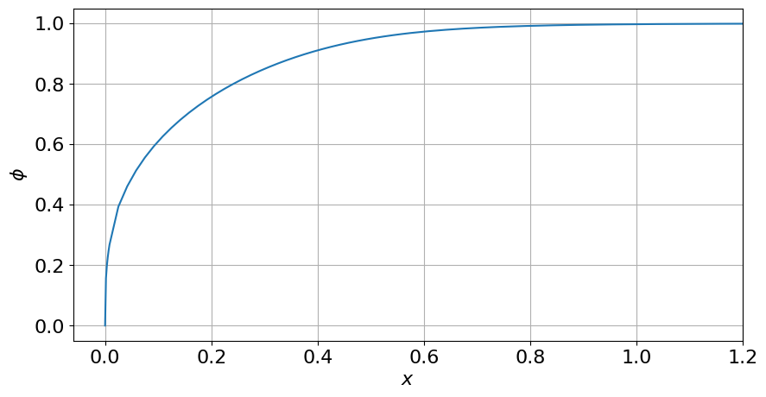

Figure 6. Solution  for spherically symmetric case for , .

Note that if the bi-Laplacian operator enters the equation (i.e., ), the solution can be non-monotone and, at some points, can achieve values grater than 1, see Figs. 3 and 5). Such behavior was also noted in [3]; to avoid this, it was suggested to use relatively small values of .

Numerical experiments confirms, that the proposed finite-difference allows for accurate simulation of the solution of the problem even in situations, where it has singular behavior in the vicinity of .

## 5. Conclusions

The present work continues the study started in the article [3]. As noted by its authors, although the study is carried out for a specific problem, it probably touches certain fundamental issues related to the application of the diffuse interface approach in general. The essence of these issues is whether the diffuse interface models in their "classical" version allow one to describe adequately inclusions that are by their nature objects of higher co-dimension. As a possible answer, the authors of the work [3] propose a generalization of the original model.

The aim of this work was to numerically investigate the above-mentioned generalization. Using a modification of the finite volume method, difficulties associated with the need to specify boundary conditions on sets of co-dimensions 2 and 3 in three-dimensional space and with the presence of a singularity in the solution at the points of these sets were overcome. The indicated approach is not essentially tied to the model under consideration — in the future it can be used to analyze other problems.

In some cases among considered, fundamental obstacles arose when constructing a finite-difference scheme: it turned out that the necessary basis functions simply do not exist. Based on this, a hypothesis was put forward that in these cases the differential problem under consideration is posed incorrectly and has no solution. This reasoning is in full agreement with the theoretical results of the work. In fact, while constructing the finite-difference scheme, the singular behavior of the solution was studied. Exactly the same approach can be used in order to study such singularities form theoretical point of view, without any back look to construction of numerical algorithm.

The presented reasoning is quite consistent with the theoretical results of the work [3]. In the future, a rigorous substantiation of the presented hypothesis is possible.

## References

1. Dissado L., Fothergill J. Electrical Degradation and Breakdown in Polymers. — London : Peter Peregrinus, 1992.

2. Pitike K. C., Hong W. Phase-field model for dielectric breakdown in solids // Journal of Applied Physics. — 2014. — Jan. — Vol. 115, no. 4. — P. 044101. — DOI: 10.1063/1.4862929. — URL: https://doi.org/10.1063/1.4862929.

3. Zipunova E., Savenkov E. On the Diffuse Interface Models for High Codimension Dispersed Inclusions // Mathematics. — 2021. — Vol. 9, no. 18. — P. 2026. — DOI: https://doi.org/10.3390/math9182206. — URL: https://doi.org/10.3390/math9182206.

4. Zipunova E., Kuleshov A., Savenkov E. Nonisothermal diffuse interface model for electrical breakdown channel propagation // Sib. Zh. Ind. Mat. — Москва, 2022. — Vol. 25, issue 1. — P. 35–53. — DOI: https://doi.org/10.33048/SIBJIM.2022.25.103. — URL: https://doi.org/10.33048/SIBJIM.2022.25.103.