Лабораторна робота №2

Пономаренко Максим

1)Множення двійкових чисел (a)

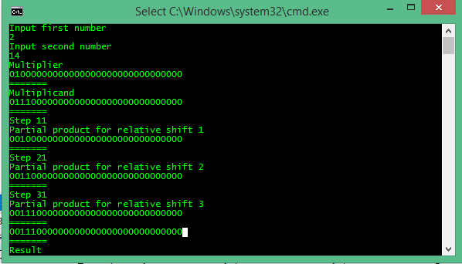

2) Ділення двійкових чисел (b)

Input first number

72

Input second number

8

Initial remainder

00001001000000000000000000000000

=======

remainder-=divisor

00001001000111111111111111111111

=======

remainder<0

00000100100011111111111111111111

=======

00000000000000000000000000000000

=======

+++++++++++++++++++++++++++++++++++++++++

remainder+=divisor

00000100100111111111111111111111

=======

remainder<0

00000010010011111111111111111111

=======

00000000000000000000000000000000

=======

+++++++++++++++++++++++++++++++++++++++++

remainder+=divisor

00000010010111111111111111111111

=======

remainder<0

00000001001011111111111111111111

=======

00000000000000000000000000000000

=======

+++++++++++++++++++++++++++++++++++++++++

remainder+=divisor

00000001001111111111111111111111

=======

remainder<0

00000000100111111111111111111111

=======

00000000000000000000000000000000

=======

+++++++++++++++++++++++++++++++++++++++++

remainder+=divisor

00000000100000000000000000000000

=======

remainder>0

01000000010000000000000000000000

=======

10000000000000000000000000000000

=======

+++++++++++++++++++++++++++++++++++++++++

remainder-=divisor

01000000010111111111111111111111

=======

remainder<0

00100000001011111111111111111111

=======

01000000000000000000000000000000

=======

+++++++++++++++++++++++++++++++++++++++++

remainder+=divisor

00100000001111111111111111111111

=======

remainder<0

00010000000111111111111111111111

=======

00100000000000000000000000000000

=======

+++++++++++++++++++++++++++++++++++++++++

remainder+=divisor

00010000000000000000000000000000

=======

remainder>0

01001000000000000000000000000000

=======

10010000000000000000000000000000

=======

+++++++++++++++++++++++++++++++++++++++++

10010000000000000000000000000000

=======

Result

3) Робота з IEEE 754 Floating Point (a)

Input first number

5

Input second number

2.5

Left operand

00000000000000000000010100000010

=======

Right operand

00000000000000000000010000000010

=======

Exponent

10000001

=======

00000001

=======

Mantisa

000000000000000000000101

=======

000000000000000000000101

=======

Alignment Step

000000000000000000000101

=======

000000000000000000001010

=======

Result mantisa

000000000000000000001111

=======

Result exponent

10000001

=======

Result

00000000000000000000111100000010

Висновок: У цій лабораторній роботі було досліджено алгоритми, що використовуються в мікропроцесорах для множення та ділення цілих чисел та підходи до роботи з дійсними числами.