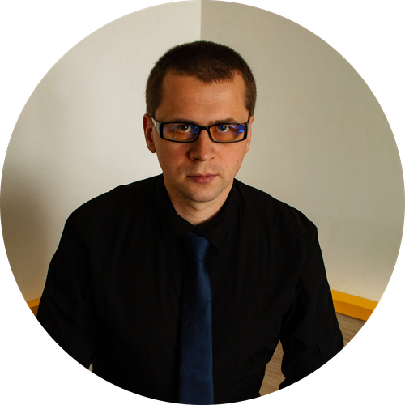

Serhii Ponomarov
Tel : +420 792 734 819
mail : serhiiponomarovs87@gmail.com
GitHub: ponomarovs87
Telegram: @Sergey_Ponomarov_Work
LinkedIn: Serhii Ponomarov
IT Administration & Development  ㅡ  Education :  Kharkiv National University of Radio Electronics (KhNURE)  Bachelor’s Degree in Radio Engineering  Kharkiv, Ukraine  ㅡ  Location :  Brno, Czech republic |  Relocate in Czech republic |  Remote  ㅡ  Languages :  English - B1  Czech - B2  Russian - Native  Ukrainian - Native  ㅡ  Portfolio links :  Vokal Studio  Photographer | Experience :  Freelance / Personal IT Administration & Development  2019 - PRESENT  • Administer and maintain Linux servers (Ubuntu/Debian) in real-world scenarios.  • Configure and manage VPN infrastructure (OpenVPN) with secure traffic routing over port 443 and encrypted connections.  • Strong knowledge of networking (TCP/IP, DNS, DHCP, VPN, routing, port forwarding).  • Design, deploy and maintain web applications (JavaScript, Node.js).  • Administer and monitor web services and websites (deployment, uptime, updates).  • Write automation scripts using Python and Bash to optimize system and server tasks.  • Configure and troubleshoot network connections, LAN infrastructure and connectivity issues.  • Experience with system diagnostics, performance monitoring, and problem resolution.  • Build automation tools and bots for various tasks.  Stoba Precizní Technika s.r.o. / Technical Operator  Jan 2024 - PRESENT, Brno  • Work in a high-responsibility technical environment requiring precision, reliability, and problem-solving.  • Monitor and maintain stable operation of production systems and equipment.  • Quickly identify and resolve technical issues to minimize downtime.  • Follow strict operational and quality standards.  AW Tools International s.r.o. / Technical Operator – Programmer  Mar 2021 - Dec 2023, Brno ( 2 years 9 months )  • Developed Python scripts to automate workflows and improve efficiency.  • Worked with technical systems requiring configuration, adjustment, and troubleshooting.  • Analyzed processes and implemented optimizations.  • Collaborated with team members to improve system reliability and performance.  TechnoPrecision / Technical Operator  Jan 2019 - Apr 2021, Kharkiv ( 2 years 4 months )  • Worked with complex technical systems and equipment.  • Diagnosed and resolved technical issues.  • Maintained stable operation of machinery and processes.  Technical Support / Device Repair  Before 2019  • Diagnosed and repaired computers, laptops, mobile devices.  • Performed firmware updates, system recovery, and troubleshooting.  • Worked with hardware components and system-level issues.

Resume version 04-26 for download this in eng : link | cz: link

