**Mortgage Calculator screen**

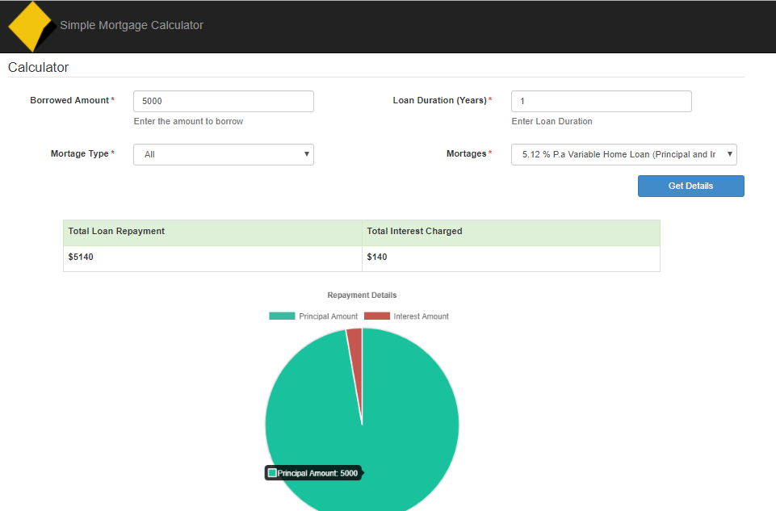

* Listed the Active Mortgages in the mortgage combo box.
* Mortgage Type is populated in the Mortgage Type combo box.
* Four fields are mandatory in the screen.
* After feeds the mandatory inputs click the Get Details button to get the repayment details.
* Results are shown as the Table and Pie Chart.

**Coding Changes**

**1**. **MortgageCalculator.Web Project**

* Added two cdn url for jquery library (Layout.cshml page).
* BlockUI library used to block the page when asynchronous action progressing in the page.
* Chart library used to create the pie chart.
* UI, Calculation, Validations are done in the index page(Index.cshtml) .
* REST Services are calling from the jquery by ajax.

**2. MortgageCalculator.Api Project**

* Done a minor bug fix on **GetAllMortgages** method in the service
* Caching implemented in the **MortgageController** methods
* Added a Custom header **Access-Control-Allow-Origin** in the web.config file for enable **CORS**

3. **MortgageCalculator.UnitTests Project**

* Added a Class to test the Web API REST service (HttpResponseTests.cs), Tested the below responses

1. GetResponseIsSuccess – Test the response of the REST Service method.
2. GetResponseContentNotNullCheck – Test the Response content of the REST service method.
3. GetResponseIsJson – Test the Response type of the REST service method.
4. ValidateCaching – Test the Response cache of the REST service method.