ICOTrial GraphQL Hybrid API Architecture Proposal
Architecture Team Discussion Draft
Version 1.0 | September 2026
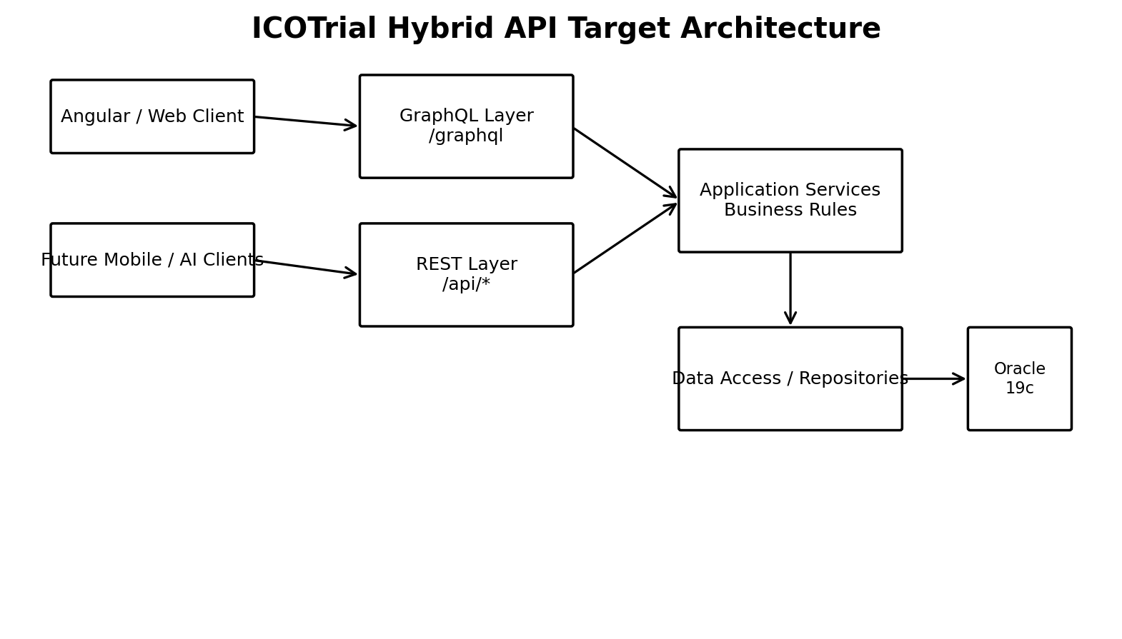

1. Executive Summary
This proposal recommends evaluating GraphQL as an additional API layer for ICOTrial rather than replacing the existing REST/.NET API estate. The proposed model is hybrid: retain REST for established integrations, file operations, exports, webhooks and simple resource APIs, while introducing GraphQL for complex, relationship-oriented UI queries where the client currently needs multiple API calls or receives more data than it requires.
The proposal is intentionally incremental. A focused proof of concept (PoC) should use one representative ICOTrial read-heavy screen, measure network calls, payload size, server execution time, Oracle query time, security behavior and development effort, and only then decide whether wider adoption is justified.

2. Decision Requested
The Architecture Team is asked to approve a time-boxed GraphQL PoC with the following boundaries:
- No retirement of existing ICOTrial REST endpoints during the PoC.
- No duplicate business rules: GraphQL and REST must call the same application/business services.
- GraphQL initially limited to complex read/composition scenarios.
- Authentication and authorization must reuse the established enterprise identity model and business authorization rules.
- Production guardrails—query depth/complexity, pagination, batching, limits and observability—must be included in the PoC.
- The PoC must produce quantitative REST-versus-GraphQL measurements before a broader adoption decision.

3. Why GraphQL is Relevant
GraphQL is an open-source query language and server-side runtime for APIs. Its schema is strongly typed, and clients can request the fields and relationships they need. The GraphQL project states that it is not tied to a particular database or storage engine and can work with existing code and data.
Facebook/Meta created GraphQL in 2012 for its mobile applications and began open-sourcing it in 2015. Facebook's engineering explanation specifically describes GraphQL as hierarchical, strongly typed, and able to sit on top of existing business logic and storage.
For ICOTrial, the relevant architectural benefit is therefore not 'GraphQL is faster than REST' as a blanket statement. The relevant hypothesis is that a client can obtain a complex, related data shape through one logical GraphQL operation while the server continues to use existing .NET business logic and Oracle data access.

4. ICOTrial Current-State Assumption
This proposal uses ICOTrial as the working example and assumes the current application pattern includes an Angular client, .NET backend services/APIs and Oracle data access. The document does not assume that every existing endpoint should move to GraphQL. Existing APIs and integrations remain valid.

5. Proposed Hybrid Architecture
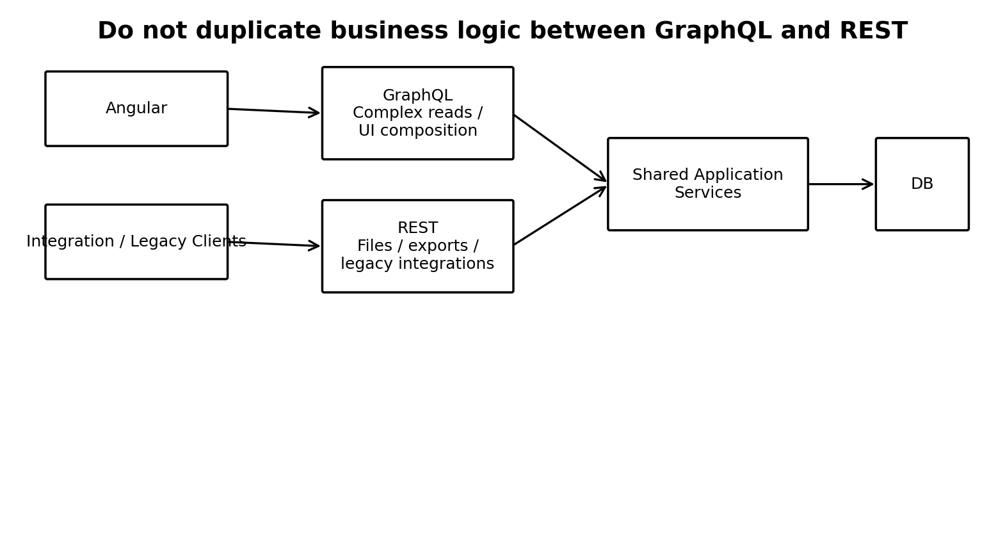
The key architectural boundary is the shared application-service layer. GraphQL should not call REST merely to reuse business logic when both interfaces can call the same service layer directly. This avoids an unnecessary internal HTTP hop and prevents the GraphQL layer from becoming a second business-logic implementation.

6. ICOTrial Example: Trip Report Read Scenario
Consider a Trip Report screen that needs Trip Report, Study, Site, Investigator, Visit and Subject information. In a resource-oriented REST model, the UI may need several calls or a purpose-built aggregation endpoint. With GraphQL, the UI can request the required shape explicitly.
query {
tripReport(id: 1001) {
id
status
study { id name }
site { id name }
investigator { id name }
visits {
id
visitDate
status
}
}
}
This query is illustrative only. The actual ICOTrial GraphQL schema should be derived from approved domain terminology and existing authorization rules, not copied directly from this example.
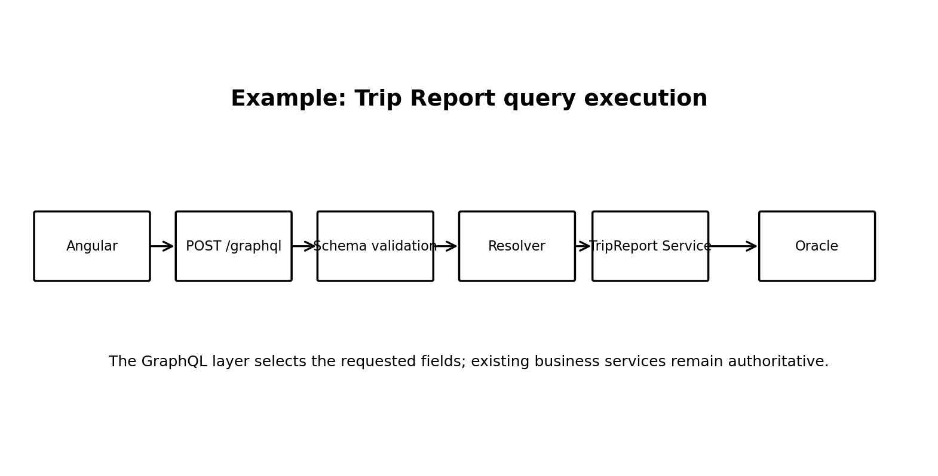

7. REST and GraphQL Responsibilities
Scenario | Recommended interface | Reason
Complex Angular data composition | GraphQL | Client can select related fields and reduce endpoint choreography.
Simple CRUD/resource access | REST | Simple, explicit and already familiar.
File upload/download and streaming | REST | HTTP resource/stream semantics are straightforward.
Exports / long-running downloads | REST | Operationally clear and easy to integrate.
External webhooks/integrations | REST | Established integration pattern.
Legacy consumers | REST | Avoid breaking existing contracts.
Complex read models / dashboards | GraphQL | Flexible field selection and nested relationships.
Complex mutations | GraphQL or REST | Choose per domain operation; business rules remain shared.

8. Server-Side Design
The GraphQL server should be treated as an API/presentation layer. A resolver maps a GraphQL field to application services. The application service remains responsible for business rules, validation and authorization decisions that belong to the domain.
- GraphQL Schema: defines types, queries and mutations exposed to clients.
- Resolver: translates a GraphQL field request into an application-service operation.
- Application Service: remains the authoritative business operation.
- Repository/Data Access: retrieves and persists data using existing approved mechanisms.
- Oracle: remains the system of record where it is currently authoritative.

9. Authentication and Authorization
GraphQL does not require a separate authentication model. The proposed design is to reuse ICOTrial's enterprise authentication/token validation and propagate the authenticated identity and claims into GraphQL execution.
Authorization should be enforced at more than one layer where appropriate: endpoint-level authentication, GraphQL operation/field authorization, and—most importantly for domain-sensitive data—existing business authorization rules. A user being able to query a field must not be interpreted as permission to access every record represented by that field.
Example flow:
Angular → JWT/SSO → /graphql → Authentication → Claims/Permissions → Resolver → Application Service → Record-level authorization → Oracle

10. GraphQL Performance Considerations
The proposal should avoid claiming that GraphQL is intrinsically faster than REST. GraphQL can reduce client round trips and payload over-fetching, but server execution can become expensive if clients are allowed to issue deep or broad queries.
- Query depth limits to prevent excessively nested requests.
- Query complexity/cost limits to control expensive operations.
- Pagination for collections.
- DataLoader/batching to reduce N+1 data-access patterns.
- Server-side timeouts and maximum result sizes.
- Caching where semantics permit.
- Oracle query tuning and execution-time monitoring.
- Per-operation metrics: query name, duration, resolver duration, database duration and error rate.
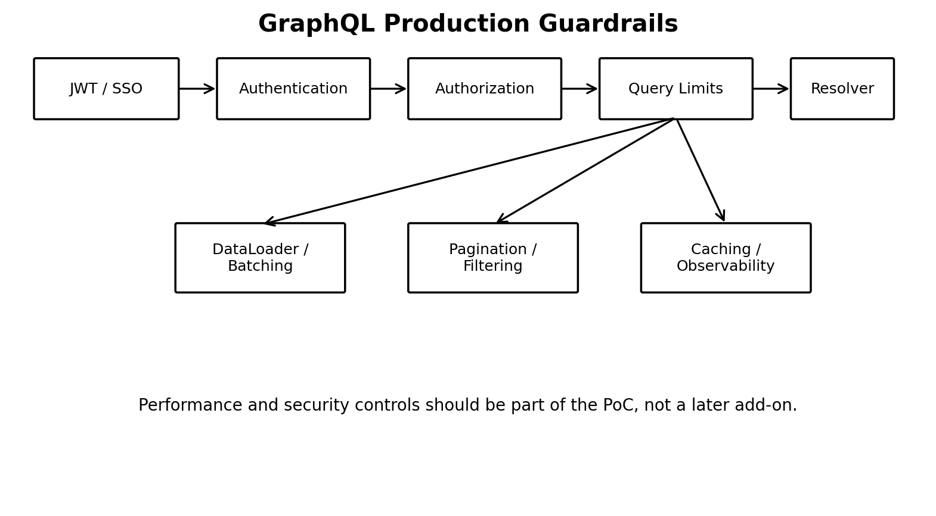

11. One Endpoint Does Not Mean One Database Call
The proposed GraphQL endpoint would normally be /graphql. Multiple queries and mutations are sent to that endpoint. However, one HTTP request does not imply one Oracle query. The GraphQL execution plan may invoke multiple resolvers/services and therefore multiple data-access operations. This is why batching, pagination and query-cost controls are essential.

12. ICOTrial .NET Framework Compatibility Consideration
A critical PoC decision is the runtime hosting model. ICOTrial's current backend context is based on .NET Framework 4.7.2. Current Microsoft guidance continues to list .NET Framework 4.7.2 as supported, while current .NET releases are the recommended platform for new development.
There are two viable evaluation paths to investigate:
- Path A — GraphQL hosted in the existing application/runtime if the selected GraphQL implementation and version are compatible with the application's framework and operational constraints.
- Path B — A separate GraphQL facade/gateway service hosted on a current supported .NET runtime, calling shared application services or approved internal APIs. This may reduce modernization coupling but introduces an additional deployment boundary.
- The selected framework/version must be validated against ICOTrial's security, deployment, support, dependency and operational requirements before architecture approval.
GraphQL.NET documents an ASP.NET Core server and also documents legacy ASP.NET Core/.NET Framework hosting scenarios; however, current framework compatibility should be checked against the exact version selected for the PoC rather than assuming that an older package is equivalent to the current platform.

13. Recommended .NET Technology for the PoC
For a modern .NET-based PoC, Hot Chocolate is one candidate GraphQL server. Its documentation describes code-first and schema-first approaches and ASP.NET Core integration, including the default /graphql endpoint. GraphQL.NET is another established open-source option. The architecture team should select the framework after checking support lifecycle, compatibility with the chosen runtime, security controls, observability, team skills and licensing.
Recommendation for the PoC: evaluate at least one current supported .NET GraphQL implementation and record the exact package/runtime versions in the PoC decision record.

14. Companies Using GraphQL in Production
The following are documented examples, included to demonstrate industry adoption rather than to imply that ICOTrial should copy their architecture.
Company | Documented GraphQL usage | Relevance to ICOTrial
Meta / Facebook | GraphQL was created at Facebook in 2012 for mobile applications and open-sourced in 2015. Meta described GraphQL as hierarchical, strongly typed and able to use existing business logic and storage. | Demonstrates the original motivation: client-driven data requirements and hierarchical data.
GitHub | GitHub announced its GraphQL API in 2016 and provides a public GraphQL API alongside its platform. | Demonstrates GraphQL for a large developer-facing API and complex relationships.
Shopify | Shopify states that GraphQL is its technology of choice for APIs; its current Admin API documentation centers on GraphQL, with the REST Admin API described as legacy from October 1, 2024. | Demonstrates GraphQL as a primary API strategy at large scale.
Expedia Group | Expedia Group describes using Apollo/GraphQL to modernize legacy REST infrastructure and create a cross-brand graph across many travel brands and sites. | Relevant to hybrid/modernization thinking and multiple backend domains.
Airbnb | Airbnb describes Viaduct as a multi-tenant GraphQL server used to compose schemas and resolvers across independent teams and data sources; Airbnb open-sourced the rebuilt Viaduct in 2025. | Demonstrates GraphQL as an internal platform/federated architecture pattern.

15. Proposed ICOTrial PoC Scope
Step | PoC activity | Outcome
1 | Select one complex read-heavy Angular screen | Prefer a screen requiring multiple related REST calls.
2 | Document current REST behavior | Capture endpoints, payload sizes, calls per screen, server time and Oracle time.
3 | Design a small GraphQL schema | Expose only the fields needed by the selected screen.
4 | Implement GraphQL resolver layer | Call existing ICOTrial application services; do not duplicate business logic.
5 | Implement security controls | Reuse authentication and enforce authorization.
6 | Implement performance guardrails | Pagination, query depth/cost limits, batching and timeouts.
7 | Run comparative tests | Use realistic user journeys and representative data volumes.
8 | Evaluate developer experience | Measure implementation effort, schema evolution and Angular integration.
9 | Architecture review | Document benefits, limitations, risks and operational requirements.
10 | Go/no-go decision | Decide whether GraphQL should expand to additional ICOTrial domains.

16. PoC Success Metrics
- Reduction in client HTTP requests for the selected user journey.
- Reduction in response payload bytes where over-fetching exists.
- End-to-end screen response time under representative load.
- GraphQL resolver execution time.
- Oracle execution time and number of database calls.
- CPU and memory impact on the API tier.
- Error rate and timeout rate.
- Security test results, including unauthorized field/record access attempts.
- Developer effort to add a new field or UI requirement.
- Operational effort: logging, tracing, monitoring and troubleshooting.

17. Risks and Mitigations
Risk | Impact | Mitigation
N+1 database access | Performance degradation | DataLoader/batching, query profiling and integration tests.
Unbounded nested queries | CPU/DB load | Depth and complexity limits, pagination, timeouts.
Authorization gaps | Data exposure | Reuse identity and business authorization; field and record-level tests.
Duplicate business logic | Behavior divergence | GraphQL and REST call shared application services.
Framework/runtime mismatch | Deployment/support risk | Validate exact GraphQL package/runtime compatibility before PoC.
Schema sprawl | Governance difficulty | Domain ownership, naming standards, deprecation policy and schema review.
Operational visibility | Troubleshooting difficulty | Structured query/resolver metrics and distributed tracing.

18. Proposed Governance
- GraphQL schema changes go through the same architecture/code-review process as API changes.
- Every field has a documented owner and authorization expectation.
- Breaking changes are avoided; deprecated fields have a defined retirement process.
- Queries have documented cost expectations for high-volume domains.
- Production GraphQL traffic is observable by operation name and resolver.
- Sensitive fields require explicit authorization review.
- GraphQL should not expose arbitrary database entities merely because they exist in Oracle.

19. Target Evolution
If the PoC is successful, adoption should proceed domain-by-domain. The target is not 'all REST becomes GraphQL'. The target is a governed hybrid API platform in which each interface is chosen based on the consumer and operation.
Possible future state: Angular and selected future clients use GraphQL for complex data composition; existing integrations and resource-oriented operations continue to use REST; both converge on the same application/business layer and data-access standards.

20. Architecture Recommendation for Discussion
Proceed with a limited GraphQL PoC for ICOTrial, using a hybrid model and a representative complex read scenario. Do not approve a broad migration until the PoC demonstrates measurable value without unacceptable performance, security, operational or framework risk.
The proposal should therefore be treated as an architectural hypothesis to validate, not as a predetermined replacement of the existing ICOTrial API strategy.

21. External References
- GraphQL official site: https://graphql.org/
- Meta Engineering — GraphQL: A data query language: https://engineering.fb.com/2015/09/14/core-infra/graphql-a-data-query-language/
- GitHub Blog — The GitHub GraphQL API: https://github.blog/developer-skills/github/the-github-graphql-api/
- Shopify — About GraphQL: https://shopify.dev/docs/apps/build/graphql
- Shopify GraphQL Design Tutorial: https://github.com/Shopify/graphql-design-tutorial
- Expedia Group + Apollo GraphQL: https://www.apollographql.com/customers/expediagroup
- Airbnb Viaduct: https://viaduct.airbnb.tech/about/
- Hot Chocolate documentation — endpoints: https://chillicream.com/docs/hotchocolate/server/endpoints
- Hot Chocolate / .NET introduction: https://www.apollographql.com/tutorials/intro-hotchocolate/03-hot-chocolate
- GraphQL.NET ASP.NET Core server: https://github.com/graphql-dotnet/server
- Microsoft .NET Framework support policy: https://dotnet.microsoft.com/en-us/platform/support/policy/dotnet-framework

Appendix A — Example GraphQL Schema for ICOTrial PoC
type Query {
tripReport(id: ID!): TripReport
}
type TripReport {
id: ID!
status: String!
study: Study
site: Site
investigator: Investigator
visits: [Visit!]!
}
type Study {
id: ID!
name: String!
}
type Site {
id: ID!
name: String!
}
type Investigator {
id: ID!
name: String!
}
type Visit {
id: ID!
visitDate: String!
status: String!
}

Appendix B — Hybrid Endpoint Example
GET/POST /api/... Existing REST APIs
POST /graphql GraphQL queries/mutations
GET /api/files/... File download/streaming
POST /api/files/... File upload
POST /api/webhooks/... External callbacks

Appendix C — Key Architecture Questions for Review
- Which ICOTrial screen is the best candidate for the PoC?
- Can the selected GraphQL implementation be hosted within the current runtime, or should a separate modern .NET service be used?
- Which existing application services can be reused directly?
- What authentication/token mechanism must GraphQL reuse?
- What record-level authorization rules apply to the selected domain?
- What are acceptable query depth, complexity and response-size limits?
- What Oracle query patterns are expected for the selected GraphQL fields?
- What monitoring and audit information is required for GraphQL operations?
- Which REST APIs are explicitly out of scope for migration?

