ICOTrial Offline Trip Report
IndexedDB-Based Complete Architecture & Implementation Approach
Version 1.0 | 18 September 2026
Standalone design document — no attached document used as a reference

1. Executive Summary
This document proposes an offline-first architecture for the ICOTrial Trip Report workflow using browser IndexedDB. The goal is to allow an authorized user to work on an eligible Trip Report when the network is unavailable, persist changes locally, and synchronize those changes with ICOTrial when connectivity returns.
IndexedDB is used as local durable storage for Trip Reports, approved Master Data, synchronization metadata, a pending-operation queue and optionally attachments. It is not treated as the system of record. The ICOTrial server remains authoritative.
The design separates application versioning, IndexedDB schema versioning, Master Data synchronization versioning and Trip Report server revisioning. This separation makes application upgrades, Master Data refresh and offline conflict handling independently manageable.

2. Goals and Non-Goals

2.1 Goals
- Provide local-first Trip Report editing.
- Allow saved drafts to survive normal browser restarts.
- Synchronize pending changes automatically when the service is reachable.
- Keep required Master Data current through versioned incremental synchronization.
- Prevent duplicate server updates through idempotency.
- Detect concurrent edits using optimistic concurrency.
- Provide explicit offline, pending, synced, conflict and failure states.
- Support recovery after missing or recreated IndexedDB storage.

2.2 Non-Goals
- This document does not define the exact existing ICOTrial Trip Report business schema.
- It does not assume any current ICOTrial API endpoint names.
- It does not define final compliance retention periods.
- It does not mandate a specific IndexedDB library; Dexie, idb or native IndexedDB may be evaluated.
- It does not assume that any attached document, existing synchronization solution or existing database mechanism is part of this design.

3. Design Principles
Principle | Design Rule
Server authoritative | Server remains the source of truth.
Local-first | User saves go to IndexedDB before waiting for network synchronization.
Deterministic sync | Use server-generated ordered change identifiers for Master Data.
Idempotent operations | Every local operation has a unique operationId.
Optimistic concurrency | Trip Report updates carry the server revision they were based on.
Explicit state | Never silently hide pending, failed or conflicted work.
Recoverable | Support full bootstrap when local data/checkpoints are unavailable.
Minimal offline data | Cache only what is required for the approved workflow.
Auditable | Correlate local operations with server-side processing.

4. Target Architecture
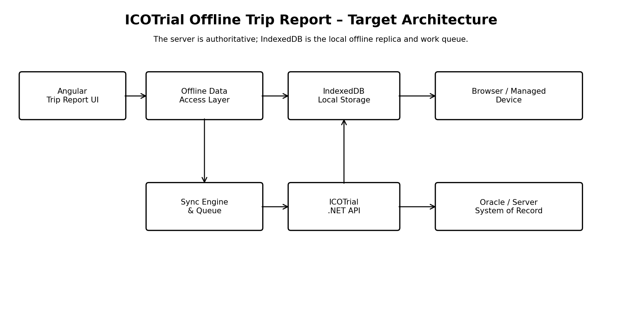
Figure 1 – Target architecture
Component | Responsibilities
Angular Trip Report UI | Rendering, user interaction, validation and synchronization status.
Offline Data Access Layer | Repository abstraction over IndexedDB.
IndexedDB | Local Trip Report data, Master Data, sync metadata, queue and optional attachments.
Sync Engine | Connectivity-aware queue processing, retry, acknowledgement and checkpoint management.
ICOTrial .NET API | Authentication, authorization, validation, concurrency, idempotency and persistence.
Oracle / Server | Authoritative business data and server-side audit.

5. Trip Report Offline Lifecycle
- User signs in while online.
- Application checks IndexedDB schema version and runs migrations if required.
- Application checks Master Data freshness.
- Application performs incremental Master Data synchronization or a full bootstrap.
- Application downloads the approved offline package for the Trip Report.
- User opens and edits the Trip Report.
- Each save commits locally to IndexedDB.
- Each material local change is represented by a syncQueue operation.
- Application indicates whether the report is locally saved and whether it is synchronized.
- When API connectivity is available, Sync Engine submits pending operations.
- Server validates and commits the operation.
- Server returns an acknowledgement and resulting server revision.
- Client marks the operation SYNCED only after acknowledgement.
- After submission/approval, local data is retained or removed according to the approved policy.

6. IndexedDB Data Model
Object Store | Key / Index | Purpose
tripReports | tripReportId; status; updatedAt | Trip Report aggregate and local state.
tripReportSections | tripReportId + sectionId | Optional normalized section records.
masterData | entityType + entityId | Offline reference/master records.
syncQueue | operationId; status; createdAt | Pending synchronization operations.
syncMetadata | key | Schema version, Master Data checkpoint, last sync time and state.
attachments | attachmentId; tripReportId | Optional offline attachment metadata/blob.
auditLocal | auditId; operationId | Optional local correlation events.

6.1 Transaction Boundary
The preferred local save transaction updates the Trip Report and creates/updates the corresponding syncQueue entry together. If the transaction fails, the application must not report the operation as locally saved.

7. Master Data Versioning
Master Data requires a reliable freshness mechanism. The recommended approach is a server-generated, monotonically increasing global Change ID. The client persists its last successfully applied Change ID.
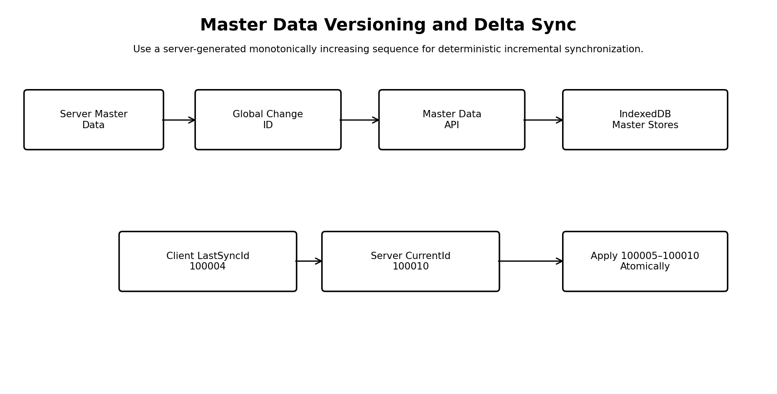
Figure 2 – Master Data versioning and delta synchronization
Field | Description
ChangeId | Ordered server-side change sequence.
EntityType | Type of Master Data record.
EntityId | Stable record identifier.
Operation | INSERT / UPDATE / DELETE.
EntityVersion | Optional per-record revision.
ChangedAt | Server timestamp.
Payload / reference | Changed data or a mechanism to retrieve it.

7.1 Incremental Sync Algorithm
- Read client lastSyncChangeId.
- Call server synchronization endpoint with the checkpoint.
- Server returns all changes after the checkpoint within a defined batch.
- Apply INSERT, UPDATE and DELETE changes transactionally to IndexedDB.
- Validate the batch.
- Advance lastSyncChangeId only after successful local commit.
- Repeat until the server checkpoint is reached.

7.2 Full Sync Conditions
- First installation or no local database.
- Required object stores/indexes are missing.
- Client checkpoint is outside the server's available change history.
- Local integrity validation fails.
- Application detects an incompatible data version.

7.3 Delete Handling
Deletion must be represented explicitly through DELETE changes or tombstones. Otherwise a client cannot distinguish a deleted record from a record that was simply omitted from a response.

8. Trip Report Versioning and Conflict Detection
Master Data Change ID and Trip Report server revision solve different problems. A Trip Report should contain a serverRevision or equivalent concurrency token. The client sends the revision it last observed when submitting an update.
Scenario | Expected behavior
Base revision matches server | Apply update and return new revision.
Base revision differs | Return conflict; do not silently overwrite.
Same operationId already processed | Return original result; no duplicate update.
Report locked/submitted | Reject or route through approved business workflow.
Master Data referenced by report is retired | Apply approved business rule and notify user if required.

9. Offline / Online Synchronization
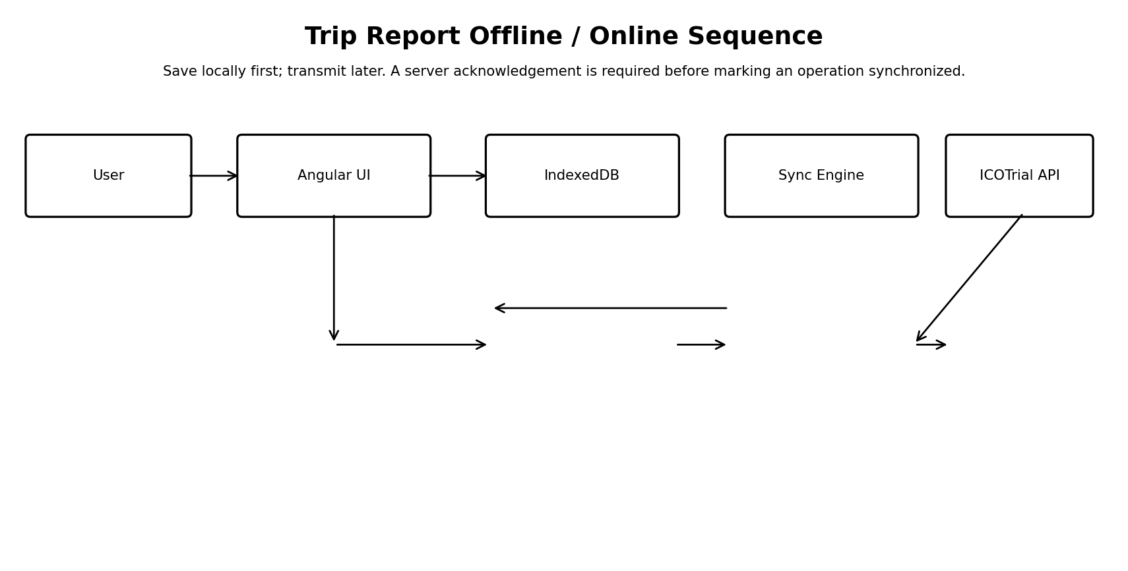
Figure 3 – Trip Report synchronization sequence

9.1 Local Save
The user experience should not require an online round trip for every keystroke or save. The application persists the current report state locally and records the pending operation. The UI can then show 'Saved locally – Pending sync'.

9.2 Queue States
State | Meaning
PENDING | Waiting to be transmitted.
IN_PROGRESS | Currently being processed.
RETRY | Temporary failure; eligible for retry.
FAILED | Permanent/business failure.
CONFLICT | Concurrency check failed.
SYNCED | Server acknowledged successful processing.
CANCELLED | Superseded/removed under an approved rule.

10. API Approach
Proposed API | Purpose
GET /api/masterdata/sync-info | Return current server Change ID.
GET /api/masterdata/changes?fromChangeId={id} | Return Master Data delta.
GET /api/tripreports/{id}/offline-package | Return approved Trip Report context.
POST /api/tripreports/sync | Submit idempotent operations.
GET /api/sync/status/{operationId} | Recover uncertain operation status.
POST /api/tripreports/{id}/attachments | Upload approved attachments.
These are proposed logical contracts for architecture discussion, not claims about current ICOTrial API names.

11. Idempotency Design
Each synchronization operation receives a client-generated unique operationId. The server must persist or otherwise recognize processed operation IDs. This is essential when the server commits successfully but the network response is lost.
Example: operationId = "OP-20260918-8F7"; entityId = "TR12345"; operation = "UPDATE"; baseRevision = 7
If the client retries the same operationId, the server should return the original processing result rather than creating a second update.

12. Failure, Retry and Recovery
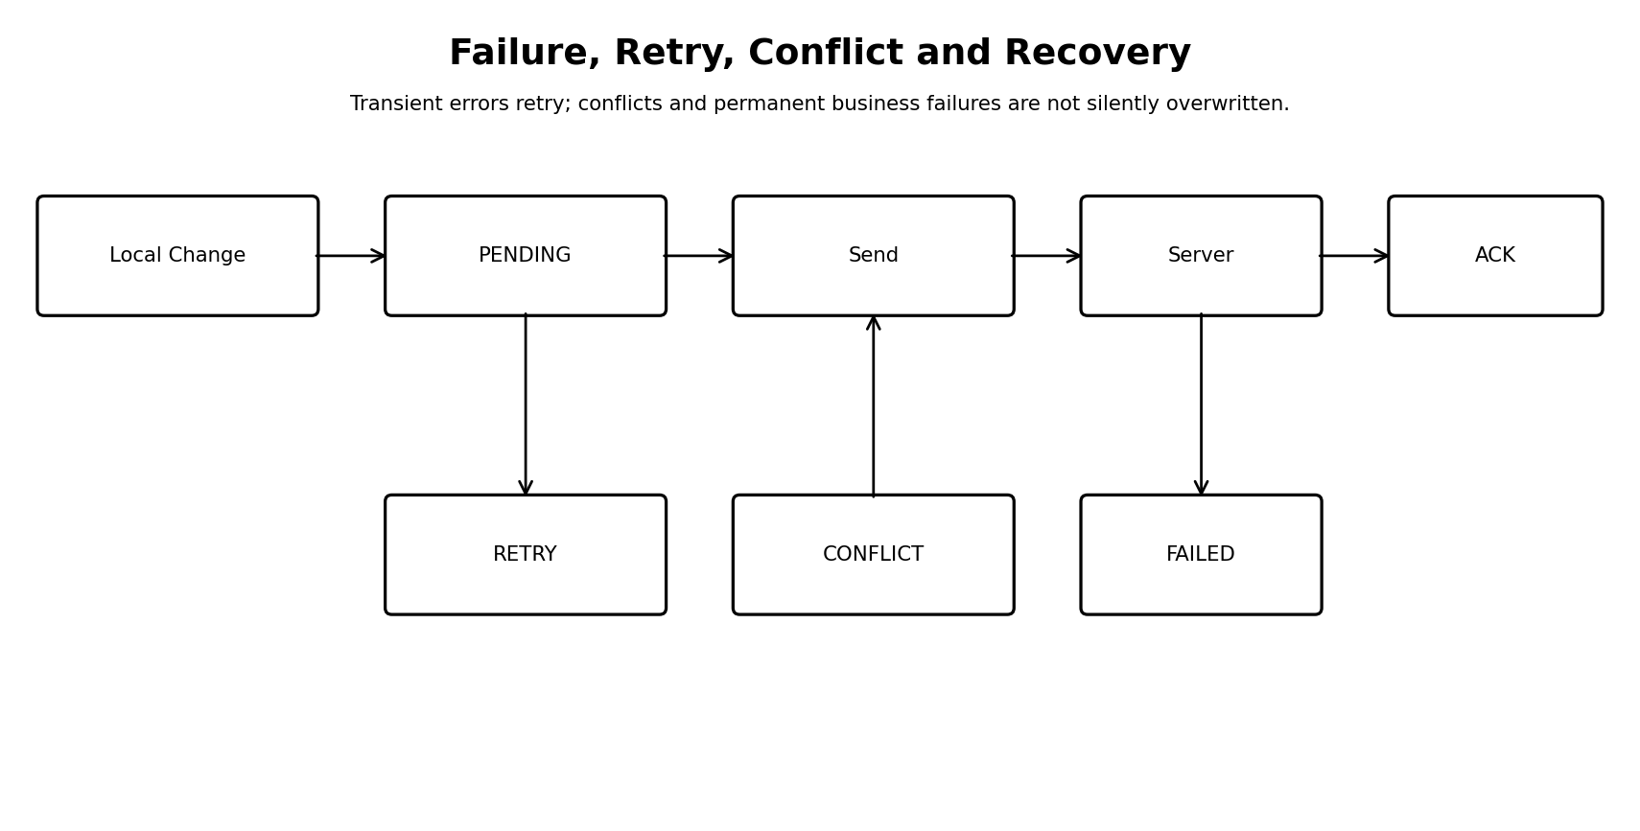
Figure 4 – Failure, retry, conflict and recovery
Failure | Handling
Offline | Keep changes local and pending.
Timeout / 5xx | Retry with bounded exponential backoff and jitter.
401 / 403 | Pause sync and execute approved authentication recovery.
409 / conflict | Mark CONFLICT and require defined resolution.
4xx business validation | Mark FAILED and present actionable information.
Response lost after commit | Retry same operationId; rely on idempotency.
IndexedDB unavailable | Do not enter offline editing mode; show controlled recovery.
IndexedDB cleared | Perform full bootstrap. Unsynchronized local-only data cannot be reconstructed unless another recovery mechanism exists.

12.1 Illustrative Retry Policy
Attempt | Delay
1 | Immediate
2 | 1 minute
3 | 5 minutes
4 | 15 minutes
5 | 30 minutes
After maximum | Pause, alert and require recovery/action

13. Connectivity Detection
navigator.onLine is only an indication that the browser has network connectivity. It does not prove that the ICOTrial API is reachable or that the user is authorized. The Sync Engine should perform an application-level connectivity/authentication check.
State | Meaning
OFFLINE | Service cannot currently be reached.
ONLINE_UNVERIFIED | Network appears available but API not verified.
ONLINE_AUTHENTICATED | API reachable and session authorized.
SYNCING | Pending operations being processed.
SYNCED | No pending work for the selected scope.

14. Security and Privacy
- Treat IndexedDB as sensitive local application storage.
- Do not store passwords or unnecessary long-lived secrets in the database.
- Use HTTPS/TLS for all network communication.
- Minimize locally stored data to the approved offline package.
- Define offline authentication/session expiry explicitly.
- Define sign-out behavior when pending changes exist.
- Evaluate application-layer encryption if required by security/compliance.
- Use device/endpoint controls appropriate to the organization's security model.
- Apply approved local cleanup/retention rules.
- Keep the authoritative audit trail on the server.

15. Audit and Traceability
Attribute | Purpose
operationId | Correlates local change with server processing.
tripReportId | Identifies business record.
actor/session | Identifies user/session context.
clientTimestamp | Time of local action.
serverTimestamp | Authoritative processing time.
baseRevision | Server version edited by client.
resultRevision | Version resulting from server commit.
syncStatus | Processing outcome.

16. Versioning Model
Version Type | Example | Controls
ICOTrial Application Version | 4.2.0 | Application code/release.
IndexedDB Schema Version | 3 | Local database structure and migration.
Master Data Change ID | 100010 | Master Data freshness and delta sync.
Trip Report Server Revision | 8 | Optimistic concurrency.
These values must remain independent. A Master Data change should not require an application release, and an application release should not imply that every Master Data record changed.

17. IndexedDB Schema Migration
- Open IndexedDB at the current schema version.
- Run deterministic upgrade functions for older schemas.
- Create stores and indexes required by the new version.
- Transform existing records explicitly.
- Validate stores and critical indexes.
- Preserve pending operations and user drafts.
- Revalidate Master Data checkpoint after migration.
- If migration fails, enter recovery mode rather than silently deleting data.

18. Attachment Strategy
- Keep attachment metadata separate from the main Trip Report object.
- Generate a checksum to detect duplicates.
- Track attachment upload status independently.
- Consider resumable/controlled upload for large files.
- Apply file type, size and security scanning requirements.
- Do not consider the report fully synchronized while required attachments remain pending.

19. Local Retention and Cleanup
Data | Policy direction
Pending operations | Retain until synchronized or resolved.
Conflicts | Retain until resolved.
Failed operations | Retain until user/support action or approved cleanup.
Synced drafts | Retain only for approved local retention period.
Master Data | Refresh and remove obsolete records through controlled sync.
Attachments | Remove after successful upload and approved retention decision.
Browser storage behavior must not be treated as a business retention mechanism. The product should explicitly manage local cleanup.

20. Performance and Storage
- Index Trip Reports by ID, status and updatedAt.
- Batch Master Data delta changes.
- Commit each sync batch atomically.
- Avoid duplicate large JSON payloads.
- Keep large binaries separate from the core report record.
- Measure offline package size and startup synchronization time.
- Test realistic enterprise browser/device storage conditions.

21. Monitoring and Support
Metric | Purpose
Pending operation count | Detect synchronization backlog.
Oldest pending age | Detect stalled synchronization.
Failure rate | Detect service/data-quality issues.
Conflict count | Identify concurrency/workflow problems.
Master Data lag | Identify stale reference data.
Full-sync frequency | Identify repeated local storage loss or checkpoint problems.
Sync latency | Measure user experience.
Attachment failure rate | Identify file/network issues.

22. Testing Strategy
Test Category | Key Scenarios
Offline | Create/edit/save/reopen after browser restart.
Reconnect | Network drops and returns during sync.
Idempotency | Same operation transmitted repeatedly.
Concurrency | Server changes record while client is offline.
Master Data | INSERT/UPDATE/DELETE and checkpoint recovery.
Full sync | Empty database and invalid/expired checkpoint.
Storage | Site-data clear, storage pressure, missing stores.
Migration | Application upgrade with older IndexedDB schema.
Security | Session expiry, sign-out with pending work, unauthorized access assumptions.
Attachments | Interrupted/duplicate/large upload.
Performance | Large Master Data, large reports and large pending queues.

23. Rollout Plan
- Prototype one Trip Report section with local-first IndexedDB persistence.
- Validate browser restart and offline recovery.
- Implement Master Data versioning and delta synchronization.
- Implement idempotent Trip Report synchronization.
- Add concurrency conflict handling.
- Add operational telemetry.
- Run a controlled pilot.
- Complete security/compliance/performance review.
- Expand to the full Trip Report scope.

24. Risks and Mitigations
Risk | Mitigation
IndexedDB cleared/evicted | Minimize unsynchronized time; provide full bootstrap and clear UI state.
Stale Master Data | Change ID + delta sync + pre-offline freshness check.
Duplicate update | operationId + server idempotency.
Silent overwrite | Optimistic concurrency.
Large offline package | Download only required data.
Session expires | Explicit offline authentication design.
Attachment loss | Separate queue and upload acknowledgement.
Schema incompatibility | IndexedDB schema version and tested migration.
Poor observability | Client/server synchronization telemetry.

25. Recommended Detailed State Model
At the Trip Report level, the UI should expose a simple business-friendly state while retaining detailed technical states internally.
User State | Internal State Examples
Saved locally | DRAFT / PENDING
Syncing | IN_PROGRESS
Synced | SYNCED
Needs attention | FAILED / CONFLICT
Offline | Connectivity state + local report state
Submitted | Server business state; local synchronization must already be complete unless explicitly designed otherwise.

26. Architecture Decisions for Review
Decision | Recommended Baseline
Local storage | IndexedDB
Data access | Repository/service abstraction
Offline model | Local-first
Server authority | ICOTrial server
Master Data sync | Global Change ID + entity version
Trip Report concurrency | Optimistic server revision
Duplicate protection | operationId
Delete handling | Explicit DELETE/tombstone
Recovery | Incremental where possible; full bootstrap otherwise
Retry | Bounded exponential backoff
Audit | Server authoritative
Cleanup | Approved business/security policy

27. Open Questions
- Which Trip Report fields are allowed to exist on the device while offline?
- Which Master Data sets are mandatory offline?
- What is the maximum acceptable Master Data age?
- What is the approved offline authentication duration?
- What should happen on sign-out with pending operations?
- What is the conflict-resolution business workflow?
- Are attachments allowed offline?
- Which browser and browser versions are supported?
- What is the approved local retention period?
- What server/API transaction boundary guarantees the Trip Report and related operations are committed consistently?

28. Conclusion
IndexedDB can provide a strong foundation for an ICOTrial offline Trip Report capability, but the complete solution is a synchronization architecture rather than a storage feature alone. The essential controls are local-first persistence, deterministic Master Data versioning, idempotent server processing, optimistic concurrency, explicit failure states and recovery.
The proposed architecture keeps ICOTrial authoritative while giving users a reliable local working copy. It also establishes clear boundaries between application version, local schema version, Master Data change version and Trip Report server revision. These boundaries should be validated with the ICOTrial application, security, compliance and business teams before implementation.

Appendix A – Illustrative TypeScript Models
interface TripReport {
tripReportId: string;
status: 'DRAFT' | 'PENDING_SYNC' | 'SYNCED' | 'CONFLICT' | 'FAILED';
serverRevision?: number;
masterDataChangeId: number;
payload: unknown;
updatedAt: string;
}
interface SyncOperation {
operationId: string;
entityType: 'TripReport' | 'Attachment';
entityId: string;
operation: 'CREATE' | 'UPDATE' | 'DELETE';
baseServerRevision?: number;
status: 'PENDING' | 'IN_PROGRESS' | 'RETRY' |
'FAILED' | 'CONFLICT' | 'SYNCED';
retryCount: number;
createdAt: string;
lastAttemptAt?: string;
}

Appendix B – Example Master Data Sync Response
{
"fromChangeId": 100004,
"toChangeId": 100010,
"changes": [
{"changeId":100005,"entityType":"SITE","entityId":"S1","operation":"UPDATE"},
{"changeId":100006,"entityType":"VISIT_TYPE","entityId":"V3","operation":"INSERT"},
{"changeId":100007,"entityType":"COUNTRY","entityId":"C7","operation":"DELETE"}
]
}

Appendix C – Implementation Checklist
- ☐ Define offline data classification.
- ☐ Define supported browsers/devices.
- ☐ Define IndexedDB stores and indexes.
- ☐ Define IndexedDB migration versions.
- ☐ Define Master Data Change ID and delta API.
- ☐ Define Trip Report server revision.
- ☐ Define operationId/idempotency contract.
- ☐ Define conflict UX and business rules.
- ☐ Define retry and recovery policy.
- ☐ Define attachment behavior.
- ☐ Define local retention and cleanup.
- ☐ Define audit fields.
- ☐ Define monitoring and support dashboards.
- ☐ Complete security/compliance review.

