ICOTrial AI-Enabled API & Natural-Language Query Architecture
English → Intent → GraphQL / REST → ICOTrial Services → Oracle
Architecture options, security, cost, implementation approach, and diagrams

1. Executive Summary
This document consolidates the proposed approaches discussed for enabling ICOTrial with natural-language AI capabilities and GraphQL. The central idea is to allow an ICOTrial user to ask a question in English, interpret the question using an AI/NLP layer, map it to an approved ICOTrial business intent, and then execute a controlled GraphQL or REST operation through the existing .NET application services and Oracle data layer.
GraphQL is an API query language and server-side execution model with a strongly typed schema. It is not tied to a specific database and can work with existing services and data. citeturn0search2turn0search4
For ICOTrial, the recommended direction is a hybrid architecture rather than replacing every existing REST API. Existing REST APIs can remain for established integrations, file operations, downloads/uploads, exports and simple resource operations, while GraphQL can be introduced for complex, read-heavy and relationship-oriented UI scenarios.

2. Objectives
- Allow business users to express selected ICOTrial queries in natural English.
- Reduce the need for users to understand API syntax or database structures.
- Provide a controlled path from natural language to approved business operations.
- Use GraphQL where flexible, relationship-oriented data retrieval is valuable.
- Retain REST where it is already appropriate or required.
- Reuse ICOTrial authentication, authorization, business rules and existing .NET services.
- Avoid direct AI access to Oracle tables or unrestricted SQL/GraphQL execution.
- Support auditability, monitoring, performance controls and enterprise security.

3. What GraphQL Provides
The GraphQL specification defines GraphQL as a query language and execution engine for describing data requirements and interactions. A GraphQL schema defines the types, fields and relationships exposed by a service, and requests are validated and executed against that schema. citeturn0search1turn0search4
- Client-defined response shape: the caller requests the fields it needs.
- Strongly typed schema: available data and relationships are explicitly defined.
- Nested data retrieval: related entities can be requested in one operation.
- Validation before execution: the query can be checked against the schema.
- GraphQL is not a database: resolvers can call application services, repositories or other backends.
- GraphQL can coexist with REST; it does not require a wholesale replacement.

4. ICOTrial Context and Assumptions
The architecture is designed around the ICOTrial context discussed previously: Angular UI, existing .NET application/services, Oracle 19c, JWT/SSO-based authentication, and existing REST/API integrations. The GraphQL layer is proposed as an additional API capability.
- Angular remains the primary web client.
- The existing .NET business/application service layer remains authoritative for business rules.
- Oracle 19c remains the system of record.
- Authentication should continue to use the enterprise identity mechanism already used by ICOTrial.
- Authorization should be enforced using the authenticated user's claims/roles/permissions and ICOTrial record-level business rules.
- GraphQL should not bypass existing authorization logic.

5. High-Level Recommended Architecture
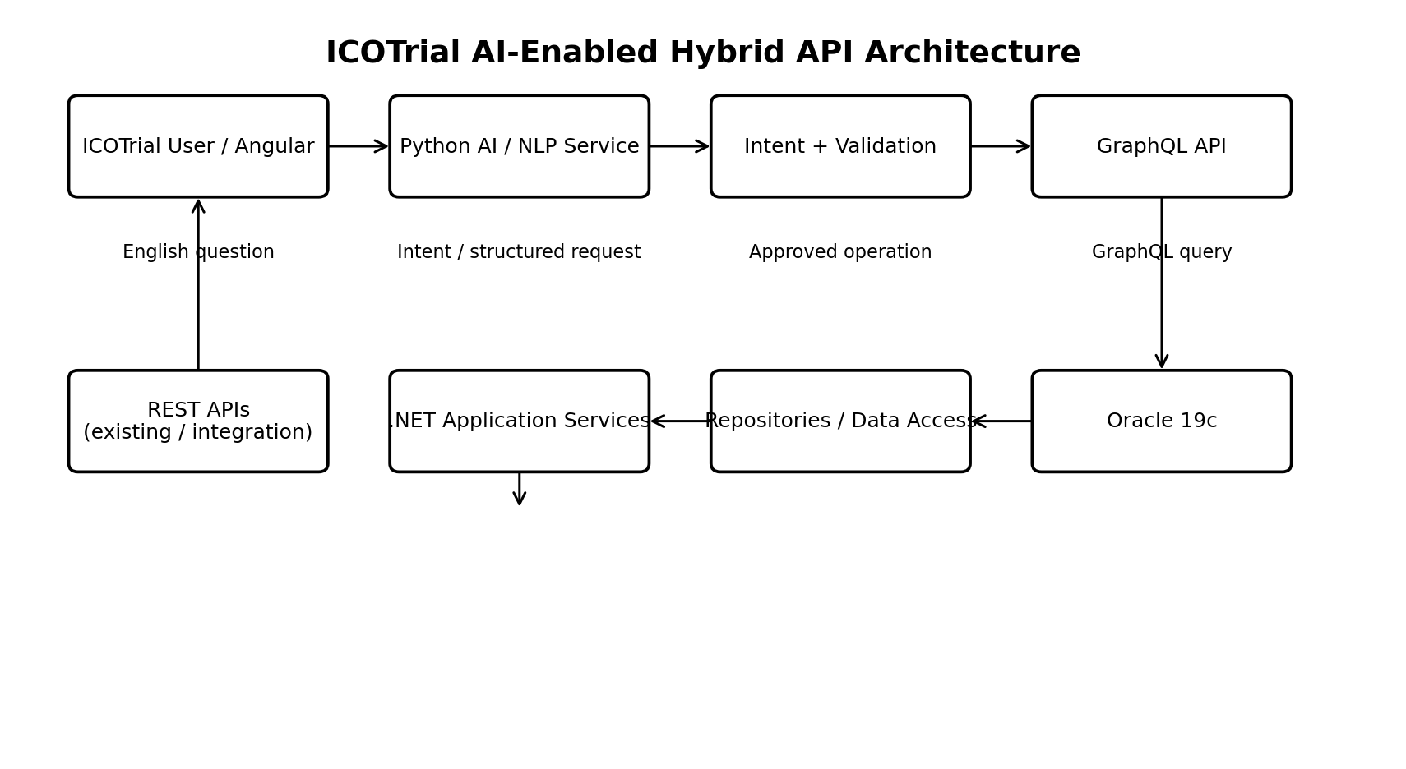
Figure 1 – Recommended ICOTrial AI-enabled hybrid API architecture
The key architectural principle is separation of responsibilities. The AI layer understands the user's language. The intent and validation layer determines which ICOTrial operation is allowed. GraphQL or REST provides the API contract. The .NET application layer remains responsible for business rules and data access.

6. Natural Language to GraphQL – Core Concept
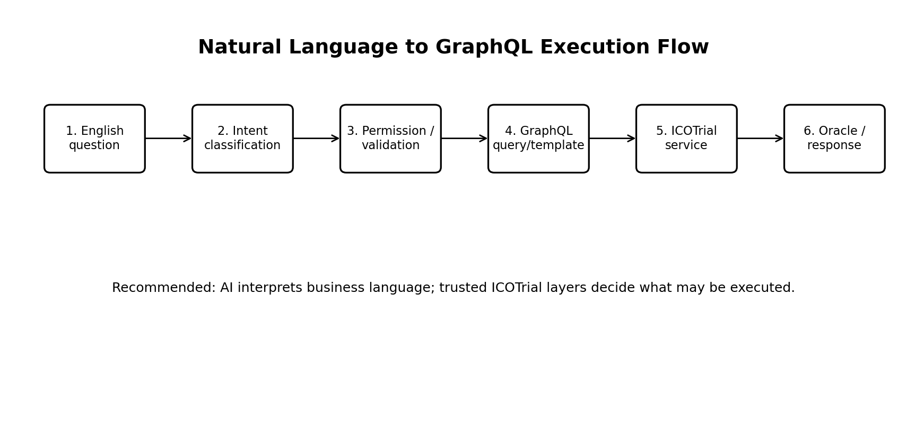
Figure 2 – Natural-language query execution flow
Example user question: “Show all active studies in India with investigator names.”
The system can normalize this to an intent such as SEARCH_STUDIES with status=ACTIVE, country=INDIA and include=INVESTIGATORS. A trusted query builder can then produce a GraphQL request similar to:
query {
studies(status: ACTIVE, country: "INDIA") {
id
name
status
investigators {
id
name
role
}
}
}
GraphQL itself does not define how natural language is interpreted. That interpretation belongs to an AI/NLP layer or to application logic. GraphQL then validates and executes the structured request against the schema. citeturn0search4

7. Four AI / English-to-GraphQL Approaches
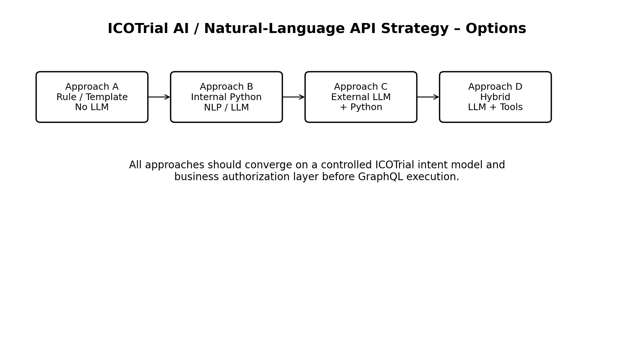
Figure 3 – Candidate implementation approaches
Approach | Description | External LLM cost | Complexity | ICOTrial fit
A. Rules/templates | Predefined English patterns map directly to approved intents and GraphQL templates. | None | Low | Good for fixed questions
B. Internal Python AI | Python service performs intent classification/NLP and builds structured requests. | No per-call external API fee; infrastructure cost remains | Medium | Good for controlled enterprise deployment
C. External LLM + Python | Python orchestrates an external LLM and converts the result into a controlled intent/query. | Usage-based LLM cost | Medium | Good for rapid experimentation
D. Hybrid AI + tools | LLM handles flexible language; approved tools/intents constrain what can execute. | LLM cost only where used | Medium/High | Strong long-term option

8. Approach A – Predefined Questions / Templates
This approach is especially suitable when ICOTrial has a finite catalog of supported questions.
- Maintain a catalog of approved intents such as SearchStudies, GetStudyDetails, SearchSites, SearchInvestigators, SearchTripReports and GetTripReport.
- Map common English variations to the same intent.
- Extract only approved parameters such as study ID, country, status, date range and site.
- Generate GraphQL from trusted templates.
- Do not allow arbitrary field selection beyond the approved schema/template.
Example:
English:
"List active studies in India"
Intent:
SEARCH_STUDIES
status = ACTIVE
country = INDIA
GraphQL:
query {
studies(status: ACTIVE, country: "INDIA") {
id
name
status
}
}
This approach can avoid an external LLM call for common questions, so there is no per-query LLM API charge. The service still has normal hosting, support and infrastructure costs.

9. Approach B – Internal Python AI/NLP Service
The internal Python service can sit between the Angular application and the ICOTrial API layer. It can perform intent classification, parameter extraction, validation and query generation.
- Python FastAPI or similar internal HTTP service can expose an endpoint such as /ai/query.
- The service can maintain an ICOTrial vocabulary and intent catalog.
- The service can use a locally hosted model if the organization chooses an internal LLM.
- The service can use deterministic rules for common questions and an internal model for more flexible language.
- The final output should be a structured intent, not unrestricted SQL.
A useful internal contract is:
{
"operation": "SearchStudies",
"filters": {
"status": "ACTIVE",
"country": "INDIA"
},
"include": ["investigators"]
}

10. Approach C – External LLM + Internal Python Orchestration
In this model, the Python service calls an enterprise-approved LLM API. The LLM interprets natural language, while the Python service validates the output and converts it into an approved ICOTrial operation.
- The LLM does language understanding.
- Python owns the ICOTrial prompt, intent schema, validation and orchestration.
- GraphQL generation remains constrained by the known ICOTrial schema.
- The user identity and authorization context must flow into the execution layer.
Cost consideration: the English-to-intent step can incur usage-based LLM costs when an external model is used. GraphQL execution itself does not inherently introduce a per-query GraphQL licensing charge; infrastructure and API provider costs are separate considerations.

11. Approach D – Hybrid LLM + Approved Tools
This is the recommended target architecture for flexible natural-language interaction. The LLM does not receive unrestricted database access. Instead, it selects from a catalog of approved ICOTrial operations/tools.
User:
"Show active studies in India with investigator names."
LLM:
{
"operation": "SearchStudies",
"filters": {
"status": "ACTIVE",
"country": "INDIA"
},
"include": ["investigators"]
}
Trusted ICOTrial layer:
Intent validation → Authorization → GraphQL generation → .NET service → Oracle
This architecture separates language interpretation from data authority and is therefore easier to govern than allowing the model to generate arbitrary SQL or unrestricted GraphQL.

12. Why the AI Should Not Query Oracle Directly
- Prevents the model from bypassing application business rules.
- Avoids exposing table structures, sensitive columns and database credentials.
- Keeps authorization in the ICOTrial application boundary.
- Makes auditing easier because every operation maps to a known business intent.
- Allows database schema changes without changing the user's language interface.
- Reduces the risk of expensive or unintended database queries.
The AI should therefore see a business vocabulary such as Study, Site, Investigator and Trip Report, rather than Oracle tables and joins.

13. GraphQL and REST – Hybrid Strategy
Use GraphQL for | Keep / use REST for | Shared layer
Complex UI reads; nested study/site/investigator data; dashboards; clients needing different response shapes | Existing integrations; file upload/download; streaming; webhooks; exports; simple CRUD; legacy contracts | Authentication; authorization; business services; validation; repositories; monitoring; audit
GitHub documents GraphQL as providing flexible queries where clients can define precisely the data they want, illustrating the type of client flexibility the ICOTrial UI could use. citeturn0search0

14. Authentication and Authorization
GraphQL does not replace ICOTrial authentication. The GraphQL endpoint should accept the same enterprise identity context used by the application, such as JWT/SSO claims.
- Authenticate the user before GraphQL execution.
- Pass user claims into the resolver/application service context.
- Enforce operation-level permissions.
- Enforce field-level permissions where required.
- Enforce study/site/sponsor/region-level data access in the business layer.
- Do not use a privileged AI service account that bypasses the user's permissions.
GraphQL.NET supports authorization validation for GraphQL fields/types and integration with ASP.NET Core authentication/authorization concepts. citeturn0search7turn0search12

15. Performance and Query Safety
- Apply query depth limits.
- Apply query complexity/cost limits.
- Use pagination for large collections.
- Use batching/DataLoader-style patterns to avoid N+1 access patterns.
- Set execution timeouts.
- Monitor Oracle execution time separately from GraphQL execution time.
- Use caching where appropriate.
- Log operation name, user/application identity, execution duration and outcome.
- Protect expensive search/report operations with explicit limits.
These controls are particularly important because flexible GraphQL queries can request nested data. The schema should expose business capabilities deliberately rather than simply mirroring every database relationship.

16. Example ICOTrial Question Catalog
Intent | Example English question | Parameters
SearchStudies | Show active studies | status
SearchStudies | Show active studies in India | status, country
GetStudyDetails | Show details for study ABC123 | studyId
SearchSites | Show sites for study ABC123 | studyId
SearchInvestigators | Show investigators for study ABC123 | studyId
SearchTripReports | Show trip reports for study ABC123 | studyId
SearchTripReports | Show completed trip reports in the last 30 days | status, dateRange
GetTripReport | Show trip report TR12345 | tripReportId
SearchStudies | Show studies with a particular investigator | investigatorId/name
SearchSites | Show active sites in a country | country, status

17. Suggested Python Service Components
- API layer – receives the English question and authenticated user context.
- Intent classifier – identifies the approved ICOTrial operation.
- Entity/parameter extractor – identifies study IDs, countries, dates, statuses, investigator names, etc.
- Policy validator – checks whether the requested operation and parameters are permitted.
- GraphQL query builder – generates only approved GraphQL selections and variables.
- ICOTrial API client – invokes the GraphQL or REST endpoint.
- Response formatter – optionally converts structured results into user-friendly text.
- Audit logger – records the question, normalized intent, operation, user context, execution result and correlation ID without unnecessarily logging sensitive data.

18. Suggested Python Project Structure
icotrial_ai/
api/
routes.py
intent/
classifier.py
entities.py
catalog.py
graphql/
query_builder.py
templates.py
validator.py
security/
authorization.py
clients/
icotrial_graphql.py
icotrial_rest.py
response/
formatter.py
audit/
logger.py
tests/
test_intents.py
test_queries.py
test_security.py
config/
settings.py

19. Example End-to-End Request
1. User:
"Show active studies in India with investigator names."
2. Python AI service:
Intent = SearchStudies
Status = ACTIVE
Country = INDIA
Include = Investigators
3. Authorization:
Verify the authenticated user may access those studies.
4. Query builder:
Generate approved GraphQL with variables.
5. GraphQL API:
Validate query against schema.
6. Resolver:
Call ICOTrial Study application service.
7. Application service:
Apply business rules and data-access policy.
8. Oracle:
Execute approved data access.
9. Response:
Structured GraphQL response.
10. UI / AI:
Display the data and optionally summarize it.

20. Companies / Industry Evidence
GraphQL was created at Facebook around 2012 and open-sourced in 2015. The official GraphQL site states that Facebook's mobile apps used GraphQL from 2012 and describes GraphQL as an open-source query language and server-side runtime. citeturn0search2turn0search3
GitHub provides a production GraphQL API and documents the flexibility of defining precisely the data a client wants to fetch. citeturn0search0
These examples demonstrate that GraphQL is an established API technology, but they do not by themselves establish that GraphQL is the correct choice for every ICOTrial workload. The ICOTrial decision should be based on its own security, performance, integration and development measurements.

21. Cost Model
Cost area | Rules/templates | Internal AI | External LLM
LLM per-request cost | None | None if fully local; otherwise infrastructure/model cost | Typically usage-based
Python service | Yes | Yes | Yes
GraphQL infrastructure | Yes | Yes | Yes
Oracle / existing backend | Yes | Yes | Yes
Model hosting/GPU | No | Potentially significant | Usually provider-side
Operational monitoring/security | Yes | Yes | Yes
For a controlled ICOTrial question catalog, the lowest variable-cost model is a deterministic intent/template approach. A hybrid model can use AI only for questions that cannot be handled by deterministic patterns.

22. Security and Compliance Guardrails
- No direct database credentials in the AI service.
- No unrestricted SQL generation.
- Prefer structured intent/tool calls over unrestricted GraphQL generation.
- Validate all model-produced parameters against allowlists and types.
- Enforce the end user's authorization, not an unrestricted AI service identity.
- Use TLS for service-to-service communication.
- Avoid logging sensitive clinical or personal data in prompts and logs unless required and approved.
- Keep prompt/model versions auditable.
- Maintain an allowlist of GraphQL fields and operations for AI-driven execution.
- Apply query complexity and execution limits.
- Retain correlation IDs for investigation and operational support.

23. Observability
- AI request count and latency.
- Intent classification accuracy.
- Unknown/unsupported question rate.
- GraphQL validation failures.
- Authorization failures.
- GraphQL execution latency.
- Application-service latency.
- Oracle execution latency.
- Error/retry rate.
- Token/LLM usage if an external model is used.
- Top intents and frequently requested fields.
Existing Elastic APM/Kibana monitoring can be extended to correlate AI → GraphQL → application-service → Oracle timing where technically feasible.

24. Proof of Concept – Recommended Scope
- Select one complex, read-heavy ICOTrial screen or workflow.
- Define 10–20 approved business questions.
- Create the GraphQL schema for only the required study/site/investigator/trip-report fields.
- Build a small internal Python intent service.
- Start with deterministic intent mapping.
- Add an LLM only for questions that do not match deterministic patterns.
- Reuse the existing .NET business service layer.
- Measure REST versus GraphQL network calls and payload sizes.
- Measure end-to-end, application and Oracle latency.
- Test authorization, invalid questions, query abuse and data leakage.
- Capture developer effort and operational support effort.

25. POC Success Metrics
Metric | Measure | Purpose
Natural-language intent accuracy | % of supported questions mapped to correct intent | Validate AI/NLP usefulness
GraphQL correctness | % valid and expected queries | Validate query generation
Authorization correctness | Allowed/denied test cases | Validate security
Response time | p50/p95 end-to-end latency | Validate performance
Oracle impact | DB time / CPU / query count | Protect backend
Network efficiency | Calls and payload size | Compare API patterns
Cost | LLM usage + infrastructure | Validate economics
Developer effort | Build/test/maintain effort | Validate sustainability

26. Risks and Mitigations
Risk | Mitigation
Incorrect intent | Use approved intent catalog, confidence thresholds and clarification for ambiguous questions.
Unauthorized data access | Enforce existing user identity and business authorization in trusted ICOTrial layers.
Expensive GraphQL query | Depth/complexity limits, pagination, batching and allowlists.
Hallucinated fields | Generate only against a known schema/catalog and validate before execution.
Database performance | Monitor Oracle execution and restrict high-cost operations.
Model dependency | Keep deterministic paths and an explicit fallback to normal APIs.
Sensitive data in prompts | Minimize prompt content and use enterprise-approved model/data-handling controls.
Operational complexity | Start with a small POC and standardize logging, correlation and deployment.

27. Recommended Target State
The recommended target is a controlled hybrid architecture:
- Angular / other clients continue to use REST and/or GraphQL according to workload.
- Python AI service provides natural-language understanding.
- An ICOTrial intent catalog defines what the AI is allowed to request.
- A trusted validation layer converts approved intents into GraphQL or REST operations.
- GraphQL provides flexible read composition where appropriate.
- .NET application services remain the business authority.
- Oracle remains the system of record.
- Security, audit and observability remain under ICOTrial enterprise controls.
The most important design principle is: **AI interprets the question; ICOTrial decides what can be executed.**

28. Architecture Decision Summary
Decision area | Proposed direction | Reason
API strategy | Hybrid REST + GraphQL | Avoid unnecessary replacement of working integrations
AI strategy | Python orchestration + controlled intents | Separates language understanding from execution
Question handling | Deterministic first, AI second | Controls cost and behavior
Data access | Existing .NET services | Preserve business rules
Database | Oracle 19c remains source of truth | Avoid AI/database coupling
Security | Existing identity + authorization | Prevent privilege bypass
GraphQL generation | Schema/allowlist/template constrained | Reduce unsafe or expensive queries
Rollout | Small POC → measured expansion | Reduce architecture and operational risk

29. External References
- GraphQL official site: https://graphql.org/ — Overview of GraphQL, its purpose and ecosystem.
- GraphQL Specification: https://spec.graphql.org/September2025/ — Specification, language, schema, validation and execution.
- Meta Engineering: https://engineering.fb.com/2015/09/14/core-infra/graphql-a-data-query-language/ — Historical background on GraphQL at Facebook.
- GitHub GraphQL API: https://docs.github.com/en/graphql — Production GraphQL API documentation and query flexibility.
- GraphQL.NET Server: https://github.com/graphql-dotnet/server — ASP.NET Core GraphQL server and authorization capabilities.

30. Open Questions for ICOTrial Architecture Review
- Which ICOTrial UI/workflow should be the first GraphQL POC?
- Which 10–20 natural-language questions provide the highest business value?
- Which GraphQL .NET implementation and version align with the supported ICOTrial runtime?
- What identity/claims model will the Python service receive?
- Should the Python AI service be deployed inside the ICON/ICOTrial network boundary?
- Is an internally hosted model required for data-handling reasons?
- Which fields and relationships should be exposed in the first GraphQL schema?
- What query depth/complexity limits are appropriate?
- How will AI prompts, model versions and intent catalogs be versioned?
- What audit data must be retained for AI-assisted queries?
- Which performance thresholds must the POC meet before production adoption?

31. Final Recommendation
For ICOTrial, start with a controlled natural-language POC rather than a broad “AI generates any GraphQL” implementation. Define a small business intent catalog, build an internal Python service, map common English questions deterministically, and use an AI/LLM only where flexible language interpretation adds value. Generate or select GraphQL through a trusted, schema-aware layer, then execute through the existing .NET business services and Oracle data access.
This approach provides a path from today's REST/API architecture toward AI-assisted natural-language access without requiring a wholesale replacement of existing ICOTrial services.

