**Terraform**

Terraform – Automation Tool – IAC – Hashicorp

**1. Provider**

a. aws

b. Authentication

Access key and secret key

**2. Resource Block**

Linux

Storage

Database

**3. Provisioners**

Shell script inside Linux

**4. Output**

Terraform File Extension is .tf

Main.tf

Variables.tf

Terraform.tfvars

**Commands:**

**1.terraform init**

**2.terraform plan**

**3.terraform apply**

**Practical:**

**Step 1:**

<https://www.terraform.io/downloads.html>

Created a Folder and place the downloaded exe into that folder.

Open command prompt

terraform –version

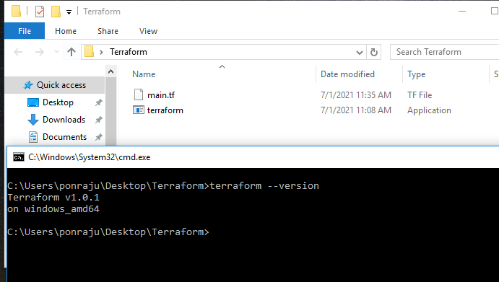

**Steps 2:**

Download Visual Studio and install the software.

create a main.tf file.

Type your script here.

To get access and secret key…

Login Your AWS account 🡪 IAM

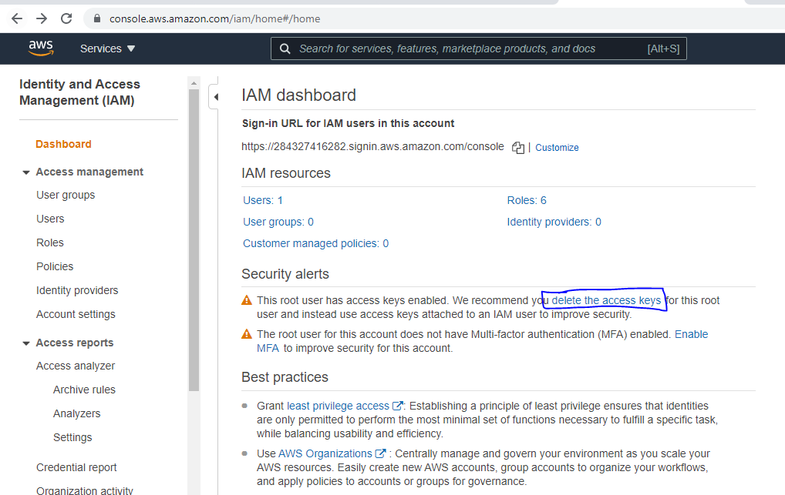

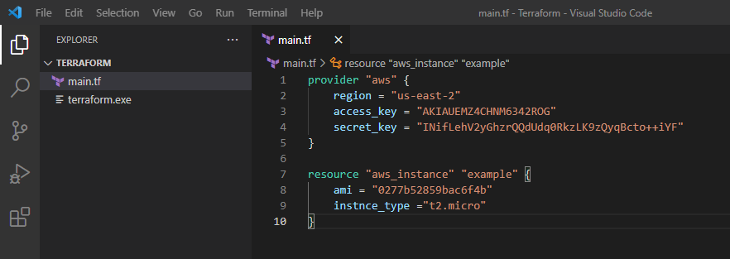

Download AWS CLI and install it to authenticate aws credentials from local machine.

<https://awscli.amazonaws.com/AWSCLIV2.msi>

Type **Aws Configue** in command prompt and enter the access key and secret key.

