Infosys Springboard Virtual Internship 6.0 Completion Report

Team Details <Do not mention any personally identifiable information like email ID, institute details, mobile phone number etc.>
Batch Number :5
Start date :13-oct-2025
Names: PONSHIVAVELl S K
Internship Duration: 8 Weeks

1. Project Title
InsurAI Corporate Policy Automation and Intelligence System

2. Project Objective
The main objective of this internship project was to design and develop an integrated insurance management system that automates core insurance operations such as user registration, authentication, premium calculations, transaction history, and policy management.

3. Project description in detail
A full-stack intelligent insurance management platform built using Java Spring Boot, React, and SQL.
Approach
The project was divided into multiple modules, each representing a key business operation within an insurance organization:
Step-by-step Approach
Requirement Analysis:
- Understood client needs such as payment remainder,payment alert.
- Identified user roles: Customer and Admin.
System Design:
o Created ER models to structure data and process flow.
o Designed the login page and registration page as well as some requirements in DashBoard.
2. Backend Development:
o Built RESTful APIs using Spring Boot (Java) and sql

3. Frontend Development:
o Developed an interactive UI using React.js with responsive layout and role-based dashboards.
o Integrated API endpoints for appointment scheduling, user management, and notifications.
4. Testing and Integration:
o Conducted module-level and integration testing using Postman and Spring Boot’s inbuilt test features.
o Verified frontend–backend connectivity and data consistency.
5. Deployment:
o The project can be deployed on local servers or cloud (e.g., AWS, Azure) for scalability.

4. Timeline Overview
Week | Activities Planned | Activities Completed
Week 1 | LOGIN PAGE | COMPLETED
Week 2 | SPRING BOOT | COMPLETED
Week 3 | SQL | COMPLETED
Week 4 | API CONNECTION | COMPLETED
Week 5 | JWT
Week 6
Week 7
Week 8

5a. Key Milestones
Milestone | Description | Date Achieved
Project Kickoff
Prototype/First Draft
Mid-Term Review
Final Submission
Presentation

5b. Project execution details
Explain in detail how this project was executed
I was done this project along with learn about it

6. Snapshots / Screenshots
Include relevant visuals such as screenshots of work done, dashboards, code snippets, or designs.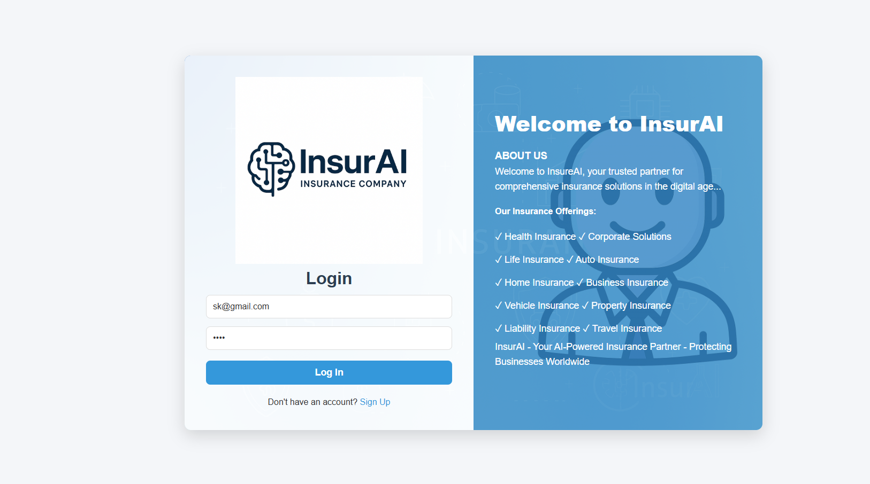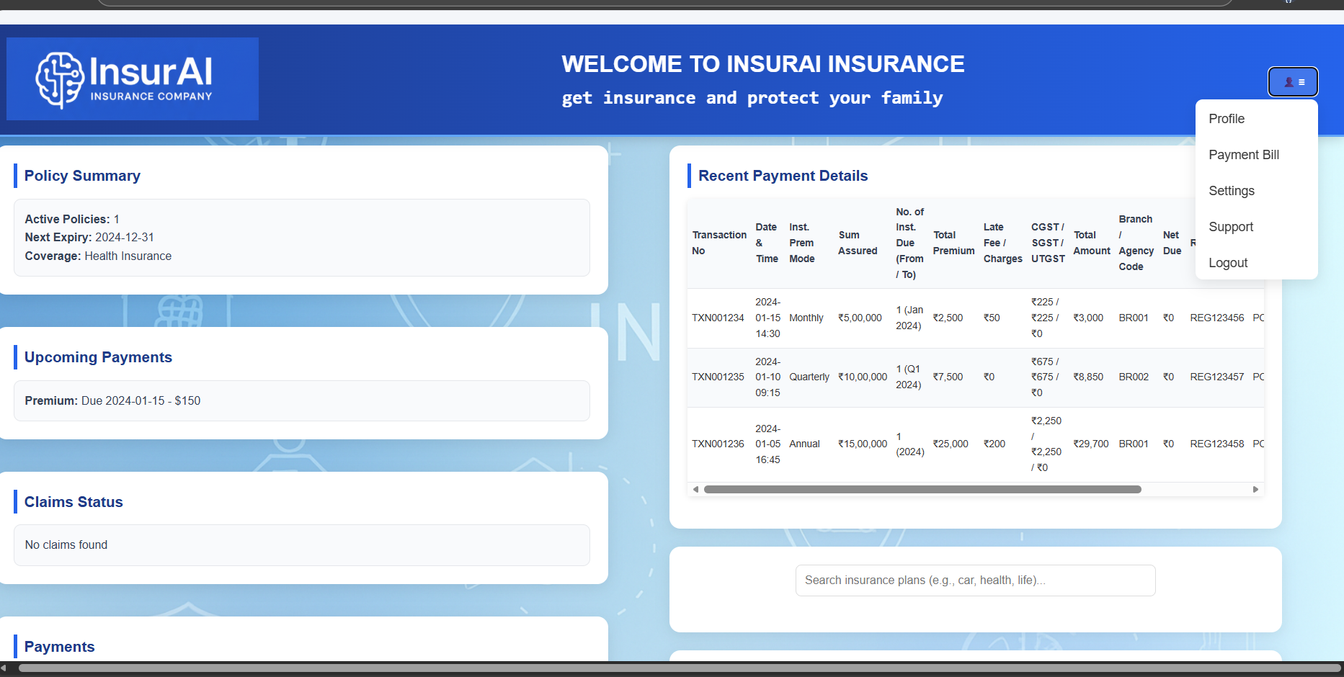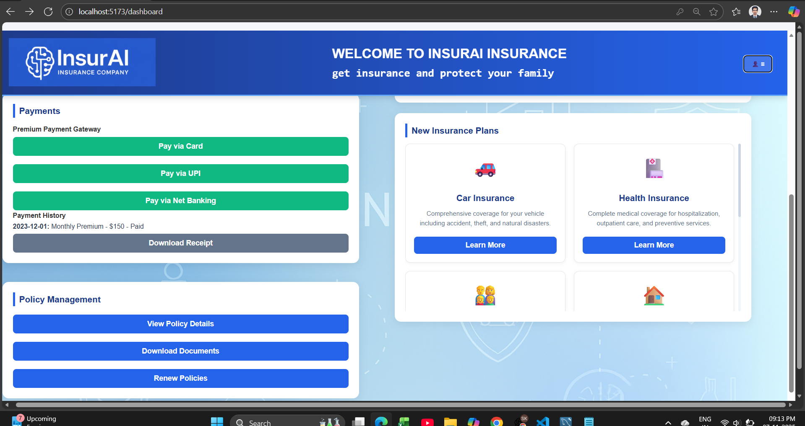

7. Challenges Faced
I was done this project along with learn about it . and it was most i learn but i have idea about html and css so the concept i understand easy and done it

8. Learnings & Skills Acquired
I have gain the knowledge about the node.js and it working and how it connect to data passing

9. Testimonials from team
I have do small project before this project there i write small code but here there is number of file which connect by each other

10. Conclusion
I learning the how the encryption is working and hash and also how there working with dependence

11. Acknowledgements
Thank the organization, mentor, and any team members who supported your internship journey.

