PHISHING EMAIL DETECTION & AWARENESS SYSTEM

Program: Future Interns — Cyber Security Internship
Task: Task 2
Repo: FUTURE_CS_02
Name: KIRUTHIKA P
Date: May 2026

1. Executive Summary
Phishing is a type of cyber attack where attackers create fake websites that look exactly like real ones — such as banks, shopping sites, or email providers. The goal is to trick users into entering their personal details, login credentials, or banking information. Once the victim enters their details, the attacker steals them and uses them for financial fraud or identity theft.
In this report, I analyzed 3 verified phishing URLs collected from PhishTank — a public phishing database. Each URL was examined to identify:
- What brand it was impersonating
- What technique the attacker used
- What risk it poses to victims
- How users can stay safe

2. Methodology
Source: PhishTank (phishtank.com) — a public database of verified phishing websites.
Steps followed for each sample:
- Checked the domain for suspicious elements
- Identified the phishing technique used
- Assessed the risk to victims
- Suggested prevention methods
Tools Used:
Tool | Purpose
PhishTank | Collecting phishing samples
Browser | Viewing technical details
WPS Office | Writing the report

Sample 1: SMBC Bank
Phishing URL: smbc-card.6688expo.com Classification: 🔴 Phishing | Risk Level: High
Field | Details
Submission ID | #9423191
Target Brand | SMBC Card — Japanese bank
Suspicious Domain | Random numbers in 6688expo.com
Technique | Subdomain Spoofing
Hosted On | Cloudflare
Finding: The URL impersonates SMBC Card by placing smbc-card before the fake domain 6688expo.com. Real banks never use random numbers in their domain. If a victim enters their login details, the attacker can steal their credentials and money.
Prevention:
- Check the full URL carefully
- Look for HTTPS and padlock
- Never click links from emails
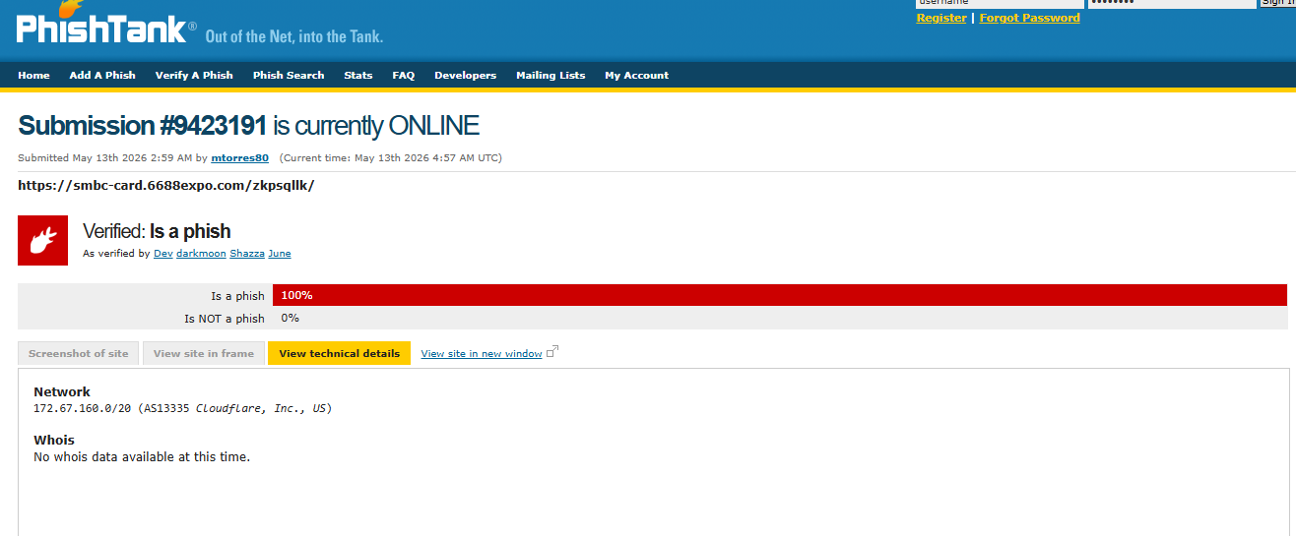

Sample 2: Allegro Lokalnie
Phishing URL: allegro-lokalnie.761273129gf-230.lat Classification: 🔴 Phishing | Risk Level: High
Field | Details
Submission ID | #9423209
Target Brand | Allegro Lokalnie — Polish online marketplace
Suspicious Domain | Random numbers 761273129gf-230 + unusual .lat extension
Technique | Subdomain Spoofing + No HTTPS
Hosted On | Unknown — Network lookup pending
Finding: Allegro Lokalnie is a real brand but this website is completely fake. The domain contains random numbers and letters which no real company would use. The real Allegro uses .pl domain — not .lat. The URL also uses HTTP instead of HTTPS meaning the connection is not encrypted. If a victim tries to login or shop here, the attacker can steal their card details and money.
Prevention:
- Verify sender email — official Allegro emails come from @allegro.pl
- Never shop on sites using HTTP — always HTTPS
- Check domain carefully before entering card details
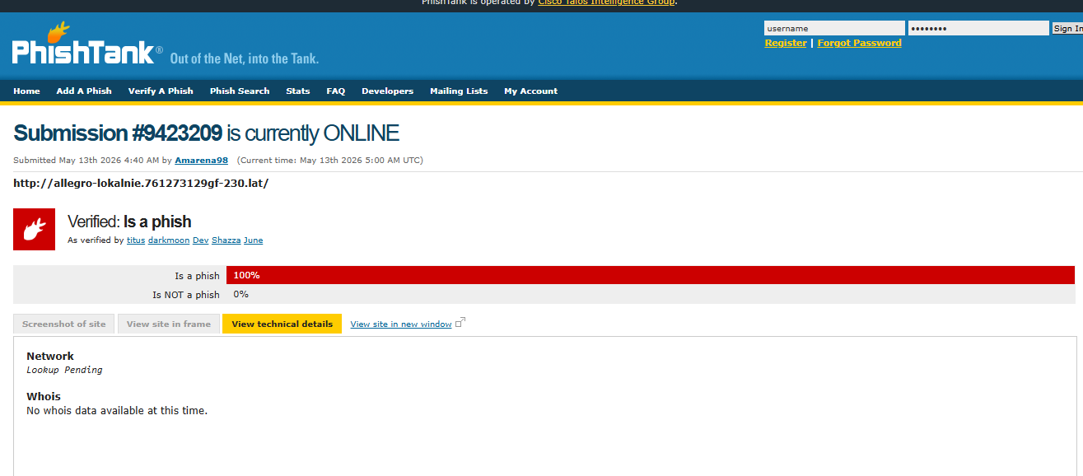

Sample 3: Raiffeisen Bank
Phishing URL: vr-raiff.de/d/index.php Classification: 🔴 Phishing | Risk Level: High
Field | Details
Submission ID | #9423198
Target Brand | Raiffeisen Bank — major European bank
Suspicious Domain | vr-raiff.de combines two real bank names
Technique | Domain Lookalike
Hosted On | Cloudflare (104.21.48.0/20)
Finding: The attacker used a Domain Lookalike technique by combining shortened names of two real banks — vr from VR Bank and raiff from Raiffeisen — to create vr-raiff.de. Users may recognize these words as real banking terms but fail to notice it is not the official domain. If a victim enters their bank login, OTP and account number, the attacker gains full access and can easily steal money.
Prevention:
- Always verify the full URL before entering details
- Check sender email — real Raiffeisen emails come from @raiffeisen.at
- Never share OTP or account number through email links

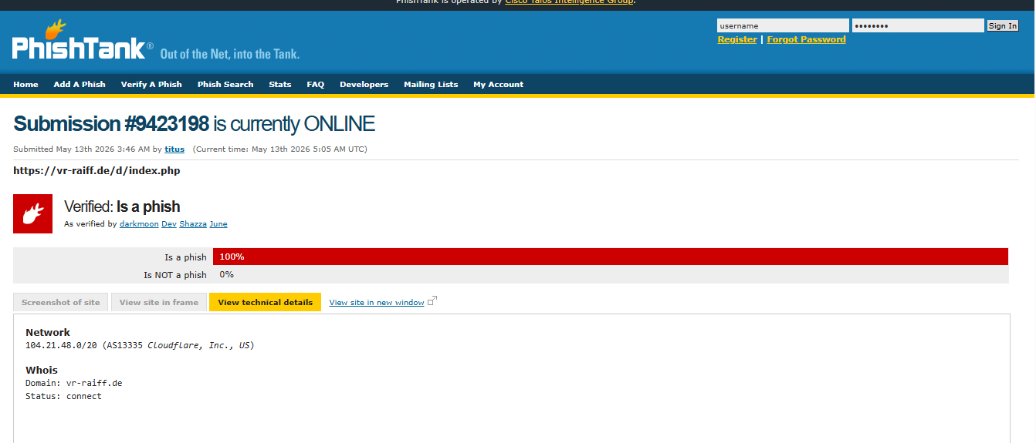

Risk Summary Table

Risk Summary
All 3 phishing URLs were verified as 100% phishing by PhishTank. Here is a summary of all samples analyzed:
# | Target Brand | Phishing URL | Technique | Risk Level
1 | SMBC Bank | smbc-card.6688expo.com | Subdomain Spoofing | 🔴 High
2 | Allegro Lokalnie | allegro-lokalnie.761273129gf-230.lat | Subdomain Spoofing + No HTTPS | 🔴 High
3 | Raiffeisen Bank | vr-raiff.de/d/index.php | Domain Lookalike | 🔴 High

Key Observations:
- All 3 phishing URLs were actively online at the time of analysis
- Subdomain Spoofing was the most commonly used technique
- All attackers hid their WHOIS information to avoid detection
- Cloudflare was used in 2 out of 3 cases to mask the real server
- All 3 attacks targeted financial or commercial brands to maximize theft

Prevention Guidelines

Prevention & Awareness Guidelines

For Users:
- Always verify the full URL before entering any personal or banking details
- Check that the website uses HTTPS and shows a padlock in the address bar
- Never click links from emails — type the official website address directly in the browser
- Always verify the sender email — official brands use their own domain (e.g. @allegro.pl, @raiffeisen.at)
- Never share OTP, account number or password through email or any link — real banks never ask for these online
- If something looks suspicious — call the company directly using the number from their official website
For Organizations:
- Enable Multi Factor Authentication (MFA) on all employee accounts
- Configure SPF, DKIM and DMARC records to prevent email spoofing
- Use email filtering tools to block phishing emails automatically
- Conduct regular phishing awareness training for all employees
- Maintain an updated blocklist of known phishing domains

Conclusion
In this report, I analyzed 3 verified phishing URLs collected from PhishTank. All 3 URLs were confirmed as 100% phishing and were actively online at the time of analysis.
The attackers used techniques such as Subdomain Spoofing and Domain Lookalike to create fake websites that closely resembled real brands like SMBC Bank, Allegro Lokalnie and Raiffeisen Bank. The main goal of these attacks was to steal victims' login credentials, banking details and money.
The key lesson from this analysis is that users should always verify the URL carefully, check the sender email, and never share sensitive information through email links. Real banks and companies will never ask for OTP or passwords through email.

References
Source | Link
PhishTank | phishtank.com
Sample 1 | Submission #9423191
Sample 2 | Submission #9423209
Sample 3 | Submission #9423198

