API SECURITY RISK ANALYSIS REPORT

Program : Future Interns — Cyber Security Internship
Task : Task 3
Repo : FUTURE_CS_03
Name : Kiruthika P
Date : May 2026
Target : https://jsonplaceholder.typicode.com
Tool : Postman Web

1. Executive Summary
An API Security Risk Analysis is a process of identifying security vulnerabilities in an API that could be exploited by attackers. In this report, I analyzed the public API https://jsonplaceholder.typicode.com using Postman Web. A total of 15 security issues were identified including missing authentication, exposed personal data, weak rate limiting, and insecure CORS configuration. Each finding is classified by risk level with remediation steps provided.

2. Methodology
Target API: https://jsonplaceholder.typicode.com
Tools Used:
Tool | Purpose
Postman Web | Sending API requests and analyzing responses
Browser DevTools | Additional header inspection
WPS Office | Report writing
Steps Followed:
- Sent GET requests to API endpoints using Postman
- Analyzed request and response headers for security issues
- Identified missing authentication and authorization controls
- Checked rate limiting and CORS configuration
- Classified each finding by risk level
- Provided remediation steps for each finding

3. Target API Information
Field | Details
API Name | JSONPlaceholder
Base URL | https://jsonplaceholder.typicode.com
Endpoint Tested | /users
Request Method | GET
Response Code | 200 OK
Response Size | 2.94 KB
Response Time | 3.14 seconds
Hosted On | Cloudflare
Scan Date | 16 May 2026
Total Findings | 15

Overall Risk Rating:
Risk Level | Count
High Risk | 5
Medium Risk | 7
Low Risk | 3

API Summary:

The API returned a 200 OK response without requiring any authentication or authorization. Personal user data including names, emails, and addresses were freely accessible to anyone. This indicates serious security misconfigurations in the API design.
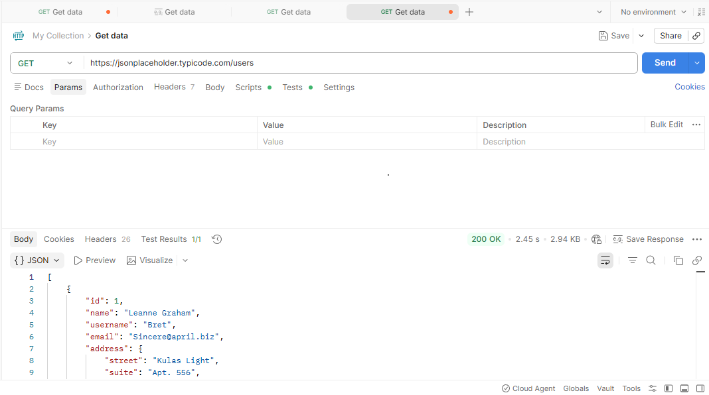

4. Security Findings

Finding 1 — No Authentication Required
Field | Details
Risk | High
Endpoint | /users
What it means | Anyone can access user data without login or API key — no authentication is required to retrieve sensitive information
Fix | Implement API key or OAuth 2.0 authentication for all endpoints

Finding 2 — Personal Data Exposed
Field | Details
Risk | High
Endpoint | /users
What it means | Full user details including name, email, username and home address are returned without any access control — this violates data privacy
Fix | Restrict sensitive fields — return only necessary data per user role

Finding 3 — No Authorization Header
Field | Details
Risk | High
Endpoint | /users
What it means | API accepts requests without any Authorization header — no token or credential verification is performed
Fix | Require Authorization header with valid Bearer token for all requests
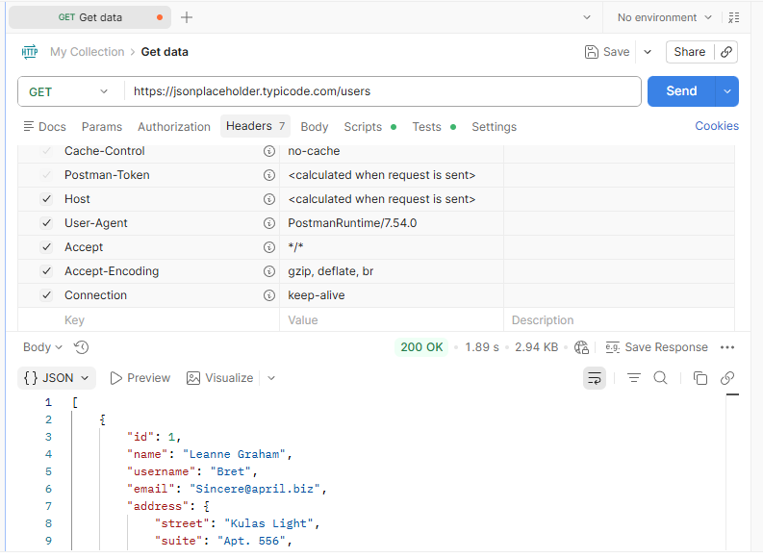

Finding 4 — Weak Rate Limiting
Field | Details
Risk | Medium
Header | x-ratelimit-remaining: 999
What it means | API allows up to 1000 requests — this is very high for sensitive user data. Attackers can make hundreds of requests to harvest data without being blocked
Fix | Reduce rate limit to maximum 100 requests per hour for sensitive endpoints

Finding 5 — Rate Limit Reset Time Exposed
Field | Details
Risk | Medium
Header | x-ratelimit-reset: 1778499707
What it means | The exact time when rate limit resets is publicly visible — attackers can time their attacks to coincide with the reset
Fix | Hide rate limit reset time from response headers

Finding 6 — Sensitive Data Cached by Cloudflare
Field | Details
Risk | Medium
Header | cf-cache-status: HIT
What it means | User data is being cached by Cloudflare CDN — sensitive personal data should never be cached as it can be served to wrong users
Fix | Add Cache-Control: no-store for endpoints returning personal data

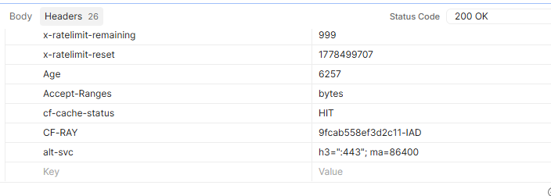

Finding 7 — Insecure CORS Configuration
Field | Details
Risk | High
Header | access-control-allow-credentials: true
What it means | API allows credentials from any origin — attackers can make cross-site requests using victim's credentials to steal data
Fix | Restrict CORS to specific trusted domains only

Finding 8 — Sensitive Data Cached for 12 Hours
Field | Details
Risk | Medium
Header | Cache-Control: max-age=43200
What it means | Personal user data is cached for 12 hours — stale or wrong data could be served to different users
Fix | Set Cache-Control: no-store, no-cache for all sensitive endpoints

Finding 9 — Internal Infrastructure Details Exposed
Field | Details
Risk | Medium
Header | CF-RAY: 9fcab558ef3d2c11-IAD
What it means | Internal Cloudflare server ID and location is exposed — attackers can use this to identify infrastructure and plan targeted attacks
Fix | Remove or mask internal server identifiers from response headers

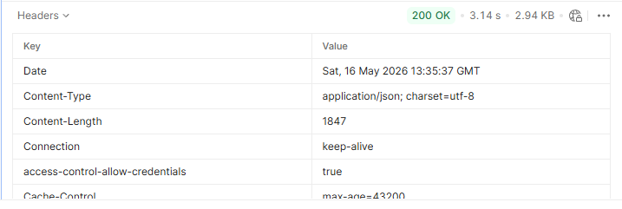

5. Risk Summary
All findings identified during the API security analysis are summarized below:
# | Finding | Source | Risk Level
1 | No Authentication Required | Postman Response | High
2 | Personal Data Exposed | Postman Response Body | High
3 | No Authorization Header | Request Headers | High
4 | Insecure CORS Configuration | Response Headers | High
5 | Accept Any Content Type | Request Headers | High
6 | Weak Rate Limiting | Response Headers | Medium
7 | Rate Limit Reset Time Exposed | Response Headers | Medium
8 | Sensitive Data Cached | Response Headers | Medium
9 | Cache-Control max-age=43200 | Response Headers | Medium
10 | CF-RAY ID Exposed | Response Headers | Medium
11 | alt-svc Exposed | Response Headers | Medium
12 | User-Agent Exposed | Request Headers | Medium
13 | Content-Length Exposed | Response Headers | Medium
14 | Connection Keep-Alive | Response Headers | Low
15 | Response Size Visible | Response Headers | Low

Risk Count:
Risk Level | Count
High | 5
Medium | 8
Low | 2
Total | 15

6. Remediation Guidelines
# | Finding | Recommended Fix
1 | No Authentication | Implement API key or OAuth 2.0 authentication
2 | Personal Data Exposed | Return only necessary data per user role
3 | No Authorization Header | Require Bearer token for all requests
4 | Insecure CORS | Restrict to specific trusted domains only
5 | Accept Any Content Type | Restrict to application/json only
6 | Weak Rate Limiting | Reduce to maximum 100 requests per hour
7 | Rate Limit Reset Exposed | Hide rate limit reset time from headers
8 | Sensitive Data Cached | Add Cache-Control: no-store for sensitive endpoints
9 | Cache max-age=43200 | Reduce cache time or disable for user data
10 | CF-RAY ID Exposed | Remove internal server identifiers from headers
11 | alt-svc Exposed | Hide server infrastructure details
12 | User-Agent Exposed | Mask or remove User-Agent from responses
13 | Content-Length Exposed | Remove unnecessary response metadata
14 | Connection Keep-Alive | Set appropriate connection timeout values
15 | Response Size Visible | Minimize exposed response metadata

General API Security Recommendations:

Always implement authentication and authorization on all API endpoints , Follow OWASP API Security Top 10 guidelines, Perform regular API security testing using tools like Postman and OWASP ZAP , Implement input validation on all API parameters , Use HTTPS for all API communications , Apply principle of least privilege — return only data the user needs

7. Conclusion
In this API Security Risk Analysis, I analyzed https://jsonplaceholder.typicode.com/users using Postman Web. A total of 15 security findings were identified — 5 High Risk, 8 Medium Risk, and 2 Low Risk.
The most critical issues are the missing authentication, exposed personal data, and insecure CORS configuration. These vulnerabilities allow anyone to access sensitive user information without any login or authorization — posing serious privacy and security risks.
Immediate action should be taken to implement proper authentication, restrict CORS policy, and reduce rate limiting to protect user data from unauthorized access.

8. References
Source | Details
Target API | https://jsonplaceholder.typicode.com
Postman Web | https://web.postman.co
OWASP API Security | https://owasp.org/www-project-api-security
GitHub Repository

