EXPERIMENT NO: 1 DATE: 16/07/26
INTRO TO DIGITAL FORENSICS
AIM:
To learn about digital forensics and related processes and experiment with a practical example.
PROCEDURE:
- Navigate to the TryHackMe room 'Intro to Digital Forensics'.
- Identify the digital evidence from the crime scene photo.
- Learn forensic phases.
- Inspect document metadata to find the document author.
- Extract EXIF metadata to find the camera model.
- Read GPS metadata coordinates to pinpoint the location.
TASKS:
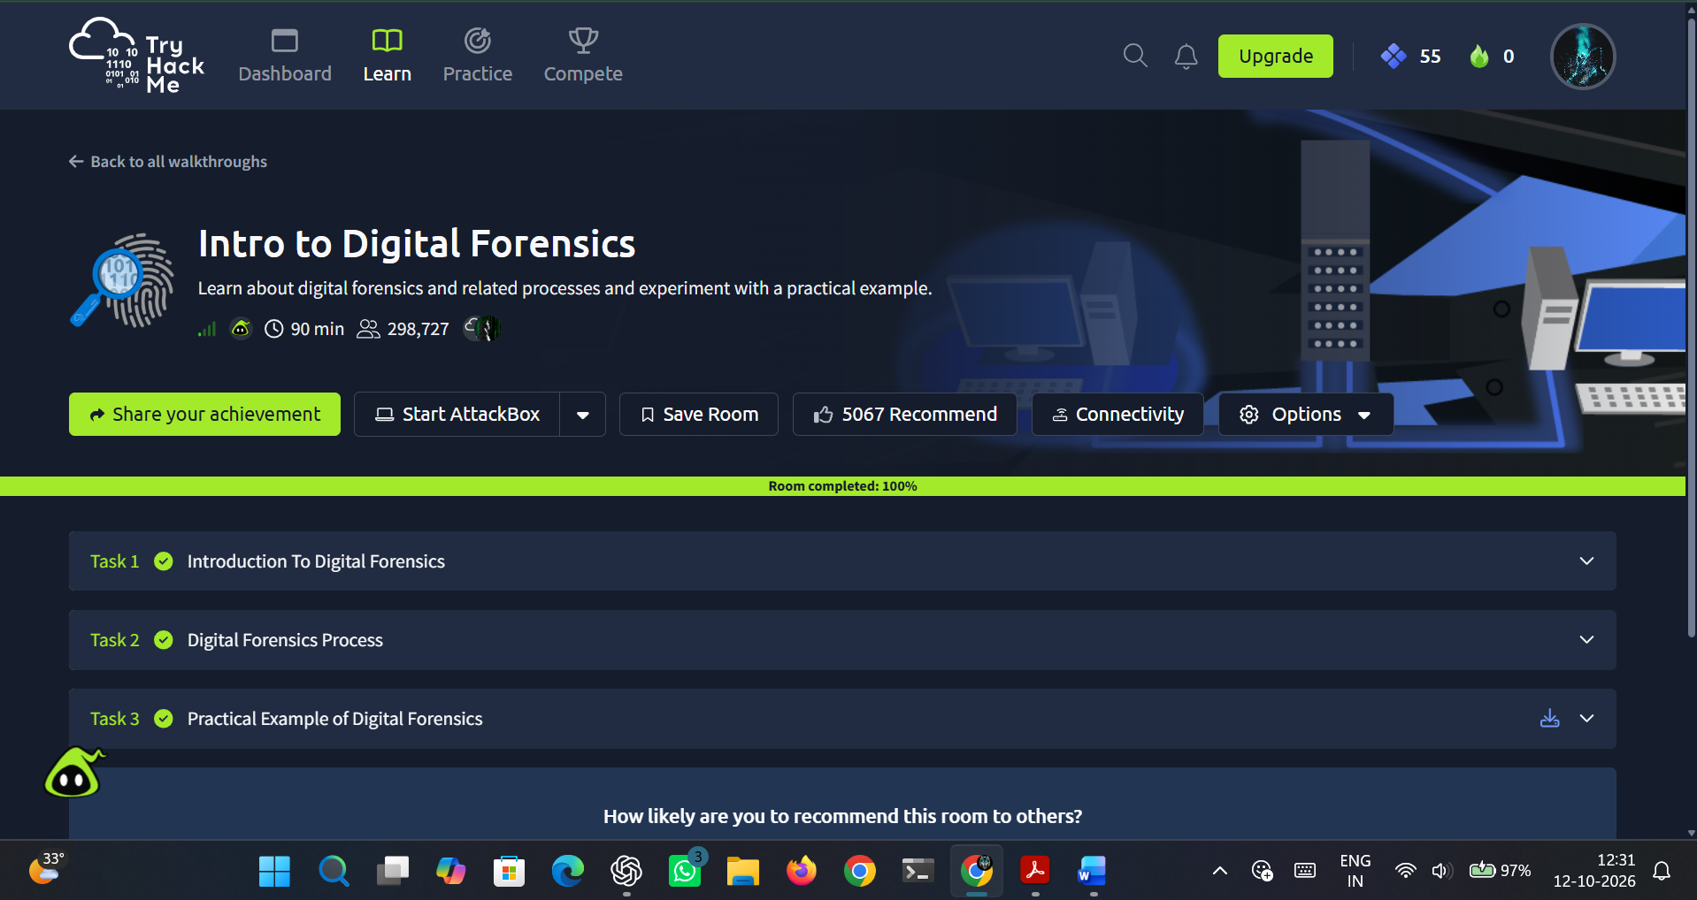
Figure 1.1 TryHackMe room completed
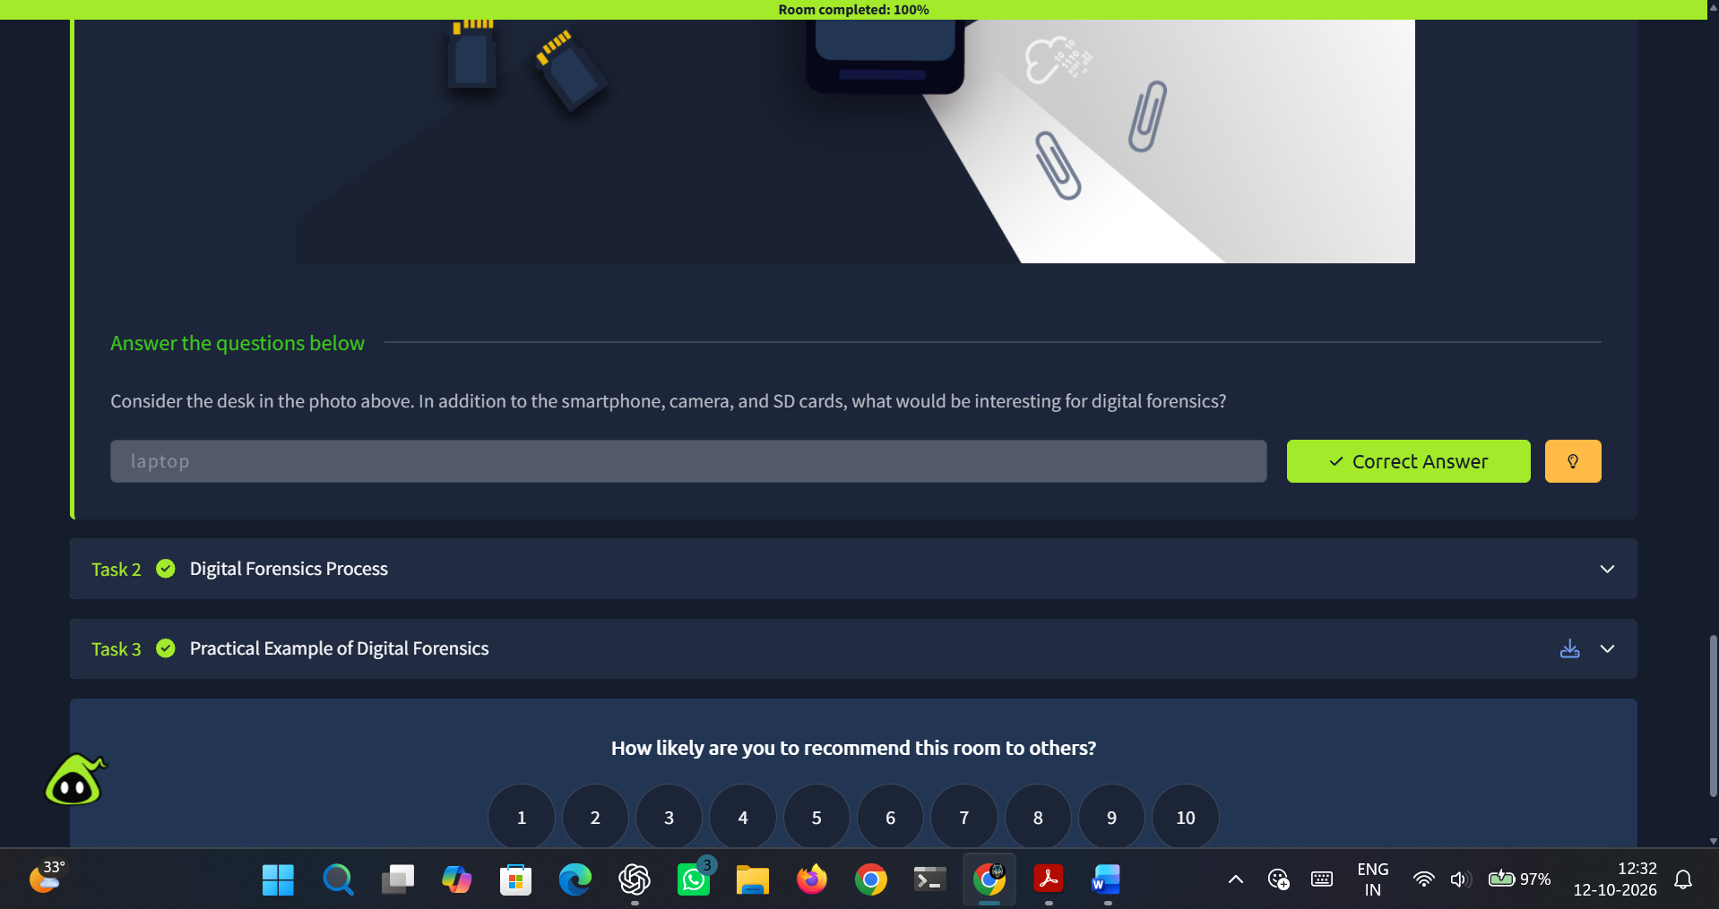
Figure 1.2 Task 1: Introduction to Digital Forensics
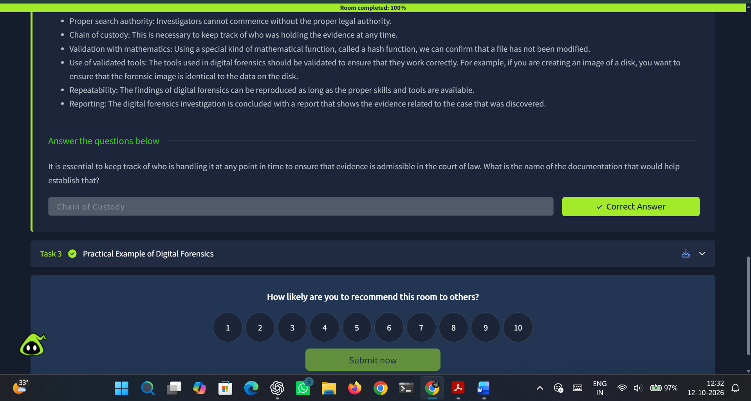
Figure 1.3 Task 2: Digital Forensics Process
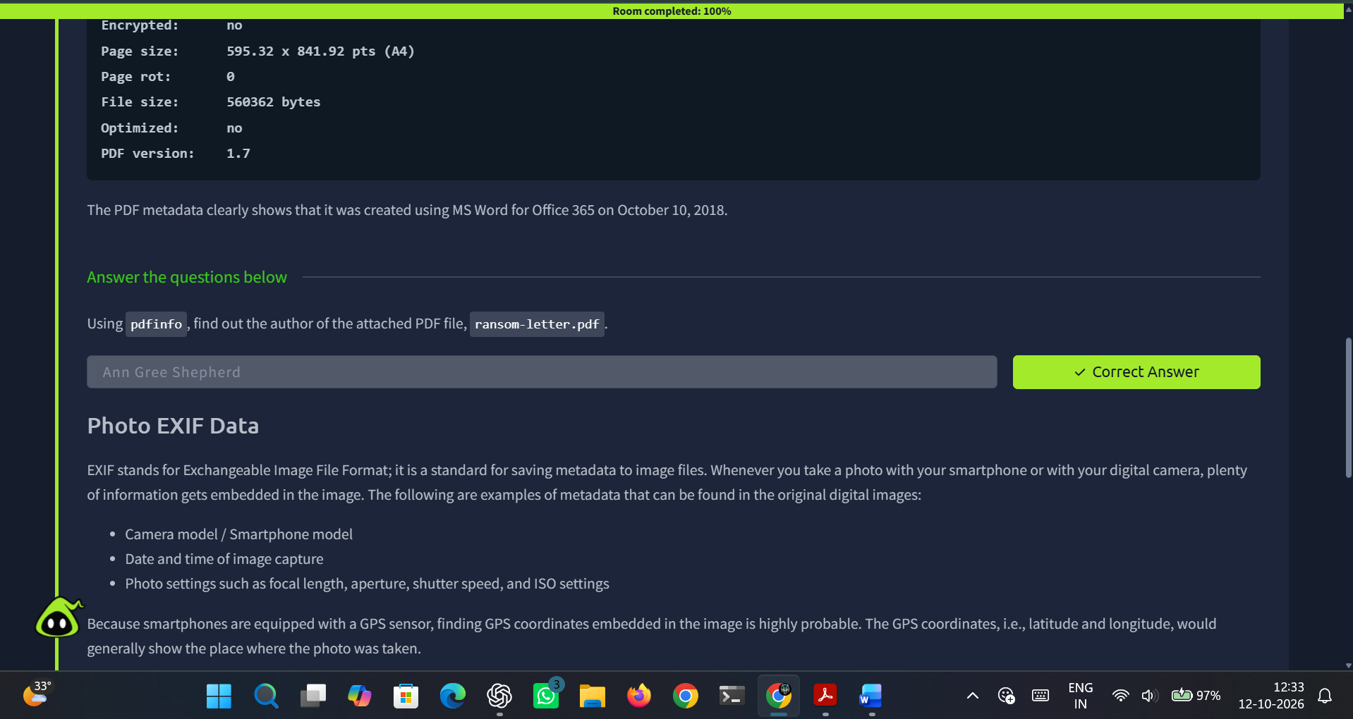
Figure 1.4 Task 3: Practical Example of Digital Forensics
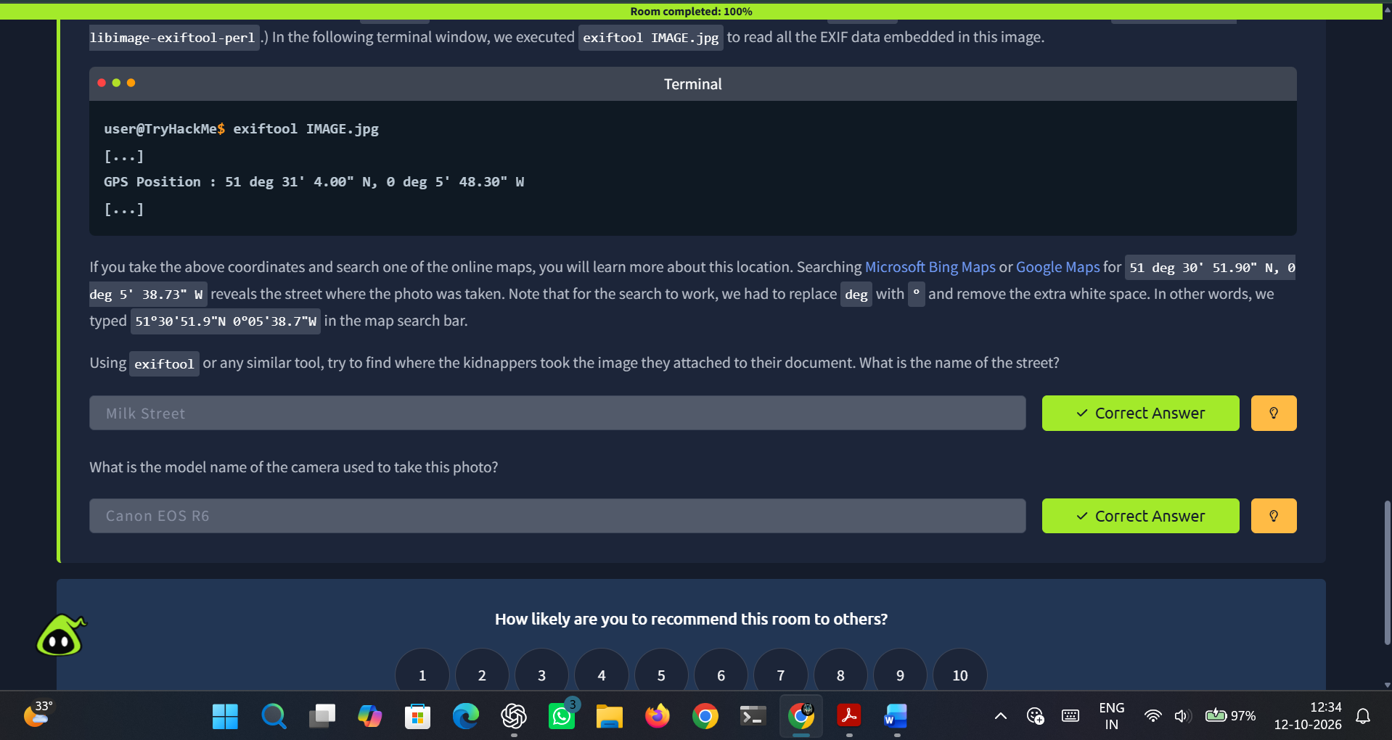
Figure 1.5 Task 3: Practical Example of Digital Forensics

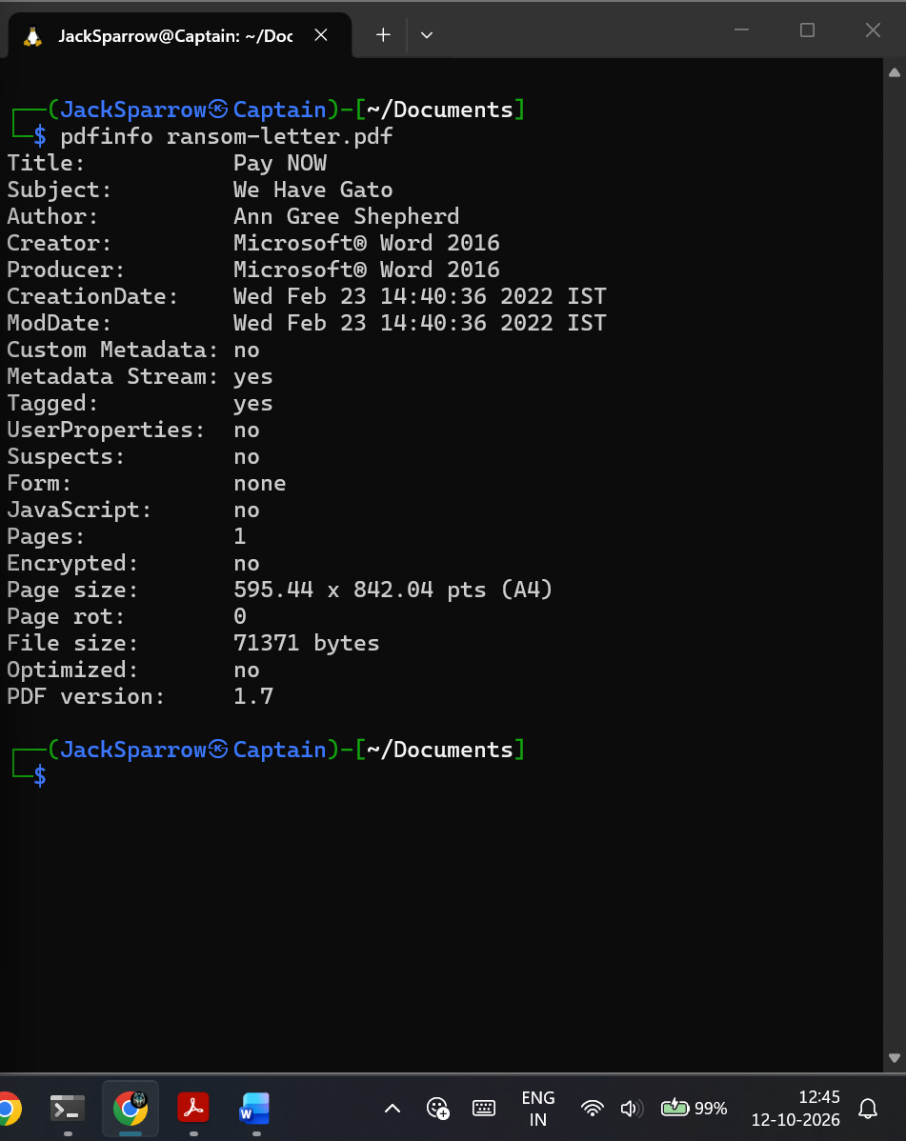
Figure 1.5 View Document Metadata
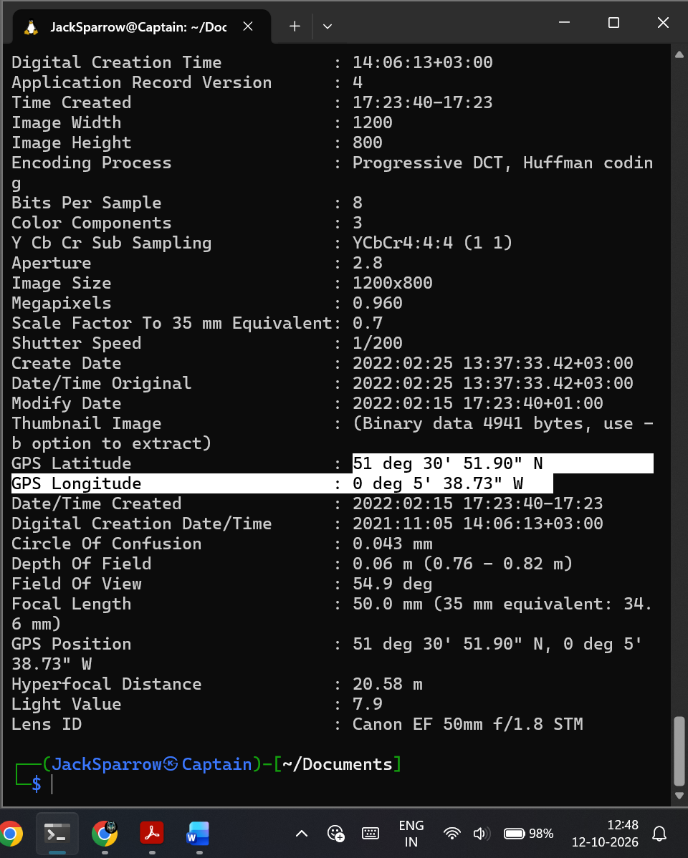
Figure 1.6 View Image metadata (GPS)
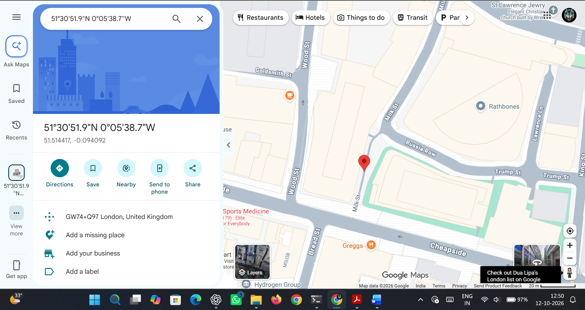
Figure 1.7 Find the street name using Google Maps

RESULT:
Thus the TryHackMe Room ‘Intro to Digital Forensics’ was completed successfully.

