EXPERIMENT NO: 3 DATE: 23/07/2026
WINDOWS FORENSICS 1
AIM:
To study about Windows Registry forensics.
PROCEDURE:
- Open Registry Explorer and load SYSTEM, SOFTWARE, SAM and NTUSER.DAT hives.
- Check computer name in Control\ComputerName and user accounts from SAM ...\Users.
- Find recent files in RecentDocs and typed commands in RunMRU.
- Verify program execution via UserAssist and BAM keys.
- Identify USB drives in USBSTOR and volume labels in Portable Devices.
- Fill in all the answers and complete the room.
TASKS:
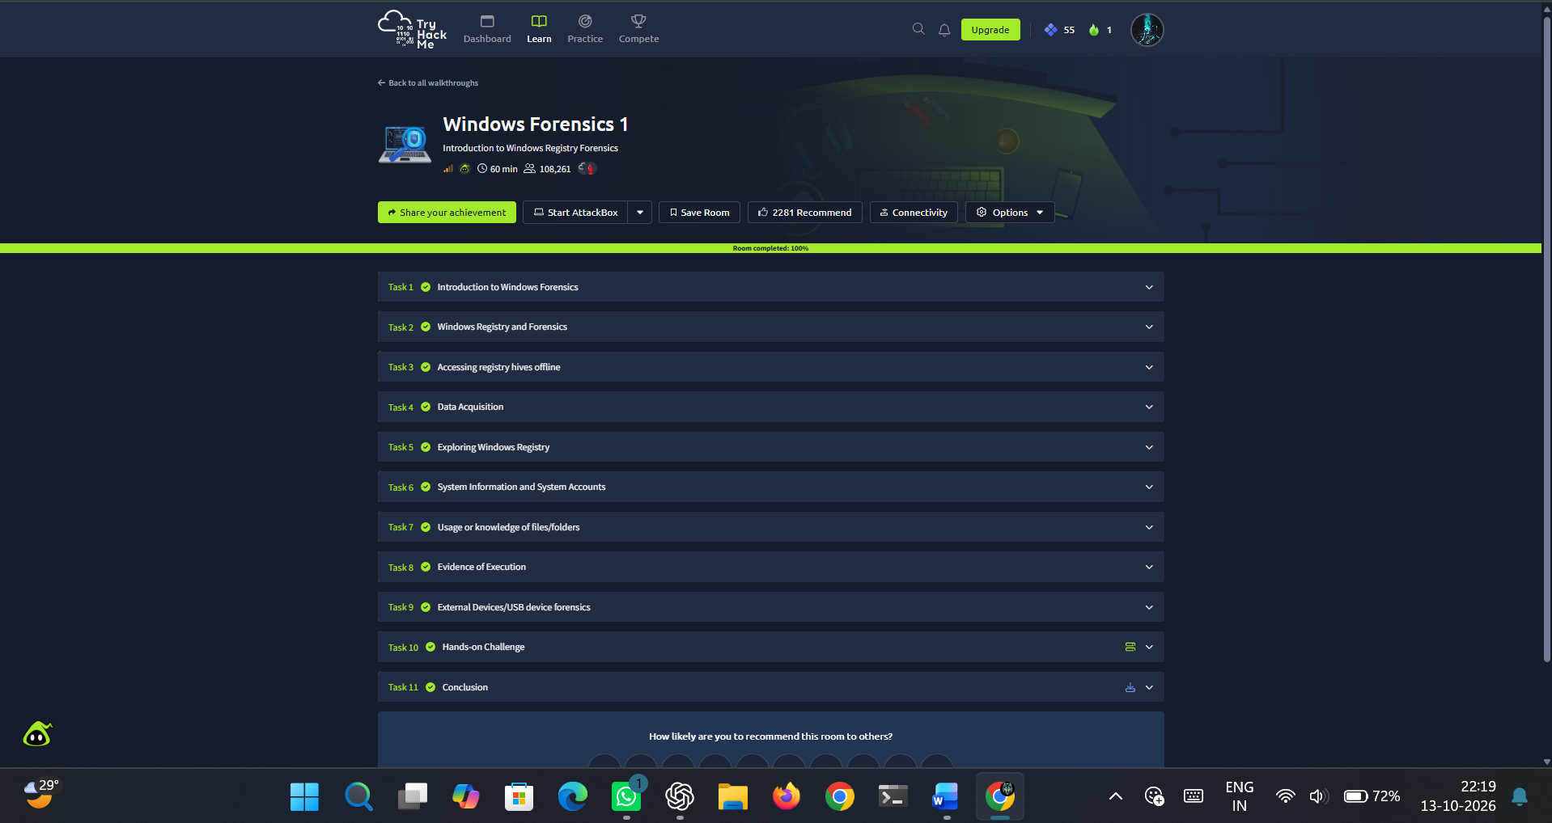
Figure 3.1 Windows Forensics 1-Tryhackme room

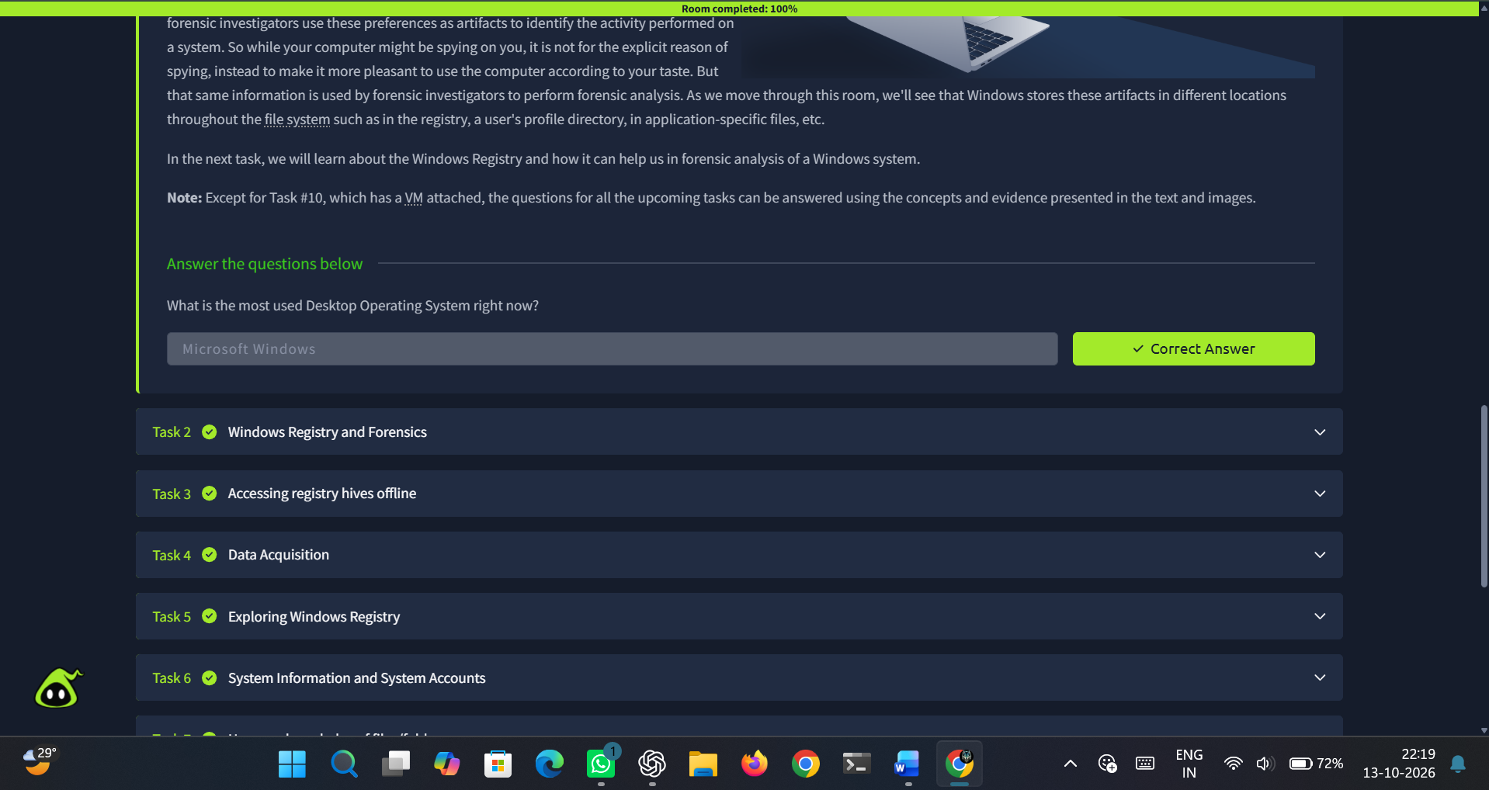
Figure 3.2 Task 1
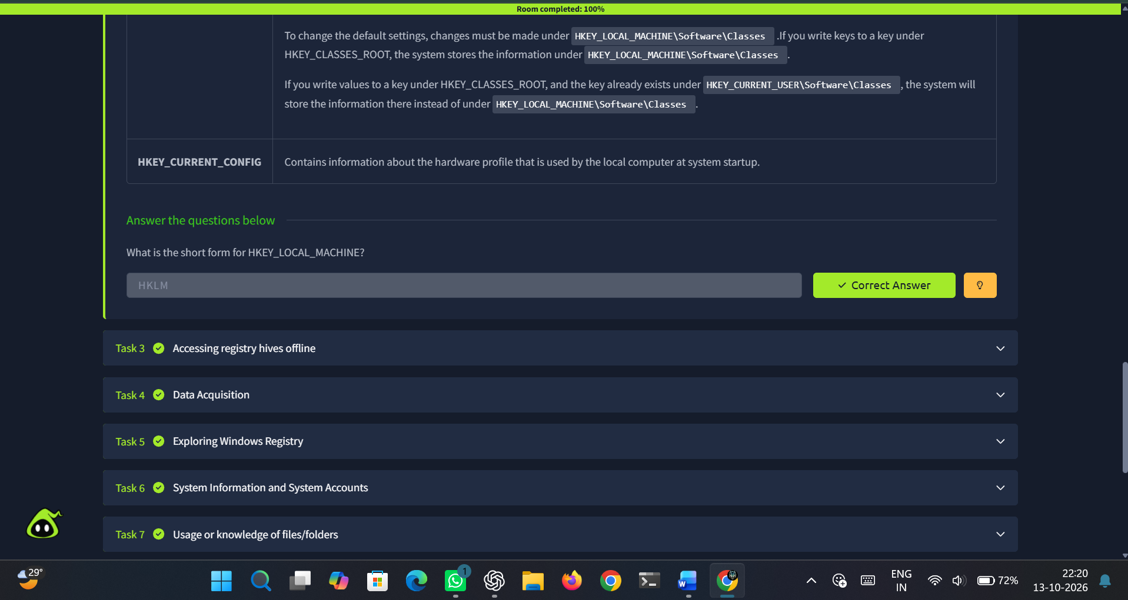
Figure 3.3 Task 2
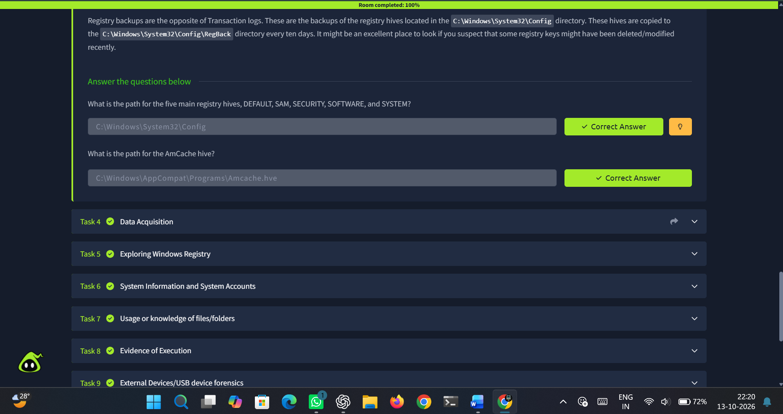
Figure 3.4 Task 3
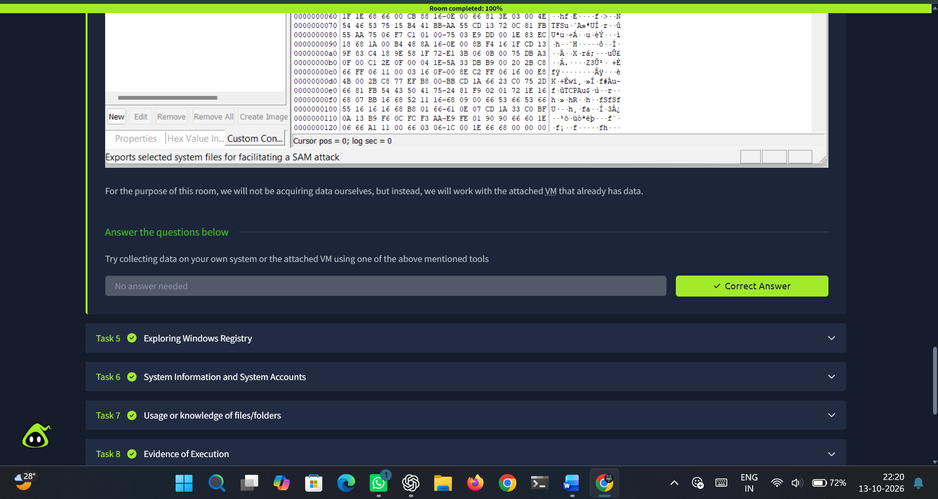
Figure 3.5 Task 4
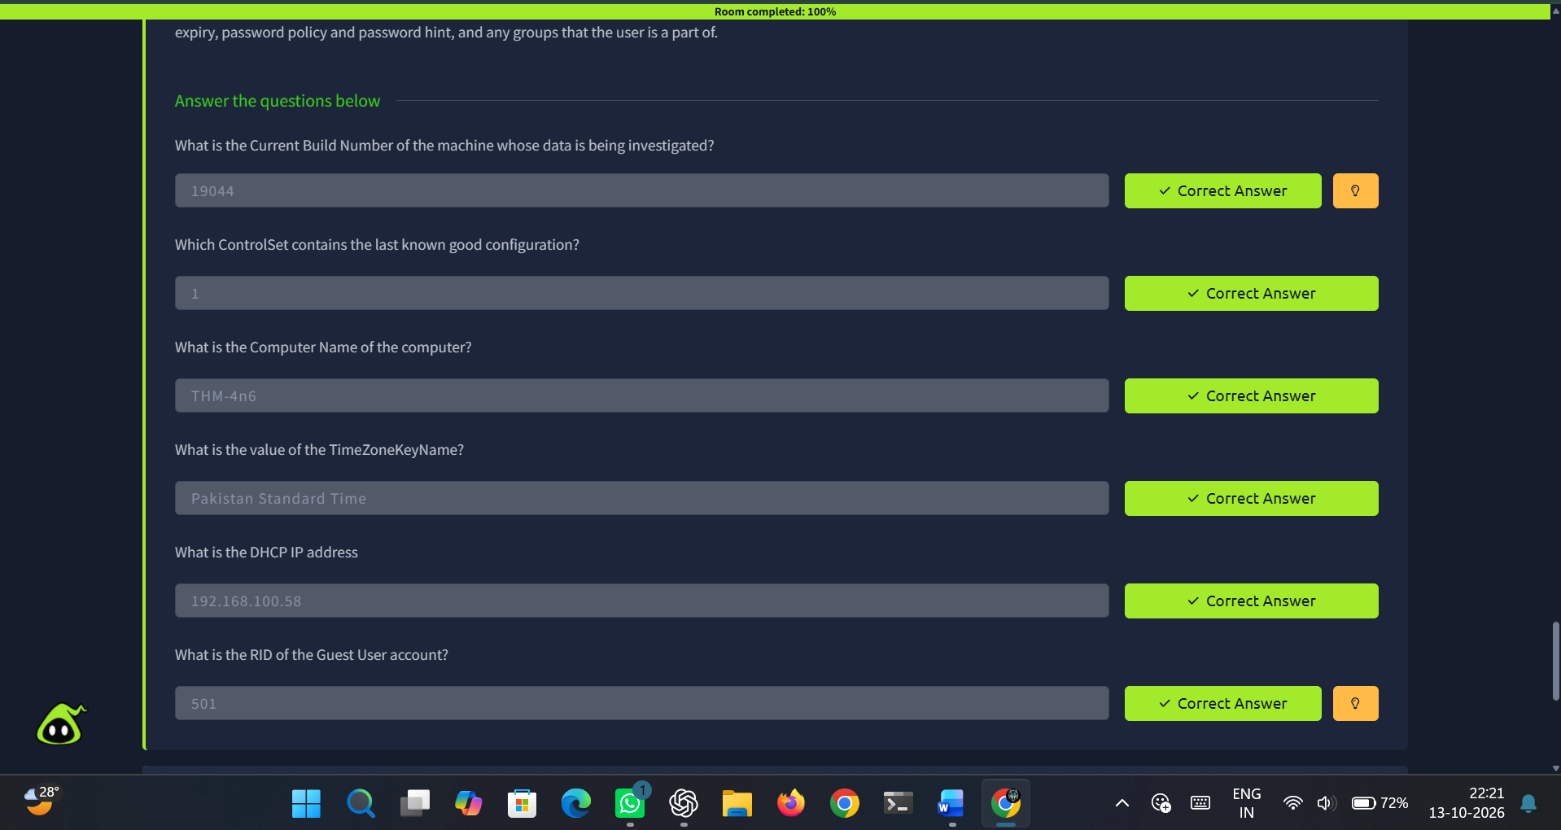
Figure 3.6 Task 6
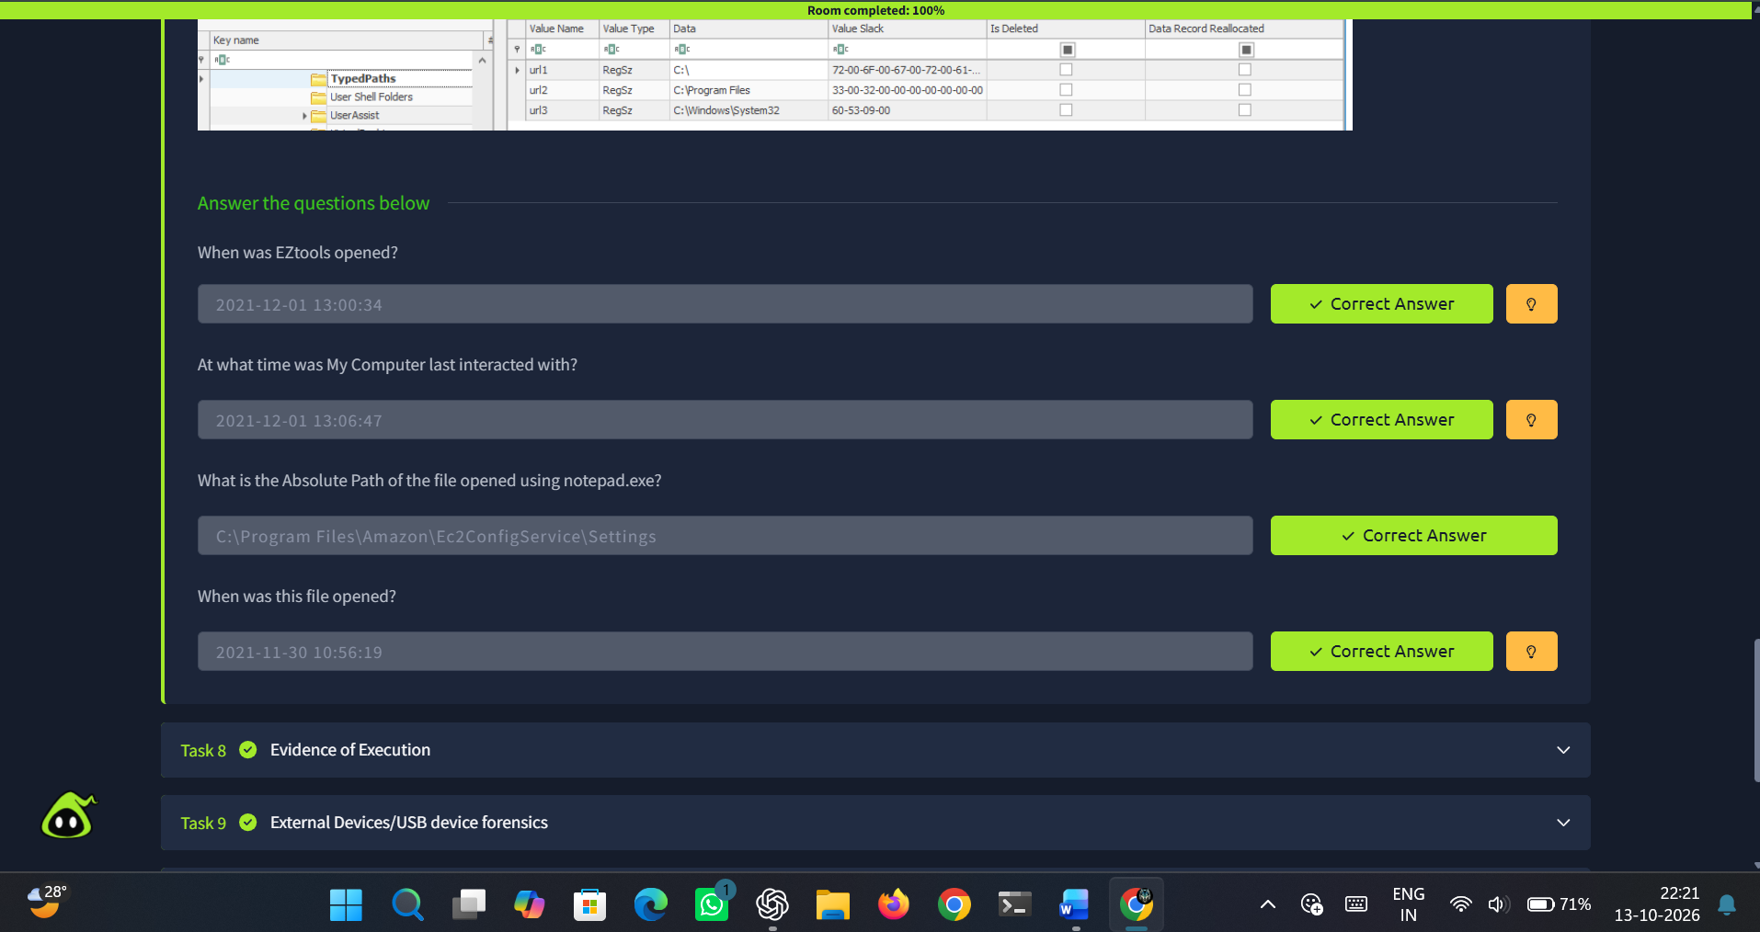
Figure 3.7 Task 7
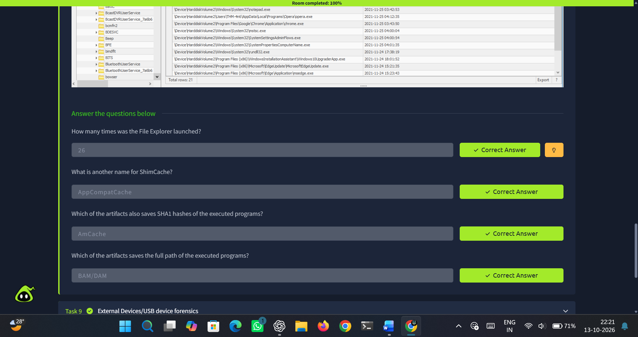
Figure 3.8 Task 8

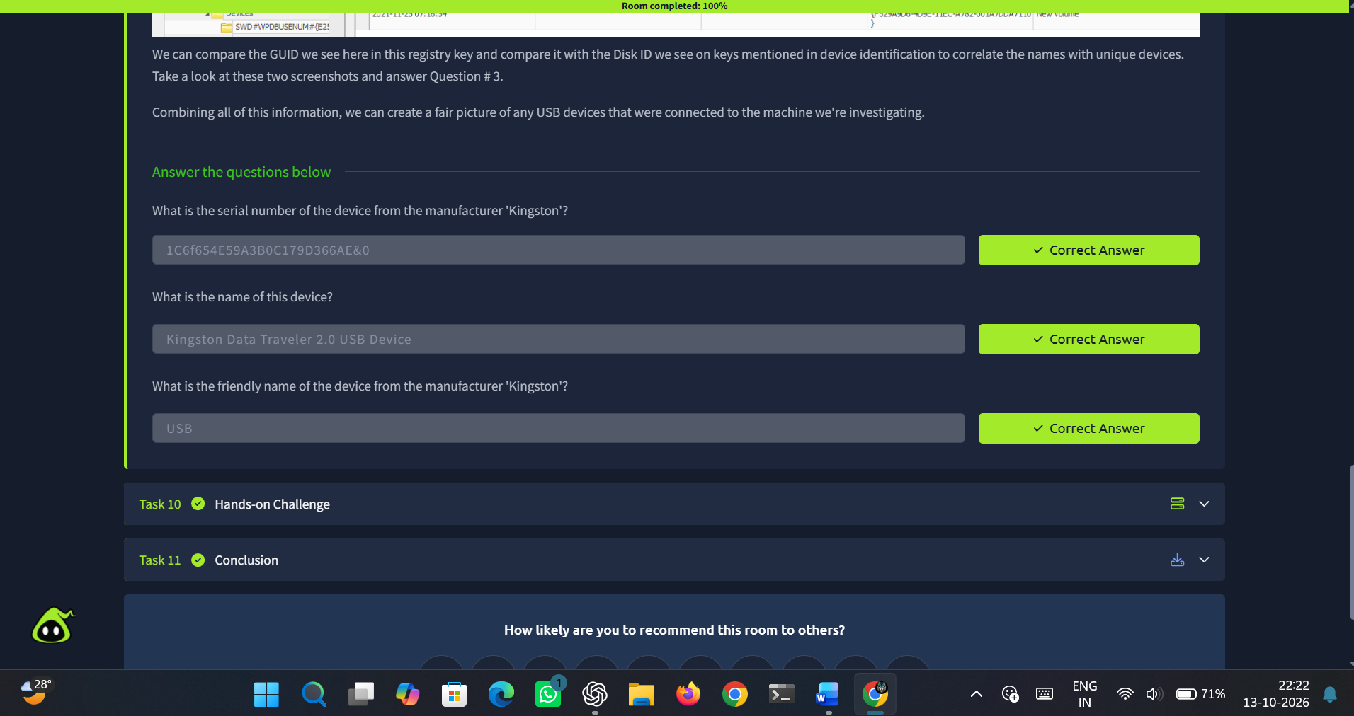
Figure 3.9 Task 9
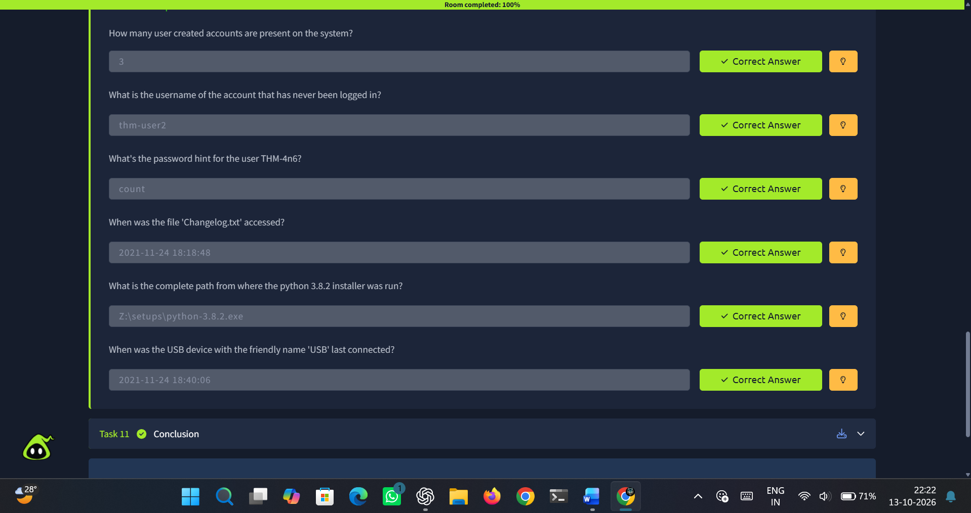
Figure 3.10 Task 10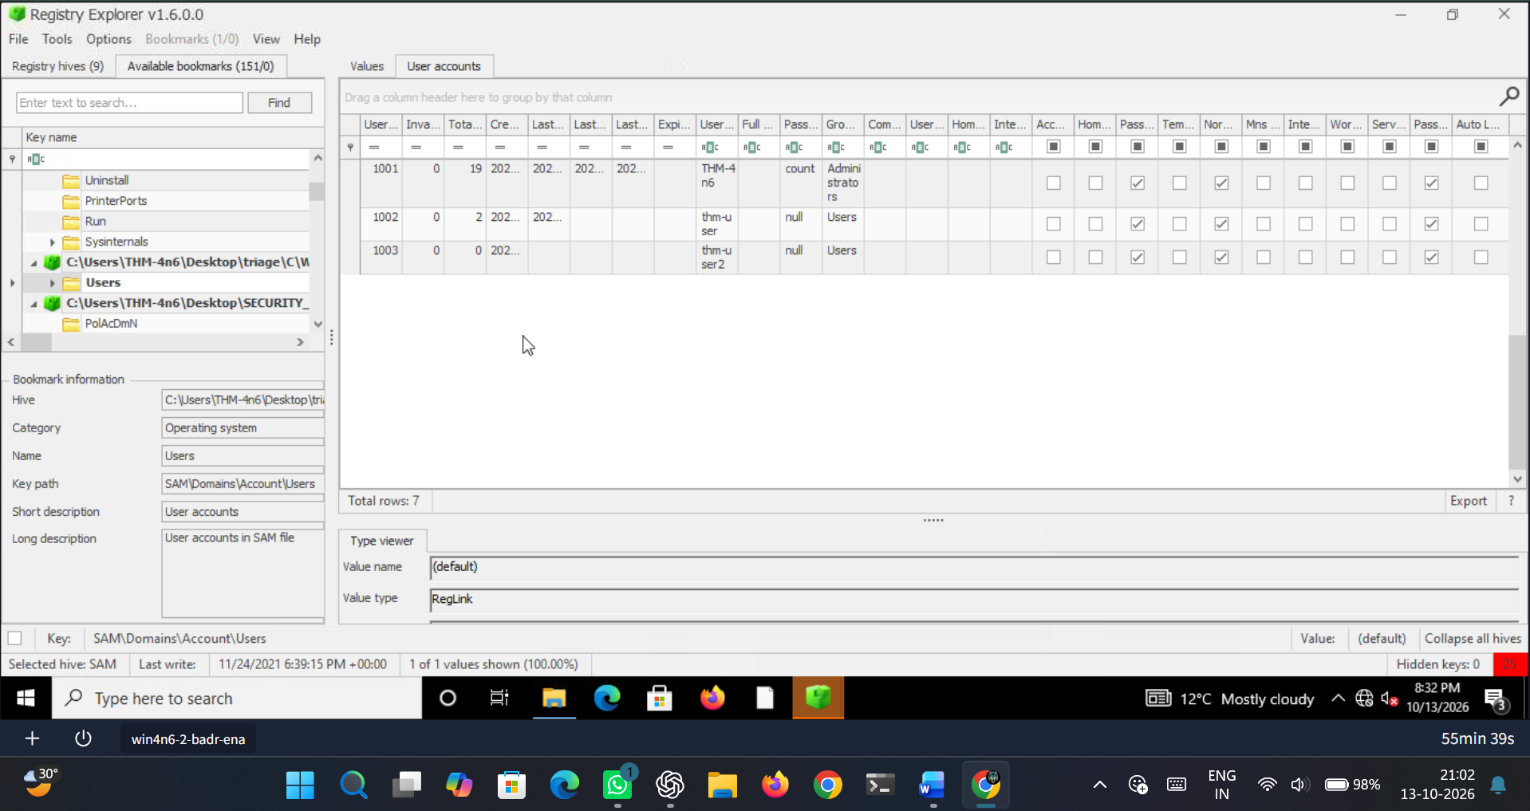
Figure 3.11 User accounts
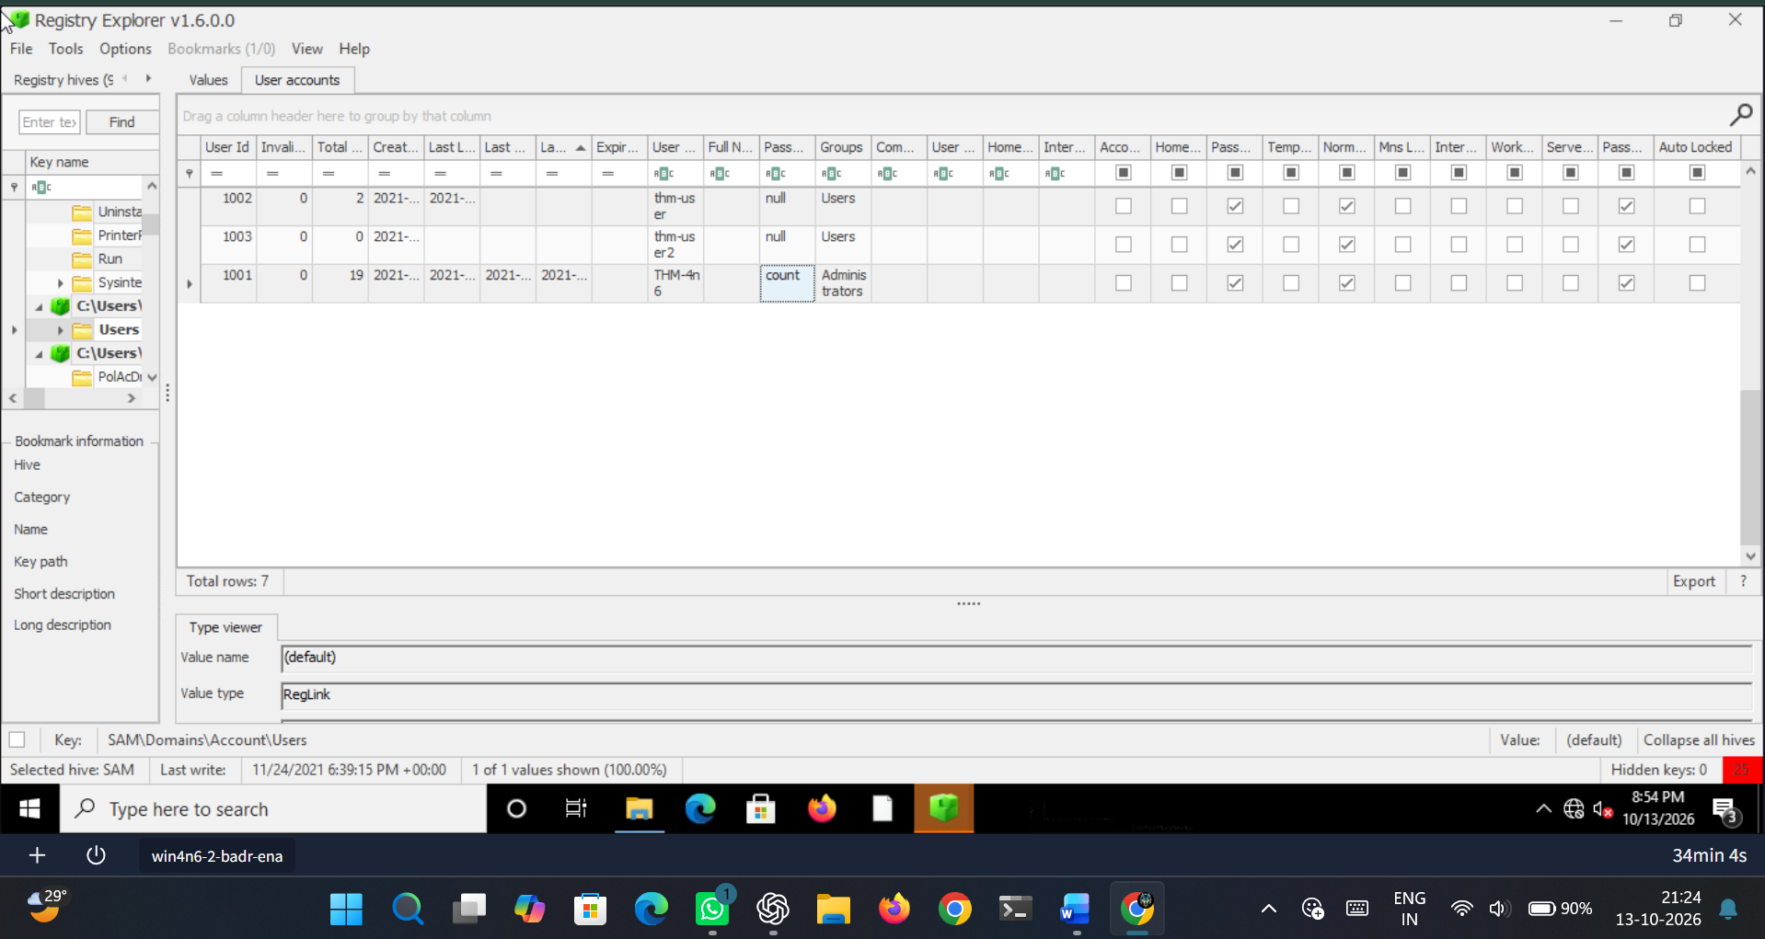
Figure 3.12 User account password
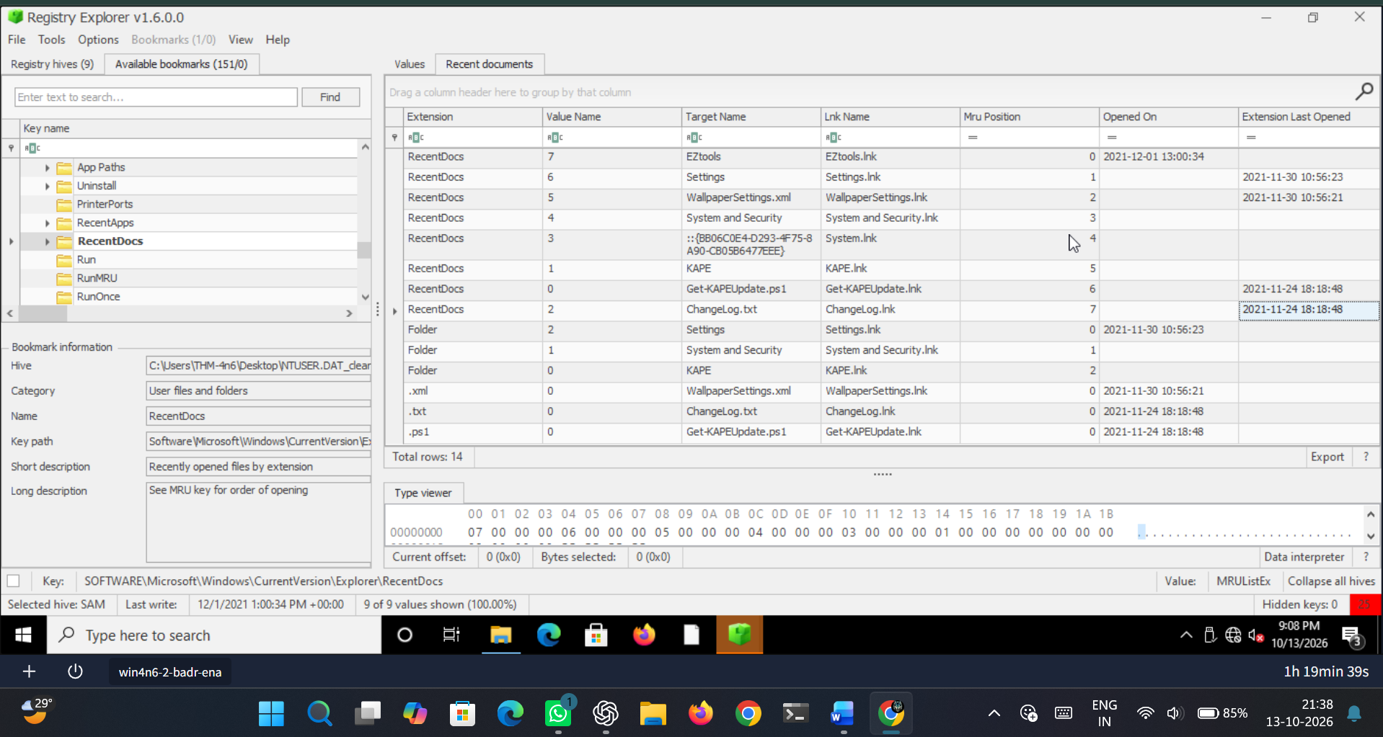
Figure 3.13 Last opened timestamp for ‘Changelog.txt’
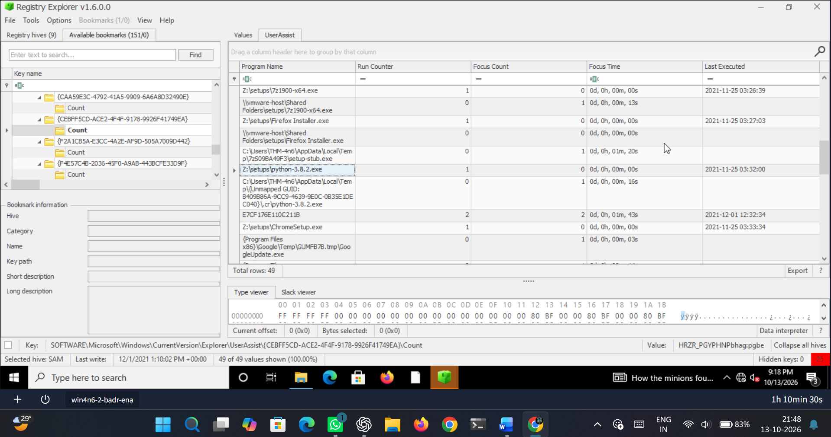
Figure 3.14 Complete path of python installer
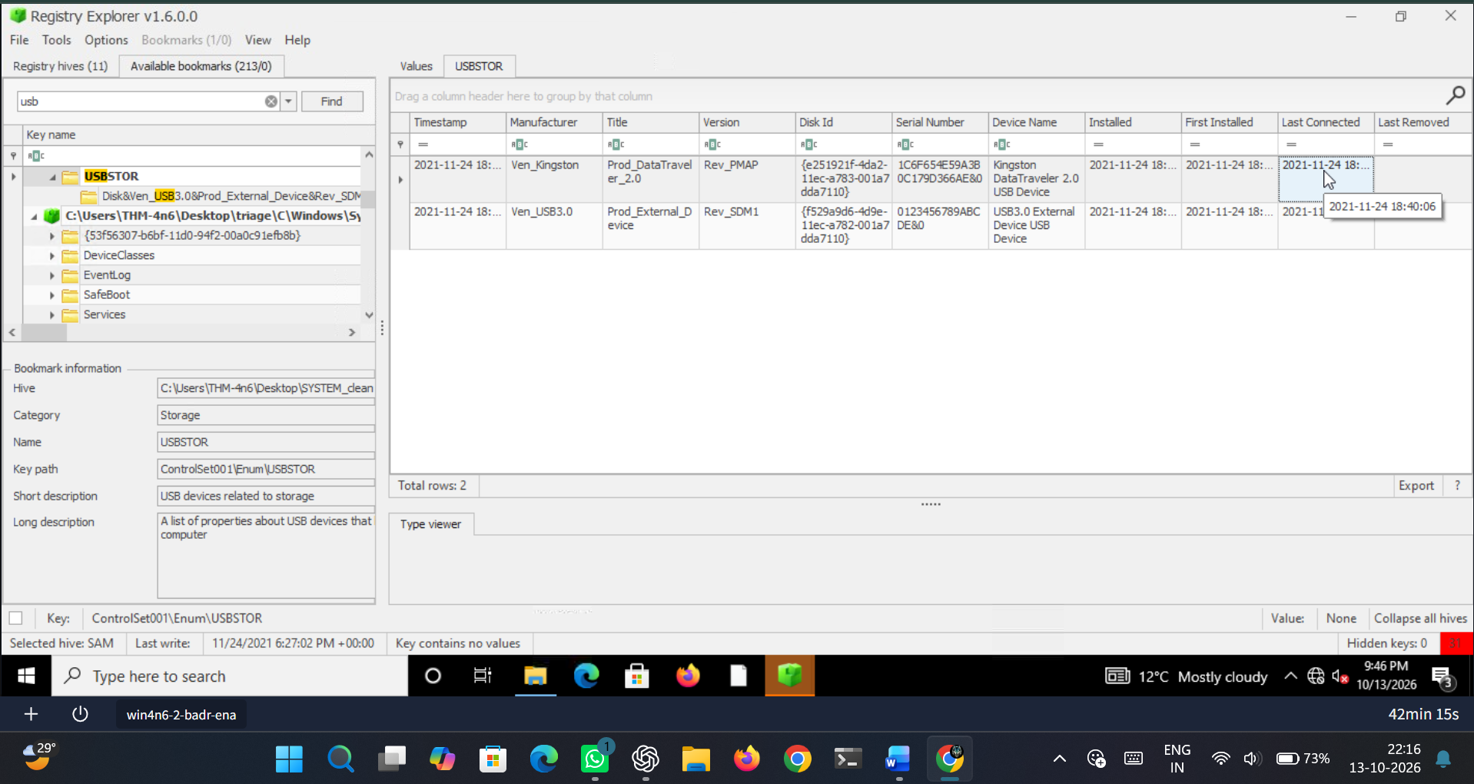
Figure 3.15 USB timestamp

RESULT:
Thus the TryHackMe Room ‘Windows Forensics 1’ was completed.

