EXPERIMENT NO: 4 DATE: 30/7/2026
LIVE FORENSIC INVESTIGATION USING AUTOPSY
AIM
To perform a basic forensic investigation of a Windows system using Autopsy and identify files, user activity, browser history, deleted files and other digital evidence.
SOFTWARE REQUIRED
- Windows 10/11
- Autopsy
- One authorized laboratory/test computer
- USB drive, if required
PROCEDURE
Step 1 – Open Autopsy
- Start Autopsy.
- Select Create New Case.
- Enter:
  - Case Name: Live_Forensics
  - Case Number: LF001
  - Examiner Name: Your Name
- Click Finish.
Step 2 – Add Evidence
- Click Add Data Source.
- Select Local Disk.
- Select the authorized test computer's C: drive.
- Click Next.
Important: Perform this only on the laboratory/test computer authorized by your instructor.
Step 3 – Select Ingest Modules
Select the following if available:
- Recent Activity
- File Type Identification
- Keyword Search
- Hash Lookup
Click Next / Finish.
Wait for the ingest process to complete.
Step 4 – Examine User Files
From the left panel, navigate to
Data Sources → C: → Users
Open the test user's folders:
- Desktop
- Documents
- Downloads
- Pictures
Identify any interesting files.
Record:
File Name | Location | File Type
325224910 | C:/Users/ponsu/Documents/NOTES/ds/325224910.pdf | .pdf

Step 5 – Examine Browser Activity
Go to
Results → Recent Activity
Look for
- Web history
- URLs
- Downloads
- Browser information
Record any two relevant entries.
Step 6 – Search for a Keyword
- Use Keyword Search.
- Search for a simple laboratory keyword such as:
ProjectX or Evidence
- Record the result.
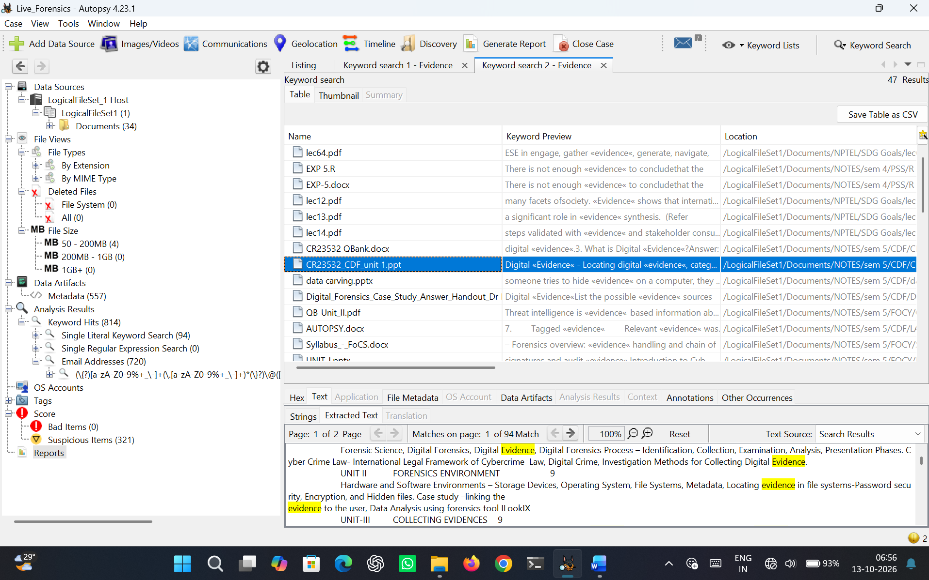
Figure 4.1 Result for keyword search ‘evidence’
Keyword | File | Location
evidence | CR23532_CDF_unit 1.ppt | C:/Users/ponsu/Documents/NOTES/sem 5/ CR23532_CDF_unit 1.ppt

Step 7 – Examine Deleted Files
Look under the available Deleted Files results.
Find one deleted file, if available.
Record:
- File name
- File type
- Location
- Size
- Deleted status

Step 8 – Examine File Details
Select one important file.
Check the Content Viewer / File Details.
Record:
- File name
- Path
- Size
- Created time
- Modified time
- Accessed time
Step 9 – Tag Important Evidence
Right-click the important file.
Select:
Tag → Interesting Item / Notable Item
Add a short comment such as:
"File identified as relevant evidence during the investigation."
Step 10 – Generate Report
Go to Tools → Generate Report
Select:
HTML Report
Generate the report.
Open the generated report and verify the evidence.

OBSERVATION:
S.No. | Evidence Examined | Finding
1. | User files | User folders were successfully examined and relevant user files were identified.
2. | Browser history | No browser history found.
3. | Downloaded files | No downloaded files were found.
4. | Keyword search | The keyword search located files containing the specific keyword, confirming the presence of matching data.
5. | Deleted files | No deleted files found.
6. | File timestamps | Created, modified, accessed timestamps of selected files were examined.
7. | Tagged evidence | Relevant evidence was tagged and documented.

SCREENSHOTS:
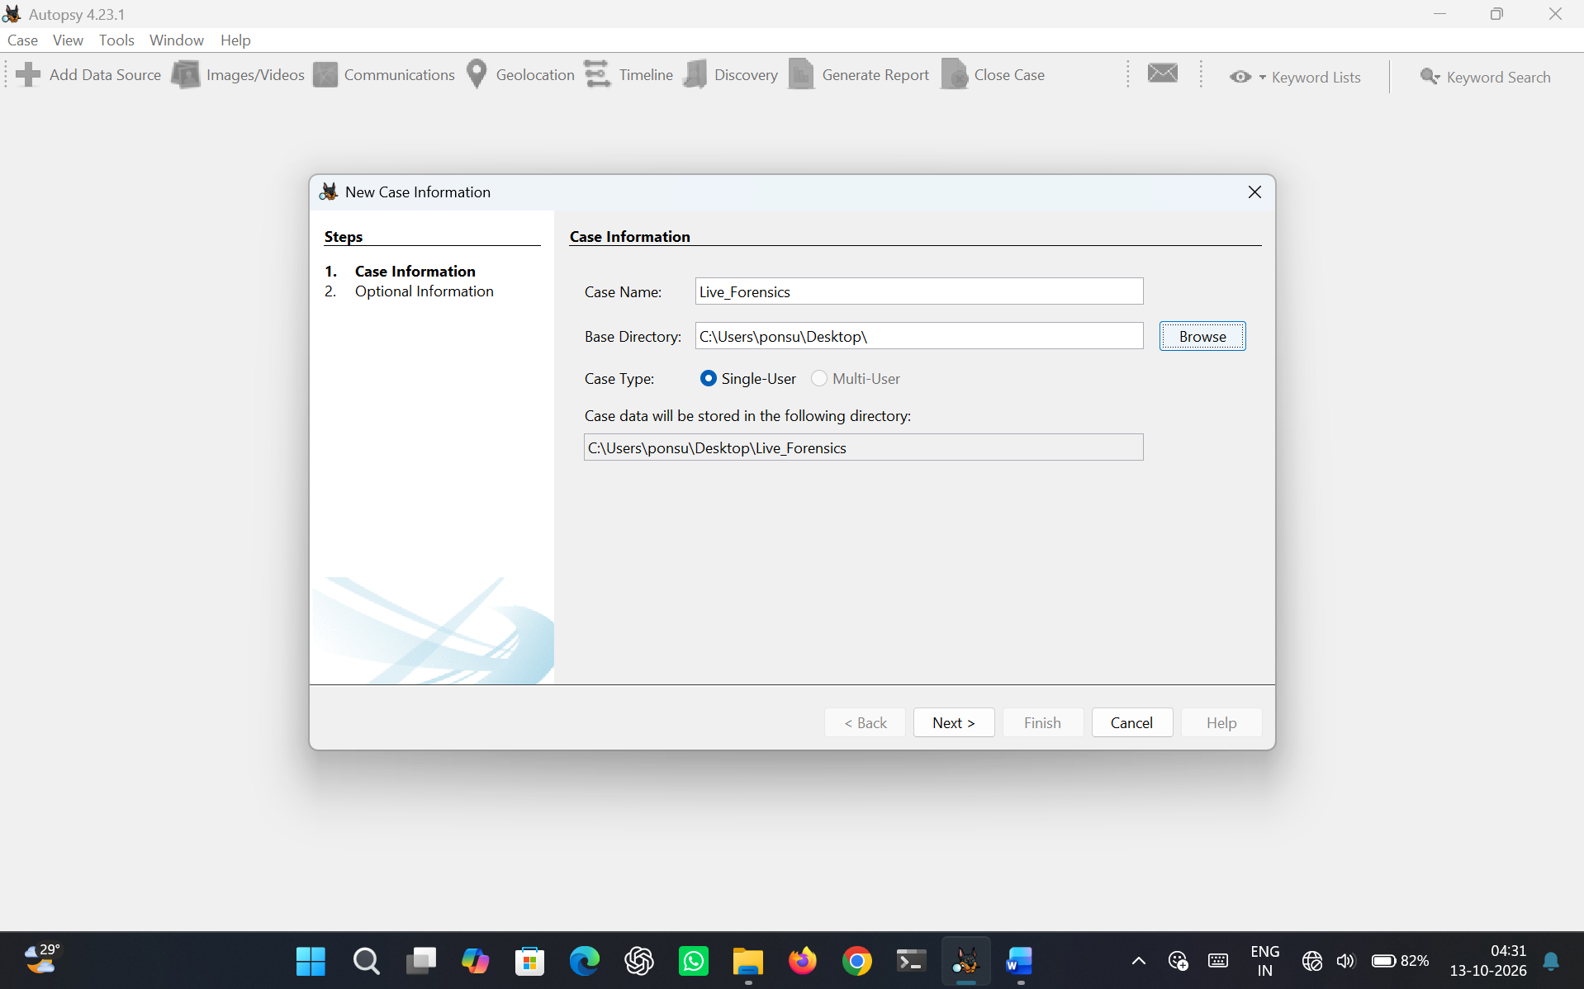
Figure 4.2 New case
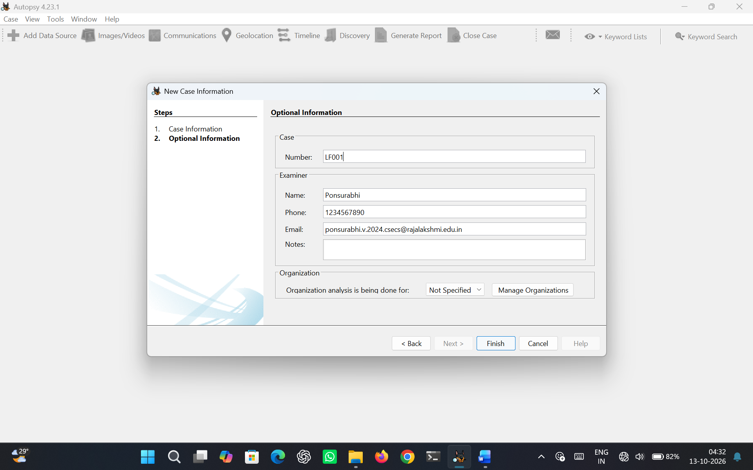
Figure 4.3 Case details

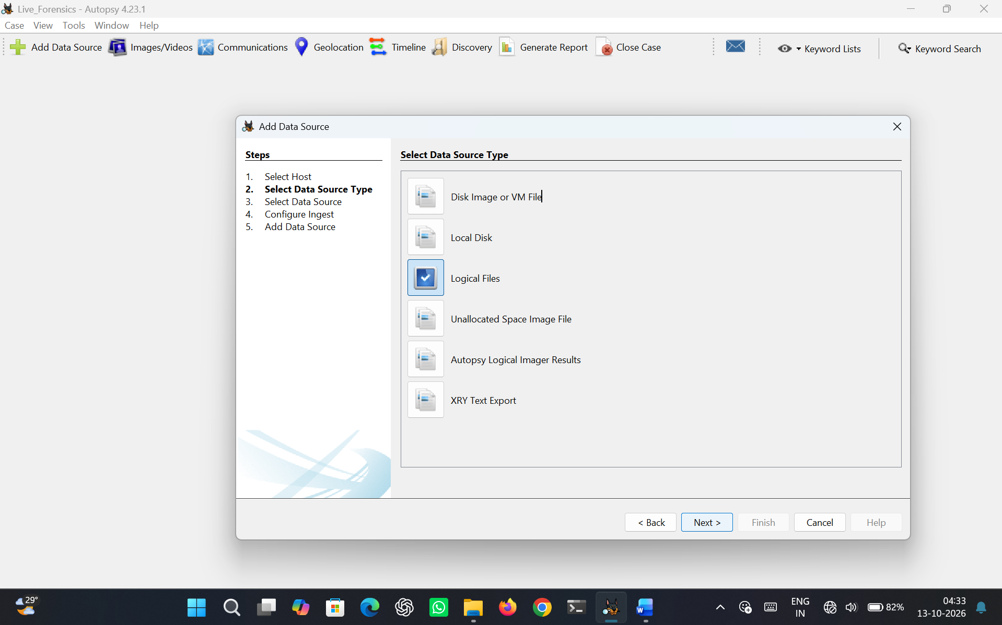
Figure 4.4 – Data source type
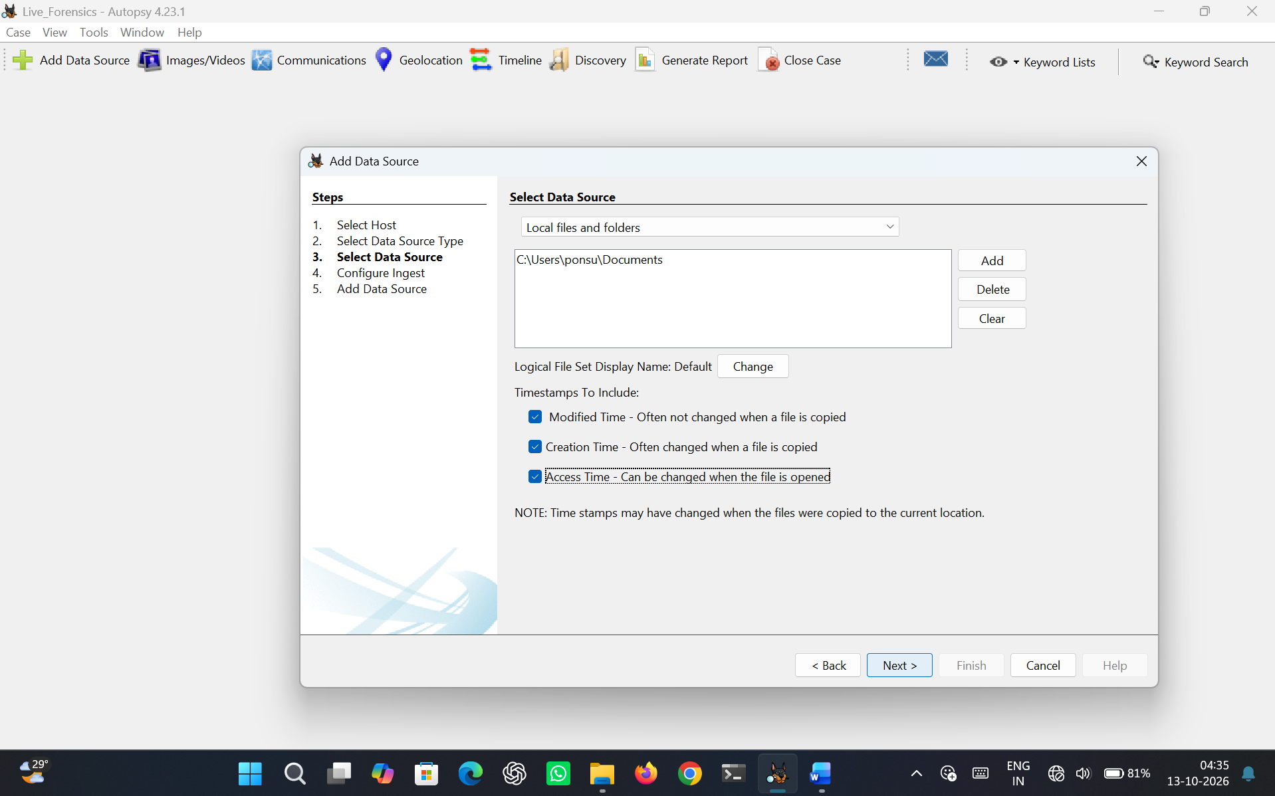
Figure 4.5 Select Data source
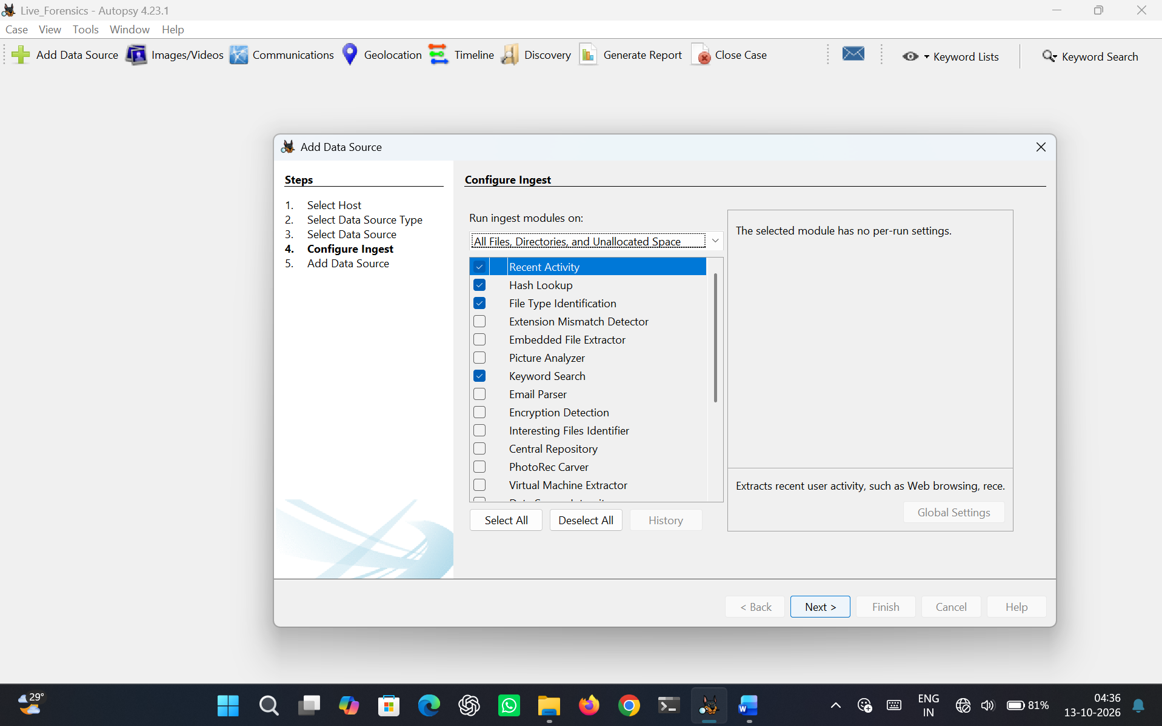
Figure 4.6 Configure Ingest
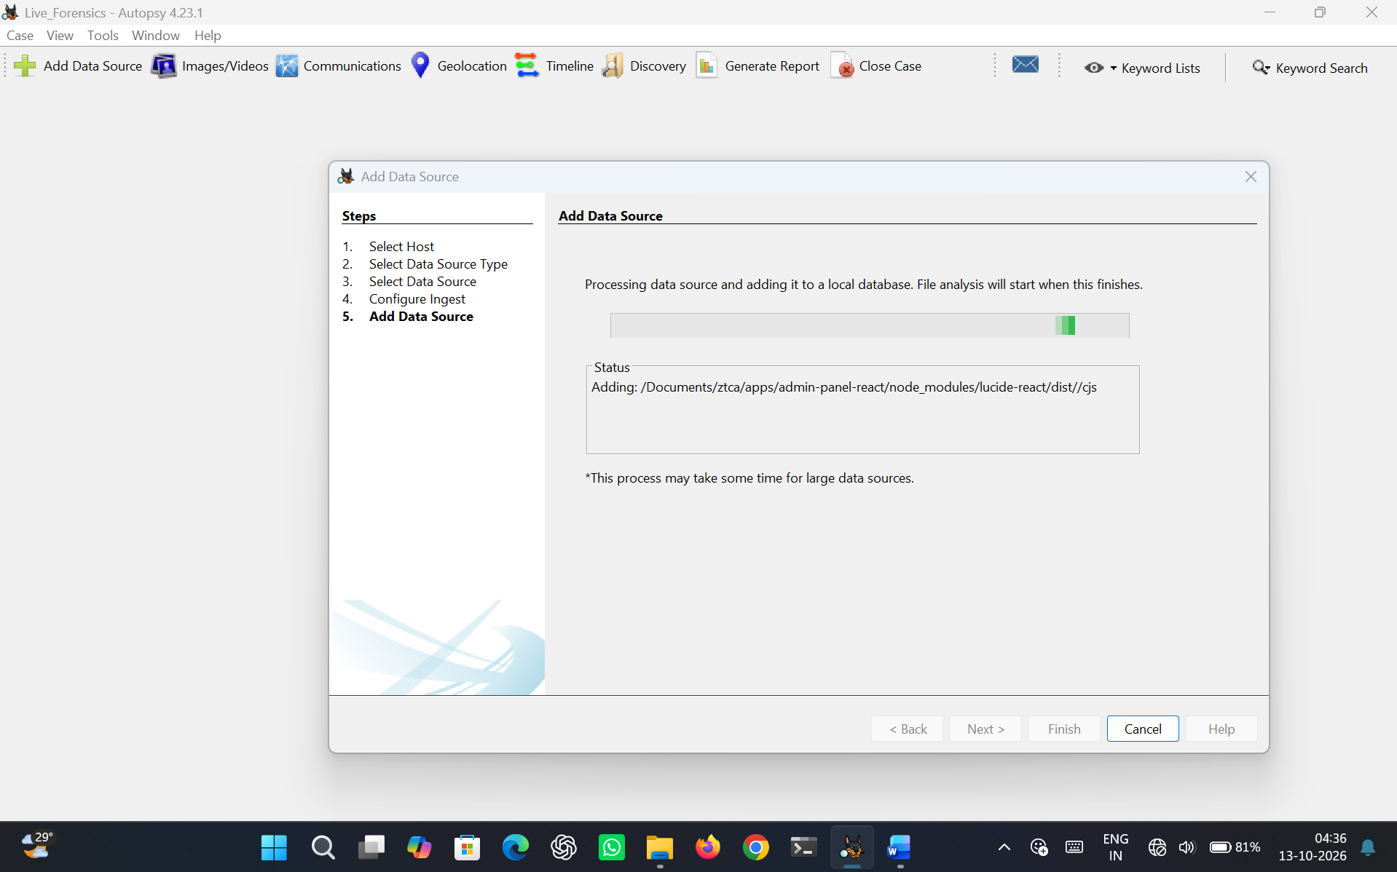
Figure 4.7 Add data source
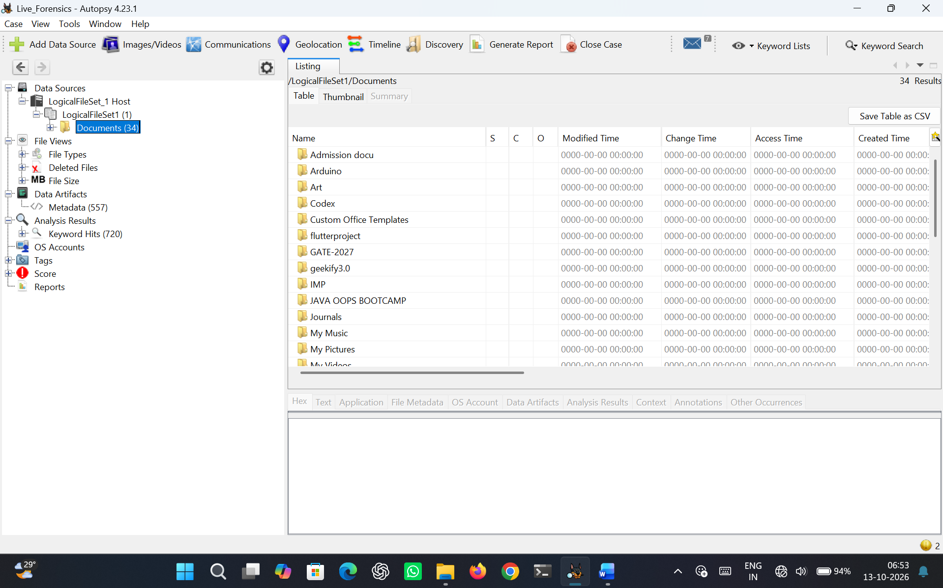
Figure 4.8 Results
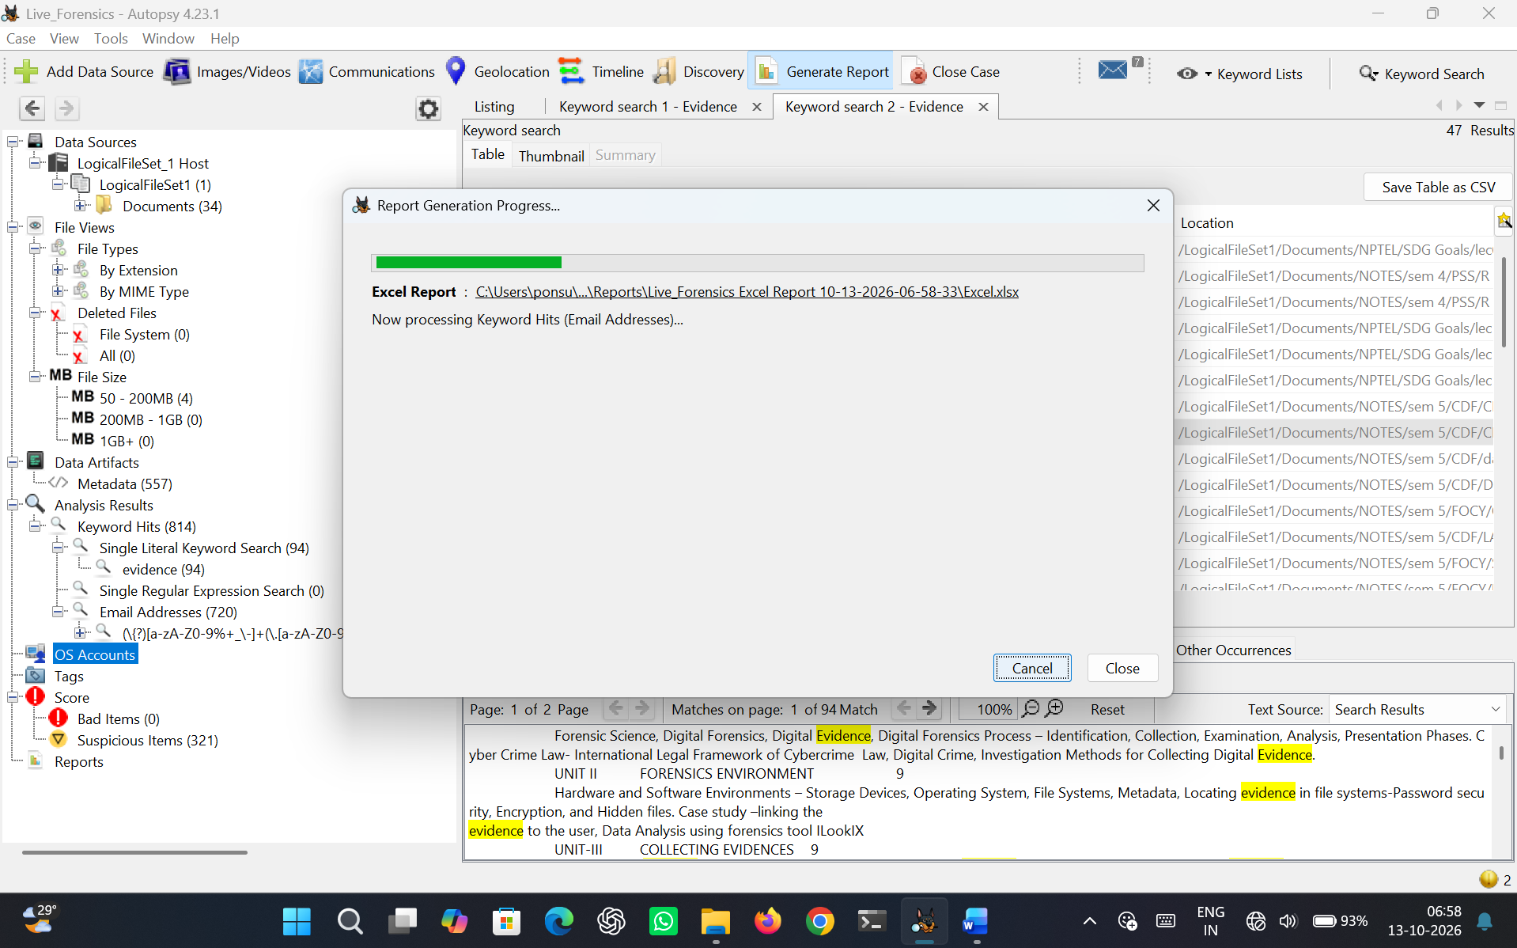
Figure 4.9 Generate Report
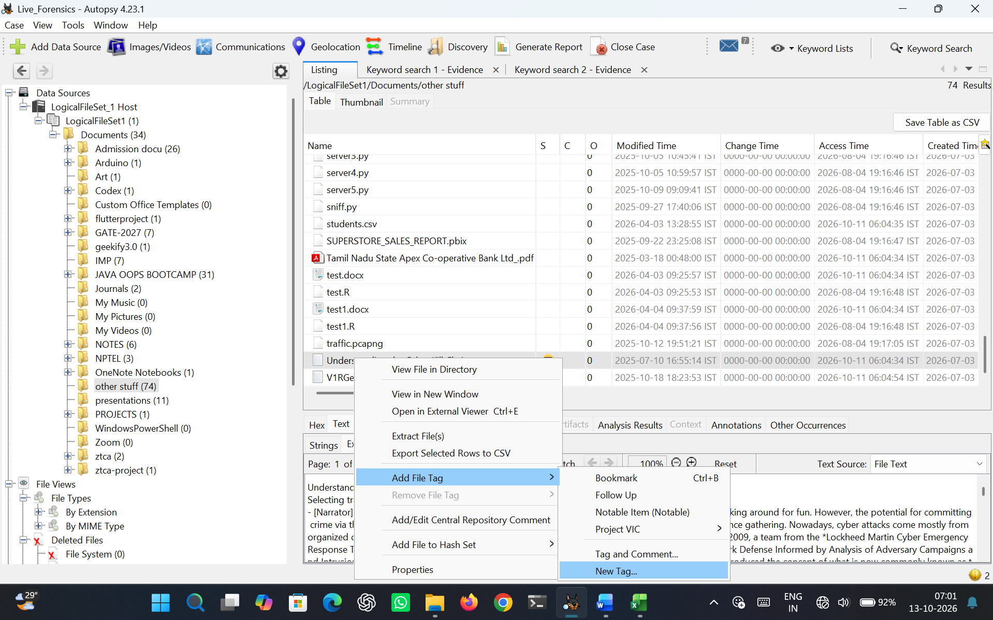
Figure 4.10 Tag Interesting Item
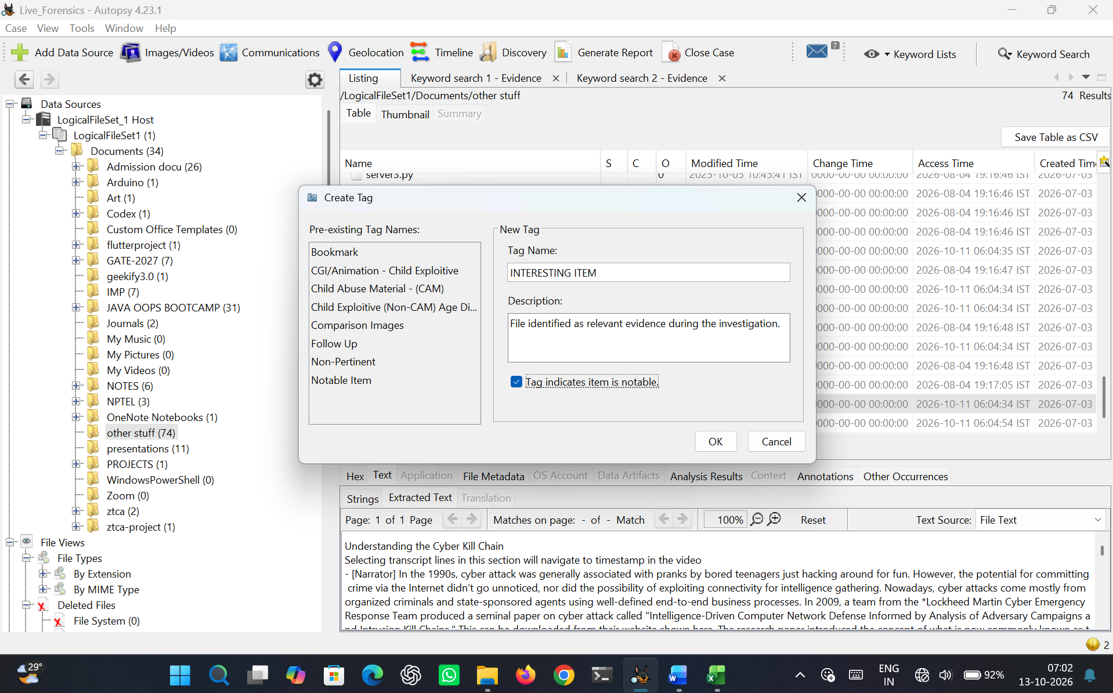
Figure 4.11 Create Tag
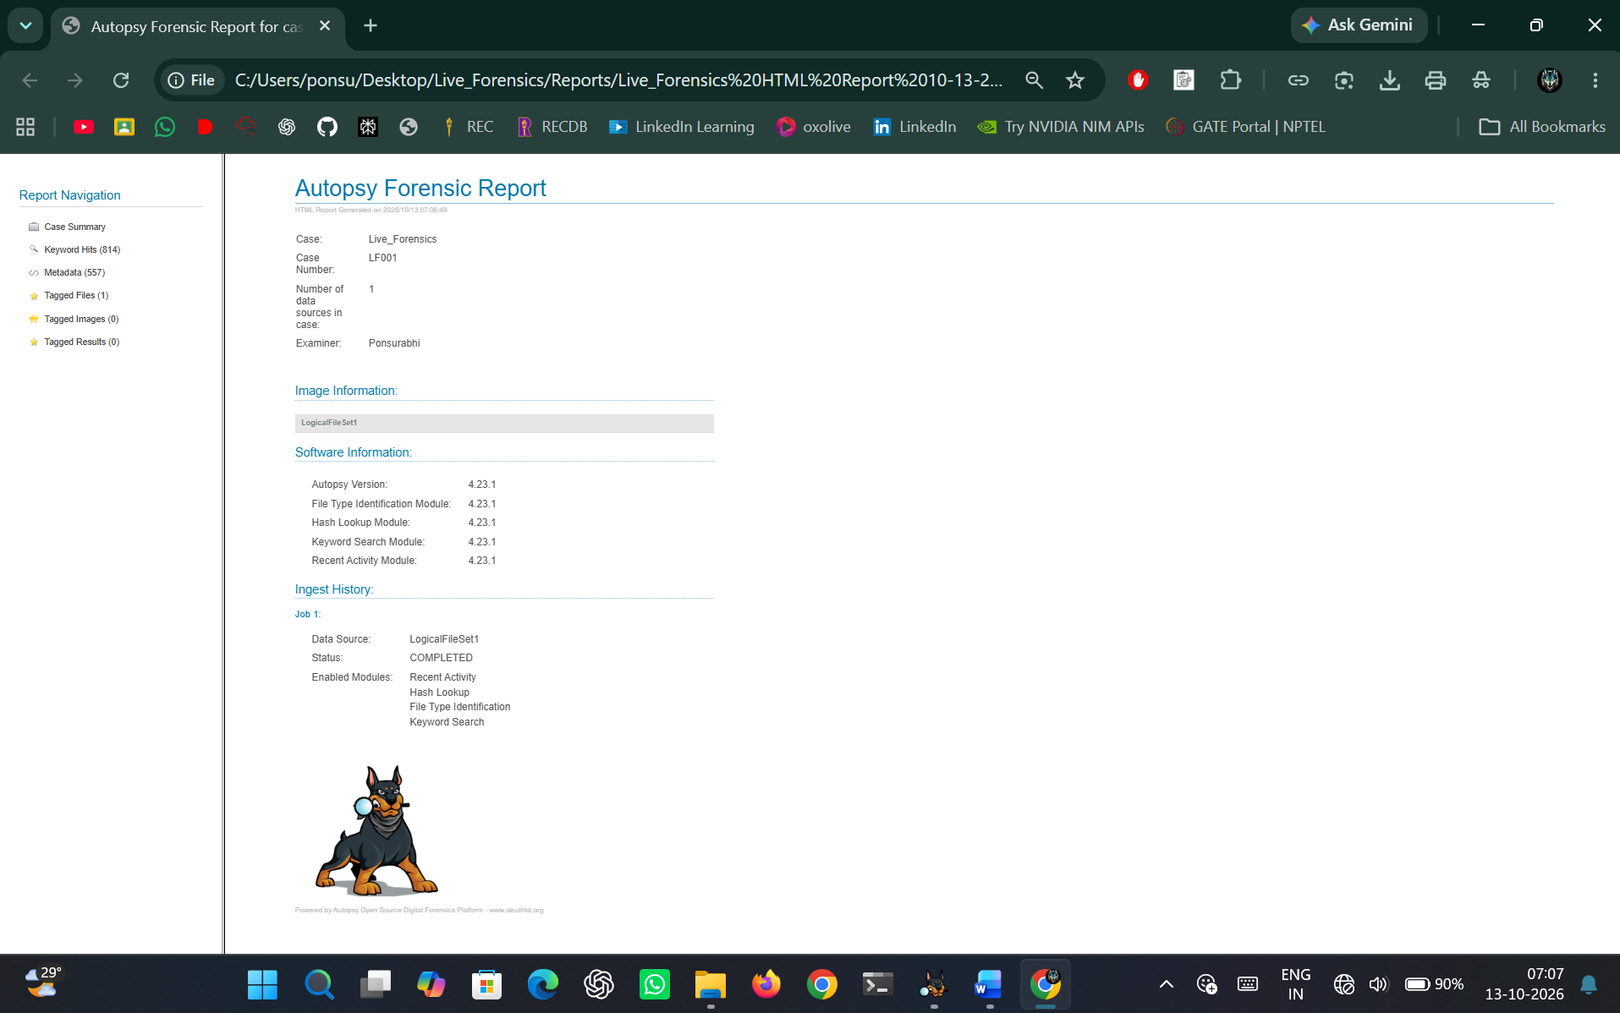
Figure 4.12 Autopsy Forensic Report

RESULT
The Windows test system was successfully investigated using Autopsy. Relevant digital evidence including user files, browser activity, deleted files and file metadata was identified, examined and documented. A forensic HTML report was successfully generated.

