EXPERIMENT NO: 5 DATE: 06/08/2026
FTK IMAGER - DISK IMAGING AND EVIDENCE ACQUISITION

AIM
To acquire a forensic image of a storage device using FTK Imager while preserving the integrity of digital evidence.
OBJECTIVES
- Understand forensic disk acquisition.
- Create a forensic image using FTK Imager.
- Generate hash values (MD5/SHA1).
- Verify image integrity.
- Document the acquisition process.
TOOLS & REQUIREMENTS
- FTK Imager
- Windows 10/11
- USB Drive (4 GB or above) or Sample Evidence Image
- External Storage Device (for saving the image)
- Write Blocker (Recommended)
THEORY
FTK Imager is a digital forensic acquisition tool used to create exact bit-by-bit copies of storage media. It captures allocated, deleted, and unallocated data without modifying the original evidence. Hash values are generated during acquisition to ensure evidence integrity.
Source Drive (Evidence) → FTK Imager (Forensic Acquisition) → Forensic Image (E01 Format)
E01 IMAGE FORMAT
- Expert Witness Compression Format.
- Stores data, metadata, and hash values.
- Widely accepted in digital forensics.
- Supports segmenting large images.
BEST PRACTICES
- Always use a write blocker.
- Never analyze the original evidence.
- Store images in secure media.
- Maintain chain of custody.
- Verify hash values after acquisition.
PROCEDURE
Step 1: Launch FTK Imager.
Step 2 : Select File → Create Disk Image.
Step 3 : Choose the source type:
- Physical Drive
- Logical Drive
- Image File
- Contents of a Folder
Click Next.
Step 4: Select the required source drive.
Step 5: Click Add to specify the destination.
Step 6: Choose E01 (Expert Witness Format).
Step 7: Enter case details:
- Case Number: CASE-001
- Evidence Number: EVD-001
- Examiner: Student Name
- Description: USB Drive Image
Click Next.
Step 8: Specify the destination folder and image filename.
Step 9: Enable verification and hash calculation:
Verify images after acquisition
- Calculate MD5
- Calculate SHA1
Click Start.
Step 10: Click Start to begin acquisition.
Step 11: Wait until imaging completes successfully.
Step 12: Note the generated MD5 and SHA1 hash values.

OBSERVATIONS:
- Evidence Source: USB Drive Image (hp x796w USB Device)
- Image Format: E01 (EnCase Evidence File)
- Image Size: 14,800 MB
- MD5 Hash: b30428587f6ebcc57d5693e4c0642594
- SHA1 Hash: 5d98684ddc5a5f8c471df0cc7e1d07c586e154b0
- Acquisition Time: 13-10-2026, 04:10:06 AM – 04:14:12 AM
- Verification Status: Verified (MD5 and SHA1 checksums matched).

SCREENSHOTS:
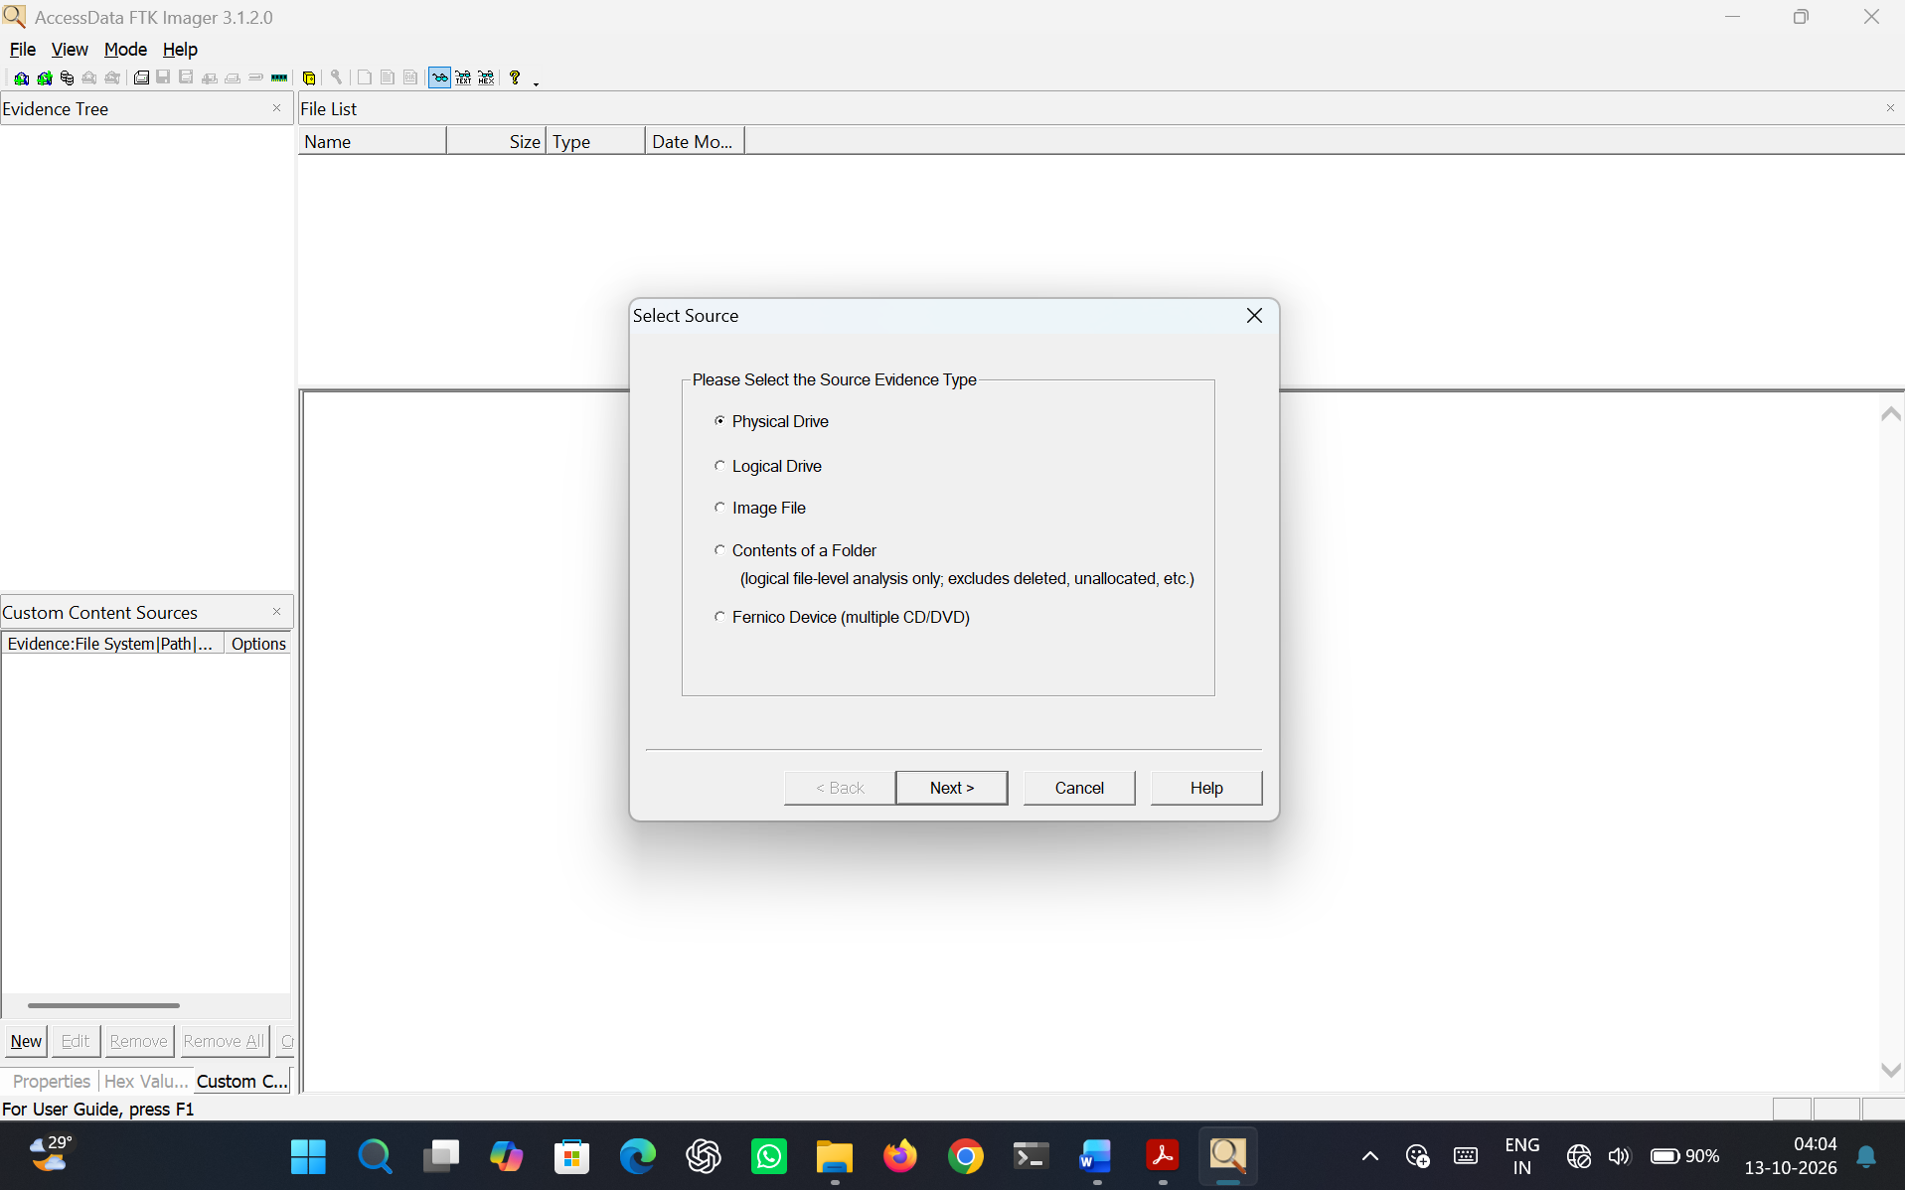
Figure 5.1 Select Source
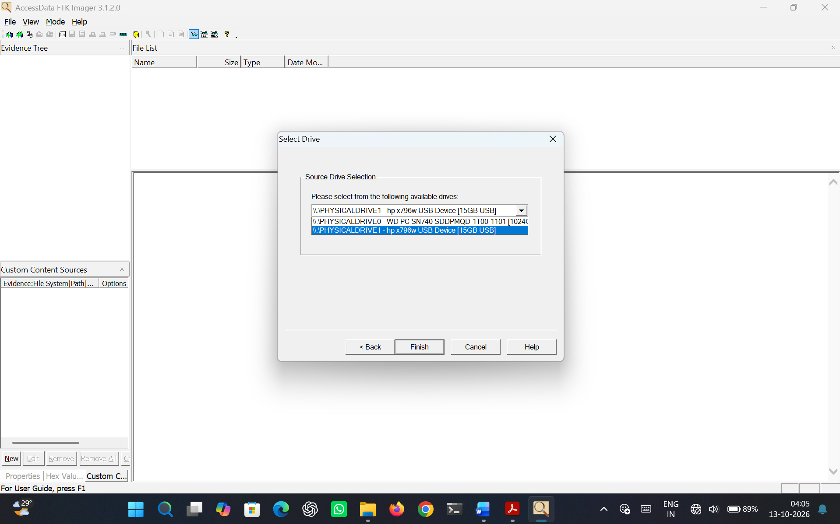
Figure 5.2 Select Drive
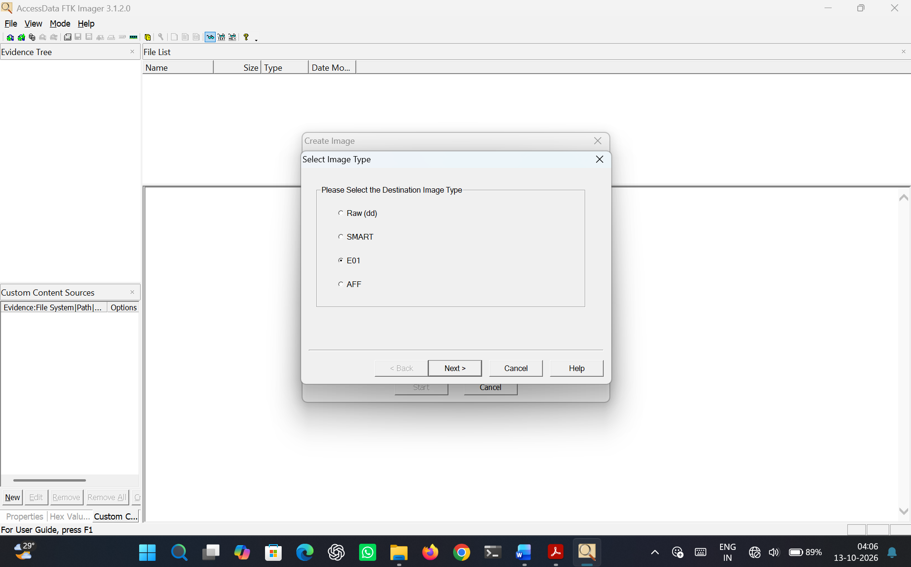
Figure 5.3 Select Image type
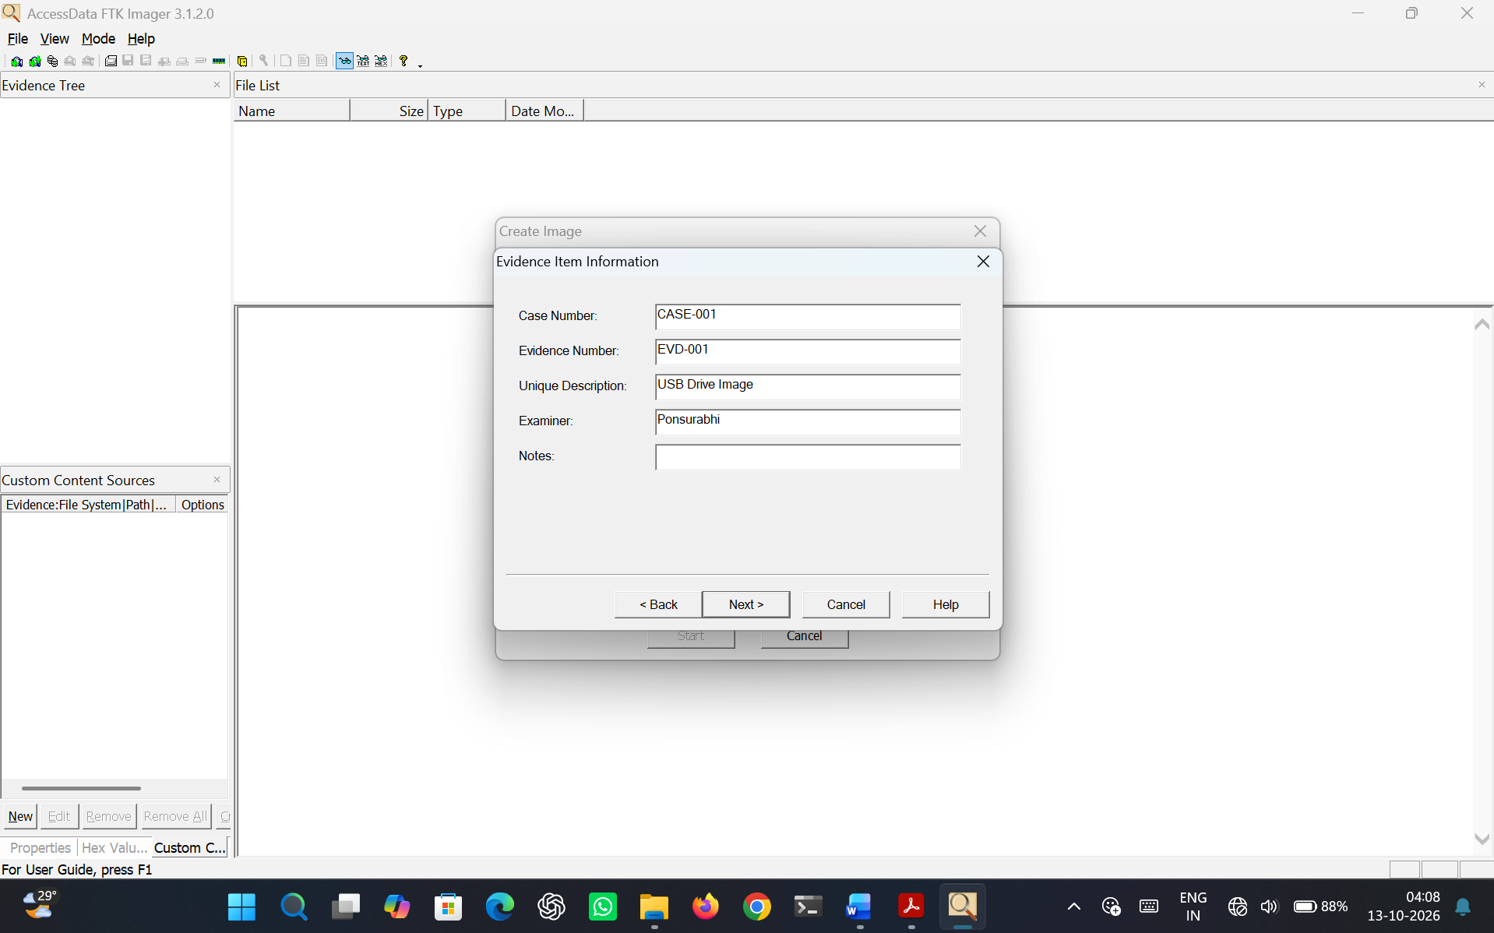
Figure 5.4 Fill evidence item information
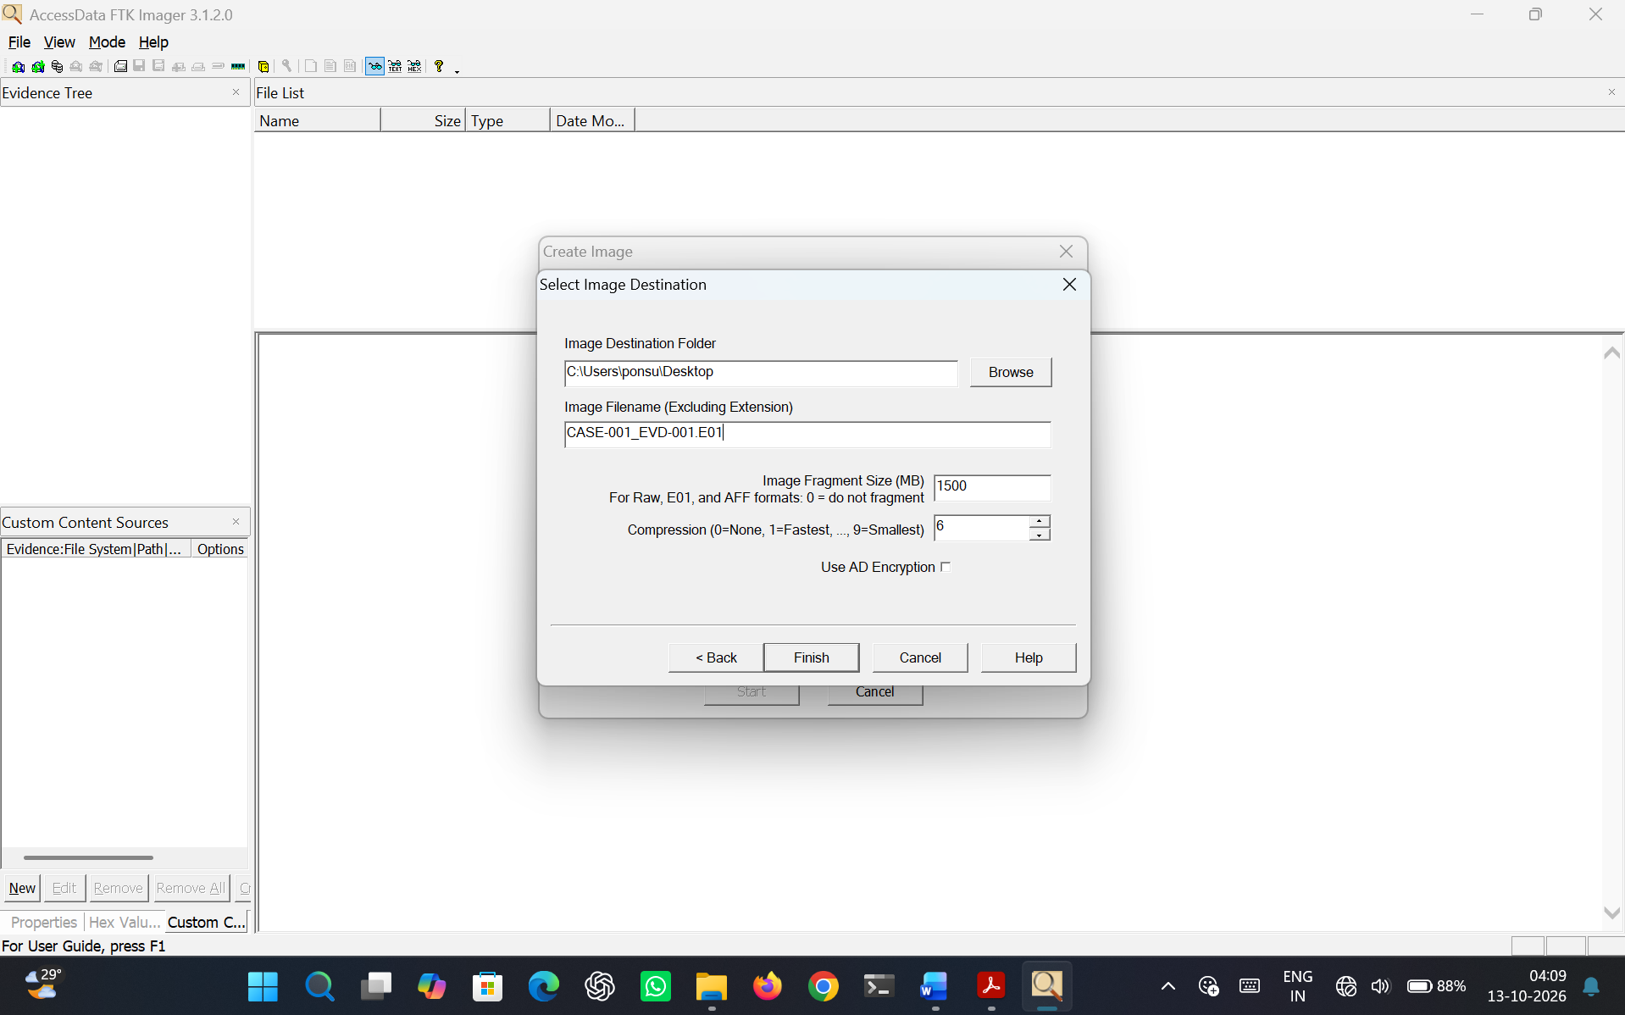
Figure 5.5 Select Image destination
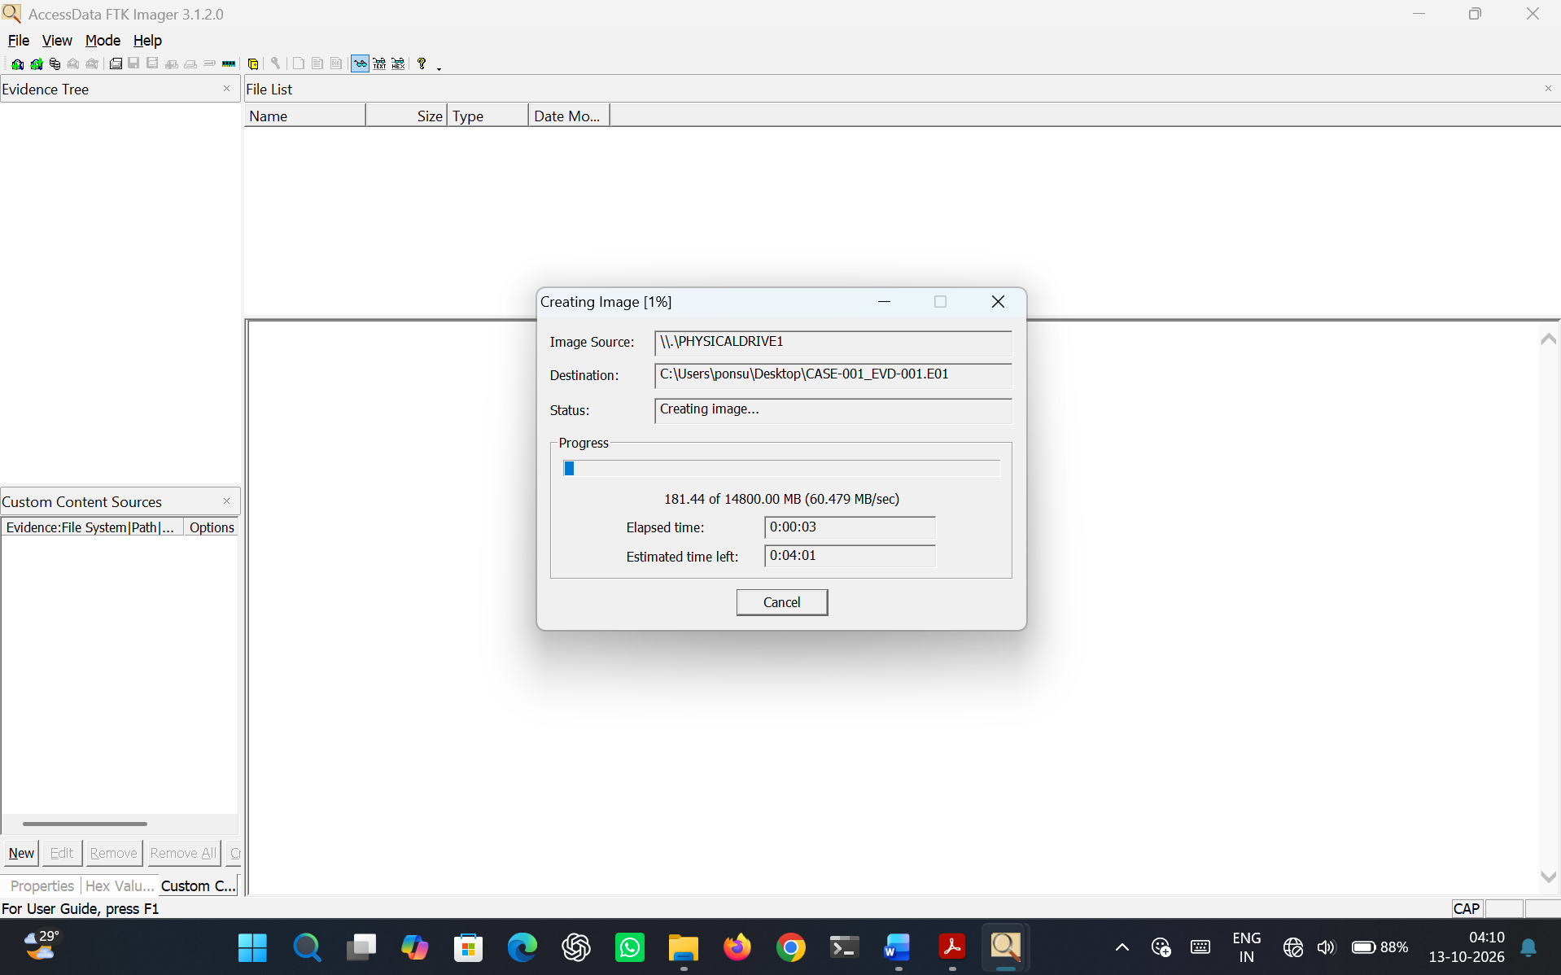
Figure 5.6 Creating Image
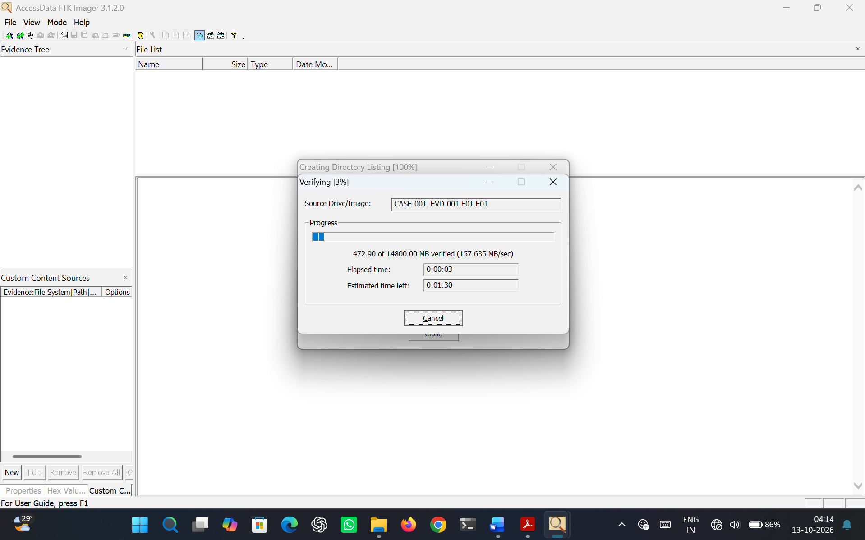
Figure 5.7 Verifying Image
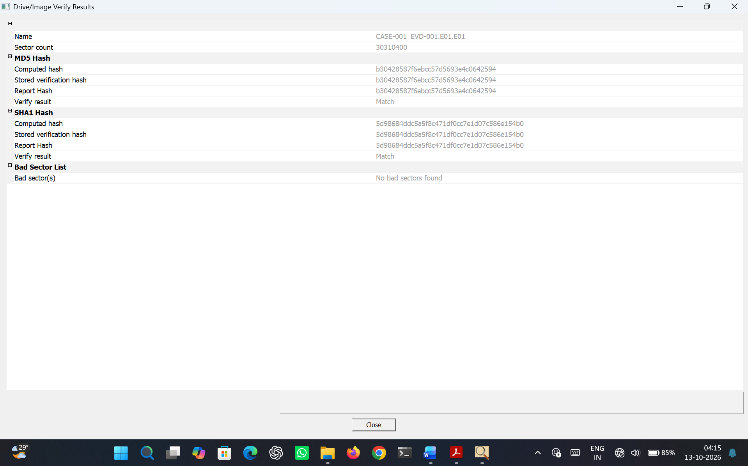
Figure 5.8 Hash generated
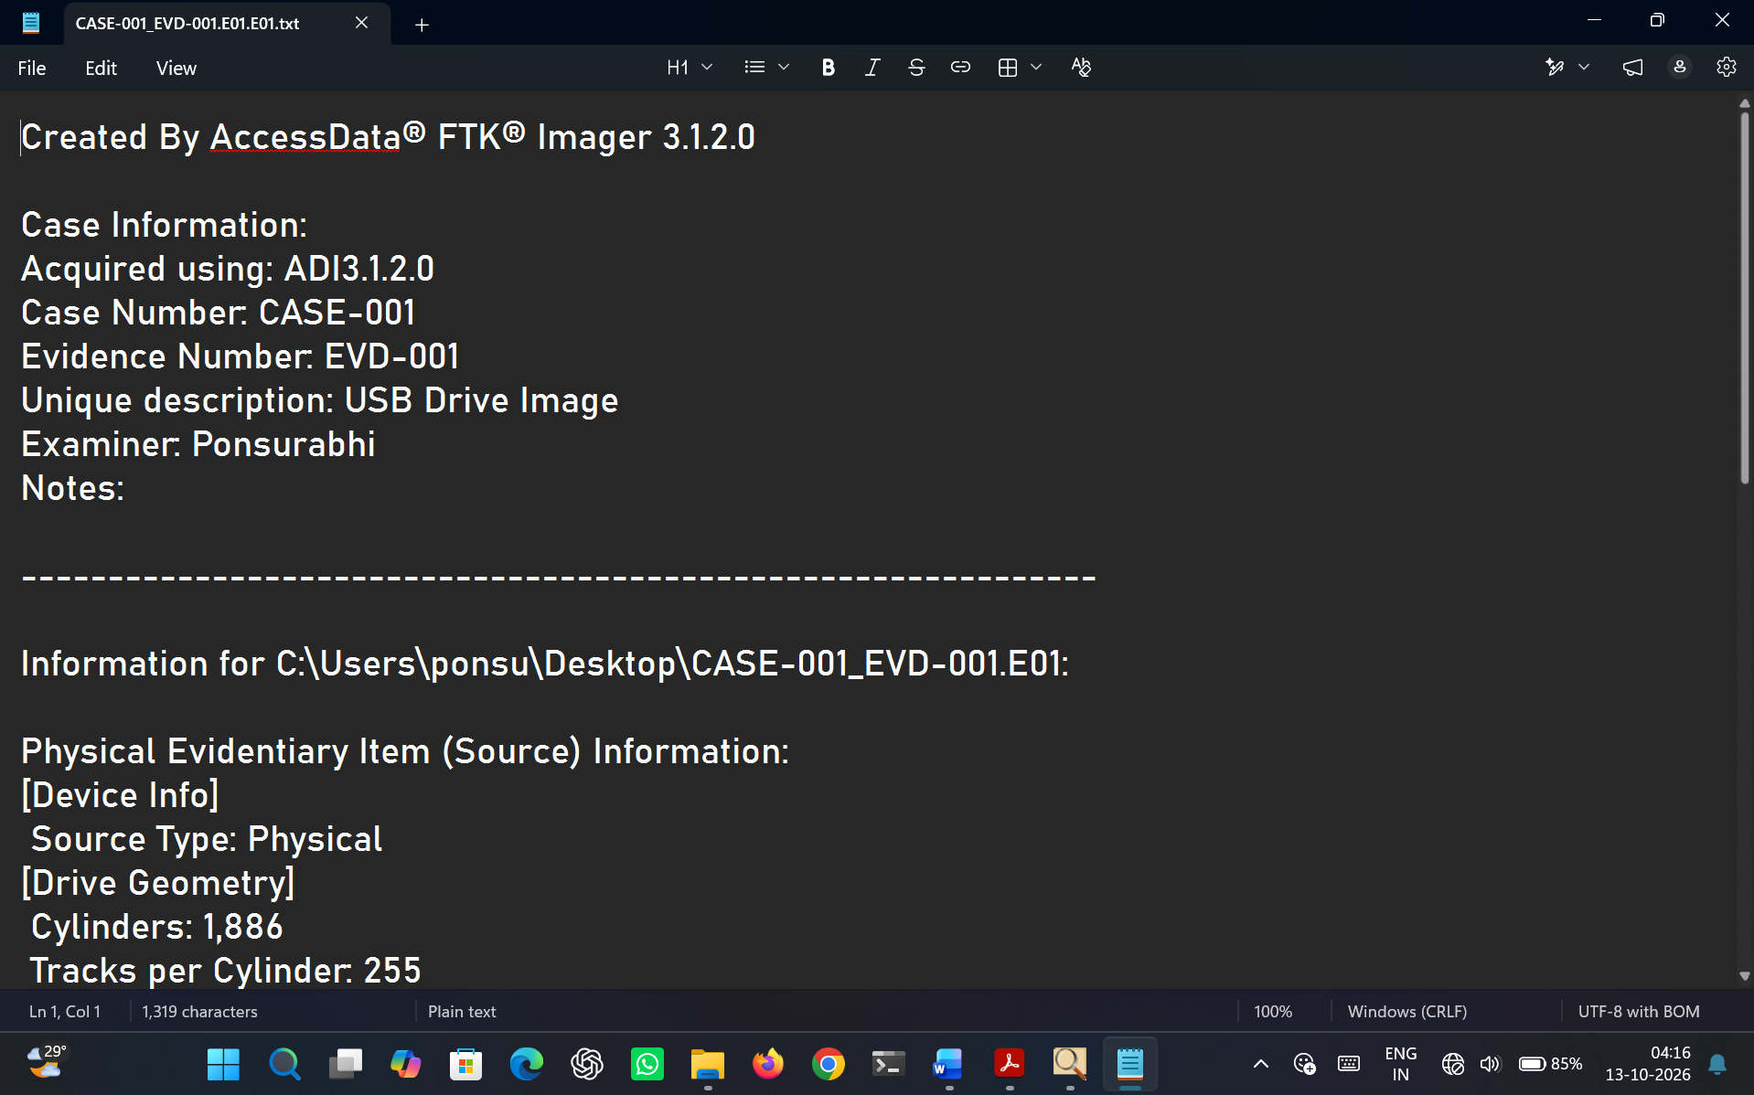
Figure 5.9 Text Report

RESULT
A forensic image of the storage device was successfully acquired and verified using FTK Imager. The generated hash values confirmed that the acquired image maintained data integrity.

