EXPERIMENT NO: 6 DATE: 13/08/2026
FIND LAST CONNECTED USB ON YOUR SYSTEM
(USB FORENSICS)
AIM
To identify the last connected USB device on your system using USBDeview.
PROCEDURE
1. Download USBDeview
- Open your browser and go to the NirSoft website.
- Download USBDeview (ZIP file).
2. Extract the Downloaded File
- Extract the downloaded ZIP file to any folder.
- Run USBDeview.exe.
3. Run USBDeview as Administrator
- Right-click on USBDeview.exe.
- Select Run as administrator.
4. USBDeview Main Window
- USBDeview lists all USB devices currently connected and previously used.
- Each entry contains detailed information about the USB device.
- The Last Plug/Unplug Date column shows when the USB device was last connected or disconnected.
5. Identify Last Connected USB
- Click on the Last Plug/Unplug Date column header to sort the entries.
- The top entry will show the most recently used USB device.
- Note the following details:
- Device Name
- Description
- Serial Number
- Last Plug/Unplug Date
6. View Detailed Information
- Double-click on any USB device to view detailed information.
- The information includes:
- Property
- Device Name
- Device Type
- Serial Number
- Last Plug/Unplug Date
- Vendor ID
- Product ID
- USB Class
- USB SubClass
- USB Protocol
7. Export the Report (Optional)
- Go to the File menu.
- Select the required export option.
- Reports can be saved in formats such as:
- HTML
- CSV
- TXT
- Save the report for documentation.
8. Optional – Uninstall / Disable USB Device
- Right-click on any previously used USB device.
- You can:
- Uninstall the selected device.
- Disable the selected device.
- Enable the selected device.
- Caution: Do not uninstall or disable devices during forensic examination unless specifically required.
9. Optional – Remote Computer
- USBDeview can also be used on a remote computer.
- Log in using an administrator account and run the tool.
10. Record Observations
- Record the last connected USB device details in the lab manual:

OBSERVATION:
- Device Name: 0000.0014.0000.0003.000.000.000.000.000
- Description: USB Audio Device
- Serial Number: Not available
- Last Plug/Unplug Date: 11-10-2026 05:53:48 AM
- Vendor ID: 001F
- Product ID: 0B21
SCREENSHOTS:
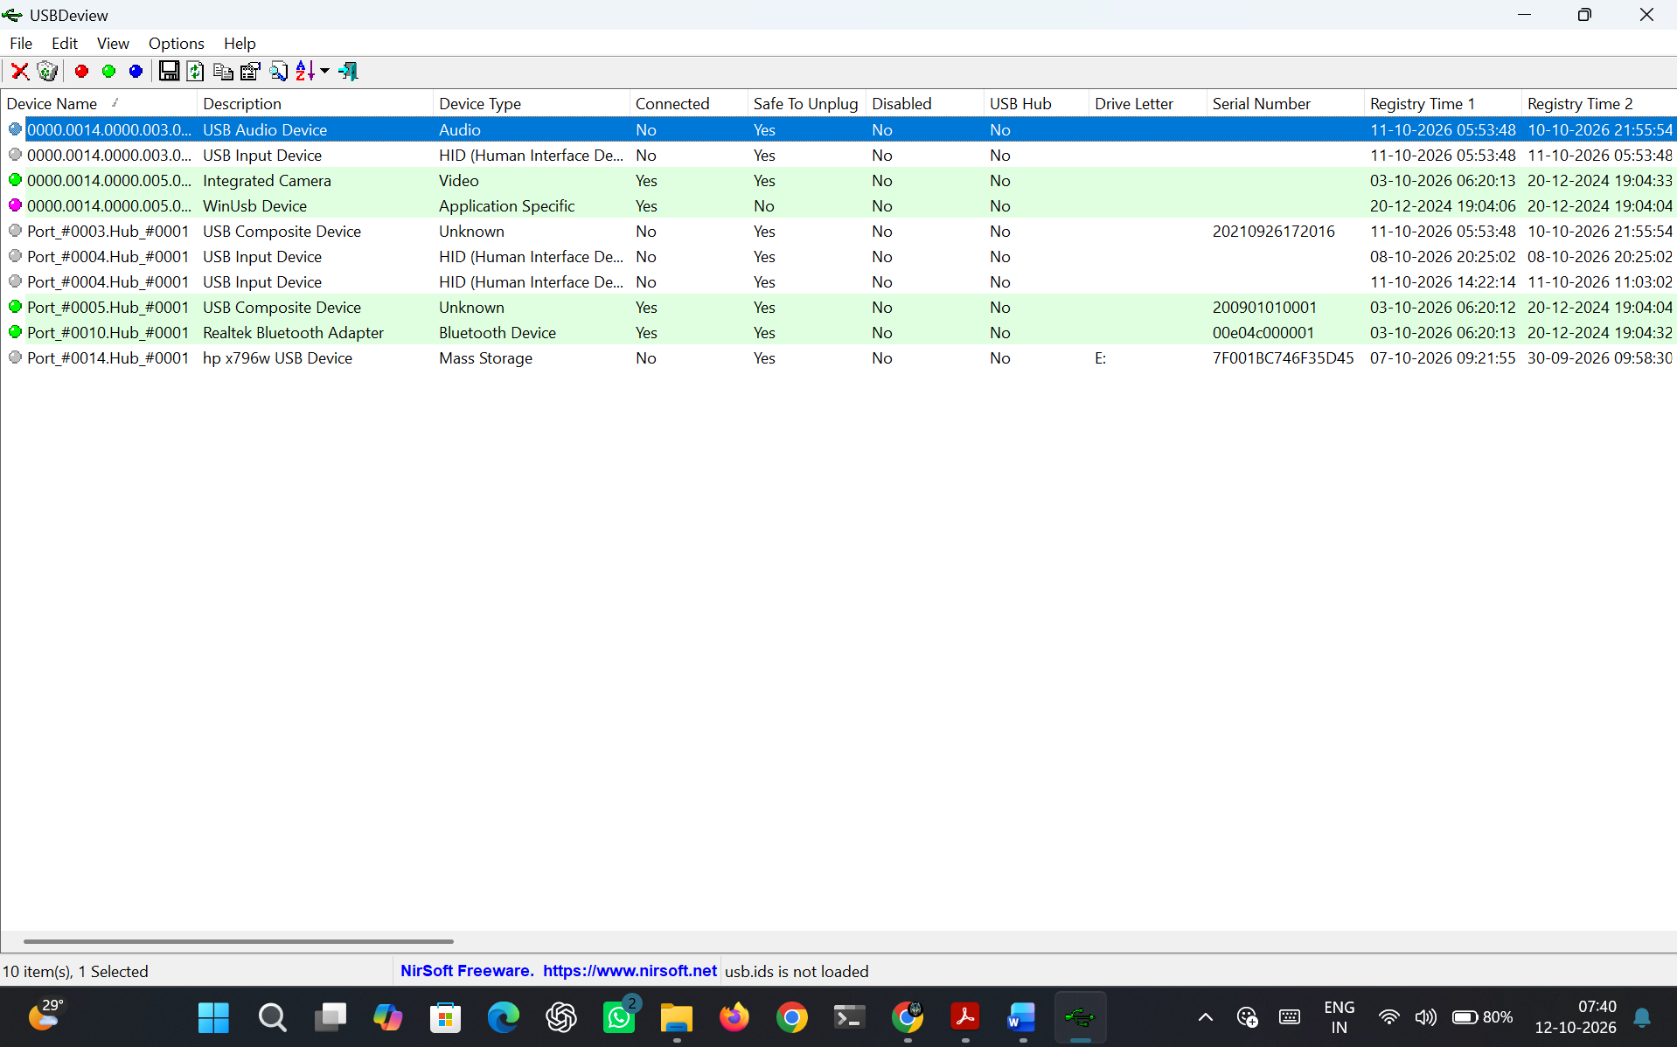
Figure 6.1 Results of USBDeview
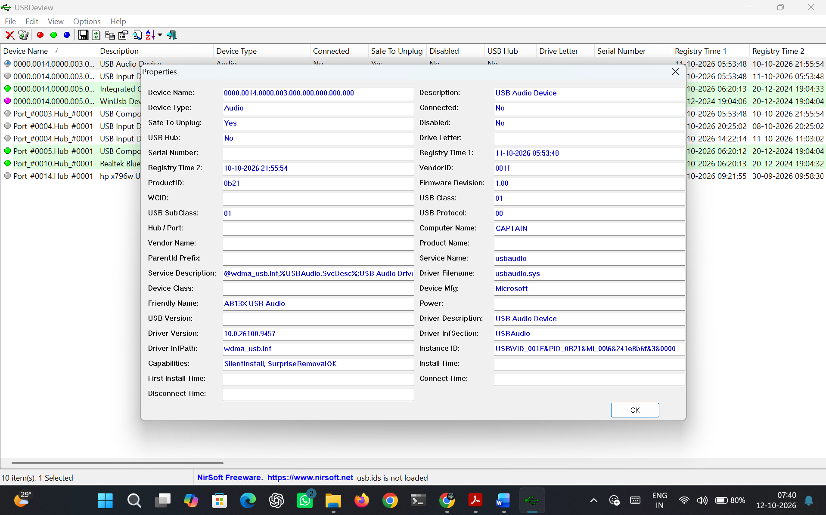
Figure 6.2 View Detailed Information
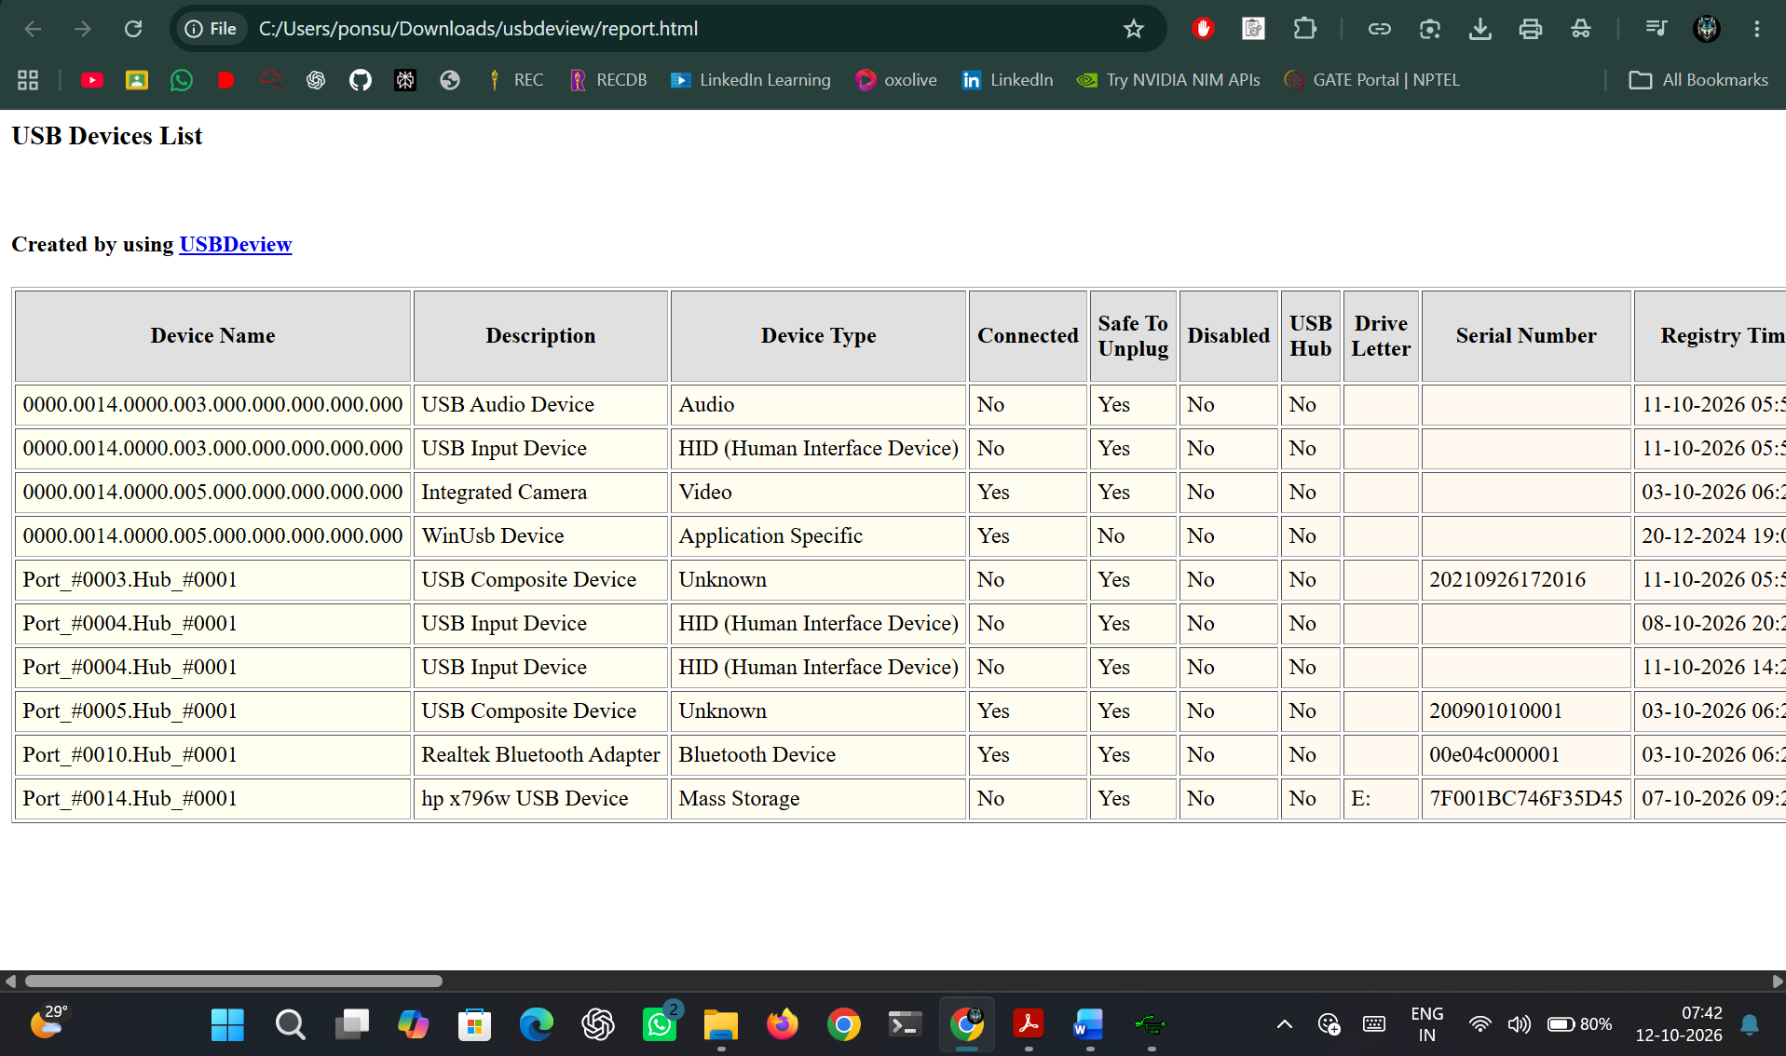
Figure 6.3 HTML Report
RESULT:
Thus USBDeview was used to identify all USB devices connected to the system, along with the exact date and time of their last connection.

