EXPERIMENT NO: 7 DATE: 20/08/2026
HOW TO VIEW LAST ACTIVITY OF YOUR PC
AIM
To view the last activity of your PC.
TOOL
LastActivityView (NirSoft)
INTRODUCTION
LastActivityView is a tool for Windows operating systems that collects information from various sources on a running system and displays a log of actions made by the user and events that occurred on the computer.
PROCEDURE
1. Download LastActivityView
- Open your browser and go to the NirSoft website.
- Search for LastActivityView.
- Download LastActivityView.
2. Extract the Downloaded File
- Download the ZIP file.
- Extract the ZIP file using WinRAR/7-Zip to any folder.
- Locate LastActivityView.exe.
3. Run LastActivityView
- Double-click on LastActivityView.exe.
- No installation is required.
4. Explore the Main Window
- LastActivityView displays all recent activities in chronological order.
- You can view:
- Action Time
- Description
- Filename / Full Path
- Other activity information
5. Filter Activities (Optional)
- Use the Filter option to view specific types of activities.
- Examples:
- Run EXE file
- Open file
- Delete file
- System events
6. View Detailed Information
- Double-click on any activity entry.
- A detailed information window will open with additional information such as:
- Action Time
- Description
- Filename / Full Path
- More Information
- File Extension
- File Type
- Product Name
- Product Version
- Company Name
7. Save Report
- Go to the File menu.
- Save the selected items or all items.
- Available formats include:
- HTML
- CSV
- Text
- XML
8. Record Observations
9. Analyze Findings
- Analyze the collected information.
- Correlate the information to understand the last activities performed by the user.
10. Close the Tool
- After analysis, close LastActivityView.
- The tool does not make any changes to the system.
OBSERVATION:
1. Last Executed Program: CONSENT.EXE
Path: C:\WINDOWS\SYSTEM32\CONSENT.EXE
2. Last Opened File: Acrobat.exe
Path: C:\PROGRAM FILES\ADOBE\ACROBAT DC\ACROBAT\ACROBAT.EXE
3. System Start Time: 12-10-2026, 07:26:13
4. Installed Software: Google Chrome, Adobe Acrobat DC, Microsoft Edge WebView2, Lenovo Modern IM Controller, and Windows Phone Link.
5. Any Other Activity: Execution of system utilities such as SEARCHFILTERHOST.EXE, SEARCHPROTOCOLHOST.EXE, and CONHOST.EXE was recorded. Multiple executions of Chrome.exe and MSEDGEWEBVIEW2.EXE were also observed.

SCREENSHOTS:
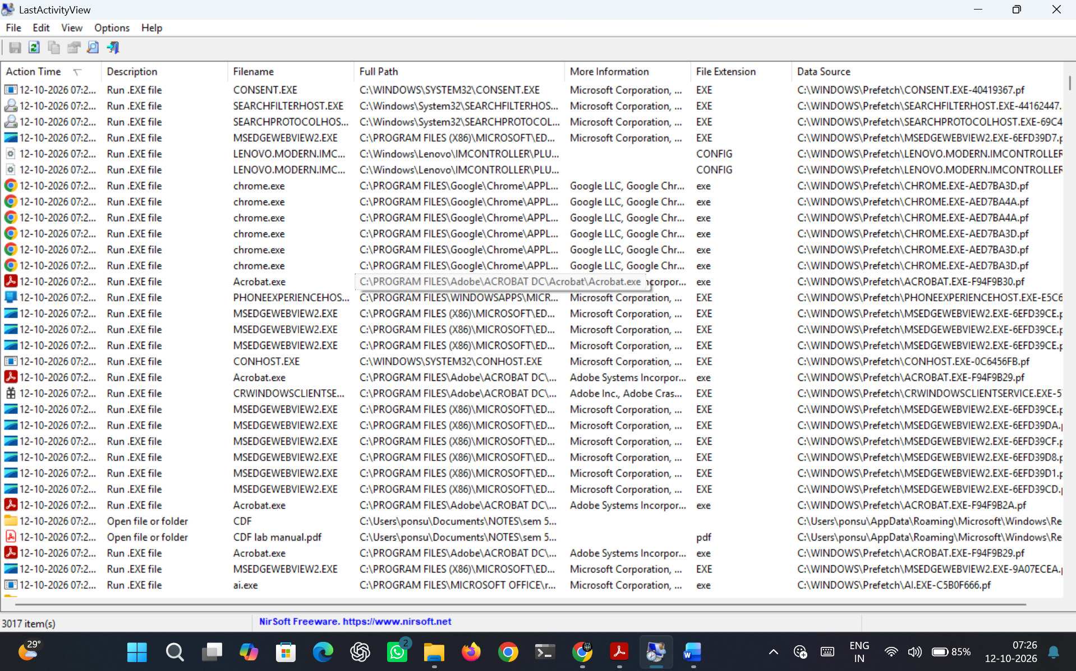
Figure 7.1 LastActivityView Results
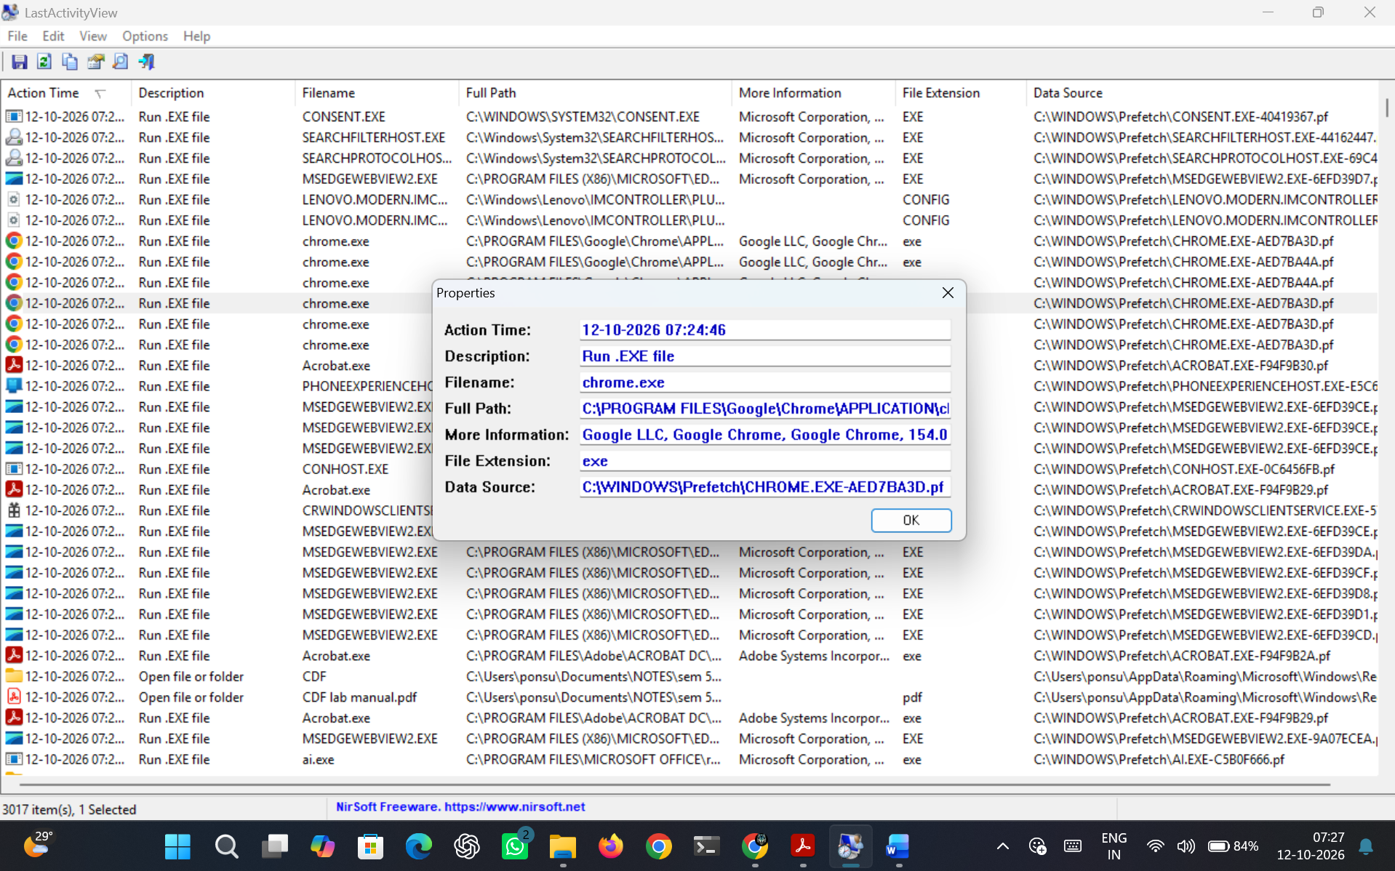
Figure 7.2 Properties of one entry
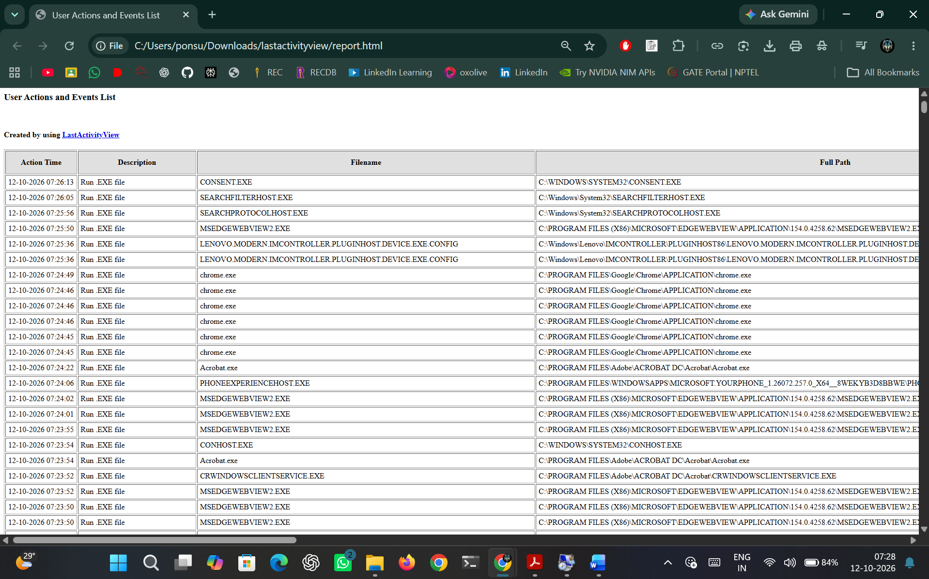
Figure 7.3 HTML Report

RESULT
LastActivityView was used to collect and view detailed logs of user activities and system events that occurred on a Windows PC.

