EXPERIMENT NO: 8 DATE:27/8/2026
HOW TO EXTRACT BROWSER ARTIFACTS
AIM
To extract browser artifacts using ChromeHistoryView.
TOOL
ChromeHistoryView (NirSoft)
ChromeHistoryView is a small utility that reads the history data file of the Google Chrome web browser and displays the list of all visited web pages in the last days.
Information displayed:
- URL
- Title
- Visit Date/Time
- Number of Visits
- Number of times that the user typed this address (Typed Count)
- Referrer
- Visit ID
PROCEDURE
Step 1: Download ChromeHistoryView
- Open your browser and go to the NirSoft website.
- Search for ChromeHistoryView.
- Download the tool from the official website.
Step 2: Extract the Downloaded File
- Download the ZIP file.
- Extract it using WinRAR or 7-Zip to any folder.
- Locate the extracted files, including ChromeHistoryView.exe.
Step 3: Run ChromeHistoryView
- Double-click on ChromeHistoryView.exe.
- No installation is required.
- The tool will automatically load your Chrome history.
Step 4: Explore the Main Window
- The main window lists all visited web pages.
- Each entry shows detailed information about the visit.
Step 5: View Additional Columns
- Click the View menu.
- Select the columns you want to display.
Step 6: Understand the Columns
URL: Web address visited.
Title: Title of the webpage.
Visit Time: Date and time of the visit.
Visit Count: Number of times the webpage was visited.
Typed Count: Number of times the user typed the URL.
Referrer: Website from which the link was opened.
Visit ID: Unique ID for the visit.
Step 7: Export the Data (Optional)
- Go to the File menu and select the export option.
- Save the data in CSV, HTML, or text format for further analysis.
Step 8: Analyze the Artifacts
- Review the list of visited websites.
- Identify interesting web activities, like frequently visited sites, search engines, social media, emails, etc.
Step 9: Record Observations
- Note important details in your lab manual.
- Capture findings such as the most visited sites, suspicious URLs, timestamps, and referrers.
Step 10: Close the Tool
- After analysis, close ChromeHistoryView.
- The tool does not make any changes to the system or browser data.

OBSERVATION:
- Most Visited Site: https://dev.azure.com/ponsurabhi365/BookSphere
- Total Number of Visits: 5,242 items.
- Suspicious URL (if any): https://www.google.com/search?q=shaft+collar
- Date and Time: 02-10-2026, 04:33 AM to 09:26 AM.
- Referrer Website: https://www.google.com/ and https://dev.azure.com/ponsurabhi365/BookSphere
- Remarks: Browser history was successfully extracted and analyzed using ChromeHistoryView. The visited URLs, webpage titles, visit dates and times, visit counts, referrers, and visit durations were displayed for digital forensic analysis.

SCREENSHOTS:
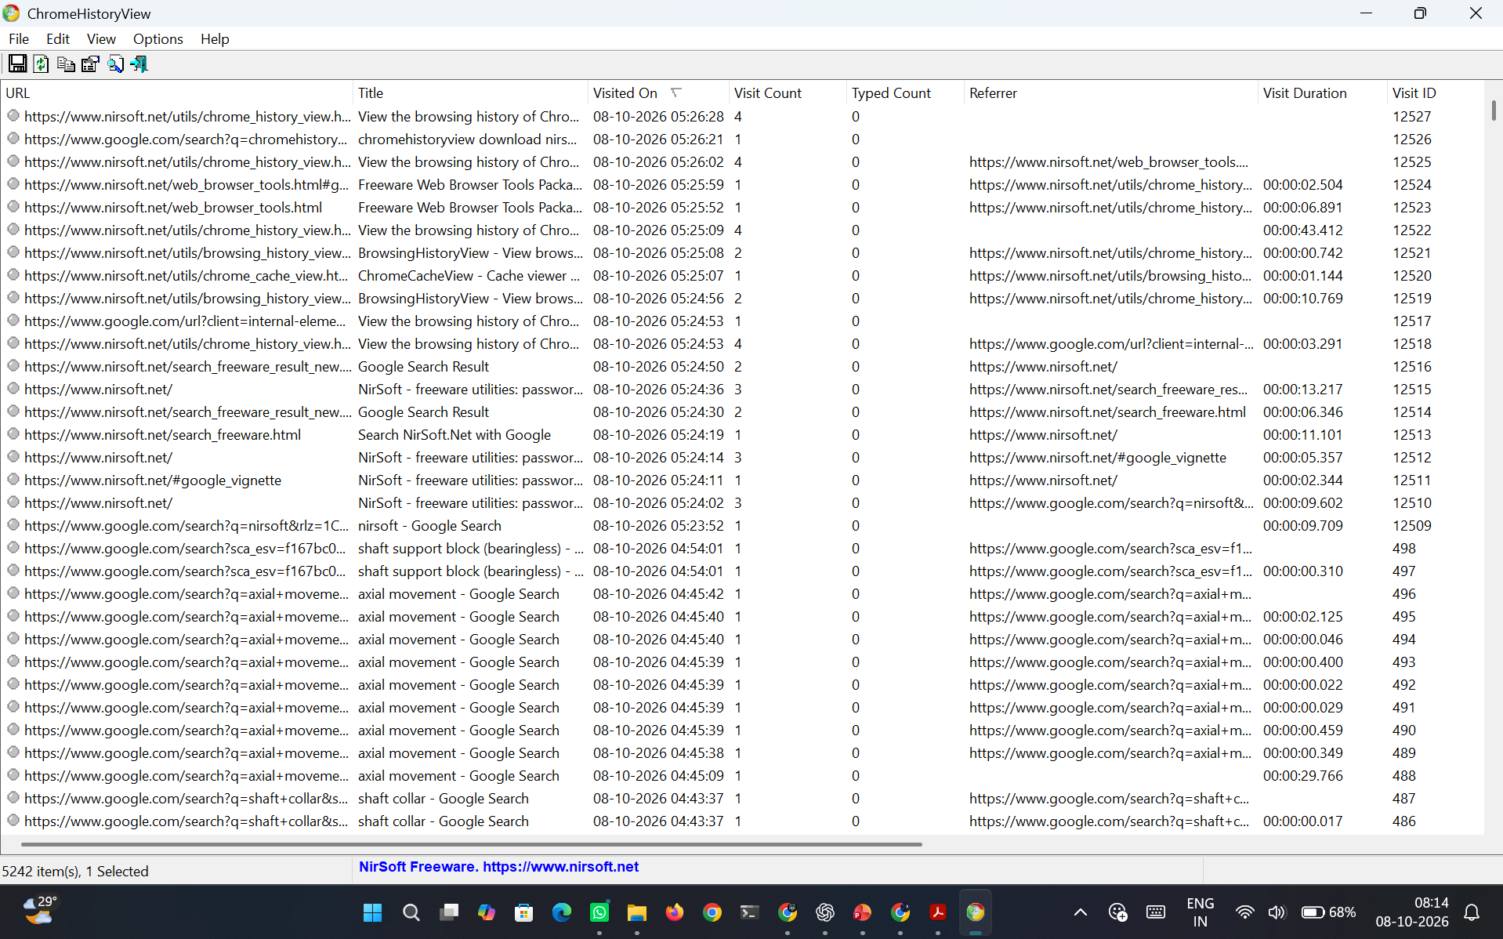
Figure 8.1 Chrome History View Results

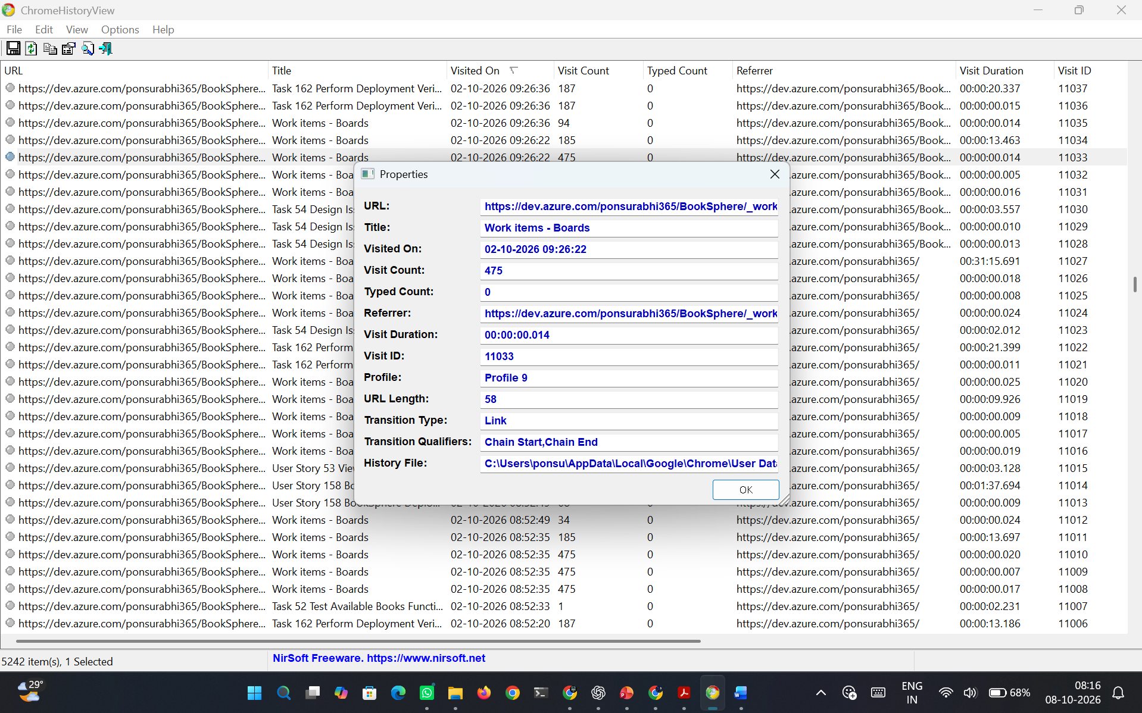
Figure 8.2 Detailed Information of a single entry
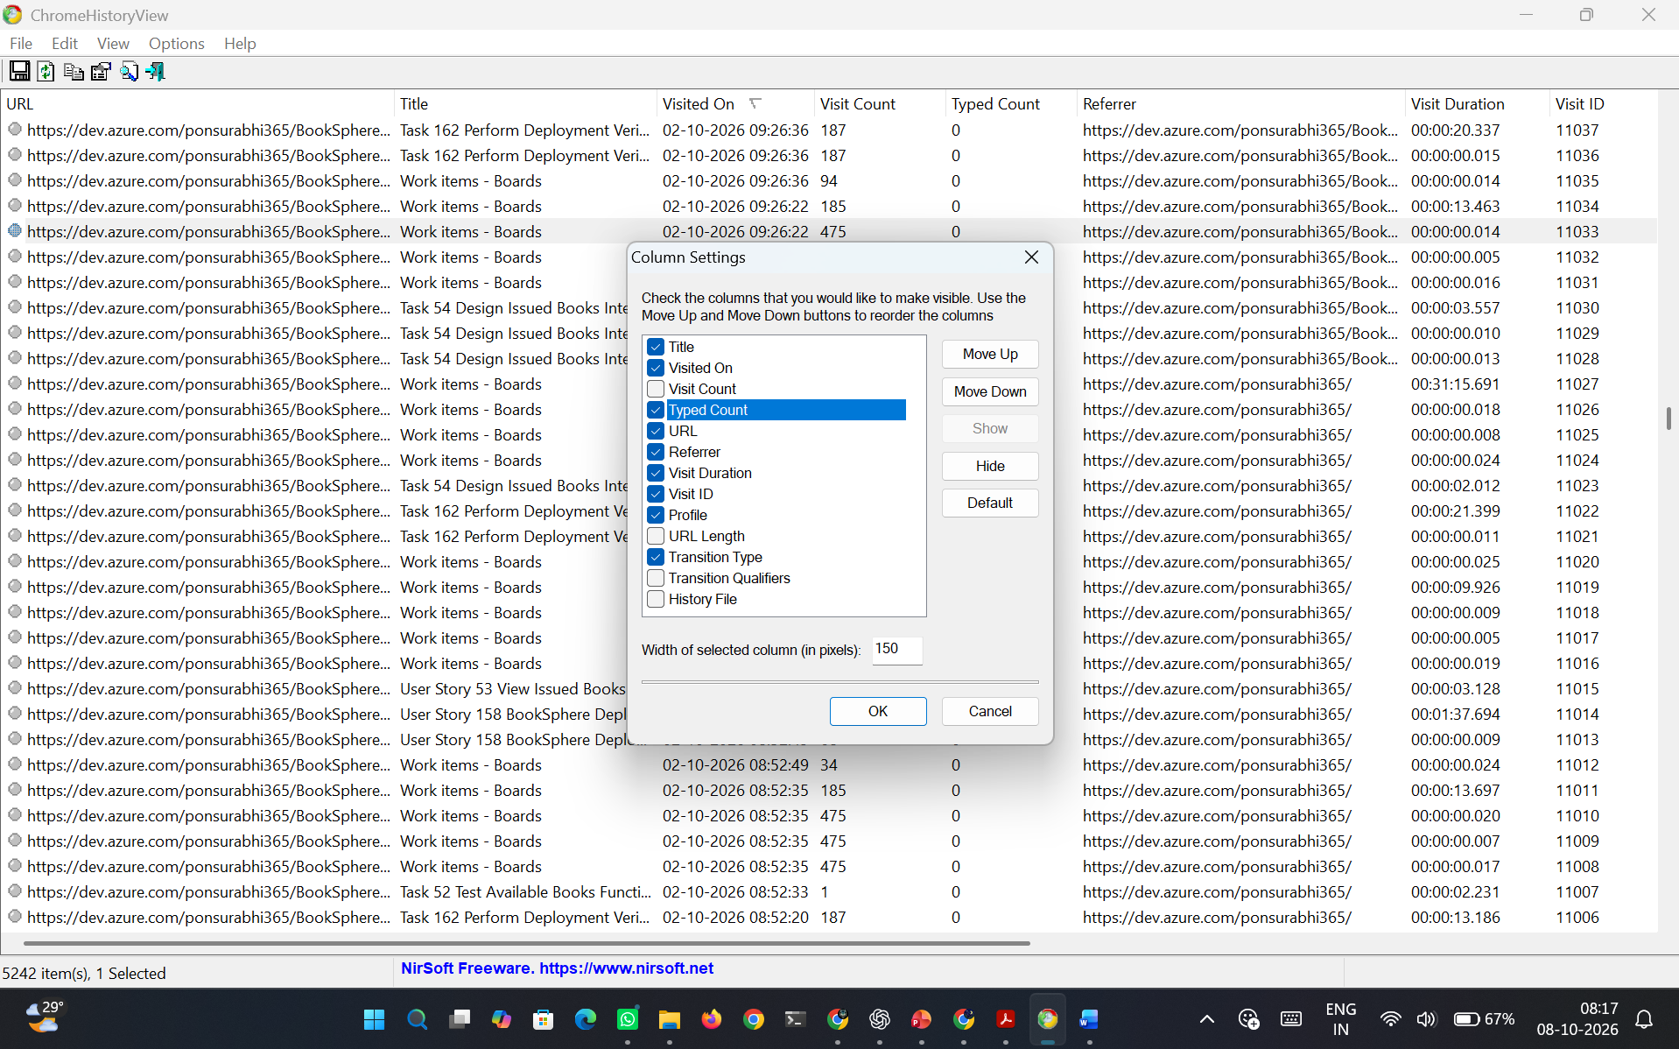
Figure 8.3 Adjust Column Settings

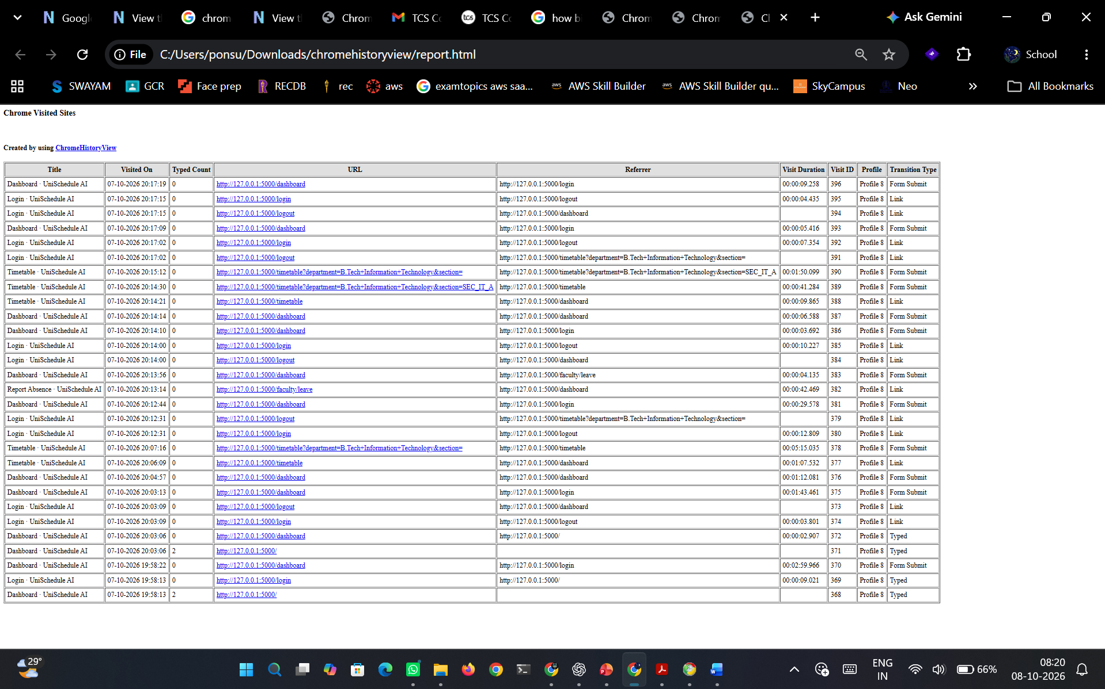
Figure 8.4 HTML Report
RESULT:
Thus ChromeHistoryView was used to extract and analyze browser history.

