EXPERIMENT NO: 9 DATE: 10/09/2026
COMPARISON OF TWO FILES FOR FORENSIC INVESTIGATION USING COMPARE IT SOFTWARE
AIM
To compare two files for forensic investigation using Compare It! software.
ABOUT COMPARE IT
Compare It is a software tool that displays two files side-by-side, with colored differences to simplify analysis. It can compare changes between files with a single mouse click or keystroke. It also allows users to edit files directly in the comparison window and provides a colored printout of the differences report.
PROCEDURE
1. Install Compare It Software
- Download Compare It! from the official source.
- Install Compare It! on the system.
2. Launch Compare It
- Click on the Compare It! icon on the desktop.
3. Select First File
- In the Compare window, click on the left-side Folder icon.
- Select the first file.
- Click Open.
4. Select Second File
- Click on the right-side Folder icon.
- Select the second file.
- Click Open.
5. Files Loaded for Comparison
- Both files will be loaded into the Compare window.
- Click Compare to start the comparison.
6. View Comparison Result
- The two files will be displayed side-by-side with colored differences.
- The differences are highlighted using different colors.
7. Analyze Differences
- Review the highlighted differences carefully.
- Color indicators:

- Green – Added content
- Red – Deleted content
- Yellow – Modified content
- The toolbar or keyboard shortcuts can be used to navigate through the differences.
8. Edit (Optional)
- The files can be edited directly in the comparison window.
- Save the changes if required.
9. Generate Report (Optional)
- Click the Print/Report option to generate a colored differences report.
- Print or save the report for documentation.
10. Close the Tool
- After completing the analysis, close Compare It!

OBSERVATION:
Statistics:
Total changed lines: 1 (<1%) Same: 466
Target Only: 0
Source Only: 0
Changed: 1

SCREENSHOTS:
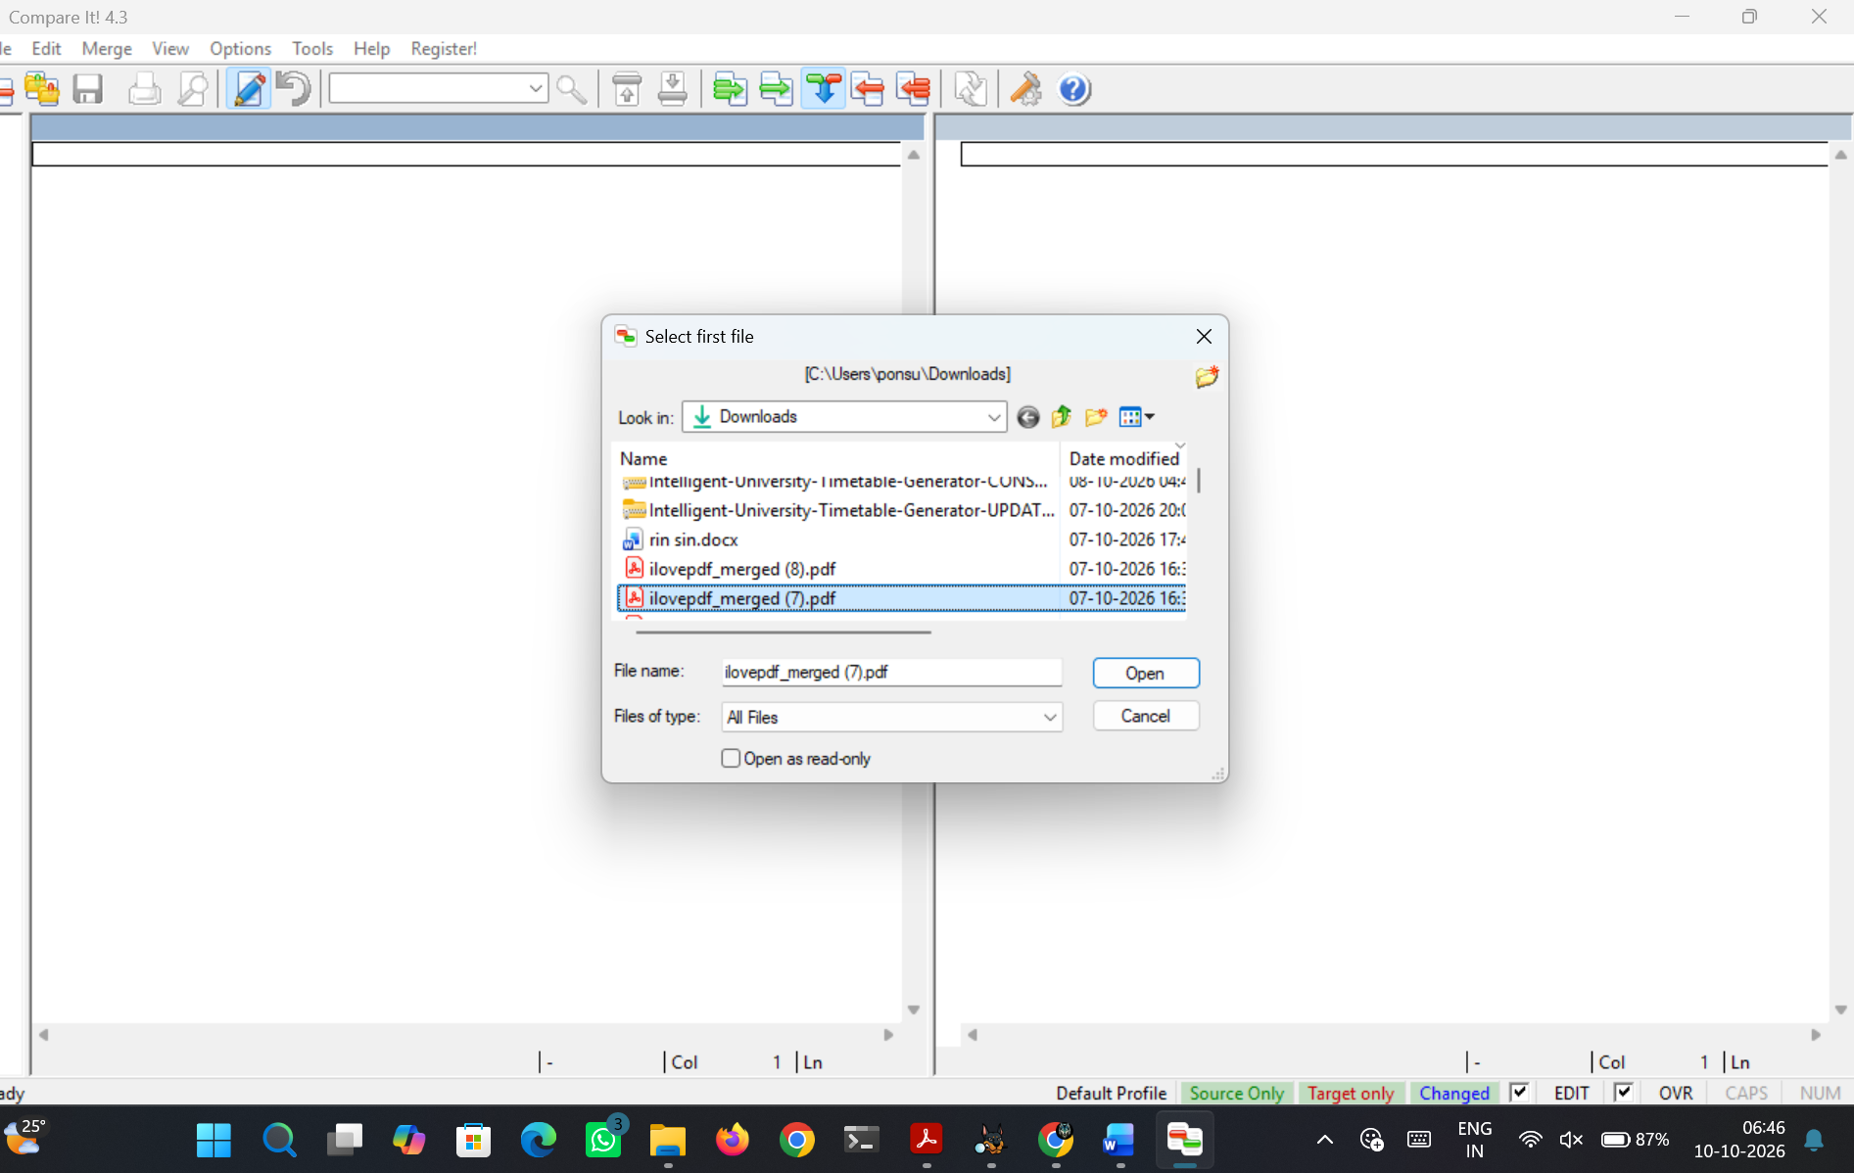
Figure 9.1 Load first file
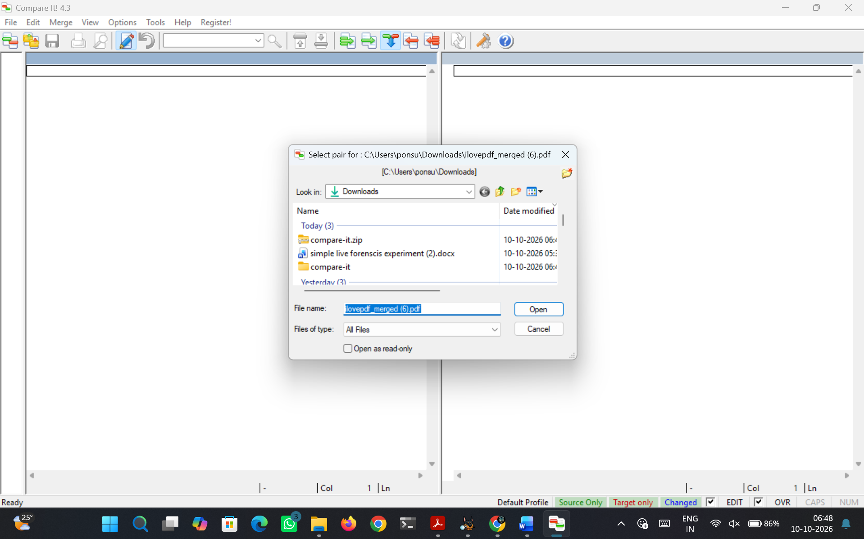
Figure 9.2 Load Second File
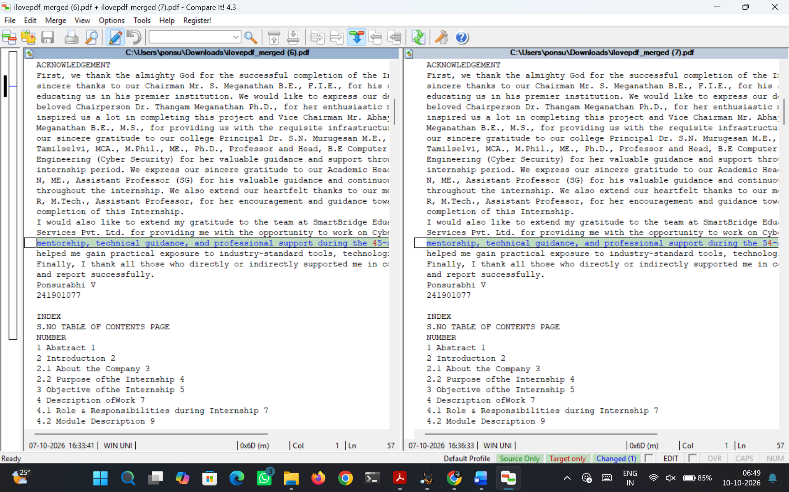
Figure 9.3 Comparison of two files
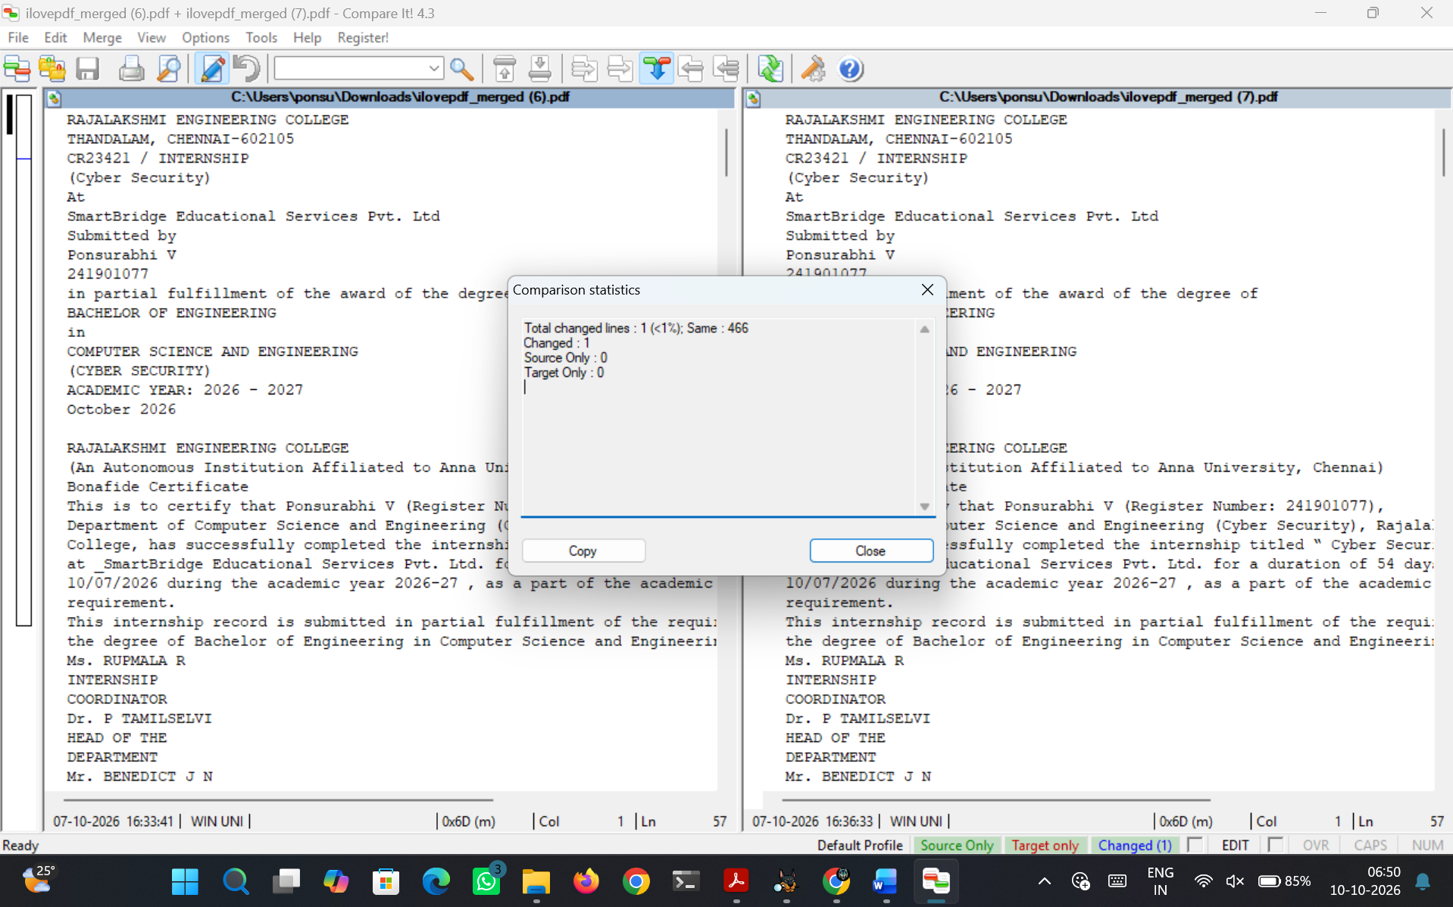
Figure 9.4 Comparison Statistics
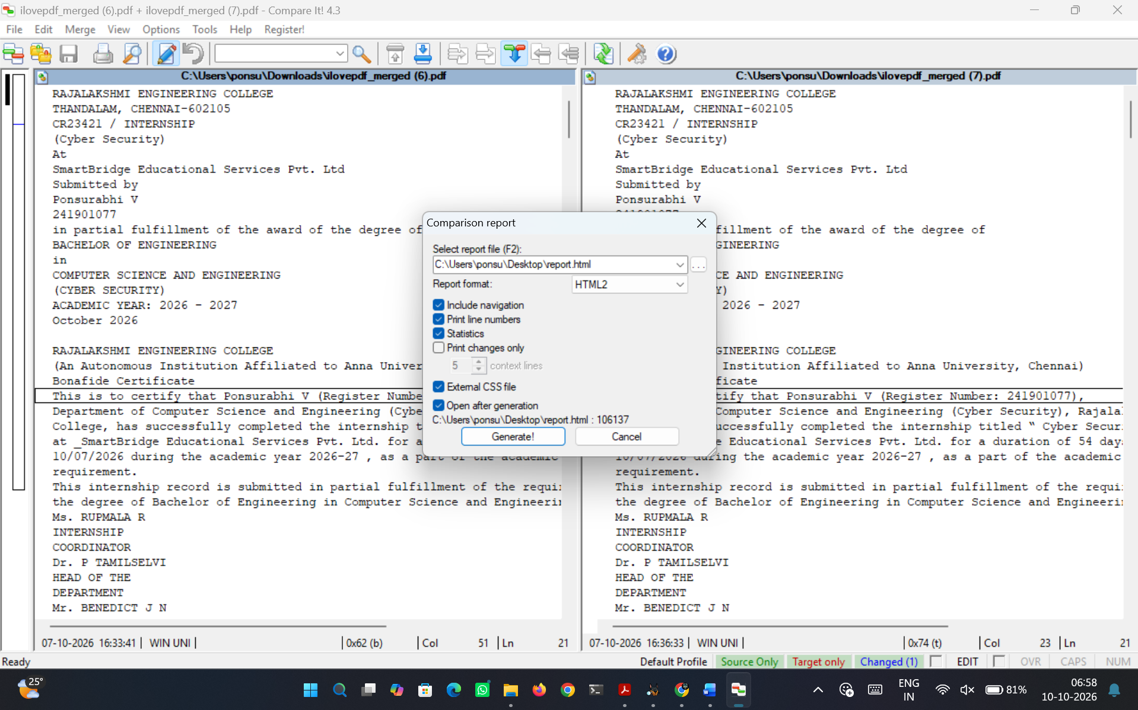
Figure 9.5 Generate Report
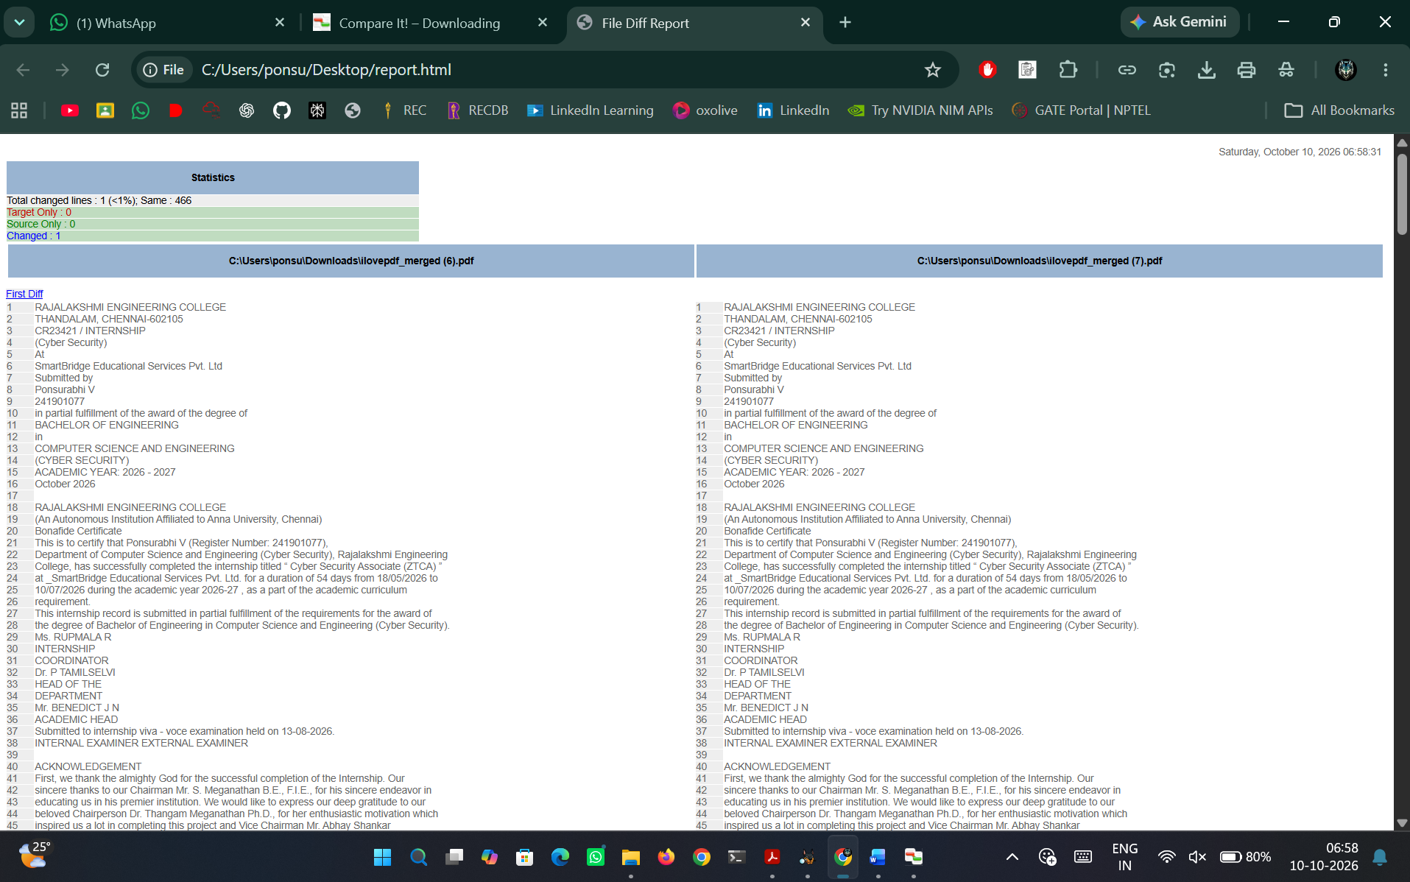
Figure 9.6 HTML Report
RESULT
Thus Compare It was used to identify differences between two files quickly and accurately.

