EXPERIMENT NO: 10 DATE: 17/09/2026
HOW TO COLLECT EMAIL EVIDENCE IN VICTIM PC
AIM
To collect email evidence from a victim PC.
TOOL
DumpIt (Forensic Memory Dumper)
ABOUT DUMPIT
DumpIt is a forensic memory acquisition tool used to dump the physical memory (RAM) of a Windows machine. It works on x86 (32-bit) and x64 (64-bit) Windows systems and is useful for forensic analysis and email artifact extraction.
PROCEDURE
1. Download DumpIt
- Open your browser and go to the MoonSols DumpIt website.
- Download the latest version of DumpIt.
2. Extract the Downloaded File
- Extract the ZIP file to any folder.
- The extracted folder will contain DumpIt.exe.
3. Run DumpIt as Administrator
- Right-click on DumpIt.exe.
- Select Run as administrator.
4. Confirm Memory Dump
- A confirmation message will appear.
- Click Yes to start capturing the system RAM.
5. Memory Dump in Progress
- DumpIt will start capturing the physical memory.
- A progress indicator will show the status of the acquisition.
6. Dump Completed
- Once the dump is complete, a success message will be displayed.
- The memory dump file will be created.
7. Locate the Dump File
- The raw memory dump file memory.raw will be saved in the same directory where DumpIt.exe is located.
- The file size will be approximately equal to the installed RAM size.
8. Preserve the Evidence
- Copy the memory.raw file to a secure external drive.
- Do not modify or rename the evidence file.
9. Analyze the Memory Dump
- Use memory forensic tools such as Volatility or Rekall to analyze the RAM dump.
- Extract relevant email artifacts, including:
- Email addresses
- Credentials
- Email-related data
- Communication artifacts
- Other relevant information
10. Document the Process
- Record important details such as:
- Date & Time of collection
- System information
- DumpIt version
- File name and size
- MD5/SHA hash values
- Chain of custody
11. Close & Secure
- Close the DumpIt window.
- Ensure the original system remains unchanged.
- Secure the collected memory dump as forensic evidence.
OBSERVATION:
- Date & Time: 17-09-2026, 14:10:11 AM
- System Info: Windows Desktop (DESKTOP-6JB69KD)
- DumpIt Version: v1.3.2.20110401
- File Name: DESKTOP-6JB69KD-20260917-081011.raw
- File Size: 35,068 MB (approximately 34.25 GB)
- Collected By: Ponsurabhi V
SCREENSHOTS:
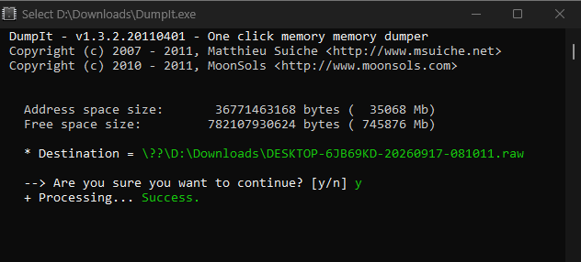
Figure 10.1 Run DumpIt Tool
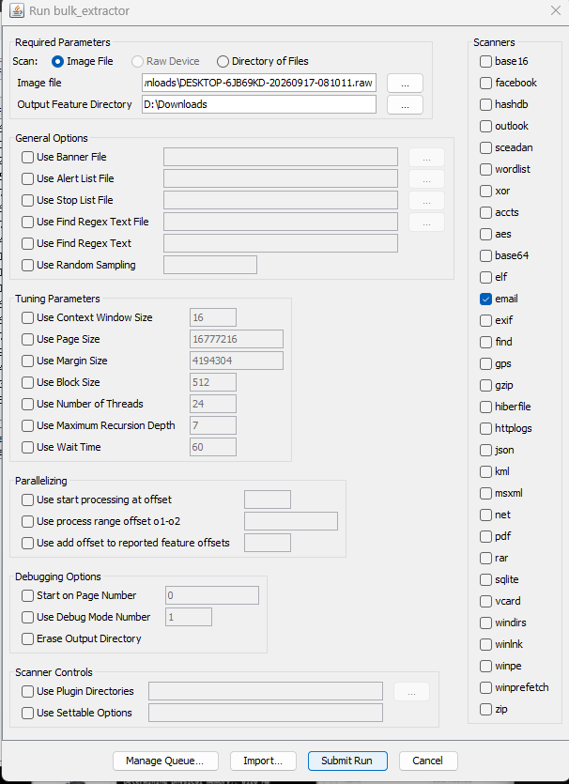
Figure 10.2 Run Bulk Extractor
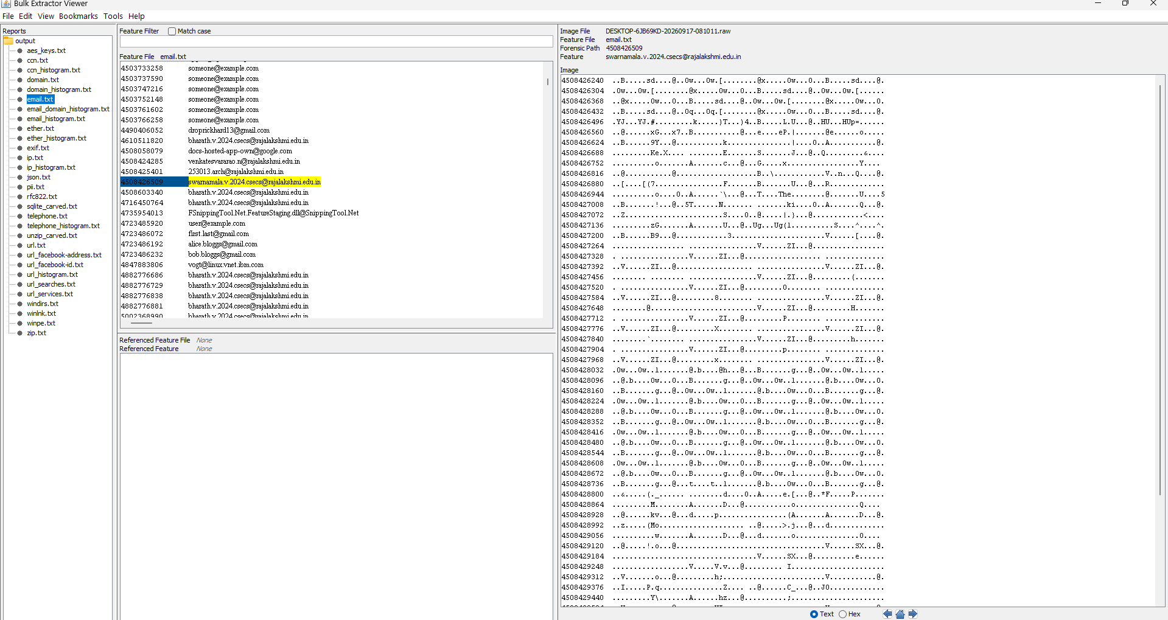
Figure 10.3 View Dumped Memory
RESULT
DumpIt was used capture volatile data (RAM) from a victim machine successfully.

