EXPERIMENT NO: 11 DATE: 24/09/2026
HIDE AND EXTRACT ANY TEXT FILE BEHIND AN IMAGE FILE USING COMMAND PROMPT
AIM
To study the steps for hiding and extracting any text file behind an image file using Command Prompt.
TOOLS
Windows Command Prompt
CONCEPT
- Any file such as .txt, .rar, .jpg, etc. can be merged inside another file.
- A text file (A.txt) is hidden inside an image file (B.jpg).
- A new file (C.jpg) is created.
- Later, the hidden text file can be extracted from C.jpg.
PROCEDURE
PART 1 – HOW TO HIDE THE FILE
1. Prepare the Files
- Keep the following files in the same folder:
- A.txt → Text file
- B.jpg → Cover image file
2. Open Command Prompt
- Press Windows + R.
- Type cmd and press Enter.
- Navigate to the folder using the cd command.
3. Check the Files
- List the files in the folder using: dir
- The folder should contain A.txt and B.jpg.
4. Hide the Text File Inside the Image File
- Use the following command: copy /b B.jpg + A.txt C.jpg
- This combines B.jpg and A.txt and creates a new file called C.jpg.
5. Verify the Output File
- Use: dir
- Check that C.jpg has been created.
- C.jpg now contains the image (B.jpg) + hidden text (A.txt).
6. Open C.jpg (Optional)
- Open C.jpg using any image viewer.
- The image will display normally even though the text file is appended to it.
PART 2 – HOW TO EXTRACT THE HIDDEN FILE
7. Extract the Hidden File
- Use the following command: copy /b C.jpg A_extracted.txt
- This extracts the hidden content into A_extracted.txt.
- It is better to use a different filename to avoid overwriting the original file.
8. Check the Extracted File
- Use: dir
- Verify that A_extracted.txt has been created.
9. View the Extracted Text
- Open A_extracted.txt using Notepad.
- Check the hidden content.
- Hidden text extracted successfully.
10. Clean Up (Optional)
- Remove the extracted file if it is no longer required.
- Keep the original evidence files unchanged during forensic examination.
OBSERVATION:
Secret Message: This is a secret message !!
SCREENSHOTS:
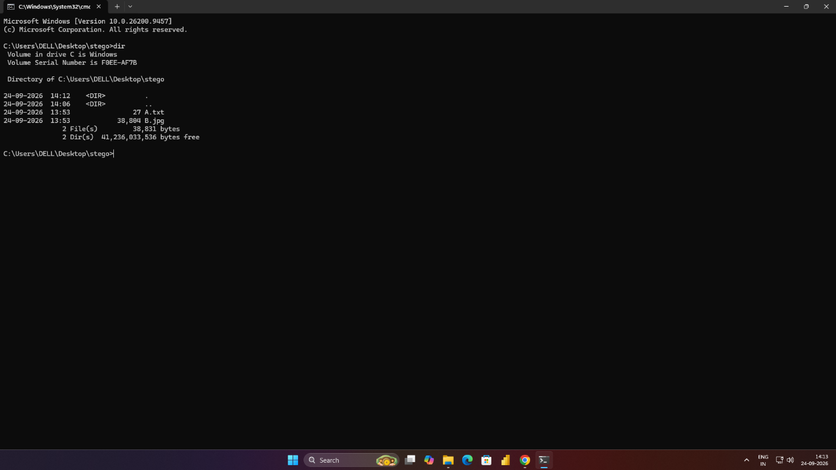
Figure 11.1 Display of 2 files in directory

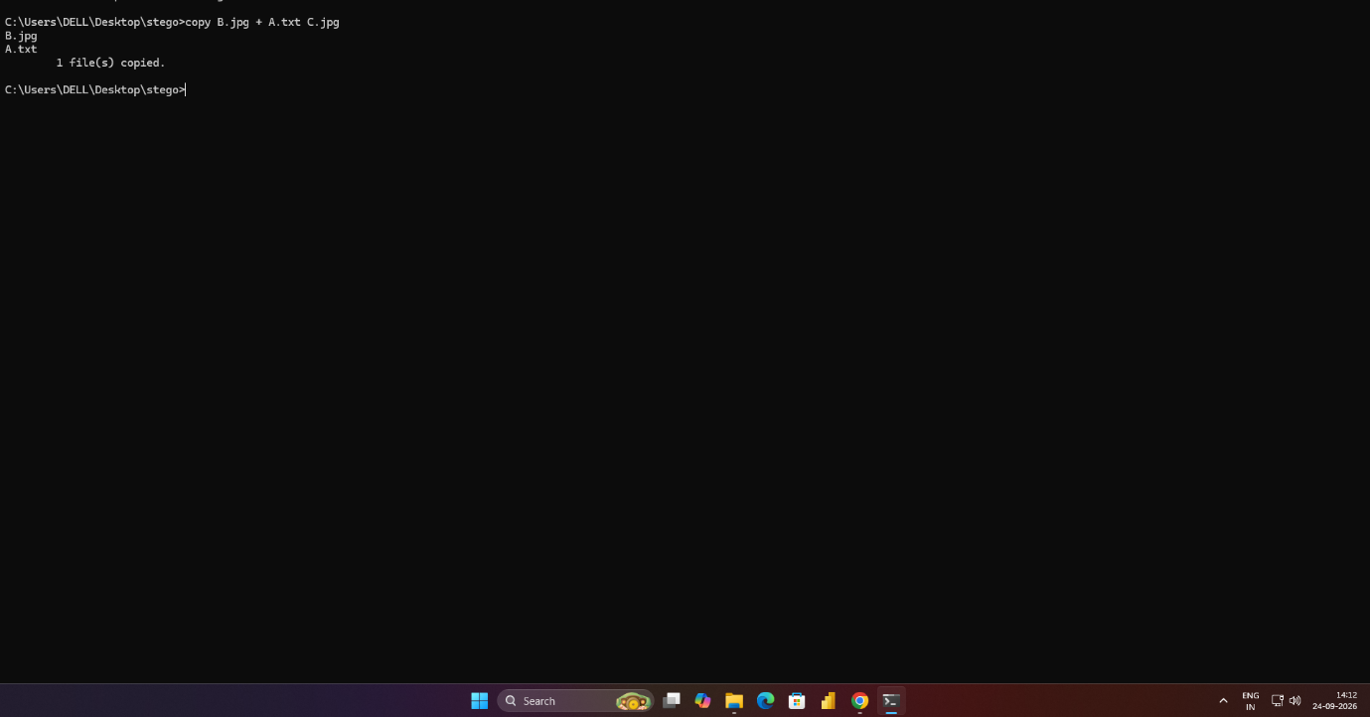
Figure 11.2 Hide txt file inside image file
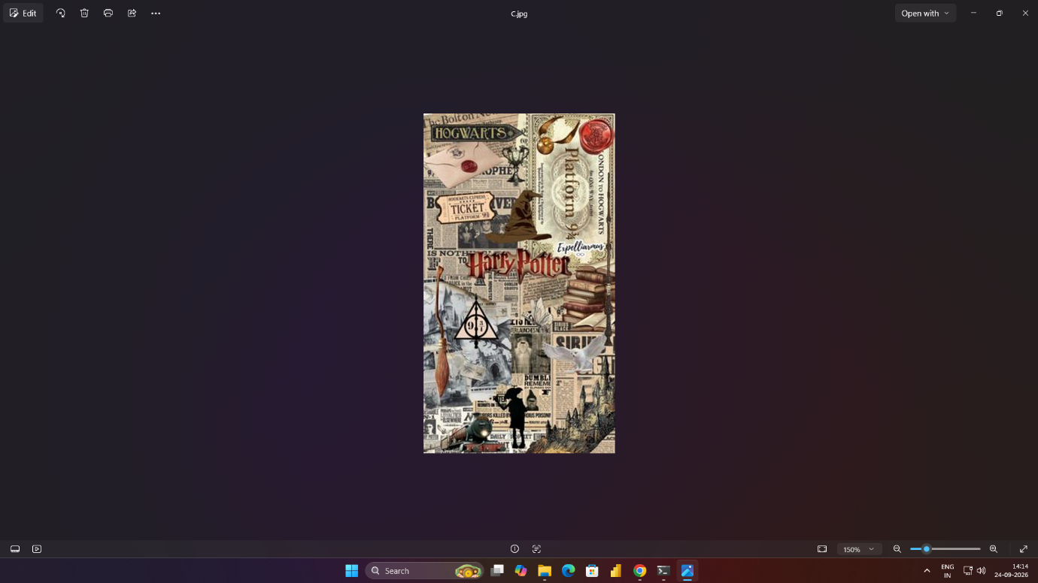
Figure 11.3 C.jpg
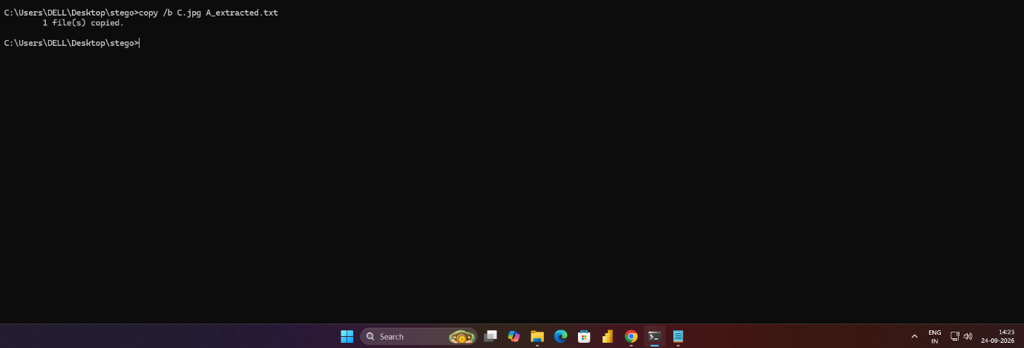
Figure 11.4 Extract C.jpg
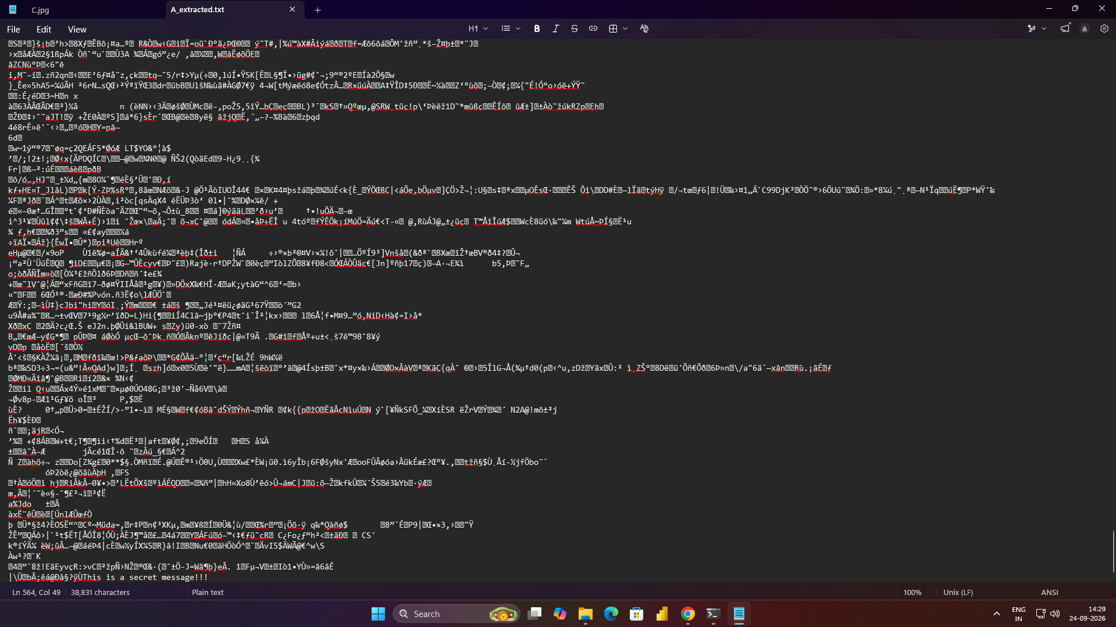
Figure 11.5 View Secret Message

RESULT
Thus a text file was appended to an image file, allowing the image to appear normal while additional data exists within the file.

