EXPERIMENT NO: 12 DATE: 01/10/2026
HOW TO EXTRACT EXCHANGEABLE IMAGE FILE FORMAT (EXIF) DATA FROM IMAGE FILES USING EXIFREADER SOFTWARE
AIM
To extract Exchangeable Image File Format (EXIF) data from image files using ExifReader software.
TOOL
ExifReader (Free Software)
INTRODUCTION
Digital cameras and mobile devices store hidden information inside image files called EXIF data. This data may include camera model, date/time, GPS location, device make and model, and other information. ExifReader is a free Windows tool that allows users to view and analyze valuable forensic information from images.
PROCEDURE
1. Download ExifReader
- Open your browser and go to the official ExifReader website.
- Download the latest version of ExifReader.
2. Install ExifReader
- Run the downloaded setup file ExifReader.exe.
- Follow the installation wizard.
- Click Next and then Install.
- Click Finish to complete the installation.
3. Launch ExifReader
- Double-click the ExifReader icon.
- The main window of ExifReader will open.
4. Open an Image File
- Click on the File menu.
- Select Open Image File.
- Browse and select the image file, such as sample.jpg.
- Click Open.
5. View EXIF Data
- Once the image is loaded, ExifReader displays the EXIF metadata of the image.
- Scroll down to view complete information.
- Common EXIF information includes:

- Date/Time – When the photo was taken.
- GPS Location – Where the photo was taken.
- Camera Make & Model – Device used to capture the image.
- Exposure Settings – Camera settings used.
- Software – Editing software, if any, used on the image.
6. Save EXIF Report (Optional)
- Click on the File menu.
- Select Save Report.
- Choose the desired location.
- Save the report as a TXT or HTML file.
7. Analyze the EXIF Data
- Analyze important information such as:
- Date/Time – When the photo was taken.
- GPS Location – Where it was taken.
- Camera Make & Model – Device used.
- Exposure Settings – Camera settings.
- Software – Editing software, if any.
8. Document the Findings
- Note down the important EXIF details for the image.
- Attach the saved EXIF report to the case documentation.
9. Close the Application
- Close ExifReader after completing the analysis.
- Ensure all reports are saved.
OBSERVATION:
Image Width: 1292
Image Height: 503
Bits Per Sample: 8
Color Type: True Color with Alpha
Compression Type: Deflate
Filter Method: Adaptive
Interlace Method: No Interlace
sRGB Rendering Intent: Perceptual
Image Gamma: 0.455
Pixels Per Unit X: 3779
Pixels Per Unit Y: 3779
Unit Specifier: Metre
Detected File Type Name: PNG
Detected File Type Long Name: Portable Network Graphics
Detected MIME Type: image/png
Expected File Name Extension: .png
File Name: Screenshot 2025-09-03 100543.png
File Size: 85154 bytes
File Modified Date: Thu Sep 03 10:05:43 +05:30 2025

SCREENSHOTS:
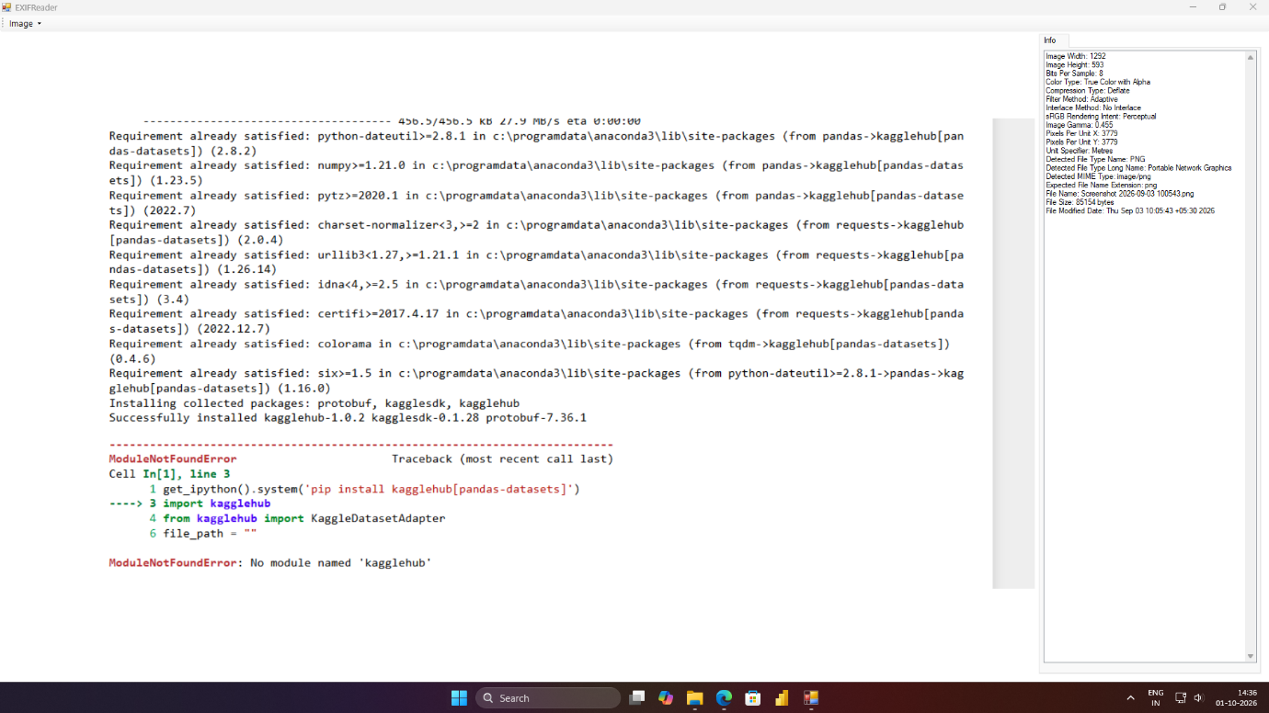
Figure 12.1 ExifReader displays metadata of the image

RESULT
Thus ExifReader was used to find EXIF data about the image and the findings were documented.

