**ASSIGNMENT – 4**

|  |  |
| --- | --- |
| **Team ID** | **PNT2022TMID27681** |
| **Name** | **PON SURYA K** |
| **Student Roll Number** | **311419104065** |
| **Maximum Marks** | **2 Marks** |

**DISTANCE DETECTION USING ULTRASONIC**

**Write code and connections in wokwi for the ultrasonic sensor.**

**Whenever the distance is less than 100 cms send an "alert" to the IBM cloud and display in the device recent events.**

**CODE:**

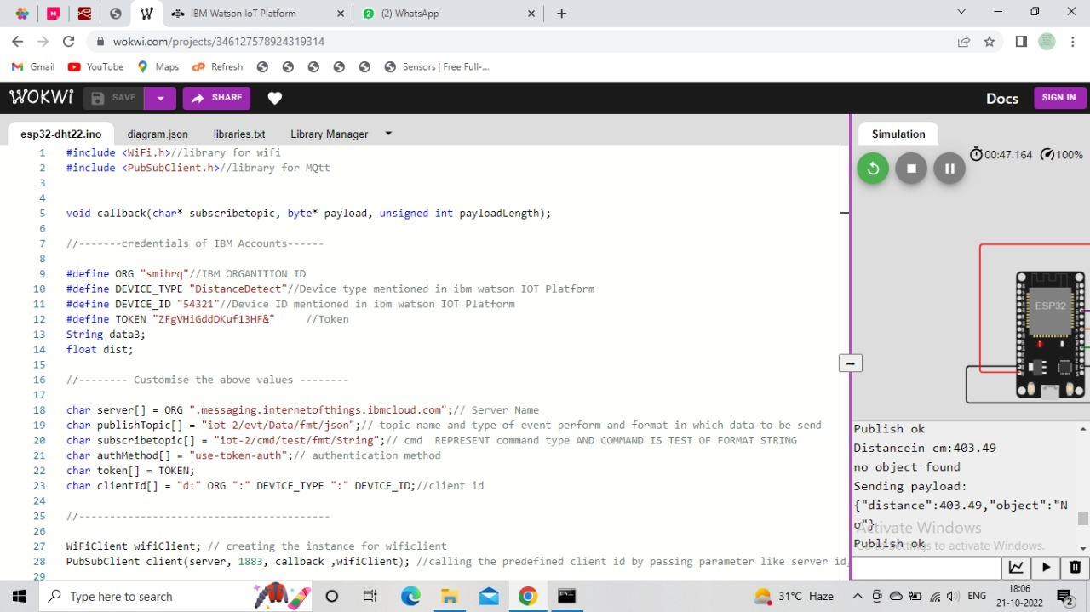

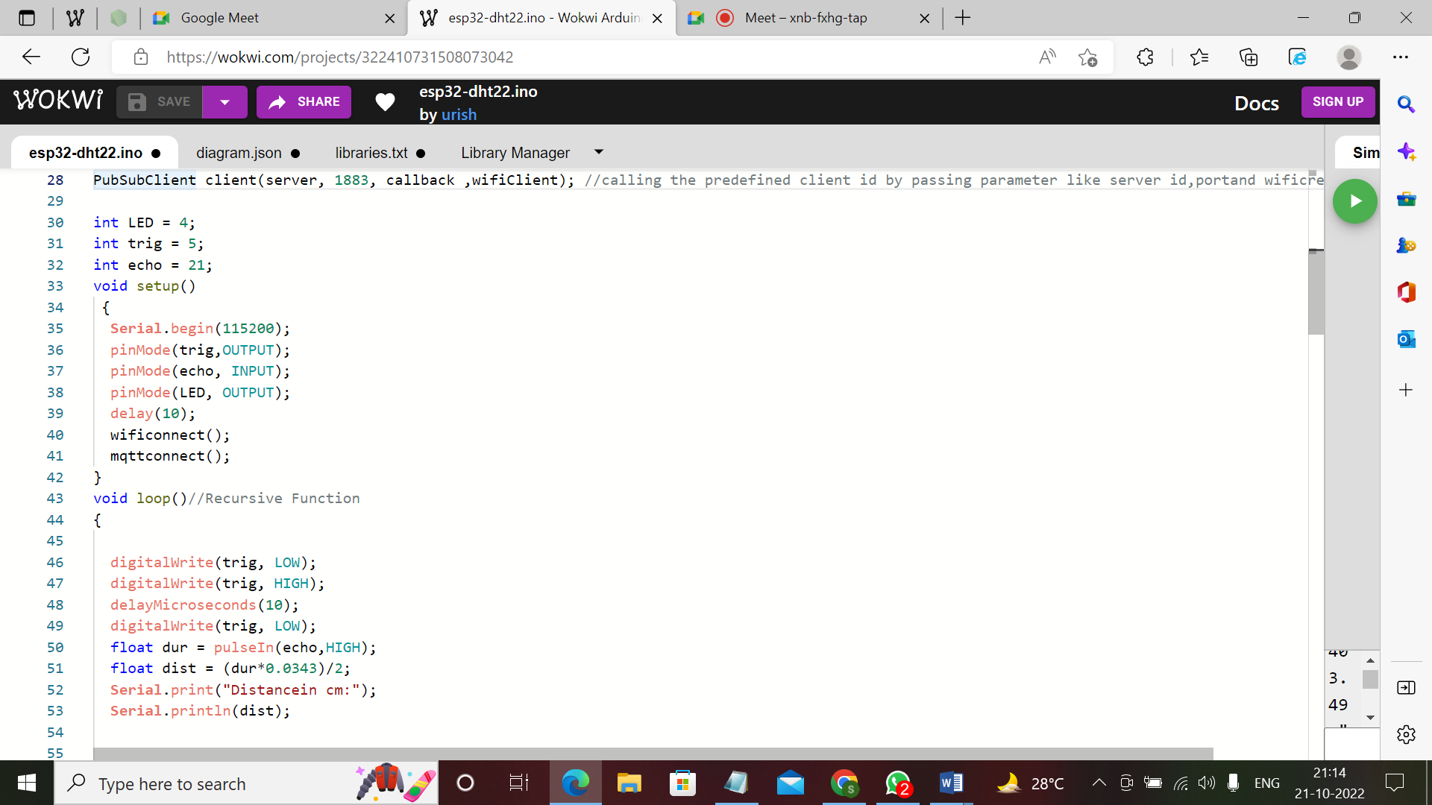

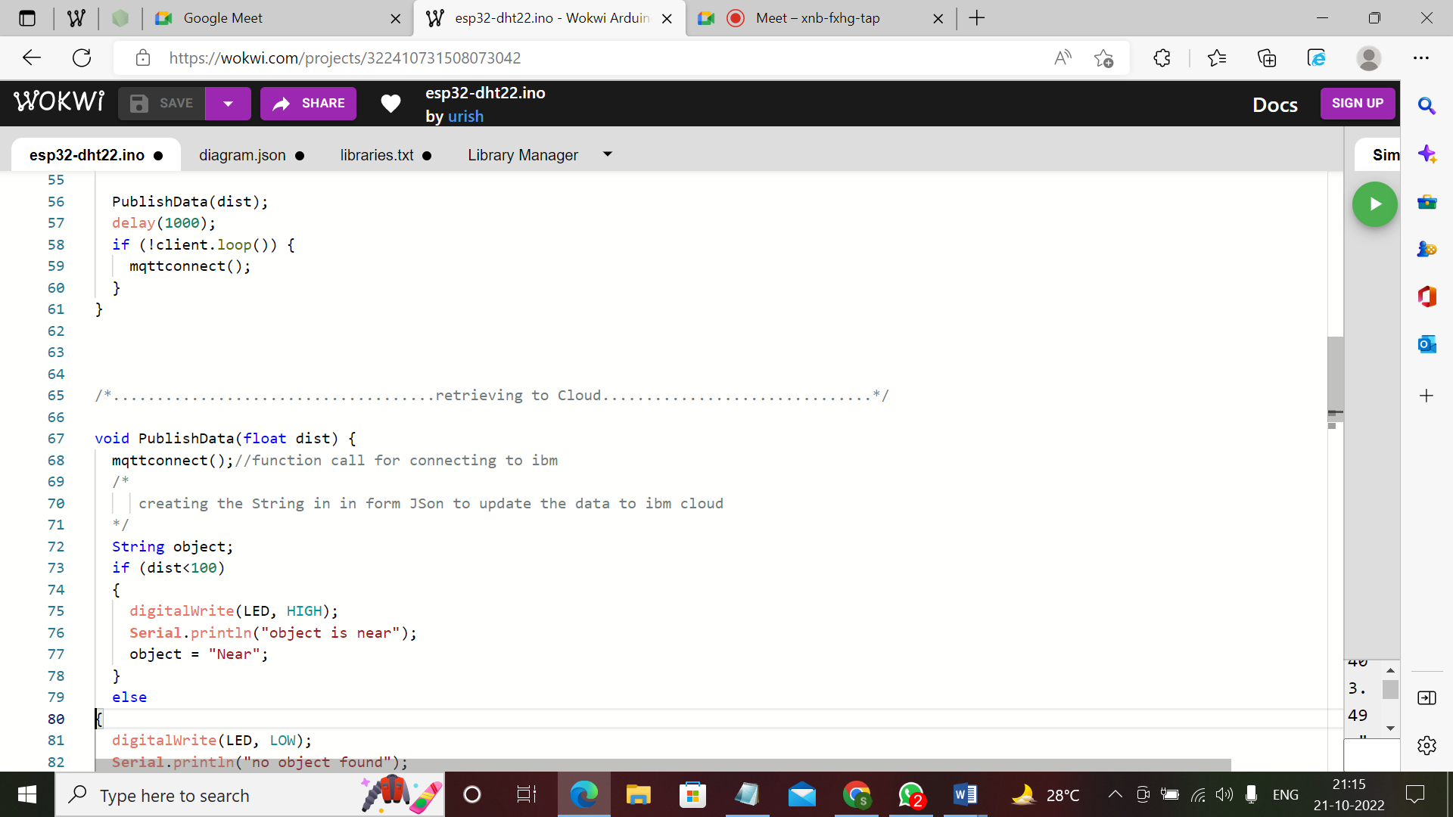

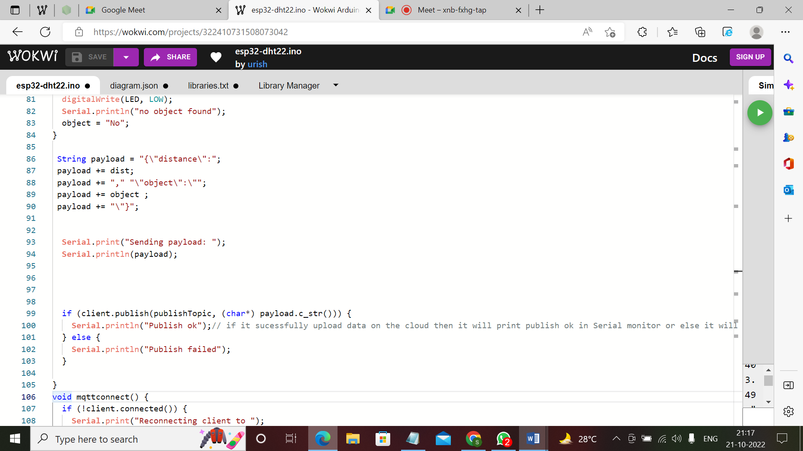

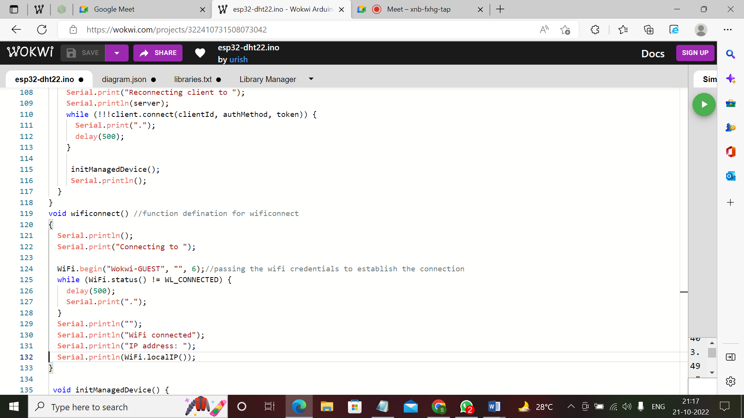

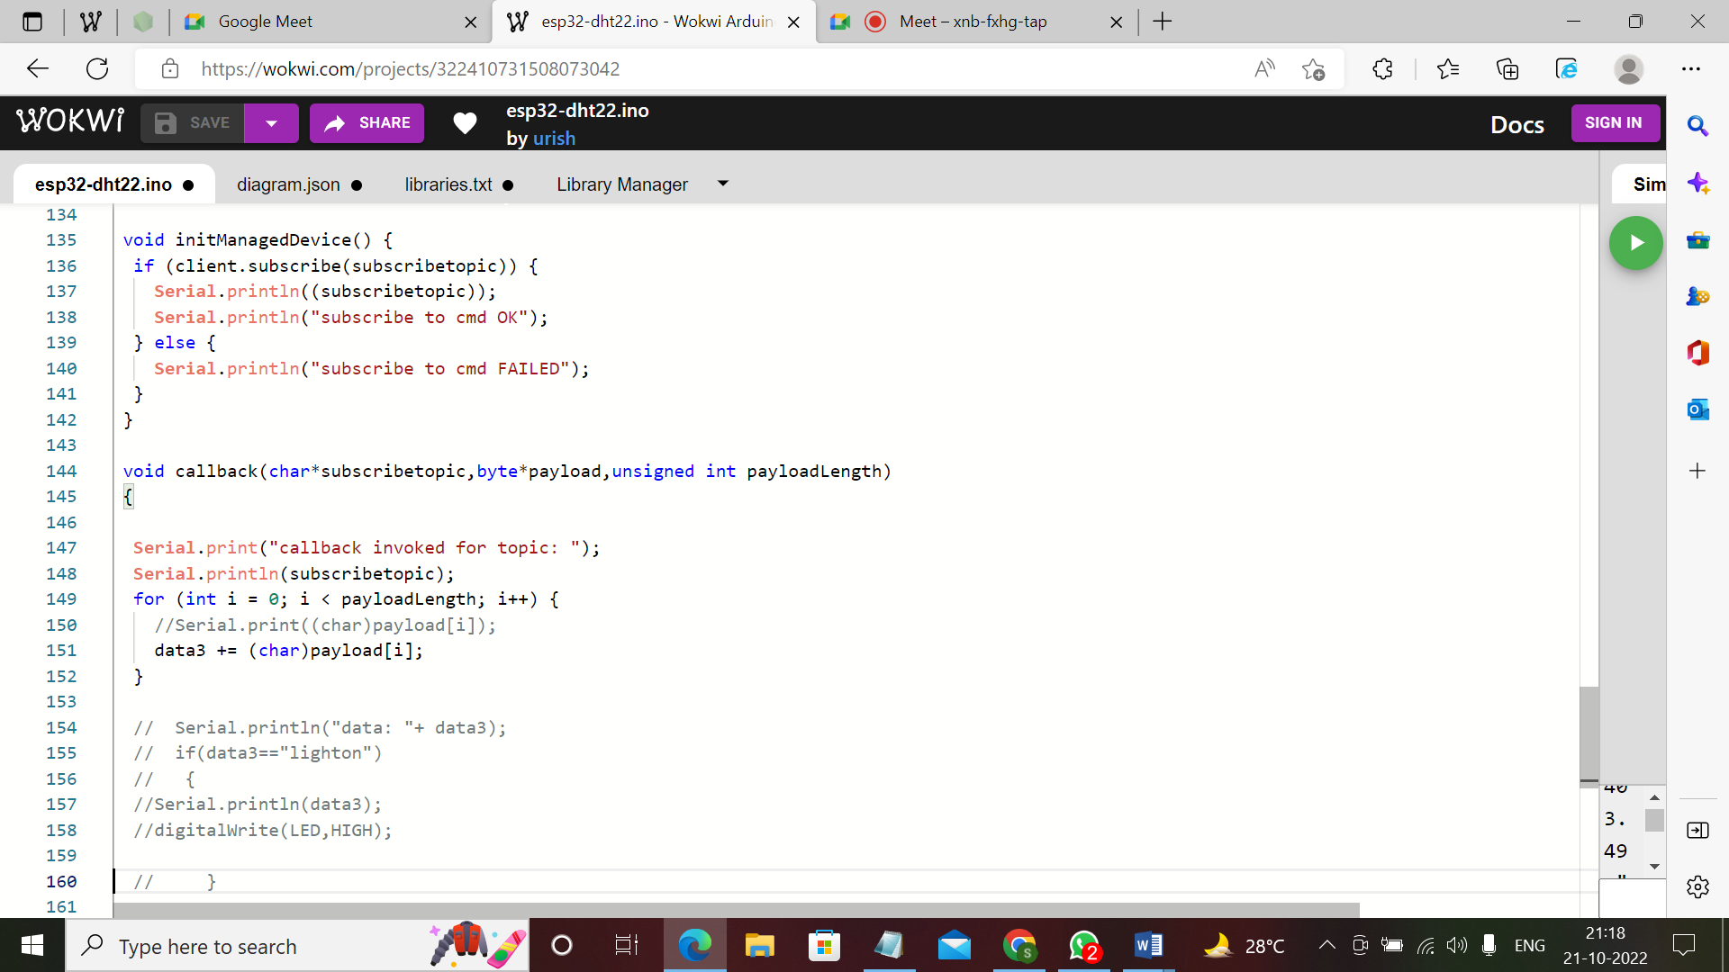

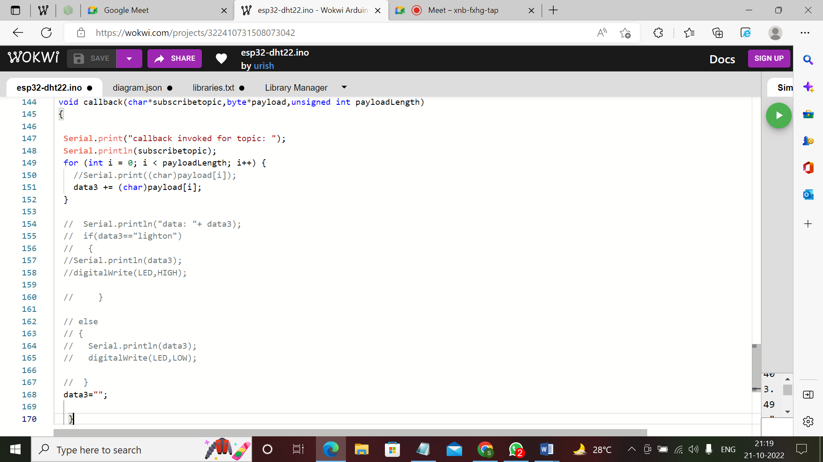

**OUTPUT:**

