Configuring coder task

* Download JDK 10
  + <https://www.oracle.com/technetwork/java/javase/downloads/java-archive-javase10-4425482.html>
  + Configure environment variables
    - JAVA_HOME
      * Path of java installation ex. C:\Program Files\Java\jdk1.8.0_152
    - Add in Path configuration
      * %JAVA_HOME%\bin
  + Test in terminal the command
    - java -version



* Download Maven
  + <https://maven.apache.org/download.cgi?Preferred=ftp://mirror.reverse.net/pub/apache/>
  + Configure environment variables
    - M2_HOME
      * Path of Maven installation ex. C:\sw\apache-maven-3.5.2
    - Add in Path configuration
      * %M2_HOME%\bin
  + Test in terminal the command
    - mvn –version

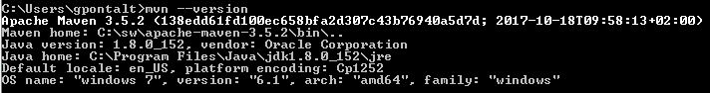

* Download Eclipse IDE for Enterprise Java Developers
  + <https://www.eclipse.org/downloads/packages/release/2019-03/r/eclipse-ide-enterprise-java-developers>
  + Extract the file on your preferred system file location
  + Open the Eclipse IDE
  + Choose a place to create a workspace folder or use a default location suggested on Eclipse startup.
  + Configure Eclipse to use your JDK installation
    - Open the menu Window→ Preferences
      * Go to Installed JRE’s on Java section

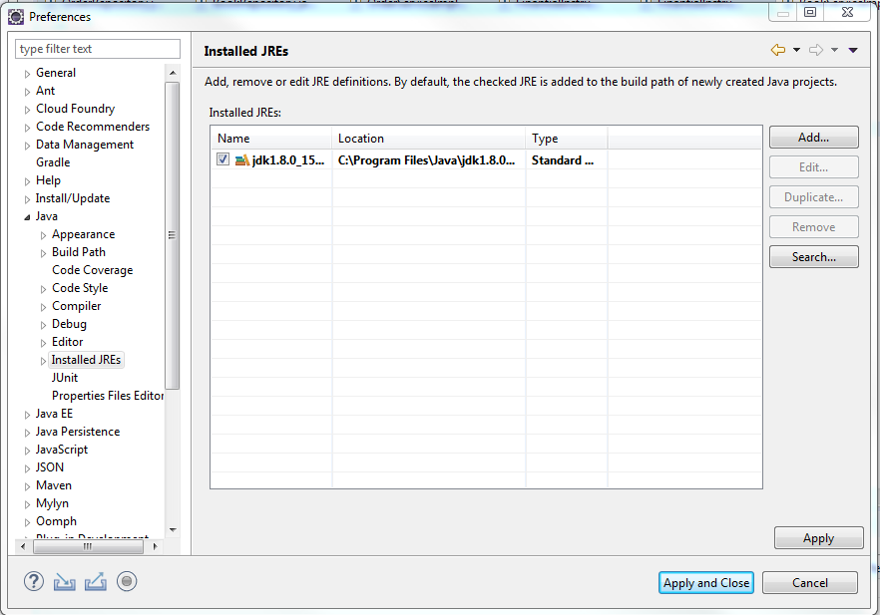

* + - * Click in edit and inform your JDK installation folder (you also can change the name alias if you prefer)
      * 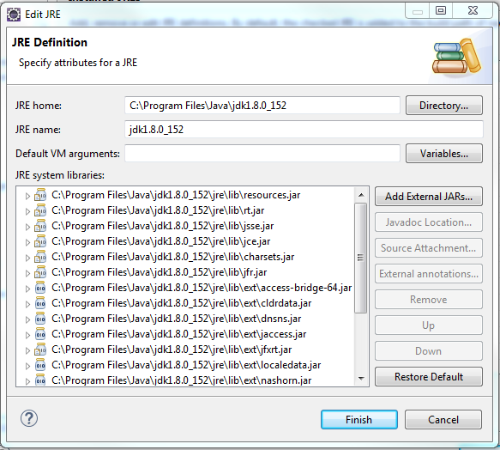Click in Finish than in Apply Close
  + Configure Maven to use your Eclipse IDE
    - Open the menu Window→ Preferences
      * Go to installation on Maven section

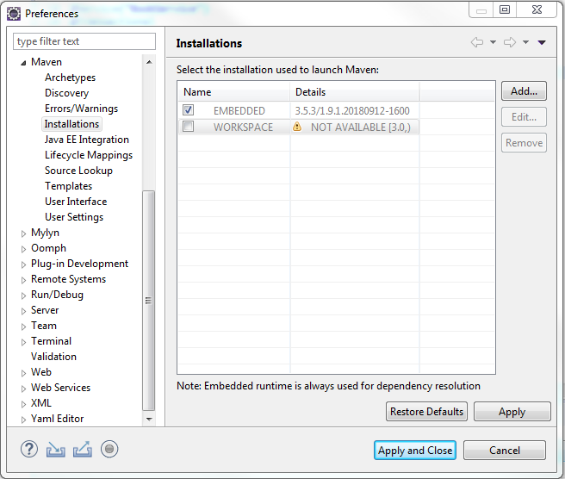

* + - * + Click in add and inform the Maven Installation Home
        + 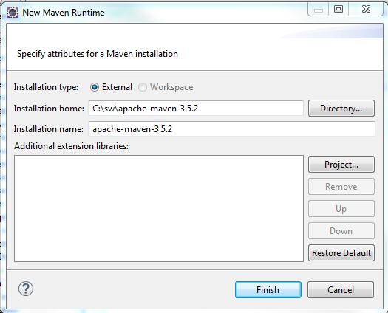Click in Finish
        + Click in the check box of your custom Maven installation.

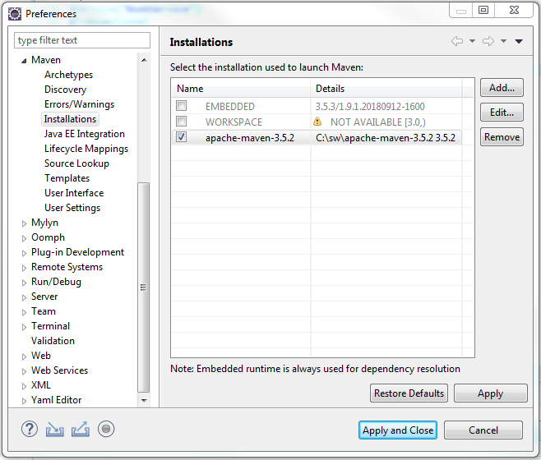

* + - * + Click in Apply and Close

Installing the project of task code

* Clone the git repository or download from there.
  + GitHub address
    - <https://github.com/pontalti/brooker-pizza-web>
* Go to menu File → Import
  + Select Existing Maven Projects on Maven section

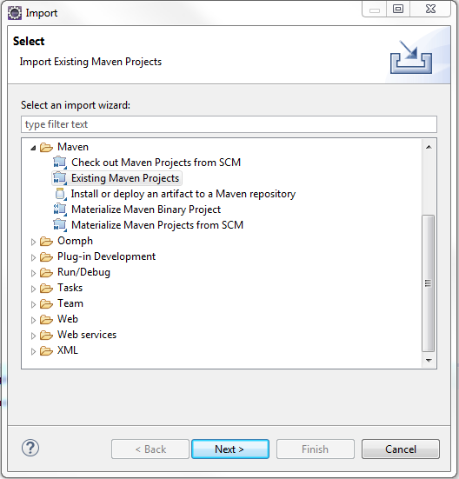

* + Click in next
  + 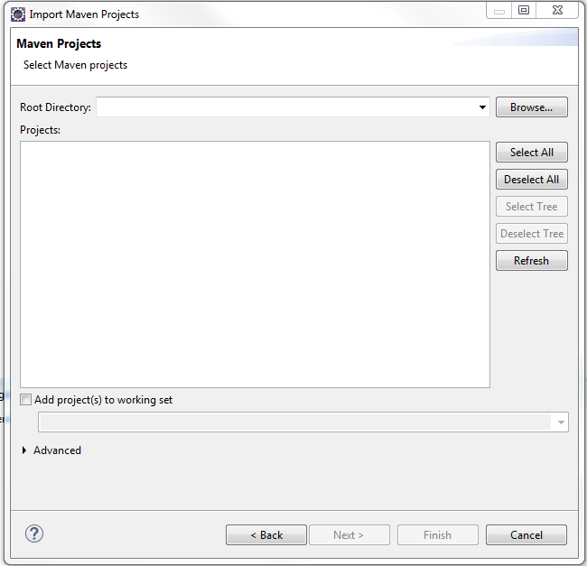Click in Browse and select the code task project folder

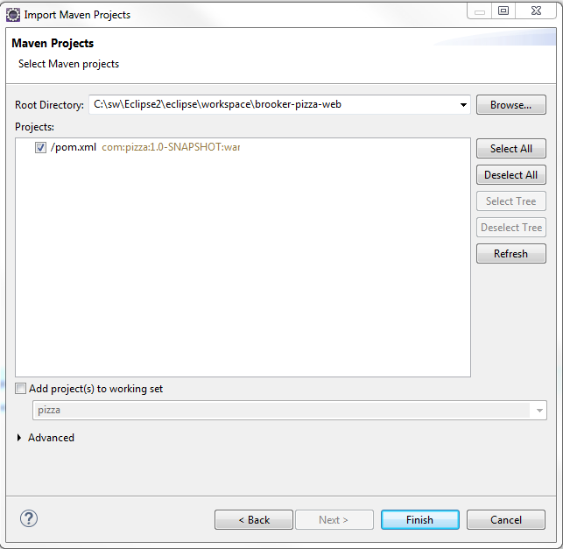

* + Click in finish and wait the build.
  + If you decide to use a different JDK version, follow the step below.
    - Open the file pom.xml
      * Change the property java.version on the properties section
        + Default value is 10 to JDK 10
        + For JDK 8 use 1.8
        + For JDK 9 use 1.9
      * Save the file and wait for the auto build.
  + Open the contextual menu on the project
  + Click in Update Project on maven section

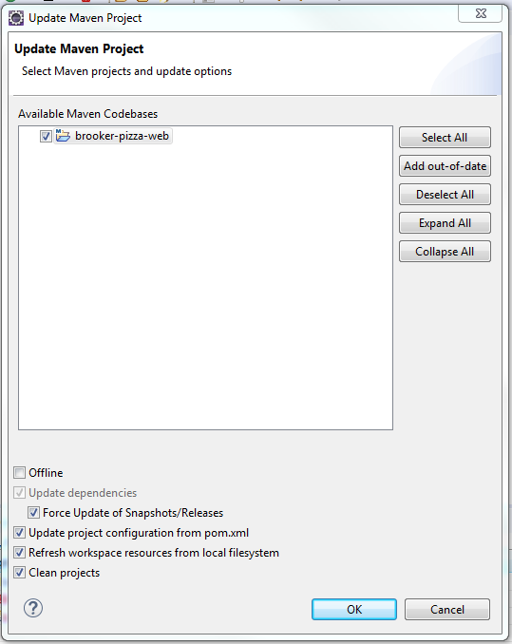

* + - Select the project and also select the option “Force Update of Snapshots/Releases”
    - Click in ok and wait for the build
* To run the app in Eclipse
  + Select the class MainApp.java on the package com
    - Open the contextual menu on the class
    - click in Java Application on the Run As section
    - wait for the build and all startup logs should be available in the eclipse console
* To run in console
  + go to project installation folder in the eclipse workspace and run the commands
    - mvn clean install -U
    - Wait for the build
  + go to the folder target and run the commands
    - java -jar pizza.war
* To test go the browser and try to use the URL below to get the description of the rest services available
  + - <http://localhost:8080/swagger-ui.html>