**Nagios**

**What is Nagios?**

**Nagios** is an Open-source program used for monitoring various kinds of servers. Designed to send a notification to System-Administrator when there is a problem or when the problem has been dealt with in the server it’s functioning on.

**Nagios’s profit**

* 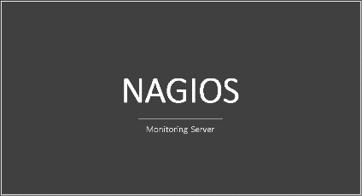Could tell when there is a problem in the server
* Know the problem and could fix it for the user
* Decrease the cost of monitoring financial.
* Declare a status of the functioning sever.
* Send data from the server in real-time

**Nagios’s Features**

* Comprehensive Monitoring - Multi-Tenant Capabilities
* Problem Remediation - Stable, Reliable, and Respected Platform
* Reporting - Customizable Code
* Extendable Architecture
* 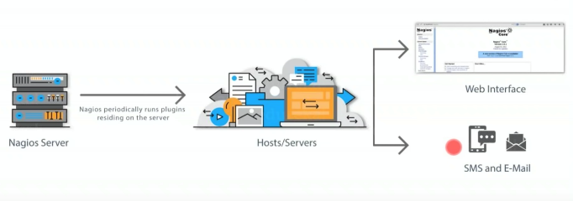Vibrant Community
* Visibility & Awareness
* Proactive Planning