HEALTH AI: INTELLIGENT HEALTHCARE ASSISTANT

**Team Leader:** PONTHANGARAJ.P

**Member 1:** PONMUTHURAMAN.R

**Member 2:** PARTHASARATHY.S

**Member 3:** RAHUL.B

# Introduction

Health AI is an AI-powered virtual healthcare assistant built using IBM Granite models integrated with a Gradio interface. It helps users analyze symptoms, predict possible medical conditions, and generate general treatment recommendations. The system emphasizes the importance of consulting healthcare professionals and acts as an informational support tool rather than a diagnostic solution.

# Project Overview

**Purpose:** The main objective of Health AI is to provide quick, AI-powered healthcare insights for patients based on their symptoms and medical history.

Key Features:

* + Disease Prediction: Users can input symptoms, and the AI suggests possible medical conditions.
  + Treatment Plan Generation: AI generates a basic treatment plan based on patient details.
  + User-Friendly Interface: Built with Gradio Blocks and Tabs for seamless navigation.
  + Important Disclaimer: Outputs are informational only, not medical advice.

# Architecture

**Frontend:** Gradio (Python-based UI framework).

**Backend:** Hugging Face Transformers with IBM Granite LLM.

**Model Used:** ibm-granite/granite-3.2-2b-instruct for text generation. **Frameworks & Libraries:** PyTorch, Hugging Face Transformers, Gradio. **Deployment:** Google Colab with GPU (T4) enabled.

# Setup Instructions

**Prerequisites:** Python 3.8+, Hugging Face account, Google Colab/local GPU environment, GitHub account.

Installation Steps:

* + Install required libraries: pip install transformers torch gradio
  + Import the IBM Granite model from Hugging Face.
  + Run the Gradio Blocks interface.
  + Launch the app (with share=True for public access).

# Application Workflow

1. Launch the application in Google Colab.
2. Disease Prediction Tab: Input symptoms and get AI-generated possible conditions.
3. Treatment Plan Tab: Enter condition, age, gender, and medical history for a personalized plan.
4. Access Gradio link to interact with the live app.

# Output

**Disease Prediction Tab:** Displays possible medical conditions with cautionary advice.

**Treatment Plans Tab:** Provides structured treatment plans.

**Gradio UI:** Clean, tab-based navigation with text input and output areas.

# GitHub Upload

1. Download code from Colab (.py file).
2. Create a repository in GitHub.
3. Upload project files and commit changes.
4. Share repo link as project submission.

# Future Enhancements

Integration with voice-based symptom input. Multi-language support.

Medical database integration. Chatbot-style conversation memory.

**Code:-**

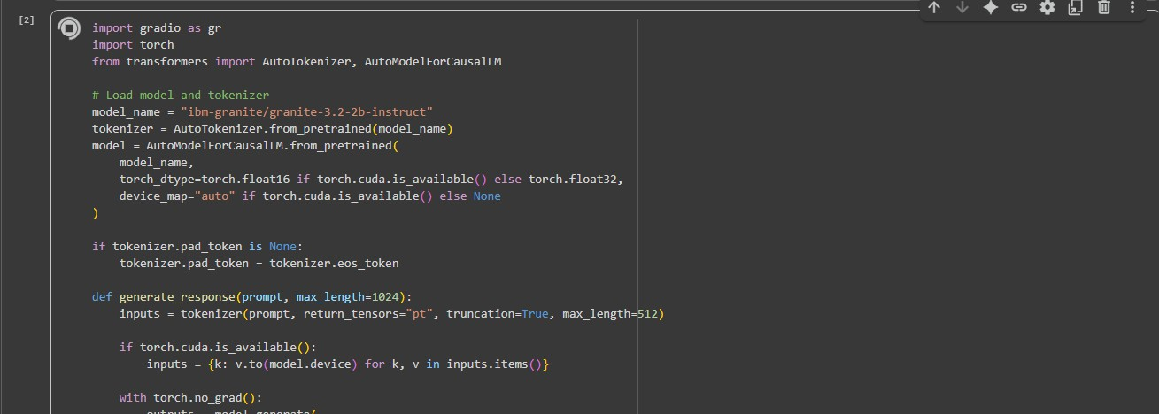

**OUTPUT:-**

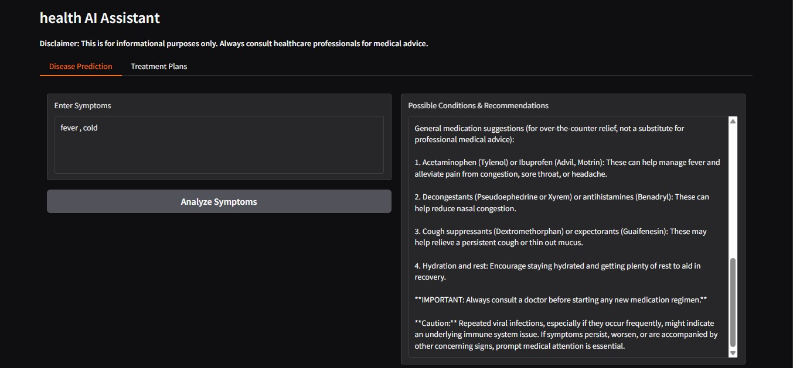

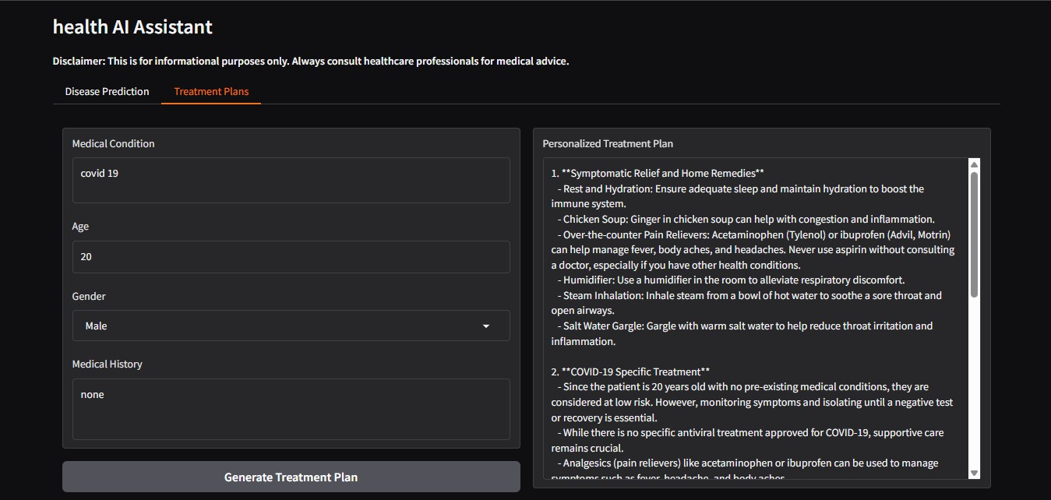

**GITHUB:-**

