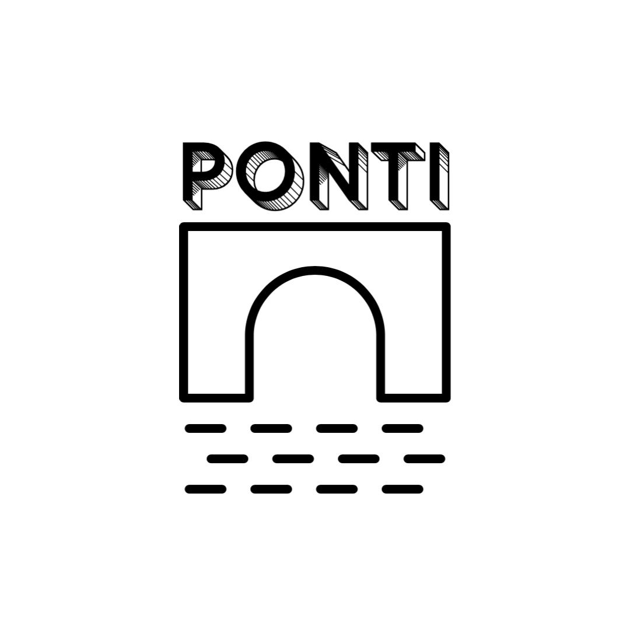

PONTI /// Your Business

Overview
We will develop your website using Webflow's platform and the CMS to make editing and maintenance easy and developer-free.

Cost
This project includes:
- Market & Business Analysis
- 2 rounds of design revisions
- Fully responsive site design & development
- CMS training

Price: $3,500

Timeline
We can begin working on your project within the next three days and believe we can complete it within 3 weeks.

These dates are under the assumption that you approve the proposal within the next three days and we can finalize the design within the first week of the project.

What's Next
1. We will be happy to answer any questions regarding this proposal.
2. After your approval, we'll send in the final dates for the project deadline.
3. Once the down payment is received, our work will commence.

Terms
- Payment
  - 50% upfront, 50% upon site deployment
  - Payment via wire transfer
- Additional Work
  - All revisions beyond 2 rounds will be charged at $150/hour
  - Any work that is not described in the SOW will be assessed in a new estimate
- Business day count starts only after the client provides all resources requested
- After the work is completed and payment has been received, we will transfer the ownership of assets.
- In the case of project cancellation after the work has started, the client will pay for the relative part of the work.

