Booking Engine Design Notes for RVPark.
2025-01-27 RMP

Overview
Booking is by a discrete time period, for a room park accommodation it is a day. (Midday to Midday).
To prevent double booking we have a per period resource – time-period availability status parameter. This notes a time-period is either available or is not. And for what resource that is being booked.
So to make a booking for a number of periods all availability records for that resource must be available. When the booking is made all these availability records are marked as no longer available.
When a booking is deleted (not completed) then its availability records need to be marked as now available so that resource to be rebooked.
These notes define the rule the booking engine follows when

- Requesting a booking.
- Making a booking.
- Changing a booking.
- Deleting a booking.

There may be a situation where bookings may be being attempted concurrently by different users. There needs to be some way of making sure that making or changing a booking is transactional and no other process can change the environment until that process is complete.

Data Model
On the next page is the reverse engineered datamodel of the booking database being used. It also includes the Authentication and Authorization objects need for the Blazor aspnet core web app. Key entities within the booking engine are:
- Bkg_User
- Bkg_Property
- Bkg_Booking
- Bkg_Availabliliy
- Bkg_Review
- Bkg_Payment
- Bkg_History (Not shown in the diagram yet)

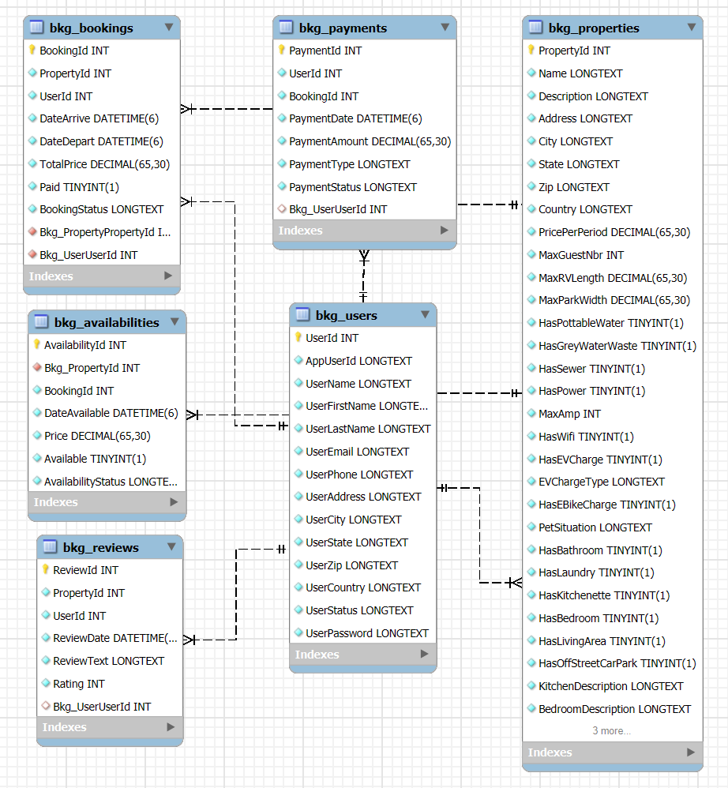

<full descriptions of entities might be added later>

Setup
Before the Booking Engine can be used a number entities need to be populated. They are:
- Bkg_Users The details of guest or customers. They may also have an Application Log in and have an entry in the AspNetUser entity and be able to use the Web Application to create and manage their bookings.
- Bkg_Properties These are the resources that are being let out or rented. A room, flat, parking space. This is not a class of object so in this engine a property has a capacity on only one. So, each room is a property. A Category of Resource/Property would need to be added to cater for types of rooms being all the same.
- Bkg_Availability This s a record for each time-period, (generally a day) for each property that holds the Availability status for that Property. It controls whether a Property can be booked on a given time-period.
- Bkg_Booking This is the entity that record the Booking of a resource/property It joins the User/guest with the Property being booked.

To prevent Update Conflict in the Booking Engine
We use
Begin Transaction, Commit Transaction and if necessary, Rollback Transaction.
There may be a need have a slightly different arrangement when SQLite is being used but that is for a future release. It is not so important as SQLite is likely to be used on single user devices so may not be a big issue.

Checking Availability (general)
There are a number of situations we need to check and change Bkg_Availability and Bkg_Booking
Each will be deal with as a separate section below.

Booking Request Checking Availability
Here a user has selected a Property, Arrival and Departure dates and asked to create a Booking.
- For the Properties selected
  - From start date to end date
    - See if Bkg is Available
      - IF NOT Exit FALSE
    - Next date
  - Loop for Property is completed so Booking can be made
- end

Making a Booking
So if we check a booking is possible then the process for making a booking is as follows
- Begin Transaction
- Check if booking possible
  - Rollback Trans. Exit false if not
- For the Resource/Property being booked
  - For each of the Bkg_Availability records in the date range
    - Set the Availability as false and status to Booked
  - Commit Trans

Deleting a Booking
Here the Bkg_Available record need to be returned to a state they can be booked again
- Begin Transaction
- For the Resource/Property being booked
  - For each of the Bkg_Availability records in the date range
    - Set the Availability as TRUE and status to BLANK
  - Delete The Booking record
  - On any error ROLLback Trans
- Commit Trans.

Making a change to an Existing Booking
This task is rather more complicated than any of the others. It needs to consider the different date ranges from the existing booking to its new start and end date as well as if a property has changes or been added. We have an original booking with its property, from and to dates. Then a desired changed booking that will likely have different from and to dates as well maybe as a different property. This task needs to be able to determine if the changes are possible given that the original booking may cover availability records for part of the date rand the new booking requires. So here we must look at the availability check in a number of places.

Below the symbols represent as follows
Original From ARRIVAL Date = A1 | Original To DEPART Date = D1 | Original Property = P1
New From ARRIVAL Date = A2 | New To DEPART Date = D2 | New Property = P2

The possibilities might be.
- Property is change as well as possibly the date range P1 != P2 therefore A1,A2,D1,D2 do not matter.
- Properties are the same P1==P2
  - A2 – D2 < A1
  - A2 < A1 AND D2 > A1 AND D2 <= D1
  - A2 < A1 AND D2 > D1
  - A2>=A1 AND D2 <= D1
  - A2>A1 AND A2 < D1 AND D2 > D1
  - A2 > D2
- So for each of these 7 cases we have up to 3 areas to check for availability
  - For (a), range is A2 to D2
  - For (b) and (c) range is A2 to A1
  - For (d) range is already covered by the A1-D1 booking
  - For c) and (e) range is D1 to D2
  - For (f) range is A2 to D2
Check availability to go ahead or not break; and exit FALSE if not.
- For class a) to f) we do slightly different things.

A2 and D2 are before A1- Change Booking (a)
A1----------D1
A2----------D2
- Begin Transaction
- Check Availability A2 to D2
  - If NOT set to EXIT FALSE as Bkg Change Not Possible
  - RollBack Trans
- If OK
  - Set Bkg_Available records for this Property between A2 and D2
  - Change Arrival and Departure dates on Bkg_Booking
  - Reset Availability from A1 to D1
  - Set to Exit TRUE as Booking change Made OK.
  - Commit Trans

A2 is before A1, D2 between A1 and D1 - Change Booking (b)
A1----------D1
A2-----------------------D2
- Begin Transaction
- Check Availability A2 to A1
  - If NOT set to EXIT FALSE as Bkg Change Not Possible
- If OK
  - Set Bkg_Available records for this Property between A2 and A1
  - Change Arrival and Departure dates on Bkg_Booking
  - Reset Availability from D2 to D1
  - Set to Exit TRUE as Booking change Made.
- Clear Semaphore flag.

A2 is before A1, D2 is after D1 - Change Booking (c)
A1----------D1
A2----------------------------------------------D2
- Begin Transaction
- Check Availability A2 to A1
  - If NOT set to EXIT FALSE as Bkg Change Not Possible
  - Rollback Trans.
- Check Availability D1 to D2
  - If NOT set to EXIT FALSE as Bkg Change Not Possible
  - Rollback Trans.
- If OK
  - Set Bkg_Available records for this Property between A2 and A1
  - Set Bkg_Available records for this Property between D1 and D2
  - Change Arrival and Departure dates on Bkg_Booking
  - Set to Exit TRUE as Booking change Made.
  - Commit Trans.

A2 and D2 are between A1 and D1 - Change Booking (d)
A1-----------------D1
A2-----D2
- Begin Transaction
- No Check Availability needed as A2-D2 within A1-D1 range
- Change Arrival and Departure dates on Bkg_Booking
  - Reset Availability from A1 to A2
  - Reset Availability from D2 to D1
  - Set to Exit TRUE as Booking change Made.
- Commit Trans.

A2 Between A1 and D1 D2 after D1 - Change Booking (e)
A1-----------------D1
A2---------------D2
- Begin Transaction
- Check Availability D1 to D2
  - If NOT set to EXIT FALSE as Bkg Change Not Possible
  - Rollback Trans.
- If OK
  - Set Bkg_Available records for this Property between D1 and D2
  - Change Arrival and Departure dates on Bkg_Booking
  - Reset Availability from A1 to A2
  - Set to Exit TRUE as Booking change Made.
  - Commit Trans.

A2 and D2 are both after D1 - Change Booking (f)
A1----------D1
A2-----------D2
- Begin Transaction
- Check Availability A2 to D2
  - If NOT set to EXIT FALSE as Bkg Change Not Possible
  - Rollback Trans.
- If OK
  - Set Bkg_Available records for this Property between A2 and D2
  - Change Arrival and Departure dates on Bkg_Booking
  - Reset Availability from A1 to D1
  - Set to Exit TRUE as Booking change Made.
  - Commit Trans.

Is EF core transactional in that we can start a series of command and until they are finished other processes cannot change any of the objects in the first series of commands all the way to the database? CoPilot Answered:
Yes, Entity Framework (EF) Core supports transactions, which allow you to execute a series of commands as a single unit of work. When you use transactions, EF Core ensures that all operations within the transaction block are completed successfully before committing the changes to the database. If any operation fails, the entire transaction is rolled back, maintaining data integrity and consistency.

### Using Transactions in EF Core
To ensure that no other process can change any of the objects in your series of commands, you can use transactions in EF Core. Here's how you can do it:

#### Example: Using `DbContextTransaction`
```csharp
using (var context = new ApplicationDbContext(options))
{
using (var transaction = context.Database.BeginTransaction())
{
try
{
// Command 1: Add a new property
var property = new Property { Name = "New Property" };
context.Properties.Add(property);
context.SaveChanges();

// Command 2: Add a new booking availability for the property
var booking = new BookingAvail { PropertyId = property.Id, StartDate = DateTime.Now, EndDate = DateTime.Now.AddDays(1) };
context.BookingAvails.Add(booking);
context.SaveChanges();

// Commit the transaction
transaction.Commit();
}
catch (Exception)
{
// Rollback the transaction if any command fails
transaction.Rollback();
}
}
}
```

### Key Points
- **Begin a Transaction**: Use `context.Database.BeginTransaction()` to start a new transaction.
- **Execute Commands**: Perform your database operations within the transaction block.
- **Commit or Rollback**: Commit the transaction if all commands succeed, or roll back if any command fails.

### Isolation Levels
You can also set the isolation level for the transaction to control the level of access other processes have to the data during the transaction.

#### Example: Setting Isolation Level
```csharp
using (var context = new ApplicationDbContext(options))
{
using (var transaction = context.Database.BeginTransaction(System.Data.IsolationLevel.Serializable))
{
try
{
// Your transactional commands here...
transaction.Commit();
}
catch (Exception)
{
transaction.Rollback();
}
}
}
```

### Summary
EF Core supports transactions, ensuring that your series of commands are executed atomically. Using transactions helps maintain data consistency and integrity by preventing other processes from changing the data until the transaction is complete.

EF core and transactional isolation.
Seems it is possible to operate a begin end commit rollback with EF core and also to have the same features if SQLite is used as the database. Following it the CoPilot Information.
What of SQLite? CoPilot Answer:
Yes, the transaction support in EF Core does depend on the underlying database's capabilities. SQLite, known for its lightweight and portable nature, does support transactions. However, it has some differences compared to other relational databases like SQL Server or PostgreSQL.

### SQLite Transaction Capabilities
- **Basic Transactions**: SQLite fully supports BEGIN TRANSACTION, COMMIT, and ROLLBACK operations, allowing you to group multiple operations into a single transaction.
- **Transaction Isolation**: SQLite supports Read Uncommitted and Serializable isolation levels. However, the default isolation level in SQLite is Serializable, which ensures strict transaction isolation.
- **Savepoints**: SQLite supports savepoints, which allow you to roll back to specific points within a transaction.

### Using Transactions with SQLite in EF Core
Here's how you can use transactions with SQLite in an EF Core application:
using (var context = new ApplicationDbContext())
{
using (var transaction = context.Database.BeginTransaction())
{
try
{
// Command 1: Add a new property
var property = new Property { Name = "New Property" };
context.Properties.Add(property);
context.SaveChanges();

// Command 2: Add a new booking availability for the property
var booking = new BookingAvail { PropertyId = property.Id, StartDate = DateTime.Now, EndDate = DateTime.Now.AddDays(1) };
context.BookingAvails.Add(booking);
context.SaveChanges();

// Commit the transaction
transaction.Commit();
}
catch (Exception)
{
// Rollback the transaction if any command fails
transaction.Rollback();
}
}
}

### Summary
- **Basic Transactions**: SQLite supports transactions, including BEGIN, COMMIT, and ROLLBACK.
- **Isolation Levels**: SQLite supports Serializable isolation level, ensuring strict transaction isolation.
- **EF Core Integration**: You can use transactions in EF Core with SQLite similarly to other databases.
By following these steps, you can achieve transactional consistency in your SQLite-based EF Core application.

