ISO 20022

Bank-to-Customer Cash Management - Maintenance 2020-2021

Message Definition Report Part 1

Approved by the Payments SEG

This document provides information about the use of the messages for Bank-to-Customer Cash Management and includes, for example, business scenarios and messages flows.

February 2021

Table of Contents

Table of Contents 2

1 Introduction 5

1.1 Terms and Definitions 5

1.2 Abbreviations and Acronyms 5

1.3 Document Scope and Objectives 5

1.4 References 6

2 Scope and Functionality 7

2.1 Background 7

2.2 Scope 7

2.3 Groups of MessageDefinitions and Functionality 7

3 BusinessRoles and Participants 9

3.1 Participants and BusinessRoles Definitions 9

3.2 BusinessRoles and Participants Table 10

4 BusinessProcess Description 11

5 Description of BusinessActivities 13

6 BusinessTransactions 19

6.1 Reporting 19

6.2 Reporting through a Forwarding Agent 20

6.3 Reporting Request to Account Servicer 21

7 Business Examples 23

7.1 BankToCustomerAccountReport camt.052.001.09 23

7.2 BankToCustomerStatement camt.053.001.09 27

7.3 BankToCustomerDebitCreditNotification camt.054.001.09 35

7.4 AccountReportingRequest camt.060.001.06 38

8 Revision Record 41

Preliminary Note

The Message Definition Report (MDR) is made of three parts:

MDR Part 1

This describes the contextual background required to understand the functionality of the proposed message set. Part 1 is produced by the submitting organisation that developed or maintained the message set in line with an MDR Part 1 template provided by the ISO 20022 Registration Authority (RA) on [www.iso20022.org](http://www.iso20022.org).

MDR Part 2

This is the detailed description of each message definition of the message set. Part 2 is produced by the RA using the model developed by the submitting organisation.

MDR Part 3

This is an extract if the ISO 20022 Business Model describing the business concepts used in the message set. Part 3 is an Excel document produced by the RA.

# Introduction

## Terms and Definitions

The following terms are reserved words defined in ISO 20022 Edition 2013 – Part1. When used in this document, the UpperCamelCase notation is followed.

|  |  |
| --- | --- |
| Term | Definition |
| BusinessRole | Functional role played by a business actor in a particular BusinessProcess or BusinessTransaction. |
| Participant | Involvement of a BusinessRole in a BusinessTransaction. |
| BusinessProcess | Definition of the business activities undertaken by BusinessRoles within a BusinessArea whereby each BusinessProcess fulfils one type of business activity and whereby a BusinessProcess may include and extend other BusinessProcesses. |
| BusinessTransaction | Particular solution that meets the communication requirements and the interaction requirements of a particular BusinessProcess and BusinessArea. |
| MessageDefinition | Formal description of the structure of a message instance. |

1. When a MessageDefinition or message identifier is specified, it should include the variant and version number. However, in this document (except in the business examples section, if present), variant and version numbers are not included. In order to know the correct variant and version number for a MessageDefinition, the related Message Definition Report Part 2 document should be consulted

## Abbreviations and Acronyms

The following is a list of abbreviations and acronyms used in the document.

|  |  |
| --- | --- |
| Abbreviation/Acronyms | Definition |
| ISTH | International Standards Team Harmonisation |
| ISITC | International Securities Association for Institutional Trade Communication |
| IFX | Interactive Financial eXchange Forum |
| TWIST | Transaction Workflow Innovation Standards Team |
| OAGi | Open Application Group |

## Document Scope and Objectives

This document is the first part of the Bank To Customer Cash Management Message Definition Report (MDR) that describes the BusinessTransactions and underlying message set. For the sake of completeness, the document may also describe BusinessActivities that are not in the scope of the business processes covered in this document.

This document describes the following:

* the BusinessProcess scope
* the BusinessRoles involved in these BusinessProcesses

The main objectives of this document are as follows:

* to provide information about the messages that support the BusinessProcesses
* to explain the BusinessProcesses and BusinessActivities these messages have addressed
* to give a high level description of BusinessProcesses and the associated BusinessRoles
* to document the BusinessTransactions
* to provide business examples

The MessageDefinitions are specified in Message Definition Report Part 2.

## References

|  |  |  |  |
| --- | --- | --- | --- |
| Document | Version | Date | Author |
| ISO 20022 Business Justification – Bank-to-Customer Cash Management |  | 2007-04-20 | ISTH |
| ISO 20022 Business Justification – Cash Account Reporting Request and Notification Messages |  | 2011-01-19 | SWIFT |
| ISO 20022 Payments Maintenance 2018/2019 Maintenance Change Request document | ISO 20022 Submission - 137 MCR | 2018-09-26 | SWIFT |

# Scope and Functionality

## Background

This Message Definition Report covers a set of four MessageDefinitions developed by SWIFT, on behalf of IFX, TWIST, OAGi and SWIFT, and approved by to the ISO 20022 Payments Standards Evaluation Group (SEG) in January 2021.

These messages are specifically designed to support reporting of cash transactions between an account servicer and its customers.

## Scope

The set of messages covers the cash management requirements in the Bank-to-Customer space. They consist of the debit and credit advices and statements forwarded by an account servicing institution to its private or corporate account owners to provide information on the cash side of all types of financial transactions. The scope does not include the advices and statements exchanged between financial intermediaries.

## Groups of MessageDefinitions and Functionality

### Groups

#### Reporting

BankToCustomerAccountReport

This message is sent by the account servicer to an account owner or to a party authorised by the account owner to receive the message. It can be used to inform the account owner, or authorised party, of the entries reported to the account, and/or to provide the owner with balance information on the account at a given point in time.

BankToCustomerStatement

This message is sent by the account servicer to an account owner or to a party authorised by the account owner to receive the message. It is used to inform the account owner, or authorised party, of the entries booked to the account, and to provide the owner with balance information on the account at a given point in time.

BankToCustomerDebitCreditNotification

This message is sent by the account servicer to an account owner or to a party authorised by the account owner to receive the message. It can be used to inform the account owner, or authorised party, of single or multiple debit and/or credit entries reported to the account.

|  |  |
| --- | --- |
| MessageDefinition | Message Identifier |
| BankToCustomerAccountReport | camt.052 |
| BankToCustomerStatement | camt.053 |
| BankToCustomerDebitCreditNotification | camt.054 |

#### Request

AccountReportingRequest

This message is sent by the account owner, either directly or through a forwarding agent, to one of its account servicing institutions. It is used to ask the account servicing institution to send a report on the account owner's account in a BankToCustomerAccountReport, a BankToCustomerStatement or a BankToCustomerDebitCreditNotification.

|  |  |
| --- | --- |
| MessageDefinition | Message Identifier |
| AccountReportingRequest | camt.060 |

### Functionality

See Message Definition Report Part 2 for the message scopes and their formats.

# BusinessRoles and Participants

A BusinessRole represents an entity (or a class of entities) of the real world, physical or legal, a person, a group of persons, a corporation. Examples of BusinessRoles: “Financial Institution”, “Automated Clearing House”, “Central Securities Depository”.

A Participant is a functional role performed by a BusinessRole in a particular BusinessProcess or BusinessTransaction. Examples of Participants: the “user” of a system, “debtor”, “creditor”, “investor”.

The relationship between BusinessRoles and Participants is many-to-many. One BusinessRole can be involved as different Participants at different moments in time or at the same time. Different BusinessRoles can be involved as the same Participant.

In the context of Bank To Customer Cash Management, the high-level BusinessRoles and typical Participants can be represented as follows:

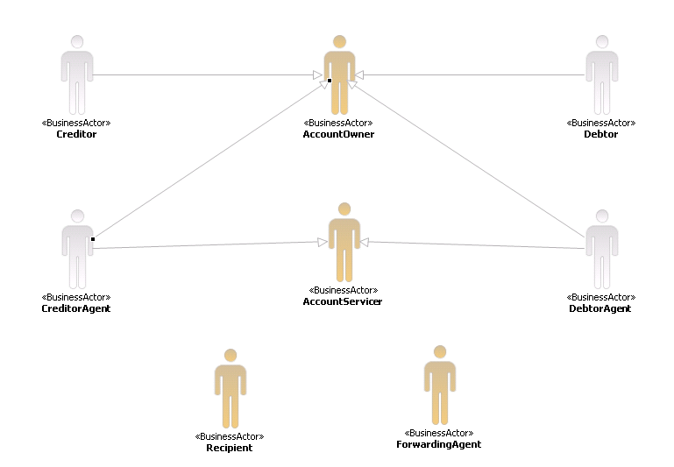

## Participants and BusinessRoles Definitions

Participants

|  |  |
| --- | --- |
| Description | Definition |
| Account Servicer | Party that manages the account on behalf of the account owner (that is, manages the registration and booking of entries on the account, calculates balances on the account and provides information about the account), or the party that has a contractual relationship with the owner (for example, market data provider). |
| Account Owner | Party that legally holds the account or the party in a contractual relationship with the servicer. |
| Recipient | Party authorised by the account owner to receive information about movements on the account. |
| Forwarding Agent | Financial institution that receives the instruction from the initiating party and forwards it to the next agent in the payment chain for execution |

BusinessRoles

|  |  |
| --- | --- |
| Description | Definition |
| Creditor | Party to which an amount of money is due. |
| Debtor | Party that owes an amount of money to the (ultimate) creditor. |
| Creditor Agent | Financial institution servicing an account for the creditor. |
| Debtor Agent | Financial institution servicing an account for the debtor. |
| Market Infrastructure | Party that processes, monitors and reports on transaction within the system received from the system member. |
| System Member | Party that instructs the executing/servicing party to process and maintain a transactions in the system. |

## BusinessRoles and Participants Table

|  |  |  |
| --- | --- | --- |
| BusinessRole | Participant  Account Servicer | Participant  Account Owner |
| Creditor |  | X |
| Debtor |  | X |
| Creditor Agent | X |  |
| Debtor Agent | X |  |
| Market Infrastructure | X |  |
| System Member |  | X |

# BusinessProcess Description

This diagram represents the high level BusinessProcesses.

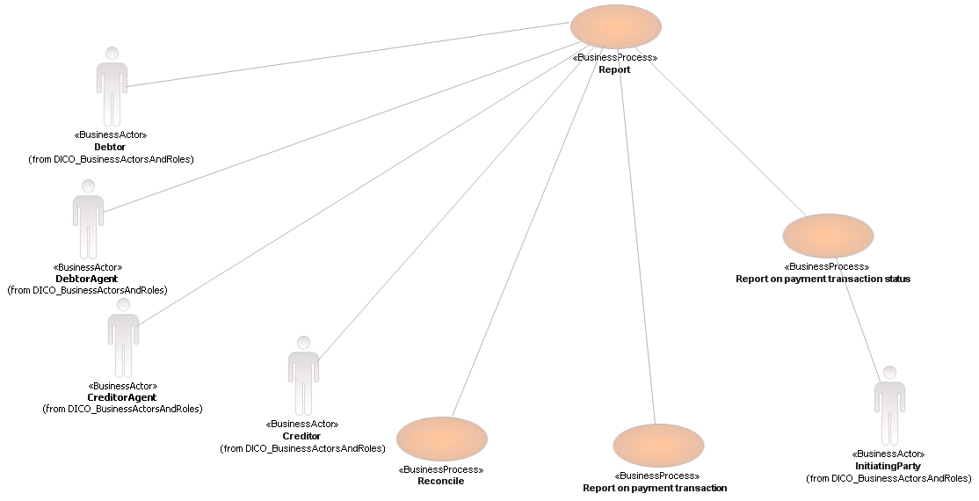

Report

Reporting applies both to interbank reporting (such as nostro account reporting), and bank-to-customer reporting. The definitions below apply to the bank-to-customer reporting.

Regulatory reporting is described as a separate process.

|  |  |
| --- | --- |
| Item | Description |
| Definition | The process includes the financial impact reporting, the reporting on the payment transaction status and the reconciliation process. Further descriptions of these sub-processes are included below. |
| Trigger | Payment process is completed. |
| Pre-conditions | An agreement exists between the reporting party and the reported party to do a specific type of reporting, in order to meet legal requirements and business requirements agreed between the reporting and reported party. |
| Post-conditions | The payment transaction is reported on. |
| Role | Account Servicer (debtor agent or creditor agent). |

Reconcile

Reporting applies both to interbank reporting, for example, nostro account reporting, and bank-to-customer reporting. The definitions below apply to the bank-to-customer reporting.

Regulatory reporting is described as a separate process.

|  |  |
| --- | --- |
| Item | Description |
| Definition | The process includes the financial impact reporting, the reporting on the payment transaction status and the reconciliation process. Further descriptions of these sub-processes are included below. |
| Trigger | Payment process is completed. |
| Pre-conditions | An agreement exists between the reporting party and the reported party to do a specific type of reporting, in order to meet legal requirements and business requirements agreed between the reporting and reported party. |
| Post-conditions | The payment transaction is reported on. |
| Role | Account Owner (debtor or creditor). |

Report on Payment Transaction

Typical examples of this type of reporting are debit advices, credit advices, intraday and end-of-day statements, etc.

|  |  |
| --- | --- |
| Item | Description |
| Definition | Reporting done by debtor agent to debtor or party authorised by the debtor to receive the report and reporting by creditor agent to creditor or party authorised by the creditor to receive the report on the financial impact of the processed transaction. |
| Trigger | Completion of the settlement process. |
| Pre-conditions | Debit or credit has been registered to the account. (The term 'registered' is used, rather than the term 'booked', as an entry on an account can have three statuses: pending, future, booked, as defined in the cash management messages set.) |
| Post-conditions | The 'financial impact' report is delivered. |
| Role | Account Servicer (debtor agent or creditor agent). |

Report on Payment Transaction Status

Report on final execution status is the reporting done by the final agent to the initiating party when the final agent has registered the item to the creditor's account. This reporting has to be conveyed to the initiating party, either through the chain of preceding agents in the original chain, or through means of investigation by such as forwarding or first agent.

|  |  |
| --- | --- |
| Item | Description |
| Definition | Report to initiating party by first or forwarding agent on negative (rejected) and/or positive status (accepted/repaired) of the payment transaction throughout the lifecycle of the transaction. |
| Trigger | Any change in status during the lifecycle of the transaction. |
| Pre-conditions | Transaction has been received by any agent in the chain. |
| Post-conditions | Status is delivered to the initiating party |
| Role | Account Servicer (debtor agent or creditor agent). |

# Description of BusinessActivities

This section presents the different BusinessActivities within each BusinessProcess. The BusinessActivities of a process are described with activity diagrams.

Legend

|  |  |  |
| --- | --- | --- |
| Symbol | Name | Definition |
|  | Start Point | Shows where the lifecycle of the business process commences. |
|  | End Point | Shows where the lifecycle of the business process may ends. |
|  | Lozenge (or diamond) | Indicates that a choice between several actions can be made. |
|  | Bar | Indicates that several actions are initiated in parallel. |

Cash Positioning

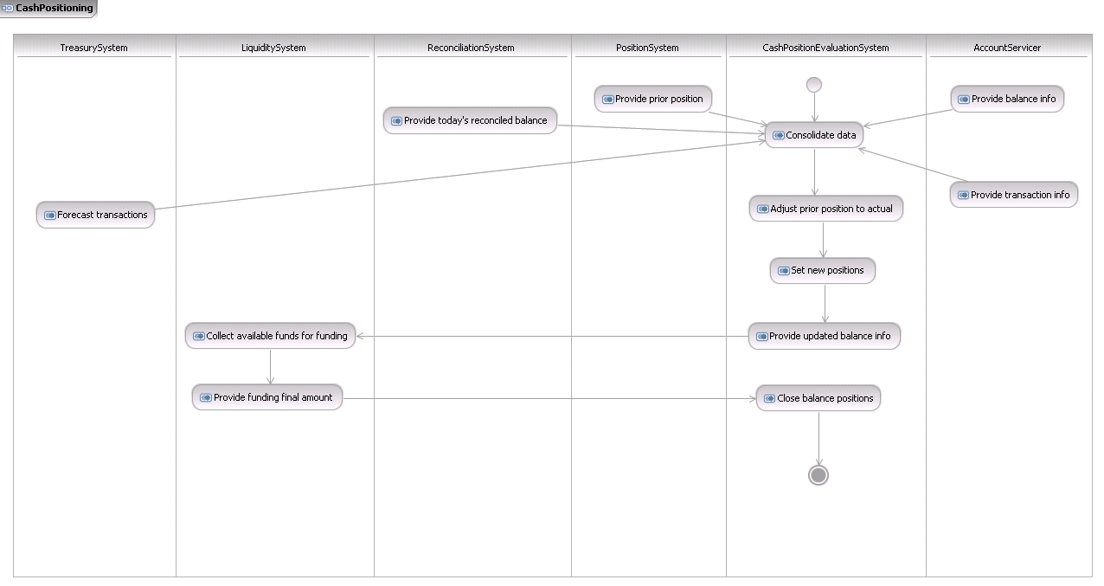

|  |  |  |
| --- | --- | --- |
| Step | Description | Initiator |
| Consolidated data | A number of different sources of actual and forecast information data are collected. | Cash Position Evaluation System |
| Adjust prior position to actual | Prior position is updated with the information collected: new closing ledger, available and forward balance positions are set. | Cash Position Evaluation Position |
| Set new positions | Prior position is updated with the information collected: new closing ledger, available and forward balance positions are set. | Cash Position Evaluation System |
| Provide updated balance information | Final balance positions are provided to the investment/liquidity management department. | Cash Position Evaluation Position |
| Collect available funds for investing/funding | All available liquidity is collected throughout the different systems. | Liquidity System |
| Provide investment/funding final amount | Available liquidity is made available to the cash position system. | Liquidity System |
| Provide balance information | New actual balance information is received from the bank. This includes information on the booked (ledger) balance (closing balance at end of previous day, opening booked balance at start of current day, available and forward available balances. Note: the different balance types that need to be reported on are further discussed in the data requirements chapter. | Account Servicer |
| Provide transaction information | If intraday reporting occurs, additional information on transactions posted to the account is received from the account servicing bank during the day. Intraday balances may be provided, even though intraday balance reconciliation is usually not done. | Account Servicer |
| Provide prior position | Prior balance position forecast information is received from the position system. | Position System |
| Provide todays reconciled balance | Forecasted balance is reconciled with actual balance information received from the bank. | Reconciliation System |
| Forecast transactions | Expected transaction information is collected. This can be a repetitive activity. | Treasury System |
| Close balance positions | Process terminates once all cash transaction activity ceases for the day, or once funding/investment options are no longer available due to market close. | Cash Position Evaluation System |

Notification to Account Owner

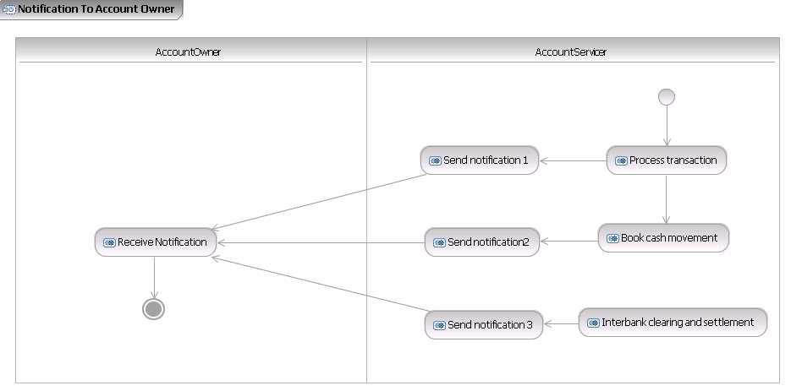

|  |  |  |
| --- | --- | --- |
| Step | Description | Initiator |
| Process transaction | The account servicer processes the transaction (either received from the account owner or from another party). On the credit side, it may be important to obtain early visibility of funds as soon as possible. This may be the case for treasury operations, or for commercial reasons (release of goods). Information is not necessarily used to start the reconciliation process, but, depending on the level of info provided, it could serve this activity as well. It could be that booking is not yet completed at the account servicer (such as item is waiting for a booking cycle), but that the account servicer has an agreement with the account owner to inform the owner of certain events that happen on the account, even if these items have not yet obtained 'final' booking status. | Account Servicer |
| Book cash movement | The account servicer books the movement of cash, which is the result of the processed transaction, to the account of the account owner. The booking may include currency conversion and charges. | Account Servicer |
| Interbank clearing and settlement | The account servicer will clear and settle the payment order through the next agent/system in the payment chain, including relevant end customer information. | Account Servicer |
| Receive notification | The account owner receives the notification. The information contained in the notification may be used for cash positioning, reconciliation, investigations by counterparties, etc. | Account Servicer |
| Send notification 1 | Under certain circumstances, the account owner may require a notification of a transaction 'in settlement' at its account servicer. As the diagram shows, the account servicer can send notifications at several stages of the processing and settlement process. As banks' posting and information practices may differ, all of the notification flows shown in the diagram are optional - and will depend on the service agreed between account owner and servicer. | Account Servicer |
| Send notification 2 / Book cash movement | It may be that booking is done real-time, but that information is usually only provided at pre-agreed intervals. In this case, a notification may be sent for certain (pre-agreed) types of cash movements that hit the account. Notifications can also be used to send details regarding underlying transactions, which are not included in full detail in, for example, a batched entry on an end-of-day statement. | Account Servicer |
| Send notification 3/ Interbank clearing and settlement | An account owner that initiated a transaction may want to know whether the transaction has already been settled in a clearing system, as the counterparty requests this information from the initiating account owner. | Account Servicer |

Transaction Reconciliation - 1

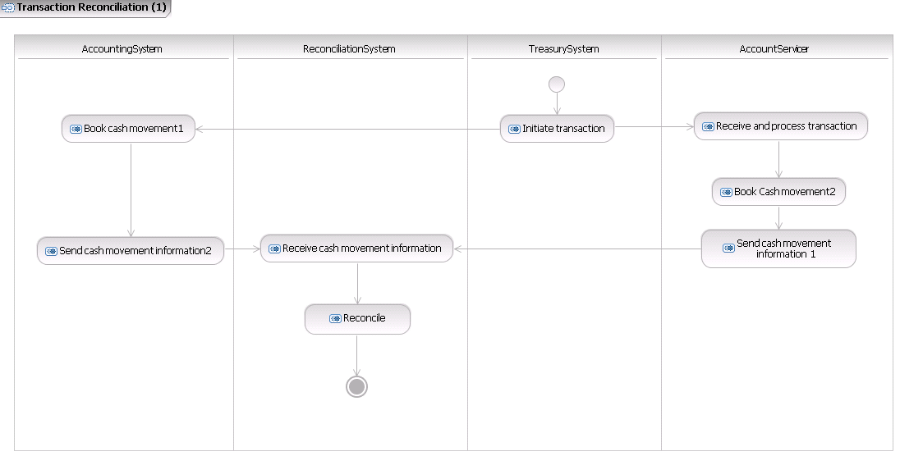

|  |  |  |
| --- | --- | --- |
| Step | Description | Initiator |
| Initiate transaction | The account owner initiates the financial leg of an underlying transaction with the account servicer. This can be any type of transaction. The underlying transaction can be concluded with a third party, or with the account servicer. | Treasury System |
| Receive and process transaction | The account servicer will do all necessary checks related to the acceptance of the transaction of the account owner and will process the transaction. | Account Servicer |
| Book cash movement 1 | The account owner will book the movement of cash, which is the result of the submitted transaction, in its internal books. | Accounting System |
| Book cash movement 2 | The account servicer will book the movement of cash, which is the result of the submitted transaction, to the account of the account owner. The booking may include currency conversion and charges. | Account Servicer |
| Send cash movement information 1 | The account servicer will send information related to the cash movements that have been booked to the account, to the account owner. | Account Servicer |
| Send cash movement information 2 | The account owner's accounting system will feed the reconciliation system with information on the booked items. | Accounting System |
| Receive cash movement information | The account owner's reconciliation system receives the cash movement information, both from the external feed, that is, the account servicer, and the internal accounting system. | Reconciliation system |
| Reconcile | The account owner's reconciliation system matches the information from the internal accounting system with the information received from the external feed (that is the account servicer). It identifies items which are not matched. These mismatched items may trigger an investigation process. | Reconciliation system |

If the cash movement information sent by the account servicer contains aggregate amounts, a “Financial Reconciliation Process” finally analyses total amounts paid according to the initial cash movement information provided by the account servicer (such as in a statement), with the specifications provided in information reports provided by the account servicer that provide detailed, individual information.

Transaction Reconciliation -2

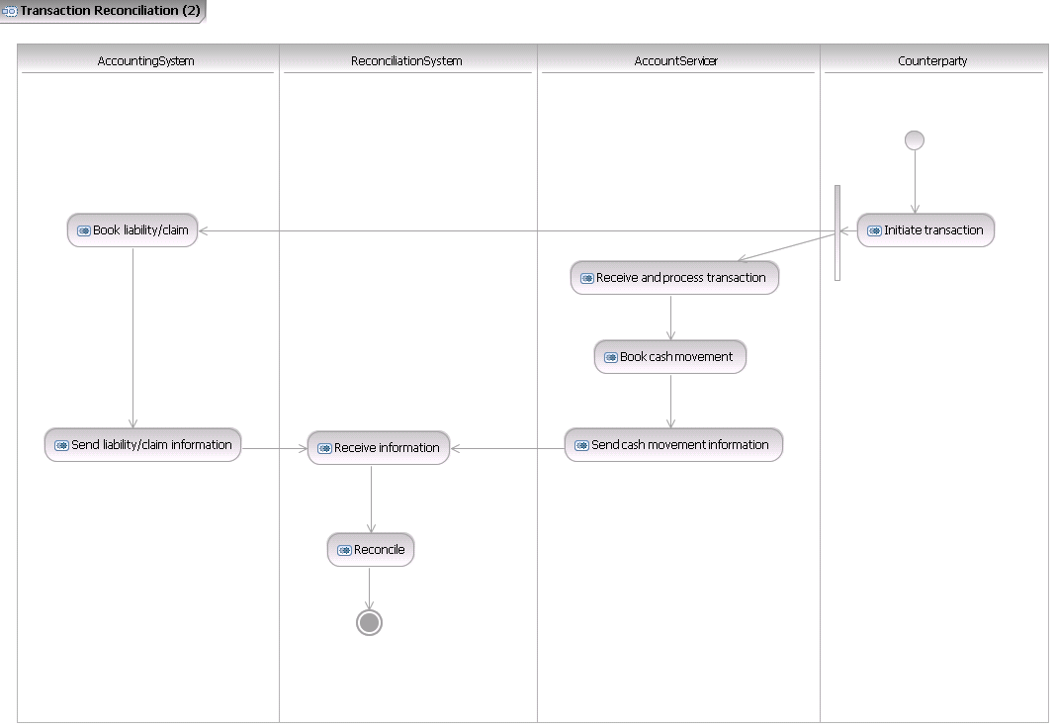

|  |  |  |
| --- | --- | --- |
| Step | Description | Initiator |
| Initiate transaction | The counterparty initiates a transaction with the account owner. This can be any type of transaction (such as securities, trade, purchase of goods, etc.). The counterparty will also initiate the financial leg of the transaction with its account servicer. The counterparty's account servicer may be or may not be equal to the account servicer of the account owner. | Counterparty |
| Receive and process transaction | The account servicer will do all necessary checks related to the acceptance of the transaction (received from the counterparty directly, or through intermediary financial institutions) and will process the transaction. | Account Servicer |
| Book cash movement | The account servicer will book the movement of cash, which is the result of the submitted transaction, to the account of the account owner. The booking may include currency conversion and charges. | Account servicer |
| Send cash movement information | The account servicer will send information related to the cash movements that have been booked to the account, to the account owner. | Account Servicer |
| Receive information | The account owner's reconciliation system receives the cash movement information from the external feed (that is the account servicer) and receives information on the liabilities/claims from the internal accounting system. | Reconciliation System |
| Book liability/claim | The accounting system of the account owner will book a 'liability/claim' for the transaction concluded with the counterparty in its internal books. | Accounting System |
| Send liability/claim | The account owner's accounting system will feed the reconciliation system with information on the open items (liabilities/claims). | Accounting System |
| Reconcile | The account owner's reconciliation system matches the information from the internal accounting system with the information received from the external feed, that is, the account servicer. It identifies items which are not matched. These mismatched items may trigger an investigation process. | Reconciliation System |

If the cash movement information sent by the account servicer contains aggregate amounts (such as in case of a lockbox scenario), a “Financial Reconciliation Process” finally analyses total amounts paid according to the initial cash movement information provided by the account servicer, for example, in a statement, with the specifications provided in information reports provided by the account servicer that provide detailed, individual information.

# BusinessTransactions

This section describes the message flows based on the activity diagrams documented above. It shows the typical exchanges of information in the context of a BusinessTransaction.

## Reporting

The Bank-to-Customer Cash Management messages are sent from the account servicer to the account owner, or a party authorised by the account owner to receive the account information (i.e. the Message Recipient).

The scenarios illustrate the reporting from account servicer to account owner.

### Scenario 1

The following service has been agreed between account owner and account servicer: During the day, the account servicer sends one or more BankToCustomerAccountReport messages to inform the account owner of any intraday movements (booked and pending) on the account. At the end of the business day, the account servicer summarises all booked entries in the BankToCustomerStatement and provides booked and available balance information.

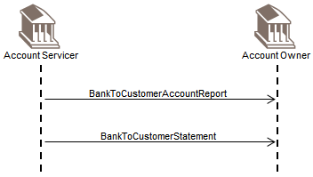

### Scenario 2

The following service has been agreed between account owner and account servicer: During the day, the account servicer will send a BankToCustomerDebitCreditNotification for any incoming credits above a certain threshold. At a pre-agreed time during the day, the account servicer will also provide an intraday BankToCustomerAccountReport, summarising all movements (booked and pending) which have been posted to the account since the start of the business day. The account servicer will also include balance information (booked and expected) in the message. At the end of the business day, the account servicer summarises all booked entries in the BankToCustomerStatement and provides booked and available balance information.

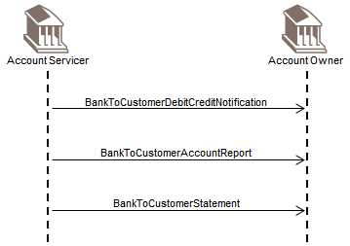

### Scenario 3

This scenario shows that the Bank to Customer Cash Management messages can also be delivered to a party authorised by the account owner to receive the account information (that is, the Message Recipient).

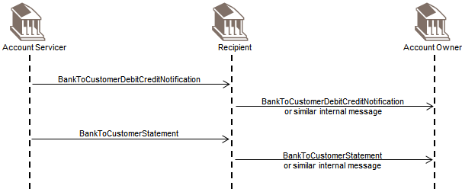

## Reporting through a Forwarding Agent

The Bank-to-Customer Cash Management messages are sent from the account servicer through a Forwarding Agent (who plays the role of 'concentrating institution' for the account owner) to the account owner, or a party authorised by the account owner to receive the account information (that is, the Message Recipient). Which messages will be sent will be agreed between the three parties.

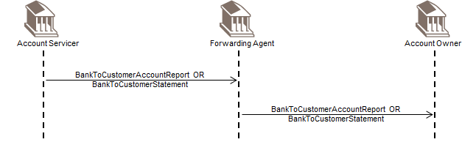

## Reporting Request to Account Servicer

### Direct Scenario

In this scenario, an account owner requests a statement directly from its account servicing institution.

The account owner sends the AccountReportingRequest directly to its account serving institution.

The account servicing institution sends the requested message to the account owner.

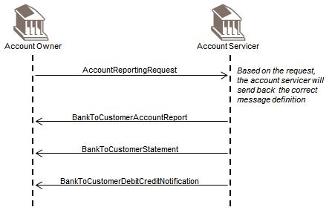

### Relay Scenario

An account owner wishes to request its account servicing institution to send a statement of the account owner's account however, the account owner uses a forwarding agent for all its communication with the account servicing institution.

The account owner sends the AccountReportingRequest to the forwarding agent or requests a forwarding agent to issue an AccountReportingRequest.

The forwarding agent forwards the AccountReportingRequest to the account servicing institution.

The account servicing institution sends the requested message to the forwarding agent- The forwarding agent forwards the message to the account owner.

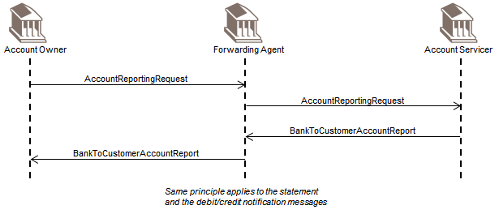

# Business Examples

This section describes business examples of the use of the various MessageDefinitions.

## BankToCustomerAccountReport camt.052.001.09

Description

AAAA Banken has agreed to provide an intraday account report to its customer Finpetrol. Each business day, at 12.30PM, AAAA Banken will provide Finpetrol with an overview of all booked and expected entries since the start of the business day. On 18 October 2010, at 12.30 PM, AAAASESS sends such an intraday BankToCustomerAccountReport to Company Finpetrol. It contains two entries: one booked, and one expected item. It has been pre-agreed between the account servicer and account owner that AAAA Banken will not include (expected) balance info in this intraday report.

Business Data

|  |  |  |
| --- | --- | --- |
| Element | <XMLTag> | Content |
| Group Header | <GrpHdr> |  |
| MessageIdentification | <MsgId> | AAAASESS-FP-ACCR001 |
| CreationDateTime | <CreDtTm> | 2015-10-18T12:30:00+01:00 |
| MessagePagination | <MsgPgntn> |  |
| PageNumber | <PgNb> | 1 |
| LastPageIndicator | <LastPgInd> | TRUE |
| Report | <Rpt> |  |
| Identification | <Id> | AAAASESS-FP-ACCR001 |
| CreationDateTime | <CreDtTm> | 2015-10-18T12:30:00+01:00 |
| FromToDate | <FrToDt> |  |
| FromDateTime | <FrmDtTm> | 2015-10-18T08:00:00+01:00 |
| ToDateTime | <ToDtTm> | 2015-10-18T12:30:00+01:00 |
| Account | <Acct> |  |
| Identification | <Id> |  |
| Other | <Othr> |  |
| Identification | <Id> | 50000000054910000003 |
| Owner | <Ownr> |  |
| Name | <Nm> | FINPETROL |
| Servicer | <Svcr> |  |
| FinancialInstitutionIdentification | <FinInstnId> |  |
| Name | <Nm> | AAAA BANKEN |
| PostalAddress | <PstlAdr> |  |
| Country | <Ctry> | SE |
| Entry | <Ntry> |  |
| Amount | <Amt> | SEK 200000 |
| CreditDebitIndicator | <CdtDbtInd> | DBIT |
| Status | <Sts> | BOOK |
| BookingDate | <BookgDt> |  |
| DateTime | <DtTm> | 2015-10-18T10:15:00+01:00 |
| ValueDate | <ValDt> |  |
| Date | <Dt> | 2015-10-18 |
| AccountServicerReference | <AcctSvcrRef> | AAAASESS-FP-ACCR-01 |
| BankTransactionCode | <BkTxCd> |  |
| Domain | <Domn> | PMNT (Payment) |
| Family | <Fmly> | ICDT (Issued Credit Transfer) |
| SubFamilyCode | <SbFmlyCd> | XBCT (X-Border Credit Transfer) |
| EntryDetails | <NtryDtls> |  |
| Batch | <Btch |  |
| MessageIdentification | <MsgId> | FINP-0055 |
| PaymentInformationId | <PmtInfID> | FINP-0055/001 |
| NumberOfTransactions | <NbOfTxs> | 20 |
| Entry | <Ntry> |  |
| Amount | <Amt> | SEK 30000 |
| CreditDebitIndicator | <CdtDbtInd> | CRDT |
| Status | <Sts> | PDNG |
| ValueDate | <ValDt> |  |
| Date | <Dt> | 2015-10-18 |
| AccountServicerReference | <AcctSvcrRef> | AAAASESS-FP-CONF-FX |
| BankTransactionCode | <BkTxCd> |  |
| Domain | <Domn> | PMNT (Payment) |
| Family | <Fmly> | RCDT (Received Credit Transfer) |
| SubFamilyCode | <SbFmlyCd> | XBCT (X-Border Credit Transfer) |
| EntryDetails | <NtryDtls> |  |
| TransactionDetails | <TxDtls> |  |
| References | <Refs> |  |
| InstructionIdentification | <InstrId> | FP-004567-FX |
| EndToEndIdentification | <EndToEndIdentification> | AAAASS1085FINPSS |
| Amount | <Amt> | EUR 3255 |
| CreditDebitIndicator | <CdtDbtInd> | CRDT |
| AmountDetails | <AmtDtls> |  |
| CountervalueAmount | <CntrValAmt> |  |
| Amount | <Amt> | EUR 3255 |
| CurrencyExchange | <CcyXchg> |  |
| SourceCurrency | <SrcCcy> | EUR |
| ExchangeRate | <XchRate> | 0.1085 |

Message Instance

<BkToCstmrAcctRpt>

<GrpHdr>

<MsgId>AAAASESS-FP-ACCR001</MsgId>

<CreDtTm>2015-10-18T12:30:00+01:00</CreDtTm>

<MsgPgntn>

<PgNb>1</PgNb>

<LastPgInd>true</LastPgInd>

</MsgPgntn>

</GrpHdr>

<Rpt>

<Id>AAAASESS-FP-ACCR001</Id>

<CreDtTm>2015-10-18T12:30:00+01:00</CreDtTm>

<FrToDt>

<FrDtTm>2015-10-18T08:00:00+01:00</FrDtTm>

<ToDtTm>2015-10-18T12:30:00+01:00</ToDtTm>

</FrToDt>

<Acct>

<Id>

<Othr>

<Id>50000000054910000003</Id>

</Othr>

</Id>

<Ownr>

<Nm>FINPETROL</Nm>

</Ownr>

<Svcr>

<FinInstnId>

<Nm>AAAA BANKEN</Nm>

<PstlAdr>

<Ctry>SE</Ctry>

</PstlAdr>

</FinInstnId>

</Svcr>

</Acct>

<Ntry>

<Amt Ccy="SEK">200000</Amt>

<CdtDbtInd>DBIT</CdtDbtInd>

<Sts>

<Cd>BOOK</Cd>

</Sts>

<BookgDt>

<DtTm>2015-10-18T10:15:00+01:00</DtTm>

</BookgDt>

<ValDt>

<Dt>2015-10-18</Dt>

</ValDt>

<AcctSvcrRef>AAAASESS-FP-ACCR-01</AcctSvcrRef>

<BkTxCd>

<Domn>

<Cd>PMNT</Cd>

<Fmly>

<Cd>ICDT</Cd>

<SubFmlyCd>XBCT</SubFmlyCd>

</Fmly>

</Domn>

</BkTxCd>

<NtryDtls>

<Btch>

<MsgId>FINP-0055</MsgId>

<PmtInfId>FINP-0055-001</PmtInfId>

<NbOfTxs>20</NbOfTxs>

</Btch>

</NtryDtls>

</Ntry>

<Ntry>

<Amt Ccy="SEK">30000</Amt>

<CdtDbtInd>CRDT</CdtDbtInd>

<Sts>

<Cd>PDNG</Cd>

</Sts>

<ValDt>

<Dt>2015-10-18</Dt>

</ValDt>

<AcctSvcrRef>AAAASESS-FP-CONF-FX</AcctSvcrRef>

<BkTxCd>

<Domn>

<Cd>PMNT</Cd>

<Fmly>

<Cd>RCDT</Cd>

<SubFmlyCd>XBCT</SubFmlyCd>

</Fmly>

</Domn>

</BkTxCd>

<NtryDtls>

<TxDtls>

<Refs>

<InstrId>FP-004567-FX</InstrId>

<EndToEndId>AAAASS1085FINPSS</EndToEndId>

</Refs>

<Amt Ccy="EUR">3255</Amt>

<CdtDbtInd>CRDT</CdtDbtInd>

<AmtDtls>

<CntrValAmt>

<Amt Ccy="EUR">3255</Amt>

<CcyXchg>

<SrcCcy>EUR</SrcCcy>

<XchgRate>0.185</XchgRate>

</CcyXchg>

</CntrValAmt>

</AmtDtls>

</TxDtls>

</NtryDtls>

</Ntry>

</Rpt>

</BkToCstmrAcctRpt>

## BankToCustomerStatement camt.053.001.09

Description

On 18 October 2010, at 5.00 PM, AAAASESS sends an end-of-day BankToCustomerStatement to Company Finpetrol. It contains all booked items during the business day.

Business Data

|  |  |  |
| --- | --- | --- |
| Element | <XMLTag> | Content |
| Group Header | <GrpHdr> |  |
| MessageIdentification | <MsgId> | AAAASESS-FP-STAT001 |
| CreationDateTime | <CreDtTm> | 2015-10-18T17:00:00+01:00 |
| MessagePagination | <MsgPgntn> |  |
| PageNumber | <PgNb> | 1 |
| LastPageIndicator | <LastPgInd> | True |
| Statement | <Stmt> |  |
| Identification | <Id> | AAAASESS-FP-STAT001 |
| CreationDateTime | <CreDtTm> | 2015-10-18T17:00:00+01:00 |
| FromToDate | <FrToDt> |  |
| FromDateTime | <FrmDtTm> | 2015-10-18T08:00:00+01:00 |
| ToDateTime | <ToDtTm> | 2015-10-18T17:00:00+01:00 |
| Account | <Acct> |  |
| Identification | <Id> |  |
| Other | <Othr> |  |
| Identification | <Id> | 50000000054910000003 |
| Owner | <Ownr> |  |
| Name | <Nm> | FINPETROL |
| Servicer | <Svcr> |  |
| FinancialInstitutionIdentification | <FinInstnId> |  |
| Name | <Nm> | AAAA BANKEN |
| PostalAddress | <PstlAdr> |  |
| Country | <Ctry> | SE |
| Balance | <Bal> |  |
| Type | <Tp> |  |
| Code | <Cd> | OPBD |
| Amount | <Amt> | SEK 500000 |
| CreditDebitIndicator | <CdtDbtInd> | CRDT |
| Date | <Dt> | 2015-10-15 |
| Balance | <Bal> |  |
| Type | <Tp> | CLBD |
| Code | <Cd> |  |
| Amount | <Amt> | SEK 435678.50 |
| CreditDebitIndicator | <CdtDbtInd> | CRDT |
| Date | <Dt> |  |
| Date | <Dt> | 2015-10-18 |
| Entry | <Ntry> |  |
| Amount | <Amt> | SEK 105678.50 |
| CreditDebitIndicator | <CdtDbtInd> | CRDT |
| Status | <Sts> | BOOK |
| BookingDate | <BookgDt> |  |
| DateTime | <DtTm> | 2015-10-18T13:15:00+01:00 |
| ValueDate | <ValDt> |  |
| Date | <Dt> | 2015-10-18 |
| AccountServicerReference | <AcctSvcrRef> | AAAASESS-FP-CN-98765/01 |
| BankTransactionCode | <BkTxCd> |  |
| Domain | <Domn> | PMNT (Payment) |
| Family | <Fmly> | RCDT (Received Credit Transfer) |
| SubFamilyCode | <SbFmlyCd> | DMCT (Domestic Credit Transfer) |
| EntryDetails | <NtryDtls> |  |
| TransactionDetails | <TxDtls> |  |
| References | <Refs> |  |
| EndToEndIdentification | <EndToEndId> | MUELL/FINP/RA12345 |
| Amount | <Amt> | SEK 0 |
| CreditDebitIndicator | <CdtDbtInd> | CRDT |
| RelatedParties | <RltdPties> |  |
| Debtor | <Dbtr> |  |
| Name | <Nm> | MUELLER |
| Entry | <Ntry> |  |
| Amount | <Amt> | SEK 200000 |
| CreditDebitIndicator | <CdtDbtInd> | DBIT |
| Status | <Sts> | BOOK |
| BookingDate | <BookgDt> |  |
| DateTime | <DtTm> | 2015-10-18T10:15:00+01:00 |
| ValueDate | <ValDt> |  |
| Date | <Dt> | 2015-10-18 |
| AccountServicerReference | <AcctSvcrRef> | AAAASESS-FP-ACCR-01 |
| BankTransactionCode | <BkTxCd> |  |
| Domain | <Domn> | PMNT (Payment) |
| Family | <Fmly> | ICDT (Issued Credit Transfer) |
| SubFamilyCode | <SbFmlyCd> | DMCT (Domestic Credit Transfer) |
| EntryDetails | <NtryDtls> |  |
| Batch | <Btch |  |
| MessageIdentification | <MsgId> | FINP-0055 |
| PaymentInformationIdentification | <PmtInfID> | FINP-0055/001 |
| NumberOfTransactions | <NbOfTxs> | 20 |
| Entry | <Ntry> |  |
| Amount | <Amt> | SEK 30000 |
| CreditDebitIndicator | <CdtDbtInd> | CRDT |
| Status | <Sts> | BOOK |
| BookingDate | <BookgDt> |  |
| DateTime | <DtTm> | 2015-10-18T15:15:00+01:00 |
| ValueDate | <ValDt> |  |
| Date | <Dt> | 2015-10-18 |
| AccountServicerReference | <AcctSvcrRef> | AAAASESS-FP-CONF-FX |
| BankTransactionCode | <BkTxCd> |  |
| Domain | <Domn> | PMNT (Payment) |
| Family | <Fmly> | RCDT (Received Credit Transfer) |
| SubFamilyCode | <SbFmlyCd> | XBCT (X-Border Credit Transfer) |
| EntryDetails | <NtryDtls> |  |
| TransactionDetails | <TxDtls> |  |
| References | <Refs> |  |
| InstructionIdentification | <InstrId> | FP-004567-FX |
| EndToEndIdentification | <EndToEndID> | AAAASS1085FINPSS |
| Amount | <Amt> | EUR 3255 |
| CreditDebitIndicator | <CdtDbtInd> | CRDT |
| AmountDetails | <AmtDtls> |  |
| CountervalueAmount | <CntrValAmt> |  |
| Amount | <Amt> | EUR 3255 |
| CurrencyExchange | <CcyXchg> |  |
| SourceCurrency | <SrcCcy> | EUR |
| ExchangeRate | <XchRate> | 0.1085 |

Message Instance

<BkToCstmrStmt>

<GrpHdr>

<MsgId>AAAASESS-FP-STAT001</MsgId>

<CreDtTm>2015-10-18T17:00:00+01:00</CreDtTm>

<MsgPgntn>

<PgNb>1</PgNb>

<LastPgInd>true</LastPgInd>

</MsgPgntn>

</GrpHdr>

<Stmt>

<Id>AAAASESS-FP-STAT001</Id>

<CreDtTm>2015-10-18T17:00:00+01:00</CreDtTm>

<FrToDt>

<FrDtTm>2015-10-18T08:00:00+01:00</FrDtTm>

<ToDtTm>2015-10-18T17:00:00+01:00</ToDtTm>

</FrToDt>

<Acct>

<Id>

<Othr>

<Id>50000000054910000003</Id>

</Othr>

</Id>

<Ownr>

<Nm>FINPETROL</Nm>

</Ownr>

<Svcr>

<FinInstnId>

<Nm>AAAA BANKEN</Nm>

<PstlAdr>

<Ctry>SE</Ctry>

</PstlAdr>

</FinInstnId>

</Svcr>

</Acct>

<Bal>

<Tp>

<CdOrPrtry>

<Cd>OPBD</Cd>

</CdOrPrtry>

</Tp>

<Amt Ccy="SEK">500000</Amt>

<CdtDbtInd>CRDT</CdtDbtInd>

<Dt>

<Dt>2015-10-15</Dt>

</Dt>

</Bal>

<Bal>

<Tp>

<CdOrPrtry>

<Cd>CLBD</Cd>

</CdOrPrtry>

</Tp>

<Amt Ccy="SEK">435678.50</Amt>

<CdtDbtInd>CRDT</CdtDbtInd>

<Dt>

<Dt>2015-10-18</Dt>

</Dt>

</Bal>

<Ntry>

<Amt Ccy="SEK">105678.50</Amt>

<CdtDbtInd>CRDT</CdtDbtInd>

<Sts>

<Cd>BOOK</Cd>

</Sts>

<BookgDt>

<DtTm>2015-10-18T13:15:00+01:00</DtTm>

</BookgDt>

<ValDt>

<Dt>2015-10-18</Dt>

</ValDt>

<AcctSvcrRef>AAAASESS-FP-CN_98765/01</AcctSvcrRef>

<BkTxCd>

<Domn>

<Cd>PMNT</Cd>

<Fmly>

<Cd>RCDT</Cd>

<SubFmlyCd>BOOK</SubFmlyCd>

</Fmly>

</Domn>

</BkTxCd>

<NtryDtls>

<TxDtls>

<Refs>

<EndToEndId>MUELL/FINP/RA12345</EndToEndId>

</Refs>

<Amt Ccy="SEK">0</Amt>

<CdtDbtInd>CRDT</CdtDbtInd>

<RltdPties>

<Dbtr>

<Pty>

<Nm>MUELLER</Nm>

</Pty>

</Dbtr>

</RltdPties>

</TxDtls>

</NtryDtls>

</Ntry>

<Ntry>

<Amt Ccy="SEK">200000</Amt>

<CdtDbtInd>DBIT</CdtDbtInd>

<Sts>

<Cd>BOOK</Cd>

</Sts>

<BookgDt>

<DtTm>2015-10-18T10:15:00+01:00</DtTm>

</BookgDt>

<ValDt>

<Dt>2015-10-18</Dt>

</ValDt>

<AcctSvcrRef>AAAASESS-FP-ACCR-01</AcctSvcrRef>

<BkTxCd>

<Domn>

<Cd>PMNT</Cd>

<Fmly>

<Cd>ICDT</Cd>

<SubFmlyCd>DMCT</SubFmlyCd>

</Fmly>

</Domn>

</BkTxCd>

<NtryDtls>

<Btch>

<MsgId>FINP-0055</MsgId>

<PmtInfId>FINP-0055/001</PmtInfId>

<NbOfTxs>20</NbOfTxs>

</Btch>

</NtryDtls>

</Ntry>

<Ntry>

<Amt Ccy="SEK">30000</Amt>

<CdtDbtInd>CRDT</CdtDbtInd>

<Sts>

<Cd>BOOK</Cd>

</Sts>

<BookgDt>

<DtTm>2015-10-18T15:15:00+01:00</DtTm>

</BookgDt>

<ValDt>

<Dt>2015-10-18</Dt>

</ValDt>

<AcctSvcrRef>AAAASESS-FP-CONF-FX</AcctSvcrRef>

<BkTxCd>

<Domn>

<Cd>PMNT</Cd>

<Fmly>

<Cd>RCDT</Cd>

<SubFmlyCd>XBCT</SubFmlyCd>

</Fmly>

</Domn>

</BkTxCd>

<NtryDtls>

<TxDtls>

<Refs>

<InstrId>FP-004567-FX</InstrId>

<EndToEndId>AAAASS1085FINPSS</EndToEndId>

</Refs>

<Amt Ccy="EUR">3255</Amt>

<CdtDbtInd>CRDT</CdtDbtInd>

<AmtDtls>

<CntrValAmt>

<Amt Ccy="EUR">3255</Amt>

<CcyXchg>

<SrcCcy>EUR</SrcCcy>

<XchgRate>0.1085</XchgRate>

</CcyXchg>

</CntrValAmt>

</AmtDtls>

</TxDtls>

</NtryDtls>

</Ntry>

</Stmt>

</BkToCstmrStmt>

## BankToCustomerDebitCreditNotification camt.054.001.09

Description

Besides providing an intraday account report at 12.30 PM (see example with BankToCustomerAccountReport), AAAA Banken and Finpetrol have agreed on a credit notification service, for all incoming credits above a certain threshold. On 18 October 2010, at 1.20 PM, AAAASESS sends a BankToCustomerDebitCreditNotification to Company Finpetrol, to advise Finpetrol of an incoming credit on its account.

Business Data

|  |  |  |
| --- | --- | --- |
| Element | <XMLTag> | Content |
| Group Header | <GrpHdr> |  |
| MessageIdentification | <MsgId> | AAAASESS-FP-00001 |
| CreationDateTime | <CreDtTm> | 2015-10-18T13:20:00+01:00 |
| Notification | <Ntfctn> |  |
| Identification | <Id> | AAAASESS-FP-CN-98765 |
| CreationDateTime | <CreDtTm> | 2015-10-18T13:20:00+01:00 |
| Account | <Acct> |  |
| Identification | <Id> |  |
| Other | <Othr> |  |
| Identification | <Id> | 50000000054910000003 |
| Owner | <Ownr> |  |
| Name | <Nm> | FINPETROL |
| Servicer | <Svcr> |  |
| FinancialInstitutionIdentification | <FinInstnId> |  |
| Name | <Nm> | AAAA BANKEN |
| PostalAddress | <PstlAdr> |  |
| Country | <Ctry> | SE |
| Entry | <Ntry> |  |
| Amount | <Amt> | SEK 105678.50 |
| CreditDebitIndicator | <CdtDbtInd> | CRDT |
| Status | <Sts> | BOOK |
| BookingDate | <BookgDt> |  |
| DateTime | <DtTm> | 2015-10-18T13:15:00+01:00 |
| ValueDate | <ValDt> |  |
| Date | <Dt> | 2015-10-18 |
| AccountServicerReference | <AcctSvcrRef> | AAAASESS-FP-CN-98765/01 |
| BankTransactionCode | <BkTxCd> |  |
| Domain | <Domn> |  |
| Code | <Cd> | PAYM |
| Family | <Fmly> |  |
| Code | <Cd> | 0001 |
| SubFamilyCode | <SbFmlyCd> | 0005 |
| EntryDetails | <NtryDtls> |  |
| TransactionDetails | <TxDtls> |  |
| References | <Refs> |  |
| EndToEndIdentification | <EndToEndId> | MUELL/FINP/RA12345 |
| Amount | <Amt> | SEK 0 |
| CreditDebitIndicator | <CdtDbtInd> | CRDT |
| RelatedParties | <RltdPties> |  |
| Debtor | <Dbtr> |  |
| Name | <Nm> | MUELLER |

Message Instance

<BkToCstmrDbtCdtNtfctn>

<GrpHdr>

<MsgId>AAAASESS-FP-00001</MsgId>

<CreDtTm>2015-10-18T13:20:00+01:00</CreDtTm>

</GrpHdr>

<Ntfctn>

<Id>AAAASESS-FP-CN-98765</Id>

<CreDtTm>2015-10-18T13:20:00+01:00</CreDtTm>

<Acct>

<Id>

<Othr>

<Id>50000000054910000003</Id>

</Othr>

</Id>

<Ownr>

<Nm>FINPETROL</Nm>

</Ownr>

<Svcr>

<FinInstnId>

<Nm>AAAA BANKEN</Nm>

<PstlAdr>

<Ctry>SE</Ctry>

</PstlAdr>

</FinInstnId>

</Svcr>

</Acct>

<Ntry>

<Amt Ccy="SEK">105678.50</Amt>

<CdtDbtInd>CRDT</CdtDbtInd>

<Sts>

<Cd>BOOK</Cd>

</Sts>

<BookgDt>

<DtTm>2015-10-18T13:15:00+01:00</DtTm>

</BookgDt>

<ValDt>

<Dt>2015-10-18</Dt>

</ValDt>

<AcctSvcrRef>AAAASESS-FP-CN-98765/01</AcctSvcrRef>

<BkTxCd>

<Domn>

<Cd>PAYM</Cd>

<Fmly>

<Cd>0001</Cd>

<SubFmlyCd>0005</SubFmlyCd>

</Fmly>

</Domn>

</BkTxCd>

<NtryDtls>

<TxDtls>

<Refs>

<EndToEndId>MUELL/FINP/RA12345</EndToEndId>

</Refs>

<Amt Ccy="SEK">0</Amt>

<CdtDbtInd>CRDT</CdtDbtInd>

<RltdPties>

<Dbtr>

<Pty>

<Nm>MUELLER</Nm>

</Pty>

</Dbtr>

</RltdPties>

</TxDtls>

</NtryDtls>

</Ntry>

</Ntfctn>

</BkToCstmrDbtCdtNtfctn>

## AccountReportingRequest camt.060.001.06

Description

On 27 October 2015, AAAABEBB sends an AccountReportingRequest message to its account servicer BBBBUS33 to request a BankToCustomerStatement for that day.

Business Data

|  |  |  |
| --- | --- | --- |
| Element | <XMLTag> | Content |
| Group Header | <GrpHdr> |  |
| MessageIdentification | <MsgId> | EXAMPLE camt.060 |
| CreationDateTime | <CreDtTm> | 2015-10-27T10:05:00 |
| ReportingRequest | <RptgReq> |  |
| RequestedMessageNameIdentification | <ReqdMsgNmId> | camt.052.001.09 |
| Account | Acct |  |
| Identification | <Id> |  |
| Other | <Othr> |  |
| Identification | <Id> | 310141014141 |
| AccountOwner | <AcctOwnr> |  |
| Agent | <Agt> |  |
| FinancialInstitutionIdentification | <FinInstnId> |  |
| BICFI | <BICFI> | AAAABEBB |
| ReportingPeriod | <RptgPrd> |  |
| FromToDate | <FrToDt> |  |
| FromDate | <FrDt> | 2015-10-27 |
| FromToTime | <FrToTM> |  |
| FromTime | <FrTm> | 07:30:00 |
| Type | <Tp> | ALLL |

Message Instance

<AcctRptgReq>

<GrpHdr>

<MsgId>EXAMPLE camt.060</MsgId>

<CreDtTm>2015-10-27T17:15:00</CreDtTm>

</GrpHdr>

<RptgReq>

<ReqdMsgNmId>camt.052.001.08</ReqdMsgNmId>

<Acct>

<Id>

<Othr>

<Id>310141014141</Id>

</Othr>

</Id>

</Acct>

<AcctOwnr>

<Agt>

<FinInstnId>

<BICFI>AAAABEBB</BICFI>

</FinInstnId>

</Agt>

</AcctOwnr>

<RptgPrd>

<FrToDt>

<FrDt>2015-10-27</FrDt>

</FrToDt>

<FrToTm>

<FrTm>07:30:00</FrTm>

</FrToTm>

<Tp>ALLL</Tp>

</RptgPrd>

</RptgReq>

</AcctRptgReq>

# Revision Record

|  |  |  |  |  |
| --- | --- | --- | --- | --- |
| Revision | Date | Author | Description | Sections affected |
| 1.0 | 1 December 2020 | SWIFT | Draft version for SEG review | All |
| 2.0 | February 2021 | RA | Final version | All |
|  |  |  |  |  |

Disclaimer:

Although the Registration Authority has used all reasonable efforts to ensure accuracy of the contents of the iso20022.org website and the information published thereon, the Registration Authority assumes no liability whatsoever for any inadvertent errors or omissions that may appear thereon. Moreover, the information is provided on an "as is" basis. The Registration Authority disclaims all warranties and conditions, either express or implied, including but not limited to implied warranties of merchantability, title, non-infringement and fitness for a particular purpose.

The Registration Authority shall not be liable for any direct, indirect, special or consequential damages arising out of the use of the information published on the iso20022.org website, even if the Registration Authority has been advised of the possibility of such damages.

Intellectual Property Rights:

The ISO 20022 MessageDefinitions described in this document were contributed by SWIFT, IFX, OAGi & TWIST as part of ISTH. The ISO 20022 IPR policy is available at www.ISO20022.org > About ISO 20022 > Intellectual Property Rights.