# Core Component Framework

## General

Semantic data modeling of ADCS is based on the Core Components Specification (CCS) defined in ISO 15000-5.

## Core Components

Core Components are building blocks for the development and publication of a library of standard Core Components and Business Information Entities containing the information pieces needed to describe a specific concept.

There are six categories of Core Components:

— Core Component Type (CCT);

— Basic Core Component (BCC);

— Relation Core Component (RLCC);

— Identifier Core Component (IDCC);

— Association Core Component (ASCC); and

— Aggregate Core Component (ACC).

Basic Core Component is detailed In this standard, Relation Core Component and Identifier Core Component are newly defined in addition to the conventional Basic Core Component.

Unless otherwise specified, the provisions for Basic Core Component also apply to Relation Core Component and Identifier Core Component. Other Core Components shall be as specified in ISO 15000-5.

**Figure 1** shows the central concept of this International Standard. The Core Component is a semantic building block, which is used as a basis to construct all electronic business messages. The RLCC is a BCC, which is a reference identifier with the value of referencing ACC's unique identifier. The IDCC is a BCC, which is a unique identifier for ACC.

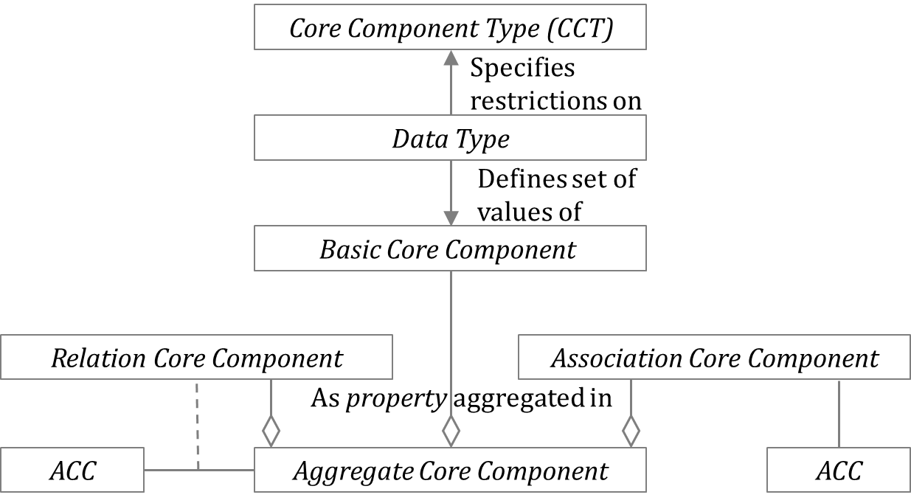

Figure 1 — Core Components

## Data Types

Data Types are specified in ISO 15000-5 4.3.

## Business Information Entities

**Figure 2** shows the Core Component library consist with Core Components and Business Information Entities. A Business Information Entity is a piece of business data or a group of pieces of business data with a unique Business Semantic definition in a specific Business Context.

A Business Information Entity can be a Basic Business Information Entity (BBIE), an Association Business Information Entity (ASBIE), an Aggregate Business Information Entity (ABIE). In addition to a conventional Basic Business Information Entity, a Reference Business Information Entity (RLBIE) and an Identifier Business Information Entity (IDBIE) are newly defined for a Basic Business Information Entity (BBIE).

Unless otherwise specified, the provisions for Basic Business Information Entity also apply to Relation Business Information Entity and Identifier Business Information Entity. Other Business Information Entities shall be as specified in ISO 15000-5.

Basic Business Information Entity is based on Basic Core Component. Relation Business Information Entity is based on Relation Core Component. Identifier Business Information Entity is based on Identifier Core Component. Association Business Information Entity is based on Association Core Component. Aggregate Business Information Entity qualifies the Object Class of Aggregate Core Component.

Figure 2 — Core Component Library

[Ba1] A Business Information Entity shall be a Basic Business Information Entity, a Reference Business Information Entity, an Identifier Business Information Entity, an Association Business Information Entity or an Aggregate Business Information Entity.

[Ba2] An Aggregate Business Information Entity shall contain at least one Business Information Entity Property. A Business Information Entity Property shall either be a Basic Business Information Entity Property, a Reference Business Information Entity Property, an Identifier Business Information Entity Property, an Association Business Information Entity Property.

## Naming Convention

### General

Unless otherwise specified, the provisions for Basic Core Component also apply to Relation Core Component and Identifier Core Component. Other Core Components shall be as specified in ISO 15000-5.

Unless otherwise specified, the provisions for Basic Business Information Entity also apply to Relation Business Information Entity and Identifier Business Information Entity. Other Business Information Entities shall be as specified in ISO 15000-5 4.1.

### Core Component Naming Rules

#### Core Component Rules for Dictionary Entry Names

[Ca1] The Dictionary Entry Name of an Identifier Core Component shall consist of the following parts in the order specified:

— the Object Class Term of the Aggregate Core Component owning the corresponding Identifier Core Component Property;

— the Property Term is " Identification ";

— the Object Class Term is "Identifier".

[Ca2] The Dictionary Entry Name of a Relation Core Component shall consist of the following parts in the order specified:

— the Object Class Term of the Aggregate Core Component owning the corresponding Reference Core Component Property;

— the Property Term reflects the nature of the relation between object classes;

— the Object Class Term of the Aggregate Core Component on which the referenced Relation Core Component Property is based.

### Rules for Business Information Entities

#### Rules for Business Information Entity Dictionary Entry Names

[Ba3] The Dictionary Entry Name of an Identifier Business Information Entity shall consist of the following components in the specified order:

— the Object Class Term of the Aggregate Business Information Entity owning the corresponding Identifier Business Information Entity Property, and possibly additional Qualifier Term(s);

— the Property Term is " Identification ";

— the Object Class Term is "Identifier".

[Ba4] The Dictionary Entry Name of a Relation Business Information Entity shall consist of the following components in the specified order:

— the Object Class Term of the Aggregate Business Information Entity, and possibly additional Qualifier Term(s);

— the Property Term that reflects the nature of the relation between object classes, and possibly additional Qualifier Term(s);

— the Object Class Term of the related Business Information Entity, and possibly additional Qualifier Terms(s).