Zaandijk

ISO Audit Data Collection Standard

Customs Extensions and Subset

Version 1.6

Document delivered to: Customs Netherlands

Digitect B.V.



***ICT Strategy***

***ICT Architecture***

***Software Solutions***

Digitect B.V. Postbus 30

1540 AA Koog aan de Zaan

The Netherlands

E-mail [mail@digitect.nl](mailto:mail@digitect.nl)

WWW [www.digitect.nl](http://www.digitect.nl/)

KvK Amsterdam 34161245

Authors

Frans van Basten

Senior Consultant

Jan Vrijenhoek

XML/EDI Consultant

2021-07-12

ADCS, Model, EC-Design, Customs

**Content Page**

1. INTRODUCTION...............................................................................................................2

2. CUSTOMS REQUIREMENTS..........................................................................................3

2.1. Product characteristics......................................................................................................3

2.2. References to source documents.....................................................................................6

2.3. Selection Criteria...............................................................................................................7

3. TECHNICAL TABLES DESIGN........................................................................................8

3.1. Inventory Product Characteristic.......................................................................................8

3.2. Inventory Transaction Characteristic..............................................................................10

3.3. Inventory Transaction Associated Referential Document...............................................11

3.4. Selection Period..............................................................................................................12

4. AUDIT DATA COLLECTION CUSTOMS........................................................................13

4.1. ADC subset for Customs.................................................................................................14

4.2. Exchange Formats CSV, XML, JSON............................................................................15

4.3. Validation.........................................................................................................................15

4.4. Additional rules and explanation.....................................................................................16

5. AUDIT EXAMPLES.........................................................................................................18

5.1. Example 1 - Stock valuation............................................................................................18

5.2. Example 2 - Assessment of the degree of traceability...................................................19

5.3. Example 3 - Tracking goods for exemptions..................................................................19

1. INTRODUCTION

This document describes the extensions on the Audit Data Collection Standard (ADCS) and the desired subset, as proposed and required by the Customs Authority in the Netherlands.

*What is ADCS?*

Audit Data Collection Standard is an international standard (ISO 21378) which provides a specification for auditors to obtain accounting data, including the specification of the content and format requirements of the data elements and exchange formats. Basis for this document was *"Audit Data Collection 20190711 FDIS PC 295 clean version"* by ISO/PC295/WG 1.

*What is the scope of ADCS until now?*

ADSC covers eight major business modules of Accounting and ERP systems, including:

• Base (BAS),

• General Ledger (GL),

• Sales (SAL),

• Accounts Receivable (AR),

• Purchase (PUR),

• Accounts Payable (AP),

• Inventory (INV),

• Property Plant and Equipment (PPE).

These modules relate to major business processes including the areas of purchase, sales, inventory, fixed assets and financial reporting with the aim to identify and to specify data elements and file formats needed for auditing.

*What is missing in ADCS?*

Detailed, characteristic information about goods and products on the level of *Product/Serial number* or *Product/Lot1 number* and on a certain date or during a certain period, is missing. This

information is required for auditing goods movements, including import and export.

Also the reference to source documents is missing. The purpose is matching transactional information with data from another system, for instance Governmental, Food regulators, Quality Surveyors, etc.

Product characteristics and reference information can easily be added to the module Inventory without changing the existing tables in this module.

*Do we need all audit data as specified in ADCS?*

In the case of Customs, it is not necessary to receive the entire Audit Data Collection (ADC) from an organization. Customs authority prefer to receive a part of the ADC that is focused on the

control work of Customs. In general, it should be able to request or receive sub-sets of the total

ADC, dependent on the purpose for which the audit data will be used.

1 In this document Lot is equivalent to Batch.

2. CUSTOMS REQUIREMENTS

2.1. Product characteristics

The current design of ADCS contains the module Inventory, which is a section for stock movements.

The Inventory module consists of the following tables:

- Inventory Location (Basics of all existing inventory locations)

- Inventory Product Type (Basics of all existing inventory product types)

- Inventory Product (Basic information of inventory items at the level of product/serial/lot)

- Inventory On Hand (Information of inventory on hand)

- Inventory Transaction (Transaction history impacting inventory accounts)

- Inventory Physical Inventory (Quantities on hand as of date of physical count)

- Inventory Period Balance (Inventory beginning and ending balances)

The most detailed level of information about goods in this design is at ***product/serial*** or ***product/lot*** level. For many companies this is not granular enough; they use registration of product characteristic information at the combination of product/serial or lot number level on a certain date or within a certain period. For instance, the alcohol percentage of a liquid could be changed after a certain date, which could change the amount excise duty (tax).

The proposal is to add characteristic information upon the basis product information. If possible this information should be delivered on the most granular level, which is at product level for individual items, and when possible on product/serial level or product/lot level. The characteristic information must include the validity start date and time. The proposal is to add a new table to the Inventory module, which is named INVENTORY PRODUCT CHARACTERISTIC.

The next diagram shows the relation between an Inventory Product and it's Inventory Product

Characteristics:

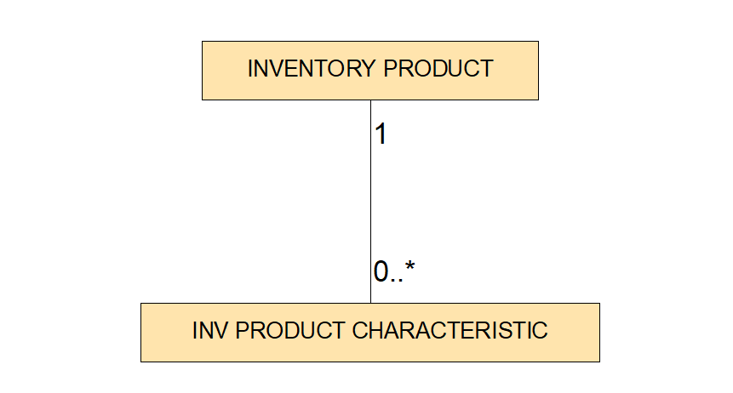

*Diagram 1: Inventory Product Characteristic*

The key information of this table should be *Inventory Product ID*, *Characteristic Type*, *Characteristic Unit Of Measurement, Start Date* and *Start Time*. Additional information should be *End Date*, *End Time, Characteristic Value, System Characteristic Value.*

Characteristic information could change during the reporting period. Therefore basic characteristic information on product/serial or product/lot level is not sufficient. Also on Inventory Transaction level the product characteristic information is required, when the transaction affects one of the possible characteristics. Therefore it is also proposed to add a new table to the Inventory module, which is named INV TRANSACTION CHARACTERISTIC.

The next diagram shows the relation between an Inventory Transaction and it's Inventory

Transaction Characteristics:

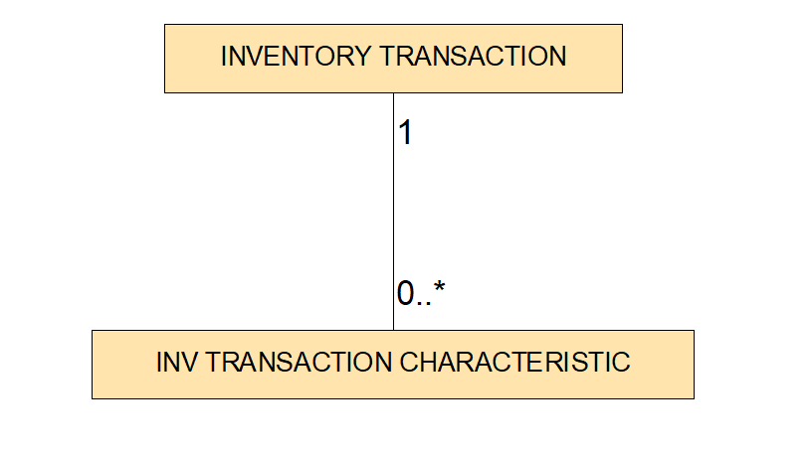

*Diagram 2: Inventory Transaction Characteristic*

The key information of this table should be *Transaction Document ID, Transaction Document Line ID*, *Characteristic Type and Characteristic Unit Of Measurement.* Additional information should be *Characteristic Value, System Characteristic Value.*

2.2. References to source documents

The proposal is to make an extension for references to source documents. The purpose is matching transactional information out of the ERP system with data from another system, for instance Governmental, Food regulators, Quality Surveyors, etc. Not only auditors working for regulators, but also auditors of the company itself (conformation of compliance, check on completeness of dealing with liabilities) have to be able to check the regulatory requirements of any kind. The most far-reaching regulation of the US Securities and Exchange Commission (SEC) is the Dodd Frank act (issued the rule that requires companies to report publicly on their due diligence and to have their reports independently audited). Multiple documents can be associated with one transaction. Therefore there should be the possibility for references to more then one document.

Some examples:

• Reference to declaration systems (in international perspective)

• Reference to other controlling government bodies, think of test reports

• Reference to private monitoring bodies, e. g. surveyors

• The external numbers assigned by a buyer or seller or contract partner

The proposal is to add a new table to the Inventory module, which is named Inventory Transaction Associated Referential Document. The next diagram shows the relation between an Inventory Transaction and it's Inventory Transaction Associated Referential Documents:

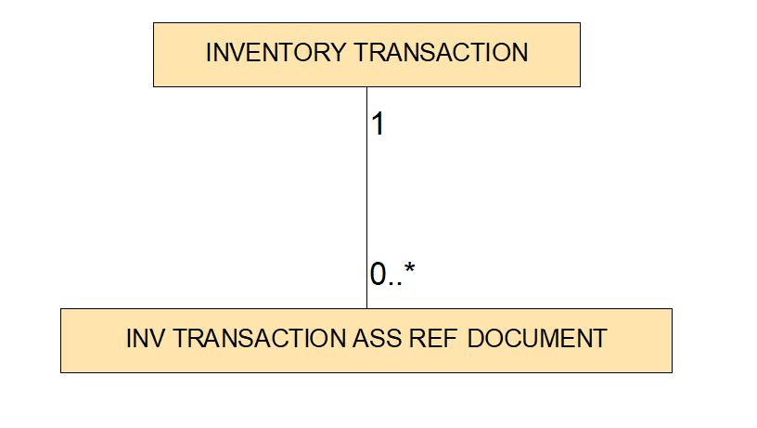

*Diagram 3: Inventory Transaction Associated Reference Document*

The key information of this table should be *Transaction Document ID, Transaction Document Line ID*, *Transaction Ass Ref Document Code*, *Transaction Ass Ref Document ID and Transaction Ass Ref Document Line ID*.

One referential document could contain information about one or more transactions, but one transaction may never appear on more then one referential document of the same type. For example, a customs declaration form.

2.3. Selection Criteria

In the case of Customs, it is not necessary to receive the entire Audit Data Collection (ADC) from an organization. Customs authority prefer to receive a part of the ADC that is focused on the control work of Customs.

In general, it should be able to request or receive sub-sets of the total ADC that have been determined in advance and which are dependent on the purpose for which the audit data will be used.

It is proposed to name a subset so that the subset specification is linked to the purpose for which the subset is specified. For instance "*ADC Customs NL*" or "*ADC Customs EU*". It is proposed to put this name in Profile Name in the Basic Profile table.

To specify the selection criteria of a subset, it is proposed to define a new table, which is named

*Basic Selection Period*.

Until now, this new table contains the selection period start date and selection end date and the selection criteria identification, which could refer to the selection criteria, specified in a separate document.

For a subset, all definitions, rules and agreements that apply to the entire ADC also apply to that subset (as far as possible).

3. TECHNICAL TABLES DESIGN

The proposal is to add 4 new tables to the ADCS. Because new tables are added and existing tables are not changed, the standard will not change, only optional tables are added to the standard.

3.1. Inventory Product Characteristic

Contains inventory product characteristic information from a certain start date and time until a certain end date and time; For example the alcohol percentage.

|  |  |  |  |
| --- | --- | --- | --- |
| **Inventory Product ID**  The unique identifier for the inventory item. Typically auto-generated by the system. Shall match the Inventory_Product_ID in the INV_Product table. | **PK** | **R** | **an..75** |
| **Characteristic Type**  Standardized type of characteristic of the goods. Some characteristic types shall be generic types, but some types shall be Customs specific. For example; Net Weight, Gross Weight, Freight Cost, Insurance Cost, Addition and Deduction Amount. Some characteristic types shall be generic types, but some types shall be Customs specific. For example: Customs_Netto_Quantity, Customs_Value_Quantity, or Customs_Package_Unit_Quantity. | **PK** | **R** | **an..60** |
| **Characteristic UOM Code**  The standardized code of measurement of the value of the product characteristic, if applicable. For example: EUR, KG, CARAT or BA. | **PK** | **R** | **an..80** |
| **Start Date**  Start date from which the product characteristic value became valid. | **PK** | **R** | **an..10** |
| **Start Time**  Start time on the start date from which the product characteristic value became valid. | **PK** | **R** | **an..8** |
| **End Date**  End date until which the product characteristic value was valid. |  | **O** | **an..10** |
| **End Time**  End time on the end date until which the product characteristic value was valid. |  | **O** | **an..8** |
| **Characteristic Value**  The value of the product characteristic on basis of the Characteristic UOM Code according to the Standard Characteristics table (to be developped). For example:  - 0.125 in case of alcohol percentage of 12,5 of wine,  - L in case of low-rated VAT product. |  | **R** | **an..1000** |

**System Characteristic Value O an..1000**

The value of the product characteristic as recorded in the source system of the organization to be audited, on basis of the Characteristic UOM Code. For example

- 0.125 in case of alcohol percentage of 12,5 of wine,

- 1 in case of low-rated VAT product.

**PK** = Primary Key

**R** = Required **O** = Optional

**an..xxx** = Alphanumeric text, variable length, xxx = maximum length

3.2. Inventory Transaction Characteristic

Contains inventory product characteristic information at the moment of the transaction. For example the alcohol percentage.

|  |  |  |  |
| --- | --- | --- | --- |
| **Transaction Document ID**  The unique identifier for the picking ticket, shipping notice, or other document created upon or associated with movement. Typically auto- generated by the system. Shall match the Transaction_Document_ID in the INV_Transaction table. | **PK** | **R** | **an..100** |
| **Transaction Document Line ID**  The unique identifier for the line number for a document other than a customer order, or supplier purchase order. Typically auto-generated by the system. Shall match the Transaction_Document_Line_ID related to the Transaction_Document_ID in the INV_Transaction table. | **PK** | **R** | **an..100** |
| **Characteristic Type**  Standardized type of characteristic of the goods in the transaction. Some characteristic types shall be generic types, but some types shall be Customs specific. For example; Net Weight, Gross Weight, Freight Cost, Insurance Cost, Addition and Deduction Amount. Some characteristic types shall be generic types, but some types shall be Customs specific. For example: Customs_Netto_Quantity, Customs_Value_Quantity, or Customs_Package_Unit_Quantity. | **PK** | **R** | **an..60** |
| **Characteristic UOM Code**  The standardized code of measurement of the value of the transaction characteristic, if applicable. For example: EUR, KG, CARAT or BA. | **PK** | **O** | **an..80** |
| **Characteristic Value**  The value of the product characteristic on basis of the Characteristic UOM Code according to the Standard Characteristics table (to be developped). For example:  - 0.125 in case of alcohol percentage of 12,5 of wine,  - L in case of low-rated VAT product. |  | **R** | **an..1000** |
| **System Characteristic Value**  The value of the product characteristic as recorded in the source system of the organization to be audited, on basis of the Characteristic UOM Code. For example:  - 0.125 in case of alcohol percentage of 12,5 of wine,  - 1 in case of low-rated VAT product. |  | **R** | **an..1000** |
| **PK** = Primary Key  **R** = Required **O** = Optional  **an..xxx** = Alphanumeric text, variable length, xxx = maximum length |  |  |  |

3.3. Inventory Transaction Associated Referential

Document

Inventory Transaction Associated Referential Document. Contains reference information of a document which is associated with the inventory transaction. One referential document could contain information about one or more transactions, but one transaction may never appear on more then one referential document of the same type. For example, a customs declaration form.

**Transaction Document ID PK R an..100**

The unique identifier for the picking ticket, shipping notice, or other document created upon or associated with movement. Typically auto- generated by the system. Shall match the Transaction_Document_ID in the INV_Transaction table.

**Transaction Document Line ID PK R an..100**

The unique identifier for the line number for a document other than a customer order, or supplier purchase order. Typically auto-generated by the system. Shall match the Transaction_Document_Line_ID related to the Transaction_Document_ID in the INV_Transaction table.

**Transaction Ass Ref Document Code PK R an..80**

The code of the transaction associated referential document. To be agreed with the auditee. For example Customs Declaration Form.

**Transaction Ass Ref Document ID PK R an..100**

The ID of the transaction associated referential document. For example the number of the customs declaration form.

**Transaction Ass Ref Document Line ID PK R an..100**

The line ID of a line on the transaction associated referential document. For example the line number on the customs declaration form.

**PK** = Primary Key

**R** = Required **O** = Optional

**an..xxx** = Alphanumeric text, variable length, xxx = maximum length

3.4. Selection Period

Basic Selection Period. Contains the unique identifier for the selection criteria and the selection period that apply to the selected data set (tables and fields).This table contains only 1 row.

**Selection ID R an..75**

Unique identifier that refers to the separately defined criteria for selecting tables and fields. Typically according with the data recipient (for example by Dutch Customs).

**Selection Start Date R an..10**

Start date of the selected period (YYYY-MM-DD). The start time is always "00:00:00".

**Selection End Date R an..10**

End date of the selected period (YYYY-MM-DD). The end time is always "23:59:59".

**an..xxx** = Alphanumeric text, variable length, xxx = maximum length

4. AUDIT DATA COLLECTION CUSTOMS

Customs authority prefer to receive a part of the ADC that is focused on the control work of

Customs.

In general, customs is interested in the initial stock of the selected period, the final stock and the transactions on products between them.

In addition, customs is interested in the data related to the product, such as the corresponding purchase invoice, sales invoice, customer, supplier, history of the product characteristics, balance values and references to related external documents.

In the case of the invoices, it could be possible that the invoice date falls outside the selection period, but the details of this invoice must be included in the subset for verification purposes.

4.1. ADC subset for Customs

The purpose of the ADC subset for Customs is to assess the quality of the administration of goods movements and to check the connection to the administration of the Customs Authority. A Customs subset has been specified for that purpose.

*ADC subset for Customs contains the following ADC tables:*

- BAS PROFILE

- BAS SELECTION PERIOD

- BAS USER

- BAS CUSTOMER TYPE

- BAS CUSTOMER

- BAS SUPPLIER TYPE

- BAS SUPPLIER

- BAS ACCOUNTING PERIOD

- BAS CURRENCY

- BAS MEASUREMENT UNIT

- BAS PROJECT

- BAS TAX TYPE

- SAL INVOICE GENERATED

- SAL INVOICE GENERATED DETAILS

- PUR INVOICE RECEIVED

- PUR INVOICE RECEIVED DETAILS

- INV LOCATION

- INV PRODUCT TYPE

- INV PRODUCT

- INV PRODUCT CHARACTERISTIC

- INV ON HAND

- INV TRANSACTION

- INV TRANSACTION CHARACTERISTIC

- INV TRANSACTION ASS REF DOCUMENT

- INV PHYSICAL INVENTORY

- INV PERIOD BALANCE

For detailed functional specifications of this subset see the following document: "*AuditDataCollectionCustoms_FunctionalTables-v1.0.pdf*"

4.2. Exchange Formats CSV, XML, JSON

Technical specifications are available for:

*Flat file (CSV or TXT)*

- AuditDataCollectionCustoms_TechnicalTables-v1.0.pdf

- Sample Table CSV files

*XML*

- AuditDataCollectionCustoms-v1.0.xsd

- Sample Table XML files

JSON

- AuditDataCollectionCustoms_jsd6-v1.0.json

- Sample Table JSON files

4.3. Validation

For the proof of concept, the easy-to-use validation tool EcCheck has been developed. EcCheck validates CSV files, XML files, and JSON files based on the XML Schema.

Please take note of the following: All CSV files have to start their filename with the table tag followed by . or - like “BasAcntingPer-v1.0-Sample.csv”.

EC-Check reports errors in a text file and presents the read table files in HTML format. Errors are detected by the colors yellow, orange and red.

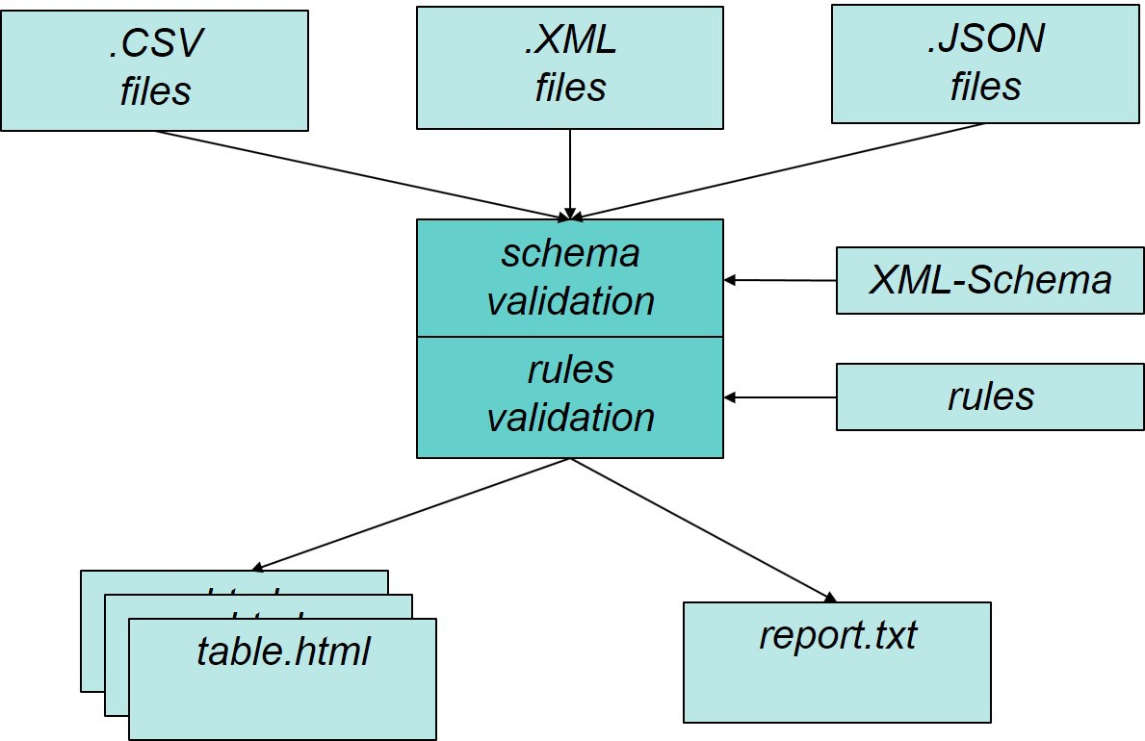

*Picture 1: EcCheck*

EcCheck is free to use and can be downloaded on request. Send your request to [support@digitect.nl](mailto:support@digitect.nl)

4.4. Additional rules and explanation

For the specified subset, all definitions, rules and agreements that apply to the entire ADC also apply to that subset (as far as possible). This chapter contains additional rules and explanations regarding the subset for Customs.

*Required and Optional fields*

Fields are specified **Required** or **Optional**. For instance *Inventory Product ID* is required because it is a primary key field in the *Inventory Product* table*.* That means it must always be

filled otherwise there is no link possible from the *Inventory Transaction* table to the *Inventory*

*Product* table. On the other hand, Optional doesn’t mean that the value can be left away in all cases. For instance *Postal Code* is Optional because sometimes there is no postal code known to the address, but when there is a postal code in the administration, then it must be filled.

*Profile data*

The name of the subset must be included in the BAS PROFILE. Because there is only one suitable field, Profile_Name, it is suggested to put the subset name in this field.

*Selection Period*

The selection period and selection ID should be included in the BAS SELECTION PERIOD. This table contains only 1 row.

*Inventory Product ID*

This is the unique identifier for the inventory item, which could be a single product or a quantity of goods in a lot. With this ID the basis information, characteristics, transactions and invoices are

linked to each other.

*Transaction Type*

Transaction Type captures information regarding movements and adjustments. Because this information will differ per organization, it is advised to include Customs specific transaction codes in the INV TRANSACTION CHARACTERISTIC table. *Characteristic Type* will be the type of transaction code, *Characteristic Value* will be the transaction code. These transaction codes will be issued by the Customs Authority in consultation with the participating organizations.

*Invoice Date*

This is the date of the invoice from which the invoice due date is calculated. It could be possible that the invoice date is outside the selection period, but because the invoice is related to the

selected Inventory Product, the invoice must be included in the data set. Every invoice line contains the *Inventory Product ID.*

*Characteristic Value*

The value in *Characteristic Value* must comply with the rules regarding to representation and data type of data elements, specified in table 2 and table 3 of the ADCS. For instance a percentage is written as *perunage*, which is a percentage divided by one hundred or in other words, a percentage written as a decimal fraction. For example, an alcohol percentage of 12,5 equals a perunage of 0.125.

When it comes to a code in the Characteristic Value, this code must appear in a code list, standardized by the data exchange partners (this code list has yet to be developed).

For example, the code “L” which according to the standardized code list means " *Low Rated VAT*

*product*".

*System Characteristic Value*

The value in *System Characteristic Value* is the value as it is stored in the source system. This does not have to be the same as *Characteristic Value*. For example, the code "1" for "*Low Rated VAT product*".

*Referential keys rules*

A lot of referential keys must match the primary key from another table (or sometimes the primary key their own table). These referential key relations are documented in

"*AuditDataCollectionCustoms_FunctionalTables-v1.0.pdf*", chapter Rules specifications, which is

the last chapter of that document. Examples of referential keys rules:

a. “I**NV ON HAND.Inventory Product ID** must match I**NV PRODUCT.Inventory Product ID**”

b. “**INV PRODUCT TYPE.Parent INV Product Type ID** must match **INV PRODUCT TYPE.Inventory Product Type Code**”

*Field to Field relations rules*

Sometimes one field is required with the valid format when another field is filled. For instance:

a. “If **INV PRODUCT CHARACTERISTIC.Characteristic UOM Code** is filled then **INV PRODUCT CHARACTERISTIC.Characteristic Value** must be numeric”

*LotNr and SerialNr filling rules*

Special attention has been paid to the LotNr and SerialNr filling rules. When a LotNr occurs once in relation to a Product (*InvPrdctCd*) then a LotNr must always be filled when it comes to the

product in question. The Product is then "LotNr required". The same with SerialNr, when a

SerialNr occurs once in relation to a Product (*InvPrdctCd*) then a SerialNr must always be filled when it comes to the product in question. The Product is then "SerialNr required".

5. AUDIT EXAMPLES

In this chapter some audit examples are described to underline the importance of exchanging data at the right granular level. There are a lot of other examples that can be used in the annual accounts audit or for similar audits such as tax and Customs.

5.1. Example 1 - Stock valuation

Stock valuation for companies with a flow of goods, such as trading and production companies, stocks of raw materials, work-in-progress, finished goods and trade stocks are often a significant item on the balance sheet. The financial auditor assesses the stocks on various aspects such as

- Presence/existence of stocks;

- Valuation of the stock on various aspects such as purchase price, level of marketability, etc.

In order to form an efficient and adequate opinion of these items, the financial auditor can make various analysis if data on goods and movements are available, such as

- the turnover rate of items in relation to the stock held for that item;

- the degree of (un)sale ability for an article for which the expiry date has passed;

- the extent to which natural products are unsalable due to deterioration, caused by the passage of time;

- the degree of (un)sale ability due to production errors, political reasons related to country

of origin, etc.;

- the adjustment/development of the market price in relation to the cost price, and

- a detailed inventory composition of the stock that preferably comes from the ADCS data set or can be connected with the ADCS data set is welcome. Ratio: assessment of the status of the changes in the ERP system.

Detailed data is required for the above analyses, otherwise, the financial auditor can only form an opinion on inventory valuation in generals/totals or through time-consuming specific verification work.

For these analyses, mutations are not only necessary at article level, but often also at lot level. In addition, master data is needed in which the characteristics for that data are present. For example, expiry date, composition of goods, quality, country of origin. This data should be

present in the table of product characteristics.

Although this is not a specific customs example, it can prove that the stock administration is in order.

5.2. Example 2 - Assessment of the degree of traceability

For some goods, it is important to know exactly where the goods come from, when the production date was, in which lot the goods were produced or purchased, what the quality of the goods (lot) is, what composition the goods consist of (especially in the case of natural products, the presence of harmful substances etc.). The number of goods that have to be tracked because of laws and regulations, from the industry, safety or social point of view, is increasing. Examples are REACH (chemicals), the many sustainability labels, automotive industry, aircraft industry, food industry (for example soy, corn, etc.).

The extent to which a company can trace the goods increases in importance for the financial auditor in order to assess the continuity of the company. This could include recall actions of products and the establishment of a compensation provision. Detailed information makes it possible for the financial auditor to analyze this. The data described can also be used for assessing the process and the company's ability to meet these obligations.

5.3. Example 3 - Tracking goods for exemptions

Tracking goods for (temporary) exemptions. Within many countries there is the possibility of transferring goods from one exempt zone to another exempt zone without having to pay indirect taxes and similar levies at that time. Examples include Free Trade zones, customs warehouses and tax warehouses where the liability of indirect taxes, levies, import duties etc. is shifted to a later point in time or even entirely absent. It is necessary for the auditor to be able to monitor not only the goods in the company accounts but also the status of the goods. For example, for products subject to excise duty, it is necessary to know whether

- they are a product subject to excise duty,

- the alcohol percentage and

- the unit of packaging.

This may vary per lot, location/country. The financial impact in case of improper application of the statutory rules can be substantial with an impact on the financial statements where disclosure in balance sheet or off-balance sheet may be necessary as a result of liabilities arising from claims on future levies. In extreme cases, even the continuity of the company may be at stake. The auditor should monitor these risks when they are current. Ideally, the financial auditor should use the same consistent data used by a supervisory authority as Customs. Some of the risks are:

- If the customer has not confirmed receipt of the goods, the customer will be obliged to pay excise duty due from the supplier;

- An obligation to pay excise duty in the event of stock losses and production differences that cannot be explained;

- Incorrect parameters in master data of alcohol percentage, resulting in underpayment of excise duty;

- A difference of product at transaction level if the measurement shows a lower alcohol percentage resulting in lower excise duty.