UADC — Universal Adapter for Data Conversion

— Detailed Program Specification: Flat CSV
Document status: Draft — For Collaborative Review
Date: 2026-08-17
Author: Nobuyuki SAMBUICHI
Role: UADC project editor and implementation reviewer
Project: UADC
Distribution: Private project repository — invited participants only
This document is a draft under development by Nobuyuki SAMBUICHI for collaborative review within the UADC project. It is shared through a private project workspace with invited participants. It has not been approved or endorsed as an official specification by XBRL Japan, XBRL Europe, XBRL International, or any other organization.
Copyright and license terms are defined by the UADC project licensing files.
Repository version: private collaborative review draft; WORK implementation snapshot.
Editors: SAMBUICHI, Nobuyuki
Contributors: invited project participants (individual names not yet confirmed for publication).

Status
Current implementation: pre-public-validation/programs/flat-csv/scripts/flat_csv.py is the single Canonical 17-column Flat CSV runtime. It accepts only the exact 17-column Binding header, validates the Binding against the selected HMD, and provides the to-structured and to-flat subcommands. Any other Binding header is rejected; no alternate parser is selected.

Abstract
flat_csv.py converts a headerless physical Flat CSV profile to the 11-column Structured CSV contract and reconstructs the Flat CSV in the reverse direction. The Binding maps physical ColumnN positions to HMD semantic_path values and declares grouping, source-row repetition, selector variants, row roles, limits, defaults, reversible transformations and required values. The HMD supplies the authoritative neutral semantic paths and sequence values.

1 Purpose and Scope
- In scope: flat_csv.py definition loading and validation, grouping, occurrence construction, forward conversion, reverse reconstruction, summary output and command-line processing.
- In scope: synthetic 81-column keyed_rows and 25-column CP932 marker_rows profiles. No real accounting data is used or described.
- Binding acceptance is exact: the 17 names, their order and the column count must match CANONICAL_FIELDS. A 13-column Binding is rejected with UNSUPPORTED_LEGACY_BINDING; other mismatches are rejected with BINDING_HEADER_INVALID.
- Supported occurrence modes are blank, single, source_rows, keyed_rows and marker_rows. fixed_columns is not accepted. max_occurs is enforced for the header-group count and the number of source rows within each group when it is declared on the applicable group or driver row.

2 System Context
Responsibility boundary: The Binding determines physical-column meaning and grouping. The HMD supplies neutral semantic paths and sequence. The program does not infer business semantics from labels and does not map between different HMDs.

3 Processing Overview
Table 1 summarizes the single Canonical runtime path and its definition-driven stages.
Table 1 — Canonical Flat CSV runtime stages
Stage | Binding-controlled input | Runtime function | Result
Definition | Exact CANONICAL_FIELDS plus HMD | load_binding, load_hmd, validate_definition | Validated Definition
Forward | Headerless Flat CSV | convert_to_structured | Exact STRUCTURED_FIELDS CSV
Reverse | Structured CSV | convert_to_flat | Headerless Flat CSV plus optional summary
CLI | to-structured or to-flat | parse_args, main | Status 0, classified status 2, or internal status 3

4 Runtime Arguments
Table 2 summarizes flat csv runtime arguments. The entries provide the implementation evidence used by the surrounding specification text.
Table 2 — Flat CSV runtime arguments
Argument | Applies to | Requirement/default | Effect
to-structured / to-flat | CLI | exactly one required | Selects conversion direction
input | both | required Path | Physical Flat CSV or Structured CSV
-o / --output | both | required Path | Direct final-path write
-m / --hmd-file | both | required Path | Selected HMD definition
-b / --binding-file | both | required Path | Exact Canonical 17-column Binding
-e / --definition-encoding | both | utf-8-sig | Binding and HMD encoding
--input-encoding | to-structured | utf-8-sig | Physical Flat CSV input encoding
--output-encoding | to-flat | utf-8-sig | Physical Flat CSV output encoding
--profile-width | both | optional positive integer | Exact physical row width; cannot be below referenced ColumnN
--summary-log | both | optional Path | Value-free JSON summary
--debug / --trace | both | flags | Accepted; no conversion-state or value logging

5 Input File Specification

5.1 Physical Flat CSV
- Headerless rows read with csv.reader.
- Width equals --profile-width when supplied, otherwise the highest physical column referenced by the Binding or grouping control.
- Every source row must contain exactly the resolved profile width; shorter and longer rows are rejected with PROFILE_WIDTH_MISMATCH.
- Forward physical encoding is selected by --input-encoding. Definition encoding is selected independently by --definition-encoding.

5.2 Exact 17-column Binding
Table 3 summarizes canonical flat csv binding fields. The entries provide the implementation evidence used by the surrounding specification text.
Table 3 — Canonical Flat CSV Binding fields
Column | Current use
sequence | Positive integer; must equal the selected HMD sequence
level/type/id/name/datatype/multiplicity | Copied to Structured CSV; level and type also guide classification and validation
column | Unique positive ColumnN physical identity
semantic_path | Selector-preserving binding_path; selector-neutral form resolves to HMD
occurrence_mode | One keyed_rows or marker_rows group and one source_rows driver; blank/single permitted elsewhere
group_key | JSON ColumnN array for keyed_rows or exact five-key object for marker_rows
row_role | group, driver, header, presence or blank
max_occurs | Positive integer when supplied; enforced for header-group count and per-group driver rows
default_value | Used when a Binding row has no physical column
transformation | Empty or jp_era_date_to_iso; applied in both directions
required | Recognized boolean; required Attribute values checked during forward conversion
note | Definition annotation; no execution effect

5.3 HMD
load_hmd requires semantic_path and sequence columns, rejects non-integer sequence values and duplicate non-empty semantic_path values, and builds the authoritative semantic_path-to-sequence map. Every selector-neutral Binding path must resolve and have the same sequence.

5.4 Canonical tidy reverse input
The header must exactly equal STRUCTURED_FIELDS: entry_key, source_row, occurrence, sequence, level, type, id, name, semantic_path, binding_path, value.

6 Output File Specification
Table 4 summarizes flat csv output structures and ordering. The entries provide the implementation evidence used by the surrounding specification text.
Table 4 — Flat CSV output structures and ordering
Output | Fields/shape | Ordering
Structured CSV | Exact STRUCTURED_FIELDS | ROOT; per group HEADER; per source row each present variant; sequence and Binding order within blocks
Flat CSV | Headerless rows of profile_width cells | Reconstructed detail identities in source_row order; marker controls regenerated when configured
Summary JSON | Counts, width and per-column overwrite totals | Sorted keys; no accounting values or row identities
stderr | Classified safe error text | ConversionError status 2; unexpected value-free status 3

7 Internal Data Model
Table 5 summarizes flat csv internal data model. The entries provide the implementation evidence used by the surrounding specification text.
Table 5 — Flat CSV internal data model
Structure | Type | Key/identity | Output effect
BindingRow | frozen dataclass | Binding order and 17-field mapping | One definition row
GroupSpec | frozen dataclass | keyed or marker controls | Grouping and marker regeneration
Definition | frozen dataclass | validated rows, group, driver, variants, width | Shared validated execution contract
ConversionOptions | frozen dataclass | paths, encodings, width, flags | One directional invocation
ConversionSummary | frozen dataclass | row/width/overwrite counts | Value-free JSON-compatible result
records | list[dict[str,str]] | entry_key + source_row + occurrence + binding_path | Structured CSV rows
header_values | defaultdict(list) | entry_key | Header facts for reverse rows
details | defaultdict(list) | (entry_key, source_row) | One reconstructed Flat CSV row per key
target | list[str] | ColumnN maps to N-1 | One exact-width physical row
overwrite_counts | Counter[str] | physical column | Value-free conflict summary

8 Class Specification
Table 6 summarizes flat csv runtime classes. The entries provide the implementation evidence used by the surrounding specification text.
Table 6 — Flat CSV runtime classes
Class | Responsibility | Owned state | Invariant
ConversionError | Classified value-safe failure | kind and message | String form contains no source value
BindingRow | Expose typed Binding properties | order and immutable values mapping | sequence/level/max_occurs are validated integers
GroupSpec | Represent keyed or marker grouping | columns or marker controls | Marker codes are distinct and non-empty
ConversionOptions | Carry one invocation | input/output/definition options | Direction resolves physical encodings explicitly
ConversionSummary | Report aggregate outcome | counts only | No business value is stored
Definition | Hold the validated model | rows, HMD map, group, driver, variants, width | Exactly one group and driver

9 Object Specification
Table 7 summarizes flat csv runtime object lifecycle. The entries provide the implementation evidence used by the surrounding specification text.
Table 7 — Flat CSV runtime object lifecycle
Object | Creation | Identity / reuse | End state
Definition | _definition | one per conversion | Reused by forward or reverse processing
Header occurrence | group_source_rows and _header_source | entry_key | HEADER Structured CSV records
Detail occurrence | convert_to_structured nested loops | entry_key + source_row + variant | One ordered Structured CSV block
Optional Class | _active_rows | Class path in current occurrence | Suppressed when all physical descendants are empty
Reverse physical row | convert_to_flat | (entry_key, source_row) | One exact-width list serialized once
Shared cell | reverse assignment | ColumnN in one target | Later non-empty value wins; aggregate increments

10 Collection and List Specification
Table 8 summarizes flat csv collections and mutation rules. The entries provide the implementation evidence used by the surrounding specification text.
Table 8 — Flat CSV collections and mutation rules
Collection | Ordering | Uniqueness | Mutation
physical columns | Binding order | Non-empty ColumnN must be unique | Validated only
variants | First appearance below driver | No duplicate variant strings | Appended on first discovery
grouped keyed rows | First key appearance and source input order | Same key reuses list | setdefault append
marker groups | Input order | Synthetic ordinal key per completed group | state-machine append
records | Explicit block order | Duplicate semantic facts allowed when identities differ | append
output_records | Built from sorted details | one per details key | append

11 Variable and State Specification
Table 9 summarizes flat csv runtime state. The entries provide the implementation evidence used by the surrounding specification text.
Table 9 — Flat CSV runtime state
State | Initial value | Transitions | Failure condition
marker group | None | start opens; continue appends; end emits | nested, orphan, unknown or unclosed marker
width | profile-width or definition maximum | constant after validation | non-positive, below definition, or row length mismatch
selected header source | first group row copy | stable non-empty header value selected | more than one distinct non-empty value
suppressed Class paths | empty | optional empty physical subtrees added | no failure; subtree omitted
target cell | empty | header then variant assignment | no failure on conflict; count then overwrite

12 Function Specification
Table 10 summarizes flat csv function contracts. The entries provide the implementation evidence used by the surrounding specification text.
Table 10 — Flat CSV function contracts
Function | Input -> result | Decisions and side effects
load_binding | Path/encoding -> list[BindingRow] | Requires exact 17-column header and exactly 17 fields per row
load_hmd | Path/encoding -> path/sequence map | Requires unique semantic_path and integer sequence
validate_definition | Binding rows + HMD -> Definition | Validates columns, paths, group, driver, variants, limits and transformations
group_source_rows | source rows + GroupSpec -> groups | Keyed grouping or marker state machine
_header_source | one group + header rows -> physical projection | Rejects changing non-empty shared header values
_active_rows | candidate rows + source -> active rows | Suppresses optional empty Class subtrees
convert_to_structured | ConversionOptions -> ConversionSummary | Builds groups and Structured CSV records, then writes output
_validated_structured_rows | rows + Definition -> header/detail indexes | Validates paths, semantic identity, sequence, occurrence and source row
convert_to_flat | ConversionOptions -> ConversionSummary | Reconstructs rows, applies reverse transforms, counts conflicts, regenerates markers
write_summary | Path + ConversionSummary -> None | Writes sorted value-free JSON
parse_args | argv -> Namespace | Defines to-structured and to-flat interfaces
main | argv -> int | Returns 0, classified 2 or internal 3

13 Detailed Processing Flow
Figure 1 illustrates canonical forward grouping and occurrence decisions. The numbered figure is referenced here as part of the implementation-level processing description.
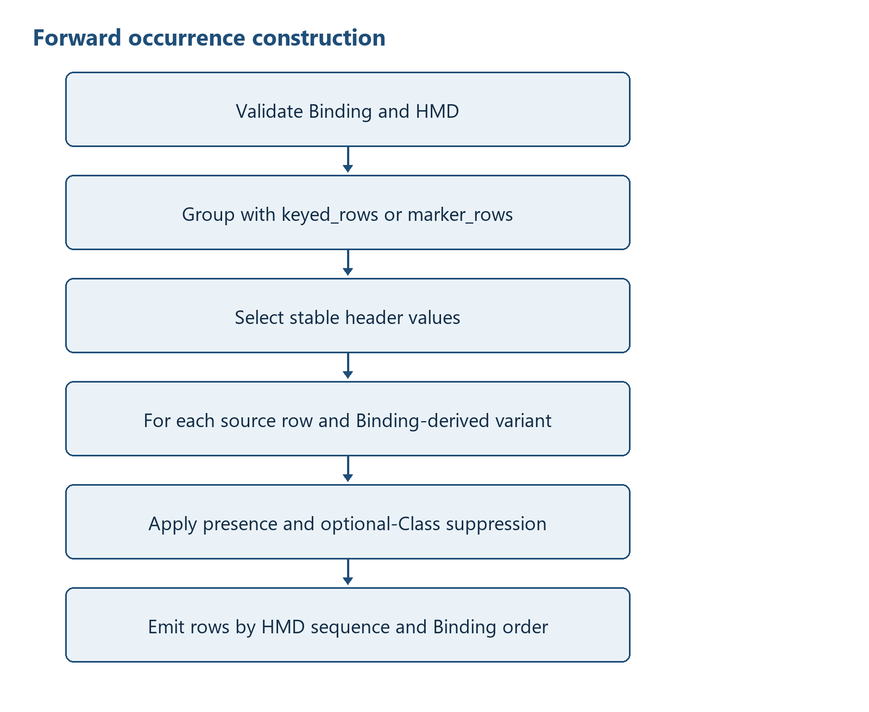
Figure 1 — Canonical forward grouping and occurrence decisions
Figure 2 illustrates canonical reverse row reconstruction. The numbered figure is referenced here as part of the implementation-level processing description.
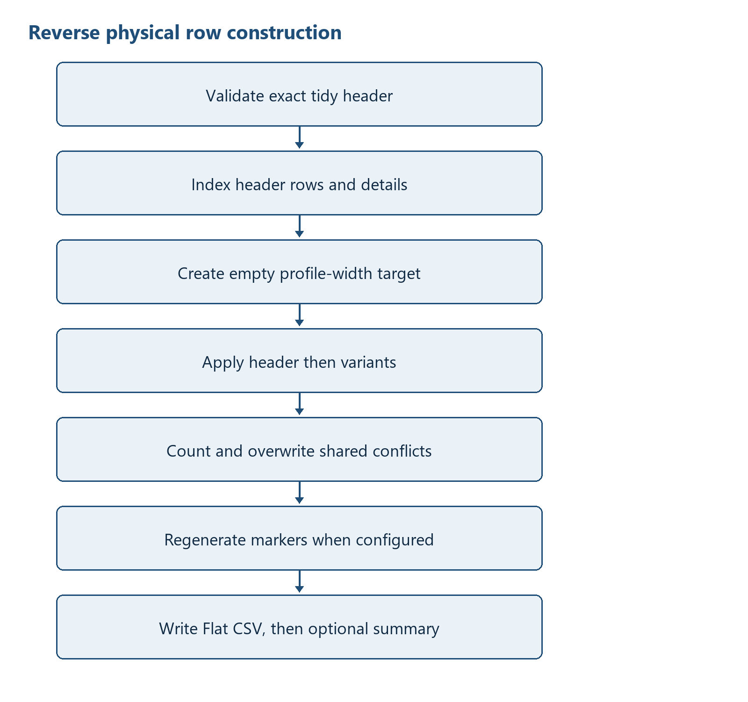
Figure 2 — Canonical reverse row reconstruction

13.1 Forward pseudocode
definition = load_binding + load_hmd + validate_definition
width = resolve exact profile width
source_rows = read rows; require every row to match width
groups = group_source_rows(source_rows, definition.group_spec)
enforce group and driver max_occurs when declared
emit ROOT rows
for entry_key, grouped_rows in groups:
select stable header source; emit HEADER rows
for source_index, source in grouped_rows:
for variant in Binding declaration order:
apply presence and optional-Class suppression
emit active rows by (HMD sequence, Binding order)
write exact STRUCTURED_FIELDS CSV

13.2 Reverse pseudocode
load and validate Binding/HMD
read exact STRUCTURED_FIELDS CSV
validate binding_path, semantic_path, sequence, occurrence and source_row
index HEADER rows by entry_key
index details by (entry_key, source_row)
for each detail identity ordered by source_row:
create an empty profile-width target
apply header then variants by rank, sequence and binding_path
reverse-transform and assign each non-empty ColumnN value
count then overwrite a differing non-empty shared value
if marker_rows: regenerate controls and blank repeated headers
write headerless Flat CSV; optionally write value-free summary

13.3 Physical Flat CSV to HTD-D and HTD-CSV
HTD-D is the logical Hierarchical Tidy Data held during conversion. The current canonical Flat CSV engine does not instantiate an HTDData tree. BindingRow and GroupSpec objects define how hierarchy is derived, while records: list[dict[str, str]] holds the values that will become HTD-CSV. Unlike XML, the input has no nested nodes; hierarchy must be constructed from group controls, physical row ordinals and selector variants. Figure 3 shows this construction.
Figure 3 illustrates flat CSV to HTD-D and HTD-CSV construction. The numbered figure is referenced here as part of the implementation-level processing description.
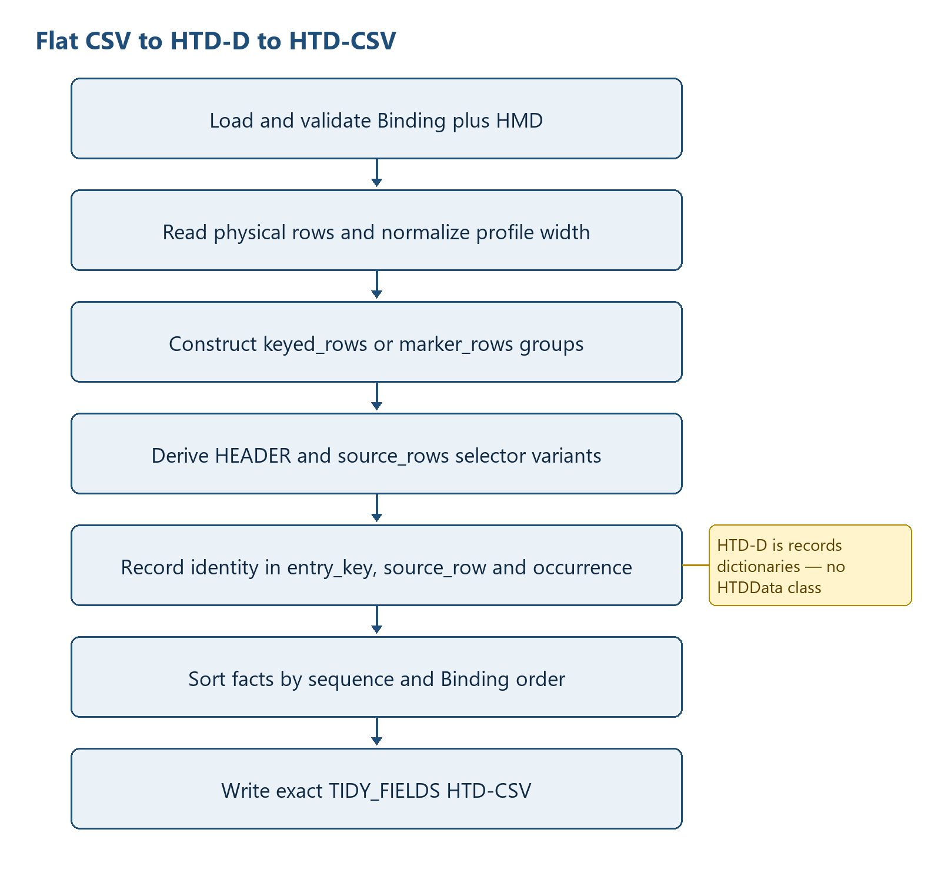
Figure 3 — Flat CSV to HTD-D and HTD-CSV construction

13.3.1 a) How HTD-D is recorded in the program
The control side consists of list[BindingRow], one GroupSpec, one source_rows driver, header/detail row subsets, a declaration-ordered variants list and variant_rows. The value side is records. Every record has the exact STRUCTURED_FIELDS keys: entry_key, source_row, occurrence, sequence, level, type, id, name, semantic_path, binding_path and value. entry_key identifies the header group; source_row retains the one-based physical input-row ordinal; occurrence is ROOT, HEADER or a selector-derived variant; semantic_path is selector-neutral for HMD identity; and binding_path retains the selector needed for the physical mapping. These explicit identity fields are the Flat CSV form of the HTD-D hierarchy.
HTD-D control = Definition(rows, GroupSpec, driver, variants, HMD sequence map)
HTD-D values = Structured CSV record dictionaries plus reverse header/detail indexes
detail identity = (entry_key, positive source_row, occurrence)
fact mapping = binding_path -> BindingRow.column; semantic_path -> HMD item

13.3.2 b) Physical Flat CSV read and processing order
convert_to_structured performs the following order:
load_binding reads the exact 17-column Binding; load_hmd reads the HMD; validate_definition verifies physical-column uniqueness, HMD resolution and sequence equality, supported transformations, one header group and one source_rows driver.
The profile width is resolved from --profile-width or the highest bound/control ColumnN; a non-positive width or a width smaller than the definition requirement is rejected.
csv.reader reads physical rows in file order. Every row must match the resolved width exactly.
Binding rows are partitioned into ROOT, HEADER and detail subsets; GroupSpec is parsed; shared rows and selector-derived variants are derived in Binding declaration order.
group_source_rows processes physical rows in source order and produces keyed_rows or marker_rows groups before any detail Structured CSV records are emitted.

13.3.3 c) Positioning physical values inside the HTD-D hierarchy
ROOT records use empty entry_key and source_row with occurrence=ROOT. For each group, keyed_rows serializes the configured non-empty key columns as a compact JSON array; marker_rows assigns a deterministic group ordinal after validating the single/start/continue/end state machine. That value becomes entry_key. _header_source selects stable header values across the group's physical rows and HEADER records use the group entry_key with an empty source_row.
Each physical row retains its one-based source_index. For every selector-derived variant in Binding declaration order, presence rows may suppress the variant. _active_rows suppresses optional Classes whose physical descendants are all empty. Remaining rows obtain a physical or default value through _value_for, apply the configured forward transformation, enforce required Attribute values, and are emitted with (entry_key, source_index, variant) as the detail identity.

13.3.4 d) HTD-D processing order when expanding to HTD-CSV
ROOT rows are emitted first, sorted by (HMD sequence, Binding order). Groups follow the first group appearance returned by group_source_rows. Within a group, HEADER rows are sorted by the same pair. Physical source rows retain their group order, variants retain Binding declaration order, and active occurrence rows are sorted by (HMD sequence, Binding order). records is therefore already in final HTD-CSV order and is not re-sorted at publication.
Table 11 summarizes flat csv htd-d to htd-csv ordering. The entries provide the implementation evidence used by the surrounding specification text.
Table 11 — Flat CSV HTD-D to HTD-CSV ordering
Ordering level | Implemented key/order | HTD-CSV effect
ROOT | (sequence, Binding order) | Document-level records first
Header groups | First keyed/marker group appearance | Stable entry_key blocks
HEADER facts | (sequence, Binding order) | Header records before detail records
Physical detail rows | Original source_index within group | Preserves physical row occurrence
Variants | First selector declaration order | Profile-defined sibling occurrence order
Facts within variant | (sequence, Binding order) | HMD order with deterministic tie-break

13.3.5 e) HTD-CSV file output
The output is opened directly with the selected output encoding and newline=''. csv.DictWriter writes the exact STRUCTURED_FIELDS header and then the records. No temporary-file promotion, manifest or hash is produced by the converter. ConversionSummary reports physical source rows, Structured CSV record count, profile width and any reverse overwrite counts.

13.4 HTD-CSV to HTD-D and physical Flat CSV
Reverse conversion rebuilds a logical HTD-D index from the explicit identity fields in HTD-CSV, then projects each detail identity into one fixed-width physical target row. Figure 4 shows the indexing, variant ordering, physical-column assignment, marker reconstruction and output sequence.
Figure 4 illustrates hTD-CSV to HTD-D and Flat CSV construction. The numbered figure is referenced here as part of the implementation-level processing description.
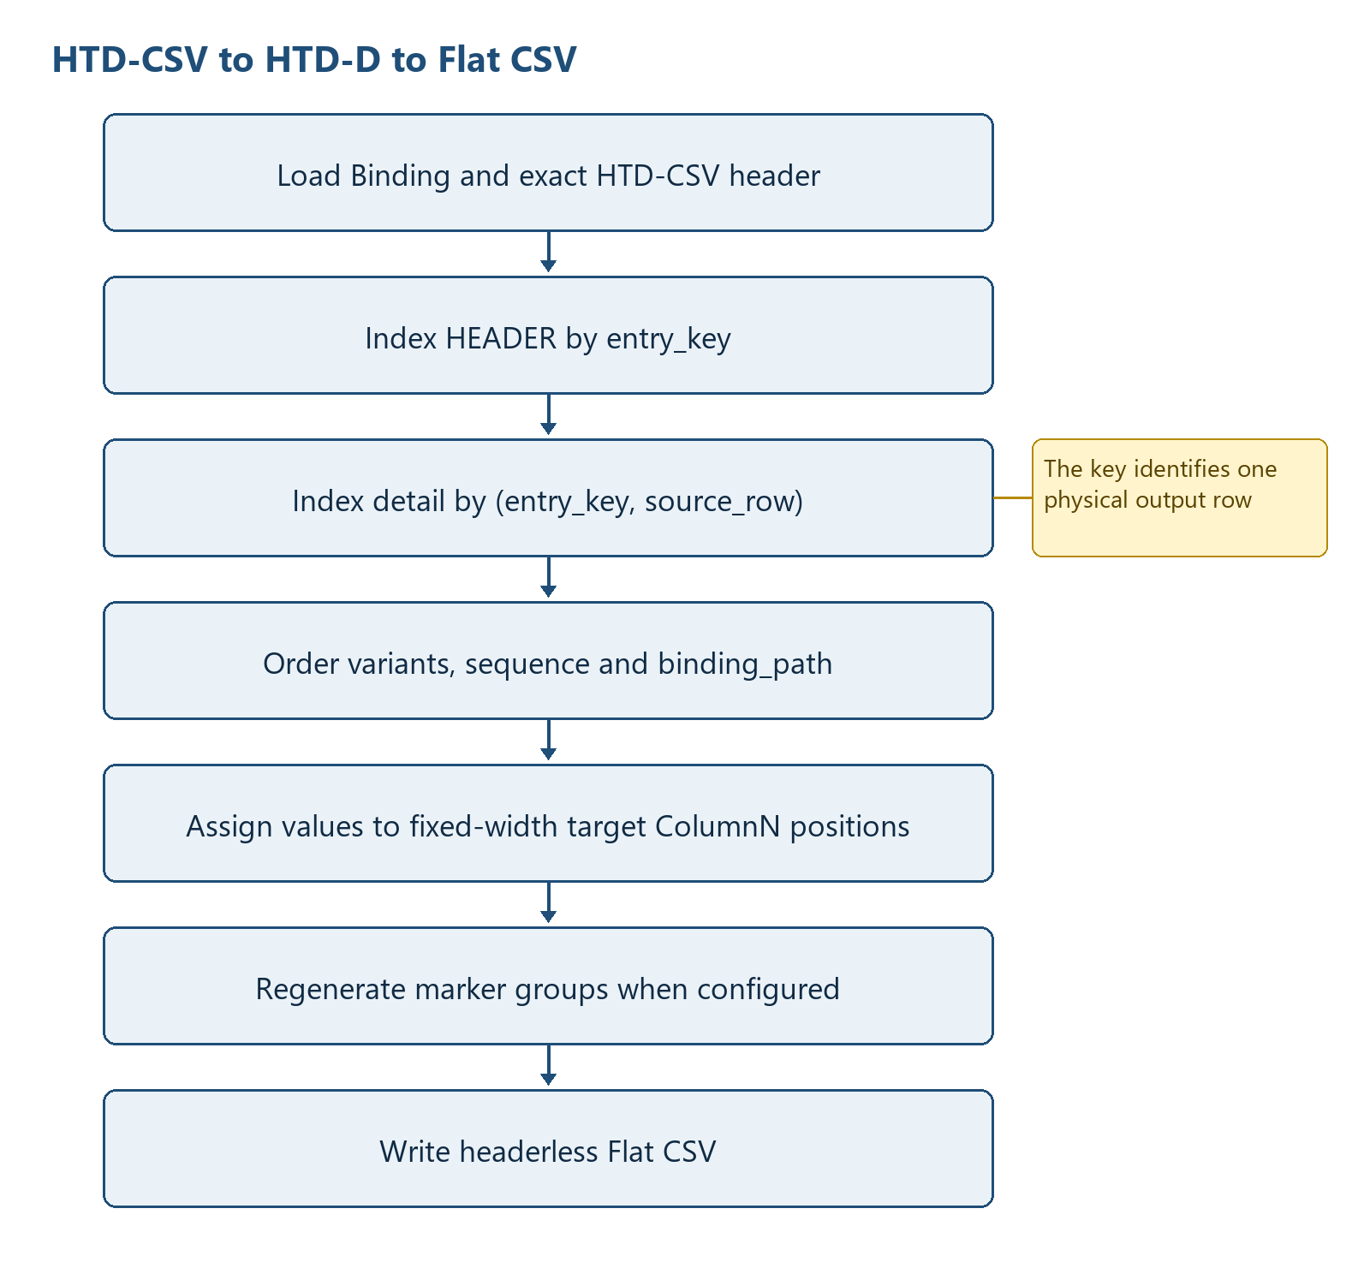
Figure 4 — HTD-CSV to HTD-D and Flat CSV construction

13.4.1 e) Reading HTD-CSV and positioning values in HTD-D
convert_to_flat loads and validates the Binding/HMD, builds by_path from selector-preserving binding_path values, derives variant_rank in Binding declaration order, resolves the profile width, and reads the complete Structured CSV. The header must equal STRUCTURED_FIELDS. _validated_structured_rows also verifies binding_path, neutral semantic_path, sequence, occurrence and positive source_row values before reconstruction.

13.4.2 d) Processing HTD-D and expanding physical Flat CSV schema data
details items are sorted by source_row only; Python's stable ordering retains insertion order for equal source-row numbers across different entry keys. For each detail identity, target = [''] * profile_width creates the physical schema row. The ordered input to that target is the matching HEADER records followed by detail records sorted by (variant_rank[occurrence], integer sequence, binding_path). by_path resolves each record to one BindingRow, reverse transformation is applied, and BindingRow.column selects the one-based target list position.
Flat CSV grouping identity is recorded in three fields: entry_key identifies the header group, source_row identifies the physical row occurrence, and occurrence identifies the selector variant. keyed_rows derives entry_key from configured physical key columns; marker_rows derives a deterministic ordinal after validating its state machine. Reverse marker processing regroups by entry_key, blanks repeated header columns after the first row, and regenerates the configured single/start/continue/end controls.
header_values[entry_key] -> HEADER HTD records
details[(entry_key, source_row)] -> variant HTD records
for (entry_key, source_row) ordered by source_row:
target = [''] * profile_width
ordered = HEADER records + detail records sorted by
(variant rank, sequence, binding_path)
for record in ordered:
binding = by_path[record.binding_path]
target[ColumnN - 1] = reverse_transform(record.value)
output_records.append((entry_key, source_row, target))
if marker_rows:
regroup targets by entry_key and regenerate marker/header repetition rules

Table 12 summarizes flat csv group identity and physical-row generation. The entries provide the implementation evidence used by the surrounding specification text.
Table 12 — Flat CSV group identity and physical-row generation
Grouping information | Where recorded | Processing order | Physical effect
Header group identity | entry_key | Index and regroup key | Shares header fields and marker scope
Physical row identity | positive source_row | Primary reverse ordering component | Creates one fixed-width row
Sibling variant | occurrence and variant_rank | Binding declaration order | Determines profile-defined precedence
Fact-to-column mapping | binding_path -> BindingRow.column | After header/variant ordering | Assigns target[ColumnN - 1]
Shared-column conflict | target value + overwrite counter | Later non-empty ordered value wins | One physical value plus aggregate count
Marker reconstruction | entry_key + GroupSpec | After targets exist | Writes configured controls and blanks repeated headers

13.4.3 c) Physical Flat CSV file output
output_rows preserves output_records order and contains one list[str] of exactly profile_width cells for each reconstructed physical row. csv.writer writes the rows directly to the requested path with the selected output encoding and no header. If summary_log is supplied, the value-free overwrite summary is written after the Flat CSV. There is no atomic pair publication or rollback.

13.5 Flat CSV versus XML Syntax Binding hierarchy construction
Table 13 highlights why Flat CSV processing cannot reuse the XML traversal algorithm. Flat CSV must infer hierarchy from positional grouping controls and variants, whereas XML begins with an explicit node hierarchy and derives dimensions from repeated contexts.
Table 13 summarizes flat csv and xml hierarchy-construction differences. The entries provide the implementation evidence used by the surrounding specification text.
Table 13 — Flat CSV and XML hierarchy-construction differences
Aspect | Flat CSV canonical Binding | XML Syntax Binding
Physical address | One-based ColumnN position plus Binding selector | XPath and namespace-aware Element context
Initial source structure | Headerless positional rows; hierarchy not explicit | Already hierarchical ElementTree
Hierarchy discovery | keyed_rows or marker_rows grouping plus source_rows driver | BindingClass recursion and repeated XML contexts
Occurrence identity | entry_key, source_row and selector-derived occurrence | Dimension column and one-based XML-context ordinal
Forward value container | records dictionaries with explicit identity fields | rows dictionaries scoped by dimension columns
Reverse physical builder | Fixed-width list[str] per (entry_key, source_row) | Element tree and (dimension, ordinal) context registry
Physical output order | Source-row/variant order and physical column index | syntax_sequence then UBL XSD child order

14 Condition and Decision Rules
Table 14 summarizes flat csv occurrence and decision rules. The entries provide the implementation evidence used by the surrounding specification text.
Table 14 — Flat CSV occurrence and decision rules
Rule | Current behaviour
Binding acceptance | Only the exact 17-column header is accepted; 13-column input receives UNSUPPORTED_LEGACY_BINDING and all other mismatches receive BINDING_HEADER_INVALID
keyed_rows identity | Compact JSON array of configured non-empty key values; repeated keys reuse the first group
marker_rows identity | Validated state-machine group ordinal
source_rows occurrence | Each physical row combines with each present selector-derived variant
Required value | Required Attribute values are checked during forward conversion
Default and presence | Defaults apply only when no column is bound; presence and optional-Class suppression prevent absent structures
max_occurs | Enforced for header group count and source rows per group when declared
Reverse shared conflict | Later non-empty value wins; aggregate column count only
Transformation | Only empty and jp_era_date_to_iso are accepted

15 Data Structure Construction
Figure 5 illustrates canonical detail occurrence identity. The numbered figure is referenced here as part of the implementation-level processing description.
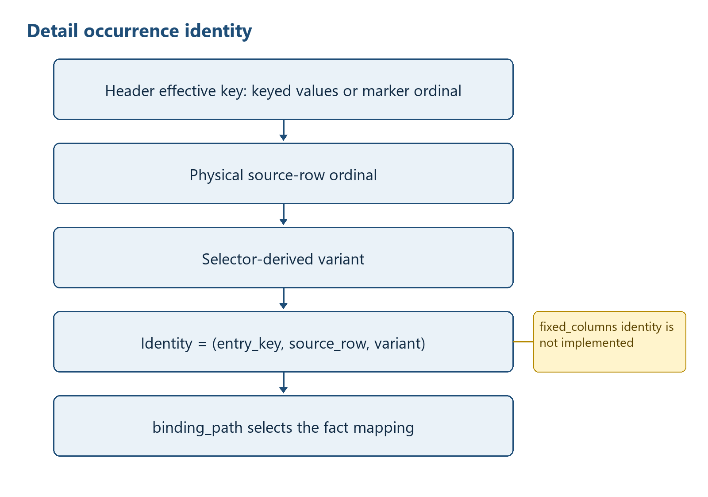
Figure 5 — Canonical detail occurrence identity

15.1 keyed_rows occurrence handling - current
The effective header identity is the compact JSON serialization of the configured ColumnN values. Every key component must be non-empty. Python dictionary insertion order preserves first-key appearance, and later non-contiguous rows with the same key append to the existing group. Detail identity extends the header key with the original 1-based source-row ordinal and selector-derived variant.

15.2 marker_rows/source_rows handling - current
Marker groups are recognized by four distinct Binding-defined codes. source_rows creates a detail driver per physical row, while selector variants create sibling occurrences such as debit and credit. row_role=presence can suppress a variant. Reverse reconstructs marker codes from the number and position of rows in each entry group.

15.3 fixed_columns handling - recommended enhancement only
fixed_columns is not a supported occurrence_mode. max_occurs is nevertheless active for the supported header group and source_rows driver: excess groups or excess source rows in a group raise MAX_OCCURS_EXCEEDED.
Figure 6 illustrates recommended fixed_columns occurrence construction (not implemented). The numbered figure is referenced here as part of the implementation-level processing description.
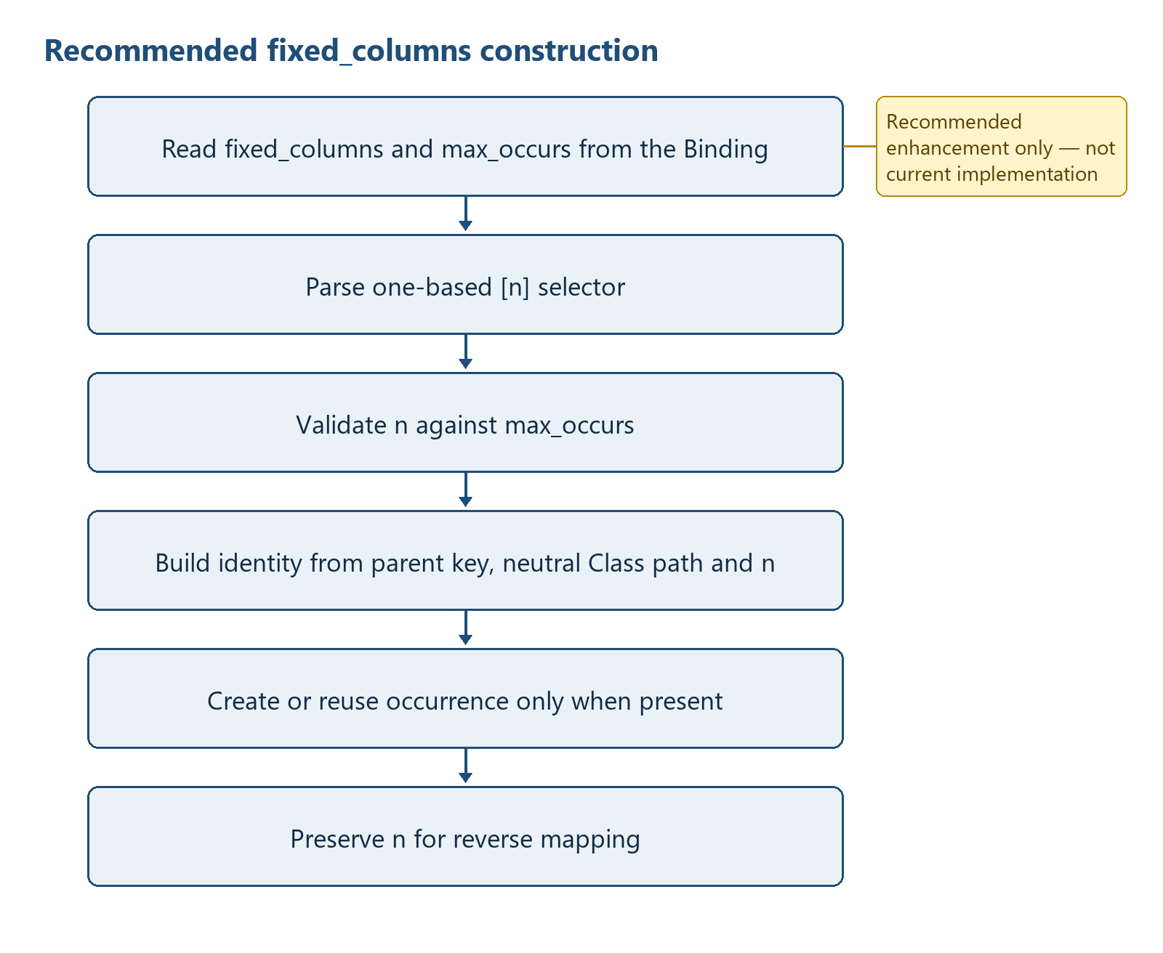
Figure 6 — Recommended fixed_columns occurrence construction (not implemented)
RECOMMENDED ONLY:
for each Class row with occurrence_mode == 'fixed_columns':
validate integer max_occurs > 0
for each descendant Attribute mapping:
parse [n] on the repeated Class segment
require 1 <= n <= max_occurs
neutral_path = path with selectors removed
identity = (parent_effective_key, neutral_class_path, n)
create/reuse identity only when a mapped source value (or permitted default) is present
persist n so reverse maps facts back to the same horizontal column group

16 Diagnostics and Error Handling
Table 15 summarizes flat csv diagnostics and publication consequences. The entries provide the implementation evidence used by the surrounding specification text.
Table 15 — Flat CSV diagnostics and publication consequences
Condition | Current mechanism | Exit/publication consequence
Binding or HMD I/O/encoding | ConversionError with value-safe definition message | main returns 2
Binding header mismatch | UNSUPPORTED_LEGACY_BINDING or BINDING_HEADER_INVALID | No conversion output; main returns 2
Definition/path/group/driver/limit validation | Classified ConversionError | No conversion output; main returns 2
Malformed marker sequence | MARKER_* ConversionError without source values | No output write has started
Required value or transformation value | Classified ConversionError without source value | No output write has started
Structured mapping mismatch | STRUCTURED_* ConversionError | No Flat CSV write has started
Shared-column conflict | Counter increment; no exception | Later value written; count-only summary
Unexpected exception | INTERNAL_ERROR without details | main returns 3
Success | No required console payload | main returns 0

Not implemented: There are no stable diagnostic codes such as PATH_SELECTOR_VALUE_MISSING in the current program, no severity catalogue, no diagnostics collection object, and no structured failure report. Do not treat terminology in design documents as emitted runtime codes.

17 File Publication and Transaction Control
Current behaviour: both directions construct their output records in memory and then write the requested final file directly. Optional summary JSON is written after the CSV. The converter does not implement temporary-file promotion, atomic multi-file publication, rollback, manifest creation or SHA-256 generation.
Recommended enhancement: Validate all inputs and construct outputs before opening final targets; write output and summary to temporary siblings; validate counts/encoding; replace finals in a defined order; document recovery of a partially replaced pair. This recommendation is not current implementation.

18 Test and Requirement Traceability
Table 16 summarizes flat csv requirement and test traceability. The entries provide the implementation evidence used by the surrounding specification text.
Table 16 — Flat CSV requirement and test traceability
Requirement | Evidence | Recorded result
Syntax | python -m py_compile flat_csv.py | PASS
Definition and negative tests | pre-public-validation/programs/flat-csv/tests | PASS: 20
PCA synthetic 81-column | test_canonical_roundtrip.py | PASS: forward, reverse, byte-exact round trip and two-run determinism
Yayoi synthetic 25-column CP932 | test_yayoi_25_roundtrip.py | PASS: marker, presence, date transform, round trip and determinism
Generic synthetic regression | test_generic_journal_entry_roundtrip.py | PASS: Binding-driven Column3 and LEFT/RIGHT variants
Shared-column conflict | PCA synthetic negative case | PASS: later non-empty value and Column27 count 1 without values
Invalid markers | definition/negative suite | PASS: unknown, orphan, nested and unclosed controls rejected
Binding rejection | definition/negative suite | PASS: missing/extra/reordered headers and 13-column Binding rejected
Real accounting data | scope control | NOT USED
Overall | 23 tests plus syntax compile | PASS

19 Known Limitations
- Exactly one keyed_rows or marker_rows header group and exactly one source_rows driver are required.
- Multiple nested keyed groups and multiple independent drivers are not supported.
- fixed_columns is unsupported; max_occurs applies only to the supported header group and source_rows driver.
- Duplicate non-empty HMD semantic_path values are rejected.
- Selector removal uses a broad regular expression and does not parse nested brackets.
- Variant extraction handles the first predicate immediately below the driver and only simple equality reliably.
- Reverse output_records are sorted primarily by source_row ordinal, not explicitly by entry group order; identical ordinals across groups can interleave stably according to dictionary construction.
- Unknown Structured CSV occurrence values are rejected; ROOT rows are validated but are not projected into physical columns by reverse conversion.
- Required checks cover forward Attribute rows only; datatype validation is limited to registered transformations.
- debug and trace are accepted CLI flags but do not change conversion processing in the current runtime.
- ConversionError is reported to stderr with process status 2; unexpected failures use a value-free INTERNAL_ERROR message and status 3.
- No atomic publication, rollback, manifest, or hash generation exists.

20 Appendices

Appendix A - Exact schemas
CANONICAL_FIELDS = ('sequence', 'level', 'type', 'id', 'name', 'datatype', 'multiplicity', 'column', 'semantic_path', 'occurrence_mode', 'group_key', 'row_role', 'max_occurs', 'default_value', 'transformation', 'required', 'note')

STRUCTURED_FIELDS = ('entry_key', 'source_row', 'occurrence', 'sequence', 'level', 'type', 'id', 'name', 'semantic_path', 'binding_path', 'value')

Appendix B - Function and method inventory
Table 17 summarizes flat csv detailed function inventory. The entries provide the implementation evidence used by the surrounding specification text.
Table 17 — Flat CSV detailed function inventory
Module | Function/method | Line | Signature
flat_csv.py | BindingRow.sequence / level / path / neutral_path / max_occurs / is_required | 69 | typed properties
flat_csv.py | ConversionSummary.as_dict | 117 | self -> dict[str, object]
flat_csv.py | module.load_binding | 237 | path, encoding -> list[BindingRow]
flat_csv.py | module.load_hmd | 271 | path, encoding -> dict[str, int]
flat_csv.py | module.validate_definition | 302 | rows, hmd_sequences -> Definition
flat_csv.py | module.group_source_rows | 478 | source_rows, GroupSpec -> grouped rows
flat_csv.py | module.convert_to_structured | 600 | ConversionOptions -> ConversionSummary
flat_csv.py | module.convert_to_flat | 741 | ConversionOptions -> ConversionSummary
flat_csv.py | module.write_summary | 821 | Path, ConversionSummary -> None
flat_csv.py | module.parse_args | 840 | argv -> argparse.Namespace
flat_csv.py | module.main | 887 | argv -> int

