UADC — Universal Adapter for Data Conversion

— Detailed Program Specification: Syntax Binding
Document status: Draft — For Collaborative Review
Date: 2026-08-16
Author: Nobuyuki SAMBUICHI
Role: UADC project editor and implementation reviewer
Project: UADC
Distribution: Private project repository — invited participants only
This document is a draft under development by Nobuyuki SAMBUICHI for collaborative review within the UADC project. It is shared through a private project workspace with invited participants. It has not been approved or endorsed as an official specification by XBRL Japan, XBRL Europe, XBRL International, or any other organization.
Copyright and license terms are defined by the UADC project licensing files.
Repository version: private collaborative review draft; WORK implementation snapshot.
Editors: SAMBUICHI, Nobuyuki
Contributors: invited project participants (individual names not yet confirmed for publication).

Status
Current implementation: The normative implementation described here is src/syntax_binding.py as tested on 2026-08-15. The companion src/syntax_binding_ads_xbrl_gl.py is identified separately. Statements about JSON adapters, generic CII reverse, atomic publication, manifests, hashes, or diagnostic catalogues are not current implementation claims.

Abstract
The program maps XML physical syntax selected by a Syntax Binding CSV to a dimension-based hierarchical Structured CSV and reconstructs UBL Invoice XML in reverse. The Binding contains HMD-aligned Class and Attribute rows, semantic_path, XML xpath, multiplicity, Structured CSV column names, syntax_sequence, and optional parent-conditional default values.

1 Purpose and Scope
This specification answers what enters and leaves the executable, how Binding rows become dataclasses, lists and indexes, how repeated XML contexts become Structured CSV rows, how reverse contexts are created or reused, where processing branches, and which tests establish the current boundary.
- In scope: src/syntax_binding.py forward XML-to-Structured CSV and reverse Structured CSV-to-UBL XML.
- In scope: EN16931 UBL Binding (199 rows), CII D16B subset Binding (34 rows), and EN16931 HMD (197 rows) as evidence references.
- Related executable: src/syntax_binding_ads_xbrl_gl.py generates XBRL GL tuple instances from Structured CSV; it is not the reverse branch of syntax_binding.py.
- Out of scope as current behaviour: JSON/JSONPath, CII reverse, Schematron conformance, transactional publication, manifest creation, and SHA-256 output generation.

2 System Context
Figure 1 illustrates current Syntax Binding system context. The numbered figure is referenced here as part of the implementation-level processing description.
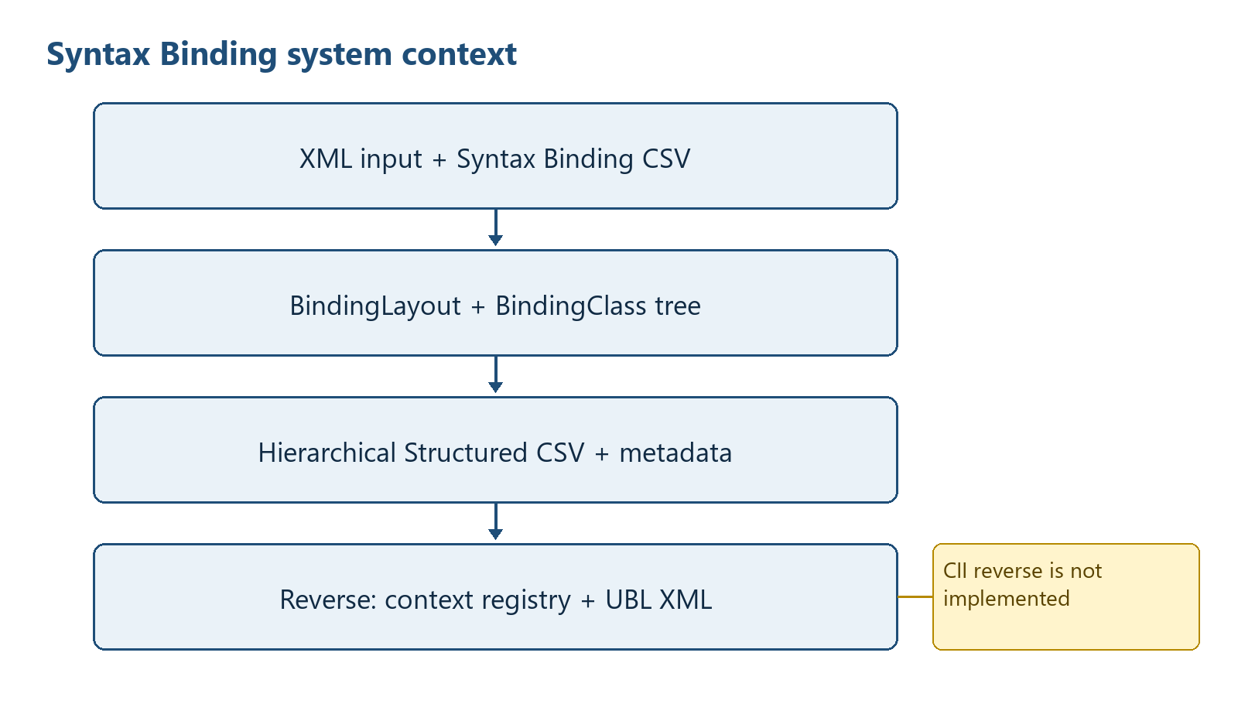
Figure 1 — Current Syntax Binding system context
Responsibility boundary: The executable performs syntax mapping within one semantic model. Cross-HMD semantic mapping belongs to the Semantic Table path. Flat physical-column grouping belongs to the Flat CSV path.

3 Processing Overview
Table 1 summarizes processing directions, principal stages, and outputs. The entries provide the implementation evidence used by the surrounding specification text.
Table 1 — Processing directions, principal stages, and outputs
Direction | Primary entry | Main stages | Result
Forward | write_hierarchical_csv | namespaces -> BindingLayout -> BindingClass tree -> recursive XML contexts -> rows -> CSV -> metadata | Hierarchical CSV plus JSON metadata
Reverse | write_xml_from_hierarchical_csv | BindingLayout -> CSV rows -> scope validation -> binding sort -> context registry -> XML values -> schema order | UBL Invoice XML
ADS XBRL GL | syntax_binding_ads_xbrl_gl.py main | load ADS bindings -> rows -> XBRL facts/tuples -> reorder -> write | XBRL GL tuple instance(s)

Figure 2 illustrates forward processing and row construction. The numbered figure is referenced here as part of the implementation-level processing description.
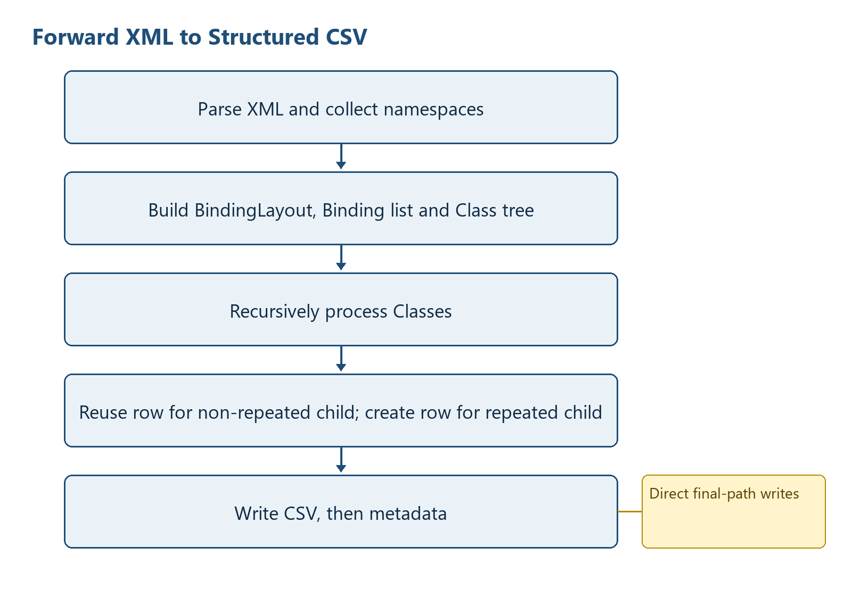
Figure 2 — Forward processing and row construction
Figure 3 illustrates reverse processing and context reuse. The numbered figure is referenced here as part of the implementation-level processing description.
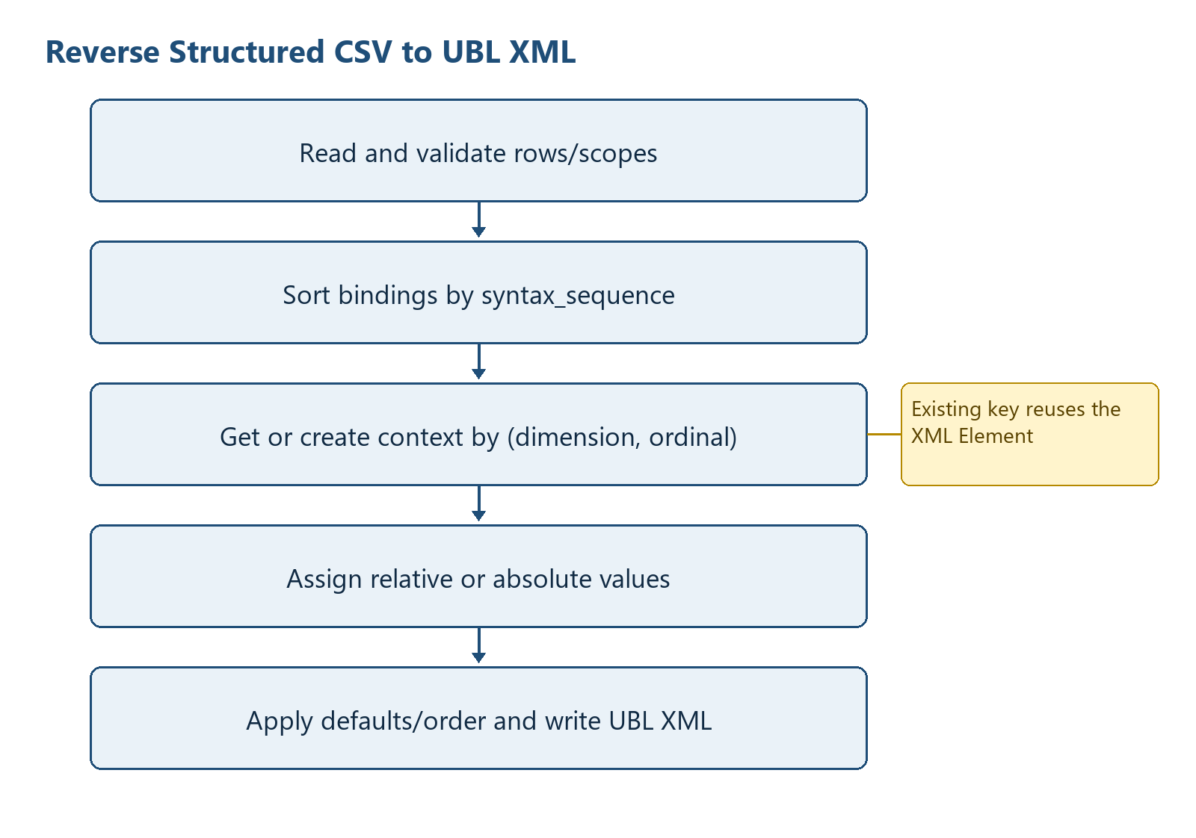
Figure 3 — Reverse processing and context reuse

4 Runtime Arguments
Table 2 summarizes syntax binding runtime arguments. The entries provide the implementation evidence used by the surrounding specification text.
Table 2 — Syntax Binding runtime arguments
Argument | Required/default | Forward effect | Reverse effect
input_file | required | XML input | Structured CSV input
-b / --binding | required | Syntax Binding CSV | Same
-o / --output | required | CSV output | XML output
--template-csv | optional | Only field-to-dimension hints are merged; template column order is not adopted | Field-to-dimension hints
--metadata-output | default: output .json | Metadata path | Ignored by reverse branch
--taxonomy-base | default: out/taxonomy | Metadata entrypoint discovery | Ignored
--reverse | false | Selects reverse branch when present | Enables reverse
--ubl-schema-root | optional | Ignored | Loads local XSD files for child order
--ubl-schema-url | empty | Ignored | Recursively downloads XSD imports/includes when supplied
--drop-empty-columns | false | Drops columns empty in all generated rows | Ignored
--d-invoice | 1 | Value placed in dInvoice | Not used to choose root
-e / --encoding | utf-8-sig | Binding/CSV encoding | Binding/CSV encoding; XML output UTF-8

4.1 ADS XBRL GL companion arguments
Table 3 summarizes ads xbrl gl companion runtime arguments. The entries provide the implementation evidence used by the surrounding specification text.
Table 3 — ADS XBRL GL companion runtime arguments
Argument | Meaning
input | Structured CSV file or directory
--binding-csv | Required ADS XBRL GL Binding CSV
--output-dir | Required output root
--schema-href | Optional schemaRef href
--monetary-decimals | Fallback decimals, default 2
--currency-csv | Currency minor-unit table
--taxonomy-base | Hidden compatibility argument; no described output effect
--output-stem-prefix | Prefix for generated stems
--output-filename | Allowed only for one input file

5 Input File Specification

5.1 XML input
- Parsed with xml.etree.ElementTree.
- Namespace declarations are collected with iterparse start-ns events.
- The supported XPath subset is child-step navigation, terminal attributes, selected equality/inequality predicates, true()/false(), and limited absolute reference comparisons.
- Unsupported predicate syntax does not raise in xml_predicate_matches; it returns True. This is a documented limitation, not validation.

5.2 Syntax Binding CSV
Table 4 summarizes syntax binding input fields. The entries provide the implementation evidence used by the surrounding specification text.
Table 4 — Syntax Binding input fields
Field | Observed use
type | C rows build classes; A rows build facts
semantic_path | Class identity and field mapping; const: marks syntax-only defaults
xpath | XML selection/construction path
structured_csv_column | Dimension or fact column
multiplicity | Repeat detection for Class rows
syntax_sequence | Binding and XML child ordering
sequence | Stable fallback order
default_value | Applied only to already existing parent contexts for const rows

Evidence snapshot: EN16931_UBL_Invoice_Syntax_Binding.csv has 199 data rows and SHA-256 5EF89BD33B17BFF0A6A44430E84DD427E2108CC497919E405593090112AE8407. EN16931_CII_D16B_Invoice_Syntax_Binding.csv has 34 data rows and SHA-256 B4CA324F066001C3DDD0469EC3A84E4C652429494E452C05E0E2BA2ED90D59B4.

5.3 Structured CSV reverse input
The file must have a header and at least one data row. Dimension columns follow d<UpperCamelClass> naming. A row containing a fact outside its owning dimension scope is rejected by validate_hierarchical_row_scopes.

6 Output File Specification
Table 5 summarizes syntax binding output files. The entries provide the implementation evidence used by the surrounding specification text.
Table 5 — Syntax Binding output files
Output | Shape | Creation behaviour
Structured CSV | Binding-derived dimension columns followed by fact columns | Header and rows written directly to requested path
Metadata JSON | documentInfo, tableTemplates, tables and column metadata | Written after CSV; default path replaces CSV suffix with .json
Reverse XML | UTF-8 XML declaration; UBL Invoice root | Written after defaults, child sorting and indentation
Console | Success count or one caught exception message | main returns 0/1 for syntax_binding.py

7 Internal Data Model
Table 6 summarizes syntax binding internal data model. The entries provide the implementation evidence used by the surrounding specification text.
Table 6 — Syntax Binding internal data model
Structure | Type | Identity / ordering | Lifetime and output effect
BindingLayout | frozen dataclass | maps semantic paths and fields to dimensions; list order from Binding | One conversion; controls columns and scopes
Binding | frozen dataclass | one semantic_path/xpath row; sorted by syntax_sequence then order | One conversion; controls extraction/construction
BindingClass | mutable dataclass tree | semantic_path; children sorted by syntax_sequence | Forward only; controls recursion
rows | list[dict[str,str]] | append order is parent row then repeated child contexts in XML order | Serialized as Structured CSV
direct_fields_by_class | dict[str,list[Binding]] | Class semantic_path key | Forward lookup index
dimension_bindings | dict[str,list[Binding]] | dimension column key | Reverse grouping
context_by_dimension_row | dict[(dimension, ordinal), Element] | reuses one XML context for all facts in same repeated row | Reverse hierarchy construction
UblSchemaIndex | object with dicts and set | QName-indexed elements/types; loaded_sources prevents repeat loading | Optional reverse child ordering

8 Class Specification
Table 7 summarizes syntax binding runtime classes. The entries provide the implementation evidence used by the surrounding specification text.
Table 7 — Syntax Binding runtime classes
Class | Responsibility | Owned state | Invariant / failure boundary
UblElementDecl | Immutable global element declaration | qname, type_qname | No behaviour; created while indexing XSD
UblSchemaIndex | Load XSD declarations and derive child sequences | elements dict, types dict, loaded_sources set | Remote load uses urlopen; failures propagate
Binding | Immutable executable binding row | order, syntax_sequence, default, semantic/xml paths, dimension/filter/field | Only parsed supported semantic_path forms become objects
BindingLayout | Immutable column/dimension maps | fieldnames plus eight maps | Generated from C/A rows
BindingClass | Forward semantic Class node | metadata and mutable children list | Tree parent is nearest exact semantic_path prefix

9 Object Specification
Table 8 summarizes syntax binding object lifecycle. The entries provide the implementation evidence used by the surrounding specification text.
Table 8 — Syntax Binding object lifecycle
Runtime object | Created by | Cardinality | State transition / end
XML root | ET.parse or ET.Element | one | parsed/created -> populated -> sorted -> written
BindingClass node | build_binding_class_tree | one per usable C row | created -> attached to parent -> traversed
Structured row dict | new_row | one root/non-repeated owner plus one per repeated XML context | empty dimensions -> facts -> append -> serialized
Repeated XML context | create_context | one per distinct (dimension, ordinal) encountered with a non-empty fact | created once -> reused for sibling facts -> serialized
Syntax-only default target | find_existing_elements | zero or more existing parents | no parent means no creation; existing target is filled only when empty

10 Collection and List Specification
Table 9 summarizes syntax binding collections and indexes. The entries provide the implementation evidence used by the surrounding specification text.
Table 9 — Syntax Binding collections and indexes
Name | Element/key | Ordering / duplicate rule | Producer -> consumer
fieldnames | str | dimensions then facts; unique by first appearance | build_layout_from_rows -> CSV writers
rows | dict | append order significant; duplicates are not de-duplicated | process_class -> writer/metadata
children | BindingClass | syntax_sequence/order | tree builder -> recursion
bindings | Binding | Binding row order then sorted where required | read_bindings -> forward/reverse
loaded_sources | str set | unique source paths/URLs | UblSchemaIndex loaders
context_by_dimension_row | tuple -> Element | dictionary lookup; no output order of its own | reverse loop -> relative setters

11 Variable and State Specification
Table 10 summarizes syntax binding runtime state. The entries provide the implementation evidence used by the surrounding specification text.
Table 10 — Syntax Binding runtime state
State | Initial value | Mutation | Decision effect
namespaces | collected map or UBL_NAMESPACES | not mutated except ET namespace registration | QName resolution
dimension_values | {'dInvoice': CLI value} | copied and extended with repeated ordinal | row hierarchy
current_row | None or inherited dict | facts filled in place | non-repeated Classes share row
written | 0 | incremented per assigned/defaulted value | success message only; not validation count
document_currency / tax_currency | first non-empty aliases | immutable | currencyID and predicate reference resolution
schema_child_order | built-in fallback or XSD-derived map | loaded before final sort | reverse element order

12 Function Specification
Table 11 summarizes syntax binding function groups and contracts. The entries provide the implementation evidence used by the surrounding specification text.
Table 11 — Syntax Binding function groups and contracts
Function group | Principal functions | Contract
Binding ingestion | read_binding_layout, build_layout_from_rows, read_bindings, build_binding_class_tree | Normalize CSV rows, derive dimensions/facts, parse executable bindings, construct semantic tree
XPath read | xml_split_xpath, xml_predicate_matches, find_nodes, get_value | Evaluate the implemented XPath subset; return empty string/list for no match
Forward hierarchy | class_contexts, fill_direct_fields, process_class | Nested functions inside write_hierarchical_csv; create rows according to multiplicity
XML construction | ensure_path, create_context, set_xml_value_with_currency, set_relative_xml_value | Create/reuse elements and set text/attributes/predicate values
Defaults/order | apply_default_to_existing_contexts, load_ubl_child_order, sort_children_for_ubl_schema | Conditional defaults and schema-order normalization
Output | write_hierarchical_csv, write_csv_metadata, write_xml_from_hierarchical_csv | Direct file writes; return row/field or value counts
CLI | main | Catch any Exception for syntax_binding.py, print one stderr line, return 1

Appendix B provides the complete module-level function inventory with source lines and signatures.

13 Detailed Processing Flow

13.1 Forward pseudocode
layout = read_binding_layout(binding)
bindings = read_bindings(binding, layout maps)
class_root = build_binding_class_tree(binding rows)
index direct A-row bindings by Class semantic_path
process_class(xml_context, class_node, active_dimensions, current_row):
row = current_row or new_row()
fill direct facts from relative XPath
recurse non-repeated children into row
append row if this Class owns it and it has facts/dimensions
for each repeated child context in input order:
copy dimensions; set child dimension to 1-based ordinal
recurse with a new row
write rows; then write metadata

13.2 Reverse pseudocode
read and validate Structured CSV rows
root = new UBL Invoice
for binding in syntax_sequence order:
if syntax-only default:
fill only existing matching parents
elif binding belongs to repeated dimension:
for non-empty rows sorted by numeric ordinal:
key = (dimension, ordinal)
context = registry.get(key) or create_context(repeat_path)
set relative value, unless path remains absolute
else:
write the first non-empty value
apply UBL defaults; sort children; write XML

13.3 Physical XML to HTD-D and HTD-CSV
In this specification, HTD-D means the logical Hierarchical Tidy Data held during execution. The current program does not define an HTDData class and does not build a second object tree containing all values. Instead, the BindingClass tree defines the hierarchy, while rows: list[dict[str, str]] contains the data. A row's non-empty dimension columns and their ordinal values encode its position in that hierarchy. Figure 4 shows the exact separation between the XML tree, hierarchy-control objects, HTD-D row representation, and HTD-CSV serialization.
Figure 4 illustrates xML to HTD-D and HTD-CSV construction. The numbered figure is referenced here as part of the implementation-level processing description.
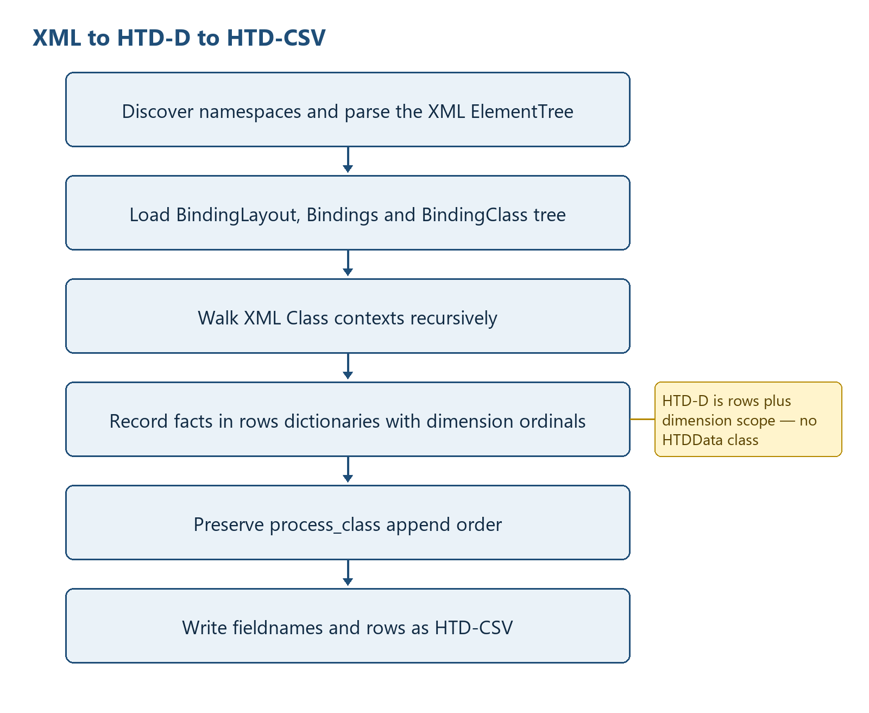
Figure 4 — XML to HTD-D and HTD-CSV construction

13.3.1 a) How HTD-D is recorded in the program
BindingLayout is the column and dimension contract. Its fieldnames list fixes the possible HTD-CSV columns; field_dimension and related maps associate fields with dimension columns. BindingClass objects form the control tree created from C rows, and direct_fields_by_class maps each Class semantic_path to the Attribute bindings owned directly by that Class. The actual values are accumulated in rows. Each member is a dictionary initialized by new_row(fieldnames, d_invoice). Dimension fields such as dInvoice and repeated-Class dimensions contain one-based string ordinals. All other populated keys contain lexical values extracted from XML. The hierarchy is therefore implicit in row scope and dimension values, not in nested Python value objects.
HTD-D control = BindingLayout + BindingClass tree + direct_fields_by_class
HTD-D values = rows: list[dict[str, str]]
hierarchy position(row) =
{dimension_column: one_based_ordinal for each non-empty dimension_column}
fact position =
(row hierarchy position, Binding.field, Binding.semantic_path)

13.3.2 b) Physical XML read and processing order
The input is not streamed into final CSV rows in one pass. The executable first establishes namespace and Binding control information, then parses and traverses the XML tree. The implemented order is:
collect_namespaces performs namespace discovery from the XML input; ET.parse then builds the complete ElementTree root.
read_binding_layout reads usable C/A rows and establishes fieldnames, semantic-path mappings, dimensions and syntax-sequence metadata.
read_bindings creates the ordered Binding list; the optional template contributes field-to-dimension hints but does not replace Binding field order.
read_binding_rows and build_binding_class_tree build the Class hierarchy; walk_binding_classes and direct_class_fields build the direct-field index.
find_nodes resolves the root Class context. process_class then walks Class nodes recursively in Binding-tree child order, using XML node order returned by find_nodes.

13.3.3 c) Positioning physical values inside the HTD-D hierarchy
For the current Class context, fill_direct_fields processes only Attribute bindings owned directly by that Class. The Attribute XPath is made relative to the Class XPath where possible, get_value reads the lexical value, and the value is assigned to Binding.field only when that field is still empty in the current row. A Binding filter also writes its declared filter_field/filter_value pair.
A non-repeated child Class is processed with the same row object, so its fields share the parent's row scope. A repeated child with a dimension is deferred into repeated_children. For each matching XML context, enumerate(..., start=1) creates a new ordinal, copies the ancestor dimension_values, adds child_class.dimension = ordinal, creates a new row, and recursively populates that row. Thus the combination of Class semantic path, field name, ancestor dimension ordinals and current repeated ordinal determines the HTD-D location.

13.3.4 d) HTD-D processing order when expanding to HTD-CSV
process_class first fills direct fields and recursively processes non-repeated children into the current row. If the Class owns the row and the row has a value beyond dimension columns, that row is appended to rows. Only after that append does the function process deferred repeated children. Repeated child Classes follow Binding-tree child order; their XML contexts follow document order; and their ordinals run from 1 through the number of contexts. The resulting rows list is already the HTD-CSV row order: owner row first, followed by each repeated subtree in recursive order.
Table 12 summarizes syntax binding htd-d to htd-csv ordering. The entries provide the implementation evidence used by the surrounding specification text.
Table 12 — Syntax Binding HTD-D to HTD-CSV ordering
Ordering level | Implemented key/order | HTD-CSV effect
Columns | BindingLayout.fieldnames | Header and dictionary projection order
Class traversal | BindingClass child insertion order | Stable semantic hierarchy traversal
Non-repeated child | Processed immediately in current row | Values merge into parent row scope
Repeated child | Deferred; XML context order; ordinal 1..n | One or more dimension-addressed rows
Final row list | Append order produced by process_class | DictWriter writes the same order

13.3.5 e) HTD-CSV file output
After traversal, drop_empty_columns may remove fields that are empty in every accumulated row. The program then creates the parent directory, opens the requested final CSV path directly with newline='' and the selected encoding, writes BindingLayout-derived fieldnames as the header, and calls writerows(rows) without an additional sort. The metadata JSON is written only after the CSV. There is no temporary-file promotion or atomic two-file transaction.

13.4 HTD-CSV to HTD-D and physical XML
The reverse direction uses the same logical HTD-D concept but a different physical construction strategy. CSV rows and dimension columns retain hierarchy identity, while an Element registry creates or reuses XML contexts. Figure 5 shows the read, position, dimension-registry, schema-expansion and output order.
Figure 5 illustrates hTD-CSV to HTD-D and UBL XML construction. The numbered figure is referenced here as part of the implementation-level processing description.
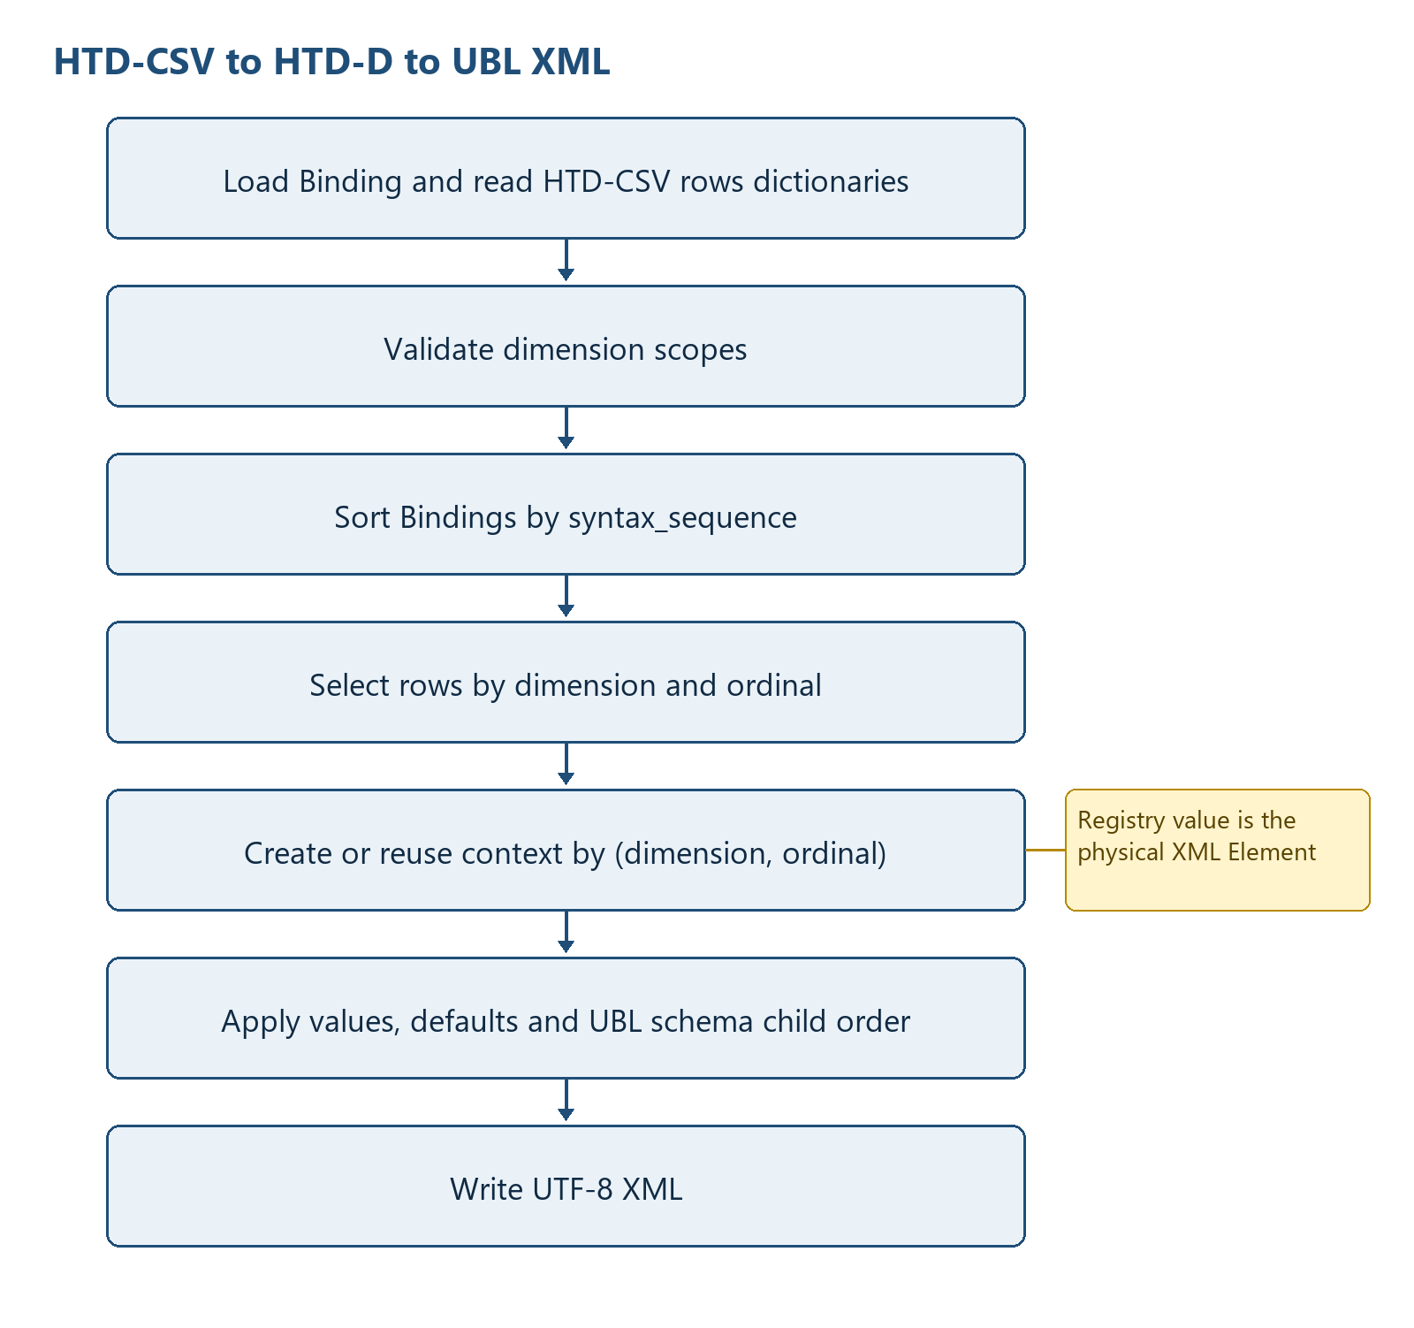
Figure 5 — HTD-CSV to HTD-D and UBL XML construction

13.4.1 e) Reading HTD-CSV and positioning values in HTD-D
The reverse function first loads BindingLayout, Binding rows and optional template dimension hints. csv.DictReader then reads the complete HTD-CSV file. BOM prefixes are removed from field names and keys, values are stripped, and the result is stored as rows: list[dict[str, str]]. validate_hierarchical_row_scopes verifies that row dimensions are compatible with field_dimension. No separate nested HTD-D value tree is created: each row remains positioned by its non-empty dimension columns, and each fact remains addressed by its Binding.field.

13.4.2 d) Processing HTD-D and expanding physical XML schema data
Bindings are grouped conceptually by their resolved dimension and are processed globally by syntax_sequence, with Binding order as the tie-breaker. repeat_path_by_dimension resolves the physical repeated XML path. context_by_dimension_row is the central dimension registry: its key is (dimension name, dimension ordinal string) and its value is the created XML Element. For one dimension-bound Binding, rows containing both that dimension and a value for the field are selected and sorted by integer dimension ordinal.
For each selected row, a missing registry key causes create_context(root, repeat_path, ...) to build the physical XML branch; an existing key reuses the same Element. A Binding XPath relative to repeat_path is written below that Element. An absolute/out-of-context path is written from the document root. A non-dimension Binding scans HTD-D rows in row order and writes the first non-empty value. A syntax-only default is applied only to contexts that already exist. This prevents a default from creating a repeated business occurrence by itself.
for binding in bindings sorted by (syntax_sequence, Binding order):
if syntax_only_default:
apply default to existing contexts only
elif binding has repeated dimension:
for row in rows sorted by integer row[dimension]:
key = (dimension, row[dimension])
context = context_by_dimension_row.get(key)
if context is None:
context = create_context(repeat_path)
context_by_dimension_row[key] = context
write value relative to context, or from root for an absolute path
else:
write the first non-empty row value

Table 13 summarizes syntax binding dimension registry and xml generation. The entries provide the implementation evidence used by the surrounding specification text.
Table 13 — Syntax Binding dimension registry and XML generation
Dimension information | Where recorded | Processing order | Physical XML effect
Dimension definition | Binding.dimension / field_dimension | Resolved before Binding processing | Selects repeated physical context
Repeated physical path | repeat_path_by_dimension | One path per dimension | Path passed to create_context
Occurrence identity | HTD-CSV row[dimension] | Integer ordinal ascending | One ordinal maps to one context key
Context reuse | context_by_dimension_row[(dimension, ordinal)] | Lookup before creation | All facts for one occurrence share an Element
Child element order | UblSchemaIndex child-order map | Applied after all values/defaults | Final children reordered to UBL schema order

13.4.3 c) Physical XML file output
After all Binding values are applied, ensure_tax_scheme_defaults supplies the implemented TaxScheme defaults, sort_children_for_ubl_schema reorders children using the optional UBL XSD-derived order, and indent_xml formats the tree. The program creates the output parent directory and writes ElementTree directly to the requested XML path as UTF-8 with an XML declaration. CII reverse is not selected from the Binding and is not implemented by this function.

13.5 XML Syntax Binding versus Flat CSV hierarchy construction
Table 14 distinguishes the XML-specific approach from the Flat CSV approach. XML starts with an existing nested node tree and derives dimension ordinals from repeated XPath contexts. Flat CSV starts with positional rows and must first construct business groups and selector variants before an HTD hierarchy exists.
Table 14 summarizes xml and flat csv hierarchy-construction differences. The entries provide the implementation evidence used by the surrounding specification text.
Table 14 — XML and Flat CSV hierarchy-construction differences
Aspect | XML Syntax Binding | Flat CSV canonical Binding
Physical address | XPath and namespace-aware Element context | One-based ColumnN position plus Binding selector
Initial source structure | Already hierarchical ElementTree | Headerless positional rows; hierarchy not explicit
Hierarchy discovery | BindingClass recursion and repeated XML contexts | keyed_rows or marker_rows grouping plus source_rows driver
Occurrence identity | Dimension column and one-based XML-context ordinal | entry_key, physical source_row ordinal and selector-derived occurrence
Forward value container | rows dictionaries scoped by dimension columns | records dictionaries carrying explicit identity fields
Reverse physical builder | Element tree and (dimension, ordinal) context registry | Fixed-width list[str] target for each (entry_key, source_row)
Physical output order | syntax_sequence then UBL XSD child order | Physical target column index; output record order

14 Condition and Decision Rules
Table 15 summarizes syntax binding decision rules. The entries provide the implementation evidence used by the surrounding specification text.
Table 15 — Syntax Binding decision rules
Condition | True branch | False branch
C row multiplicity repeats | Create dimension and one row per XML context | Reuse parent row
XPath value non-empty and field empty | Assign fact | Preserve existing value
Filter metadata present | Assign filter field/value in row | No discriminator assignment
drop_empty enabled | Remove all-empty columns | Keep full Binding layout
Reverse binding has default and no field | Apply only in existing contexts | Normal fact branch
Repeated reverse context key exists | Reuse element | Create repeat path context
relative_xpath remains absolute | Write from document root | Write under repeated context
No XSD option | Use built-in UBL_CHILD_ORDER fallback | Use derived XSD order where available

15 Data Structure Construction
Figure 6 illustrates binding rows to runtime structures and output. The numbered figure is referenced here as part of the implementation-level processing description.
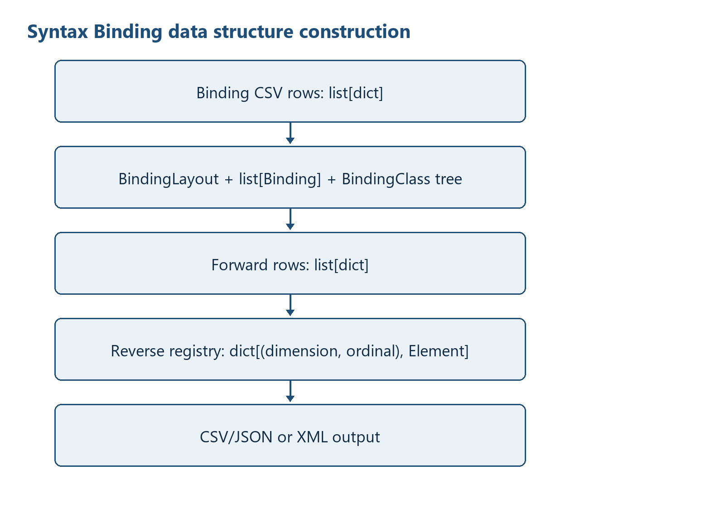
Figure 6 — Binding rows to runtime structures and output
Hierarchy is not represented by nested Python occurrence objects in forward conversion. It is represented by a BindingClass tree plus dimension columns in flat row dictionaries. Reverse conversion materializes XML Elements lazily and reuses them through context_by_dimension_row.

16 Diagnostics and Error Handling
Table 16 summarizes syntax binding diagnostics and failure results. The entries provide the implementation evidence used by the surrounding specification text.
Table 16 — Syntax Binding diagnostics and failure results
Observed condition | Mechanism | External result
No Binding header / no usable rows | ValueError | main prints syntax_binding.py: <message>; exit 1
No input CSV header/data | ValueError | Same
Invalid row scope | ValueError | Same
XML/XSD parse, path or network failure | Underlying exception | Same in syntax_binding.py; ADS companion may terminate with traceback/SystemExit
Success | return count | stdout success line; exit 0

Not implemented: There is no diagnostic-code catalogue, severity object/list, structured diagnostics file, partial-success status, or row-level error aggregation in src/syntax_binding.py.

17 File Publication and Transaction Control
Current behaviour: Output parents are created, then CSV/JSON/XML is written directly to the requested final path. Forward CSV is written before metadata; a later metadata failure can leave a CSV. Reverse XML is written once construction finishes. Existing targets can be overwritten by normal file-open semantics.
Recommended enhancement: Write all related outputs to sibling temporary files, fsync where required, validate, and replace final targets as one documented publication operation. Add a manifest/hash only if a future requirement explicitly adopts them. This is not current behaviour.

18 Test and Requirement Traceability
Table 17 summarizes syntax binding requirement and test traceability. The entries provide the implementation evidence used by the surrounding specification text.
Table 17 — Syntax Binding requirement and test traceability
Requirement area | Evidence | Result / boundary
Forward hierarchy | tests/test_syntax_binding.py | PASS: 9 rows, 177 columns
UBL reverse | tests/test_syntax_binding_reverse.py | PASS: 87 values and 9-row round-trip
PINT Japan forward | tests/test_pint_jp_examples_conversion.py | PASS: 9/9, 4-20 rows
Round-trip artifacts | tests/test_roundtrip_artifacts.py | PASS: 19 cases
UBL schema | tests/test_roundtrip_xml_ubl_schema.py | PASS: 19/19 UBL 2.1
Syntax order/defaults | test_ubl_binding_syntax_sequence.py; test_ubl_required_syntax_defaults.py; test_ubl_schema_child_order.py | PASS in recorded review
CII forward | tests/test_cii_d16b_conversion.py | PASS: 54 XSD refs, 3 instances, 34 Binding rows; reverse not tested
Determinism | review/TEST_RESULTS.md | PASS: PINT 18 outputs and CII 6 outputs, zero mismatches
Profile rules | PINT/CII Schematron | NOT RUN

19 Known Limitations
- Reverse always creates a UBL Invoice root; generic CII reverse is not implemented.
- CII dates retain source lexical forms; explicit ISO transformation is pending.
- The XPath evaluator supports a limited subset and treats an unrecognized predicate as matched.
- Repeated reverse identity is (dimension, ordinal); multiple nested dimensions with the same local ordinal are not represented by a composite ancestor key.
- Only the first non-empty singleton fact is written in reverse.
- No output validation is called inside main after writing; schema tests are external.
- Supplying --ubl-schema-url performs network access; this must be operationally controlled.
- JSON/JSONPath and an adapter registry described in older target specifications are not present in this module.
- No atomic multi-file publication, rollback, manifest, or hash generation is implemented.

20 Appendices

Appendix A - Exact file references
Table 18 summarizes syntax binding source and reference inventory. The entries provide the implementation evidence used by the surrounding specification text.
Table 18 — Syntax Binding source and reference inventory
File | Role
src/syntax_binding.py | Primary executable specified here
src/syntax_binding_ads_xbrl_gl.py | Related ADS Structured CSV to XBRL GL tuple generator
specs/bindings/syntax/EN16931_UBL_Invoice_Syntax_Binding.csv | 199-row UBL Binding
specs/bindings/syntax/EN16931_CII_D16B_Invoice_Syntax_Binding.csv | 34-row CII forward subset
specs/lhm/EN16931_CIUS_Invoice_LHM.csv | 197-row HMD reference

Appendix B - Function inventory
Table 19 summarizes syntax binding detailed function inventory. The entries provide the implementation evidence used by the surrounding specification text.
Table 19 — Syntax Binding detailed function inventory
Function | Line | Signature | Purpose
xml_local_name | 342 | name: str | Return the local component of a qualified or prefixed XML name.
collect_namespaces | 359 | xml_file: Path | Collect namespace prefix declarations from an XML file.
xml_qualify_step | 376 | step: str, namespaces: Dict[str, str] | Convert an XPath step into an ElementTree-qualified tag when possible.
xml_split_step_predicate | 398 | step: str | Separate an XPath step from its optional predicate.
xml_split_xpath | 414 | xpath: str | Split an XPath into steps while preserving predicate expressions.
xml_split_terminal_attribute | 447 | xpath: str | Separate a terminal attribute selector from an XPath.
xml_path_value | 472 | context: ET.Element, path: str, namespaces: Dict[str, str], root: Optional[ET.Element]=None | Resolve a scalar value from an XML context using a relative path.
xml_predicate_matches | 499 | child: ET.Element, predicate: Optional[str], namespaces: Dict[str, str], root: Optional[ET.Element]=None | Evaluate the supported XPath predicate forms against an XML element.
xml_child_matches | 539 | child: ET.Element, step: str, namespaces: Dict[str, str], root: Optional[ET.Element]=None | Check whether a child element matches an XPath step and predicate.
find_nodes | 561 | context: ET.Element, xpath: str, namespaces: Dict[str, str], root: Optional[ET.Element]=None | Find XML nodes matching the limited XPath subset used by syntax bindings.
get_value | 595 | context: ET.Element, xpath: str, namespaces: Dict[str, str], root: Optional[ET.Element]=None | Extract text or a terminal attribute value from an XML context.
first_present | 701 | row: Dict[str, str], names: Iterable[str] | Return the first non-empty value from a set of candidate field names.
parse_order | 719 | value: str, fallback: int=0 | Parse a row-order value with a fallback for blanks or invalid input.
syntax_sequence_sort_key | 739 | value: str, fallback: int=0 | Return a stable sort key for an XSD-derived hierarchical syntax sequence.
upper_camel | 756 | value: str | Convert text to UpperCamelCase.
dimension_name | 772 | element: str | Build a d-prefixed dimension column name from an element name.
multiplicity_repeats | 785 | multiplicity: str | Return whether an LHM multiplicity allows repeated rows.
read_binding_layout | 807 | binding_csv: Path, encoding: str | Read LHM-style class and attribute rows embedded in a syntax binding CSV.
build_layout_from_rows | 826 | rows: List[Dict[str, str]] | Build Structured CSV layout metadata from LHM-style C/A rows.
read_template | 930 | template_csv: Optional[Path], encoding: str | Read an optional template CSV and infer dimension placement rules.
is_dimension_column | 967 | name: str | Return whether a column name represents a dimension column.
parse_semantic_path | 980 | semantic_path: str, xpath: str, order: int, syntax_sequence: str='', default_value: str='', path_dimension: Optional[Dict[str, str]]=None, field_by_semantic_path: Optional[Dict[str, str]]=None, semantic_path_dimension: Optional[Dict[str, str]]=None | Parse a semantic path into hierarchy parts and a leaf field.
read_bindings | 1057 | binding_csv: Path, encoding: str, path_dimension: Optional[Dict[str, str]]=None, field_by_semantic_path: Optional[Dict[str, str]]=None, semantic_path_dimension: Optional[Dict[str, str]]=None | Read usable binding rows from a CSV file.
read_binding_rows | 1107 | binding_csv: Path, encoding: str | Read normalized rows from a binding CSV.
build_binding_class_tree | 1125 | rows: List[Dict[str, str]] | Build a semantic class tree from C rows in the syntax binding table.
direct_class_fields | 1178 | class_path: str, bindings: List[Binding] | Return A-row bindings whose direct semantic parent is a class path.
walk_binding_classes | 1200 | root: BindingClass | Return binding class nodes in pre-order.
xpath_element_path | 1216 | xpath: str | Return the element portion of an XPath without a terminal attribute.
xpath_parent | 1231 | xpath: str | Return the parent XPath for an element or attribute XPath.
common_xpath_prefix | 1247 | xpaths: List[str] | Find the common path prefix across XPath strings.
infer_repeat_path | 1268 | bindings: List[Binding] | Infer the repeated XML context path from binding rows.
relative_xpath | 1286 | full_xpath: str, context_xpath: str | Make a binding XPath relative to a context XPath.
qname | 1306 | name: str, namespaces: Dict[str, str] | Build an ElementTree QName from a prefixed XML name.
element_local_name | 1325 | tag: str | Return the local XML element name from a tag or step.
step_base_and_predicate | 1340 | step: str | Split an XPath step into its base name and predicate text.
predicate_child_value | 1356 | predicate: str | Parse a simple child-equals-literal predicate.
find_predicate_value | 1382 | parent: ET.Element, relative_path: str, namespaces: Dict[str, str] | Read the value referenced by a predicate child path.
set_predicate_value | 1411 | parent: ET.Element, relative_path: str, value: str, namespaces: Dict[str, str] | Write the value referenced by a predicate child path.
split_xpath_steps | 1435 | xpath: str | Split an XML path into steps while preserving predicates.
split_terminal_attribute | 1467 | xpath: str | Separate a terminal XML attribute from an XPath.
child_satisfies_predicate | 1492 | child: ET.Element, predicate: str, namespaces: Dict[str, str] | Check whether a child element satisfies a simple predicate.
find_or_create_child | 1515 | parent: ET.Element, step: str, namespaces: Dict[str, str], force_new: bool=False | Find an existing matching child or create a new XML child.
split_xml_path | 1541 | xpath: str | Split an XML path into element steps and terminal attribute name.
ensure_path | 1557 | root: ET.Element, xpath: str, namespaces: Dict[str, str], force_new_leaf: bool=False | Ensure an XML path exists and return its final element and attribute.
set_xml_value | 1579 | root: ET.Element, xpath: str, value: str, namespaces: Dict[str, str] | Set an XML element text or attribute value by XPath.
find_existing_elements | 1601 | root: ET.Element, parts: List[str], namespaces: Dict[str, str] | Find existing elements for an absolute binding path without creating nodes.
apply_default_to_existing_contexts | 1621 | root: ET.Element, xpath: str, value: str, namespaces: Dict[str, str] | Apply a syntax-only default only where the bound parent context already exists.
is_amount_xpath | 1663 | xpath: str | Return whether an XPath points to an amount element.
apply_currency_attribute | 1679 | element: ET.Element, xpath: str, document_currency: str, tax_currency: str | Set currencyID on amount elements when appropriate.
resolve_currency_references | 1699 | xpath: str, document_currency: str, tax_currency: str | Replace currency reference paths with currency codes.
create_context | 1720 | root: ET.Element, xpath: str, namespaces: Dict[str, str], document_currency: str='', tax_currency: str='' | Create the root XML context for reverse hierarchical conversion.
set_xml_value_with_currency | 1745 | root: ET.Element, xpath: str, value: str, namespaces: Dict[str, str], document_currency: str, tax_currency: str | Set an XML value and apply currency attributes or references.
set_relative_xml_value | 1778 | context: ET.Element, xpath: str, value: str, namespaces: Dict[str, str], document_currency: str='', tax_currency: str='' | Set a value below a row-specific XML context.
load_ubl_child_order | 1815 | schema_root: Optional[Path]=None, schema_url: str='' | Load UBL child element order from a local schema root or schema URL.
child_order_for | 1840 | element: ET.Element, schema_child_order: Optional[Dict[str, List[str]]]=None | Return the schema child-order map for an element.
sort_children_for_ubl_schema | 1863 | element: ET.Element, schema_child_order: Optional[Dict[str, List[str]]]=None | Recursively sort UBL children according to schema order.
find_child_by_local_name | 1890 | element: ET.Element, local_name: str | Find the first direct child with a local element name.
ensure_tax_scheme_defaults | 1907 | root: ET.Element, namespaces: Dict[str, str] | Add required TaxScheme ID defaults when missing.
indent_xml | 1933 | element: ET.Element, level: int=0 | Apply readable indentation to XML elements.
new_row | 1956 | fieldnames: List[str], d_invoice: str | Create an empty hierarchical CSV row with an invoice dimension value.
row_has_values | 1973 | row: Dict[str, str], dimension_columns: List[str] | Return whether a row has any non-dimension fact values.
validate_hierarchical_row_scopes | 1987 | rows: List[Dict[str, str]], fieldnames: List[str], field_dimension: Dict[str, str] | Reject rows that mix facts belonging to different row scopes.
drop_empty_columns | 2017 | rows: List[Dict[str, str]], fieldnames: List[str] | Remove columns that are empty across all rows.
add_derived_fieldnames | 2038 | fieldnames: List[str], bindings: List[Binding] | Add binding-derived field names missing from a template.
relative_metadata_path | 2062 | path: Optional[Path], metadata_file: Path | Format a metadata path relative to its JSON metadata file.
latest_file | 2081 | directory: Path, pattern: str | Find the latest matching file in a directory.
taxonomy_entrypoints | 2096 | taxonomy_base: Optional[Path], metadata_file: Path | Build metadata links to available taxonomy entrypoint files.
taxonomy_version | 2120 | entrypoints: Dict[str, str] | Infer a taxonomy version label from entrypoint file names.
xbrl_csv_column_definition | 2137 | column: Dict[str, str] | Build one XBRL CSV metadata column definition.
binding_column_metadata | 2154 | binding_csv: Path, encoding: str | Build column metadata from a syntax binding CSV file.
write_csv_metadata | 2209 | metadata_file: Path, csv_file: Path, xml_file: Path, binding_csv: Path, fieldnames: List[str], row_count: int, taxonomy_base: Optional[Path], encoding: str | Write JSON metadata for a hierarchical CSV file.
write_hierarchical_csv | 2287 | xml_file: Path, binding_csv: Path, out_csv: Path, template_csv: Optional[Path], metadata_output: Optional[Path], taxonomy_base: Optional[Path], encoding: str, d_invoice: str='1', drop_empty: bool=False | Extract XML data and write hierarchical CSV plus metadata.
row_value | 2458 | row: Dict[str, str], field: str | Return a stripped value from a CSV row field.
row_has_dimension | 2472 | row: Dict[str, str], dimension: str | Return whether a row has a value for a dimension column.
first_row_value | 2486 | rows: List[Dict[str, str]], fields: Iterable[str] | Return the first non-empty value among fields across rows.
write_xml_from_hierarchical_csv | 2505 | input_csv: Path, binding_csv: Path, out_xml: Path, template_csv: Optional[Path], encoding: str, namespaces: Optional[Dict[str, str]]=None, ubl_schema_root: Optional[Path]=None, ubl_schema_url: str='' | Rebuild XML from hierarchical CSV rows and bindings.
main | 2663 |  | Parse command-line arguments, run the script workflow, and return an exit code.

Appendix C - Saved diagram sources
- diagrams/01_system_context.mmd
- diagrams/02_forward_flow.mmd
- diagrams/03_reverse_flow.mmd
- diagrams/04_data_structure_construction.mmd

