UADC (Universal Adapter for Data Conversion)

—Program Specification: Flat CSV
Document status: Draft — For Collaborative Review
Date: 2026-09-27
Author: Nobuyuki SAMBUICHI
Role: UADC project editor and implementation reviewer
Project: UADC
Distribution: Private project repository — invited participants only
Repository version: private collaborative review draft; WORK implementation snapshot.
Editors: SAMBUICHI, Nobuyuki
Contributors: invited project participants (individual names not yet confirmed for publication).
This document is a draft under development by Nobuyuki SAMBUICHI for collaborative review within the UADC project. It is shared through a private project workspace with invited participants. Copyright and license terms are defined by the UADC project licensing files.

Status
Current implementation: tools/binding/flat_csv.py is the Canonical 16-column Flat CSV runtime. Its reverse CLI supports source_rows (default), balanced_single_counterpart, exact_unique_amount_pairing, and ordered_cumulative_pairing materialization modes. It validates the Binding against the selected HMD and provides the to-structured and to-flat subcommands. The reverse CLI selects these modes with --materialization-mode; ordered_cumulative_pairing delegates to aggregate_pairing.py. Tax reverse policy is selected by --tax-reverse-mode and may use TaxTransactionClassification, TaxType, TaxCategory, and TaxPercentageRate facts; PCA/EPSON profile policy is not generic Flat CSV behavior. A profile directory loads one same-prefix *_BINDING.csv and *_ACCOUNT_MAPPING.csv pair; legacy 17-column Binding input is normalized before validation. Physical interface width and header labels are profile-defined rather than hard-coded by application. They may be supplied by a separate column definition and, where present, compatible inline physical-header declarations. For keyed_rows, the Binding declares which physical C<n> columns constitute the key; the runtime interprets those declared columns generically and does not assume any particular column numbers.

Abstract
flat_csv.py converts a profile-controlled physical Flat CSV to the 11-column Structured CSV contract and reconstructs the Flat CSV in the reverse direction. The Binding maps physical C<n> positions to HMD semantic_path values and declares grouping, source-row repetition, selector variants, row roles, limits, defaults, reversible transformations and required values. The HMD supplies the authoritative neutral semantic paths and sequence values.
Table of Contents
Status 1
Abstract 1
1 Purpose and Scope 4
2 System Context 4
3 Processing Overview 4
4 Runtime Arguments 4
5 Input File Specification 5
5.1 Physical Flat CSV 5
5.2 Exact canonical 16-column Binding; legacy 17-column input is normalized 5
5.3 HMD 6
5.4 Canonical tidy reverse input 6
6 Output File Specification 6
7 Internal Data Model 7
8 Class Specification 7
9 Object Specification 8
10 Collection and List Specification 8
11 Variable and State Specification 9
12 Function Specification 9
13 Detailed Processing Flow 10
13.1 Forward pseudocode 12
13.2 Reverse pseudocode 13
13.3 Physical Flat CSV to HTD-D and HTD-CSV 13
a) How HTD-D is recorded in the program 14
b) Physical Flat CSV read and processing order 14
c) Positioning physical values inside the HTD-D hierarchy 15
d) HTD-D processing order when expanding to HTD-CSV 15
e) HTD-CSV file output 15
13.4 HTD-CSV to HTD-D and physical Flat CSV 16
a) Reading HTD-CSV and positioning values in HTD-D 16
b) Processing HTD-D and expanding physical Flat CSV schema data 16
c) Physical Flat CSV file output 17
13.5 Flat CSV versus XML Syntax Binding hierarchy construction 18
14 Condition and Decision Rules 18
15 Data Structure Construction 19
15.1 keyed_rows occurrence handling - current 19
15.2 marker_rows/source_rows handling - current 19
15.3 fixed_columns handling - recommended enhancement only 19
16 Diagnostics and Error Handling 20
17 File Publication and Transaction Control 21
18 Test and Requirement Traceability 21
19 Known Limitations 22
19.1 HMD boundary and profile-bound Account Mapping 23
19.2 Accepted runtime evidence and remaining limitations 24
Appendix A Exact schemas 25
Appendix B Function and method inventory 26
Appendix C Saved diagram sources 27
Appendix D Specification Accepted on 2026/9/15 28
D.1 Identifiers in the Binding and Structured CSV 28
D.2 Taxonomy and Validation Entry Points 28
D.3 Structured CSV, Formal xBRL-CSV, and LedgerExplorer 29
D.4 Flat CSV Definition-Table Contracts 29
D.5 Tax Conversion 30
D.6 Physical-Row Materialization for Compound Journal Entries 30
D.7 Implementation Functions and Diagnostic Boundaries 31
Appendix E Revision History 32

1 Purpose and Scope
- In scope: flat_csv.py definition loading and validation, grouping, occurrence construction, forward conversion, reverse reconstruction, summary output and command-line processing.
- In scope: synthetic profile tests and private reviewed PCA 81-column and EPSON R4 43-column integration evidence. Private source values are not reproduced in this specification.
- For the accepted PCA/EPSON profiles, the fixed-order 16 names and count must match CANONICAL_FIELDS; the legacy 17-column header is compatibility input. A 13-column Binding is rejected with UNSUPPORTED_LEGACY_BINDING; other mismatches are rejected with BINDING_HEADER_INVALID.
- Supported occurrence modes are blank, single, source_rows, keyed_rows and marker_rows. fixed_columns is not accepted. max_occurs is enforced for the header-group count and the number of source rows within each group when it is declared on the applicable group or driver row.

2 System Context
Responsibility boundary: The Binding determines physical-column meaning and grouping. The HMD supplies neutral semantic paths and sequence. The program does not infer business semantics from labels and does not map between different HMDs.

3 Processing Overview
Table 1 summarizes the single Canonical runtime path and its definition-driven stages.
Table 1 — Canonical Flat CSV runtime stages
Stage | Binding-controlled input | Runtime function | Result
Definition | Exact CANONICAL_FIELDS plus HMD | load_binding, load_hmd, validate_definition | Validated Definition
Forward | Physical Flat CSV (headerless or with configured header rows) | convert_to_structured | Exact STRUCTURED_FIELDS CSV
Reverse | Structured CSV | convert_to_flat | Physical Flat CSV (configured header behavior) plus optional summary
CLI | to-structured or to-flat | parse_args, main | Status 0, classified status 2, or internal status 3

4 Runtime Arguments
Table 2 summarizes flat csv runtime arguments. The entries provide the implementation evidence used by the surrounding specification text.
Table 2 — Flat CSV runtime arguments
Argument | Applies to | Requirement/default | Effect
to-structured / to-flat | CLI | exactly one required | Selects conversion direction
input | both | required Path | Physical Flat CSV or Structured CSV
-o / --output | both | required Path | Direct final-path write
-m / --hmd-file | both | required Path | Selected HMD definition
-b / --binding-file | both | Required exactly when --profile-dir is absent | Loads Binding only; Account Mapping is not applied
-e / --definition-encoding | both | utf-8-sig | Binding and HMD encoding
--input-encoding | to-structured | utf-8-sig | Physical Flat CSV input encoding
--output-encoding | to-flat | utf-8 | Physical Flat CSV output encoding
--profile-width | both | optional positive integer | Exact physical row width; cannot be below referenced C<n>
--summary-log | both | optional Path | Value-free JSON summary
--debug / --trace | both | flags | Accepted; no conversion-state or value logging
--profile-dir | both | Mutually exclusive with --binding-file | Loads exactly one same-prefix *_BINDING.csv and *_ACCOUNT_MAPPING.csv pair
--unbound-report | to-structured | optional path | Writes value-free HMD-undefined physical positions; report from private input remains private
--columns-file | both | optional path | Separate column,name definition of the physical interface width and header labels. It does not define semantic facts.

5 Input File Specification

5.1 Physical Flat CSV
- Headerless rows read with csv.reader.
- Width equals --profile-width when supplied, otherwise the highest physical column referenced by the Binding or grouping control.
- Every source row must contain exactly the resolved profile width; shorter and longer rows are rejected with PROFILE_WIDTH_MISMATCH.
- Forward physical encoding is selected by --input-encoding. Definition encoding is selected independently by --definition-encoding.

5.2 Exact canonical 16-column Binding; legacy 17-column input is normalized
The fixed-order 16-column Binding definition contract was adopted for PCA/EPSON on 2026-09-03 and reconfirmed on 2026-09-13. The former 17-column Binding remains compatibility input for this runtime, not the contract for newly created PCA/EPSON Bindings. The canonical physical-column notation is C<n>; historical ColumnN is compatibility notation. Acceptance of all other legacy profiles is not asserted. The accepted converter is tools/binding/flat_csv.py, with PCA and EPSON Bindings in the same project's bindings/semantic/ directory.
Table 3 summarizes canonical flat csv binding fields. The entries provide the implementation evidence used by the surrounding specification text.
Table 3 — Canonical Flat CSV Binding fields
Column | Current use
sequence | Positive integer. Semantic rows must equal the selected HMD sequence; type=P physical-header rows use a positive declaration sequence and do not resolve to the HMD.
level/type/name/datatype/multiplicity | Semantic rows carry Binding metadata; level, type and name contribute to Structured CSV. type=P is reserved for a physical-header declaration: name is the exact physical header label, row_role must be header, and the row has no semantic value contract. id is not a Binding field.
column | Positive C<n> physical identity. Semantic mapped C<n> values are unique among semantic rows. A type=P header declaration may address the same C<n>; physical-header declarations themselves must be unique by C<n>.
semantic_path | Selector-preserving binding_path for semantic rows; selector-neutral form resolves to HMD. Must be blank for type=P physical-header rows.
occurrence_mode | One keyed_rows or marker_rows group and one source_rows driver; blank/single permitted elsewhere
group_key | For keyed_rows, a JSON array containing one or more unique physical C<n> identifiers selected by the Binding. The array order is significant. For each source row, the runtime reads the value from each declared C<n> in that order and uses the complete ordered value array as the occurrence key. Each value is used exactly as supplied, including the empty string. No particular C<n> positions are reserved by the runtime. For marker_rows, group_key is the defined marker-control object.
row_role | group, driver, header, presence or blank. type=P physical-header rows require row_role=header.
max_occurs | Positive integer when supplied; enforced for header-group count and per-group driver rows
default_value | Used when a semantic Binding row has no physical column; must be blank on type=P rows.
transformation | Registered reversible transformation or blank; must be blank on type=P rows.
required | Recognized boolean; required semantic Attribute values are checked during forward conversion. A blank value used as a keyed_rows component is not made required merely by key participation; type=P rows must be false/blank.
note | Definition annotation; no execution effect

5.3 HMD
load_hmd requires semantic_path and sequence columns, rejects non-integer sequence values and duplicate non-empty semantic_path values, and builds the authoritative semantic_path-to-sequence map. Every selector-neutral Binding path must resolve and have the same sequence.
For the PCA/EPSON profiles, semantic_path and its embedded selector identify the conversion target. The selector-neutral path resolves to the HMD. HMD id is not used for matching, completion or alternative resolution; source_bsm_id and identifier are not substitutes for a conversion id. This decision was explicitly confirmed on 2026-09-13 and does not retrospectively alter the 2026-09-03 acceptance record.

5.4 Canonical tidy reverse input
The header must exactly equal STRUCTURED_FIELDS: entry_key, source_row, occurrence, sequence, level, type, id, name, semantic_path, binding_path, value.
The Structured CSV id output column is a separate format field and is unchanged by this Binding correction. An empty id value alone is not a Flat CSV conversion defect. No HMD id, source_bsm_id or identifier is substituted into that output field.

6 Output File Specification
Table 4 summarizes flat csv output structures and ordering. The entries provide the implementation evidence used by the surrounding specification text.
Table 4 — Flat CSV output structures and ordering
Output | Fields/shape | Ordering
Structured CSV | Exact STRUCTURED_FIELDS | ROOT; per group HEADER; per source row each present variant; sequence and Binding order within blocks
Flat CSV | Rows of profile_width cells; configured header rows are handled separately | Reconstructed detail identities in source_row order; marker controls regenerated when configured
Summary JSON | Counts, width and per-column overwrite totals | Sorted keys; no accounting values or row identities
stderr | Classified safe error text | ConversionError status 2; unexpected value-free status 3

7 Internal Data Model
Table 5 summarizes flat csv internal data model. The entries provide the implementation evidence used by the surrounding specification text.
Table 5 — Flat CSV internal data model
Structure | Type | Key/identity | Output effect
BindingRow | frozen dataclass | Binding order and 16-field canonical mapping | One definition row
GroupSpec | frozen dataclass | keyed or marker controls | Grouping and marker regeneration
Definition | frozen dataclass | validated rows, group, driver, variants, width | Shared validated execution contract
ConversionOptions | frozen dataclass | paths, encodings, width, flags | One directional invocation
ConversionSummary | frozen dataclass | row/width/overwrite counts | Value-free JSON-compatible result
records | list[dict[str,str]] | entry_key + source_row + occurrence + binding_path | Structured CSV rows
header_values | defaultdict(list) | entry_key | Header facts for reverse rows
details | defaultdict(list) | (entry_key, source_row) | One reconstructed Flat CSV row per key
target | list[str] | C<n> maps to zero-based n-1 | One exact-width physical row
overwrite_counts | Counter[str] | physical column | Value-free conflict summary

8 Class Specification
Table 6 summarizes flat csv runtime classes. The entries provide the implementation evidence used by the surrounding specification text.
Table 6 — Flat CSV runtime classes
Class | Responsibility | Owned state | Invariant
ConversionError | Classified value-safe failure | kind and message | String form contains no source value
BindingRow | Expose typed Binding properties | order and immutable values mapping | sequence/level/max_occurs are validated integers
GroupSpec | Represent keyed or marker grouping | columns or marker controls | Keyed column names are valid unique C<n> declarations; runtime key values may be empty strings. Marker codes remain distinct and non-empty.
ConversionOptions | Carry one invocation | input/output/definition options | Direction resolves physical encodings explicitly
ConversionSummary | Report aggregate outcome | counts only | No business value is stored
Definition | Hold the validated model | rows, HMD map, group, driver, variants, width | Exactly one group and driver
AccountMapping | Immutable forward/reverse lookup contract | by_source and by_target | Source and target account codes are each unique
ProfilePair | Same-profile file selection | name, binding_path, account_mapping_path | Both exact same-prefix files are the only pair candidates

9 Object Specification
Table 7 summarizes flat csv runtime object lifecycle. The entries provide the implementation evidence used by the surrounding specification text.
Table 7 — Flat CSV runtime object lifecycle
Object | Creation | Identity / reuse | End state
Definition | _definition | one per conversion | Reused by forward or reverse processing
Header occurrence | group_source_rows and _header_source | entry_key | HEADER Structured CSV records
Detail occurrence | convert_to_structured nested loops | entry_key + source_row + variant | One ordered Structured CSV block
Optional Class | _active_rows | Class path in current occurrence | Suppressed when all physical descendants are empty
Reverse physical row | convert_to_flat | (entry_key, source_row) | One exact-width list serialized once
Shared cell | reverse assignment | C<n> in one target | Legacy/source_rows modes count later-value overwrite; ordered_cumulative_pairing rejects conflicting semantic values

10 Collection and List Specification
Table 8 summarizes flat csv collections and mutation rules. The entries provide the implementation evidence used by the surrounding specification text.
Table 8 — Flat CSV collections and mutation rules
Collection | Ordering | Uniqueness | Mutation
physical columns | Binding order | Semantic mapped C<n> values are unique among semantic rows; type=P header declarations are unique among header rows and may describe the same C<n>. | Validated only
variants | First appearance below driver | No duplicate variant strings | Appended on first discovery
grouped keyed rows | First key appearance and source input order | Same key reuses list | setdefault append
marker groups | Input order | Synthetic ordinal key per completed group | state-machine append
records | Explicit block order | Duplicate semantic facts allowed when identities differ | append
output_records | Built from sorted details | one per details key | append

11 Variable and State Specification
Table 9 summarizes flat csv runtime state. The entries provide the implementation evidence used by the surrounding specification text.
Table 9 — Flat CSV runtime state
State | Initial value | Transitions | Failure condition
marker group | None | start opens; continue appends; end emits | nested, orphan, unknown or unclosed marker
width | profile-width or definition maximum | constant after validation | non-positive, below definition, or row length mismatch
selected header source | first group row copy | stable non-empty header value selected | more than one distinct non-empty value
suppressed Class paths | empty | optional empty physical subtrees added | no failure; subtree omitted
target cell | empty | header then variant assignment | no failure on conflict; count then overwrite

12 Function Specification
Table 10 summarizes flat csv function contracts. The entries provide the implementation evidence used by the surrounding specification text.
Table 10 — Flat CSV function contracts
Function | Input -> result | Decisions and side effects
load_binding | Path/encoding -> list[BindingRow] | Requires exact canonical 16-column header or the supported normalized legacy 17-column header and a row width equal to the selected header
load_hmd | Path/encoding -> path/sequence map | Requires unique semantic_path and integer sequence
validate_definition | Binding rows + HMD -> Definition | Validates columns, paths, group, driver, variants, limits and transformations
group_source_rows | source rows + GroupSpec -> groups | For keyed_rows, interpret GroupSpec.columns exactly as declared by Binding.group_key; read each corresponding physical value in order, retain empty strings, serialize the ordered array deterministically, and group rows by exact array equality. marker_rows uses the declared state machine.
_header_source | one group + header rows -> physical projection | Rejects changing non-empty shared header values
_active_rows | candidate rows + source -> active rows | Suppresses optional empty Class subtrees
convert_to_structured | ConversionOptions -> ConversionSummary | Builds groups and Structured CSV records, then writes output
_validated_structured_rows | rows + Definition -> header/detail indexes | Validates paths, semantic identity, sequence, occurrence and source row
convert_to_flat | ConversionOptions -> ConversionSummary | Reconstructs rows, applies reverse transforms, counts conflicts, regenerates markers
write_summary | Path + ConversionSummary -> None | Writes sorted value-free JSON
parse_args | argv -> Namespace | Defines to-structured and to-flat interfaces
main | argv -> int | Returns 0, classified 2 or internal 3
load_profile_pair | profile directory -> ProfilePair | Rejects missing, additional or differently prefixed pair files
load_account_mapping | six-column CSV -> AccountMapping | Rejects blanks, duplicate source/target codes and invalid NTA suffixes
_apply_account_mapping_forward | Structured records + mapping -> mapped records | Maps account facts and appends HMD Subaccount facts for numeric suffixes
_apply_account_mapping_reverse | Structured records + mapping -> application account facts | Requires unique base-plus-suffix and name; removes only mapping-generated Subaccount rows
_write_unbound_report | source rows + definition -> count/report | Counts unbound populated cells and optionally writes the six-field value-free report

13 Detailed Processing Flow
Figure 1 illustrates canonical forward grouping and occurrence decisions. The numbered figure is referenced here as part of the implementation-level processing description.
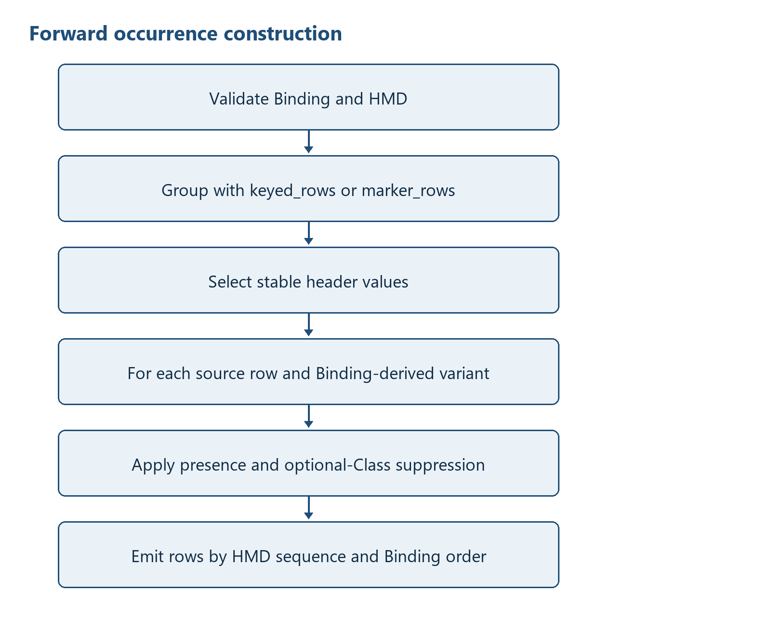
Figure 1 — Canonical forward grouping and occurrence decisions
Figure 2 illustrates canonical reverse row reconstruction. The numbered figure is referenced here as part of the implementation-level processing description.
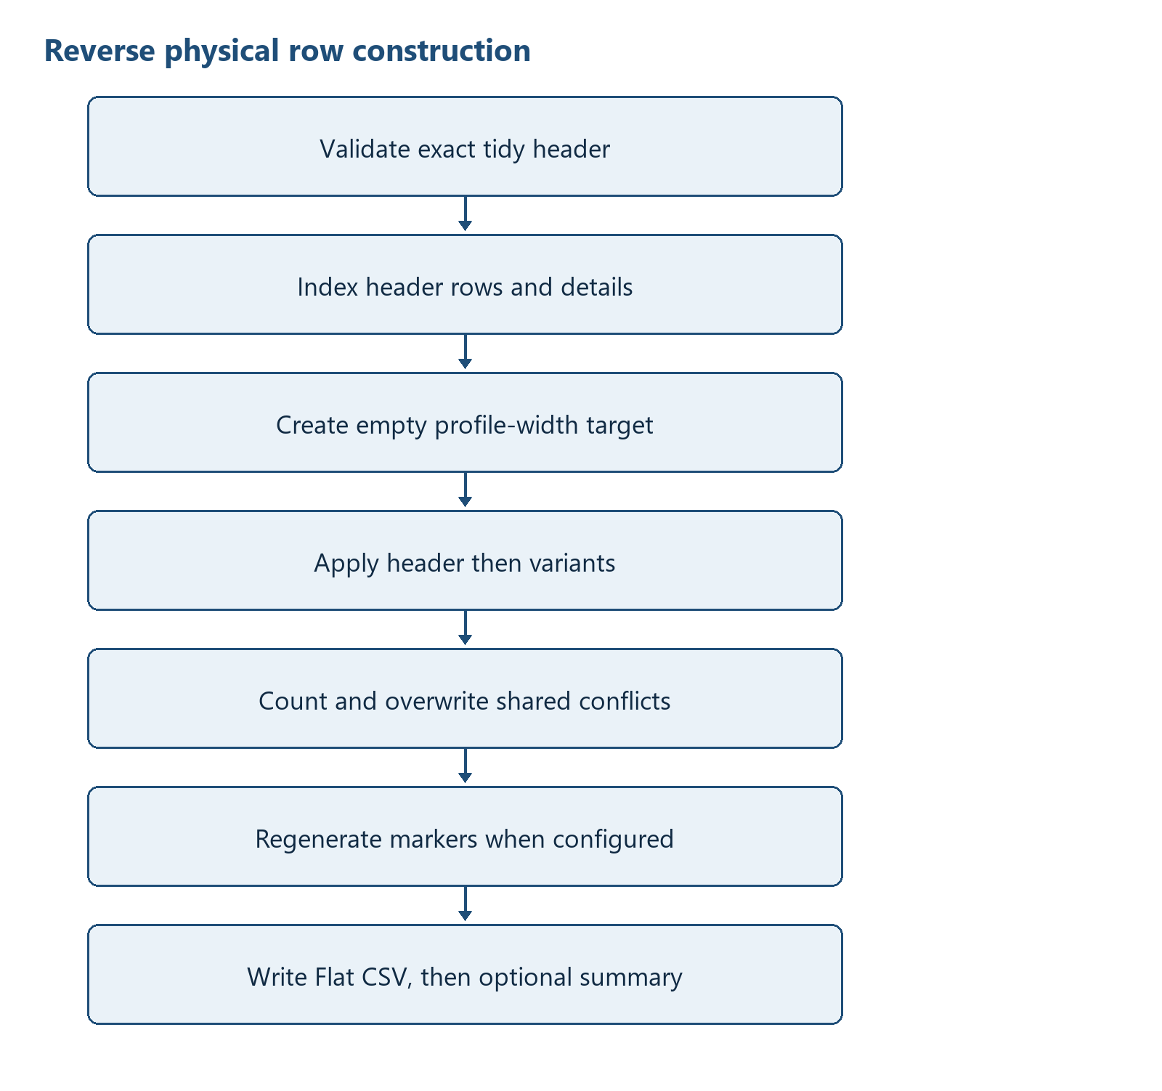
Figure 2 — Canonical reverse row reconstruction

13.1 Forward pseudocode
definition = load_binding + load_hmd + validate_definition
width = resolve exact profile width
source_rows = read rows; require every row to match width
groups = group_source_rows(source_rows, definition.group_spec)
enforce group and driver max_occurs when declared
emit ROOT rows
for entry_key, grouped_rows in groups:
select stable header source; emit HEADER rows
for source_index, source in grouped_rows:
for variant in Binding declaration order:
apply presence and optional-Class suppression
emit active rows by (HMD sequence, Binding order)
write exact STRUCTURED_FIELDS CSV

13.2 Reverse pseudocode
load and validate Binding/HMD
read exact STRUCTURED_FIELDS CSV
validate binding_path, semantic_path, sequence, occurrence and source_row
index HEADER rows by entry_key
index details by (entry_key, source_row)
for each detail identity ordered by source_row:
create an empty profile-width target
apply header then variants by rank, sequence and binding_path
reverse-transform and assign each non-empty C<n> value
count then overwrite a differing non-empty shared value
if marker_rows: regenerate controls and blank repeated headers
write headerless Flat CSV; optionally write value-free summary

13.3 Physical Flat CSV to HTD-D and HTD-CSV
HTD-D is the logical Hierarchical Tidy Data held during conversion. The current canonical Flat CSV engine does not instantiate an HTDData tree. BindingRow and GroupSpec objects define how hierarchy is derived, while records: list[dict[str, str]] holds the values that will become HTD-CSV. Unlike XML, the input has no nested nodes; hierarchy must be constructed from group controls, physical row ordinals and selector variants. Figure 3 shows this construction.
Figure 3 illustrates flat CSV to HTD-D and HTD-CSV construction. The numbered figure is referenced here as part of the implementation-level processing description.
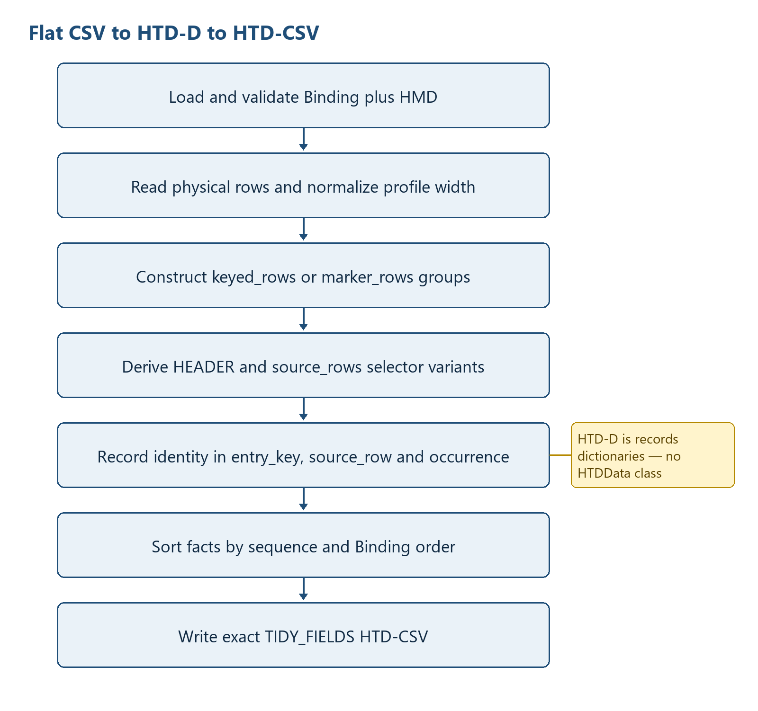
Figure 3 — Flat CSV to HTD-D and HTD-CSV construction

a) How HTD-D is recorded in the program
The control side consists of list[BindingRow], one GroupSpec, one source_rows driver, header/detail row subsets, a declaration-ordered variants list and variant_rows. The value side is records. Every record has the exact STRUCTURED_FIELDS keys: entry_key, source_row, occurrence, sequence, level, type, id, name, semantic_path, binding_path and value. entry_key identifies the header group; source_row retains the one-based physical input-row ordinal; occurrence is ROOT, HEADER or a selector-derived variant; semantic_path is selector-neutral for HMD identity; and binding_path retains the selector needed for the physical mapping. These explicit identity fields are the Flat CSV form of the HTD-D hierarchy.
HTD-D control = Definition(rows, GroupSpec, driver, variants, HMD sequence map)
HTD-D values = Structured CSV record dictionaries plus reverse header/detail indexes
detail identity = (entry_key, positive source_row, occurrence)
fact mapping = binding_path -> BindingRow.column; semantic_path -> HMD item

b) Physical Flat CSV read and processing order
convert_to_structured performs the following order:
load_binding reads the exact canonical 16-column Binding; load_hmd reads the HMD; validate_definition verifies physical-column uniqueness, HMD resolution and sequence equality, supported transformations, one header group and one source_rows driver.
The profile width is resolved from --profile-width or the highest bound/control C<n>; a non-positive width or a width smaller than the definition requirement is rejected.
csv.reader reads physical rows in file order. Every row must match the resolved width exactly.
Binding rows are partitioned into ROOT, HEADER and detail subsets; GroupSpec is parsed; shared rows and selector-derived variants are derived in Binding declaration order.
group_source_rows processes physical rows in source order and produces keyed_rows or marker_rows groups before any detail Structured CSV records are emitted.

c) Positioning physical values inside the HTD-D hierarchy
ROOT records use empty entry_key and source_row with occurrence=ROOT. For each group, keyed_rows reads the physical columns named by the Binding's group_key array, in the declared order, and serializes their values exactly as supplied, including empty strings, as a compact JSON array; marker_rows assigns a deterministic group ordinal after validating the single/start/continue/end state machine. That value becomes entry_key. _header_source selects stable header values across the group's physical rows and HEADER records use the group entry_key with an empty source_row.
Each physical row retains its one-based source_index. For every selector-derived variant in Binding declaration order, presence rows may suppress the variant. _active_rows suppresses optional Classes whose physical descendants are all empty. Remaining rows obtain a physical or default value through _value_for, apply the configured forward transformation, enforce required Attribute values, and are emitted with (entry_key, source_index, variant) as the detail identity.

d) HTD-D processing order when expanding to HTD-CSV
ROOT rows are emitted first, sorted by (HMD sequence, Binding order). Groups follow the first group appearance returned by group_source_rows. Within a group, HEADER rows are sorted by the same pair. Physical source rows retain their group order, variants retain Binding declaration order, and active occurrence rows are sorted by (HMD sequence, Binding order). records is therefore already in final HTD-CSV order and is not re-sorted at publication.
Table 11 summarizes flat csv htd-d to htd-csv ordering. The entries provide the implementation evidence used by the surrounding specification text.
Table 11 — Flat CSV HTD-D to HTD-CSV ordering
Ordering level | Implemented key/order | HTD-CSV effect
ROOT | (sequence, Binding order) | Document-level records first
Header groups | First keyed/marker group appearance | Stable entry_key blocks
HEADER facts | (sequence, Binding order) | Header records before detail records
Physical detail rows | Original source_index within group | Preserves physical row occurrence
Variants | First selector declaration order | Profile-defined sibling occurrence order
Facts within variant | (sequence, Binding order) | HMD order with deterministic tie-break

e) HTD-CSV file output
The output is opened directly with the selected output encoding and newline=''. csv.DictWriter writes the exact STRUCTURED_FIELDS header and then the records. With a profile pair, reviewed Account Mapping is applied before output and NTA extensions are emitted as HMD Subaccount facts. --unbound-report writes value-free positions of populated physical cells outside the HMD/Binding model. No temporary-file promotion, manifest or hash is produced. ConversionSummary includes profile, mapped and extended account occurrence counts, and ignored_hmd_undefined_cells.

13.4 HTD-CSV to HTD-D and physical Flat CSV
Reverse conversion rebuilds a logical HTD-D index from the explicit identity fields in HTD-CSV, then projects each detail identity into one fixed-width physical target row. Figure 4 shows the indexing, variant ordering, physical-column assignment, marker reconstruction and output sequence.
Figure 4 illustrates hTD-CSV to HTD-D and Flat CSV construction. The numbered figure is referenced here as part of the implementation-level processing description.
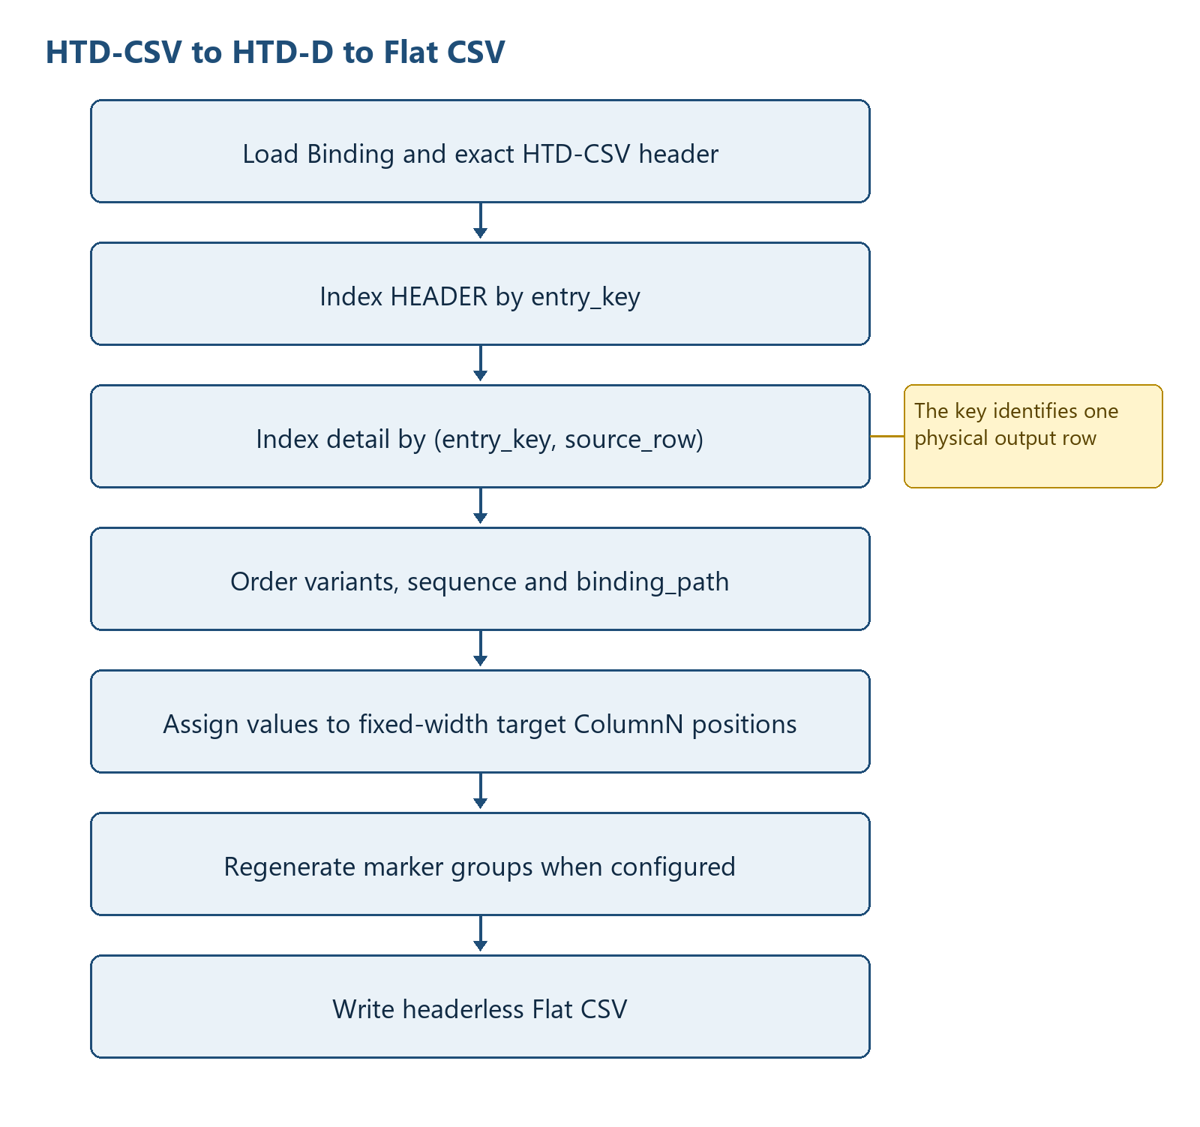
Figure 4 — HTD-CSV to HTD-D and Flat CSV construction

a) Reading HTD-CSV and positioning values in HTD-D
convert_to_flat loads and validates the Binding/HMD and, when --profile-dir is used, the same-prefix Account Mapping. Structured records are grouped by entry_key, source_row and occurrence. Account Identifier plus the account-subaccount suffix and target account name must resolve uniquely before values are changed back to application Account_Code and Account_Name. Mapping-generated Subaccount rows are then removed before the existing by_path, occurrence, sequence and physical reconstruction validation.

b) Processing HTD-D and expanding physical Flat CSV schema data
details items are sorted by source_row only; Python's stable ordering retains insertion order for equal source-row numbers across different entry keys. For each detail identity, target = [''] * profile_width creates the physical schema row. The ordered input to that target is the matching HEADER records followed by detail records sorted by (variant_rank[occurrence], integer sequence, binding_path). by_path resolves each record to one BindingRow, reverse transformation is applied, and BindingRow.column selects the one-based target list position.
Flat CSV grouping identity is recorded in three fields: entry_key identifies the header group, source_row identifies the physical row occurrence, and occurrence identifies the selector variant. keyed_rows derives entry_key from configured physical key columns; marker_rows derives a deterministic ordinal after validating its state machine. Reverse marker processing regroups by entry_key, blanks repeated header columns after the first row, and regenerates the configured single/start/continue/end controls.
header_values[entry_key] -> HEADER HTD records
details[(entry_key, source_row)] -> variant HTD records
for (entry_key, source_row) ordered by source_row:
target = [''] * profile_width
ordered = HEADER records + detail records sorted by
(variant rank, sequence, binding_path)
for record in ordered:
binding = by_path[record.binding_path]
target[n - 1] = reverse_transform(record.value)
output_records.append((entry_key, source_row, target))
if marker_rows:
regroup targets by entry_key and regenerate marker/header repetition rules
Table 12 summarizes flat csv group identity and physical-row generation. The entries provide the implementation evidence used by the surrounding specification text.
Table 12 — Flat CSV group identity and physical-row generation
Grouping information | Where recorded | Processing order | Physical effect
Header group identity | entry_key | Index and regroup key | Shares header fields and marker scope
Physical row identity | positive source_row | Primary reverse ordering component | Creates one fixed-width row
Sibling variant | occurrence and variant_rank | Binding declaration order | Determines profile-defined precedence
Fact-to-column mapping | binding_path -> BindingRow.column | After header/variant ordering | Assigns target[n - 1]
Shared-column conflict | target value + overwrite counter | Later non-empty ordered value wins | One physical value plus aggregate count
Marker reconstruction | entry_key + GroupSpec | After targets exist | Writes configured controls and blanks repeated headers

c) Physical Flat CSV file output
output_rows preserves output_records order and contains one list[str] of exactly profile_width cells for each reconstructed physical row. csv.writer writes the rows directly to the requested path with the selected output encoding and no header. If summary_log is supplied, the value-free overwrite summary is written after the Flat CSV. There is no atomic pair publication or rollback.

13.5 Flat CSV versus XML Syntax Binding hierarchy construction
Table 13 highlights why Flat CSV processing cannot reuse the XML traversal algorithm. Flat CSV must infer hierarchy from positional grouping controls and variants, whereas XML begins with an explicit node hierarchy and derives dimensions from repeated contexts.
Table 13 summarizes flat csv and xml hierarchy-construction differences. The entries provide the implementation evidence used by the surrounding specification text.
Table 13 — Flat CSV and XML hierarchy-construction differences
Aspect | Flat CSV canonical Binding | XML Syntax Binding
Physical address | One-based C<n> position plus Binding selector | XPath and namespace-aware Element context
Initial source structure | Headerless positional rows; hierarchy not explicit | Already hierarchical ElementTree
Hierarchy discovery | keyed_rows or marker_rows grouping plus source_rows driver | BindingClass recursion and repeated XML contexts
Occurrence identity | entry_key, source_row and selector-derived occurrence | Dimension column and one-based XML-context ordinal
Forward value container | records dictionaries with explicit identity fields | rows dictionaries scoped by dimension columns
Reverse physical builder | Fixed-width list[str] per (entry_key, source_row) | Element tree and ancestor-lineage occurrence-key context registry
Physical output order | Source-row/variant order and physical column index | syntax_sequence then UBL XSD child order

14 Condition and Decision Rules
Table 14 summarizes flat csv occurrence and decision rules. The entries provide the implementation evidence used by the surrounding specification text.
Table 14 — Flat CSV occurrence and decision rules
Rule | Current behaviour
Binding acceptance | Only the exact canonical 16-column header or the supported normalized legacy 17-column header is accepted; 13-column input receives UNSUPPORTED_LEGACY_BINDING and all other mismatches receive BINDING_HEADER_INVALID
keyed_rows identity | The selected Binding's ordered group_key C<n> array determines the key columns. For each source row, the runtime reads exactly those columns in the declared order and serializes the complete value array, including empty strings. Equal arrays identify the same group; unequal arrays identify different groups. No C<n> position is hard-coded or inferred.
marker_rows identity | Validated state-machine group ordinal
source_rows occurrence | Each physical row combines with each present selector-derived variant
Required value | Required Attribute values are checked during forward conversion
Default and presence | Defaults apply only when no column is bound; presence and optional-Class suppression prevent absent structures
max_occurs | Enforced for header group count and source rows per group when declared
Reverse shared conflict | Later non-empty value wins; aggregate column count only
Transformation | Accepted transformations are empty, jp_era_date_to_iso, iso_date_to_yyyymmdd, percentage_to_pure, and governed code_map:<name>

15 Data Structure Construction
Figure 5 illustrates canonical detail occurrence identity. The numbered figure is referenced here as part of the implementation-level processing description.
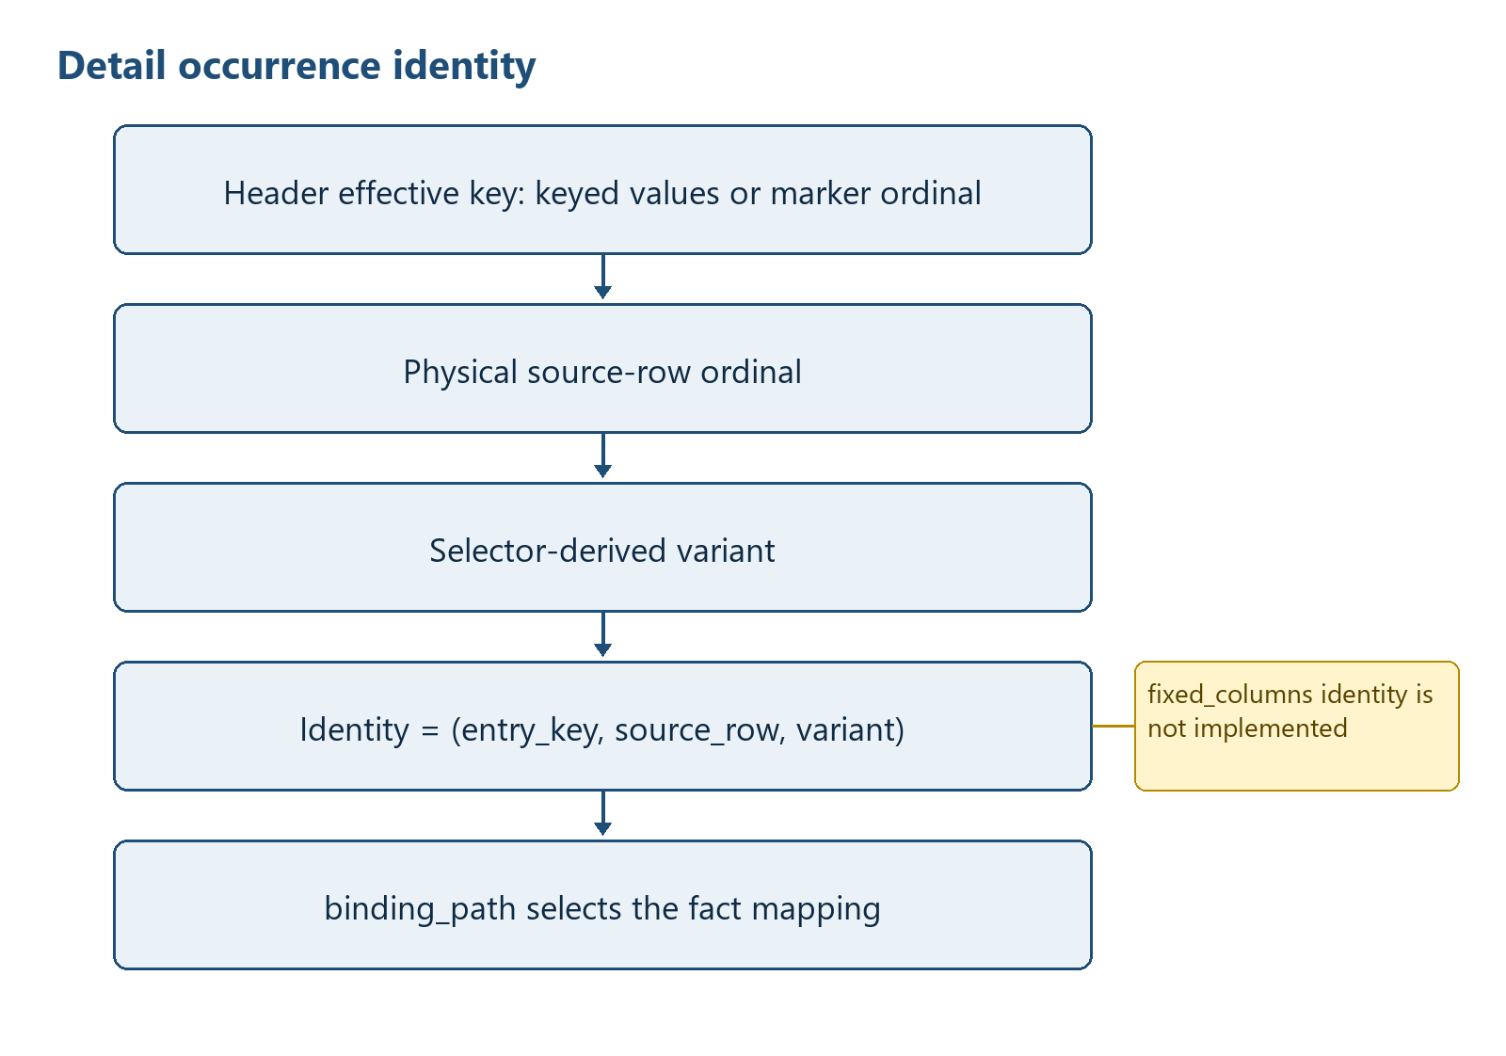
Figure 5 — Canonical detail occurrence identity

15.1 keyed_rows occurrence handling - current
For keyed_rows, the effective header identity is determined only by the group_key declaration in the selected Binding. group_key names one or more physical C<n> columns in an ordered JSON array. For each source row, the runtime reads those declared columns in array order and appends each value exactly as supplied. Empty string is an ordinary key value. The complete ordered value array is serialized deterministically and used as entry_key. Rows whose complete arrays are equal belong to the same header occurrence; rows whose arrays differ belong to different header occurrences. The runtime shall not add, remove, substitute, infer, or reserve any application-specific key column. Detail identity extends the header key with the original 1-based source-row ordinal and selector-derived variant.

15.2 marker_rows/source_rows handling - current
Marker groups are recognized by four distinct Binding-defined codes. source_rows creates a detail driver per physical row, while selector variants create sibling occurrences such as debit and credit. row_role=presence can suppress a variant. Reverse reconstructs marker codes from the number and position of rows in each entry group.

15.3 fixed_columns handling - recommended enhancement only
fixed_columns is not a supported occurrence_mode. max_occurs is nevertheless active for the supported header group and source_rows driver: excess groups or excess source rows in a group raise MAX_OCCURS_EXCEEDED.
Figure 6 illustrates recommended fixed_columns occurrence construction (not implemented). The numbered figure is referenced here as part of the implementation-level processing description.
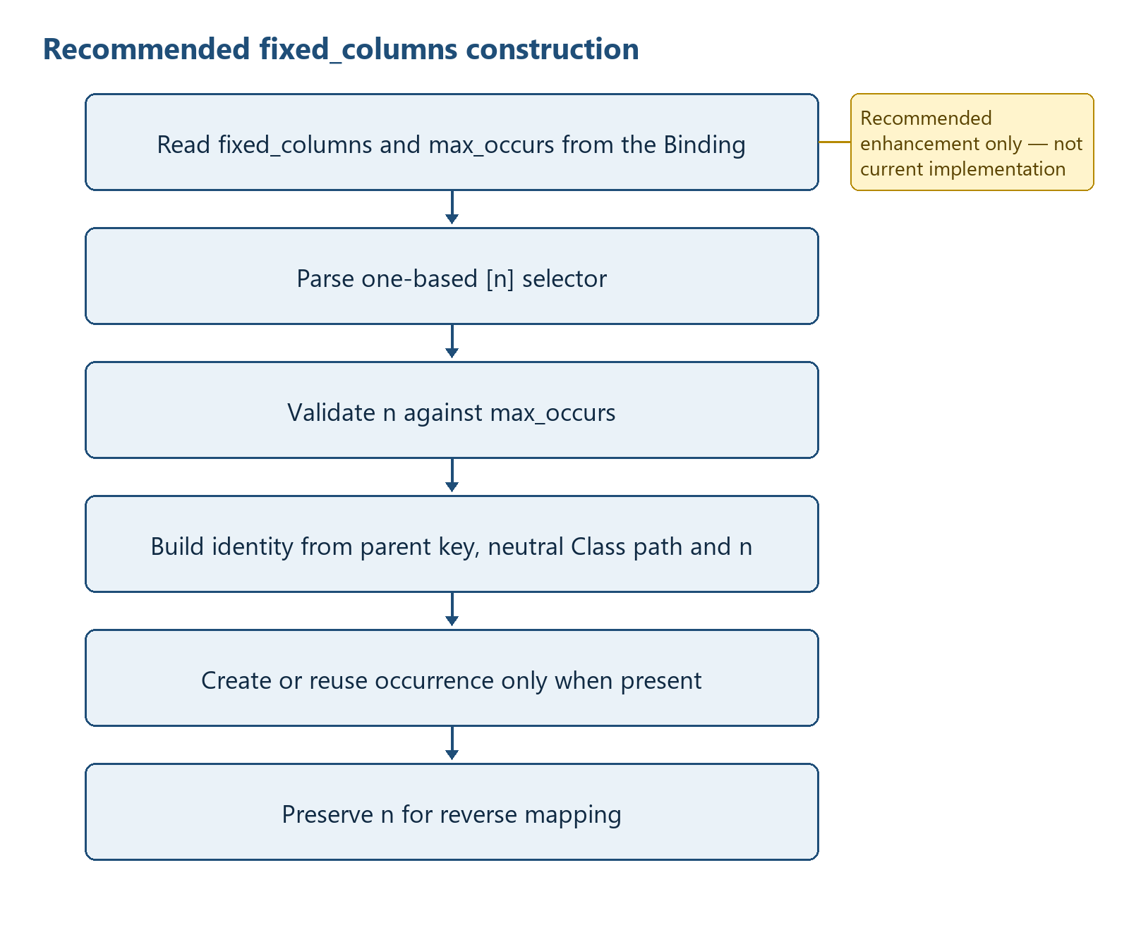
Figure 6 — Recommended fixed_columns occurrence construction (not implemented)
RECOMMENDED ONLY:
for each Class row with occurrence_mode == 'fixed_columns':
validate integer max_occurs > 0
for each descendant Attribute mapping:
parse [n] on the repeated Class segment
require 1 <= n <= max_occurs
neutral_path = path with selectors removed
identity = (parent_effective_key, neutral_class_path, n)
create/reuse identity only when a mapped source value (or permitted default) is present
persist n so reverse maps facts back to the same horizontal column group

16 Diagnostics and Error Handling
Table 15 summarizes flat csv diagnostics and publication consequences. The entries provide the implementation evidence used by the surrounding specification text.
Table 15 — Flat CSV diagnostics and publication consequences
Condition | Current mechanism | Exit/publication consequence
Binding or HMD I/O/encoding | ConversionError with value-safe definition message | main returns 2
Binding header mismatch | UNSUPPORTED_LEGACY_BINDING or BINDING_HEADER_INVALID | No conversion output; main returns 2
Definition/path/group/driver/limit validation | Classified ConversionError | No conversion output; main returns 2
Malformed marker sequence | MARKER_* ConversionError without source values | No output write has started
Required value or transformation value | Classified ConversionError without source value | No output write has started
Structured mapping mismatch | STRUCTURED_* ConversionError | No Flat CSV write has started
Shared-column conflict | Counter increment; no exception | Later value written; count-only summary
Unexpected exception | INTERNAL_ERROR without details | main returns 3
Success | No required console payload | main returns 0
Profile directory/pair mismatch | PROFILE_DIRECTORY_INVALID or PROFILE_PAIR_INVALID | main returns 2; no conversion output is accepted
Invalid or non-unique Account Mapping | ACCOUNT_MAPPING_* classified error | main returns 2; fails closed without source values
HMD-undefined populated cell | IGNORED_HMD_UNDEFINED report row | conversion continues; cell is excluded and not reconstructed
Unbound report write failure | UNBOUND_REPORT_IO_ERROR | main returns 2
Current diagnostics are classified ConversionError kinds with value-safe messages. Profile and mapping integration adds PROFILE_DIRECTORY_INVALID, PROFILE_PAIR_INVALID, ACCOUNT_MAPPING_HEADER_INVALID, ACCOUNT_MAPPING_ROW_INVALID, ACCOUNT_MAPPING_EXTENSION_INVALID, ACCOUNT_MAPPING_DUPLICATE, ACCOUNT_MAPPING_UNMAPPED, ACCOUNT_MAPPING_REVERSE_UNRESOLVED, ACCOUNT_MAPPING_AMBIGUOUS and UNBOUND_REPORT_IO_ERROR. There is still no severity catalogue or general diagnostics collection object.

17 File Publication and Transaction Control
Current behaviour: both directions construct their output records in memory and then write the requested final file directly. Optional summary JSON is written after the CSV. The converter does not implement temporary-file promotion, atomic multi-file publication, rollback, manifest creation or SHA-256 generation.
Recommended enhancement: Validate all inputs and construct outputs before opening final targets; write output and summary to temporary siblings; validate counts/encoding; replace finals in a defined order; document recovery of a partially replaced pair. This recommendation is not current implementation.

18 Test and Requirement Traceability
Table 16 summarizes flat csv requirement and test traceability. The entries provide the implementation evidence used by the surrounding specification text.
Table 16 — Flat CSV requirement and test traceability
Requirement | Evidence | Recorded result
Syntax | python -m py_compile flat_csv.py | PASS
Definition and negative tests | pre-public-validation/programs/flat-csv/tests | PASS: 20
PCA synthetic 81-column | test_canonical_roundtrip.py | PASS: forward, reverse, byte-exact round trip and two-run determinism
Yayoi synthetic 25-column CP932 | test_yayoi_25_roundtrip.py | PASS: marker, presence, date transform, round trip and determinism
Generic synthetic regression | test_generic_journal_entry_roundtrip.py | PASS: Binding-driven Column3 and LEFT/RIGHT variants
Shared-column conflict | PCA synthetic negative case | PASS: later non-empty value and Column27 count 1 without values
Invalid markers | definition/negative suite | PASS: unknown, orphan, nested and unclosed controls rejected
Binding rejection | definition/negative suite | PASS: missing/extra/reordered headers and 13-column Binding rejected
Real accounting data | scope control | NOT USED
Overall | 23 tests plus syntax compile | PASS
Profile pair integrity | Task 20260904_1402 negative same-prefix/missing/duplicate checks | PASS
PCA profile runtime roundtrip | 438 rows; 246 vouchers; semantic differences 0; 5,676 HMD-undefined cells; two-run hashes | PASS
EPSON R4 2022-07 runtime roundtrip | 112 rows; 78 vouchers; 43 columns; CP932/CRLF/header; semantic differences 0; 901 HMD-undefined cells; two-run hashes | PASS

19 Known Limitations
- Exactly one keyed_rows or marker_rows header group and exactly one source_rows driver are required.
- Multiple nested keyed groups and multiple independent drivers are not supported.
- fixed_columns is unsupported; max_occurs applies only to the supported header group and source_rows driver.
- Duplicate non-empty HMD semantic_path values are rejected.
- Selector removal uses a broad regular expression and does not parse nested brackets.
- Variant extraction handles the first predicate immediately below the driver and only simple equality reliably.
- Reverse output_records are sorted primarily by source_row ordinal, not explicitly by entry group order; identical ordinals across groups can interleave stably according to dictionary construction.
- Unknown Structured CSV occurrence values are rejected; ROOT rows are validated but are not projected into physical columns by reverse conversion.
- Required checks cover forward Attribute rows only; datatype validation is limited to registered transformations.
- debug and trace are accepted CLI flags but do not change conversion processing in the current runtime.
- ConversionError is reported to stderr with process status 2; unexpected failures use a value-free INTERNAL_ERROR message and status 3.
- No atomic publication, rollback, manifest, or hash generation exists.

19.1 HMD boundary and profile-bound Account Mapping
Flat CSV Binding is defined against the HMD. If a source CSV column contains data but no corresponding semantic element is defined in the HMD, that data is outside the Structured CSV semantic model and is not preserved through Structured CSV roundtrip conversion. If such data must be preserved, the corresponding semantic element must first be defined in the HMD and then mapped in the applicable application/version/interface Binding.
Normative requirement: Flat CSV mappings are defined against the HMD. If an input CSV contains a value for which no corresponding semantic element is defined in the HMD, that value is outside the Structured CSV semantic model; it is not preserved during conversion to Structured CSV and cannot be restored during reverse conversion. Data that must be preserved through a round trip must first be defined as a semantic element in the HMD and then mapped in the Binding for the applicable application, version, and interface.
Figure 7 shows the implemented boundary: only HMD-defined facts enter Structured CSV, while populated unbound cells follow IGNORE + REPORT and are not reconstructed. HTD-D physical retention, sidecar JSON and passthrough are not used.
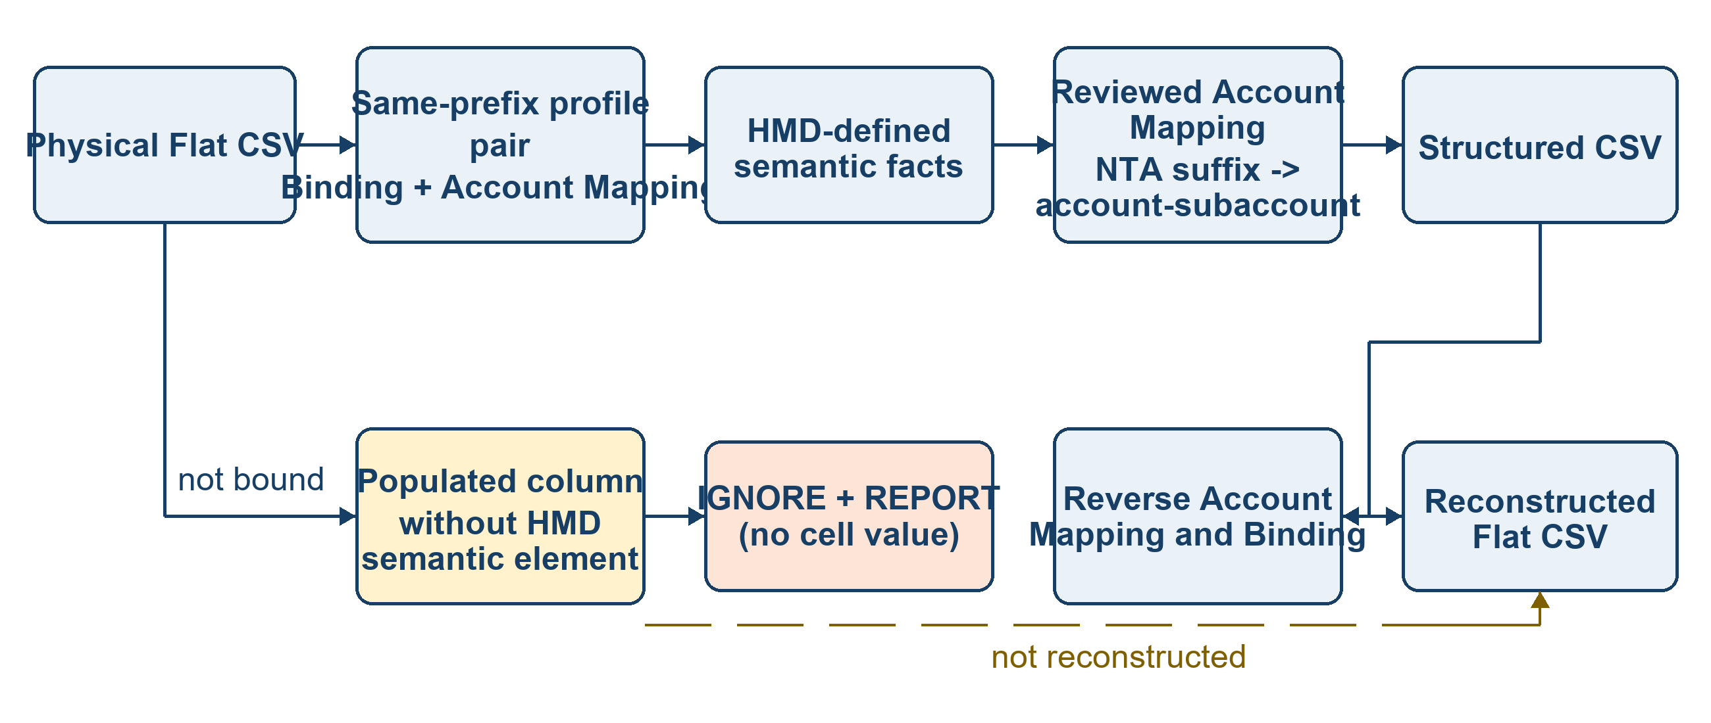
Figure 7 — Profile-bound semantic roundtrip and HMD-undefined reporting
Table 18 defines the exact current behavior, including the profile loading boundary, NTA extension construction, reverse uniqueness and accepted PCA/EPSON evidence.
Table 18 — HMD-undefined and Account Mapping runtime contract
Rule | Current implementation | Decision / invariant | Evidence or consequence
Semantic boundary | Binding semantic_path must resolve to HMD | No HMD element means no Structured CSV fact | Unbound populated values are excluded
Unbound policy | _write_unbound_report counts and optionally writes six fields | IGNORE + REPORT; no source cell value in report | PCA 5,676; EPSON 901
Profile loading | --profile-dir loads exact same-prefix pair | Binding and mapping from different profiles cannot be combined | PROFILE_PAIR_INVALID
Forward mapping | Account_Code + Account_Name lookup | Reviewed CSV data only; no hard-coded vendor map | Unmapped account fails closed
NTA extension | base-n becomes Account Identifier base plus account-subaccount ID n | Suffix is an HMD Subaccount fact | PCA 208; EPSON 72 extended occurrences
Reverse mapping | Target code + suffix + target name lookup | Must resolve uniquely before physical reconstruction | Ambiguous/unresolved mapping fails closed
Semantic acceptance | Bound physical columns compare after roundtrip | Differences, unmapped and ambiguous must all equal zero | PCA and EPSON PASS
Remaining scope | EPSON tax mapping and actual application import | Separate production HOLD; does not invalidate account semantic PASS | Canonical promotion recommendation may be YES while production remains HOLD

19.2 Accepted runtime evidence and remaining limitations
PCA_Accounting_81col passed with 438 rows, 246 vouchers, zero semantic differences, zero unmapped accounts, zero ambiguous reverse mappings, balanced voucher totals and deterministic output. EPSON_ZaimuKaikeiR4_43col for 2022-07 passed with 112 rows, 78 vouchers, 43 columns, CP932, CRLF, a header row, the same zero semantic defects and deterministic output. HMD-undefined counts are known limitations and not Canonical promotion blockers.
Known limitation: profile-bound Account Mapping is validated for the canonical 11-column Structured CSV route. Reverse ingestion of OIM/XBRL-CSV facts for mapping-generated account-subaccount rows is not covered by this integration. EPSON governed tax mapping and actual EPSON application import remain HOLD. File output remains direct and non-atomic as described in Section 17.
The reproducible source for Figure 7 is research/pre-public-validation/diagram-sources/FLAT_CSV_PROFILE_HMD_BOUNDARY_FIGURE_7.dot.

- Exact schemas
CANONICAL_FIELDS = ('sequence', 'level', 'type', 'name', 'datatype', 'multiplicity', 'column', 'semantic_path', 'occurrence_mode', 'group_key', 'row_role', 'max_occurs', 'default_value', 'transformation', 'required', 'note')

STRUCTURED_FIELDS = ('entry_key', 'source_row', 'occurrence', 'sequence', 'level', 'type', 'id', 'name', 'semantic_path', 'binding_path', 'value')
- Function and method inventory
Table 17 summarizes flat csv detailed function inventory. The entries provide the implementation evidence used by the surrounding specification text.
Table 17 — Flat CSV detailed function inventory
Module | Function/method | Line | Signature
flat_csv.py | BindingRow.sequence / level / path / neutral_path / max_occurs / is_required | 141 | typed properties
flat_csv.py | ConversionSummary.as_dict | 238 | self -> dict[str, object]
flat_csv.py | module.load_binding | 435 | path, encoding -> list[BindingRow]
flat_csv.py | module.load_hmd | 512 | path, encoding -> dict[str, int]
flat_csv.py | module.validate_definition | 519 | rows, hmd_sequences, hmd_rows=None, code_maps=None -> Definition
flat_csv.py | module.group_source_rows | 947 | source_rows, GroupSpec -> grouped rows
flat_csv.py | module.convert_to_structured | 1749 | ConversionOptions -> ConversionSummary
flat_csv.py | module.convert_to_flat | 2317 | ConversionOptions -> ConversionSummary
flat_csv.py | module.write_summary | 2456 | Path, ConversionSummary -> None
flat_csv.py | module.parse_args | 2475 | argv -> argparse.Namespace
flat_csv.py | module.main | 2597 | argv -> int
flat_csv.py | module.load_profile_pair | 699 | Path -> ProfilePair
flat_csv.py | module.load_account_mapping | 720 | Path, encoding -> AccountMapping
flat_csv.py | module._apply_account_mapping_forward | 1248 | records, mapping, Definition -> records and counts
flat_csv.py | module._apply_account_mapping_reverse | 1313 | records, mapping -> records and counts
flat_csv.py | module._write_unbound_report | 1703 | options, Definition, source rows, groups -> int

- Saved diagram sources
Figure 7 source: research/pre-public-validation/diagram-sources/FLAT_CSV_PROFILE_HMD_BOUNDARY_FIGURE_7.dot

- Specification Accepted on 2026/9/15
This section defines the current specification and takes precedence over earlier candidate descriptions and descriptions specific to the former 17-column format elsewhere in this document. It distinguishes design decisions, implemented behavior, and the validated scope. Arelle conformance does not constitute acceptance of complete accounting-information preservation or import into an actual application.
Category | Current Status
Design Decision | The canonical PCA/EPSON Binding uses 16 columns in a fixed order. The former 17-column form is accepted as compatibility input. Semantic identity is the selector-qualified semantic_path; selectors are removed for HMD resolution. The Binding does not contain an id column.
Implemented | tools/binding/flat_csv.py reads the 16-column CANONICAL_FIELDS and the 17-column LEGACY_17_FIELDS, validates the HMD semantic_path and sequence, definition tables, grouping, and tax and account mappings, and performs bidirectional conversion.
Validated | The accepted formal PCA and EPSON xBRL-CSV instances contain 130,807 and 134,281 facts, respectively, and pass Arelle 2.37.77 validation with 0 errors and 0 warnings. Each AE and BT Tuple/OIM entry point also passes with 0 errors and 0 warnings.
Unresolved | The following remain unresolved: tax-amount facts are not preserved for explicitly stated EPSON tax amounts totaling JPY 141,601,937 across 3,490 detail lines; EPSON-to-PCA conversion reports TAX_POLICY_AMBIGUOUS; and EPSON account registration and import into the actual application have not been verified.
  - Identifiers in the Binding and Structured CSV
The 16-column Binding order is sequence, level, type, name, datatype, multiplicity, column, semantic_path, occurrence_mode, group_key, row_role, max_occurs, default_value, transformation, required, note. The former 17-column form includes id after type and is normalized for compatibility when read. Do not restore id to newly created PCA/EPSON Bindings.
Removal of id from the Binding and the id column in Structured CSV are separate contracts. The Flat CSV runtime retains the following 11 Structured CSV columns: entry_key, source_row, occurrence, sequence, level, type, id, name, semantic_path, binding_path, value. An empty Structured CSV id does not, by itself, indicate a conversion defect. Do not populate it from HMD id, source_bsm_id, or identifier.
  - Taxonomy and Validation Entry Points
The project module namespace is https://www.xbrl.or.jp/taxonomy/xbrl-gl-next/{module} for the applicable module. Accounting Entries and Business Transactions are split DTSs generated from different root HMDs. The type, structure, and multiplicity differences in 14 shared declarations are accepted root-HMD-specific structural differences; exact equality between AE and BT is not required. Consumers select the corresponding AE or BT entry point and must neither overwrite same-named files nor combine both DTSs unconditionally. Integration into a single DTS is outside the accepted scope.
  - Structured CSV, Formal xBRL-CSV, and LedgerExplorer
Artifact | Role and Acceptance Boundary
Structured CSV | Long-form or hierarchical data for conversion and review, containing semantic_path and occurrence/dimension information. Do not submit this data itself to Arelle in place of formal xBRL-CSV metadata.
Formal xBRL-CSV | Use the JSON metadata as the entry point and validate the referenced CSV together with the DTS identified by documentInfo.taxonomy. Use Arelle to determine conformance of QNames, concepts, datatypes, entities, periods, units, and dimensions.
LedgerExplorer | A separate consumer that uses the corresponding Cn Structured Tidy input contract. Accepted Phase 1 screen evidence exists, but it does not automatically establish acceptance of an actual connection to the latest PCA/EPSON versions or verification of all screens.
  - Flat CSV Definition-Table Contracts
Definition | Location | Role and Column Specification
Binding | bindings/flat-csv/<profile>/<profile>_BINDING.csv | Defines semantic C<n> mappings, semantic_path, occurrence rules, group_key, defaults, transformations, and required values. For keyed_rows, group_key is an ordered JSON array of the physical C<n> identifiers chosen by that profile; the runtime assigns no fixed key columns. The canonical format has 16 columns; the former 17-column format is supported for compatibility.
Account Mapping | *_ACCOUNT_MAPPING.csv for the Same Profile | Account_Code, Account_Name, Category, eTax_Account_Code, eTax_Account_Name, eTax_Category. Defines account mappings and conversion of <base>-<suffix> into an account-subaccount structure.
Standard Tax Mapping PCA | *_STANDARD_TAX_MAPPING.csv for the PCA Profile | profile_version, application_tax_code, application_tax_name, transaction_classification, return_flag, uncl5153_tax_type, tax_type_placement_status, uncl5305_tax_category, tax_rate_ratio, reverse_priority, mapping_status, source_status, note。
Standard Tax Mapping EPSON | *_STANDARD_TAX_MAPPING.csv for the EPSON Profile | profile_version, application_tax_code, rate_pattern, rate_output, transaction_classification, uncl5153_tax_type, tax_type_placement_status, uncl5305_tax_category, tax_rate_ratio, tax_inclusion_mode, reverse_priority, mapping_status, source_status, note。
Account Tax Mapping | *_ACCOUNT_TAX_MAPPING.csv for the Applicable Profile | source_account_code, source_account_name, application_tax_code, tax_type, tax_category, note. Explicitly classifies non-VAT accounts, such as corporate tax accounts, and does not infer a breakdown.
Code Mapping | Governed Code Map Referenced by the Binding | map_name, semantic_value, physical_value. Defines the code_map:<name> transformation.
Column/Profile Definition | Profile-Specific *_COLUMNS.csv or Equivalent | Defines the physical interface C<n> inventory, width and header labels independently of semantic facts. The current runtime can load a separate column,name file with --columns-file. Compatible inline type=P header declarations may also be accepted, but new semantic Bindings need not embed the physical header inventory.
  - Tax Conversion
- Select the Standard Tax Mapping using the combination of the application tax code and the tax-rate pattern, and output the tax rate to TaxPercentageRate as a ratio of 0.10 or 0.08. Do not treat a missing value as equivalent to TaxCategory O.
- taxTransactionClassification is Purchase or Sales; taxType is VAT or OTH; for VAT, TaxCategory is UNCL 5305 S, AA, E, or O; TaxPercentageRate is the applicable rate; and AmountofTaxes is the input tax amount. Preserve these as separate facts. Do not recalculate and overwrite the tax amount from the rate.
- Account Tax Mapping classifies corporate tax and similar taxes as taxType OTH with a project-specific tax_category. Do not force them into a UNCL 5305 VAT category.
- Preserve the PCA return_flag in the tax trace as an explicit value from the tax mapping table. The current implementation does not infer returns from account attributes and debit/credit information alone. Return identification during reverse conversion based on account attributes and debit/credit information is not implemented; do not resolve TAX_POLICY_AMBIGUOUS by making an arbitrary choice.
  - Physical-Row Materialization for Compound Journal Entries
Pattern | Accepted Processing | Relationship to Original Row Structure
1:1 | Places 1 debit occurrence and 1 credit occurrence in 1 physical row. | Uniquely reconstructs the corresponding semantic values and physical row.
N:1 | Splits and copies a single credit amount across multiple debit amounts so that each generated row is balanced. | The resulting row arrangement may differ from the original compound voucher. Evaluate equivalence using semantic facts, amounts, and voucher boundaries.
1:N | Splits and copies a single debit amount across multiple credit amounts so that each generated row is balanced. | The resulting row arrangement may differ from the original compound voucher.
N:M | ordered_cumulative_pairing closes cumulative matching blocks in input order. It uses a unique amount, an aggregate split, or another preservable correspondence, and fails closed on ambiguity, an unclosed block, or a semantic conflict in a shared column. | Can be materialized as normalized 1:1 rows; restoration of the original compound-row structure is not an acceptance criterion.
Assess round-trip equivalence within the scope that the applicable profile defines as preserved: Binding-targeted semantic_path values and occurrences, vouchers and dates, debit/credit information, accounts, subaccounts and trading partners, taxes, amounts, and descriptions. Treat physical columns not represented in the HMD/Binding as IGNORE + REPORT; do not pass their values silently into Structured CSV. When materialization does not restore the original row structure, do not require byte-for-byte row equality; verify semantic facts, debit/credit balance, totals, voucher boundaries, and fail-closed diagnostics.
  - Implementation Functions and Diagnostic Boundaries
Function | Current Implementation | Primary Failure Conditions
Binding Loading | load_binding | BINDING_HEADER_INVALID、UNSUPPORTED_LEGACY_BINDING
HMD Resolution | load_hmd_rows／validate_definition | HMD_PATH_UNRESOLVED、BINDING_HMD_SEQ_PATH_MISMATCH
Account Mapping | load_account_mapping / forward and reverse mapping | ACCOUNT_MAPPING_UNMAPPED、ACCOUNT_MAPPING_AMBIGUOUS
Tax Normalization | Standard Tax／Account Tax／trace | TAX_MAPPING_AMBIGUOUS、TAX_POLICY_UNRESOLVED、TAX_POLICY_AMBIGUOUS
Compound Materialization | _materialize_compound_entries＋aggregate_pairing | COMPOUND_PAIRING_UNRESOLVED、MATERIALIZATION_SEMANTIC_CONFLICT

2026-09-27 keyed_rows blank-value and physical-header clarification
For keyed_rows, the Binding interpretation is normative: group_key is an ordered JSON array of physical C<n> identifiers chosen by that Binding. The runtime resolves exactly those declared columns for each source row and constructs entry_key from their values in the same order. Empty strings are retained as ordinary values; no missing-value surrogate or application-specific fallback is introduced. The specific C<n> identifiers are profile data, not a program rule. Physical interface width and header labels are likewise profile definitions and may be supplied by a separate columns definition; compatible inline physical-header declarations remain supported where present.
- Revision History
Revision Date | Description
15 September 2026 | Aligned with the canonical 16-column Binding, definition tables, tax processing, compound journal entries, formal xBRL-CSV, the stable namespace, the AE/BT split, and known issues.
27 September 2026 | Clarified keyed_rows as a generic Binding interpretation rule: group_key selects an ordered set of physical C<n> columns, whose source values (including empty strings) form the complete key. No application-specific key columns are normative. Also aligned physical interface width/header description with the separate columns definition supported by the current runtime.

