UADC — Universal Adapter for Data Conversion

— Program Specification: Flat CSV
Document status: Draft — For Collaborative Review
Date: 2026-08-16
Author: Nobuyuki SAMBUICHI
Role: UADC project editor and implementation reviewer
Project: UADC
Distribution: Private project repository — invited participants only
This document is a draft under development by Nobuyuki SAMBUICHI for collaborative review within the UADC project. It is shared through a private project workspace with invited participants. It has not been approved or endorsed as an official specification by XBRL Japan, XBRL Europe, XBRL International, or any other organization.
Copyright and license terms are defined by the UADC project licensing files.
Repository version: private collaborative review draft; WORK implementation snapshot.
Editors: SAMBUICHI, Nobuyuki
Contributors: invited project participants (individual names not yet confirmed for publication).

Status
Current implementation: The canonical implementation is private/legacy_sources/accounting/programs/flat_csv_canonical.py, dispatched only when csv2tidy.py or tidy2csv.py sees the exact 17-column header. The legacy positional routes remain separate. The canonical engine implements keyed_rows, marker_rows and one source_rows driver. It does not implement fixed_columns occurrence construction.

Abstract
The current canonical path converts a headerless physical CSV profile to a canonical tidy CSV and reverses it. Binding rows provide physical ColumnN identities, HMD semantic paths, selectors, grouping modes, group keys, variant roles, defaults, reversible transformations, and required flags. Runtime identity is explicit: entry_key plus source-row ordinal plus selector-derived variant.

1 Purpose and Scope
- In scope: csv2tidy.py and tidy2csv.py dispatch; flat_csv_canonical.py validation, grouping, occurrence construction, reverse mapping and summary output.
- In scope: anonymous 81-column keyed_rows profile and 25-column marker_rows profile; tests use synthetic data, with private real-data results reported only as counts.
- Retained legacy route is inventoried but is not treated as the canonical 17-column implementation.
- fixed_columns is documented as a Transformation Table concept and recommended enhancement only; no current processing branch implements it.

2 System Context
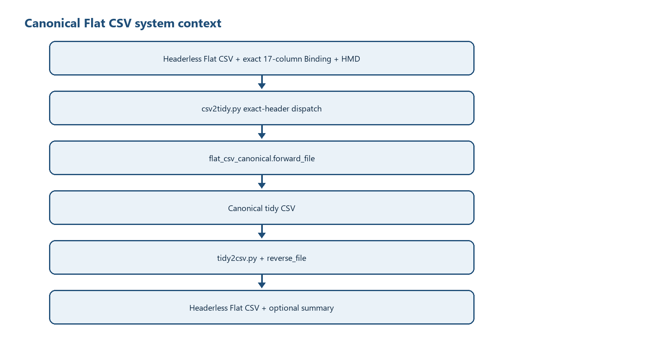
Figure 1 - Current canonical Flat CSV context
Responsibility boundary: The Binding determines physical-column meaning and grouping. The HMD supplies neutral semantic paths and sequence. The program does not infer business semantics from labels and does not map between different HMDs.

3 Processing Overview
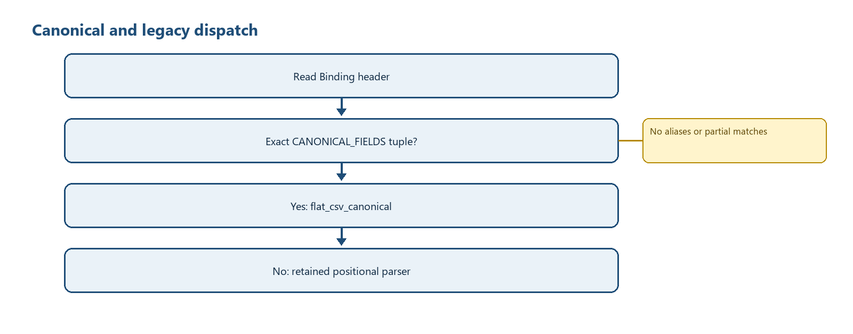
Figure 2 - Exact-header dispatch and legacy separation
Path | Selection | Main object model | Result
Canonical forward | Exact CANONICAL_FIELDS tuple | list[BindingRow], GroupSpec, source row lists, tidy record dicts | TIDY_FIELDS CSV
Canonical reverse | Exact CANONICAL_FIELDS tuple | Binding path index, header/detail defaultdicts, target column lists | Headerless Flat CSV plus optional summary
Legacy forward | Any other header | StructuredCSV hierarchy dictionaries/lists | Legacy tidy CSV and JSON metadata
Legacy reverse | Any other header | ReverseDataProcessor nested dict/list | Legacy proprietary CSV

4 Runtime Arguments
Argument | csv2tidy.py | tidy2csv.py | Current effect
inFile | required Flat CSV | required tidy CSV | Resolved relative to script directory unless absolute by file_path rules
-o / --outfile | required tidy output | required Flat output | Direct final-path write
-m / --lhm_file | required | required | Definition encoding uses --encoding
-b / --binding_file | required | required | Exact header controls dispatch
-e / --encoding | utf-8-sig | utf-8-sig | Binding/HMD/tidy default encoding
--input-encoding | optional | not present | Physical forward input encoding only
--output-encoding | not present | optional | Physical reverse output encoding only
--profile-width | optional | optional | Pads/reconstructs headerless row width; must not be below max bound ColumnN
--summary-log | not present | optional | JSON aggregate overwrite summary; no accounting values
-t / --trace | flag | flag | Used by retained legacy route; canonical functions do not consult TRACE
-d / --debug | flag | flag | Used by retained legacy route; canonical functions do not consult DEBUG

5 Input File Specification

5.1 Physical Flat CSV
- Headerless rows read with csv.reader.
- Width equals --profile-width or the highest bound ColumnN.
- Rows shorter than width are padded with empty strings; rows longer than width are rejected.
- Forward physical encoding is --input-encoding when supplied, otherwise --encoding.

5.2 Exact 17-column Binding
Column | Current use
sequence | Integer HMD sequence; exact equality to HMD required
level/type/id/name/datatype/multiplicity | Copied to tidy records; type and level drive selected validation/processing
column | Unique ColumnN physical identity
semantic_path | Selector-preserving binding_path; selectors removed for HMD lookup
occurrence_mode | One header group keyed_rows or marker_rows; exactly one source_rows driver
group_key | JSON ColumnN array for keyed_rows or exact five-key object for marker_rows
row_role | driver, presence, group or blank; driver/presence affect processing
max_occurs | Loaded but not used by current canonical engine
default_value | Used when column is blank on a Binding row
transformation | Empty or jp_era_date_to_iso
required | Truthy required Attribute values are checked in forward
note | Loaded/copied only; no execution effect

5.3 HMD
csv.DictReader builds semantic_path -> integer sequence. Each Binding neutral_path must exist and match its sequence. Duplicate HMD semantic paths would be overwritten by the dictionary; the loader does not separately diagnose duplicates.

5.4 Canonical tidy reverse input
The header must exactly equal TIDY_FIELDS: entry_key, source_row, occurrence, sequence, level, type, id, name, semantic_path, binding_path, value.

6 Output File Specification
Output | Fields/shape | Ordering
Canonical tidy CSV | Exact TIDY_FIELDS | ROOT rows; each entry HEADER rows; per source row each variant in Binding declaration order; within block sequence/order
Flat CSV | Headerless list of profile_width cells | details sorted by source_row ordinal; grouping order is not explicitly part of sort key
Summary JSON | profile width, source row count, per-column overwrite counts and total | Keys sorted; no values or row identities
Console | Counts and aggregate overwrite dictionary | Printed by entry points

7 Internal Data Model
Structure | Type | Key/identity | Output effect
BindingRow | frozen dataclass | order plus values dict; path property | One row's metadata/value mapping
GroupSpec | frozen dataclass | mode and keyed/marker configuration | Groups source rows and regenerates markers
binding | list[BindingRow] | Binding file order preserved | Variant declaration order and stable tie-break
source_rows | list[list[str]] | 1-based enumerate ordinal | Physical row identity
entry_key | compact JSON string | keyed values or ['marker', group ordinal] | Header/detail association
records | list[dict[str,str]] | entry_key + source_row + occurrence + binding_path | Canonical tidy rows
by_path | dict[str,BindingRow] | selector-preserving binding_path | Reverse lookup
header_values | defaultdict(list) | entry_key | Header fields copied into each physical row
details | defaultdict(list) | (entry_key, int(source_row)) | One target Flat row per key
target | list[str] | ColumnN -> index N-1 | One headerless output row
overwrite_counts | Counter[str] | physical column | Value-free completion summary

8 Class Specification
Class | Responsibility | Owned state | Invariant
BindingRow | Expose sequence, selector path and neutral HMD path | order; values dict | sequence converts to int; neutral path strips every [..] segment
GroupSpec | Represent keyed or marker group settings | columns or marker codes | marker codes are four distinct non-empty strings
StructuredCSV (legacy) | Build legacy hierarchical dictionary/list model | binding/semantic dictionaries, hierarchy and tidy_data | Not used in canonical exact-header route
DataProcessor (legacy) | Flatten legacy nested structures | record/line state | Not used in canonical route
ReverseDataProcessor (legacy) | Restore and flatten legacy tidy data | binding and reconstructed data | Not used in canonical route

9 Object Specification
Object | Creation | Identity / reuse | End state
Header occurrence | _group_sources | entry_key; one selected header-source projection per group | HEADER tidy records
Detail occurrence | forward nested loops | entry_key + physical source-row ordinal + selector-derived variant | One ordered record block
Optional Class occurrence | _active_occurrence_rows | Class path under current detail occurrence | Suppressed when all physical descendants are blank
Reverse physical row | reverse loop | (entry_key, source_row) | profile_width list serialized once
Shared physical cell | reverse assignment | ColumnN in one target list | Later non-empty different value wins; aggregate count increments

10 Collection and List Specification
Collection | Ordering | Uniqueness | Mutation
physical columns | Binding order | Non-empty ColumnN must be unique | Validated only
variants | First appearance below driver | No duplicate variant strings | Appended on first discovery
grouped keyed rows | First key appearance and source input order | Same key reuses list | setdefault append
marker groups | Input order | Synthetic ordinal key per completed group | state-machine append
records | Explicit block order | Duplicate semantic facts allowed when identities differ | append
output_records | Built from sorted details | one per details key | append

11 Variable and State Specification
State | Initial value | Transitions | Failure condition
current marker group | None | start -> list; continue append; end -> emit/None | nested, continuation/end without start, unclosed EOF, unknown marker
width | profile_width or max bound | constant after validation | below max binding or source row too wide
selected header source | first grouped row copy | one stable non-empty value per header column | more than one distinct non-empty value
suppressed Class paths | empty list | append optional Class whose physical descendants are all blank | No error; Class and descendants omitted
target cell | empty | assigned in header then variant order | No failure on conflict; count and overwrite

12 Function Specification
Function | Input -> result | Decisions and side effects
is_canonical_binding | path/encoding -> bool | Exact first-row tuple equality; no fuzzy aliases
load_binding | Binding + HMD -> list[BindingRow] | Validates header, columns, HMD resolution/sequence, transformations, one driver and one group
_group_spec | BindingRow -> GroupSpec | Parses keyed array or marker object
_group_sources | source rows + GroupSpec -> grouped list | Key validation or marker state machine
_header_source | grouped rows -> projected row | Rejects changing non-empty header values
_variant_for | BindingRow + driver path -> string | Extracts first driver predicate value; raw predicate fallback
_active_occurrence_rows | rows/source/driver -> active rows | Suppresses optional Classes with no physical descendant value
_value_for | BindingRow + source -> transformed value | ColumnN or default; forward transformation
forward_file | paths/options -> count dict | Reads/pads source, builds groups/variants/records, writes tidy directly
reverse_file | paths/options -> summary dict | Indexes tidy, builds target lists, overwrites/counts, regenerates markers, writes outputs
csv2tidy.main | CLI -> None/SystemExit | Path checks may call sys.exit() with default zero status; canonical or legacy dispatch
tidy2csv.main | CLI -> None/SystemExit | Same dispatch; optional summary path

13 Detailed Processing Flow
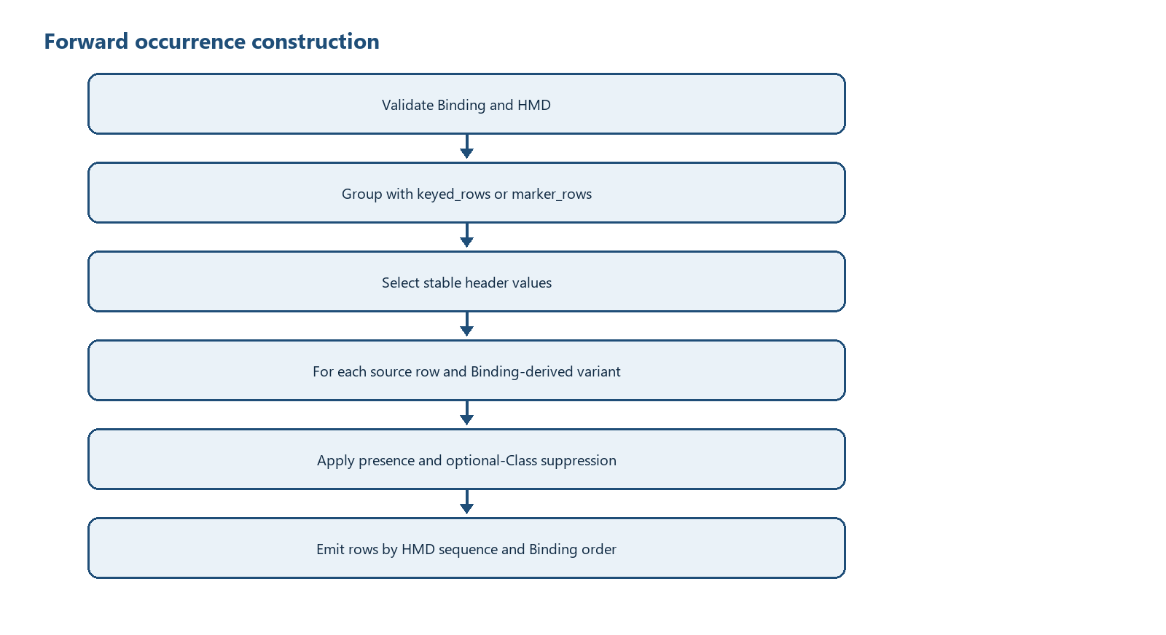
Figure 3 - Canonical forward grouping and occurrence decisions
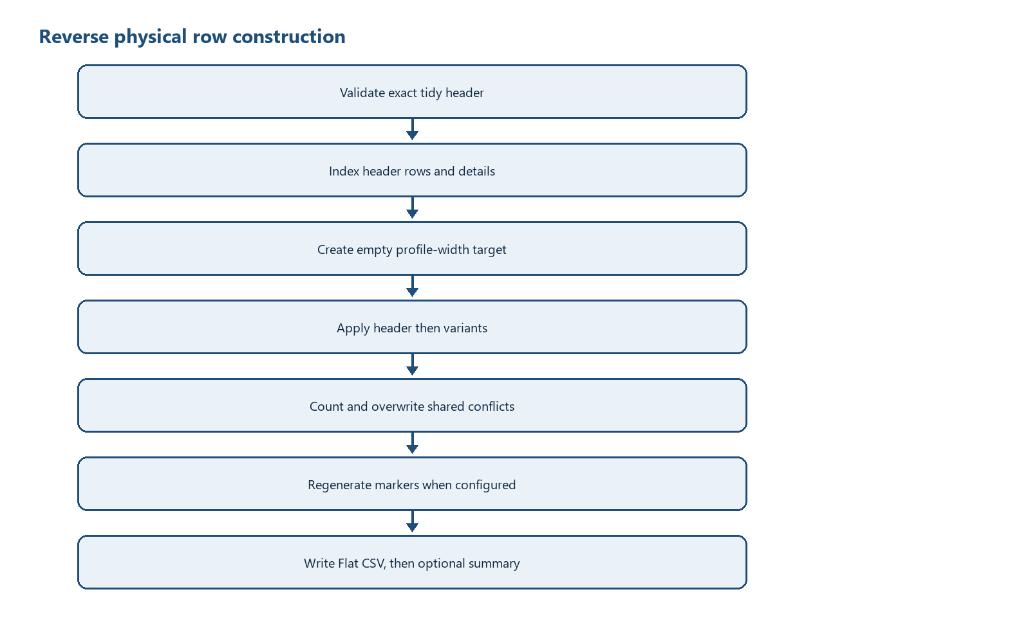
Figure 4 - Canonical reverse row reconstruction

13.1 Forward pseudocode
binding = load_binding(binding, hmd)
source_rows = read, reject rows wider than width, pad shorter rows
derive root rows, header rows, one header group, one source_rows driver
derive shared rows and selector variants in Binding declaration order
emit ROOT rows
for entry_key, grouped_rows in group_sources(...):
validate/select header source; emit HEADER rows
for source_index, source in grouped_rows:
for variant in variants:
if presence rows exist and all values are blank: continue
active = suppress optional Classes with all physical descendants blank
emit active rows sorted by (HMD sequence, Binding order)
write exact TIDY_FIELDS CSV

13.2 Reverse pseudocode
validate tidy header
header_values[entry_key].append(row)
details[(entry_key, int(source_row))].append(row)
for detail key sorted by source_row:
target = [''] * width
ordered = header rows + detail rows sorted by variant rank, sequence, binding_path
for tidy row:
binding_row = by_path[binding_path] or fail
reverse-transform value
if physical column and value:
count conflict when old is non-empty and different
target[column_number - 1] = value
if marker_rows: rebuild markers and blank repeated header cells
write Flat CSV; optionally write value-free JSON summary

14 Condition and Decision Rules
Rule | Current behaviour
Canonical dispatch | Only exact 17-column header; every other header takes legacy path
keyed_rows identity | Compact JSON array of configured non-empty key values; repeated non-contiguous keys reuse the same group list
marker_rows identity | State-machine group ordinal, not physical key values
source_rows occurrence | Each physical row ordinal combines with each present selector variant
Predicate/variant | First predicate immediately after driver path; quoted RHS value if simple equality
Required value | Only required Attribute rows are checked during forward; required Class rows are not separately checked
Default | Used when Binding column is empty; optional-Class suppression prevents default-only creation when all physical descendants are blank
Reverse shared conflict | Later non-empty different value wins; aggregate per-column count only
Transformation | Only empty and jp_era_date_to_iso accepted

15 Data Structure Construction
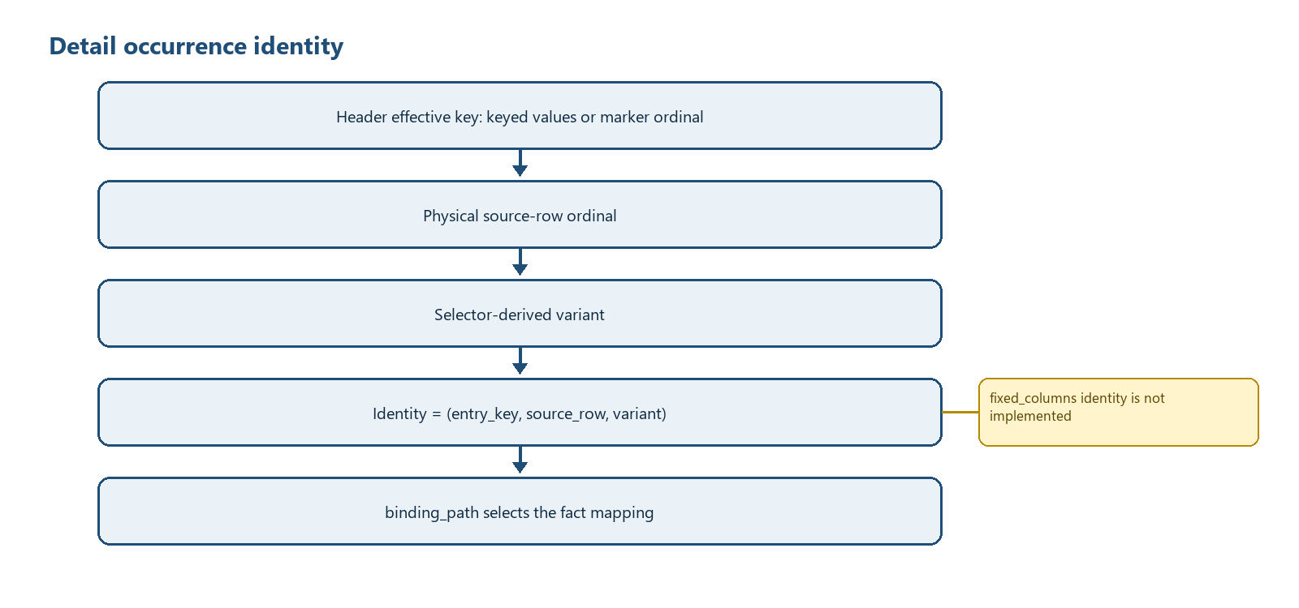
Figure 5 - Canonical detail occurrence identity

15.1 keyed_rows occurrence handling - current
The effective header identity is the compact JSON serialization of the configured ColumnN values. Every key component must be non-empty. Python dictionary insertion order preserves first-key appearance, and later non-contiguous rows with the same key append to the existing group. Detail identity extends the header key with the original 1-based source-row ordinal and selector-derived variant.

15.2 marker_rows/source_rows handling - current
Marker groups are recognized by four distinct Binding-defined codes. source_rows creates a detail driver per physical row, while selector variants create sibling occurrences such as debit and credit. row_role=presence can suppress a variant. Reverse reconstructs marker codes from the number and position of rows in each entry group.

15.3 fixed_columns handling - recommended enhancement only
Not implemented: flat_csv_canonical.py has no fixed_columns branch, does not read max_occurs for execution, and does not create/reuse occurrences from one-based [n] selectors. A Binding using fixed_columns would not receive the required occurrence semantics.
RECOMMENDED ONLY:
for each Class row with occurrence_mode == 'fixed_columns':
validate integer max_occurs > 0
for each descendant Attribute mapping:
parse [n] on the repeated Class segment
require 1 <= n <= max_occurs
neutral_path = path with selectors removed
identity = (parent_effective_key, neutral_class_path, n)
create/reuse identity only when a mapped source value (or permitted default) is present
persist n so reverse maps facts back to the same horizontal column group

16 Diagnostics and Error Handling
Condition | Current mechanism | Exit/publication consequence
Missing input/HMD/Binding path in entry point | Print fixed message; sys.exit() without explicit non-zero code | May report process status 0; no output from canonical call
Binding/header/HMD/group validation | ValueError | Uncaught by entry-point main; traceback and non-zero interpreter exit
Malformed marker sequence | ValueError without source values | No canonical output write has started
Required Attribute empty | ValueError containing semantic path | No canonical output write has started
Reverse unknown binding_path | ValueError | No final output write until target records are complete
Shared column conflict | Counter increment; no exception | Output continues; later value wins
Success | Printed counts | Entry-point returns normally

Not implemented: There are no stable diagnostic codes such as PATH_SELECTOR_VALUE_MISSING in the current program, no severity catalogue, no diagnostics collection object, and no structured failure report. Do not treat terminology in design documents as emitted runtime codes.

17 File Publication and Transaction Control
Current behaviour: Canonical forward and reverse accumulate records in memory and then open the requested final output directly. Summary JSON is written after Flat CSV. There is no temporary-file promotion, atomic multi-file transaction, rollback, manifest, or SHA-256 generation. Existing files can be overwritten.
Recommended enhancement: Validate all inputs and construct outputs before opening final targets; write output and summary to temporary siblings; validate counts/encoding; replace finals in a defined order; document recovery of a partially replaced pair. This recommendation is not current implementation.

18 Test and Requirement Traceability
Requirement | Evidence | Recorded result
Exact 17-column/HMD checks | test_generic_journal_entry_roundtrip.py | PASS: 37/37 paths, 20/20 unique physical columns
Forward/reverse/exact round-trip | same | PASS: 2 x 81-column rows -> 75 tidy rows -> exact source
keyed_rows genericization | same | PASS: Column3 key without program change
Variant genericization | same | PASS: LEFT/RIGHT without program change
Legacy dispatch separation | same and test_canonical_roundtrip.py | PASS: 13-column Binding not canonical
Shared overwrite | same | PASS: later value, Column27 count 1, no values in log
marker_rows/presence/transformation | test_yayoi_25_roundtrip.py | PASS: single/compound, side presence, era date, suppression, malformed markers
Private real input | profile review/TEST_RESULTS.md | 244 rows/groups; counts only; full round-trip not claimed due 976 unbound cells
Determinism | both profile tests | PASS for forward and reverse synthetic outputs
fixed_columns | No executable test | NOT IMPLEMENTED

19 Known Limitations
- Exactly one keyed_rows or marker_rows header group and exactly one source_rows driver are supported.
- Multiple nested keyed groups and multiple independent drivers are not supported.
- fixed_columns and max_occurs execution are not implemented.
- HMD duplicate semantic paths are not separately detected before dictionary overwrite.
- Selector removal uses a broad regular expression and does not parse nested brackets.
- Variant extraction handles the first predicate immediately below the driver and only simple equality reliably.
- Reverse output_records are sorted primarily by source_row ordinal, not explicitly by entry group order; identical ordinals across groups can interleave stably according to dictionary construction.
- Unknown tidy occurrence values are ignored unless they match a Binding-derived variant or HEADER.
- Required checks cover forward Attribute rows only; datatype validation is limited to registered transformations.
- Legacy file_path assumes pathname[0:1] is available; empty path handling relies on argparse required values.
- Missing-file branches use sys.exit() with no explicit failure code.
- No atomic publication, rollback, manifest, or hash generation exists.

20 Appendices

Appendix A - Exact schemas
CANONICAL_FIELDS = ('sequence', 'level', 'type', 'id', 'name', 'datatype', 'multiplicity', 'column', 'semantic_path', 'occurrence_mode', 'group_key', 'row_role', 'max_occurs', 'default_value', 'transformation', 'required', 'note')

TIDY_FIELDS = ('entry_key', 'source_row', 'occurrence', 'sequence', 'level', 'type', 'id', 'name', 'semantic_path', 'binding_path', 'value')

Appendix B - Function and method inventory
Module | Function/method | Line | Signature
private\legacy_sources\accounting\programs\csv2tidy.py | DataProcessor.__init__ | 95 | self, binding_dict
private\legacy_sources\accounting\programs\csv2tidy.py | DataProcessor.get_dim_line | 122 | self
private\legacy_sources\accounting\programs\csv2tidy.py | DataProcessor.get_data_line | 125 | self
private\legacy_sources\accounting\programs\csv2tidy.py | DataProcessor.get_records | 128 | self
private\legacy_sources\accounting\programs\csv2tidy.py | DataProcessor.debug_print | 131 | self, message
private\legacy_sources\accounting\programs\csv2tidy.py | DataProcessor.determine_type | 135 | self, value
private\legacy_sources\accounting\programs\csv2tidy.py | DataProcessor.set_record | 143 | self, element, value
private\legacy_sources\accounting\programs\csv2tidy.py | DataProcessor.atomic_process | 151 | self, d, path
private\legacy_sources\accounting\programs\csv2tidy.py | DataProcessor.list_process | 156 | self, d, path
private\legacy_sources\accounting\programs\csv2tidy.py | DataProcessor.dict_process | 179 | self, d, path
private\legacy_sources\accounting\programs\csv2tidy.py | DataProcessor.flatten_dict | 195 | self, d, path='/'
private\legacy_sources\accounting\programs\csv2tidy.py | StructuredCSV.__init__ | 206 | self, binding_dict, semantic_dict
private\legacy_sources\accounting\programs\csv2tidy.py | StructuredCSV.debug_print | 213 | self, message
private\legacy_sources\accounting\programs\csv2tidy.py | StructuredCSV.trace_print | 217 | self, message
private\legacy_sources\accounting\programs\csv2tidy.py | StructuredCSV.escape | 221 | self, string
private\legacy_sources\accounting\programs\csv2tidy.py | StructuredCSV.isblank | 231 | self, string
private\legacy_sources\accounting\programs\csv2tidy.py | StructuredCSV.unescape | 234 | self, string
private\legacy_sources\accounting\programs\csv2tidy.py | StructuredCSV.is_multiple | 242 | self, id
private\legacy_sources\accounting\programs\csv2tidy.py | StructuredCSV.initialize_hierarchy | 252 | self, binding_dict
private\legacy_sources\accounting\programs\csv2tidy.py | StructuredCSV.extract_key | 301 | self, condition
private\legacy_sources\accounting\programs\csv2tidy.py | StructuredCSV.extract_bracket_content | 309 | self, condition
private\legacy_sources\accounting\programs\csv2tidy.py | StructuredCSV.is_numeric_condition | 317 | self, condition
private\legacy_sources\accounting\programs\csv2tidy.py | StructuredCSV.extract_key_value_from_node | 323 | self, d
private\legacy_sources\accounting\programs\csv2tidy.py | StructuredCSV.split_query | 333 | self, query
private\legacy_sources\accounting\programs\csv2tidy.py | StructuredCSV.split_path_ignoring_brackets | 343 | self, path
private\legacy_sources\accounting\programs\csv2tidy.py | StructuredCSV.check_date_format | 362 | self, value, datatype
private\legacy_sources\accounting\programs\csv2tidy.py | StructuredCSV.check_column_condition | 385 | self, record, column, semPath, columnValue, value
private\legacy_sources\accounting\programs\csv2tidy.py | StructuredCSV.update_dimension | 420 | self, record, semPath, column, columnValue, whichLine, value, n, index
private\legacy_sources\accounting\programs\csv2tidy.py | StructuredCSV.process_record | 508 | self, record, n
private\legacy_sources\accounting\programs\csv2tidy.py | StructuredCSV.reflect_column_value | 548 | self, path, semPath
private\legacy_sources\accounting\programs\csv2tidy.py | StructuredCSV.prepare_dimension_column | 567 | self, record, column, semPath, columnValue, whichLine, value, n, index
private\legacy_sources\accounting\programs\csv2tidy.py | StructuredCSV.split_xpath | 597 | self, xpath
private\legacy_sources\accounting\programs\csv2tidy.py | StructuredCSV.remove_redundant_conditions | 604 | self, xpath
private\legacy_sources\accounting\programs\csv2tidy.py | StructuredCSV.process_dimension | 632 | self, path
private\legacy_sources\accounting\programs\csv2tidy.py | StructuredCSV.process_dimension_column | 638 | self, record, column, semPath, columnValue, whichLine, value, n, index
private\legacy_sources\accounting\programs\csv2tidy.py | StructuredCSV.combine_queries | 646 | self, query1, query2
private\legacy_sources\accounting\programs\csv2tidy.py | StructuredCSV.swap_patterns | 680 | self, input_string
private\legacy_sources\accounting\programs\csv2tidy.py | StructuredCSV.refrect_dimension | 721 | self, leading_part
private\legacy_sources\accounting\programs\csv2tidy.py | StructuredCSV.process_element_column | 785 | self, record, column, datatype, semPath, value
private\legacy_sources\accounting\programs\csv2tidy.py | StructuredCSV.split_key_value | 809 | self, condition
private\legacy_sources\accounting\programs\csv2tidy.py | StructuredCSV.check_node_condition | 817 | self, node, condition
private\legacy_sources\accounting\programs\csv2tidy.py | StructuredCSV.update_list_based_on_condition | 851 | self, lst, condition
private\legacy_sources\accounting\programs\csv2tidy.py | StructuredCSV.set_dimension_value | 875 | self, path
private\legacy_sources\accounting\programs\csv2tidy.py | StructuredCSV.set_element_value | 983 | self, path
private\legacy_sources\accounting\programs\csv2tidy.py | StructuredCSV.lookup | 998 | self, node, query_elements
private\legacy_sources\accounting\programs\csv2tidy.py | debug_print | 1163 | message
private\legacy_sources\accounting\programs\csv2tidy.py | trace_print | 1168 | message
private\legacy_sources\accounting\programs\csv2tidy.py | file_path | 1173 | pathname
private\legacy_sources\accounting\programs\csv2tidy.py | read_lhm_file | 1183 | LHM_file, encoding=encoding
private\legacy_sources\accounting\programs\csv2tidy.py | read_binding_file | 1204 | binding_file, encoding=encoding
private\legacy_sources\accounting\programs\csv2tidy.py | sort_headers_by_semSort | 1236 | header, semantic_dict
private\legacy_sources\accounting\programs\csv2tidy.py | transform_id | 1250 | id
private\legacy_sources\accounting\programs\csv2tidy.py | tidy_to_csv | 1266 | data, filename, encoding='utf-8-sig'
private\legacy_sources\accounting\programs\csv2tidy.py | fill_json_meta | 1305 | out_csv, out_json, header
private\legacy_sources\accounting\programs\csv2tidy.py | main | 1391
private\legacy_sources\accounting\programs\tidy2csv.py | ReverseDataProcessor.__init__ | 93 | self, binding_dict
private\legacy_sources\accounting\programs\tidy2csv.py | ReverseDataProcessor.process_tidy_data | 105 | self, tidy_data
private\legacy_sources\accounting\programs\tidy2csv.py | ReverseDataProcessor.update_dict | 113 | self, d, idxs, key, value
private\legacy_sources\accounting\programs\tidy2csv.py | ReverseDataProcessor.restore_tidy_dict | 130 | self, tidy_data
private\legacy_sources\accounting\programs\tidy2csv.py | ReverseDataProcessor.split_xpath | 152 | self, xpath
private\legacy_sources\accounting\programs\tidy2csv.py | ReverseDataProcessor.split_key_value | 158 | self, condition
private\legacy_sources\accounting\programs\tidy2csv.py | ReverseDataProcessor.fill_row | 165 | self, path, id, val, row=None
private\legacy_sources\accounting\programs\tidy2csv.py | ReverseDataProcessor.get_nth_indices | 194 | self, selected_candidates
private\legacy_sources\accounting\programs\tidy2csv.py | ReverseDataProcessor.replace_keys | 304 | self, rows, binding_dict
private\legacy_sources\accounting\programs\tidy2csv.py | ReverseDataProcessor.fill_record | 317 | self, tidy_record, root_id, header_row, rows
private\legacy_sources\accounting\programs\tidy2csv.py | ReverseDataProcessor.flatten_dict | 396 | self, tidy_dict
private\legacy_sources\accounting\programs\tidy2csv.py | ReverseDataProcessor.get_data | 412 | self
private\legacy_sources\accounting\programs\tidy2csv.py | read_lhm_file | 416 | LHM_file, encoding=encoding
private\legacy_sources\accounting\programs\tidy2csv.py | read_binding_file | 436 | binding_file, encoding=encoding
private\legacy_sources\accounting\programs\tidy2csv.py | tidy_to_proprietary | 465 | tidy_file, out_file, binding_dict
private\legacy_sources\accounting\programs\tidy2csv.py | file_path | 492 | pathname
private\legacy_sources\accounting\programs\tidy2csv.py | main | 502
private\legacy_sources\accounting\programs\flat_csv_canonical.py | BindingRow.sequence | 41 | self
private\legacy_sources\accounting\programs\flat_csv_canonical.py | BindingRow.path | 45 | self
private\legacy_sources\accounting\programs\flat_csv_canonical.py | BindingRow.neutral_path | 49 | self
private\legacy_sources\accounting\programs\flat_csv_canonical.py | _truthy | 63 | value: str
private\legacy_sources\accounting\programs\flat_csv_canonical.py | _column_number | 67 | column: str
private\legacy_sources\accounting\programs\flat_csv_canonical.py | _group_columns | 72 | row: BindingRow
private\legacy_sources\accounting\programs\flat_csv_canonical.py | _group_spec | 85 | row: BindingRow
private\legacy_sources\accounting\programs\flat_csv_canonical.py | _variant_for | 115 | row: BindingRow, driver_path: str
private\legacy_sources\accounting\programs\flat_csv_canonical.py | _transform_forward | 131 | name: str, value: str
private\legacy_sources\accounting\programs\flat_csv_canonical.py | _transform_reverse | 144 | name: str, value: str
private\legacy_sources\accounting\programs\flat_csv_canonical.py | is_canonical_binding | 160 | path: str | Path, encoding: str='utf-8-sig'
private\legacy_sources\accounting\programs\flat_csv_canonical.py | load_binding | 165 | binding_path: str | Path, hmd_path: str | Path, encoding: str='utf-8-sig'
private\legacy_sources\accounting\programs\flat_csv_canonical.py | _value_for | 227 | row: BindingRow, source: list[str]
private\legacy_sources\accounting\programs\flat_csv_canonical.py | _group_sources | 238 | source_rows: list[list[str]], spec: GroupSpec
private\legacy_sources\accounting\programs\flat_csv_canonical.py | _header_source | 290 | grouped_rows: list[tuple[int, list[str]]], header_rows: list[BindingRow], width: int
private\legacy_sources\accounting\programs\flat_csv_canonical.py | _active_occurrence_rows | 309 | rows: list[BindingRow], source: list[str], driver: BindingRow
private\legacy_sources\accounting\programs\flat_csv_canonical.py | _tidy_record | 328 | row: BindingRow, entry_key: str, source_row: str, occurrence: str, value: str
private\legacy_sources\accounting\programs\flat_csv_canonical.py | forward_file | 350 | input_path: str | Path, output_path: str | Path, binding_path: str | Path, hmd_path: str | Path, encoding: str='utf-8-sig', profile_width: int | None=None, input_encoding: str | None=None, output_encoding: str | None=None, definition_encoding: str | None=None
private\legacy_sources\accounting\programs\flat_csv_canonical.py | _write_summary | 439 | path: str | Path, summary: dict[str, object]
private\legacy_sources\accounting\programs\flat_csv_canonical.py | reverse_file | 445 | input_path: str | Path, output_path: str | Path, binding_path: str | Path, hmd_path: str | Path, encoding: str='utf-8-sig', profile_width: int | None=None, summary_log: str | Path | None=None, input_encoding: str | None=None, output_encoding: str | None=None, definition_encoding: str | None=None

Appendix C - Saved diagram sources
- diagrams/01_system_context.mmd
- diagrams/02_dispatch_flow.mmd
- diagrams/03_forward_occurrence_flow.mmd
- diagrams/04_reverse_flow.mmd
- diagrams/05_occurrence_identity.mmd
- diagrams/06_fixed_columns_recommended_only.mmd

Validated PCA to Accounting Entries OIM contract (2026-08-22)
The validated public-safe input is a synthetic, headerless, 81-column PCA fixture with two rows. Private PCA accounting data is excluded. The 37-row PCA Flat CSV Binding and XBRL GL Next Accounting Entries HMD control conversion; the applicable OIM taxonomy is generated or identity-verified and validated before conversion.
When a taxonomy entry point is supplied, forward processing writes a same-directory, same-basename CSV/JSON XBRL-CSV pair with a relative taxonomy URI. Repeated Class selectors and source-row occurrence keys are represented as OIM typed dimensions. Reverse processing restores the physical 81-column records. Normalized comparison is field-position and value based, with line-ending and CSV quoting normalization only.
Item | Validated contract
Validated converter | pre-public-validation/programs/flat-csv/scripts/flat_csv.py
Forward result | 2 source rows to 53 XBRL-CSV facts; Arelle error 0 and warning 0.
Reverse result | 2 rows restored; normalized differences 0.

