UADC — Universal Adapter for Data Conversion

— Program Specification: Syntax Binding
Document status: Draft — For Collaborative Review
Date: 2026-08-26
Author: Nobuyuki SAMBUICHI
Role: UADC project editor and implementation reviewer
Project: UADC
Distribution: Private project repository — invited participants only
This document is a draft under development by Nobuyuki SAMBUICHI for collaborative review within the UADC project. It is shared through a private project workspace with invited participants. It has not been approved or endorsed as an official specification by XBRL Japan, XBRL Europe, XBRL International, or any other organization.
Copyright and license terms are defined by the UADC project licensing files.
Repository version: private collaborative review draft; WORK implementation snapshot.
Editors: SAMBUICHI, Nobuyuki
Contributors: invited project participants (individual names not yet confirmed for publication).

Status
Current implementation: The normative implementation described here is src/syntax_binding.py as formally reviewed on 2026-08-26. The approved generic runtime SHA-256 is 7CA92B9DB1724D1A5A3AE9C0FDD9A081ED73F34D1125A8626C880BE2AE5B11A9. The companion src/syntax_binding_ads_xbrl_gl.py remains separately identified.

Abstract
The program maps XML physical syntax selected by a Syntax Binding CSV to a dimension-based hierarchical Structured CSV and reconstructs XML from the same Binding-driven occurrence model. The approved UBL and CII profiles use HMD-aligned Class, Attribute and syntax-only F rows; semantic_path, XML xpath, multiplicity, Structured CSV columns, syntax_sequence, defaults, required flags and named transformations are declarative Binding data.

1 Purpose and Scope
This specification answers what enters and leaves the executable, how Binding rows become dataclasses, lists and indexes, how repeated XML contexts become Structured CSV rows, how reverse contexts are created or reused, where processing branches, and which tests establish the current boundary.
- In scope: src/syntax_binding.py forward XML-to-Structured CSV and Binding-driven reverse Structured CSV-to-XML for the approved UBL and CII profiles.
- In scope: EN16931 UBL Binding (199 rows), formally reviewed CII D16B Binding (237 rows), and EN16931 HMD (197 rows) as evidence references.
- Related executable: src/syntax_binding_ads_xbrl_gl.py generates XBRL GL tuple instances from Structured CSV; it is not the reverse branch of syntax_binding.py.
- Out of scope as current behaviour: JSON/JSONPath adapters, Schematron conformance, transactional publication, manifest creation, and SHA-256 output generation.

2 System Context
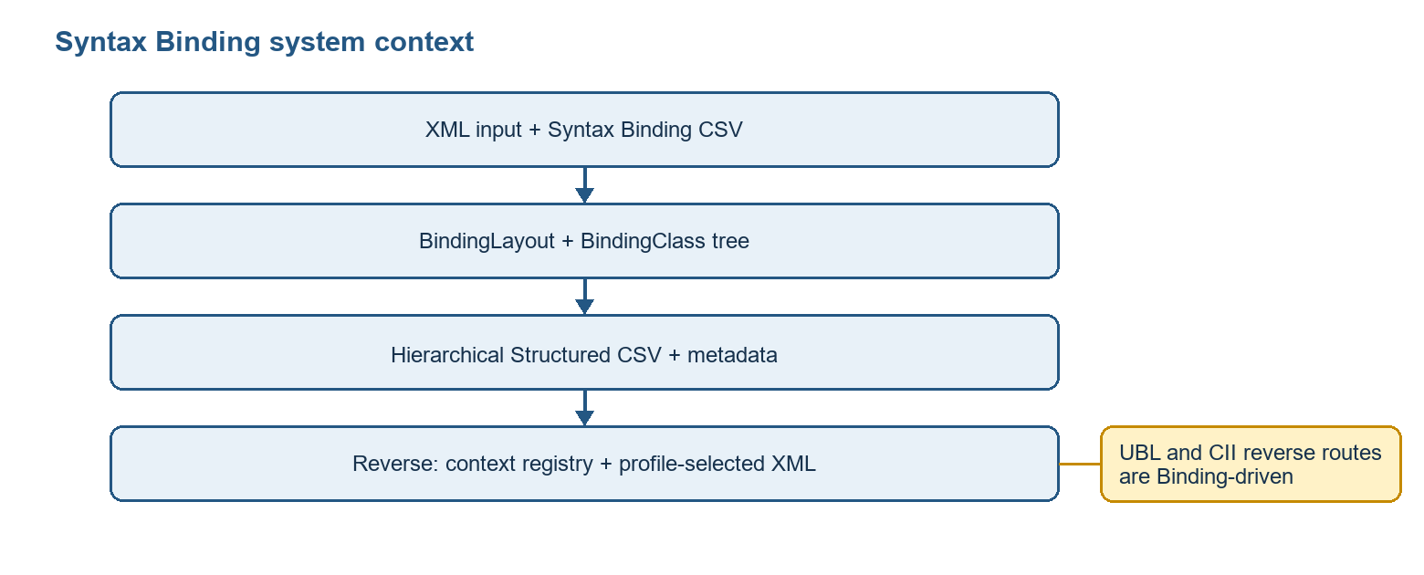
Figure 1 - Current Syntax Binding system context
Responsibility boundary: The executable performs syntax mapping within one semantic model. Cross-HMD semantic mapping belongs to the Semantic Table path. Flat physical-column grouping belongs to the Flat CSV path.

3 Processing Overview
Direction | Primary entry | Main stages | Result
Forward | write_hierarchical_csv | namespaces -> BindingLayout -> BindingClass tree -> recursive XML contexts -> rows -> CSV -> metadata | Hierarchical CSV plus JSON metadata
Reverse | write_xml_from_hierarchical_csv | BindingLayout -> CSV rows -> scope validation -> binding sort -> context registry -> XML values -> schema order | profile-selected XML
ADS XBRL GL | syntax_binding_ads_xbrl_gl.py main | load ADS bindings -> rows -> XBRL facts/tuples -> reorder -> write | XBRL GL tuple instance(s)

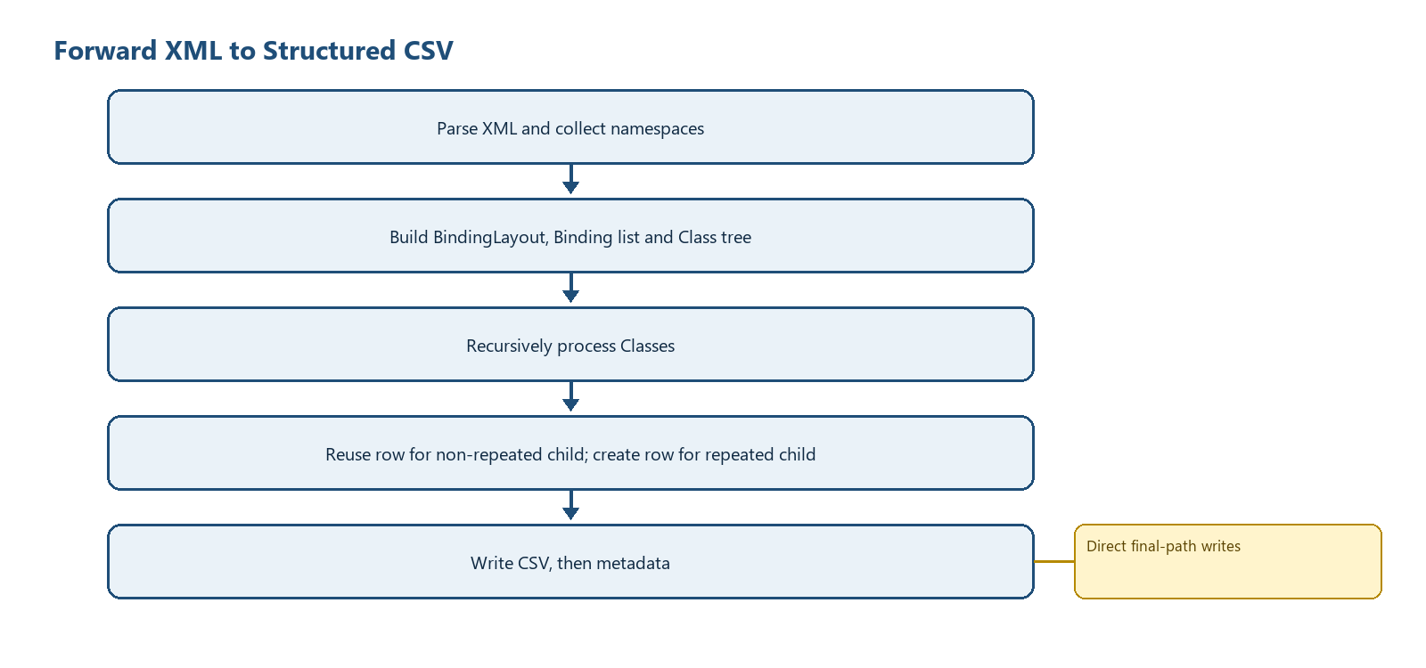
Figure 2 - Forward processing and row construction
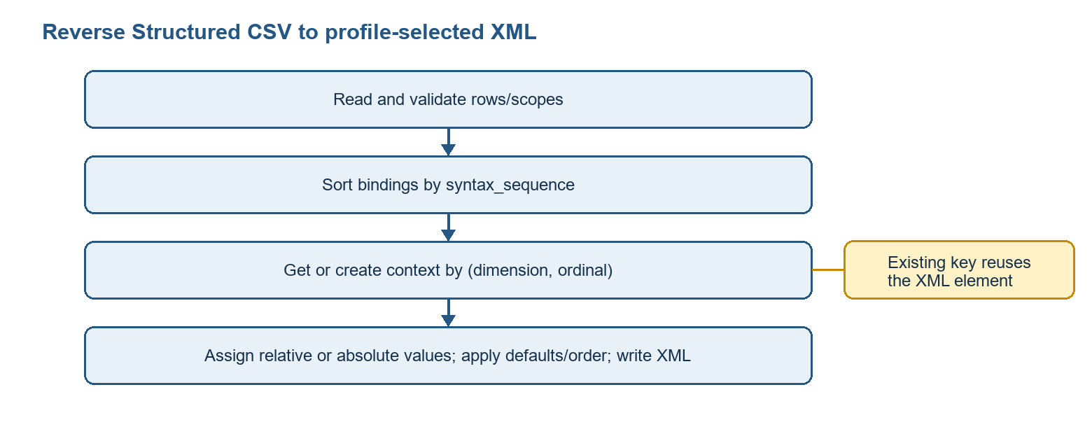
Figure 3 - Reverse processing and context reuse

4 Runtime Arguments
Argument | Required/default | Forward effect | Reverse effect
input_file | required | XML input | Structured CSV input
-b / --binding | required | Syntax Binding CSV | Same
-o / --output | required | CSV output | XML output
--template-csv | optional | Only field-to-dimension hints are merged; template column order is not adopted | Field-to-dimension hints
--metadata-output | default: output .json | Metadata path | Ignored by reverse branch
--taxonomy-base | default: out/taxonomy | Metadata entrypoint discovery | Ignored
--reverse | false | Selects reverse branch when present | Enables reverse
--ubl-schema-root | optional | Ignored | Loads local XSD files for child order
--ubl-schema-url | empty | Ignored | Recursively downloads XSD imports/includes when supplied
--drop-empty-columns | false | Drops columns empty in all generated rows | Ignored
--d-invoice | 1 | Value placed in dInvoice | Not used to choose root
-e / --encoding | utf-8-sig | Binding/CSV encoding | Binding/CSV encoding; XML output UTF-8

4.1 ADS XBRL GL companion arguments
Argument | Meaning
input | Structured CSV file or directory
--binding-csv | Required ADS XBRL GL Binding CSV
--output-dir | Required output root
--schema-href | Optional schemaRef href
--monetary-decimals | Fallback decimals, default 2
--currency-csv | Currency minor-unit table
--taxonomy-base | Hidden compatibility argument; no described output effect
--output-stem-prefix | Prefix for generated stems
--output-filename | Allowed only for one input file

5 Input File Specification

5.1 XML input
- Parsed with xml.etree.ElementTree.
- Namespace declarations are collected with iterparse start-ns events.
- The supported XPath subset is child-step navigation, terminal attributes, selected equality/inequality predicates, true()/false(), and limited absolute reference comparisons.
- Unsupported predicate syntax does not raise in xml_predicate_matches; it returns True. This is a documented limitation, not validation.

5.2 Syntax Binding CSV
Field | Observed use
type | C rows build classes; A rows build facts
semantic_path | Class identity and field mapping; const: marks syntax-only defaults
xpath | XML selection/construction path
structured_csv_column | Dimension or fact column
multiplicity | Repeat detection for Class rows
syntax_sequence | Binding and XML child ordering
sequence | Stable fallback order
default_value | Applied only to already existing parent contexts for const rows

Evidence snapshot: EN16931_UBL_Invoice_Syntax_Binding.csv has 199 data rows and SHA-256 5EF89BD33B17BFF0A6A44430E84DD427E2108CC497919E405593090112AE8407. The CEN/TS 16931-3-3:2020 Table 2 reviewed EN16931_CII_D16B_Invoice_Syntax_Binding.csv has 237 data rows and SHA-256 B529F2585CA2A5FBFDAF673A6F96B98135CE274B8B022C1B791FF9863C23BD23.

5.2.1 Approved generic Binding/runtime capabilities
- Syntax-only F rows declare required physical containers or attributes with const: semantic paths and do not create EN semantic facts.
- Required empty containers, literal and nested predicates, and parent-conditional defaults are materialized from Binding rows.
- Alias-relative child paths such as . and @schemeID are evaluated inside the selected Class occurrence; zero or multiple matching aliases are errors.
- Named transformations are resolved through a strict registry with deterministic inverse behaviour for the approved bidirectional routes.
- When a local XSD is supplied, sibling order is derived generically from that schema rather than from a CII document-family branch.

5.3 Structured CSV reverse input
The file must have a header and at least one data row. Dimension columns follow d<UpperCamelClass> naming. A row containing a fact outside its owning dimension scope is rejected by validate_hierarchical_row_scopes.

6 Output File Specification
Output | Shape | Creation behaviour
Structured CSV | Binding-derived dimension columns followed by fact columns | Header and rows written directly to requested path
Metadata JSON | documentInfo, tableTemplates, tables and column metadata | Written after CSV; default path replaces CSV suffix with .json
Reverse profile XML | UTF-8 XML declaration; Binding-selected document root | Written after defaults, child sorting and indentation
Console | Success count or one caught exception message | main returns 0/1 for syntax_binding.py

7 Internal Data Model
Structure | Type | Identity / ordering | Lifetime and output effect
BindingLayout | frozen dataclass | maps semantic paths and fields to dimensions; list order from Binding | One conversion; controls columns and scopes
Binding | frozen dataclass | one semantic_path/xpath row; sorted by syntax_sequence then order | One conversion; controls extraction/construction
BindingClass | mutable dataclass tree | semantic_path; children sorted by syntax_sequence | Forward only; controls recursion
rows | list[dict[str,str]] | append order is parent row then repeated child contexts in XML order | Serialized as Structured CSV
direct_fields_by_class | dict[str,list[Binding]] | Class semantic_path key | Forward lookup index
dimension_bindings | dict[str,list[Binding]] | dimension column key | Reverse grouping
context_by_dimension_row | dict[(dimension, ordinal), Element] | reuses one XML context for all facts in same repeated row | Reverse hierarchy construction
UblSchemaIndex | object with dicts and set | QName-indexed elements/types; loaded_sources prevents repeat loading | Optional reverse child ordering

8 Class Specification
Class | Responsibility | Owned state | Invariant / failure boundary
UblElementDecl | Immutable global element declaration | qname, type_qname | No behaviour; created while indexing XSD
UblSchemaIndex | Load XSD declarations and derive child sequences | elements dict, types dict, loaded_sources set | Remote load uses urlopen; failures propagate
Binding | Immutable executable binding row | order, syntax_sequence, default, semantic/xml paths, dimension/filter/field | Only parsed supported semantic_path forms become objects
BindingLayout | Immutable column/dimension maps | fieldnames plus eight maps | Generated from C/A rows
BindingClass | Forward semantic Class node | metadata and mutable children list | Tree parent is nearest exact semantic_path prefix

9 Object Specification
Runtime object | Created by | Cardinality | State transition / end
XML root | ET.parse or ET.Element | one | parsed/created -> populated -> sorted -> written
BindingClass node | build_binding_class_tree | one per usable C row | created -> attached to parent -> traversed
Structured row dict | new_row | one root/non-repeated owner plus one per repeated XML context | empty dimensions -> facts -> append -> serialized
Repeated XML context | create_context | one per distinct (dimension, ordinal) encountered with a non-empty fact | created once -> reused for sibling facts -> serialized
Syntax-only default target | find_existing_elements | zero or more existing parents | no parent means no creation; existing target is filled only when empty

10 Collection and List Specification
Name | Element/key | Ordering / duplicate rule | Producer -> consumer
fieldnames | str | dimensions then facts; unique by first appearance | build_layout_from_rows -> CSV writers
rows | dict | append order significant; duplicates are not de-duplicated | process_class -> writer/metadata
children | BindingClass | syntax_sequence/order | tree builder -> recursion
bindings | Binding | Binding row order then sorted where required | read_bindings -> forward/reverse
loaded_sources | str set | unique source paths/URLs | UblSchemaIndex loaders
context_by_dimension_row | tuple -> Element | dictionary lookup; no output order of its own | reverse loop -> relative setters

11 Variable and State Specification
State | Initial value | Mutation | Decision effect
namespaces | collected map or UBL_NAMESPACES | not mutated except ET namespace registration | QName resolution
dimension_values | {'dInvoice': CLI value} | copied and extended with repeated ordinal | row hierarchy
current_row | None or inherited dict | facts filled in place | non-repeated Classes share row
written | 0 | incremented per assigned/defaulted value | success message only; not validation count
document_currency / tax_currency | first non-empty aliases | immutable | currencyID and predicate reference resolution
schema_child_order | built-in fallback or XSD-derived map | loaded before final sort | reverse element order

12 Function Specification
Function group | Principal functions | Contract
Binding ingestion | read_binding_layout, build_layout_from_rows, read_bindings, build_binding_class_tree | Normalize CSV rows, derive dimensions/facts, parse executable bindings, construct semantic tree
XPath read | xml_split_xpath, xml_predicate_matches, find_nodes, get_value | Evaluate the implemented XPath subset; return empty string/list for no match
Forward hierarchy | class_contexts, fill_direct_fields, process_class | Nested functions inside write_hierarchical_csv; create rows according to multiplicity
XML construction | ensure_path, create_context, set_xml_value_with_currency, set_relative_xml_value | Create/reuse elements and set text/attributes/predicate values
Defaults/order | apply_default_to_existing_contexts, load_ubl_child_order, sort_children_for_ubl_schema | Conditional defaults and schema-order normalization
Output | write_hierarchical_csv, write_csv_metadata, write_xml_from_hierarchical_csv | Direct file writes; return row/field or value counts
CLI | main | Catch any Exception for syntax_binding.py, print one stderr line, return 1

Appendix B provides the complete module-level function inventory with source lines and signatures.

13 Detailed Processing Flow

13.1 Forward pseudocode
layout = read_binding_layout(binding)
bindings = read_bindings(binding, layout maps)
class_root = build_binding_class_tree(binding rows)
index direct A-row bindings by Class semantic_path
process_class(xml_context, class_node, active_dimensions, current_row):
row = current_row or new_row()
fill direct facts from relative XPath
recurse non-repeated children into row
append row if this Class owns it and it has facts/dimensions
for each repeated child context in input order:
copy dimensions; set child dimension to 1-based ordinal
recurse with a new row
write rows; then write metadata

13.2 Reverse pseudocode
read and validate Structured CSV rows
root = new profile-selected document root
for binding in syntax_sequence order:
if syntax-only default:
fill only existing matching parents
elif binding belongs to repeated dimension:
for non-empty rows sorted by numeric ordinal:
key = (dimension, ordinal)
context = registry.get(key) or create_context(repeat_path)
set relative value, unless path remains absolute
else:
write the first non-empty value
apply Binding defaults; sort children; write XML

14 Condition and Decision Rules
Condition | True branch | False branch
C row multiplicity repeats | Create dimension and one row per XML context | Reuse parent row
XPath value non-empty and field empty | Assign fact | Preserve existing value
Filter metadata present | Assign filter field/value in row | No discriminator assignment
drop_empty enabled | Remove all-empty columns | Keep full Binding layout
Reverse binding has default and no field | Apply only in existing contexts | Normal fact branch
Repeated reverse context key exists | Reuse element | Create repeat path context
relative_xpath remains absolute | Write from document root | Write under repeated context
No XSD option | Use built-in fallback order | Use derived XSD order where available

15 Data Structure Construction
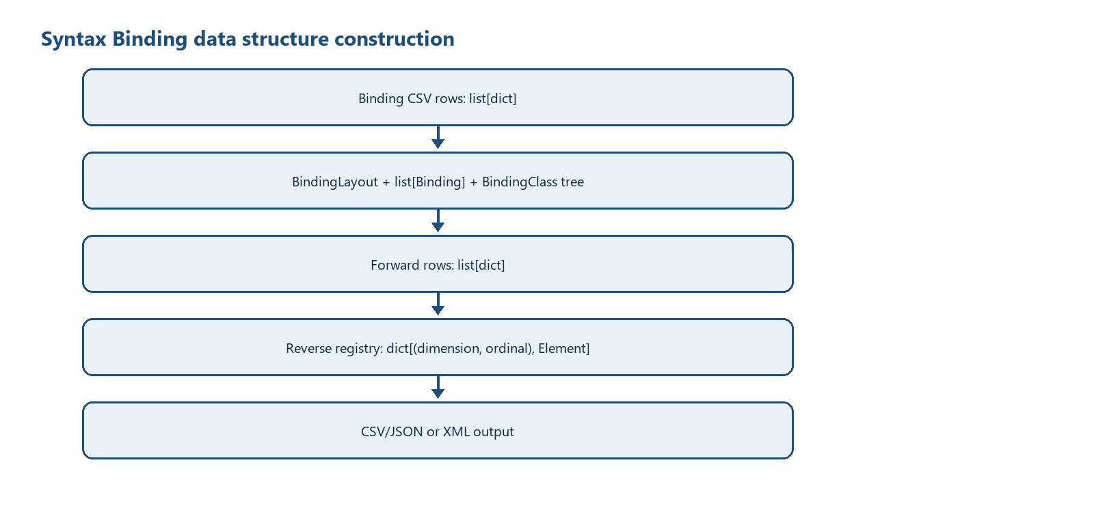
Figure 4 - Binding rows to runtime structures and output
Hierarchy is not represented by nested Python occurrence objects in forward conversion. It is represented by a BindingClass tree plus dimension columns in flat row dictionaries. Reverse conversion materializes XML Elements lazily and reuses them through context_by_dimension_row.

16 Diagnostics and Error Handling
Observed condition | Mechanism | External result
No Binding header / no usable rows | ValueError | main prints syntax_binding.py: <message>; exit 1
No input CSV header/data | ValueError | Same
Invalid row scope | ValueError | Same
XML/XSD parse, path or network failure | Underlying exception | Same in syntax_binding.py; ADS companion may terminate with traceback/SystemExit
Success | return count | stdout success line; exit 0

Not implemented: There is no diagnostic-code catalogue, severity object/list, structured diagnostics file, partial-success status, or row-level error aggregation in src/syntax_binding.py.

17 File Publication and Transaction Control
Current behaviour: Output parents are created, then CSV/JSON/XML is written directly to the requested final path. Forward CSV is written before metadata; a later metadata failure can leave a CSV. Reverse profile XML is written once construction finishes. Existing targets can be overwritten by normal file-open semantics.
Recommended enhancement: Write all related outputs to sibling temporary files, fsync where required, validate, and replace final targets as one documented publication operation. Add a manifest/hash only if a future requirement explicitly adopts them. This is not current behaviour.

18 Test and Requirement Traceability
Requirement area | Evidence | Result / boundary
Forward hierarchy | tests/test_syntax_binding.py | PASS: 9 rows, 177 columns
UBL reverse | tests/test_syntax_binding_reverse.py | PASS: 87 values and 9-row round-trip
PINT Japan forward | tests/test_pint_jp_examples_conversion.py | PASS: 9/9, 4-20 rows
Round-trip artifacts | tests/test_roundtrip_artifacts.py | PASS: 19 cases
UBL schema | tests/test_roundtrip_xml_ubl_schema.py | PASS: 19/19 UBL 2.1
Syntax order/defaults | test_ubl_binding_syntax_sequence.py; test_ubl_required_syntax_defaults.py; test_ubl_schema_child_order.py | PASS in recorded review
CII forward/reverse | tests/test_cii_d16b_conversion.py | PASS: 237 Binding rows; 9 EN roundtrips, 3 public CII roundtrips, schema errors 0, semantic diffs 0
Determinism | review/TEST_RESULTS.md | PASS: PINT 18 outputs and CII 6 outputs, zero mismatches
Profile rules | PINT/CII Schematron | NOT RUN

19 Known Limitations
- Reverse creates the root and child order declared by the selected Binding/profile; UBL and CII reverse routes are covered by accepted tests.
- CII date format 102 is handled by the declared reversible CII_DATE_102 transformation; unknown transformation names are errors.
- The XPath evaluator supports a limited subset and treats an unrecognized predicate as matched.
- Repeated reverse identity is (dimension, ordinal); multiple nested dimensions with the same local ordinal are not represented by a composite ancestor key.
- Only the first non-empty singleton fact is written in reverse.
- No output validation is called inside main after writing; schema tests are external.
- Supplying --ubl-schema-url performs network access; this must be operationally controlled.
- JSON/JSONPath and an adapter registry described in older target specifications are not present in this module.
- No atomic multi-file publication, rollback, manifest, or hash generation is implemented.

20 Appendices

Appendix A - Exact file references
File | Role
src/syntax_binding.py | Primary executable specified here
src/syntax_binding_ads_xbrl_gl.py | Related ADS Structured CSV to XBRL GL tuple generator
specs/bindings/syntax/EN16931_UBL_Invoice_Syntax_Binding.csv | 199-row UBL Binding
specs/bindings/syntax/EN16931_CII_D16B_Invoice_Syntax_Binding.csv | 237-row formally reviewed CII D16B bidirectional Binding
specs/lhm/EN16931_CIUS_Invoice_LHM.csv | 197-row HMD reference

Appendix B - Function inventory
Function | Line | Signature | Purpose
xml_local_name | 343 | name: str | Return the local component of a qualified or prefixed XML name.
collect_namespaces | 360 | xml_file: Path | Collect namespace prefix declarations from an XML file.
xml_qualify_step | 377 | step: str, namespaces: Dict[str, str] | Convert an XPath step into an ElementTree-qualified tag when possible.
xml_split_step_predicate | 399 | step: str | Separate an XPath step from its optional predicate.
xml_split_xpath | 415 | xpath: str | Split an XPath into steps while preserving predicate expressions.
xml_split_terminal_attribute | 448 | xpath: str | Separate a terminal attribute selector from an XPath.
xml_path_value | 473 | context: ET.Element, path: str, namespaces: Dict[str, str], root: Optional[ET.Element]=None | Resolve a scalar value from an XML context using a relative path.
xml_predicate_matches | 500 | child: ET.Element, predicate: Optional[str], namespaces: Dict[str, str], root: Optional[ET.Element]=None | Evaluate the supported XPath predicate forms against an XML element.
xml_child_matches | 544 | child: ET.Element, step: str, namespaces: Dict[str, str], root: Optional[ET.Element]=None | Check whether a child element matches an XPath step and predicate.
find_nodes | 566 | context: ET.Element, xpath: str, namespaces: Dict[str, str], root: Optional[ET.Element]=None | Find XML nodes matching the limited XPath subset used by syntax bindings.
get_value | 600 | context: ET.Element, xpath: str, namespaces: Dict[str, str], root: Optional[ET.Element]=None | Extract text or a terminal attribute value from an XML context.
parse_semantic_selector | 731 | semantic_path: str | Return canonical path plus the last syntax-variant selector.
parse_semantic_selectors | 742 | semantic_path: str | Return every presence/absence selector in left-to-right AND order.
transform_binding_value | 751 | value: str, transformation: str, reverse: bool=False | Apply a declared reversible lexical or representation transformation.
tax_total_occurrence_value | 806 | context: ET.Element, xpath: str, transformation: str, namespaces: Dict[str, str], root: ET.Element | Select one same-path tax-total occurrence as declared by a transform.
tax_total_write_xpath | 828 | xpath: str, transformation: str, document_currency: str, tax_currency: str | Qualify a same-path tax-total occurrence using declared currency role.
first_present | 851 | row: Dict[str, str], names: Iterable[str] | Return the first non-empty value from a set of candidate field names.
parse_order | 869 | value: str, fallback: int=0 | Parse a row-order value with a fallback for blanks or invalid input.
syntax_sequence_sort_key | 889 | value: str, fallback: int=0 | Return a stable sort key for an XSD-derived hierarchical syntax sequence.
upper_camel | 906 | value: str | Convert text to UpperCamelCase.
dimension_name | 922 | element: str | Build a d-prefixed dimension column name from an element name.
effective_structured_column | 935 | semantic_path: str, declared: str | Disambiguate generic child column labels from semantic-path context.
multiplicity_repeats | 948 | multiplicity: str | Return whether an LHM multiplicity allows repeated rows.
read_effective_binding_rows | 970 | binding_csv: Path, encoding: str, hmd_file: Optional[Path]=None | Load Binding rows and supplement semantic columns from an HMD.
read_binding_layout | 1005 | binding_csv: Path, encoding: str, hmd_file: Optional[Path]=None | Read LHM-style class and attribute rows embedded in a syntax binding CSV.
build_layout_from_rows | 1024 | rows: List[Dict[str, str]] | Build Structured CSV layout metadata from LHM-style C/A rows.
read_template | 1135 | template_csv: Optional[Path], encoding: str | Read an optional template CSV and infer dimension placement rules.
is_dimension_column | 1172 | name: str | Return whether a column name represents a dimension column.
parse_semantic_path | 1185 | semantic_path: str, xpath: str, order: int, syntax_sequence: str='', default_value: str='', path_dimension: Optional[Dict[str, str]]=None, field_by_semantic_path: Optional[Dict[str, str]]=None, semantic_path_dimension: Optional[Dict[str, str]]=None | Parse a semantic path into hierarchy parts and a leaf field.
read_bindings | 1278 | binding_csv: Path, encoding: str, path_dimension: Optional[Dict[str, str]]=None, field_by_semantic_path: Optional[Dict[str, str]]=None, semantic_path_dimension: Optional[Dict[str, str]]=None, rows: Optional[List[Dict[str, str]]]=None | Read usable binding rows from a CSV file.
read_binding_rows | 1335 | binding_csv: Path, encoding: str | Read normalized rows from a binding CSV.
build_binding_class_tree | 1353 | rows: List[Dict[str, str]] | Build a semantic class tree from C rows in the syntax binding table.
direct_class_fields | 1433 | class_path: str, bindings: List[Binding] | Return A-row bindings whose direct semantic parent is a class path.
binding_applies_to_alias | 1456 | binding: Binding, alias: BindingClassAlias | Return whether an Attribute Binding belongs to a selected Class alias.
walk_binding_classes | 1467 | root: BindingClass | Return binding class nodes in pre-order.
xpath_element_path | 1483 | xpath: str | Return the element portion of an XPath without a terminal attribute.
xpath_parent | 1498 | xpath: str | Return the parent XPath for an element or attribute XPath.
common_xpath_prefix | 1514 | xpaths: List[str] | Find the common path prefix across XPath strings.
infer_repeat_path | 1535 | bindings: List[Binding] | Infer the repeated XML context path from binding rows.
relative_xpath | 1553 | full_xpath: str, context_xpath: str | Make a binding XPath relative to a context XPath.
qname | 1573 | name: str, namespaces: Dict[str, str] | Build an ElementTree QName from a prefixed XML name.
element_local_name | 1592 | tag: str | Return the local XML element name from a tag or step.
step_base_and_predicate | 1607 | step: str | Split an XPath step into its base name and predicate text.
predicate_child_value | 1623 | predicate: str | Parse a simple child-equals-literal predicate.
find_predicate_value | 1657 | parent: ET.Element, relative_path: str, namespaces: Dict[str, str] | Read the value referenced by a predicate child path.
set_predicate_value | 1686 | parent: ET.Element, relative_path: str, value: str, namespaces: Dict[str, str] | Write the value referenced by a predicate child path.
split_xpath_steps | 1710 | xpath: str | Split an XML path into steps while preserving predicates.
split_terminal_attribute | 1742 | xpath: str | Separate a terminal XML attribute from an XPath.
child_satisfies_predicate | 1767 | child: ET.Element, predicate: str, namespaces: Dict[str, str] | Check whether a child element satisfies a simple predicate.
find_or_create_child | 1792 | parent: ET.Element, step: str, namespaces: Dict[str, str], force_new: bool=False | Find an existing matching child or create a new XML child.
split_xml_path | 1818 | xpath: str | Split an XML path into element steps and terminal attribute name.
ensure_path | 1834 | root: ET.Element, xpath: str, namespaces: Dict[str, str], force_new_leaf: bool=False | Ensure an XML path exists and return its final element and attribute.
set_xml_value | 1856 | root: ET.Element, xpath: str, value: str, namespaces: Dict[str, str] | Set an XML element text or attribute value by XPath.
find_existing_elements | 1878 | root: ET.Element, parts: List[str], namespaces: Dict[str, str] | Find existing elements for an absolute binding path without creating nodes.
apply_default_to_existing_contexts | 1898 | root: ET.Element, xpath: str, value: str, namespaces: Dict[str, str] | Apply a syntax-only default only where the bound parent context already exists.
is_amount_xpath | 1940 | xpath: str | Return whether an XPath points to an amount element.
apply_currency_attribute | 1956 | element: ET.Element, xpath: str, document_currency: str, tax_currency: str | Set currencyID on amount elements when appropriate.
resolve_currency_references | 1976 | xpath: str, document_currency: str, tax_currency: str | Replace currency reference paths with currency codes.
create_context | 1997 | root: ET.Element, xpath: str, namespaces: Dict[str, str], document_currency: str='', tax_currency: str='' | Create the root XML context for reverse hierarchical conversion.
set_xml_value_with_currency | 2022 | root: ET.Element, xpath: str, value: str, namespaces: Dict[str, str], document_currency: str, tax_currency: str | Set an XML value and apply currency attributes or references.
set_relative_xml_value | 2055 | context: ET.Element, xpath: str, value: str, namespaces: Dict[str, str], document_currency: str='', tax_currency: str='' | Set a value below a row-specific XML context.
load_ubl_child_order | 2095 | schema_root: Optional[Path]=None, schema_url: str='' | Load UBL child element order from a local schema root or schema URL.
child_order_for | 2168 | element: ET.Element, schema_child_order: Optional[Dict[str, List[str]]]=None | Return the schema child-order map for an element.
sort_children_for_ubl_schema | 2191 | element: ET.Element, schema_child_order: Optional[Dict[str, List[str]]]=None | Recursively sort UBL children according to schema order.
find_child_by_local_name | 2218 | element: ET.Element, local_name: str | Find the first direct child with a local element name.
ensure_tax_scheme_defaults | 2235 | root: ET.Element, namespaces: Dict[str, str] | Add required TaxScheme ID defaults when missing.
indent_xml | 2261 | element: ET.Element, level: int=0 | Apply readable indentation to XML elements.
new_row | 2284 | fieldnames: List[str], d_invoice: str | Create an empty hierarchical CSV row with an invoice dimension value.
row_has_values | 2301 | row: Dict[str, str], dimension_columns: List[str] | Return whether a row has any non-dimension fact values.
validate_hierarchical_row_scopes | 2315 | rows: List[Dict[str, str]], fieldnames: List[str], field_dimension: Dict[str, str] | Reject rows that mix facts belonging to different row scopes.
drop_empty_columns | 2345 | rows: List[Dict[str, str]], fieldnames: List[str] | Remove columns that are empty across all rows.
add_derived_fieldnames | 2366 | fieldnames: List[str], bindings: List[Binding] | Add binding-derived field names missing from a template.
relative_metadata_path | 2390 | path: Optional[Path], metadata_file: Path | Format a metadata path relative to its JSON metadata file.
latest_file | 2409 | directory: Path, pattern: str | Find the latest matching file in a directory.
taxonomy_entrypoints | 2424 | taxonomy_base: Optional[Path], metadata_file: Path | Build metadata links to available taxonomy entrypoint files.
taxonomy_version | 2454 | entrypoints: Dict[str, str] | Infer a taxonomy version label from entrypoint file names.
xbrl_csv_column_definition | 2471 | column: Dict[str, str] | Build one XBRL CSV metadata column definition.
binding_column_metadata | 2488 | binding_csv: Path, encoding: str, rows: Optional[List[Dict[str, str]]]=None | Build column metadata from a syntax binding CSV file.
write_csv_metadata | 2545 | metadata_file: Path, csv_file: Path, xml_file: Path, binding_csv: Path, fieldnames: List[str], row_count: int, taxonomy_base: Optional[Path], encoding: str, binding_rows: Optional[List[Dict[str, str]]]=None | Write JSON metadata for a hierarchical CSV file.
write_hierarchical_csv | 2625 | xml_file: Path, binding_csv: Path, out_csv: Path, template_csv: Optional[Path], metadata_output: Optional[Path], taxonomy_base: Optional[Path], encoding: str, d_invoice: str='1', drop_empty: bool=False, hmd_file: Optional[Path]=None | Extract XML data and write hierarchical CSV plus metadata.
row_value | 2912 | row: Dict[str, str], field: str | Return a stripped value from a CSV row field.
row_has_dimension | 2926 | row: Dict[str, str], dimension: str | Return whether a row has a value for a dimension column.
first_row_value | 2940 | rows: List[Dict[str, str]], fields: Iterable[str] | Return the first non-empty value among fields across rows.
write_xml_from_hierarchical_csv | 2959 | input_csv: Path, binding_csv: Path, out_xml: Path, template_csv: Optional[Path], encoding: str, namespaces: Optional[Dict[str, str]]=None, ubl_schema_root: Optional[Path]=None, ubl_schema_url: str='', hmd_file: Optional[Path]=None | Rebuild XML from hierarchical CSV rows and bindings.
main | 3302 |  | Parse command-line arguments, run the script workflow, and return an exit code.

Appendix C - Saved diagram sources
- diagrams/01_system_context.mmd
- diagrams/02_forward_flow.mmd
- diagrams/03_reverse_flow.mmd
- diagrams/04_data_structure_construction.mmd

Validated EN CIUS OIM processing contract (2026-08-22)
The validated input is a repository-owned synthetic UBL Invoice XML fixture. The EN Syntax Binding and Canonical 18-column HMD control extraction and reconstruction. The HMD-derived OIM taxonomy is generated and validated before conversion; the converter does not infer semantic fields.
Forward processing writes a same-directory, same-basename CSV/JSON XBRL-CSV pair. JSON metadata uses a clone-resolvable relative taxonomy URI. Arelle validation is performed with Load From OIM. Reverse processing reconstructs UBL XML, and acceptance compares business-semantic values rather than byte identity.
Item | Validated contract
Validated converter | src/syntax_binding.py
Forward result | 9 Structured CSV context rows; metadata contract and Arelle validation PASS.
Reverse result | 87 bound values reconstructed; semantic re-forward comparison reports zero differences.

